**DEDAN KIMATHI UNIVERSITY OF TECHNOLOGY**

**COURSE: BACHELOR OF SCIENCE IN MECHATRONIC ENGINEERING**

**UNIT NAME: ELECTRONIC PRODUCT DESIGN**

**TASK: LAB REPORT: MINI BOOST-1**

**LECTURER’S NAME: MR. FRANCIS**

**GROUP MEMBERS:**

**DUNCAN MWANIK E022-01-1046/2018**

**GYAVIRA MBAGA E022-01-0762/2018**

**JOY MUGI E022-01-0771/2019**

**SUBMISSION DATE: 23/12/2022**

**INTRODUCTION**

Electronic product design involves the design, development and production of the electronic hardware that allows your project to come to life. Whatever special features and capabilities your solution provides are made possible by the hardware that does the work beneath the surface.

It can often be the case that off-the-shelf products won’t do what you need them to and electronic product design enables the creation of bespoke and completely customized electronic products and circuit boards to realize these specific applications.

Electronic product design involves remits that range from the simple to the incredibly complex and everything in between. It can involve just basic control circuitry or it can require the management and delivery of complete multi-layer, multi-board projects from beginning to end, including fully assembled and tested production quantities.

**THEORY**

A printed circuit board (PCB) is an electronic assembly that uses copper conductors to create electrical connections between components. Printed circuit boards provide mechanical support for electronic components so that a device can be mounted in an enclosure. A printed circuit board design must include a specific set of steps that aligns with the manufacturing process, integrated circuit packaging, and the structure of the bare circuit board.

Conductive features on printed circuit boards include copper traces, pads, and conductive planes. The mechanical structure is made up of an insulating material laminated between layers of conductors. The overall structure is plated and covered with a nonconductive solder mask, and a silk screen material is printed on top of the solder mask to provide a legend for electronic components. After these fabrication steps are completed, the bare board is sent into printed circuit board assembly, where components are soldered to the board and the PCBA can be tested.

**The boost converter**

The boost converter is a DC-to-DC converter designed to perform the step-up conversion of applied DC input. In the Boost converter, the supplied fixed DC input is boosted (or increased) to adjustable DC output voltage i.e., output voltage of the boost converter is always greater than the input voltage. So, a Boost converter is also called a step-up converter or step-up chopper. It is given the name “boost” because the obtained output voltage is higher than the supplied input voltage. It performs the reverse operation of the buck converter which converts higher DC input into lower DC output.

The PCB Layout was designed to be a building block component with four mounting holes, a USB micro-B input connector and a terminal block output connector. Attention was made to maximize the ground plane, use a shielded power inductor, EMI beads (L2 and L5), and maximize bulk capacitance to minimize conducted and Radiated EMI noise.

1. Input voltage: 5v.
2. Output Voltage: 170v
3. Maximum Design Current: 20mA
4. Input capacitance: 200uF
5. Output Capacitance: 2uF
6. Switching Frequency: 50kHz
7. 10mm Max Component Height (by Inductor)
8. 14.5cm^2 Footprint size.
9. Input Connector: USB Micro b
10. Output Connector: Terminal Block
11. M2 Sized Mounting Holes
12. Shielded Inductor
13. EMI Beads in series with 5v Input and 160v output Nets

This design uses the discontinuous conduction mode (DCM) boost converter topology to achieve the high 170v output voltage, high efficiency, fast transient and small footprint. DCM gets its name because the boost inductor current resets to zero amps every switching cycle. Two other possible design approaches are the continuous conduction mode (CCM) boost converter and the flyback converter. With only a 5v input, the CCM boost converter is extremely limited in transient performance and has an extremely hard time to reach a 170v output voltage (the duty ratio must be more than 97%), while the flyback requires a custom transformer and you need to deal with leakage inductance losses. From an efficiency point of view, the DCM boost converter looks quite good and is comparable and possibly better than both of these approaches. For a low-profile power supply, it is hard to beat the DCM boost converter and the simulations and equations shown later back this up.

**SCHEMATIC**

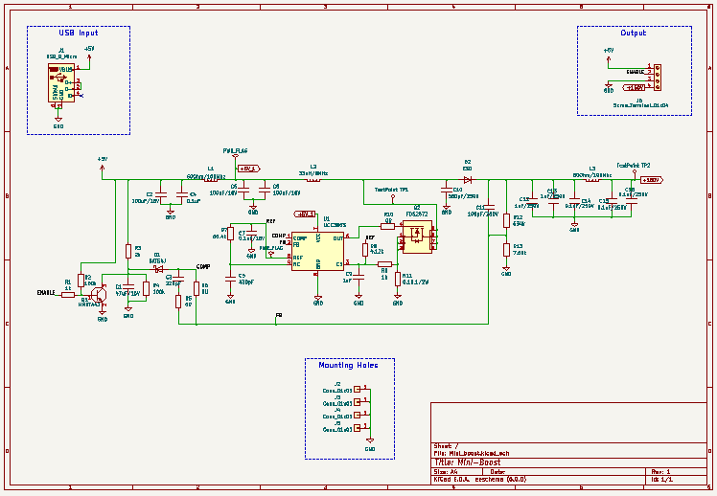

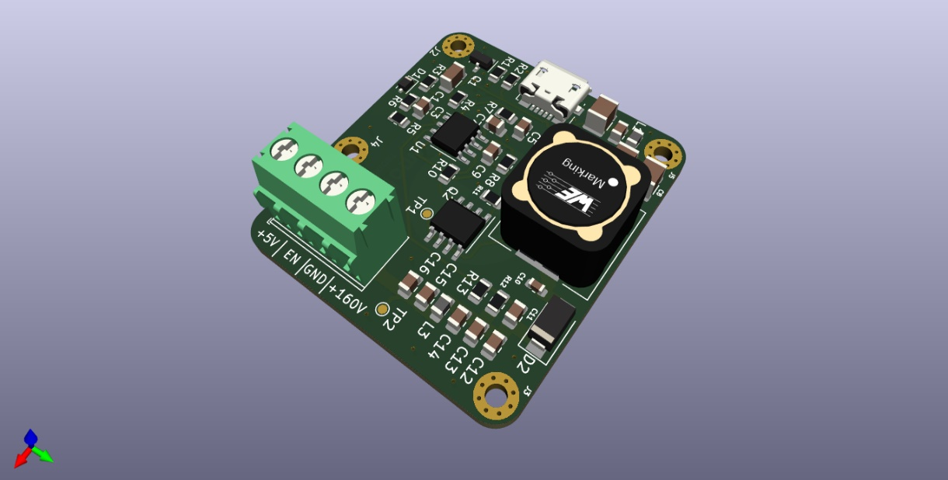**PCB**

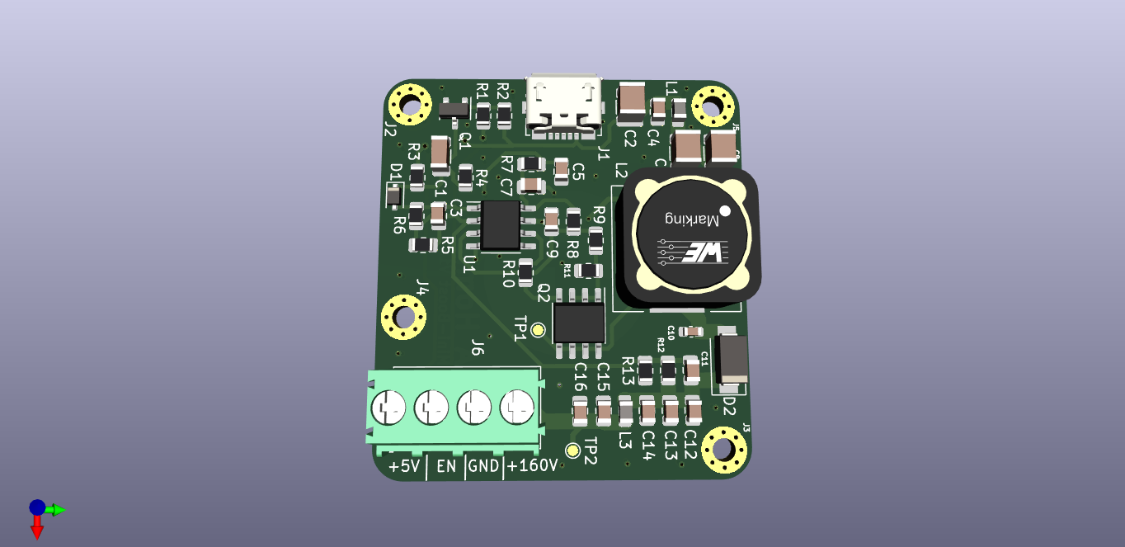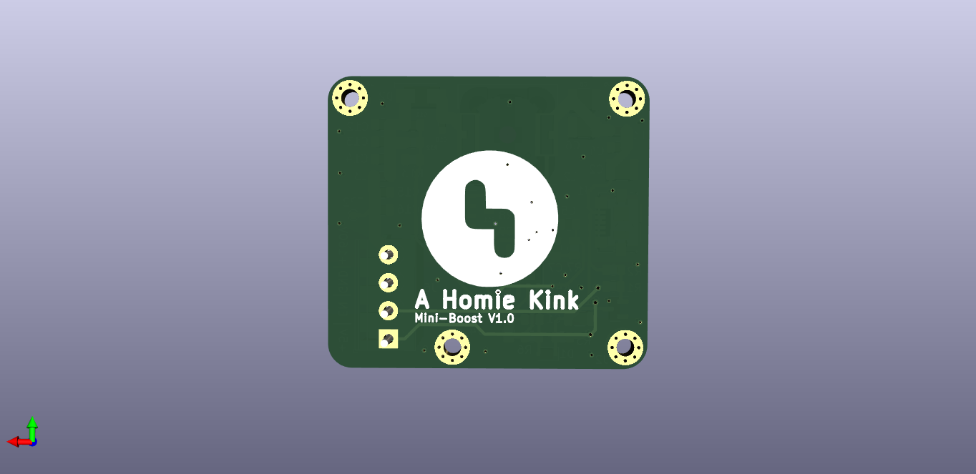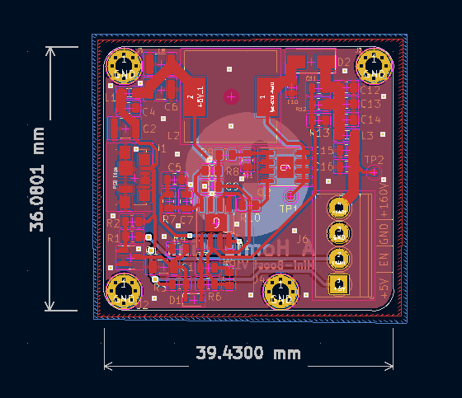

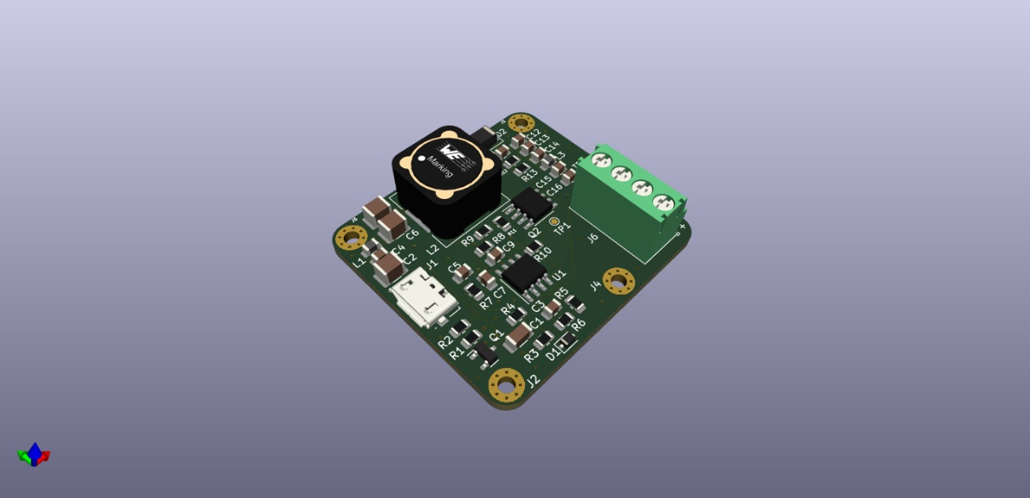

**DISCUSSION**

The design focused on achieving 170V output voltage with the highest efficiency possible and with the smallest footprint. The 5v to 170v DCM boost converter design is managed by the TI UCC3803 controller. This controller has the advantage of operating from a 5v supply. The discontinuous conduction mode (DCM) of operation was chosen for this design to ensure we could reach the high output voltage and low profile without the need for a custom flyback transformer winding. The 33uH power inductor ensures DCM at 50kHz switching frequency up to the maximum full power (3.6Watts). The peak current is limited to around 4amps by resistors R8, R10 and R12. The DCM mode of operation also allows for a fast response and simple compensation method. The input and output capacitors are all surface mount ceramic capacitors for ultra-low footprint, long lifetime, good filtering and minimal ESR. Additional ferrite beads L2 and L5 reduce input and output ripple further and help with EMI. The soft start time was increased by C14 from the default 4ms value programmed into the UCC3808 to approximately 20ms.

**CONCLUSION**

The DCM boost converter has zero Diode reverse recovery losses and does not have any flyback transformer leakage inductance loses, offsetting the higher RMS losses in the power FET and sense resistor.

**REFERENCES**

1. A nice design of a 25 cm^2 footprint 9v to 160v CCM boost power supply with 85% efficiency. Layout and schematic provided: http://desmith.net/NMdS/Electronics/NixiePSU.html
2. A simple 9v input power supply: http://www.instructables.com/id/High-Voltage-Power-Supply-for-Nixie-and-Valve-Tube/
3. More techniques and discussion for generating Nixie power supply: https://threeneurons.wordpress.com/nixie-power-supply/