**RING TURN PAGE**

**Design Document**

Function Summary:

* Connects to phones, tablets or other devices via BT.
* Single press button presses next page keyboard button in the client.
* Double press button presses previous page keyboard button in the client.
* Long press turns off the ring (puts it in deep sleep).
* Single press while in deep sleep wakes it up (turns on the ring).

**Flow Diagrams**

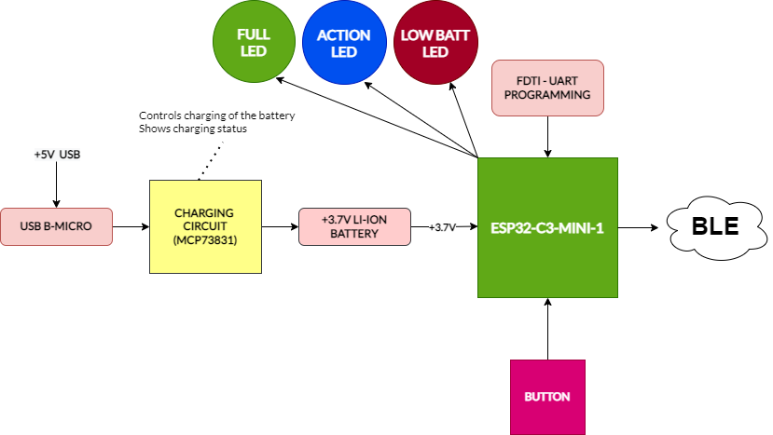

**Microcontroller**

ESP32-C3-MINI1-N4.

It comes with BLE and antenna already embedded.

It is cheap and is easier to program as it has a considerable wide developer and guiding community plus resources.

Has deep sleep capability and programming readily available.

Flashed with Arduino C++.

**Power and Power Management**

Runs on a 3.7V Li-ion battery connected to the PCB via a JST connector.

Battery charging is based on the MCP73831-2-OT IC.

The charging uses a USB Micro-B connector providing 5V.

**Button**

A suitable SPST button is to be soldered to the PCB via connecting wires.

**PCB**

Size: 21.11mm x 20 mm.

A 2-layer board.