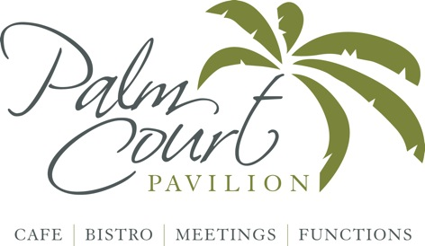

Sunday Lunch Menu midday-4.00pm-Afternoon tea from 2pm

**2 Courses £15.95 3 Courses £17.95**

**Starters**

**Homemade soup of the day** with artisan rustic bread and butter **£4.95**

**Chicken liver, sherry and balsamic parfait** with crostini and local chutney **£5.95**

**Crispy Calamari rings** with lemon garlic mayo or sweet chilli sauce **£5.95**

**Mains**

**Roast Beef** with Yorkshire pudding, roast potatoes, selection of vegetables and house gravy **£12.95**

**Roast Chicken Supreme** with Yorkshire pudding, roast potatoes, selection of vegetables and house gravy **£12.95**

**Sea Trout fillet** with lemon & parsley butter served with roasted veg & roast potatoes **£9.95**

**Goats cheese,** caramelised onion and roasted vegetables in a crisp filo pastry parcel with pesto dressing **£9.95 V**

**Deep filled potato** **skins** with coleslaw & sour cream **£6.95**

**Homemade Quiche** served with fries or selection of vegetables **£6.95**

**All Day English Breakfast** Egg, bacon, sausage, tomato, chestnut mushroom & sourdough toast **£7.99** **Veggie Breakfast** Egg, veggie sausage, spinach, chestnut mushroom & toast **£7.99**

**Desserts**

**Sticky Toffee Pudding** in caramel sauce served with vanilla ice cream **£4.50**

**Warmed Chocolate Brownie** served with clotted cream **£4.50**

**Individual Tarte au Citron** with raspberry coulis **£4.50**

**Rhubarb & custard pudding** served with caramel sauce **£4.50**

**Trio of ice creams** please ask for varieties £4.50

**Kids Menu** (Under 10’s)

Kids portion Sunday Roast **£6.50**

Sausage & mash or fries **£5.50**

Homemade chicken fingers & fries **£5.50**

Vegetable Lasagne **£4.50**

*Booking advisable*