Working with OpenOffice Documents with R
Duncan Temple Lang

Background
This is an OpenOffice word-processing document. In it, we can do all sorts of interesting things to layout text, images, tables, etc.
For example, in this new paragraph, we add a table
Col 1 | Col 2
A | B

We skip a line, leaving a blank paragraph and then we add an image
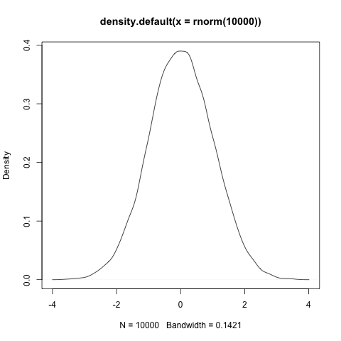
And then we follow up again with some text and a link.

