This is an example of an R document that contains R code. We start with some simple simulation.

x <- rnorm(100)

The next step is to create y:

y = 3 + 15\*x + rnorm(length(x))

Now let’s compute the correlation

cor(x, y)

[1] 0.9977178

And how about a plot:

plot(x, y)

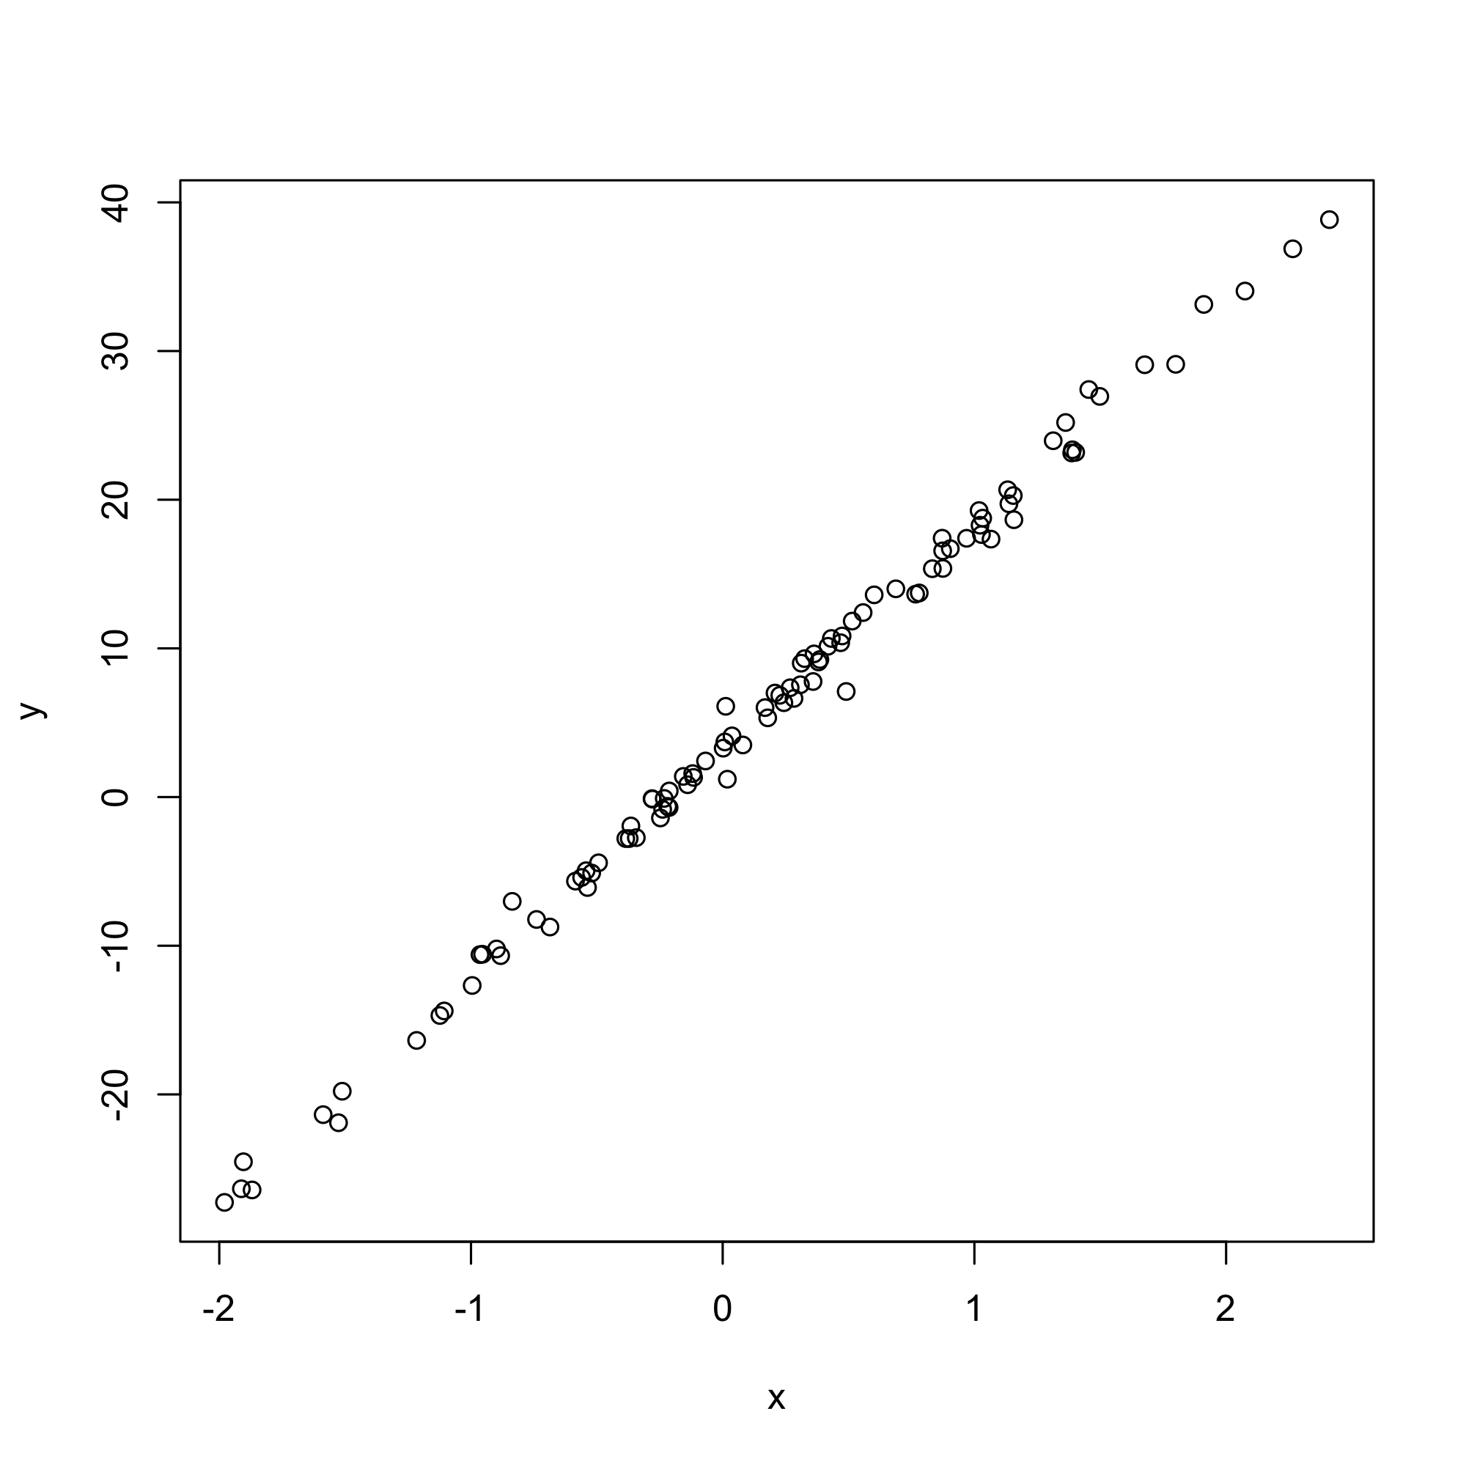

And that’s about it.