Analysis 1: As seen in the scatter plot below, **generally speaking** (although there are a few outliers), the total number of rides and the average fare are inversely proportional based on city types. As an example, while there are more rides in urban cities, average fares for those are relatively low. On the other hand, the exact opposite situation (less # of rides with higher average fare) is applicable to rural areas. And, the data for suburban areas lies between those two opposite ends (medium level # of rides with medium level average fares). These results are well aligned with two well-known facts: 1) Less people live in rural areas and distances are greater, 2) Despite the fact that distances are shorter in urban areas there are more people.

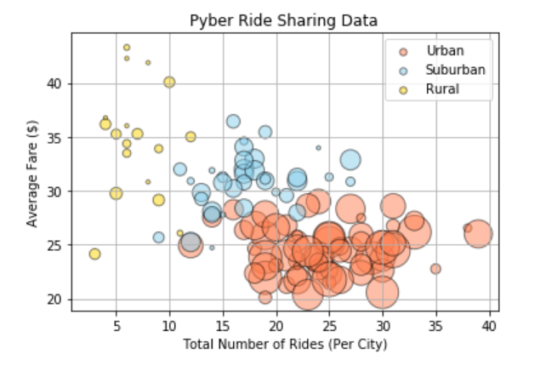

Analysis 2: If three pie charts given below are analyzed, an interesting result can be seen easily. Even though only 2.6% of the drivers work in rural areas, they collect 6.8% of the total fares. This is due not only the fact that average fare in rural areas are higher but also the percent of total rides in rural areas is 5.3% (~ twice of the percent of total drivers in this area). This combination (less drivers having relatively higher number of rides with higher average fares) results the fact that, in average, a driver in rural area makes more money than that in a suburb or an urban area.

