Particle Methods Homework 2 – Metehan Dündar

1. **NVE Simulation Analysis (N=400, dt=0.005)**

* In this part, a simulation in the microcanonical ensemble (NVE) was performed, where the number of particles N, volume V, and energy E were constant. The chosen parameters were N=400, dt=0.005, and an initial temperature T_init=0.5.
* **Energy Conservation and Equilibration**:
  + **Total Energy Evolution**: The total energy remained nearly constant, demonstrating good conservation with a relative fluctuation of approximately 4.15×10^(−2). This indicates a stable and well-implemented numerical integration (Velocity-Verlet).
  + **Equilibration Time**: From the energy plots, kinetic, potential, and total energies equilibrated rapidly, within about 0.5 units of reduced time. This quick equilibration is characterized by the rapid stabilization of kinetic and potential energy curves.
* **Momentum Conservation**:
  + The total momentum was essentially conserved, as indicated by the plots, which remained very close to zero throughout the simulation, demonstrating a correct implementation of momentum conservation checks.
* **Radial Distribution Function (RDF)**:
  + A The RDF exhibited clear peaks at short distances around r ≈ 1.0, suggesting structured local particle ordering typical of liquids or dense fluids. After a certain distance, RDF approached the ideal gas value of 1, indicating a uniform particle distribution at longer distances, consistent with expectations in equilibrium fluids.

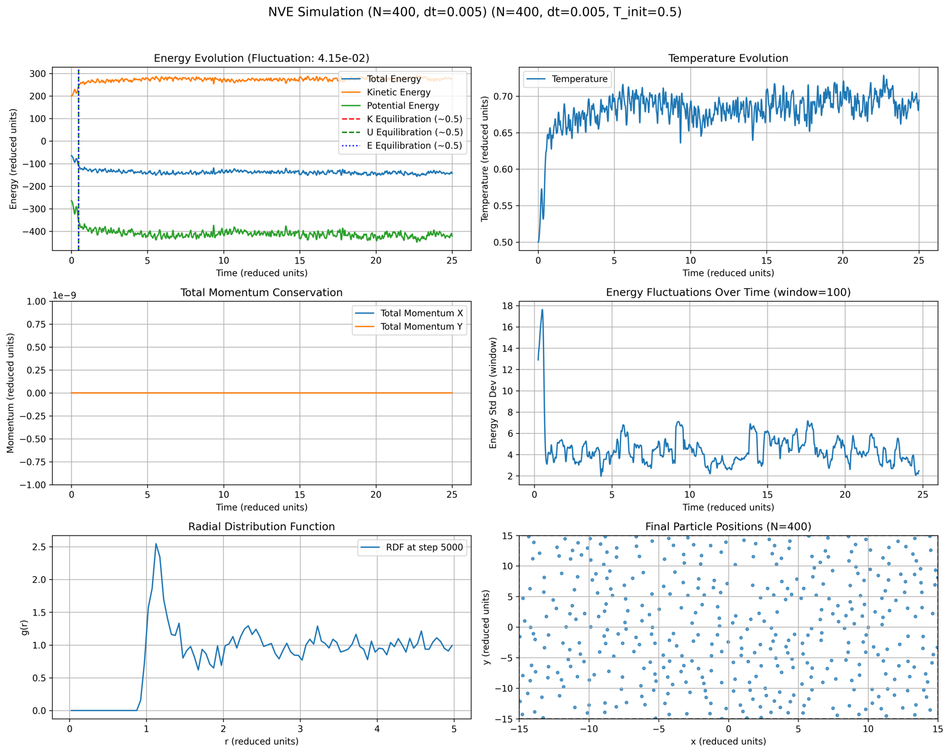

1. **NVT Simulations Using Berendsen Thermostat**

* Simulations in the canonical ensemble (NVT) were carried out using the Berendsen thermostat for various particle numbers and temperatures.

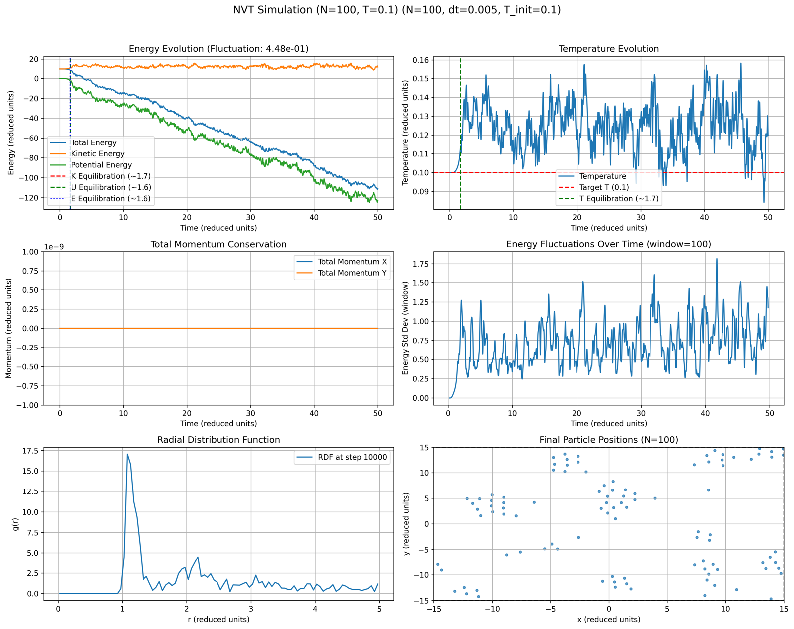

* **Case 1: N=100, T=0.1**
  + **Temperature Evolution**: Temperature equilibrated after about 1.7 units of reduced time, fluctuating around the set target temperature of T=0.1. The temperature fluctuations were relatively larger due to the small number of particles.
  + **Energy Evolution**: The kinetic energy stabilized quickly, but the total and potential energies showed a steady decrease, likely due to the thermostat continually removing energy to maintain the low temperature.
  + **RDF Analysis**: The RDF showed a prominent first peak, indicating strong particle clustering at short distances due to the low thermal agitation. At greater distances, the RDF rapidly approached zero, signifying limited particle mobility and strong local ordering at this low temperature.

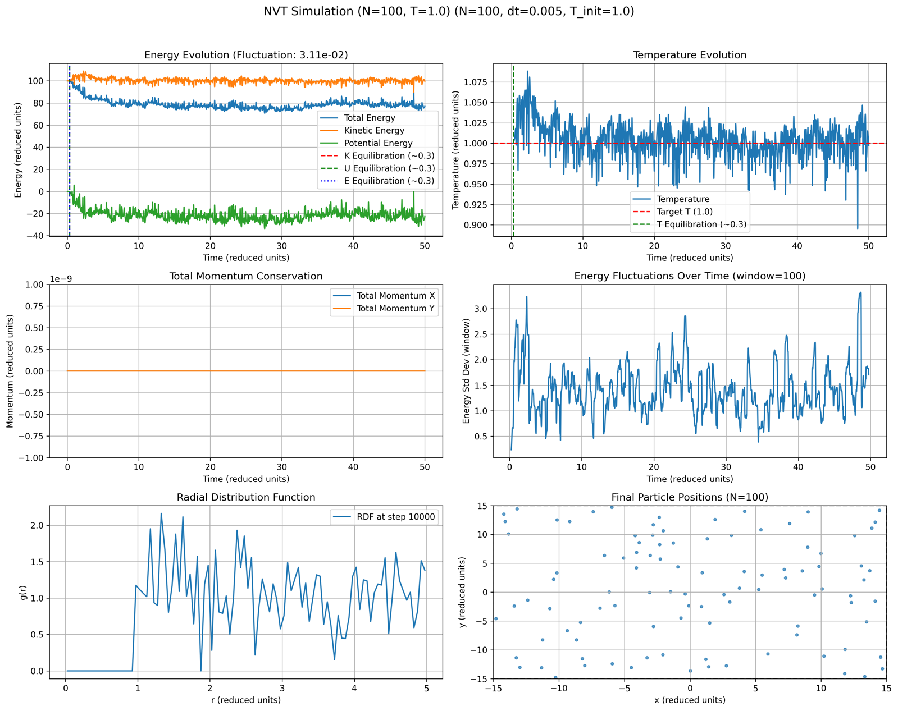

* **Case 2: N=100, T=1.0**
  + **Temperature Evolution**: Equilibration occurred rapidly (~0.3 reduced units), closely aligning with the target T=1.0. Temperature fluctuations were moderate due to a higher thermal energy level.
  + **Energy Evolution**: Both kinetic and potential energies quickly stabilized after equilibration, with total energy fluctuations relatively low (3.11×10^(−2)), indicating stable thermal equilibrium.
  + **RDF Analysis**: RDF exhibited less pronounced peaks compared to the low-temperature case, reflecting increased particle movement and decreased local structure.

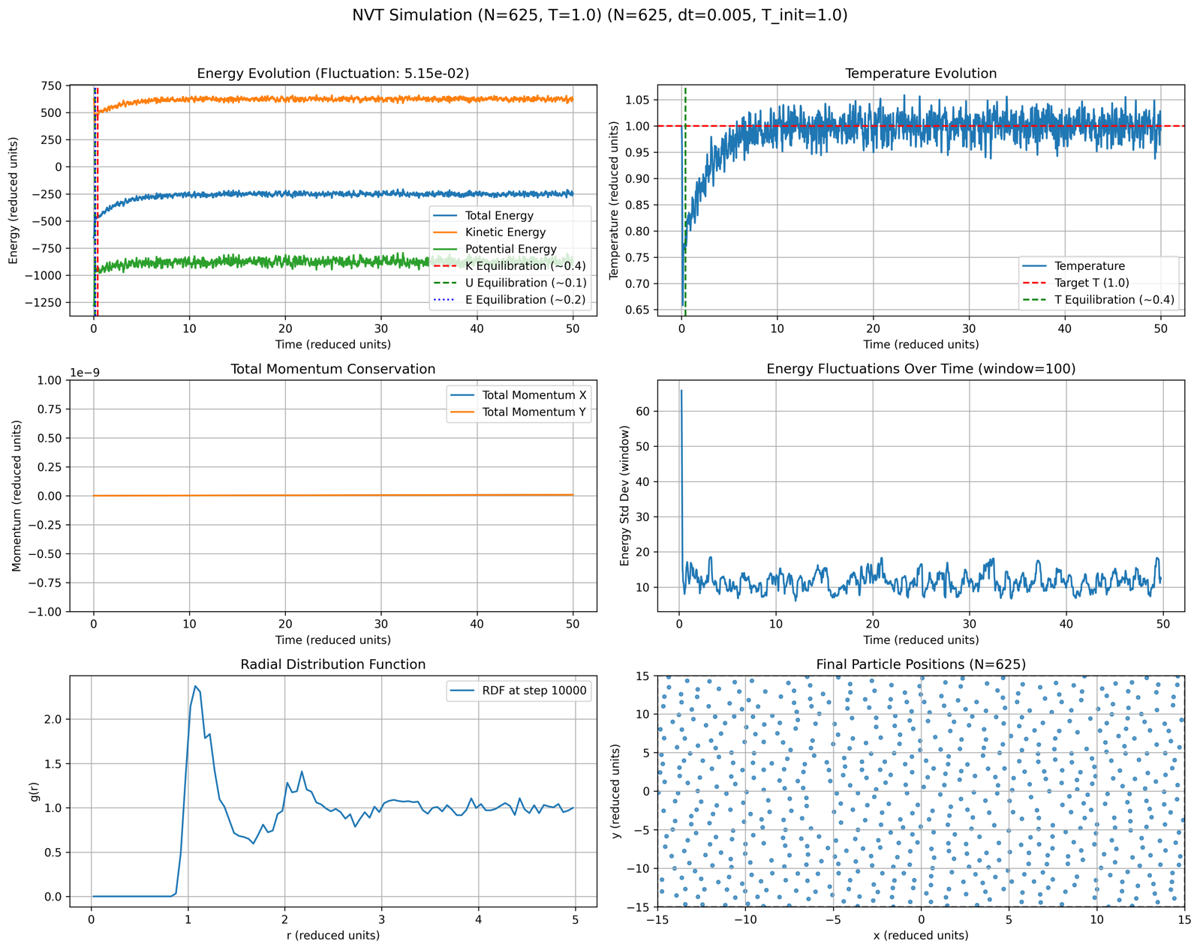

* **Case 3: N=625, T=1.0**
  + **Temperature Evolution**: Equilibration occurred quickly (~0.4 reduced units), achieving a steady temperature profile near the target of 1.0.
  + **Energy Evolution**: Total energy fluctuation was moderate (5.15×10^(−2)), demonstrating stable thermodynamic conditions. The system showed a well-maintained energy balance.
  + **RDF Analysis**: RDF showed clear peaks at short-range distances, indicative of structured yet fluid-like particle arrangement typical for moderate temperatures and higher particle densities.

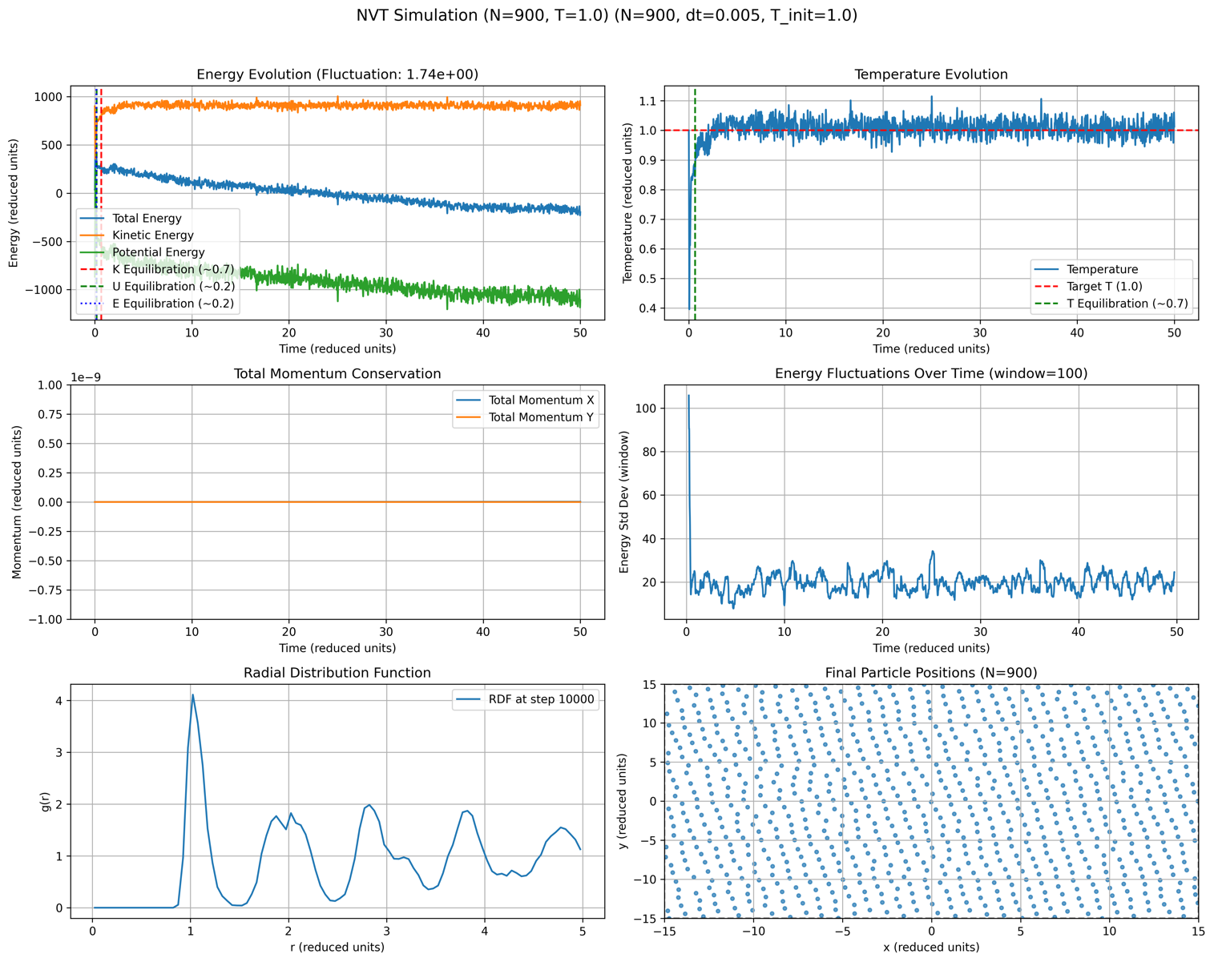

* **Case 4: N=900, T=1.0**
  + **Temperature Evolution**: Equilibration time was slightly longer (~0.7 reduced units), stabilizing close to the target temperature of 1.0. Energy fluctuations were larger (1.74×10^0), possibly due to increased system complexity and particle interactions.
  + **Energy Evolution**: Larger fluctuations and a slight energy drift were observed, suggesting that with increased particle number, the thermostat required careful adjustment or longer equilibration times.
  + **RDF Analysis**: Multiple well-defined peaks were visible, reflecting stronger spatial correlations and ordering typical of denser, thermally agitated fluids. The structured peaks corresponded to successive layers of neighboring particles.

**Conclusion**

* Optimal Configuration: For NVE simulations, the chosen parameters N=400, dt=0.005, and T_init=0.5 provided optimal results, ensuring accurate energy conservation and rapid equilibration.
* Thermostat Performance: The Berendsen thermostat effectively maintained the target temperature across different particle counts and temperatures. However, higher particle numbers introduced complexities in energy stabilization and fluctuations, highlighting the importance of sufficient equilibration time and careful parameter choice.
* Particle Distribution: RDF analysis clearly captured changes in local particle structure with temperature and density, consistent with theoretical expectations of liquid-like behaviors at lower temperatures and increasing disorder with higher thermal energies.

In conclusion, the simulation results matched theoretical predictions closely, demonstrating correct implementation and effective thermodynamic control. The chosen parameters provided reliable results, ensuring both physical accuracy and computational stability.