Particle Methods Homework 4 – Metehan Dündar

1. **Preliminary Fluid Test**

* **Momentum Conservation:**
  + The output shows that the total momentum components for all three timestep runs (dt=0.02,0.01,0.005) remain very close to zero throughout the simulations (on the order of 10^{−14} or 10^{−15}). This confirms that the implementation correctly conserves total momentum, as expected in the absence of external forces and with periodic boundary conditions.
* **Temperature and Timestep Dependence:**
  + The measured temperature is strongly dependent on the timestep (dt) used. Larger timesteps (dt=0.02,0.01) lead to very low final temperatures (around 0.002 and 0.001, respectively), significantly below the target kBT=1/9≈0.1111.

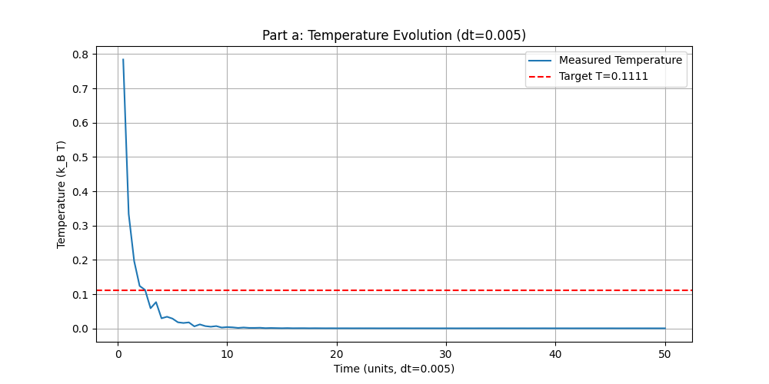

* + Using a smaller timestep (dt=0.005) initially shows a higher temperature, but even after running for 10,000 steps (as seen in the long run output and the plot above), the temperature drops drastically and stabilizes at a very low value (around 0.0005), failing to reach the target kBT.

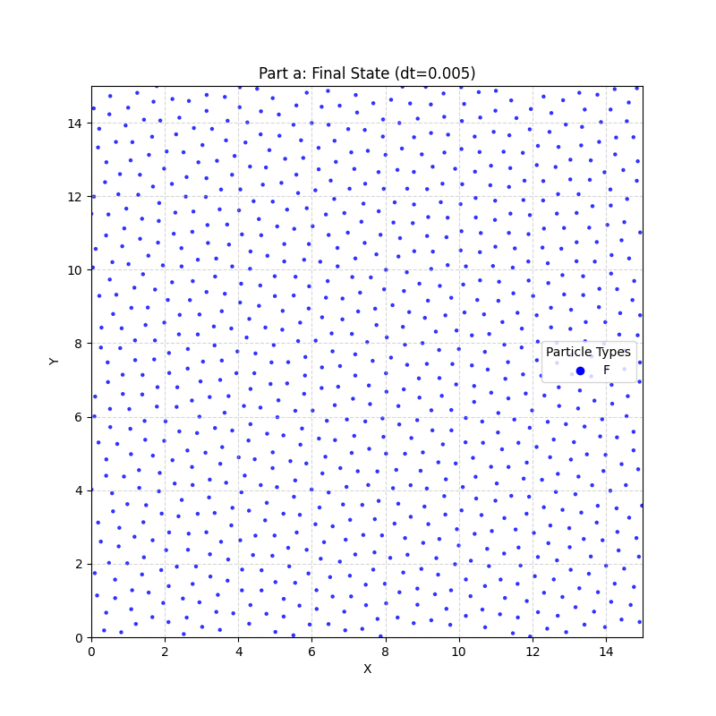

* + **Conclusion:** While momentum is conserved, the DPD thermostat, as implemented with the given parameters (γ=4.5, σ=1) and the specific conservative force (a_FF=25), does not achieve the target temperature kBT=1/9. The system rapidly "cools" down, especially with larger timesteps, suggesting potential issues with integrator accuracy at larger dt or that the parameter set leads to an unexpectedly low equilibrium temperature in this specific implementation. The final particle configuration is visible in the plot above.

1. **Couette Flow with Chain Molecules**

* **Motion and Distribution:**

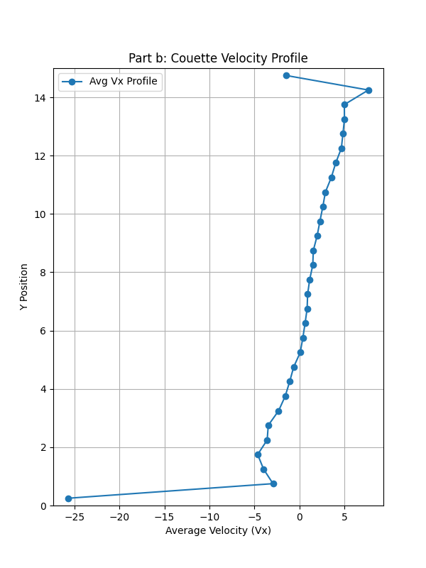

* + **Velocity Profile:** The above plot shows a roughly linear velocity profile across the channel (in the y-direction). The velocity ranges from approximately −v_wall=−5 near the bottom wall to +v_wall=+5 near the top wall, characteristic of Couette shear flow.
  + **Temperature:** The simulation output shows very high temperatures (e.g., ending around T≈42, though fluctuating significantly). This is far above the target kBT≈0.1111 and indicates substantial viscous heating due to the high shear rate imposed by the fast-moving walls (v_wall=5). The DPD thermostat struggles to dissipate this heat.

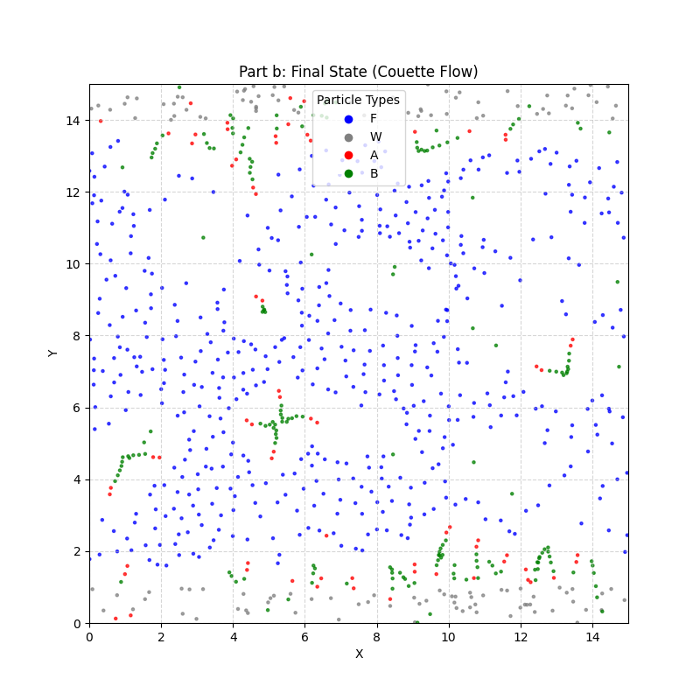

* + **Molecule Behavior:** In the strong shear flow, the chain molecules (A−A−B−B−B−B−B) stretch and align themselves predominantly in the flow (x) direction. This alignment minimizes the drag they experience. The above plot visually confirms the positions and general orientation of the chains (red 'A' and green 'B' particles) relative to the fluid (blue) and walls (grey).

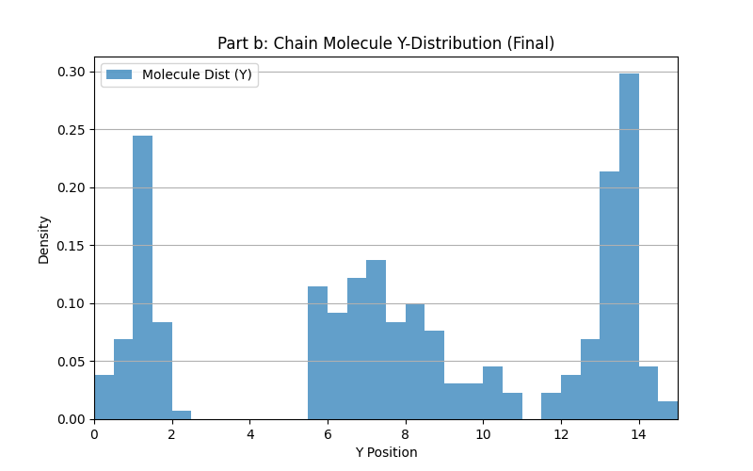

* + **Distribution:** The above plot shows the final distribution of the chain molecule particles along the y-axis. Given the high repulsion between all particle types and the walls (a_XW=200), molecules will be excluded from the immediate vicinity of the walls. There is not significant migration towards the center, as shear tends to distribute particles. The strong repulsion between B and F particles (a_BF=300) might also influence the local structure around the chains.
* **Explanation:** The system exhibits classic Couette flow behavior modified by the presence of polymer chains. The high shear dominates, leading to molecular alignment and significant heating. The interactions defined by the a_ij matrix and bond parameters govern the detailed structure and distribution.

1. **Poiseuille Flow with Ring Molecules**

* Motion and Distribution:

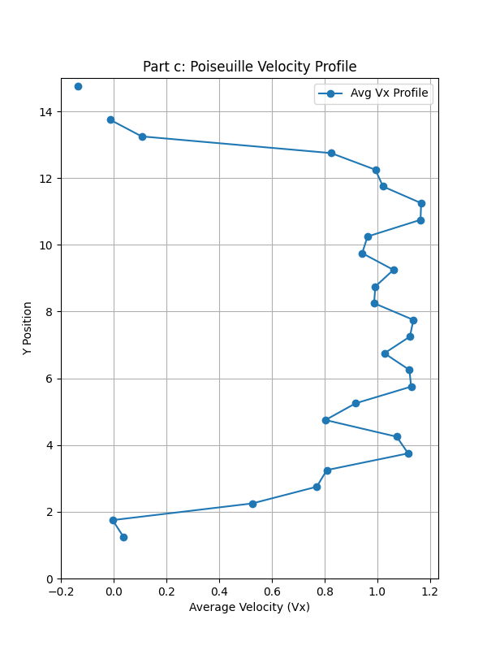

* + **Velocity Profile:** The above plot displays a parabolic velocity profile, peaking at the center of the channel (y=L/2) and decreasing to zero at the fixed walls (y=0, y=L). This is characteristic of Poiseuille flow driven by a uniform body force (F^body=0.3).
  + **Temperature:** The temperature stabilizes around T≈0.53, which is higher than the target kBT≈0.1111 but much lower than in Part b. The body force adds energy, causing some heating, but less intense than the shear in Part b. It's still noteworthy that it doesn't perfectly match the target kBT.

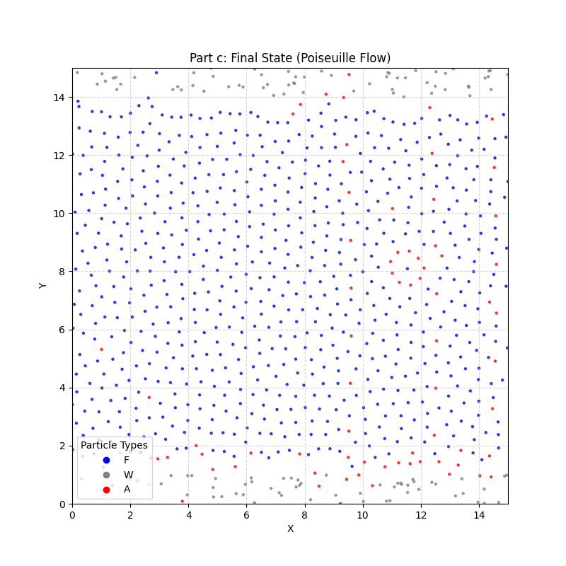

* + **Molecule Behavior:** The ring molecules (composed of 9 'A' particles) move along with the fluid flow, driven by the body force. The above plot shows their final positions (red particles).