**MINISTRY OF EDUCATION AND TRAINING**

**FPT UNIVERSITY**

**CAPSTONE PROJECT DOCUMENT**

LIVE CODING MENTORSHIP

|  |  |
| --- | --- |
| **LIVE CODING MENTORSHIP** | |
| **Group Member** | Bui Cong Anh – SE05256  Tran Nguyen Anh – HE130019  Hoang Cong Nghia – HE130499  Le Thanh Dat – HE130450  Nguyen Quang Dung – HE151250 |
| **Supervisor** | Pham Ngoc Ha |
| **Capstone Project code** | LCM |

- Hanoi, January 13, 2020 –

**Table of Contents**

**LIVE CODING MENTORSHIP 1**

**I. Project Introduction 6**

1. Overview 6

1.1 Project Information 6

1.2 Project Team 6

2. Product Background 6

3. Existing Systems 9

3.1. FUNiX 9

3.2. Codementor 10

4. Business Opportunity 11

5. Software Product Vision 11

6. Project Scope & Limitations 11

6.1. Major Features 11

6.2. Limitations 12

**II. Project Management Plan 12**

1. Overview 12

1.1 WBS & Estimation 12

1.2 Project Objectives 14

1.3 Project Risks 14

2. Management Approach 16

2.1 Project Process 16

2.2 Quality Management 17

2.3 Training Plan 18

3. Master Schedule 18

4. Project Organization 19

4.1 Team Structure 19

4.2 Roles & Responsibilities 19

5. Project Communication 20

5.1 Communication Plan 20

5.2 External Interface 20

6. Configuration Management 21

6.1. Tools & Techniques 21

6.2 Document Management 22

6.3 Source Code Management 22

**III. Software Requirement Specification 22**

1. Overall Description 22

1.1. Product Overview 22

1.2 Business Rules 23

2. Functional Requirements 25

2.1. Use Case Diagram 25

2.3. Use Case Specification 34

2.4. Entity Relationship Diagram 82

3. Non-Functional Requirements 83

3.1. Reliability 83

3.2. Security 83

3.3. Maintainability and Extensibility 84

3.4. Availability and Scalability 84

3.5. Performance 84

3.6 Usability 84

4. Other Requirements 84

**IV. Software Design Description 84**

1. Overall Description 84

1.1. Assumptions 84

1.2. Design Constraints 85

2. System Architecture Design 85

2.1. Overall Architecture 85

2.2. System Architecture 87

2.3. Package Diagram 90

3. System Detailed Design 90

3.1. Guest 90

3.2. Staff 90

3.3. Admin 90

3.4. Mentor 90

3.5. Mentee 90

4. Class Specification 90

4.1. LCM Back-end 90

4.2. LCM Front-end 91

5. Database Design 91

**V. Software Testing Documentation 91**

1.Overall Description 91

1.1. Test Model 91

1.2. Testing level: 93

1.3. Testing Types 97

2. Test Plan 98

2.1 Test Stages 98

2.2. Resource 98

2.3. Test Milestones 98

2.4. Deliverables 98

3. Test Cases 99

4. Test Reports 99

**VI. Release Package & User Guides 99**

1. Deliverable Package 99

1.1 Source codes & documents 99

1.2 Known Issues, Limitations & Restrictions 99

2. Installation Guides 99

2.1 System Requirements 99

2.2 Setup Files 99

2.3 Installation Instruction 99

3. User Manual 99

3.1 Terms and definitions 99

3.2 System requirements 99

3.3 Application Usage 99

3.4 Troubleshooting 100

**VII. Appendix 100**

1. Glossary [Optional] 100

2. References [Optional] 100

3. Others [Optional] 100

**Definition and Acronyms**

|  |  |
| --- | --- |
| **Acronym** | **Definition** |
| API | Application Program Interface |
| BA | Business Analysis |
| BR | Business Rule |
| CRUD | Create, Read, Update, Delete |
| DB | Database |
| DBMS | Database Management System |
| EC2 | Elastic Compute Cloud |
| ERD | Entity Relationship Diagram |
| FK | Foreign Key |
| IDE | Integrated Development Environment |
| IT | Information Technology |
| JS | Javascript |
| PK | Primary Key |
| PM | Project Manager |
| QA | Quality Assurance |
| RDS | Relational Database Service |
| S3 | Simple Storage Service |
| SRS | Software Requirement Specification |
| UAT | User Acceptance Test |
| UC | Use Case |
| UI | User Interface |
| UML | Unified Modeling Language |
| UX | User Experience |
| WBS | Work Breakdown Structure |

# I. Project Introduction

## 1. Overview

### 1.1 Project Information

* Project name: **Live Coding Mentorship**
* Project code: **LCM**
* Group name: **SWP490_G10**
* Software type: **Website**
* Timeline:

### 1.2 Project Team

**1.2.1. Supervisor**

|  |  |  |  |
| --- | --- | --- | --- |
| **Full Name** | **Email** | **Mobile** | **Title** |
| Pham Ngoc Ha | hapn10@fe.edu.vn | 0988623000 | Lecturer |

*Table 1.1: Supervisor Information*

**1.2.2. Team Members**

|  |  |  |  |
| --- | --- | --- | --- |
| **Full Name** | **Email** | **Mobile** | **Role** |
| Bui Cong Anh | anhbcse05256@fpt.edu.vn | 0985532210 | Leader |
| Tran Nguyen Anh | anhtnhe130019@fpt.edu.vn | 0946382755 | Member |
| Hoang Cong Nghia | nghiahche130499@fpt.edu.vn | 0982386548 | Member |
| Le Thanh Dat | datlthe130450@fpt.edu.vn | 0969758599 | Member |
| Nguyen Quang Dung | dungnqhe151250@fpt.edu.vn | 0971757404 | Member |

*Table 1.2: Team Member Information*

## 2. Product Background

Nowadays, Information Technology is a very hot major, which is the goal of many students worldwide.

The Live Coding Mentorship team realized the potential for learning development in the IT field of Viet Nam:

* According to current statistics, in more than 250 universities across the country, about 150 schools are training IT.
* More than 150 institutions provide training for about 50,000 employees for the industry IT each year.
* In FPT University, there are more than 8,000 students, of which >50% study IT majors
* By 2020, there will be nearly 3,000 new students. The number of new students increases by 20-30% each year.

Moreover, more and more Universities and High-Tech Corp (Viettel, CMC, VNU Hanoi,…) proves an explosion of demand for learning. But it’s not easy to approach. A lot of students tried hard to study but still did not get a good result. According to the Ministry of Education and Training, every year about 50,000 IT students graduate, of which only 30% can work immediately, 70% have to be trained.

In 2021, Team Live Coding Mentorship launched a survey on learning online and the need to hire mentors online. There were 81 participants, of which 21% are employed; 79% are students. There are 97,5% of surveyed people studying and working in the IT field.

After surveying, statistics show that:

* 92,6% of respondents have difficulty in self-study because there is no one to explain it clearly.

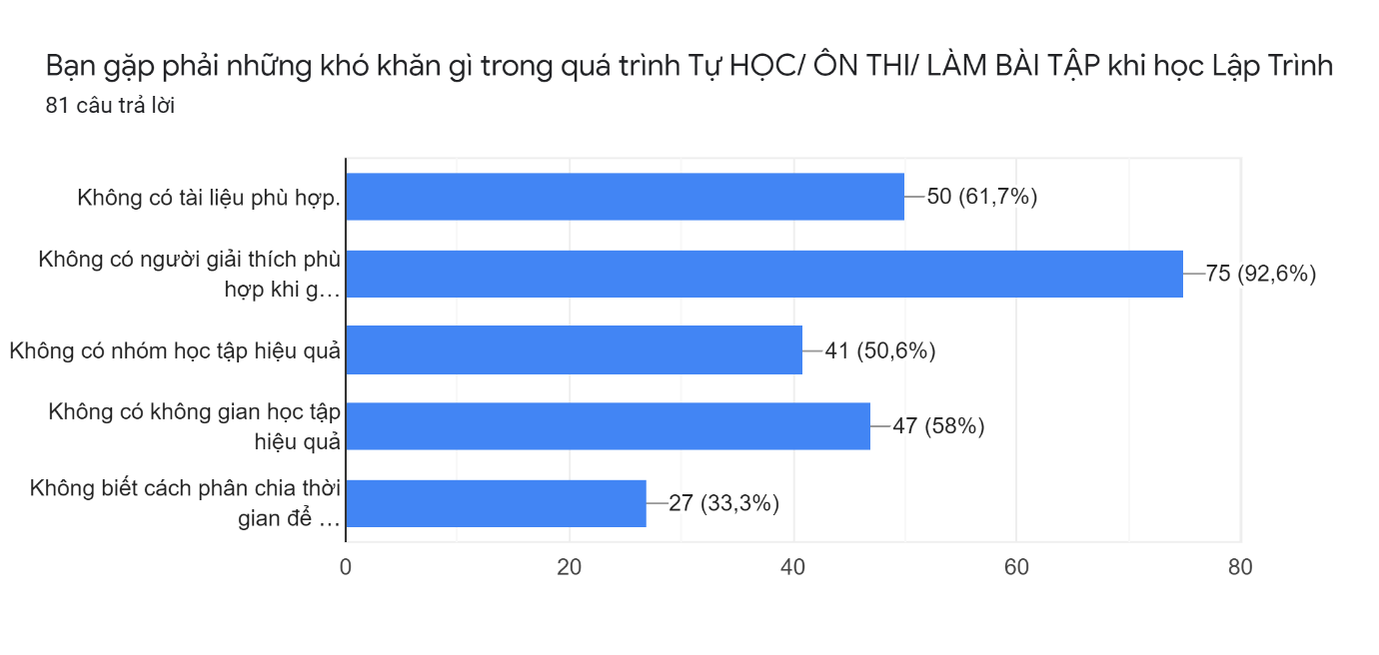*Figure 1.1: Statistics about the difficulties in self-study and programing.*

* 93,8% of respondents want to find qualified people to support.

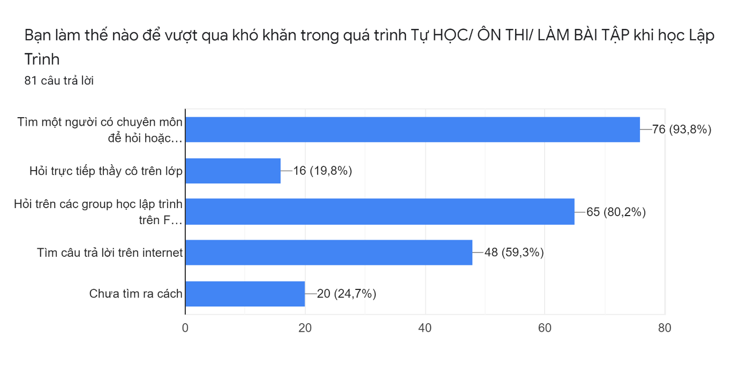

*Figure 1.2: Statistics about the ways to overcome difficulties*

97,5% of respondents want a website to connect them with the right mentor.

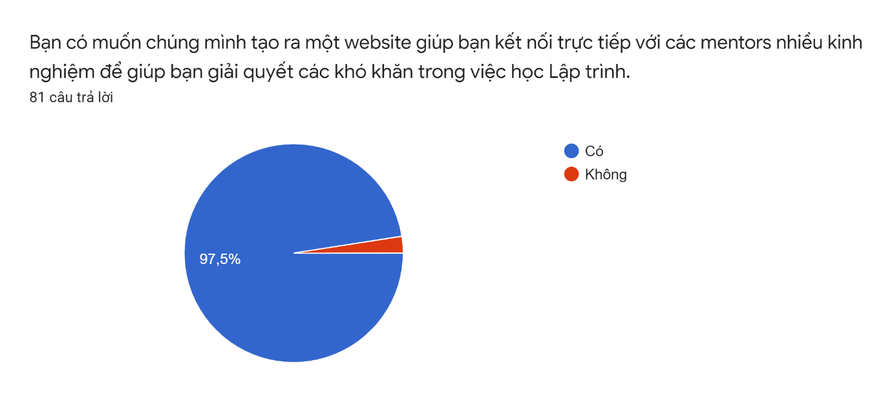

*Figure 1.3: Statistics about the user’s needs*

From the above figures, the Live Coding Mentorship team decided to create a website to help connect mentors and mentees. Aim to tap into the education market based on individual needs, boost the learning process, and give mentors an additional income opportunity. This project will bring good mentors to students who need to improve their coding skills. Ask and answer in real-time. Everything you think hard will come easier when you can ask someone who already knows about it.

## 3. Existing Systems

### 3.1. FUNiX

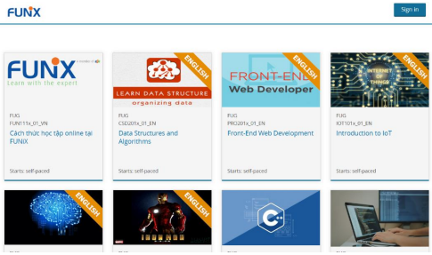

*Figure: FUNiX website (Link: https://fu.funix.edu.vn)*

FUNiX Online University is a university in the FPT Education system, providing Bachelor of Information Technology and certificates of career and soft skills.

FUNiX online university, which inherits the above principles, presents for the first time a new method of education, like every student, from day one:

* Will decide on their learning progress.
* Learn from lectures from the world's best experts.
* Get in contact with leading experts working in the IT industry in Vietnam.

Differences with Live Coding Mentorship:

|  |  |
| --- | --- |
|  |  |
| * FUNiX courses are all long-term courses.      * FUNiX only allows Mentee to select online Mentors. | * Live Coding Mentorship focuses on micro-courses, small knowledge sections, and questions of each Mentee.      * Mentee in Live Coding Mentorship can choose a Mentor through their CV, achievements, and rating. |

### 3.2. Codementor



*Figure: Codementor website (Link:* [*https://www.codementor.io*](https://www.codementor.io/)*)*

Codementor was founded in 2013 by serial entrepreneur Weiting Liu, a Y Combinator alumnus with his previous startup SocialPicks, which was acquired by FinancialContent in 2009.

Codementor's website acts as an open marketplace platform for experienced web developers to offer live help, long-term mentorship, and team training course on the programming languages or web technology they specialize in, with rates set by the mentor themselves. Mentors include O’Reilly’s authors, active Stack Overflow experts, and developers at tech firms such as Google or Amazon.

Differences with Live Coding Mentorship:

|  |  |
| --- | --- |
|  |  |
| * The target market is the entire territory of the world.      * All mentors on websites around the world.      * Using English. | * The target market is the entire territory of Viet Nam.      * All mentors on websites in Viet Nam.      * Using Vietnamese. |

## 4. Business Opportunity

Information technology is an industry with rapid growth in the number of new learners in the last 5 years. Almost all universities open additional IT faculties to attract more students to enroll. This presents a great opportunity to implement business models around this sector.

However, the issues related to education are very complex and require a lot of time to improve and perfect. While the number of new learners continues to increase rapidly, answering questions as well as creating a common environment for people to help each other to gain more understanding and expand knowledge is essential.

To solve that problem, a system or platform connecting new learners, those with questions, and those with a lot of experience need to be born.

## 5. Software Product Vision

With the Applying LCM for providing live help. We aim to optimize the operational structure of managing LCM for each user, the software brings the best result and experience to both mentors and mentees. Specifically, the software assists management functions allow mentors and mentees to open a chat window with integrated video call, screen share. Mentors can periodically schedule when they have free time to teach. Mentees (members) submit questions, choose a topic (course). (text, pictures) - below the group members can chat. Mentors can get answers. Using the software will help mentees quickly improve their coding skills as well as develop the developer community and create more income for Mentors.

## 6. Project Scope & Limitations

### 6.1. Major Features

Live Coding Mentorship is an on-demand marketplace for top Scope engineers, developers, programmers, and tutors. Get your projects built by vetted Scope freelancers or learn from expert mentors with team training & coaching experiences.

|  |  |
| --- | --- |
| **Type of User** | **Description** |
| Admin | People who manage the LCM System |
| Guest | The user that has not yet registered an account |
| Staff | People who manage the transaction |
| Mentor | The registered user that has registered to be a mentor |
| Mentee | The registered user wishes to hire mentors |

### 6.2. Limitations

* **Limited Internet:** The critical requirement of Live Coding Mentorship is the Internet. The only good internet connection can bring the user a good experience and get a better result. But this project can ensure that everyone's network connection is the same.
* **Limited skill confirms**: Live coding mentorship running on the commission of users. Mentor use can show their skills, ability to get more and more students. But this information can be fake.
* **Limited security:** Live coding mentorship will implement the best security solutions and protect users but can't commit 100% a user is safe.

### 6.3 Source Code Management

Source code is managed by Git on github.com

For version control of our source code, we use GitKraken. It tracks the changes team members make to files, so we have a record of what has been done, and we can revert to specific versions should we ever need to.

# III. Software Requirement Specification

## 1. Overall Description

### 1.1. Product Overview

Nowadays, Information Technology is a very hot major, which is the goal of many students worldwide. But it’s not easy to approach. A lot of students tried hard to study but still did not get a good result.

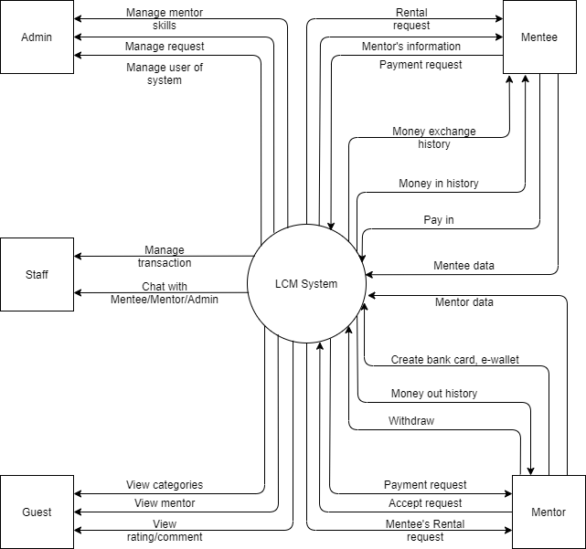

Figure 3.1 Context diagram

So along with the development of the internet, this project will bring good mentors to students who need to improve their coding skills. Ask and answer in real-time. Everything you think hard will come easier when you can ask someone who already knows about it.

### 1.2 Business Rules

|  |  |
| --- | --- |
| **ID** | **Description** |
| B01 | Email address must be valid |
| B02 | Password must be at least 8 characters in length |
| B03 | Password must be encrypted |
| B04 | When registering or changing password, user must enter the new password twice |
| B05 | A guest cannot register with username and email that has already been registered |
| B06 | User must provide their username or email and password when logging into the website |
| B07 | Access token must be encrypted when saving into browser’s storage |
| B08 | JWT token is expired in 1 day |
| B09 | User cannot update their username and email once it has been registered |
| B10 | When changing password, new password must not be the same as the current password |
| B11 | A user must belong to one of the three roles: Mentee, Mentor and Admin |
| B12 | When an account is registered, the initial role of the account is Mentee |
| B13 | When an account is registered, the initial role of the account is Mentee |
| B14 | When mentor unregisters mentor, role of mentor becomes Mentee |
| B15 | Deadline of request when creating or updating must be in the futur |
| B16 | User can only choose 3 types of skill for each request |
| B17 | The price must be at least 10.000 VND |
| B18 | After creating or re-opening, the status of request is OPEN |
| B19 | After closing, the status of request is CLOSE |
| B20 | Mentee can only update request, close request, invite mentor, accept or reject waiting mentors when request’s status is OPEN |
| B21 | Mentee can only reopen request when request’s status is CLOSE |
| B22 | Mentor can only accept request when request’s status is OPEN |
| B23 | Mentee can only hire mentor if having enough money |
| B24 | When mentee accepts mentor, mentee can chat with mentor, request’s status is changed to DOING, other waiting mentors will be rejected |
| B25 | When mentee confirms request finished, mentor can take the money of request, request’s status is changed to COMPLETED |
| B26 | When mentee confirms request is not finished, mentor will have notification to confirm again. If mentor confirms not finished, back money to mentee, the status of request is changed to OPEN. Otherwise, admin will resolve the conflict. |
| B27 | Only mentor can withdraw money |
| B28 | Mentor can only withdraw with the amount of money less than or equal the current income |
| B29 | Only mentor can create bank card, e-wallet |
| B30 | The bank card number must be unique |
| B31 | The e-wallet number and e-wallet name must be unique |
| B32 | All lists must be displayed with the pagination |
| B33 | Only display the information of mentors that have active status |
| B34 | Only display the information of requests that are within the deadline in list public requests |
| B35 | Chat with admin function only displays in home page |

## 2. Functional Requirements

### 2.1. Use Case Diagram

* Admin

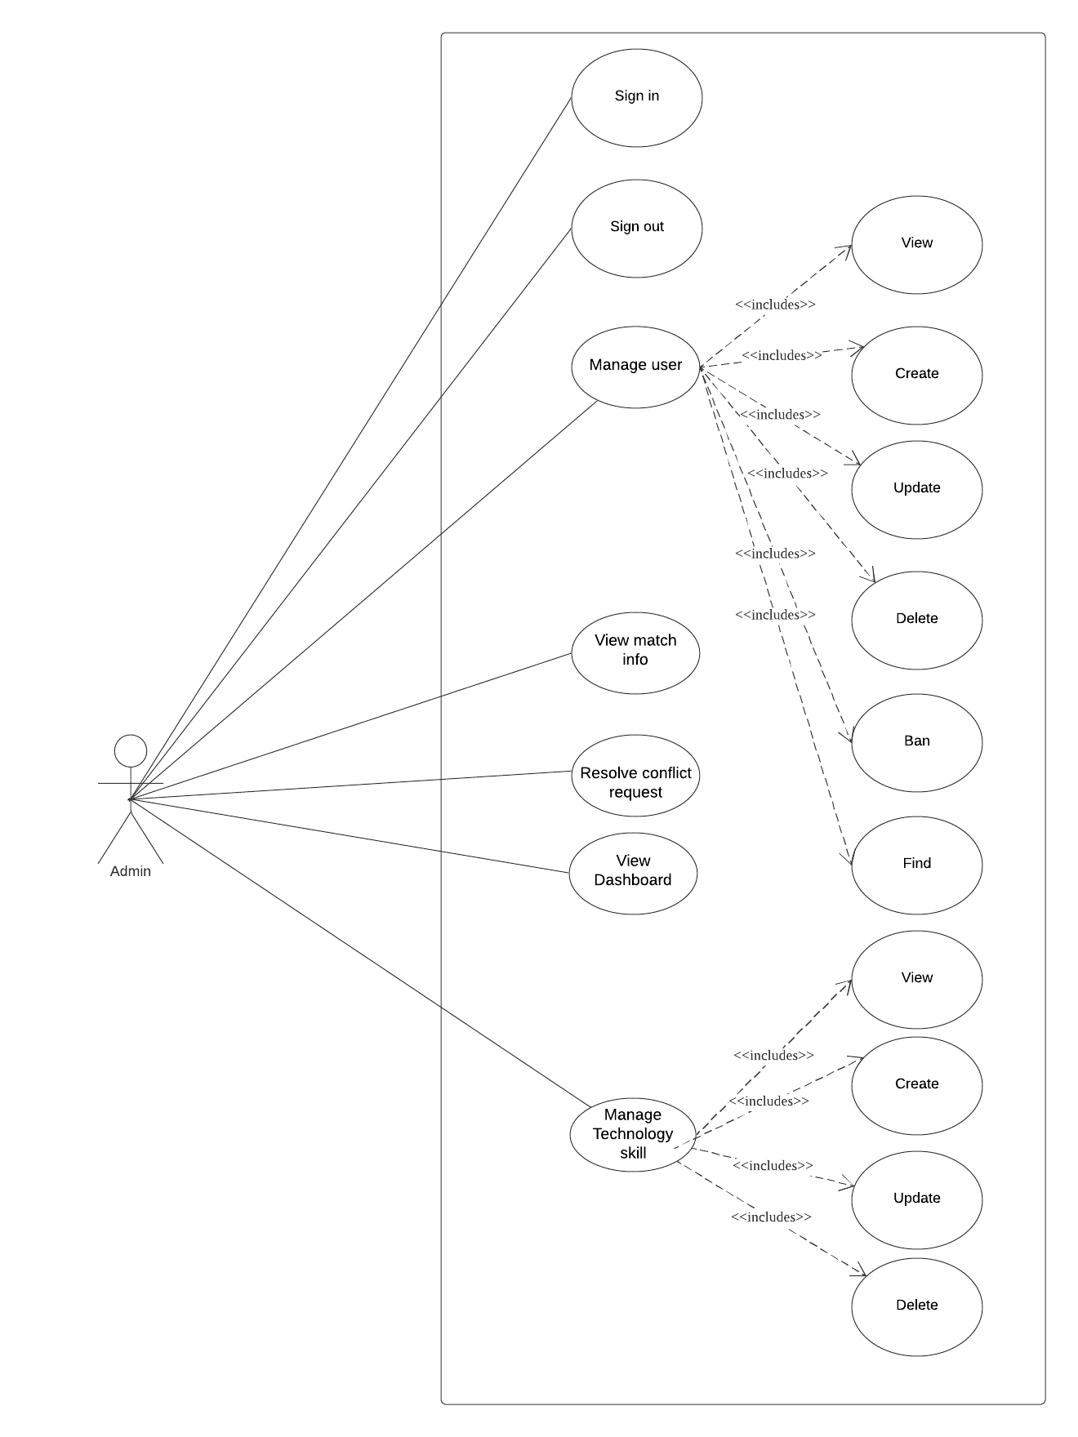

Figure 3.2: Use Case Diagram - Admin

* Guest

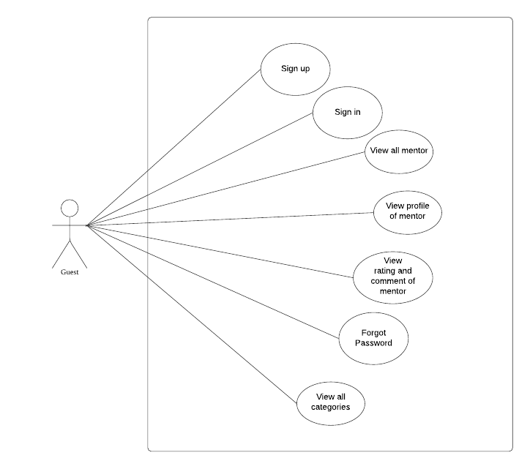

Figure 3.3: Use Case Diagram - Guest

* Mentee

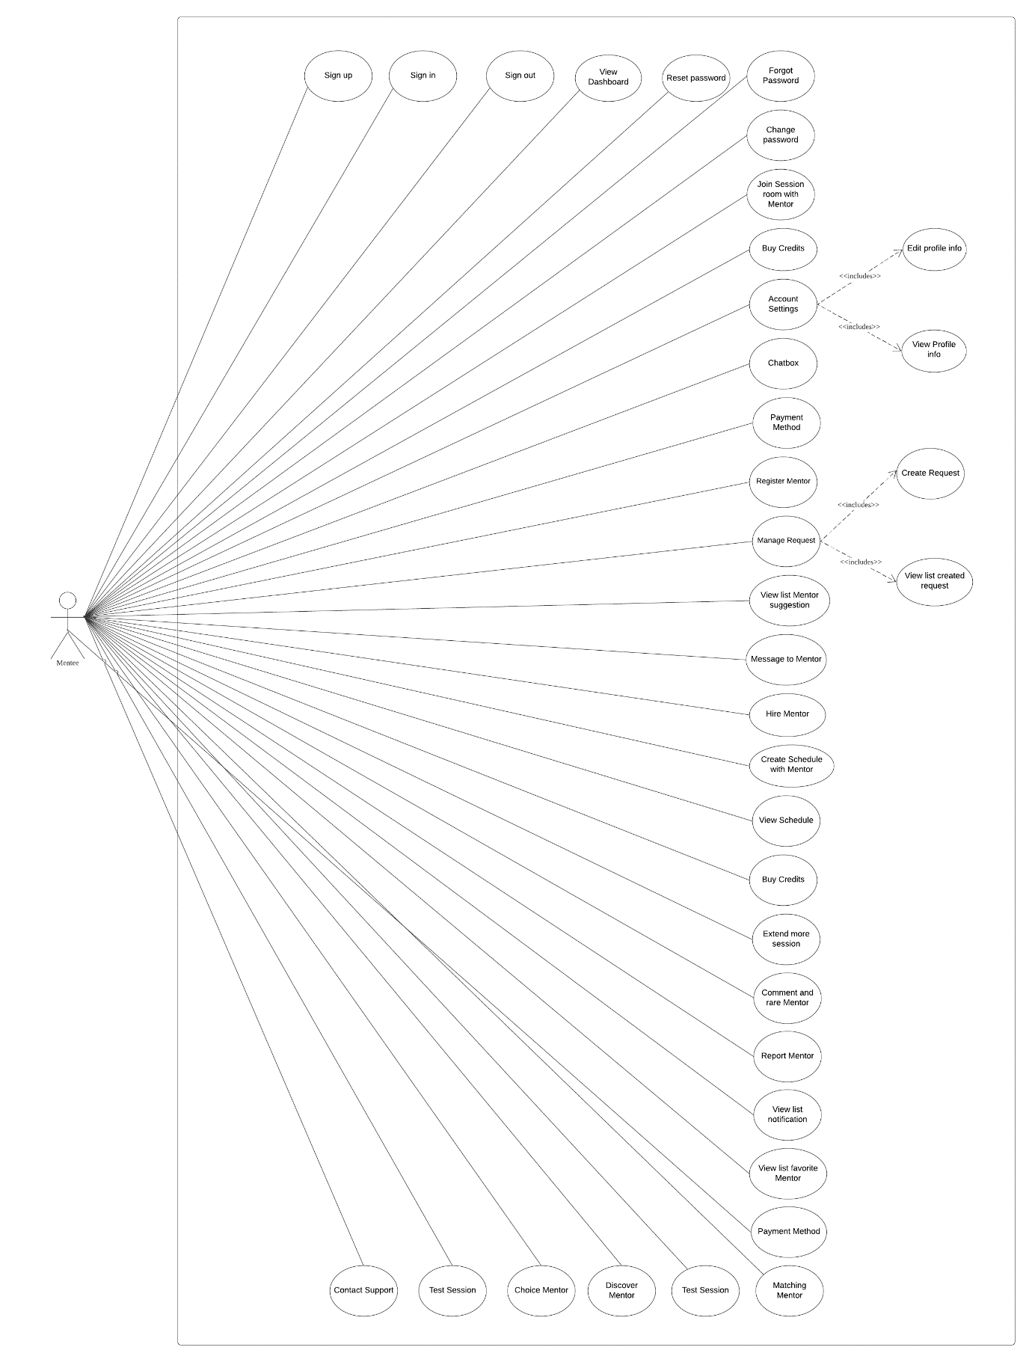

Figure 3.4: Use Case Diagram - Mentee

* Mentor

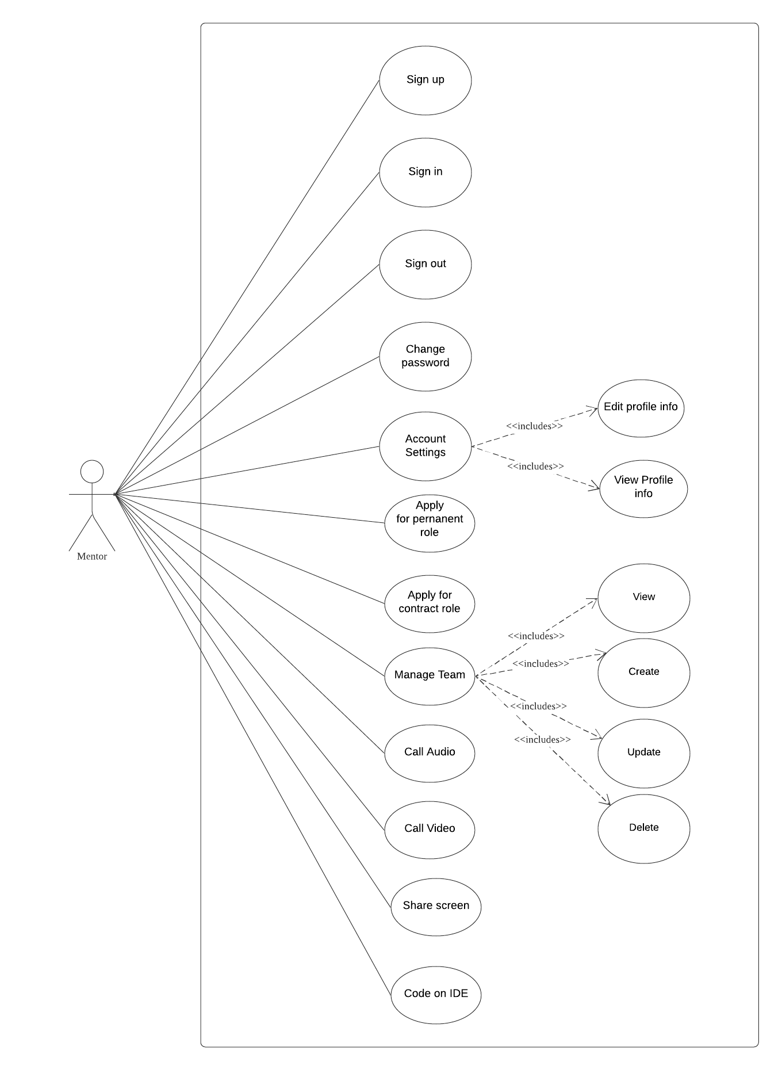

Figure 3.5: Use Case Diagram - Mentor

* Staff

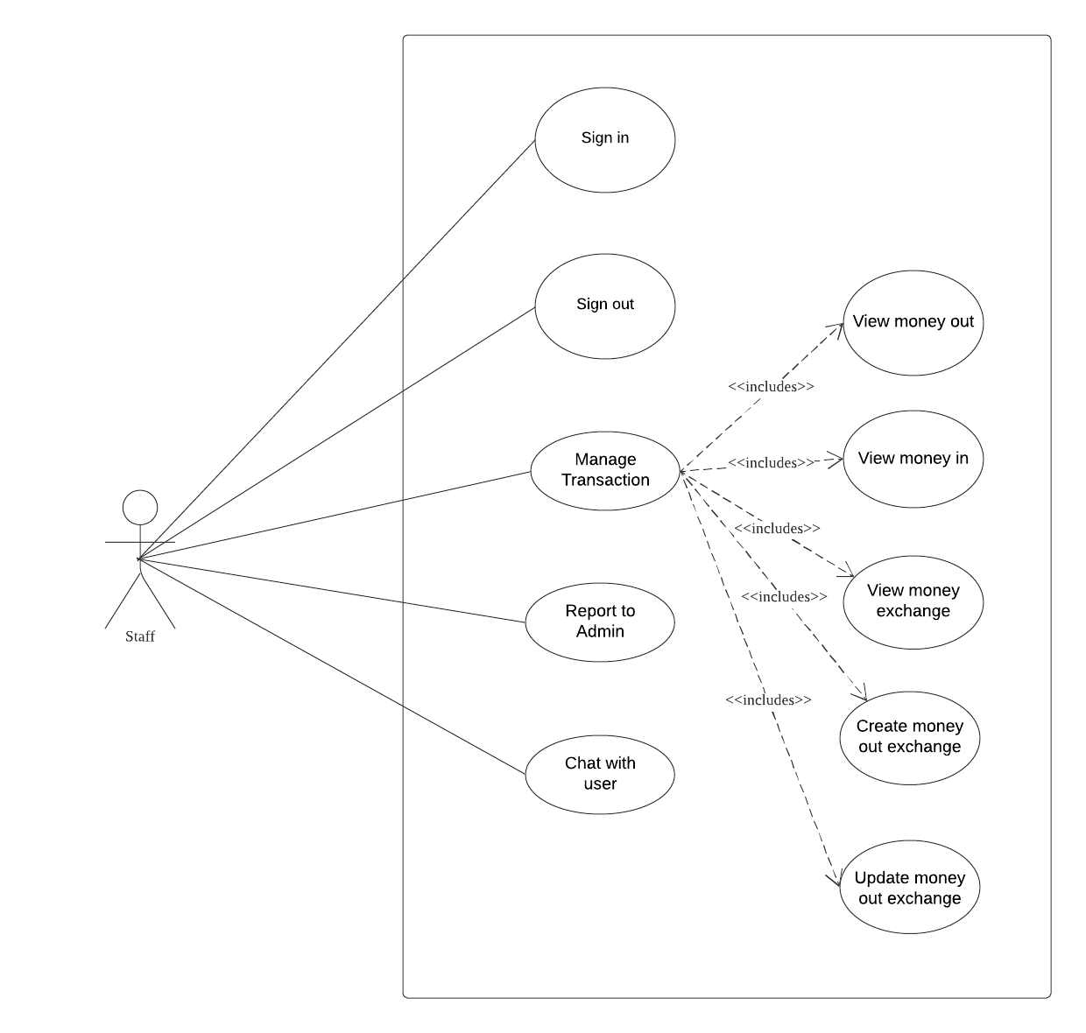

Figure 3.6: Use Case Diagram – Staff

#### **b. System Actors**

|  |  |  |
| --- | --- | --- |
| **#** | **Actors** | **Description** |
| 1 | Admin | People who manage the LCM System |
| 2 | Guest | The user that has not yet registered an account |
| 3 | Mentee | The registered user wishes to hire mentors |
| 4 | Mentor | Mentors of LCM System |
| 5 | Staff | People who work the LCM System |

#### **c. Use Cases List**

|  |  |  |  |
| --- | --- | --- | --- |
| **ID** | **Use Case** | **Primary Actors** | **Secondary Actor** |
| UC-01 | Sign up | Guest | N/A |
| UC-02 | View dashboard | Admin | N/A |
| UC-03 | View user info | Admin | N/A |
| UC-04 | View mentor info | Admin | N/A |
| UC-05 | View request info | Admin | N/A |
| UC-06 | View Report | Admin | N/A |
| UC-07 | View technology/skill | Admin | N/A |
| UC-08 | Create technology/skill | Admin | N/A |
| UC-09 | Update technology/skill | Admin | N/A |
| UC-10 | Delete technology/skill | Admin | N/A |
| UC-11 | Update User Info | Admin | N/A |
| UC-12 | Ban User | Admin | N/A |
| UC-13 | Unban User | Admin | N/A |
| UC-14 | View Question Info | Admin | N/A |
| UC-15 | Search Mentor | Admin | N/A |
| UC-16 | View Point | Staff | N/A |
| UC-17 | Create Point | Staff | N/A |
| UC-18 | Update Point Transaction | Staff | N/A |
| UC-19 | Request To Admin | Staff | N/A |
| UC-20 | Confirm Register Mentor | Staff | N/A |
| UC-21 | Registered as mentor | Mentor | N/A |
| UC-22 | Login | Mentor | N/A |
| UC-23 | Logout | Mentor | N/A |
| UC-24 | Edit profile | Mentor | N/A |
| UC-25 | Call Audio/Video | Mentor | User |
| UC-26 | Share screen | Mentor | User |
| UC-27 | Code on IDE | Mentor | User |
| UC-28 | Login | Mentee | N/A |
| UC-29 | Logout | Mentee | N/A |
| UC-30 | Change password | Mentee | N/A |
| UC-31 | Forgot Password | Mentee | N/A |
| UC-32 | View Profile info | Mentee | N/A |
| UC-33 | Edit profile info | Mentee | N/A |
| UC-34 | View Dashboard | Mentee | N/A |
| UC-35 | Create Question | Mentee | N/A |
| UC-36 | View List Created Question | Mentee | N/A |
| UC-37 | View list Mentor suggestion | Mentee | N/A |
| UC-38 | Payment Method | Mentee | N/A |
| UC-39 | View list notification | Mentee | N/A |
| UC-40 | Join Session room with Mentor | Mentee | N/A |
| UC-41 | Extend more session | Mentee | N/A |
| UC-42 | Rate Mentor | Mentee | N/A |
| UC-43 | Report Mentor | Mentee | N/A |
| UC-44 | View list favorite Mentor | Mentee | N/A |
| UC-45 | Matching Mentor | Mentee | N/A |
| UC-46 | View Point In Transaction | Mentee | Staff |
| UC-47 | View Point Out Transaction | Mentee | Staff |
| UC-48 | Delete Question | Mentee | N/A |
| UC-49 | Update Question | Mentee | N/A |

### 2.2 Use Case Specification

#### 2.2.1. Guest

2.2.1.1. Sign up

|  |  |  |  |
| --- | --- | --- | --- |
| **Use Case ID** | UC - 01 | **Use Case Name** | Sign up |
| **Created By** | Lê Thành Đạt | **Created Date** | 25/01/2021 |
| **Primary Actor** | Guest | **Secondary Actor** | User |
| **Description** | Sign up an account on system. | | |
| **Pre-conditions** | N/A | | |
| **Post-conditions** | When the normal flow completes successfully, a new account will be created with the role of mentee and saved into database. | | |
| **Normal Flow** | 1. Go to Home Page. 2. Click “Đăng ký”. 3. System displays “Sign Up” form. 4. Input username, email, password, fullname, phone number, date of birth, gender. 5. Clicks “Đăng ký” button. 6. System displays toast success message. 7. Redirect to Login Screen. | | |
| **Alternative Flow** | N/A | | |
| **Exceptions** | System displays error message when:   1. Not input all field in “Sign Up” form 2. Username or Email existed 3. Cannot connect to server | | |
| **Priority** | High | | |
| **Frequency of Use** | High | | |
| **Business Rules** |  | | |
| **Other Information** | N/A | | |
| **Assumptions** | N/A | | |

#### 2.2.2. Admin

2.2.2.1. View dashboard

|  |  |  |  |
| --- | --- | --- | --- |
| **Use Case ID** | UC - 02 | **Use Case Name** | View dashboard |
| **Created By** | Lê Thành Đạt | **Created Date** | 25/01/2021 |
| **Primary Actor** | Admin | **Secondary Actor** | N/A |
| **Description** | View dashboard screen about general information | | |
| **Pre-conditions** | Admin has logged into Admin Website | | |
| **Post-conditions** | N/A | | |
| **Normal Flow** | 1. Go to Admin Page. 2. Click on “Dashboard” on sidebar 3. System displays all | | |
| **Alternative Flow** | N/A | | |
| **Exceptions** | System displays error message when:   1. Cannot connect to server | | |
| **Priority** | High | | |
| **Frequency of Use** | High | | |
| **Business Rules** |  | | |
| **Other Information** | N/A | | |
| **Assumptions** | N/A | | |

2.2.2.2 View user info

|  |  |  |  |
| --- | --- | --- | --- |
| **Use Case ID** | UC – 03 | **Use Case Name** | View user info |
| **Created By** | Lê Thành Đạt | **Created Date** | 25/01/2021 |
| **Primary Actor** | Admin | **Secondary Actor** | N/A |
| **Description** | View information of all registered users in system | | |
| **Pre-conditions** | Admin has logged into Admin Website | | |
| **Post-conditions** | N/A | | |
| **Normal Flow** | 1. Go to Admin Page. 2. Click on “Quản lý thành viên” on sidebar 3. System displays all the information of registered users | | |
| **Alternative Flow** | N/A | | |
| **Exceptions** | System displays error message when:   1. Cannot connect to server | | |
| **Priority** | High | | |
| **Frequency of Use** | High | | |
| **Business Rules** |  | | |
| **Other Information** | N/A | | |
| **Assumptions** | N/A | | |

2.2.2.3 View mentor info

|  |  |  |  |
| --- | --- | --- | --- |
| **Use Case ID** | UC – 04 | **Use Case Name** | View mentor info |
| **Created By** | Lê Thành Đạt | **Created Date** | 25/01/2021 |
| **Primary Actor** | Admin | **Secondary Actor** | N/A |
| **Description** | View information of all registered mentors in system | | |
| **Pre-conditions** | Admin has logged into Admin Website | | |
| **Post-conditions** | N/A | | |
| **Normal Flow** | 1. Go to Admin Page. 2. Click on “Quản lý mentor” on sidebar 3. System displays all the information of registered mentor | | |
| **Alternative Flow** | N/A | | |
| **Exceptions** | System displays error message when:   1. Cannot connect to server | | |
| **Priority** | High | | |
| **Frequency of Use** | High | | |
| **Business Rules** |  | | |
| **Other Information** | N/A | | |
| **Assumptions** | N/A | | |

2.2.2.4 View request info

|  |  |  |  |
| --- | --- | --- | --- |
| **Use Case ID** | UC – 05 | **Use Case Name** | View request info |
| **Created By** | Lê Thành Đạt | **Created Date** | 25/01/2021 |
| **Primary Actor** | Admin | **Secondary Actor** | N/A |
| **Description** | View all requests in system | | |
| **Pre-conditions** | Admin has logged into Admin Website | | |
| **Post-conditions** | N/A | | |
| **Normal Flow** | 1. Go to Admin Page 2. Click “Quản lý yêu cầu” in sidebar 3. System displays all the information of existing requests in system | | |
| **Alternative Flow** | N/A | | |
| **Exceptions** | System displays error message when:   1. Cannot connect to server | | |
| **Priority** | High | | |
| **Frequency of Use** | High | | |
| **Business Rules** |  | | |
| **Other Information** | N/A | | |
| **Assumptions** | N/A | | |

2.2.2.5 View Report

|  |  |  |  |
| --- | --- | --- | --- |
| **Use Case ID** | UC – 06 | **Use Case Name** | View Report |
| **Created By** | Lê Thành Đạt | **Created Date** | 25/01/2021 |
| **Primary Actor** | Admin | **Secondary Actor** | N/A |
| **Description** | View all requests in system | | |
| **Pre-conditions** | 1. Admin has logged into Admin Website 2. Having at least 1 conflict request on system | | |
| **Post-conditions** | When the normal flow completes successfully, the request will be updated in database | | |
| **Normal Flow** | 1. Go to Admin Page 2. Click “Quản lý yêu cầu” in sidebar 3. System displays all the information of existing requests in system 4. Select Report 5. Click “Xử lý” button 6. System displays a popup with 2 options: “Hoàn thành” and “Không hoàn thành” | | |
| **Alternative Flow** | N/A | | |
| **Exceptions** | System displays error message when:   1. Cannot connect to server | | |
| **Priority** | High | | |
| **Frequency of Use** | High | | |
| **Business Rules** |  | | |
| **Other Information** | N/A | | |
| **Assumptions** | N/A | | |

2.2.2.6 View technology/skill

|  |  |  |  |
| --- | --- | --- | --- |
| **Use Case ID** | UC – 07 | **Use Case Name** | View technology/skill |
| **Created By** | Lê Thành Đạt | **Created Date** | 25/01/2021 |
| **Primary Actor** | Admin | **Secondary Actor** | N/A |
| **Description** | View all requests in system | | |
| **Pre-conditions** | 1. Admin has logged into Admin Website | | |
| **Post-conditions** | N/A | | |
| **Normal Flow** | 1. Go to Admin Page 2. Click “Quản lý kĩ năng” in sidebar 3. System displays all the information of existing technology/skill in system | | |
| **Alternative Flow** | N/A | | |
| **Exceptions** | System displays error message when:   1. Cannot connect to server | | |
| **Priority** | High | | |
| **Frequency of Use** | High | | |
| **Business Rules** |  | | |
| **Other Information** | N/A | | |
| **Assumptions** | N/A | | |

2.2.2.7 Create technology/skill

|  |  |  |  |
| --- | --- | --- | --- |
| **Use Case ID** | UC – 08 | **Use Case Name** | Create technology/skill |
| **Created By** | Lê Thành Đạt | **Created Date** | 25/01/2021 |
| **Primary Actor** | Admin | **Secondary Actor** | N/A |
| **Description** | View all requests in system | | |
| **Pre-conditions** | 1. Admin has logged into Admin Website | | |
| **Post-conditions** | When the normal flow completes successfully, the new skill will be saved into database | | |
| **Normal Flow** | 1. Go to Admin Page 2. Click “Quản lý kỹ năng” in sidebar 3. Input name of skill 4. Click “Thêm kỹ năng” button | | |
| **Alternative Flow** | N/A | | |
| **Exceptions** | System displays error message when:   1. Cannot connect to server 2. Duplicate skill name in system | | |
| **Priority** | High | | |
| **Frequency of Use** | High | | |
| **Business Rules** |  | | |
| **Other Information** | N/A | | |
| **Assumptions** | N/A | | |

2.2.2.8 Update technology/skill

|  |  |  |  |
| --- | --- | --- | --- |
| **Use Case ID** | UC – 09 | **Use Case Name** | Update technology/skill |
| **Created By** | Lê Thành Đạt | **Created Date** | 25/01/2021 |
| **Primary Actor** | Admin | **Secondary Actor** | N/A |
| **Description** | Update an existed skill | | |
| **Pre-conditions** | Admin has logged into Admin Website | | |
| **Post-conditions** | When the normal flow completes successfully, the new skill will be saved into database | | |
| **Normal Flow** | 1. Go to Admin Page 2. Click “Quản lý kỹ năng” in sidebar 3. Click “Sửa” button in 1 skill 4. Update name and status of skill 5. Click “Lưu” button | | |
| **Alternative Flow** | N/A | | |
| **Exceptions** | System displays error message when:   1. Cannot connect to server 2. Duplicate skill name in system | | |
| **Priority** | High | | |
| **Frequency of Use** | High | | |
| **Business Rules** |  | | |
| **Other Information** | N/A | | |
| **Assumptions** | N/A | | |

2.2.2.9 Delete technology/skill

|  |  |  |  |
| --- | --- | --- | --- |
| **Use Case ID** | UC – 10 | **Use Case Name** | Delete technology/skill |
| **Created By** | Lê Thành Đạt | **Created Date** | 25/01/2021 |
| **Primary Actor** | Admin | **Secondary Actor** | N/A |
| **Description** | Delete an existed skill | | |
| **Pre-conditions** | Admin has logged into Admin Website | | |
| **Post-conditions** | When the normal flow completes successfully, the new skill will be deleted in database | | |
| **Normal Flow** | 1. Go to Admin Page 2. Click “Quản lý kỹ năng” in sidebar 3. Click icon in “Trạng thái” column 4. System change icon to inactive icon | | |
| **Alternative Flow** | 1. Go to Admin Page 2. Click “Quản lý kỹ năng” in sidebar 3. Click “Sửa” button in 1 skill 4. Update name and status of skill 5. Click “Lưu” button | | |
| **Exceptions** | System displays error message when:   1. Cannot connect to server | | |
| **Priority** | High | | |
| **Frequency of Use** | High | | |
| **Business Rules** |  | | |
| **Other Information** | N/A | | |
| **Assumptions** | N/A | | |

2.2.2.10. Update user info

|  |  |  |  |
| --- | --- | --- | --- |
| **Use Case ID** | UC - 11 | **Use Case Name** | Update User Info |
| **Created By** | Hoàng Công Nghĩa | **Created Date** | 25/01/2021 |
| **Primary Actor** | Admin | **Secondary Actor** | N/A |
| **Description** | Admin edit the information of the user. | | |
| **Pre-conditions** | 1. Admin has logged into Admin Website 2. Choose a user to edit info. | | |
| **Post-conditions** | N/A | | |
| **Normal Flow** | 1. On page screen dashboard of Admin 2. Admin click to “View User Info”. 3. The system displays a list of all users. 4. Admin choose a user to edit info 5. After that, the admin clicks the “Edit”. 6. Admin click “Xác nhận”. 7. The system displays the success message | | |
| **Alternative Flow** | 1. On page screen dashboard of Admin 2. Admin click to “View User Info” 3. The system displays a list of all users. 4. Admin choose a user to edit info 5. After that, admin click button “Hủy”. 6. The info of the system won’t be deleted. | | |
| **Exceptions** | The system displays an error message when:   1. Not input text 2. Cannot connect to the server | | |
| **Priority** | Medium | | |
| **Frequency of Use** | Medium | | |
| **Business Rules** |  | | |
| **Other Information** | N/A | | |
| **Assumptions** | N/A | | |

2.2.2.11 Ban user

|  |  |  |  |
| --- | --- | --- | --- |
| **Use Case ID** | UC - 12 | **Use Case Name** | Ban user |
| **Created By** | Bùi Công Ánh | **Created Date** | 25/01/2021 |
| **Primary Actor** | Admin | **Secondary Actor** | N/A |
| **Description** | Admin ban user if user when user violate the terms | | |
| **Pre-conditions** | 1. Admin has logged into Admin Website 2. Choose a user admin wants to ban. | | |
| **Post-conditions** | User has banned will not to login into the system | | |
| **Normal Flow** | 1. On the page screen dashboard of admin. 2. Choose “View List User”. 3. Admin click to “View User Info”. 4. The system displays a list of all users. 5. Admin choose what user wants to ban. 6. Admin click the “Ban” button. 7. The system displays the ban success message. | | |
| **Alternative Flow** | N/A | | |
| **Exceptions** | The system displays an error message when:   1. Cannot connect to the server. | | |
| **Priority** | Medium | | |
| **Frequency of Use** | Medium | | |
| **Business Rules** |  | | |
| **Other Information** | N/A | | |
| **Assumptions** | N/A | | |

2.2.2.12 Unban user

|  |  |  |  |
| --- | --- | --- | --- |
| **Use Case ID** | UC - 13 | **Use Case Name** | Unban user |
| **Created By** | Bùi Công Ánh | **Created Date** | 25/01/2021 |
| **Primary Actor** | Admin | **Secondary Actor** | N/A |
| **Description** | Admin ban user if user when user violate the terms | | |
| **Pre-conditions** | 1. Admin has logged into Admin Website 2. Choose a user admin wants to unban. | | |
| **Post-conditions** | User has unbanned can login in to use the system | | |
| **Normal Flow** | 1. On the page screen dashboard of admin. 2. Choose “View List User”. 3. Admin click to “View User Info”. 4. The system displays a list of all users. 5. Admin choose what user wants to ban. 6. Admin click “Ban” button. 7. The system displays the unban success message. | | |
| **Alternative Flow** | N/A | | |
| **Exceptions** | The system displays an error message when:   1. Cannot connect to the server. | | |
| **Priority** | Medium | | |
| **Frequency of Use** | Medium | | |
| **Business Rules** |  | | |
| **Other Information** | N/A | | |
| **Assumptions** | N/A | | |

2.2.2.13 View Question info

|  |  |  |  |
| --- | --- | --- | --- |
| **Use Case ID** | UC - 14 | **Use Case Name** | View Question Info |
| **Created By** | Hoang Cong Nghia | **Created Date** | 25/01/2021 |
| **Primary Actor** | Admin | **Secondary Actor** | N/A |
| **Description** | Admin can view question’s info | | |
| **Pre-conditions** | Admin must login. | | |
| **Post-conditions** | Admin view match question’s Info | | |
| **Normal Flow** | 1. Go to Home Page 2. Admin click “View question’s info”. 3. The system will redirect User to the view question’s info page. | | |
| **Alternative Flow** | N/A | | |
| **Exceptions** | N/A | | |
| **Priority** | High | | |
| **Frequency of Use** | High | | |
| **Business Rules** |  | | |
| **Other Information** | N/A | | |
| **Assumptions** | N/A | | |

2.2.2.14 Search mentor

|  |  |  |  |
| --- | --- | --- | --- |
| **Use Case ID** | UC - 15 | **Use Case Name** | Search mentor |
| **Created By** | Bùi Công Ánh | **Created Date** | 25/01/2021 |
| **Primary Actor** | Admin | **Secondary Actor** | N/A |
| **Description** | Search mentor on the system | | |
| **Pre-conditions** | N/A | | |
| **Post-conditions** | N/A | | |
| **Normal Flow** | 1. Go to List Mentor Screen. 2. Input text in search area 3. Click “Xác nhận” button 4. After each character typing, the system displays all mentors that have a username or full name including the text search | | |
| **Alternative Flow** | N/A | | |
| **Exceptions** | The system displays an error message when:   1. Not input text 2. Cannot connect to the server | | |
| **Priority** | Medium | | |
| **Frequency of Use** | Medium | | |
| **Business Rules** |  | | |
| **Other Information** | N/A | | |
| **Assumptions** | N/A | | |

#### 2.2.3. Staff

2.2.3.1 View point

|  |  |  |  |
| --- | --- | --- | --- |
| **Use Case ID** | UC – 16 | **Use Case Name** | View Point |
| **Created By** | Lê Thành Đạt | **Created Date** | 25/01/2021 |
| **Primary Actor** | Staff | **Secondary Actor** | N/A |
| **Description** | View all point exchange transactions in system | | |
| **Pre-conditions** | Satf has logged into Staff Website | | |
| **Post-conditions** | N/A | | |
| **Normal Flow** | 1. Go to Homepage 2. Click “Quản lý giao dịch” in sidebar 3. System displays all the information of existing point exchange transactions in system | | |
| **Alternative Flow** | N/A | | |
| **Exceptions** | System displays error message when:   1. Cannot connect to server | | |
| **Priority** | High | | |
| **Frequency of Use** | High | | |
| **Business Rules** |  | | |
| **Other Information** | N/A | | |
| **Assumptions** | N/A | | |

2.2.3.2 Create point

|  |  |  |  |
| --- | --- | --- | --- |
| **Use Case ID** | UC – 17 | **Use Case Name** | Create Point |
| **Created By** | Lê Thành Đạt | **Created Date** | 25/01/2021 |
| **Primary Actor** | Staff | **Secondary Actor** | N/A |
| **Description** | Create a money in transaction for user | | |
| **Pre-conditions** | Staff has logged into Staff Website | | |
| **Post-conditions** | When the normal flow completes successfully, the new point in transaction will be saved into the database and the current point of the user will be increased by the input amount to buy points. | | |
| **Normal Flow** | 1. Go to Homepage 2. Click “Nạp Point” in menu 3. Input username, point, method 4. Click “Nạp Point” button | | |
| **Alternative Flow** | N/A | | |
| **Exceptions** | System displays error message when:   1. Cannot connect to server | | |
| **Priority** | High | | |
| **Frequency of Use** | High | | |
| **Business Rules** |  | | |
| **Other Information** | N/A | | |
| **Assumptions** | User has transferred money through a bank account or e-wallet. | | |

2.2.3.5. Update point transaction

|  |  |  |  |
| --- | --- | --- | --- |
| **Use Case ID** | UC – 18 | **Use Case Name** | Update Point Transaction |
| **Created By** | Lê Thành Đạt | **Created Date** | 25/01/2021 |
| **Primary Actor** | Staff | **Secondary Actor** | N/A |
| **Description** | Staff transferred manually the point request to the mentor and updated the status of the transaction on the system. | | |
| **Pre-conditions** | 1. Staff has logged into Staff Website 2. A mentor has created a withdrawal request | | |
| **Post-conditions** | When the normal flow completes successfully, the point-out transaction will be updated to success and saved into the database. | | |
| **Normal Flow** | 1. Go to Homepage. 2. Click “Quản lý giao dịch” in sidebar 3. Click “Rút tiền” tab. 4. Click “Xác nhận” button in 1 record 5. Convert points to money. 6. System displays a popup to confirm 7. Click “Xác nhận” button | | |
| **Alternative Flow** | N/A | | |
| **Exceptions** | System displays error message when:   1. Cannot connect to server | | |
| **Priority** | High | | |
| **Frequency of Use** | High | | |
| **Business Rules** |  | | |
| **Other Information** | N/A | | |
| **Assumptions** | N/A | | |

2.2.5. Request to Admin

|  |  |  |  |
| --- | --- | --- | --- |
| **Use Case ID** | UC - 19 | **Use Case Name** | Request to Admin |
| **Created By** | Bùi Công Ánh | **Created Date** | 25/01/2021 |
| **Primary Actor** | Staff | **Secondary Actor** | N/A |
| **Description** | Staff send some request to Admin | | |
| **Pre-conditions** | 1. Staff has logged into the Staff Website. 2. Having at least one request wants to send to Admin. | | |
| **Post-conditions** | N/A | | |
| **Normal Flow** | 1. On page screen dashboard of staff. 2. Staff clicks the “Request to Admin” button. 3. The system displays input form to request a mentor. 4. After that, staff click “Gửi” button. 5. The system displays the send success message. | | |
| **Alternative Flow** | 1. On page screen dashboard of staff. 2. Staff click the “Request to Admin” button. 3. The system displays a form to request a mentor. 4. After that, staff click “Huỷ” button. 5. The system displays the cancel send success message. | | |
| **Exceptions** | The system displays an error message when:   1. Not input text 2. Cannot connect to the server | | |
| **Priority** | Medium | | |
| **Frequency of Use** | Medium | | |
| **Business Rules** |  | | |
| **Other Information** | N/A | | |
| **Assumptions** | N/A | | |

2.2.6. Confirm Register Mentor

|  |  |  |  |
| --- | --- | --- | --- |
| **Use Case ID** | UC - 20 | **Use Case Name** | Confirm Register Mentor |
| **Created By** | Bùi Công Ánh | **Created Date** | 25/01/2021 |
| **Primary Actor** | Staff | **Secondary Actor** | N/A |
| **Description** | Staff confirm the user wants to become a mentor in the system | | |
| **Pre-conditions** | 1. Staff has logged into the Staff Website. 2. Having at least 1 request of user wants register mentor on the system | | |
| **Post-conditions** | N/A | | |
| **Normal Flow** | 1. On page screen dashboard of staff. 2. Staff click to “Register Mentor”. 3. Staff click to “Xác nhận” button. 4. The system displays the success message. | | |
| **Alternative Flow** | 1. On page screen dashboard of staff. 2. Staff click to “Register Mentor”. 3. Staff click to “Huỷ” button. 4. The system displays the cancel message. | | |
| **Exceptions** | The system displays an error message when:   1. Cannot connect to the server | | |
| **Priority** | Medium | | |
| **Frequency of Use** | Medium | | |
| **Business Rules** |  | | |
| **Other Information** | N/A | | |
| **Assumptions** | N/A | | |

#### **2.2.4. Mentor**

2.2.4.1. Register as mentor

|  |  |  |  |
| --- | --- | --- | --- |
| **Use Case ID** | UC - 21 | **Use Case Name** | Register as mentor |
| **Created By** | Hoang Cong Nghia | **Created Date** | 25/01/2021 |
| **Primary Actor** | Mentor | **Secondary Actor** | N/A |
| **Description** | Sign up to become a mentor | | |
| **Pre-conditions** | N/A | | |
| **Post-conditions** | When the normal flow completes successfully, a new account will be created with the role of mentor and saved into database. | | |
| **Normal Flow** | 1. Go to Home Page 2. Click “Become a mentor”. 3. System displays “Create an account to continue to Codementor” form. 4. Input username, full name, email, password, phone number, date of birth, gender, CV. 5. Clicks “Create account” button. | | |
| **Alternative Flow** | N/A | | |
| **Exceptions** | System displays error message when:   1. Not input all field in “Create an account to continue to Codementor” 2. Username or Email existed. 3. Cannot connect to server. | | |
| **Priority** | High | | |
| **Frequency of Use** | High | | |
| **Business Rules** |  | | |
| **Other Information** | N/A | | |
| **Assumptions** | N/A | | |

2.2.4.2. Login

|  |  |  |  |
| --- | --- | --- | --- |
| **Use Case ID** | UC - 22 | **Use Case Name** | Login |
| **Created By** | Hoang Cong Nghia | **Created Date** | 25/01/2021 |
| **Primary Actor** | Mentor | **Secondary Actor** | N/A |
| **Description** | Login an account using email and password. | | |
| **Pre-conditions** | 1. Mentor can access the system. 2. - Mentor has already registered an account. | | |
| **Post-conditions** | - Mentor is Logged into the system. | | |
| **Normal Flow** | 1. Go to Home Page 2. Click “Login”. 3. The system loads the Login page. 4. Mentor enters “Email” and “password”. 5. Mentor clicks "Login" button. 6. The system checks your input data. If Mentor entered true, Mentor will be Login successful. 7. The system redirects Mentor to the Home page. | | |
| **Alternative Flow** | N/A | | |
| **Exceptions** | EXC1: At step 4 of normal flow, Mentor leaves “Email” blank, then proceeds to step 5.   1. The system displays the error message "You have to enter email.". 2. Mentor is not Loged in.   EXC2: At step 4 of normal flow, Mentor leaves “password” blank, then proceeds to step 5.   1. The system displays the error message “You have to enter password". 2. Mentor is not Logged in.   EXC3: At step 4 of normal flow, Mentor enters invalid Login credentials, then proceeds to step 5.   1. The system displays the error message "Wrong username or password, please enter again” 2. Mentor is not Logged in. | | |
| **Priority** | High | | |
| **Frequency of Use** | High | | |
| **Business Rules** |  | | |
| **Other Information** | N/A | | |
| **Assumptions** | N/A | | |

2.2.4.3. Logout

|  |  |  |  |
| --- | --- | --- | --- |
| **Use Case ID** | UC - 23 | **Use Case Name** | Logout |
| **Created By** | Hoang Cong Nghia | **Created Date** | 25/01/2021 |
| **Primary Actor** | Mentor | **Secondary Actor** | N/A |
| **Description** | Logout the system. | | |
| **Pre-conditions** | 1. Mentor accesses to the system. 2. Mentor is currently Logged in. | | |
| **Post-conditions** | Mentor is Logged out of the system. | | |
| **Normal Flow** | 1. In “Home page” screen, select the menu with the three-tile icon in the upper right corner. 2. Mentor clicks “Logout”. 3. The system will redirect Mentor to the Home page. | | |
| **Alternative Flow** | N/A | | |
| **Exceptions** | N/A | | |
| **Priority** | High | | |
| **Frequency of Use** | High | | |
| **Business Rules** |  | | |
| **Other Information** | N/A | | |
| **Assumptions** | N/A | | |

2.2.4.4. Edit profile

|  |  |  |  |
| --- | --- | --- | --- |
| **Use Case ID** | UC - 24 | **Use Case Name** | Edit profile |
| **Created By** | Hoang Cong Nghia | **Created Date** | 25/01/2021 |
| **Primary Actor** | Mentor | **Secondary Actor** | N/A |
| **Description** | Mentor edit profile. | | |
| **Pre-conditions** | 1. Mentor accesses to the system. 2. Mentor is currently Logged in. | | |
| **Post-conditions** | Mentor is Logged out of the system. | | |
| **Normal Flow** | 1. In “Home page” screen, select the menu with the three-tile icon in the upper right corner. 2. Mentor clicks “My profile”. 3. The system will redirect Mentor to the profile page. 4. Mentor click”Edit profile”. 5. The system will redirect Mentor to the edit profile page. 6. Mentor edit their profile. 7. The system will redirect Mentor to the profile page. | | |
| **Alternative Flow** | N/A | | |
| **Exceptions** | EXC1: At step 5 of normal flow, Mentor leaves full name blank, then proceeds to step 6.   1. The system displays the error message "name cannot be blank". 2. Mentor is not changed profile.   EXC2: At step 5 of normal flow, Mentor leaves email, then proceeds to step 6.   1. The system displays the error message "email cannot be blank". 2. Mentor is not changed profile. | | |
| **Priority** | Medium | | |
| **Frequency of Use** | High | | |
| **Business Rules** |  | | |
| **Other Information** | N/A | | |
| **Assumptions** | N/A | | |

2.2.4.5 Call Audio/Video

|  |  |  |  |
| --- | --- | --- | --- |
| **Use Case ID** | UC - 25 | **Use Case Name** | Call Audio/Video |
| **Created By** | Hoang Cong Nghia | **Created Date** | 26/01/2021 |
| **Primary Actor** | Mentor | **Secondary Actor** | N/A |
| **Description** | Mentor call Audio/Video with mentee. | | |
| **Pre-conditions** | 1. Mentor must logged in. 2. Mentor must enable camera and microphone. | | |
| **Post-conditions** | Mentor call Audio/Video with mentee. | | |
| **Normal Flow** | 1. In “Home page” screen, select the menu with the three-tile icon in the upper right corner. 2. Mentor click:”Test session”. 3. The system will redirect Mentor to the Test session page. 4. Clicks “Audio/Video” button. 5. Mentor enable camera and microphone. 6. System displays the call screen. | | |
| **Alternative Flow** | N/A | | |
| **Exceptions** | EXC1: At step 6 of normal flow, if Mentor doesn’t enable camera, then proceeds to step 7.   1. Mentor cannot call video with the mentee.   EXC2: At step 6 of normal flow, if Mentor doesn’t enable microphone, then proceeds to step 7.   1. Mentor cannot call audio with the mentee. | | |
| **Priority** | High | | |
| **Frequency of Use** | High | | |
| **Business Rules** |  | | |
| **Other Information** | N/A | | |
| **Assumptions** | N/A | | |

2.2.4.6. Share screen

|  |  |  |  |
| --- | --- | --- | --- |
| **Use Case ID** | UC - 26 | **Use Case Name** | Share screen |
| **Created By** | Hoang Cong Nghia | **Created Date** | 26/01/2021 |
| **Primary Actor** | Mentor | **Secondary Actor** | N/A |
| **Description** | Mentor call share screen with mentee. | | |
| **Pre-conditions** | Mentor must logged in. | | |
| **Post-conditions** | Mentor share screen with mentee. | | |
| **Normal Flow** | 1. In “Home page” screen, select the menu with the three-tile icon in the upper right corner. 2. Mentor click:”Test session”. 3. The system will redirect Mentor to the Test session page. 4. Clicks “share screen” button. 5. System displays the share screen. | | |
| **Alternative Flow** | N/A | | |
| **Exceptions** | N/A | | |
| **Priority** | High | | |
| **Frequency of Use** | High | | |
| **Business Rules** |  | | |
| **Other Information** | N/A | | |
| **Assumptions** | N/A | | |

2.2.4.7. Code on IDE

|  |  |  |  |
| --- | --- | --- | --- |
| **Use Case ID** | UC - 27 | **Use Case Name** | Code on IDE |
| **Created By** | Hoang Cong Nghia | **Created Date** | 26/01/2021 |
| **Primary Actor** | Mentor | **Secondary Actor** | N/A |
| **Description** | Mentor call Audio/Video with mentee. | | |
| **Pre-conditions** | Mentor must logged in. | | |
| **Post-conditions** | Mentor code on IDE with mentee. | | |
| **Normal Flow** | 1. In “Home page” screen, select the menu with the three-tile icon in the upper right corner. 2. Mentor click:”Test session”. 3. The system will redirect Mentor to the Test session page. 4. Clicks “Code Editor” button. 5. System displays the code editor screen. | | |
| **Alternative Flow** | N/A | | |
| **Exceptions** | EXC1: At step 6 of normal flow, if Mentor doesn’t choose language, then proceeds to step 7.   1. Code cannot run. | | |
| **Priority** | High | | |
| **Frequency of Use** | High | | |
| **Business Rules** |  | | |
| **Other Information** | N/A | | |
| **Assumptions** | N/A | | |

## 3. Functional Requirements

### 3.1 System Functional Overview

#### a. Screen Flow

*[This part show the system screens and the relationship among screens. You can draw the Screens Flow for the system in the form of diagram as below]*

