**ASSIGNMENT 2 FRONT SHEET**

|  |  |  |  |
| --- | --- | --- | --- |
| **Qualification** | **BTEC Level 5 HND Diploma in Computing** | | |
| **Unit number and title** | Unit 30: Application Development | | |
| **Submission date** | 10/4/2024 | **Date Received 1st submission** |  |
| **Re-submission Date** |  | **Date Received 2nd submission** |  |
| **Student Name** | Truong Viet Dung | **Student ID** | BH00227 |
| **Class** | IT0502 | **Assessor name** | Nguyen Thanh Trieu |
| **Student declaration**  I certify that the assignment submission is entirely my own work and I fully understand the consequences of plagiarism. I understand that making a false declaration is a form of malpractice. | | | |
|  |  | **Student’s signature** | Dung |

**Grading grid**

|  |  |  |  |  |  |  |  |
| --- | --- | --- | --- | --- | --- | --- | --- |
| P4 | P5 | P6 | M3 | M4 | M5 | D2 | D3 |
|  |  |  |  |  |  |  |  |

|  |  |  |
| --- | --- | --- |
| **❒ Summative Feedback: ❒ Resubmission Feedback:** | | |
| **Grade:** | **Assessor Signature:** | **Date:** |
| **Lecturer Signature:** | | |

# INTRODUCTION

# BODY

## CREATE A FORMAL QUESTIONNAIRE THAT EFFECTIVELY REVIEWS YOUR BUSINESS APPLICATION, PROBLEM DEFINITION STATEMENT, PROPOSED SOLUTION AND DEVELOPMENT STRATEGY. USE THIS QUESTIONNAIRE AS PART OF A PEER-REVIEW AND DOCUMENT ANY FEEDBACK GIVEN(P4)

### Formal questionnaire.

* A few survey questions about user information:

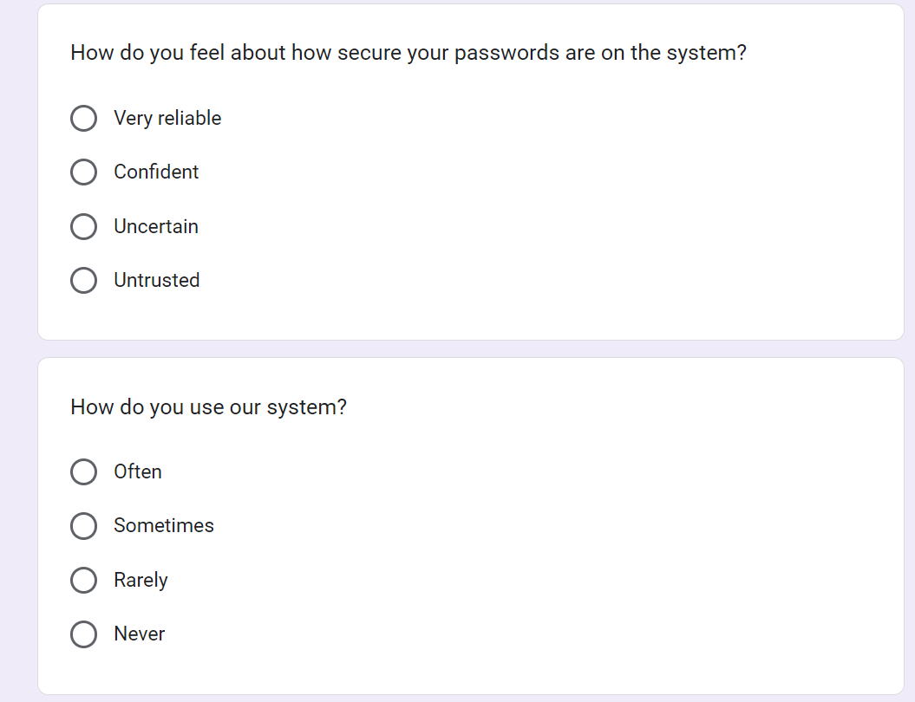

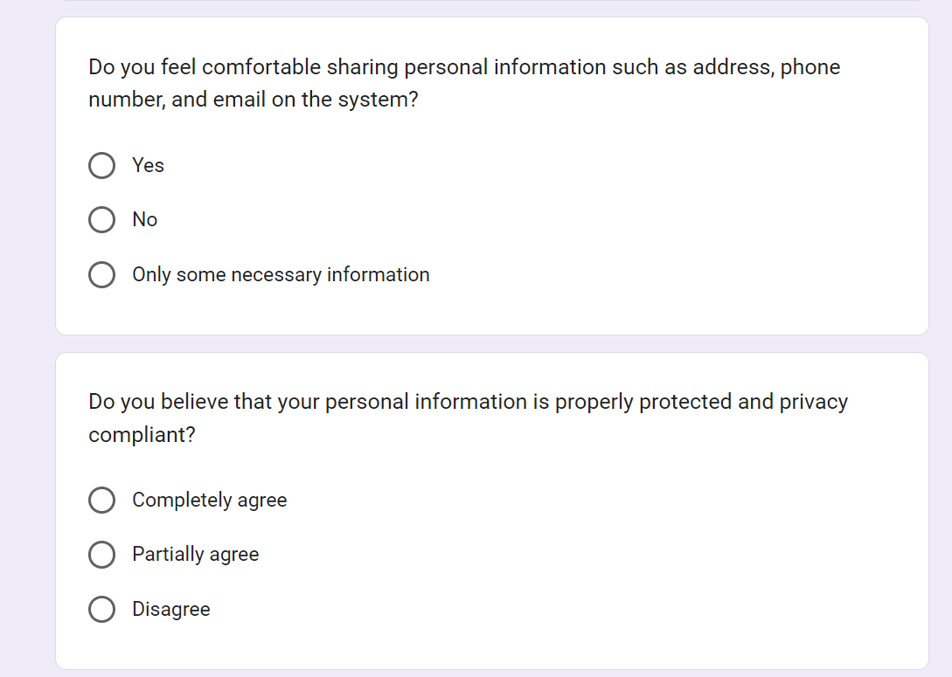

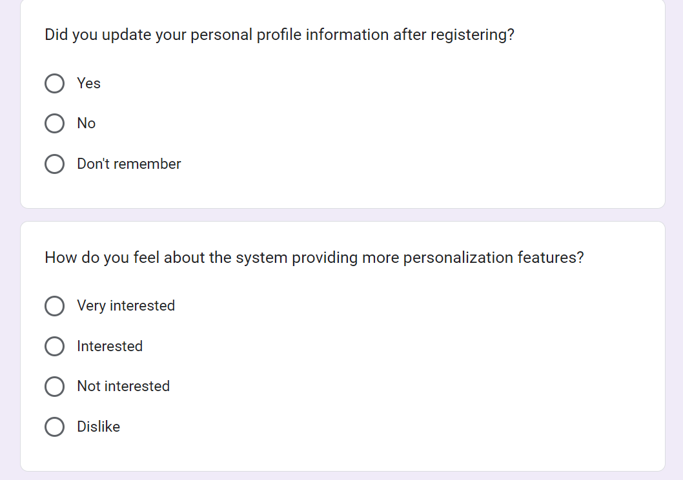

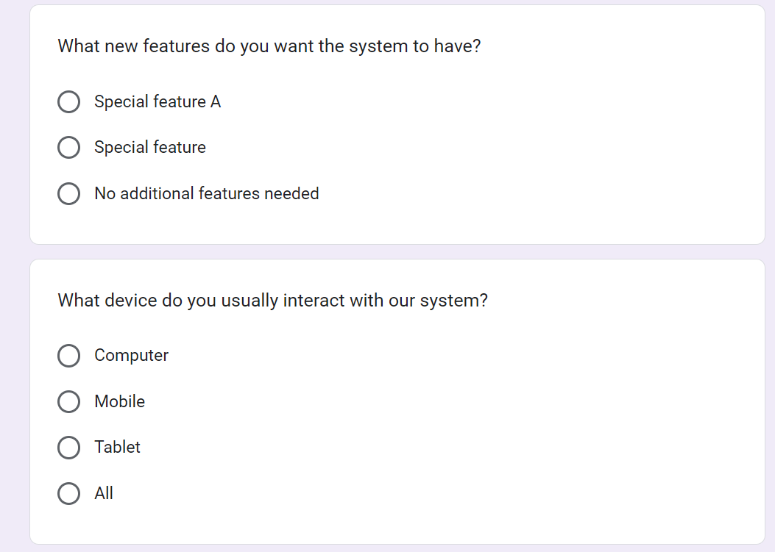

### Admin

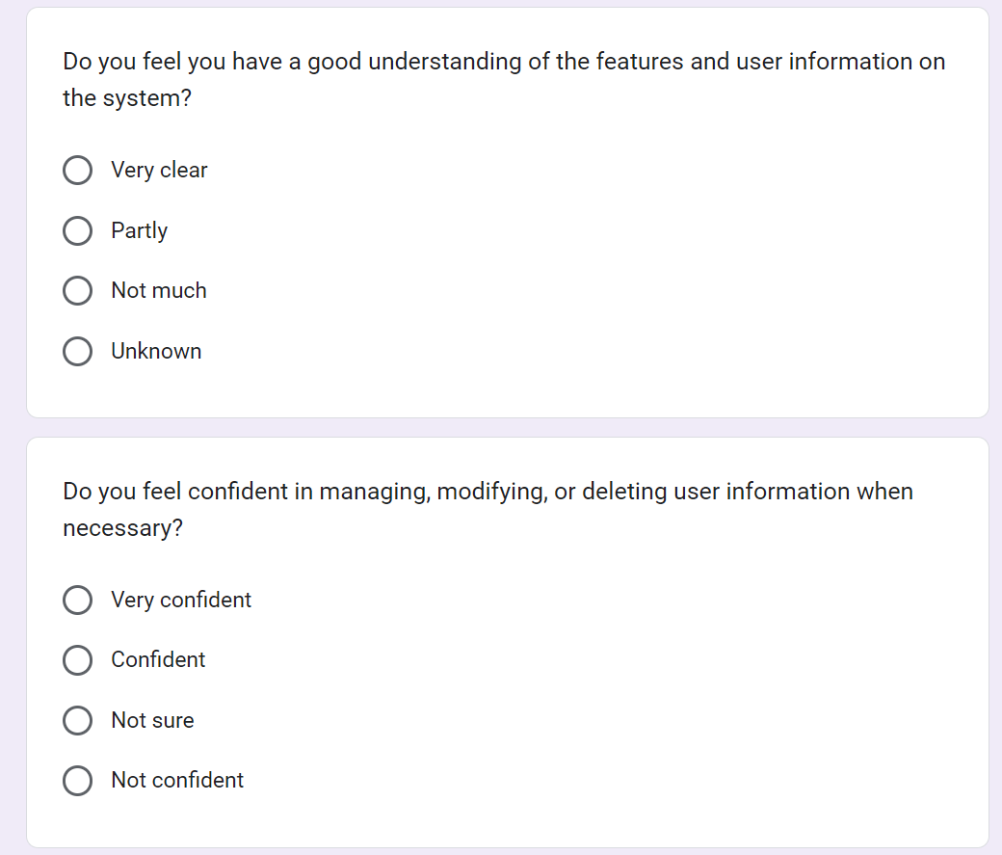

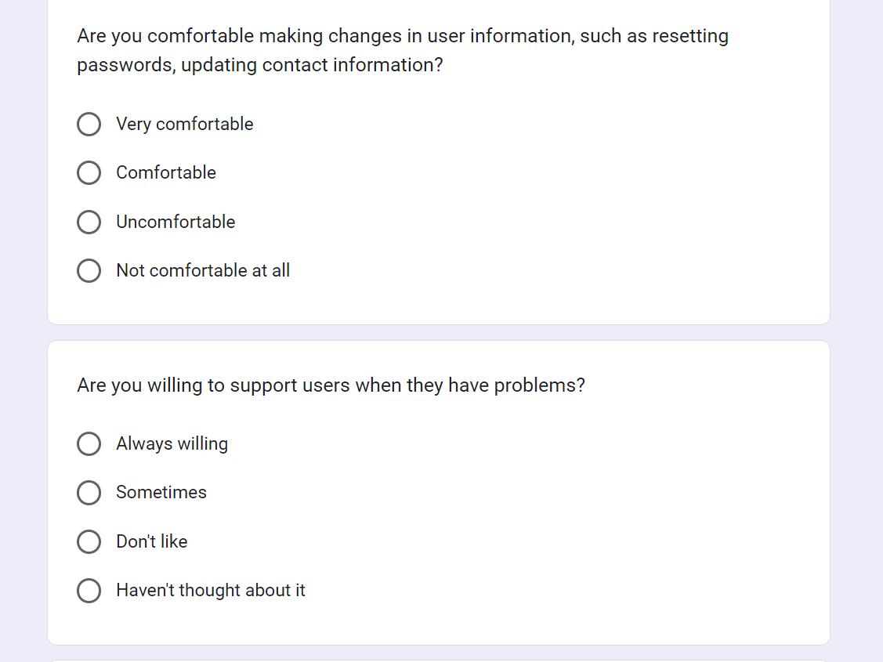

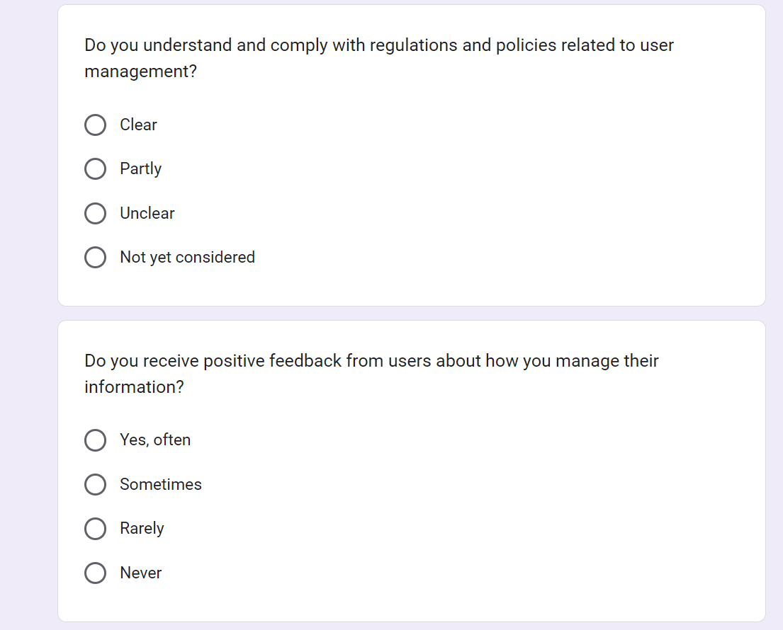

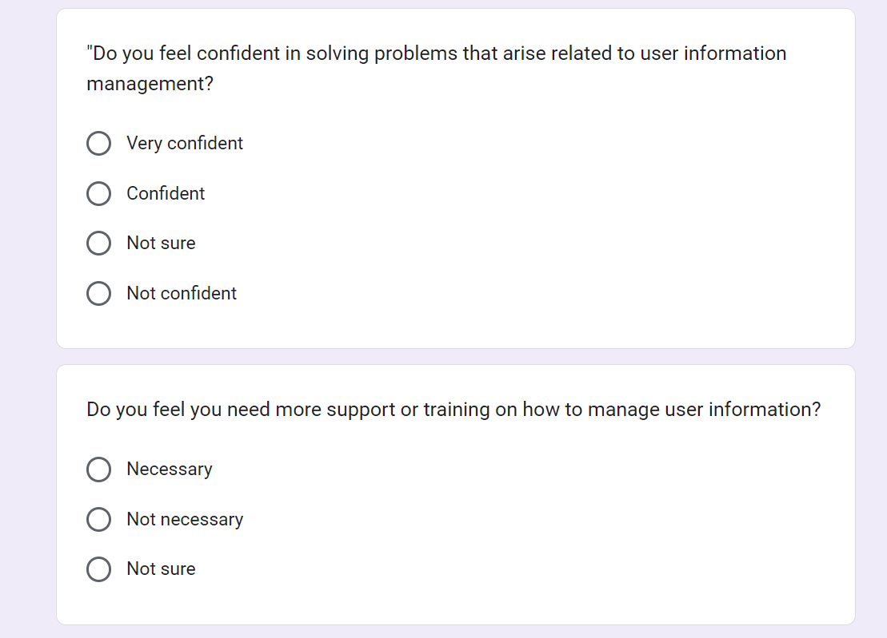

### Training staff

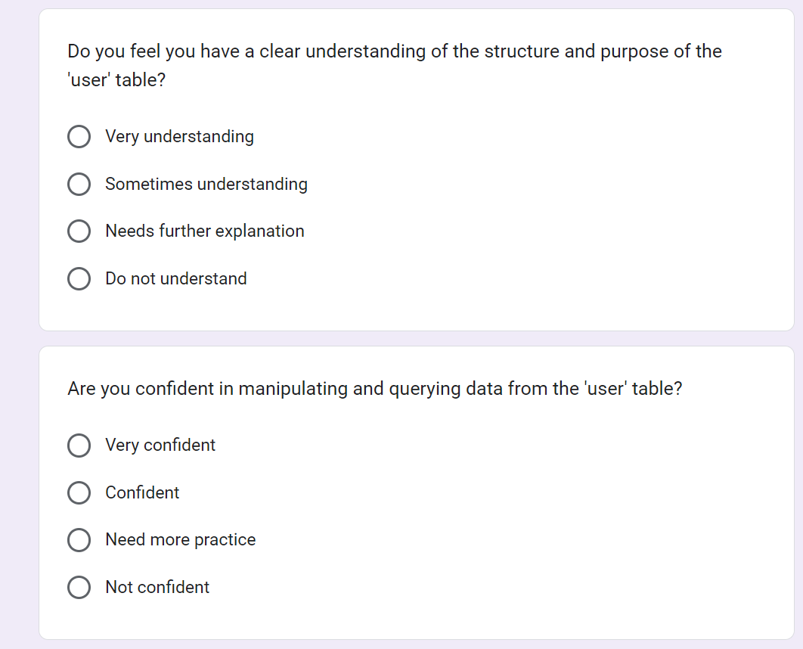

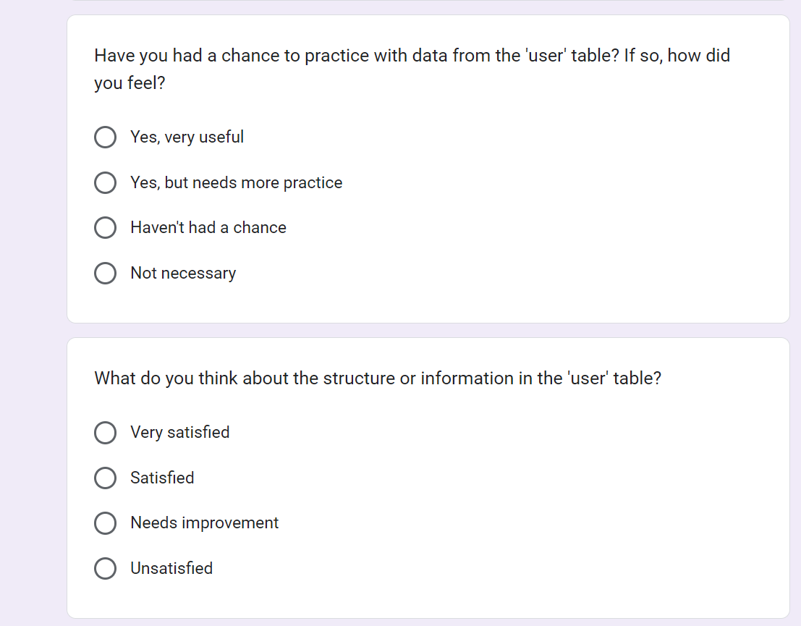

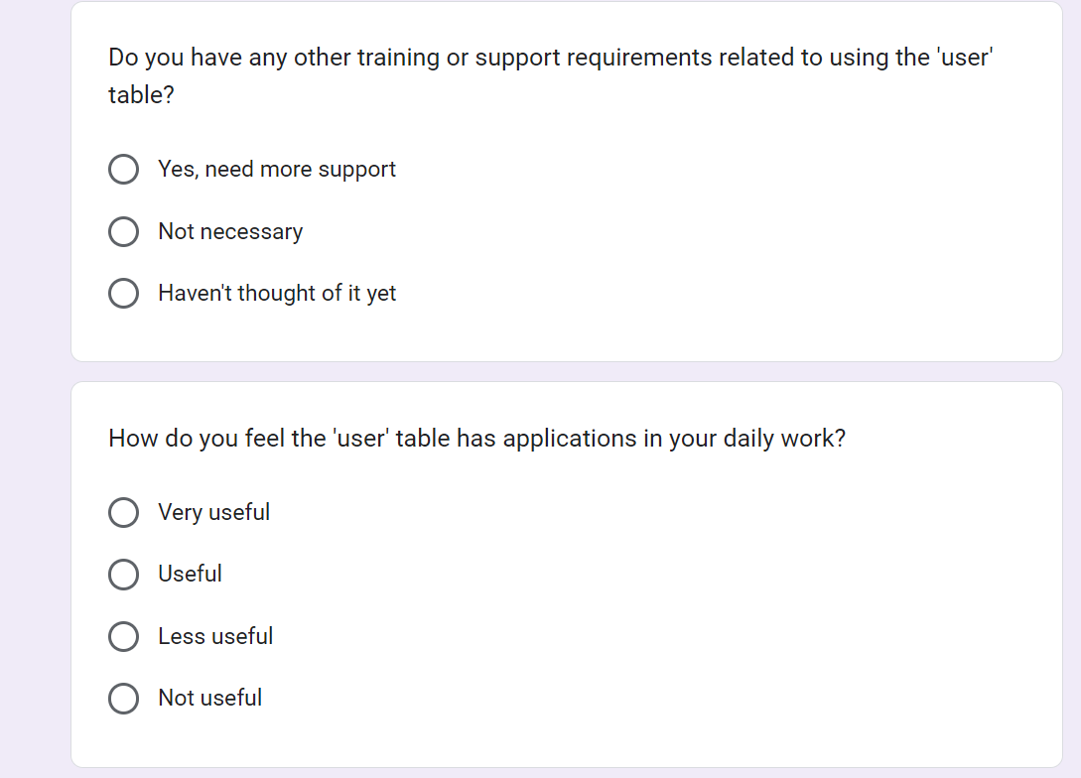

### Trainer

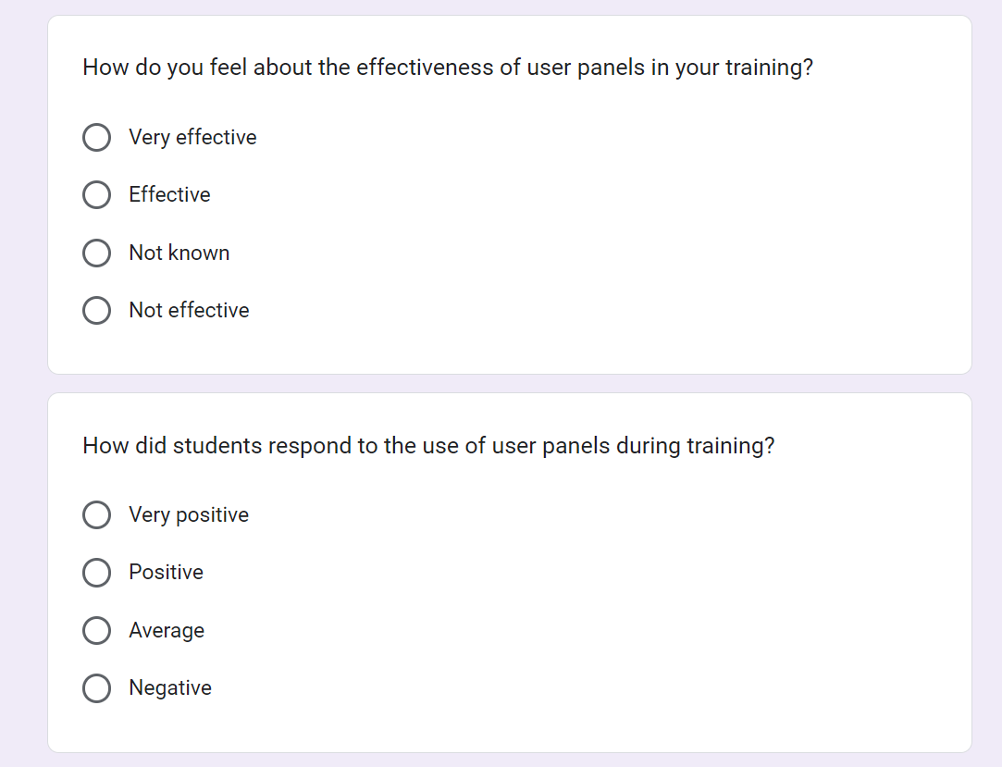

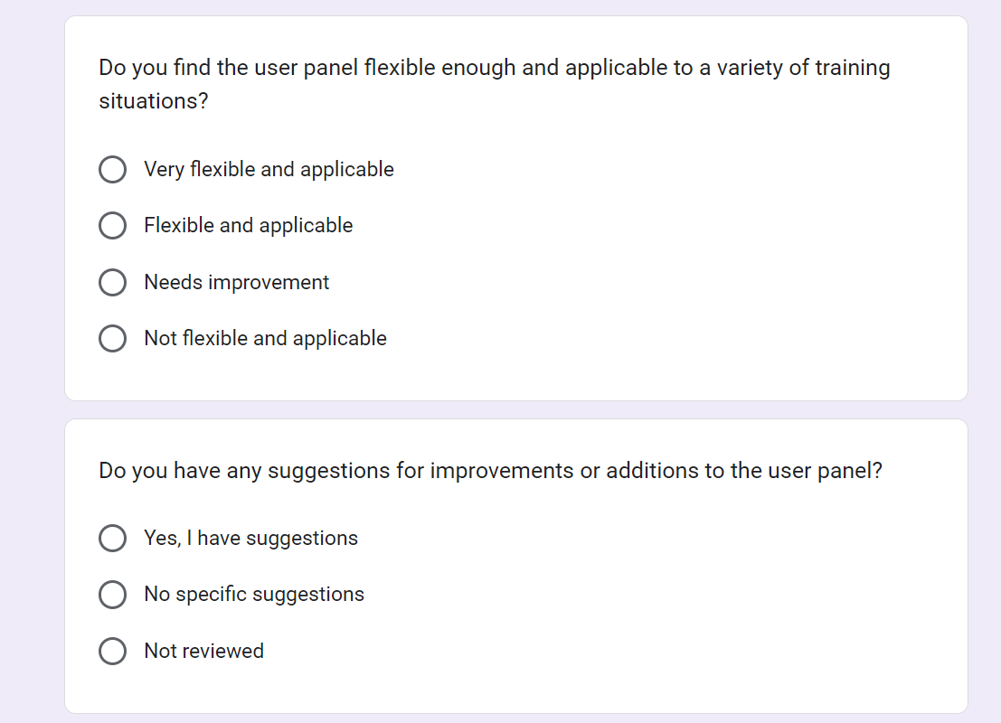

### The result of survey.

#### Personal information.

* How do you feel about how secure your passwords are on the system?

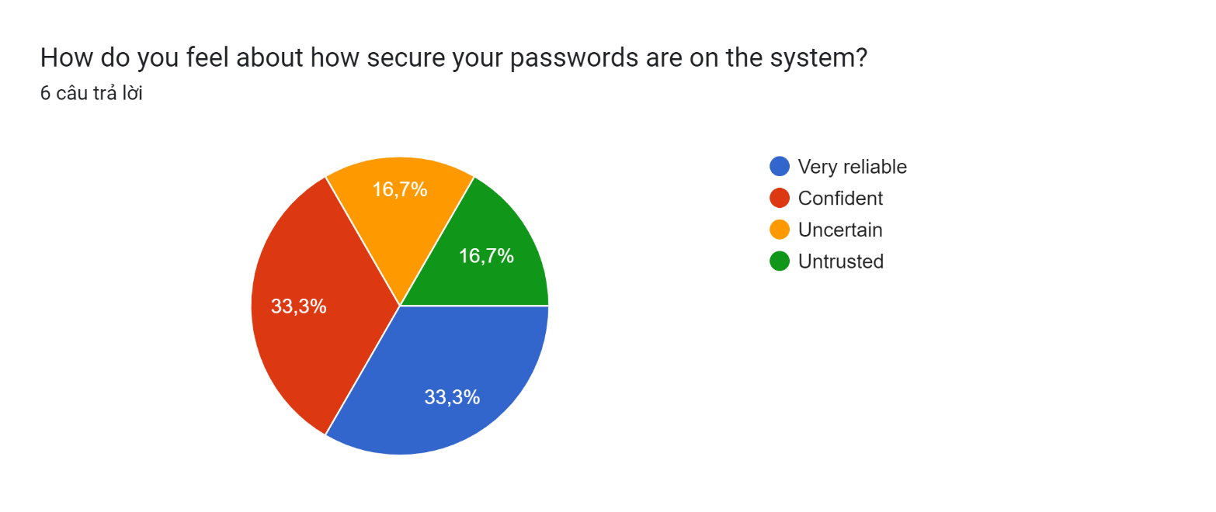

"33.3% Very reliable": 33.3% of users feel that their passwords on the system are very reliable. This may indicate they have high confidence in the security of the system and feel confident about protecting their personal information.

"33.3% Confident": 33.3% of users appear confident about the security of their passwords. Even though they don't feel the password is completely trustworthy, they still have a significant amount of confidence in its security.

"16.7% Uncertain": 16.7% of users feel uncertain about the security level of passwords on the system. This could reflect concerns about the security of the system, or it could be because they need more information or support on how to create stronger passwords.

"16.7% Untrusted": 16.7% of users do not trust the security level of passwords on the system. This can raise concerns about the safety and reliability of the system, and needs to be tested and improved to enhance security.

* How do you use our system?

Biểu đồ câu trả lời của biểu mẫu. Tên câu hỏi: How do you use our system?
. Số lượng câu trả lời: 6 câu trả lời.

- "16.7% Often": 16.7% of users regularly use our system. This may indicate that they are primary users and depend on your system to perform important tasks.

- "50% Sometimes": 50% of users use your system sometimes. This shows they have flexibility in using the system and may not be full users but still seek value from it.

- "16.7% Rarely": 16.7% of users rarely use your system. This may indicate that they do not feel comfortable or needed to use the system, or it may be because they do not see value from using it.

- "16.7% Never": 16.7% of users have never used your system. This may raise questions about the level of awareness and accessibility of the system to this user group, and there is a need to learn more about the causes and how to improve.

* Do you feel comfortable sharing personal information such as address, phone number, and email on the system?

Biểu đồ câu trả lời của biểu mẫu. Tên câu hỏi: Do you feel comfortable sharing personal information such as address, phone number, and email on the system?
. Số lượng câu trả lời: 6 câu trả lời.

33.3% Yes": 33.3% of users feel comfortable sharing personal information such as address, phone number and email on the system. This shows that they trust the security of the system and feel feel secure when sharing your personal information.

"50% No": 50% of users do not feel comfortable sharing personal information on the system. This may reflect concerns about security and privacy, and requires measures to protect personal information and provide clear information about its use.

"16.7% Only some necessary information": 16.7% of users only comfortably share some necessary information on the system. This may suggest that they want to keep their personal information to a minimum on the system and only share the most necessary information.

* Do you believe that your personal information is properly protected and privacy compliant?

Biểu đồ câu trả lời của biểu mẫu. Tên câu hỏi: Do you believe that your personal information is properly protected and privacy compliant?
. Số lượng câu trả lời: 6 câu trả lời.

Based on feedback from users on Google Form, we have the following responses:

- "50% Completely agree": 50% of users completely agree that their personal information is properly protected and complies with privacy regulations. This shows that they trust the security of the system and feel secure about using personal information on it.

- "33.3% Partially agree": 33.3% of users partly agree that their personal information is protected and complies with privacy regulations. This may indicate that although they have confidence in the security of the system, certain concerns or concerns remain.

- "16.7% Disagree": 16.7% of users do not agree that their personal information is protected and complies with privacy regulations. This highlights a serious security and privacy issue on the system and needs to be reviewed and resolved to increase security and trust from users.

* Did you update your personal profile information after registering?

Biểu đồ câu trả lời của biểu mẫu. Tên câu hỏi: Did you update your personal profile information after registering?
. Số lượng câu trả lời: 6 câu trả lời.

- "16.7% Yes": 16.7% of users updated their personal information after registering. This shows that users are proactive and interested in updating their information to ensure that it is always the latest and most accurate information.

- "50% No": 50% of users have not updated their personal information after registering. This may reflect their lack of commitment or lack of interest in updating their personal information, or it may be because they do not realize the importance of doing so.

- "33.3% Don't remember": 33.3% of users do not remember whether they updated their personal information after registering or not. This may reflect a degree of lack of concern or neglect towards the management of personal information on the system.

* Did you update your personal profile information after registering?

Biểu đồ câu trả lời của biểu mẫu. Tên câu hỏi: How do you feel about the system providing more personalization features?
. Số lượng câu trả lời: 6 câu trả lời.

- "0% Very interested": No users are very interested in the system providing more personalization features. This may indicate that there is no great demand on the part of users for more personalization on the system.

- "16.7% Interested": 16.7% of users are interested in the system providing more personalization features. This may indicate that some users appreciate the ability to customize and personalize their experience on the system.

- "50% Not interested": 50% of users are not interested in the system providing more personalization features. This shows that a significant number of users do not need or do not want to use personalization features.

- "33.3% Dislike": 33.3% of users do not like that the system provides more personalization features. This may reflect resistance or dissatisfaction with the integration of personalization features into the system.

* Do you feel you have a good understanding of the features and user information on the system?

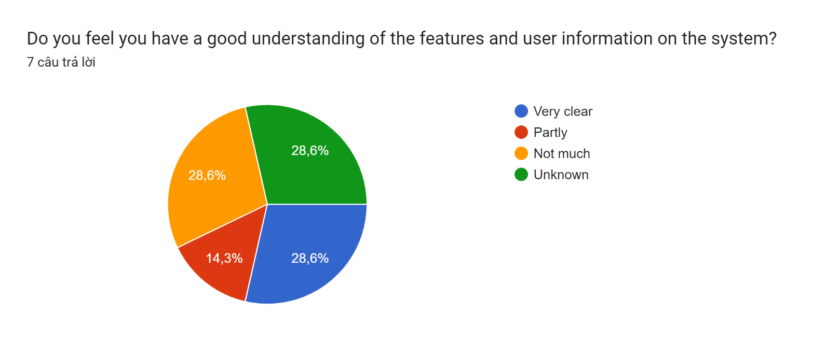

- "28.6% Very clear": 28.6% of users said they have a clear understanding of the features and user information on the system. This shows that a portion of users feel confident and comfortable using the system and understand it well.

- "14.3% Partly": 14.3% of users said they only partially understand the features and user information on the system. This may indicate that some users need additional support or information to better understand the system.

- "28.6% Not much": 28.6% of users said they do not understand much about the features and user information on the system. This may indicate that a large portion of users need additional support or training to understand the system.

- "28.6% Unknown": 28.6% of users said they do not know much about the features and user information on the system. This may reflect a lack of information or awareness of the system on the part of users and the need for increased information and support.

* Do you feel confident in managing, modifying, or deleting user information when necessary?

Biểu đồ câu trả lời của biểu mẫu. Tên câu hỏi: Do you feel confident in managing, modifying, or deleting user information when necessary?
. Số lượng câu trả lời: 7 câu trả lời.

- "14.3% Very confident": 14.3% of users are very confident when managing, modifying or deleting user information when necessary. This shows that a small portion of users feel comfortable and confident in performing user information management operations on the system.

- "28.6% Confident": 28.6% of users are confident when managing, modifying or deleting user information when necessary. This shows that a large majority of users feel confident and comfortable when performing user information management operations.

- "28.6% Not sure": 28.6% of users are not sure about the ability to manage, modify or delete user information when necessary. This may reflect a lack of understanding or confidence in using the management features on the system.

- "28.6% Not confident": 28.6% of users are not confident when managing, modifying or deleting user information when necessary. This shows that some users do not have trust or do not feel comfortable when performing user information management operations.

* Are you comfortable making changes in user information, such as resetting passwords, updating contact information?

Biểu đồ câu trả lời của biểu mẫu. Tên câu hỏi: Are you comfortable making changes in user information, such as resetting passwords, updating contact information?
. Số lượng câu trả lời: 7 câu trả lời.

- "14.3% Very comfortable": 14.3% of users are very comfortable when making changes in user information, such as resetting passwords, updating contact information. This shows that a small portion of users have high confidence and feel comfortable in performing these operations.

- "28.6% Comfortable": 28.6% of users feel comfortable making changes in user information, such as resetting passwords, updating contact information. This shows that a large majority of users have confidence and feel comfortable in performing these operations.

- "28.6% Uncomfortable": 28.6% of users are not comfortable making changes in user information. This may reflect a lack of confidence or experience in managing user information.

- "28.6% Not comfortable at all": 28.6% of users are uncomfortable or not confident when making changes in user information. This suggests that a large portion of users require additional support or training to perform these operations confidently and effectively.

* Do you feel you have a clear understanding of the structure and purpose of the 'user' table?

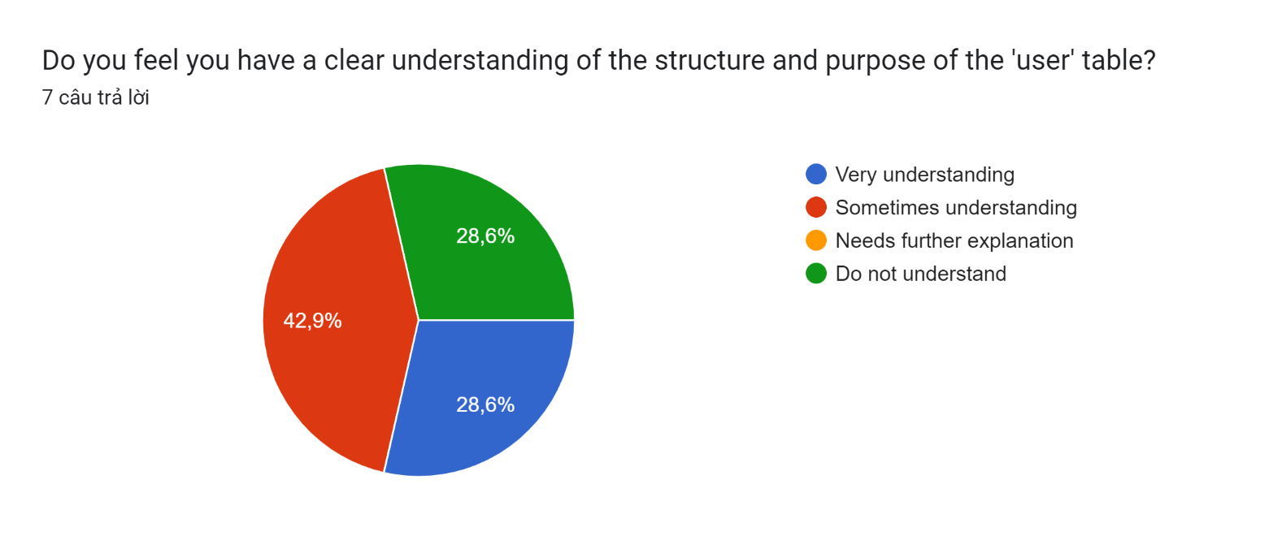

- "28.6% Very understanding": 28.6% of users said they clearly understand the structure and purpose of the 'user' table. This suggests that a small portion of users have a deep understanding and confidence in the structure and purpose of the user table in the system.

- "42.9% Sometimes understand": 42.9% of users sometimes understand the structure and purpose of the 'user' table. This shows that a large portion of users have a fair understanding of the user table, but there may be some aspects or details they need to clarify further.

- "0% Needs further explanation": No users need further explanation about the structure and purpose of the 'user' table. This may indicate that the majority of users understand and are satisfied with the current information about the user table.

- "28.6% Do not understand": 28.6% of users do not understand the structure and purpose of the 'user' table. This may reflect a lack of information or understanding of how the system works on the part of the user, and the need to provide additional information or support.

* Are you confident in manipulating and querying data from the 'user' table?

Biểu đồ câu trả lời của biểu mẫu. Tên câu hỏi: Are you confident in manipulating and querying data from the &apos;user&apos; table?
. Số lượng câu trả lời: 7 câu trả lời.

- "28.6% Very confident": 28.6% of users are very confident in manipulating and querying data from the 'user' table. This suggests that a small portion of users have sufficient knowledge and skills to work effectively with data from the user table.

- "0% Confident": No users are confident in manipulating and querying data from the 'user' table. This may indicate low confidence or a lack of understanding of how to perform data query operations.

- "28.6% Need more practice": 28.6% of users need more practice to be more confident in manipulating and querying data from the 'user' table. This shows that a large portion of users realize their skill level is limited and needs to be improved.

- "42.6% Not confident": 42.6% of users are not confident in manipulating and querying data from the 'user' table. This may reflect a lack of confidence and dissatisfaction with their ability to work with data from user tables.

* Do you find the user panel flexible enough and applicable to a variety of training situations?

Biểu đồ câu trả lời của biểu mẫu. Tên câu hỏi: Do you find the user panel flexible enough and applicable to a variety of training situations?
. Số lượng câu trả lời: 7 câu trả lời.

- "28.6% Very flexible and applicable": 28.6% of users said they felt the user interface was flexible and applicable to many training situations. This shows that a small portion of users appreciate the flexibility and applicability of the user interface in a variety of training situations.

- "57.1% Flexible and applicable": 57.1% of users feel the user interface is flexible and applicable to many training situations. This shows that the majority of users value the flexibility and usability of the user interface in meeting their training needs.

- "0% Needs improvement": No users think the user interface needs improvement. This may indicate that the majority of users are satisfied with the flexibility and applicability of the user interface in training scenarios.

- "14.3% Not flexible and applicable": 14.3% of users feel the user interface is not flexible and not applicable to many training situations. This may reflect their dissatisfaction with the flexibility and usability of the user interface in meeting their training needs.

* Do you have any suggestions for improvements or additions to the user panel?

Biểu đồ câu trả lời của biểu mẫu. Tên câu hỏi: Do you have any suggestions for improvements or additions to the user panel?
. Số lượng câu trả lời: 7 câu trả lời.

- "71.4% Yes, I have suggestions": 71.4% of users have suggestions for improvements or additions to the user interface. This shows that a large portion of users have opinions and wish to contribute to improving the system through suggesting improvements or additions.

- "14.3% No specific suggestions": 14.3% of users have no specific opinions on improvements or additions to the user interface. This may indicate that a small portion of users are satisfied with the current user interface and do not need to change.

- "14.3% Not reviewed": 14.3% of users have not reviewed or have no comments on improvements or additions to the user interface. This may be because they have not had the opportunity or do not want to participate in the feedback process.

## DEVELOP A FUNCTIONAL BUSINESS APPLICATION BASED ON A SPECIFIED BUSINESS PROBLEM(P5).

### Requirement:

In the current era of rapid technological advancement, FPT Co. recognizes the importance of fostering a culture of continuous learning across the organization. To facilitate this, there is a need to develop a web-based system that oversees the training activities within the company. This system will serve as a central hub for managing various aspects of internal training programs. Its functionalities will include the management of trainee accounts, trainers, course categories, courses, topics, as well as the assignment of topics to courses, trainers to topics, and trainees to courses. The Human Resources department will primarily utilize this system.

Within this system, three distinct roles are defined: administrator, training staff, and trainer. Each role carries out specific responsibilities, outlined as follows:

### 2.2. Administrator's Responsibilities:

- Ability to access the system via the initial login page.

- Authority to create, edit, and delete user accounts for trainers and training staff, thus facilitating the management of personnel within the system."

### 2.3.A training staff’s role:

Upon registration, a training staff member is provided with a unique username and password by the administrator. Upon logging in, they are empowered to create trainee accounts by inputting relevant details such as name, age, date of birth, education, primary programming language, TOEIC score, experience, department, location, and more. Once all trainee details are successfully entered, they are securely stored in the database.

The training staff member is equipped with tools to manage trainee accounts, including the ability to update or delete them. Additionally, they can oversee course categories by performing functions such as searching, adding, updating, and deleting categories. These categories encompass essential information such as category name and description.

Furthermore, the training staff member can manage courses by executing similar actions such as searching, adding, updating, and deleting courses. Each course includes pertinent details such as name and description.

They also have the authority to enrich courses by adding topics, including details like topic name and description, and assigning courses to categories.

Moreover, the training staff member is tasked with managing trainer profiles, which involves adding, updating, and deleting information such as trainer name, classification (external or internal), workplace, telephone number, and email address. They can also assign trainers to specific topics and assign trainees to courses.

### 2.4. A trainer’s role:

Within the same system, trainers registered by the administrator can log in to update their profiles, including details such as name, classification (external or internal), education, workplace, telephone number, and email address.

Additionally, trainers have the ability to view courses associated with topics they are assigned to."

### 2.5. Administrator ‘s role

#### User Login

