**Homework lecture 1**

**Sort**

1. Given a list of integer numbers: 2, 1, 10, 6, 3, 8, 7, 13, 20. Draw the steps to sort (ascending sort) the list by following methods:

* Selection sort

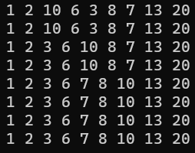

* Insertion sort

* Bubble sort

* Merge sort

* Quick sort

* Heap sort
* Radix sort

1. Same question for these lists:

* 1, 2, 3, 4, 5, 6, 7, 8, 9, 10
* Selection Sort

* Insertion Sort

* Bubble Sort

* Merge Sort

* Quick Sort

* 10, 9, 8, 7, 6, 5, 4, 3, 2, 1
* Selection Sort

* Insertion Sort

* Bubble Sort

* Merge Sort

* Quick Sort

* 9, 10, 1, 2, 3, 4, 5, 6, 7, 8
* Selection Sort

* Insertion Sort

* Bubble Sort

* Merge Sort

* Quick Sort

* 3, 4, 5, 6, 7, 8, 9, 10, 1, 2
* Selection Sort

* Insertion Sort

* Bubble Sort

* Merge Sort

* Quick Sort

1. Write a program to sort (ascending sort) the list by following methods:

* Selection sort
* Insertion sort
* Bubble sort
* Merge sort
* Quick sort
* Heap sort
* Radix sort

https://github.com/dung250804/CTDL-GT-HW