CS512 – Lab 10

Team Members:
Harsh (Student Id: 201309087)
Apurva (Student Id: 201010906 )
Ranjitha (Student Id: 201317810 )
Milan (Student Id: 201010009 )
Yashaswini Prakash (Student Id: 201317797 )

- Based on the following rules and the given data determine the “Coverage” and “Accuracy of each rule.
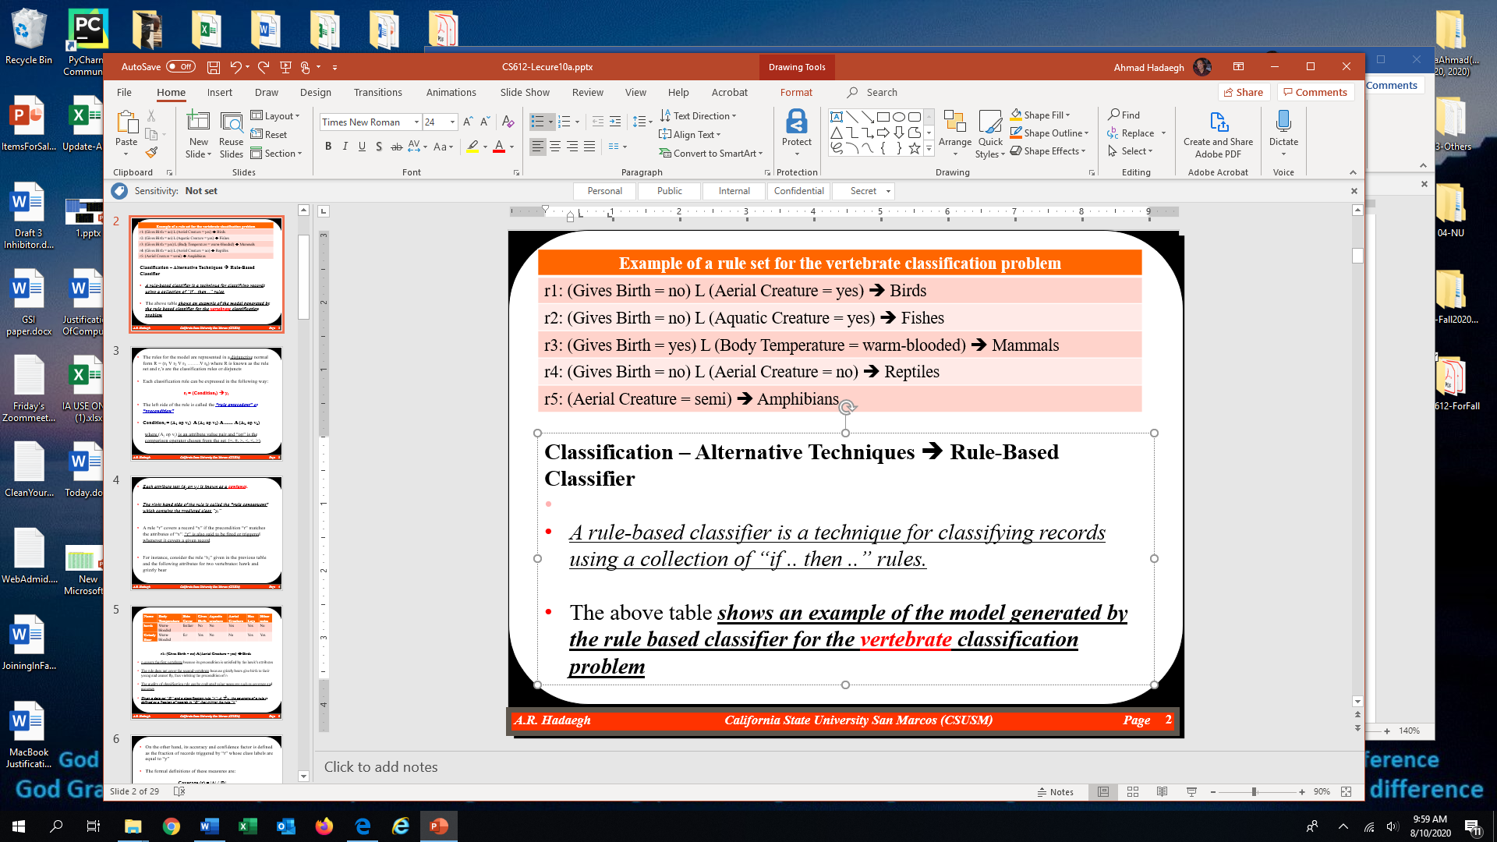
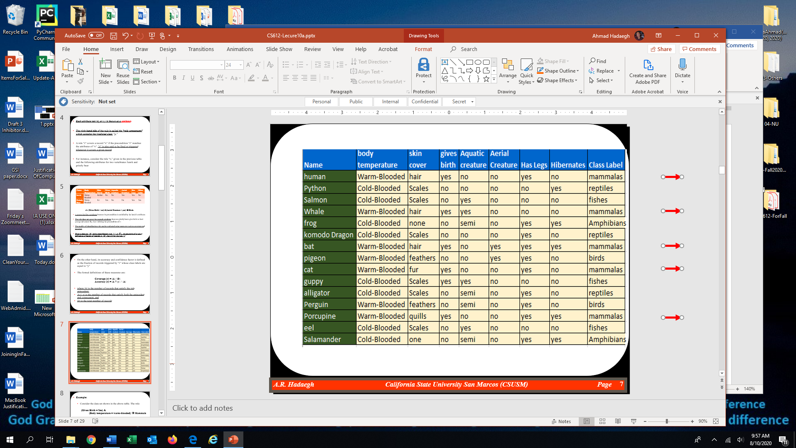

r1: (Gives Birth = no) L (Aerial Creature = yes) => Birds
|A| = 1
|A ∩ y| = 1
|D| = 15
Coverage (r) = |A| / |D| = 1/15 = 6.67 %
Accuracy (r) = |A ∩ y| / |A| = 1/1 = 100%

r2: (Gives Birth = no) L (Aquatic Creature = yes) => Fishes
|A| = 2
|A ∩ y| = 2
|D| = 15
Coverage (r) = |A| / |D| = 2/15 = 13.33 %
Accuracy (r) = |A ∩ y| / |A| = 2/2 = 100%
r3: (Gives Birth = yes) L (Body Temperature = warm-blooded) => Mammals
|A| = 5
|A ∩ y| = 5
|D| = 15
Coverage (r) = |A| / |D| = 5/15 = 33.33 %
Accuracy (r) = |A ∩ y| / |A| = 1/1 = 100%

r4: (Gives Birth = no) L (Aerial Creature = no) => Reptiles
|A| = 8
|A ∩ y| = 3
|D| = 15
Coverage (r) = |A| / |D| = 8/15 = 53.33 %
Accuracy (r) = |A ∩ y| / |A| = 3/8 = 37.5%

r5: (Aquatic creature = semi) => Amphibians
|A| = 4
|A ∩ y| = 2
|D| = 15
Coverage (r) = |A| / |D| = 4/15 = 26.67 %
Accuracy (r) = |A ∩ y| / |A| = 2/4 = 50%

- Consider the above table

  - What is the problem if you write 15 separate rules that makes it mutually exclusive? What is the problem if you only write a few rules?
- What is the problem if you write 15 separate rules that make it mutually exclusive? What is the problem if you only write a few rules?
- If you write the separate rule for each record, then there is a huge effort of getting the rules even though multiple rules are pointing to the same record. But the accuracy will be 100%.
- If you write few rules, means if the rule set is not mutually exclusive, then a record can be covered by several rules, some of which may predict conflicting classes. Also, it’s possible that rules don’t cover all classes. Which supposed be covered all the classes at least once.

  - Write 15 class-based rules, one for each row, and then simplify them by removing some rules or combining some rules or taking out some of the conditions to get between 70% to 80% coverage.
Mammals: 5, reptiles: 3, fishes: 3, amphibians: 2, birds: 2
*Hibernates(H)

R1 : (BODY TEMPERATURE=warm blooded) && (skin cover=hair) && (give birth=yes) && (aquatic creature=no) && (aerial creature=no) && (Has Legs=yes) && (H=no) = mammals
R2 : (BODY TEMPERATURE=warm blooded) && (skin cover=hair) && (give birth=yes) && (aquatic creature=yes) && (aerial creature=no) && (Has Legs=no) && (H=no) = mammals
R3 : (BODY TEMPERATURE=warm blooded) && (skin cover=hair) && (give birth=yes) && (aquatic creature=no) && (aerial creature=yes) && (Has Legs=yes) && (H=yes) = mammals
R4 : (BODY TEMPERATURE=warm blooded) && (skin cover=fur) && (give birth=yes) && (aquatic creature=no) && (aerial creature=no) && (Has Legs=yes) && (H=no) = mammals
R5 : (BODY TEMPERATURE=warm blooded) && (skin cover=quills) && (give birth=yes) && (aquatic creature=no) && (aerial creature=no) && (Has Legs=yes) && (H=yes) = mammals
After minimization: (give birth=yes) = mammals

R6 : (BODY TEMPERATURE=warm blooded) && (skin cover=feathers) && (give birth=no) && (aquatic creature=no) && (aerial creature=yes) && (Has Legs=yes) && (H=no) = birds
R7 : (BODY TEMPERATURE=warm blooded) && (skin cover=feathers) && (give birth=no) && (aquatic creature=semi) && (aerial creature=no) && (Has Legs=yes) && (H=no) = birds
After minimization:
(give birth=no) && (aquatic creature=semi) = birds
or (give birth=no) && (aquatic creature=no) && (aerial creature=yes) = birds

R8 : (BODY TEMPERATURE=cold blooded) && (skin cover=scales) && (give birth=no) && (aquatic creature=no) && (aerial creature=no) && (Has Legs=no) && (H=yes) = reptiles
R9 : (BODY TEMPERATURE=cold blooded) && (skin cover=scales) && (give birth=no) && (aquatic creature=no) && (aerial creature=no) && (Has Legs=yes) && (H=no) = reptiles
R10 : (BODY TEMPERATURE=cold blooded) && (skin cover=scales) && (give birth=no) && (aquatic creature=semi) && (aerial creature=no) && (Has Legs=yes) && (H=no) = reptiles
After minimization: (give birth=no) && (aquatic creature=no) && (aerial creature=no) = reptiles

R11 : (BODY TEMPERATURE=cold blooded) && (skin cover=scales) && (give birth=no) && (aquatic creature=yes) && (aerial creature=no) && (Has Legs=no) && (H=no) = fishes
R12 : (BODY TEMPERATURE=cold blooded) && (skin cover=scales) && (give birth=no) && (aquatic creature=yes) && (aerial creature=no) && (Has Legs=no) && (H=no) = fishes
R13 : (BODY TEMPERATURE=cold blooded) && (skin cover=scales) && (give birth=yes) && (aquatic creature=yes) && (aerial creature=no) && (Has Legs=no) && (H=no) = fishes
After minimization: (give birth=no) && (aquatic creature=yes) = fishes

R14 : (BODY TEMPERATURE=cold blooded) && (skin cover=none) && (give birth=no) && (aquatic creature=semi) && (aerial creature=no) && (Has Legs=yes) && (H=yes) = amphibians
R15 : (BODY TEMPERATURE=cold blooded) && (skin cover=none) && (give birth=no) && (aquatic creature=semi) && (aerial creature=no) && (Has Legs=yes) && (H=yes) = amphibians
After minimization: (give birth=no) && (aquatic creature=semi) = amphibians

First level in the tree
R1 : (give birth=yes) = mammals
R2 : (give birth=yes) = mammals
R3 : (give birth=yes) = mammals
R4 : (give birth=yes) = mammals
R5 : (give birth=yes) = mammals
R6 : (give birth=yes) = fishes

Second level in the tree
R7 : (give birth=no) && (aquatic creature=yes) = fishes
R8 : (give birth=no) && (aquatic creature=yes) = fishes
R9 : (give birth=no) && (aquatic creature=semi) = amphibians
R10 : (give birth=no) && (aquatic creature=semi) = amphibians
R11 : (give birth=no) && (aquatic creature=semi) = reptiles
R12 : (give birth=no) && (aquatic creature=semi) = birds

Third level in the tree
R13 : (give birth=no) && (aquatic creature=no) && (aerial creature=yes) = birds
R14 : (give birth=no) && (aquatic creature=no) && (aerial creature=no) = reptiles
R15 : (give birth=no) && (aquatic creature=no) && (aerial creature=no) = reptiles

Based on 15 rules, minimizing the rules.
At the first level
(give birth=yes) = mammals
Coverage = 5/15

At the second level
(give birth=no) && (aquatic creature=yes) = fishes
Coverage = 2/15

(give birth=no) && (aquatic creature=semi) = amphibians
Coverage = 2/15

At the third level
(give birth=no) && (aquatic creature=no) && (aerial creature=yes) = birds
Coverage = 1/15

(give birth=no) && (aquatic creature=no) && (aerial creature=no) = reptiles
Coverage = 2/15

Total coverage = 5/15 + 2/15 + 2/15 + 2/15 + 1/15 = 12/15 = 80%
This one is the sum of the coverage of each rule

On the other hand, we can think that one rule coverage might be between 70% to 80%.
I am thinking to choose one attribute to calculate the coverage and it seems two attributes can be used to get more than 70% coverage, Aerial Creature.

(Aerial Creature = no), 13/15 = 86.67% (coverage)

  - Which one is better “to get 100% coverage” or “70% to 80% coverage”? Explain.
- The quality of classification rule can be evaluated using measures such as coverage. More the coverage, high the quality of the rule given in set. 100% is the best here.

