**COS30020: Advanced Web Development**

**Lab 07**

**Student Name: Tran Quoc Dung**

**Student ID: 103803891**

**Task 1: Creating a table and entering data**

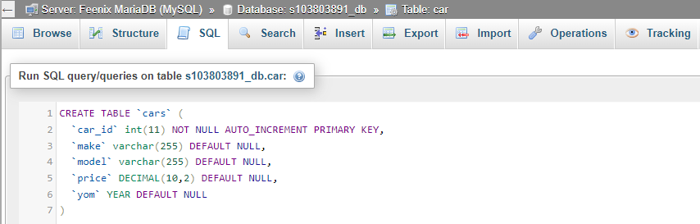

Creating table ‘cars’ with given fields.

Table ‘cars’ created.

­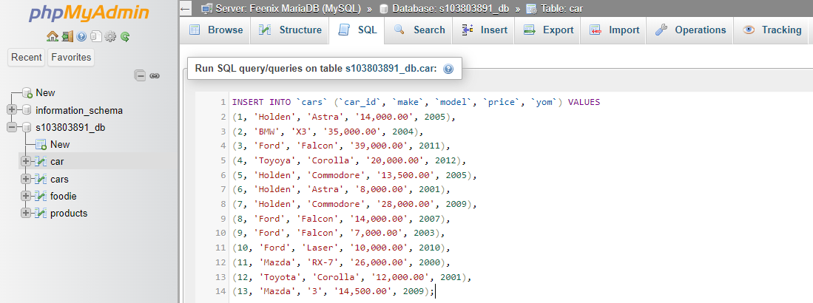

Inserting data records into ‘cars’.

**Task 2: Querying the table**

1. All records:

SQL commands that display all records.

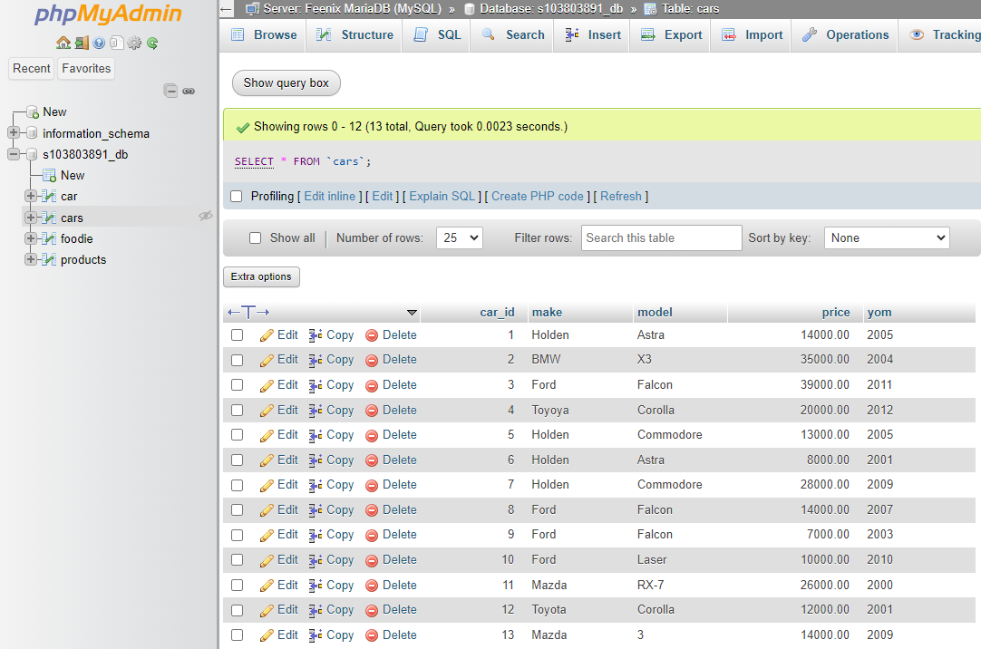

Displaying all records.

1. Make, model and price, sorted by make and model:

SQL commands that display make, model and price, sorted by make and model.

Displaying make, model and price, sorted by make and model.

1. The make and model of the cars which costs $20,000.00 or more:

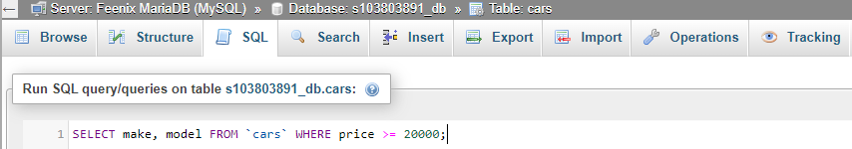

SQL commands that display make, model of the cars which cost $20,000.00 or more.

Displaying make, model of the cars which cost $20,000.00 or more.

1. The make and model of the cars which costs below $15,000.00:

SQL commands that display make, model of the cars which cost below $15,000.00

* A screenshot of a computer

  Description automatically generated

Displaying make, model of the cars which cost below $15,000.00

1. The average price of cars for similar make:

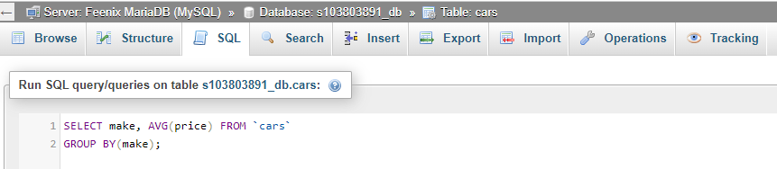

SQL commands that display average price of cars for similar make.

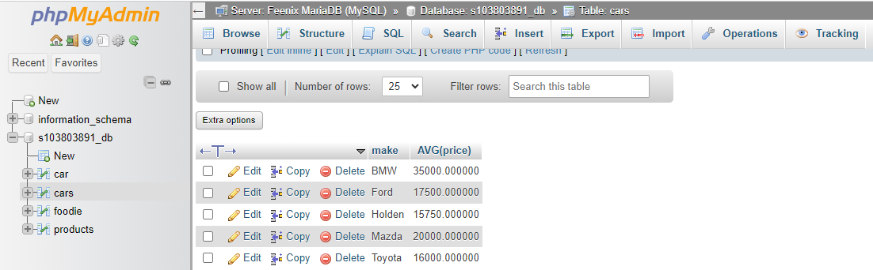

Displaying average price of cars for similar make.