Appendices

# Appendix A – Background Research

## Scrum Process

* Scrum Alliance: [http://www.scrumalliance.org](http://www.scrumalliance.org/)
* The Scrum Guide: <https://www.scrum.org/Portals/0/Documents/Scrum%20Guides/Scrum_Guide.pdf>

## AI Searching Algorithms

* A-star
* Yen
* …

# Appendix B – Website Reference

## **Website URL**

**Website of the project is available at:** <http://aggiehack.dngdiary.com>

## **Screenshots**

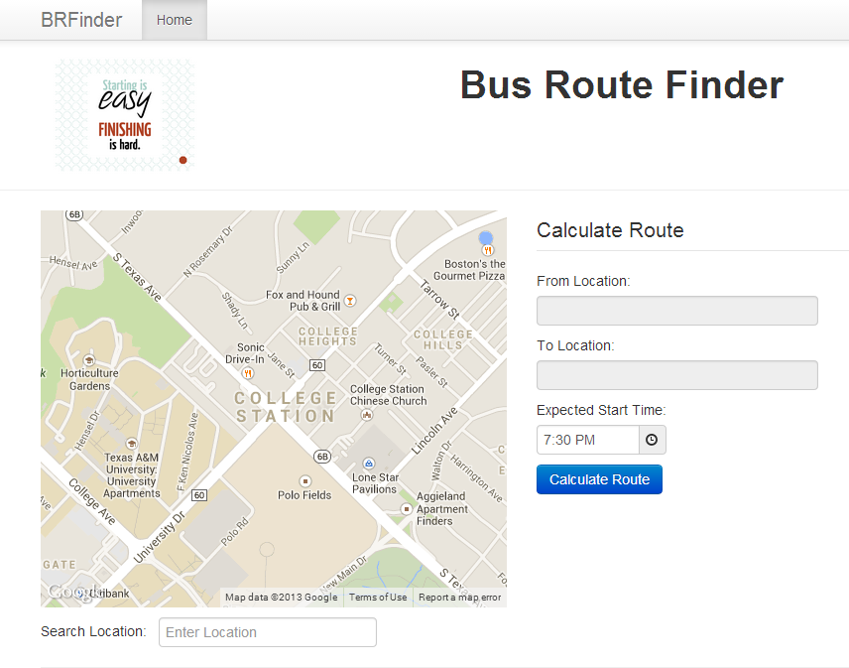

Figure - Main Search Page

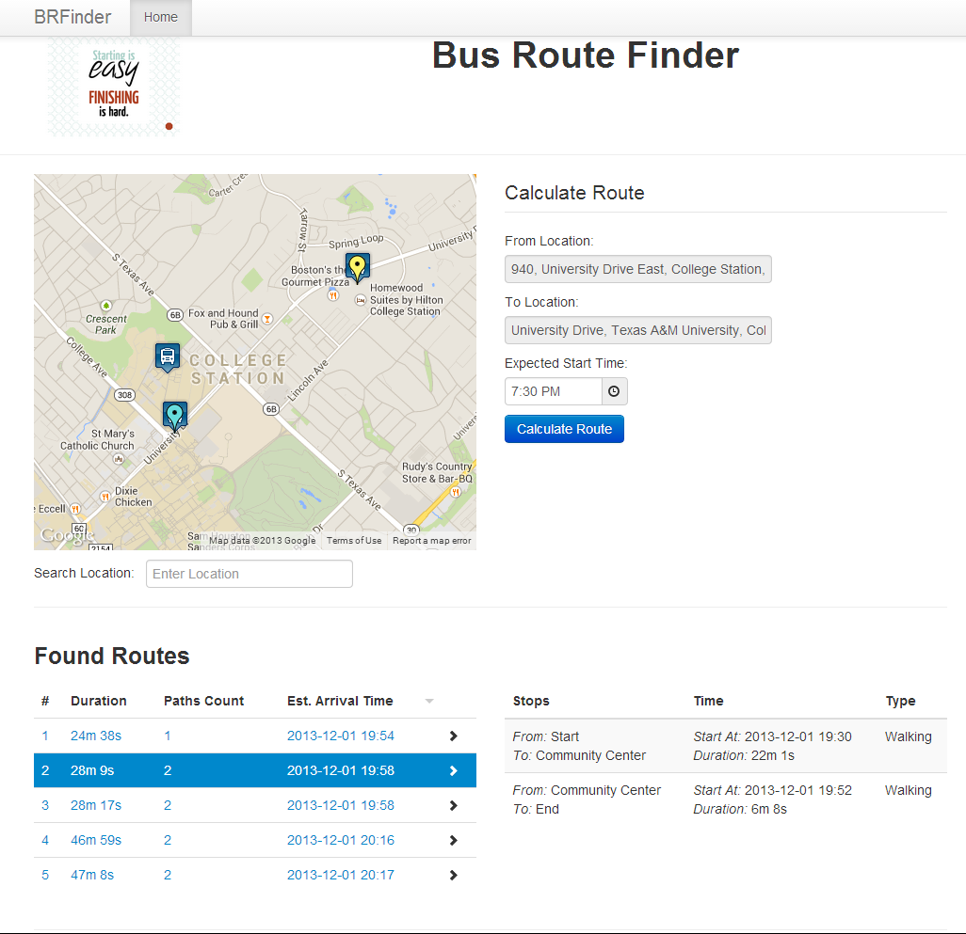

Figure - Search Page with Results

# Appendix C – Detailed Project Reports and Logs

## Scrum Task Board

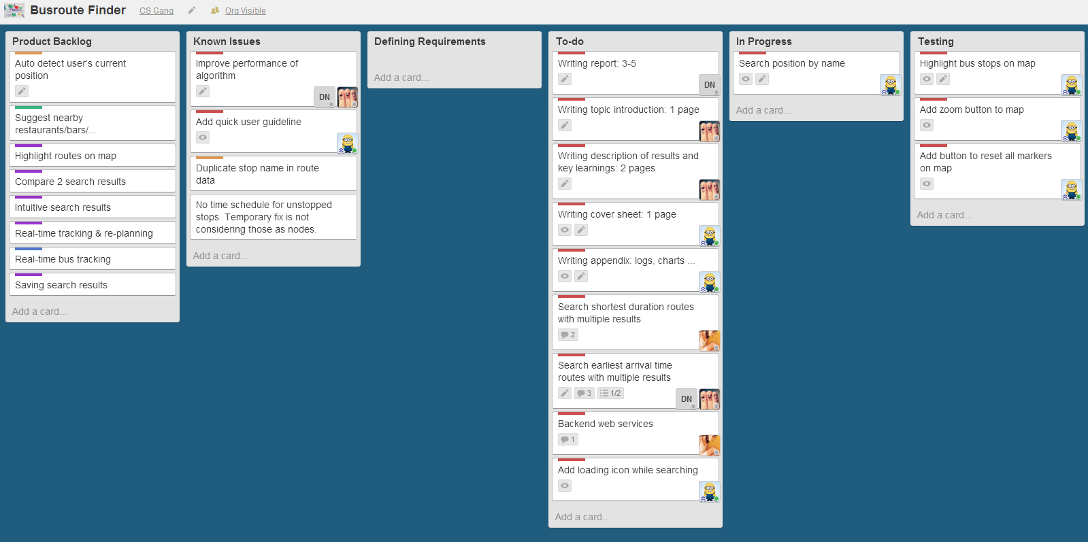

Figure - Scrum task board on Trello

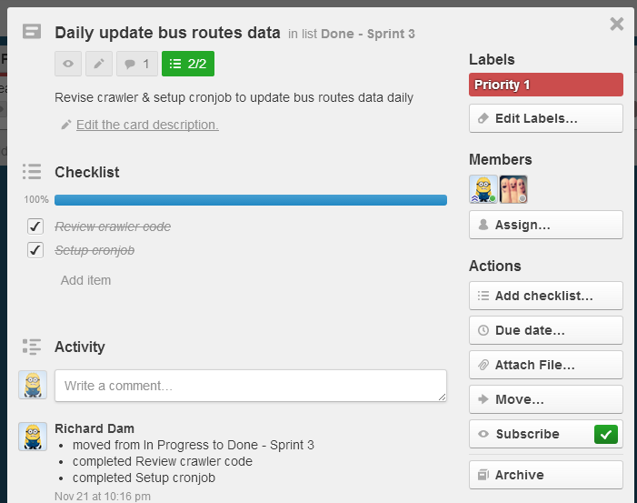

Figure - Detailed Information of a task

## Sprint Schedule and Results

Due to the low availability of team members during the development, we cannot make the schedule with fixed hours and deadline for each task such as Gantt chart. Instead, we use a simple spreadsheet where team members can estimate the hours they can spend in each sprint, and make the schedule based on the availability of each member and estimate of each task. The screenshot below shows part of our schedule:

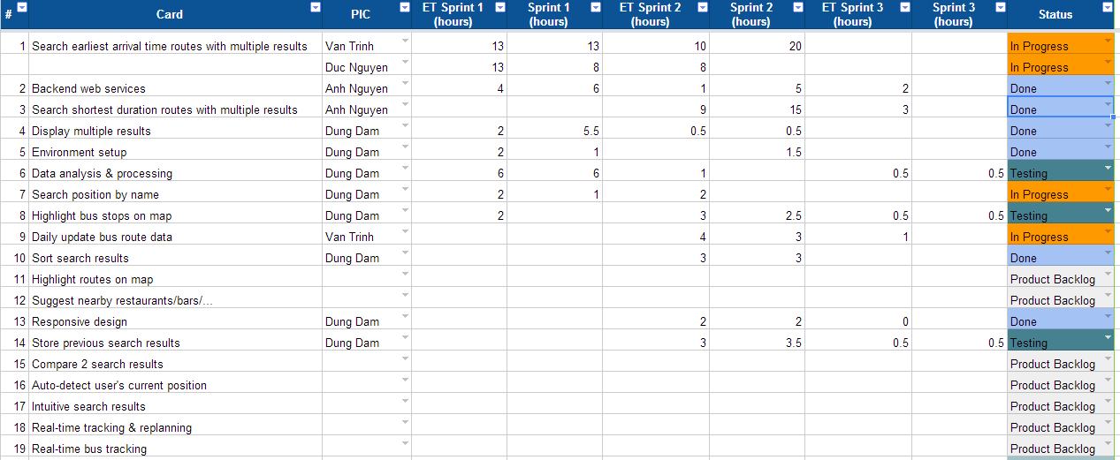

Figure - Project Schedule

The overall effort of the team can be built from the hours that each member log into the spreadsheet after they finished any task.

Figure - Diagram: Total effort per team member

Also, the estimated hours and the actually spent hours in each sprint can be extracted easily from the spreadsheet:

Figure - Diagram: Estimated & actual hours per sprint

## Activity Logs

Figure - Diagram: Commit by author

Figure - Diagram: Commits by sprint

Figure - Diagram: Average commits by day