**FACULTY OF ELECTRICAL**

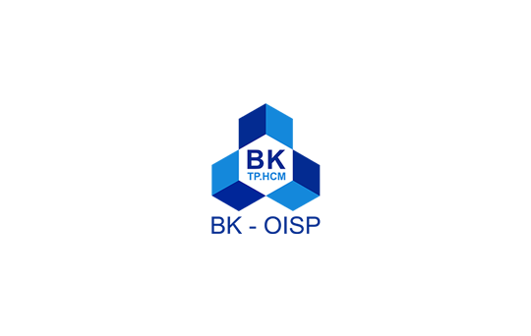**AND ELECTRONIC ENGINEERING  
2020 – 2021**

**INDUSTRIAL QUALITY CONTROL**

**GROUP ASSIGNMENT TASK 1**

**Name: Đặng Tiểu Bình - 1851047**

**Nguyễn Trí Cường - 1851049**

**Hoàng Chí Dũng - 1752014**

**Lê Nguyễn Tuấn Dũng - 1851003**

**Bùi Thế Minh Duy - 1851001**

**Trần Hoàng Duy - 1751017**

**Lâm Hồng Hải - 1551036**

**Văn Trí Hào - 1751025**

**Ho Chi Minh City, 25th September 2021**

**TABLE OF CONTENT**

1. **INTRODUCTION 2**
2. **QUALITY ACTIVITIES 2**
3. Value-based quality 2
4. User-based quality 3
5. Manufacturing-based quality 4
6. **COMPARISON BETWEEN THEORICAL POINTS AND   
   PRACTICAL ACTIVITIES 5**
7. **REFERENCE 6**
8. **INTRODUCTION:**

VinGroup is the largest private enterprise in Vietnam, operates in three core business areas, including:

* Technology
* Industry
* Trade and Services

With the desire to bring to the market products and services of international standards and completely new experiences in modern lifestyle, VinFast, a member of VinGroup, has proved the pioneering and leading in the Automobile Industry Field with a lot of impressive products.

1. **QUALITY ACTIVITIES:**
   1. **Value-based quality:**

VinFast has come up with great strategies and activities to have their product becoming the best combination of price and features for consumers. Fadil, Vinfast’s A-segment luxe car, has become one of the best-selling cars in July, 2021 according to Vnexpress because of those reason:

* In July 2020, the tax for accessories and component import from other countries has decreased to 0%, lead to the reduction in manufacture expense.
* Provide a lot of incentive for customer such as: discount 10% when buy immediately, installment for the first 2 years with 0% interest, provide 100% registration fee.
* Parking car is a major issue for driver in Vietnam as it takes a huge amount of space, also the parking lots are very expensive as well. But VinFast has come with a great idea that every Vin’s car can park for free at every Vin’s building, which save lots of money for consumer.
* In term of design, performance, comfortable, safety, the product provides a very high-quality experiment for customer. It is also supplied with high technologies for safe-driving and have a lot of functions to support driver.
  1. **User-based quality:**

Vinfast provides their customers with many sales policies. Through VinFast's customer gratitude programs, customer interests are gradually re-evaluated and reshaped. For the first time in the market, customers who have bought VinFast car are given a gift of gratitude up to 240 million VND without any binding conditions. Buying a VinFast Fadil car gets a gift of gratitude, buying a VinFast Lux car gets a double gift. Additional incentives from 80-120 million VND if buying more VinFast Lux A2.0 or VinFast Lux SA2.0 cars. VinFast's sales policy is special in that, incentives can freely give and transfer their gifts as a positive spread for relatives and friends. Customers who buy VinFast cars will go from one surprise to another.

With those significant policies to satisfy their customers, after only 2 years of entering the market, in 2020, Vinfast was in top 4 car brands which has the most selling cars in Vietnam with 29485 cars being sold. VinFast Fadil was the best-selling cars of Vinfast, which was in top 3 most selling cars in Vietnam in the same year. And Vinfast Fabil is the only one in top 10 manufactured by Vietnamese car company.

* 1. **Manufacturing-based quality:**

As a member of Vingroup, one of Vietnam’s largest private enterprises, VinFast teamed up with car manufacturers from America, Europe and Siemens to build the first fully digital automotive factory in only 21 months start from scratches. They also create their own engineer team, training for the future and for the automotive industry.

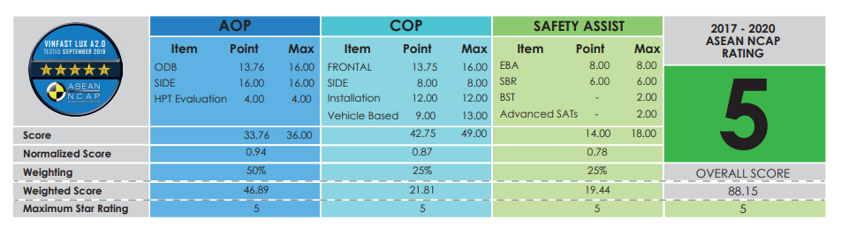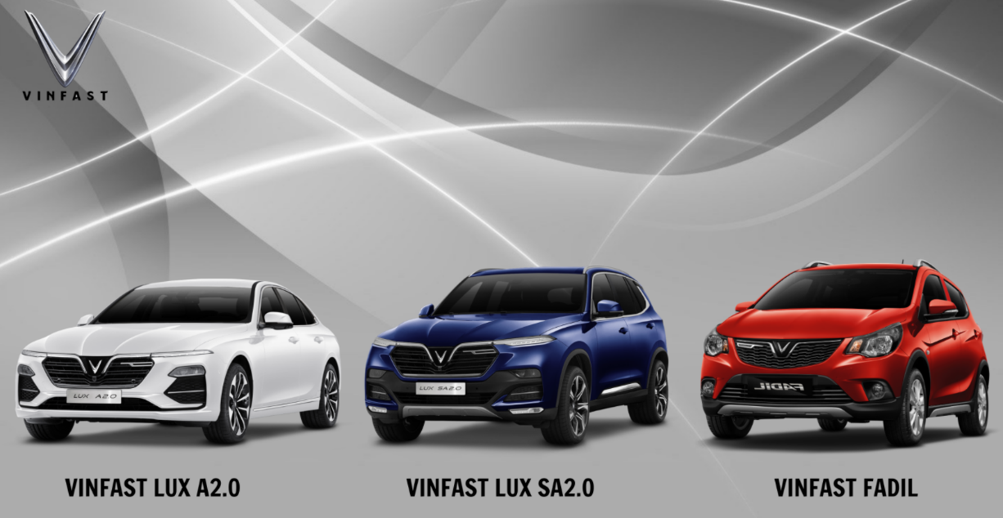VinFast took an almost entirely digital approach to design their and prioritize the safety standard on their vehicles. There are three classes of VinFast car that achieve the standard of ASEAN New Car Assessment Program(ASEAN NCAP), an automobile safety rating program to evaluate the safety of the driver inside the car when a collision happened or the ability to avoid unwanted accidents.

*Three classes of VinFast car achieved the ASEAN NCAP standard and the general rating of ASEAN NCAP standard*

1. **COMPARISON BETWEEN THEORICAL POINTS AND PRACTICAL ACTIVIES:**

**Theorical:**

TQM is defined as both philosophy and a set of guiding principles that represents the foundation of a continuously improving organization. It is the application of quantitative methods and human resources to improve all the processes within an organization and exceed customer needs now and in future. TQM integrates fundamental management techniques, existing improvement efforts, and technical tools under disciplined approach.

In definition, M is management, meaning that top management lead the drive to achieve quality for customers, by communicating the business vision and values to all employees, ensuring the right business processes are in place, introducing and maintaining a continuous improvement culture

**Practical:**

* The role of top management is appropriate when ensuring the quality of VinFast cars, delivering the best products to customers. The value of VinFast cars has been confirmed through provided statistics and customer reviews.
* Selling policies satisfy customers such as installment purchase, exchanging old car with the new one or depositing car.
* VinFast employees are well informed about business visions and its value. Top managements have strictly managed from production to sale services, maintenance and after sale services (professional production lines from EU based on BMW platform, maintenance and customers services support customers all the best, many promotions with Vingroup services)
* VinFast provide a website online to support customers when buying a car or reporting problems but when having issues, managers handle problems slowly, it makes customers feel uncomfortable

Moreover, many companies and businesses are also using Deming’s 14 points and achieving considerable success. It becomes a model in management process.

VinFast has applied some of those points in their management:

* Create constancy of purpose towards improvement of product and service:

From the early days of its establishment, VinFast has committed to customers to bring a line of Vietnamese-branded cars that are comparable to the world, not losing to any brands which present in Vietnam nowadays. With the mission “For a better life for Vietnamese people”, Vingroup wants to build a proud, stylish and classy car brand imbued with the Vietnamese spirit, with ambitions beyond Vietnam border, reaching to the world. And we can see VinFast has proven that when they affirmed their name with 3 car models: Fadil, Lux A and Lux SA. Fadil has dominated the A segment, far ahead of Korea cars which are on top of Vietnam car market over the years. Lux A and Lux SA have also gradually stood out in the Sedan and SUV 7 seat segment. VinFast also reaches out to the world when setting up many showrooms and testing zones in NA and EU. VinFast cars are also began to sell in many countries.

* Adopt the new philosophy. We can no longer live with commonly accepted levels of delay, mistakes and defective workmanship:

VinFast always aims for improvement and transformation with the development of the world. VinFast always put customer’s need on top priority, offering cars with many price segments but also ensuring the quality. VinFast chooses to build their brand as a car company that ensures customers safety, unlike some car brands that choose their image as price or entertainment technology, this contributes to a stronger affirmation of VinFast when achieving many safety certifications of ASEAN and around the world.

But there are also some weaknesses still exist:

* Find problems. It is management’s job to work continually on the system

VinFast has a problem about their service and their product’s quality. The manager did not make it to a reasonable agreement between them and their customer which then causing an adverse effect on the company’s reputation and become a hot headline on many national newspapers at that time. Throughout this problem, managers should find problems early and solve them suitably to protect Vinfast’s reputation in domestically as well as internationally.

# **References**

[1] Chi, Q. (2021, March 16). *VTCNEWS*. Retrieved from Lý do VinFast Fadil trở thành xe bán chạy nhất Việt Nam?: https://vtc.vn/ly-do-vinfast-fadil-tro-thanh-xe-ban-chay-nhat-viet-nam-ar601221.html

[2] Chung, V., & Dũng, L. (2021, August 10). *VNEXPRESS*. Retrieved from Top ôtô bán chạy tháng 7 - Fadil bỏ xa Vios, Accent tụt hạng: https://vnexpress.net/top-oto-ban-chay-thang-7-fadil-bo-xa-vios-accent-tut-hang-4338526.html

[3] Chung, V., & Dũng, L. (2021, January 12). *VNEXPRESS*. Retrieved from 10 ôtô bán chạy nhất 2020: https://vnexpress.net/10-oto-ban-chay-nhat-2020-4219780.html

[4] Di, T. (2020, August 5). *VNEXPRESS*. Retrieved from VinFast và chiêu chinh phục bằng 'đặc quyền khách cũ': https://vnexpress.net/vinfast-va-chieu-chinh-phuc-bang-dac-quyen-khach-cu-4141795.html

[5] My, T. (2021, July 16). *VOV*. Retrieved from Người dùng nói gì về VinFast sau hai năm gia nhập thị trường ô tô?: https://vov.vn/doanh-nghiep/nguoi-dung-noi-gi-ve-vinfast-sau-hai-nam-gia-nhap-thi-truong-o-to-874402.vov

[6] Ngô, B. (2018, October 2). *BBC NEWS*. Retrieved from VinFast 'là niềm tự hào quốc dân'?: https://www.bbc.com/vietnamese/vietnam-45702851

[7] *SIEMENS*. (n.d.). Retrieved from The first fully digital automotive factory in South East Asia: https://new.siemens.com/global/en/markets/automotive-manufacturing/references/vinfast.html

[8] *VINFAST*. (2020, August 12). Retrieved from Chính sách bán hàng VinFast gây ấn tượng trên thị trường ô tô Việt: https://vinfastauto.com/vn_vi/chinh-sach-ban-hang-vinfast-gay-an-tuong