WEEKLY STUDY REPORT

Employee Name: Tom_Vu

Week: 2024/8/26 - 2024/30/8

1. Network Knowledge

- TCP/IP Model

This model defines how data is transmitted over networks, ensuring reliable communication between devices. It consists of four layers: the Link Layer, the Internet Layer, the Transport Layer, and the Application Layer. Each layer has specific functions that help manage different aspects of network communication, making it essential for understanding and working with modern networks.

+ TCP - Transmission Control Protocol help applications can interact with one another using TCP as though they were physically connected by a circuit. TCP transmits data in a way that resembles character-by-character transmission rather than separate packets. A starting point that establishes the connection, the whole transmission in byte order, and an ending point that closes the connection make up this transmission.

+ FTP - File Transfer Protocol is a protocol that computers on the internet use to transfer files to and from one another

+ UDP - User Datagram Protocol which is very similar to TCP. UDP is for sending and receiving data. The mean differences between UDP and TCP is that UDP is connection less. When a computer sends their data, it does not really care if the data is received at the other end.

+ HTTP - Hypertext transfer protocol is used by the World Wide Web to manage communications between web browsers and servers. It’s base on Client - Server Model. When Client sends a request, Server handles and process it. Ater that Client will be received a respond include data, header and HTTP Status.

- Network Devices

+ Hub is a networking devices which is used to transmit the signal to each port to respond from which the signal was received. Hub is not an intelligent device that sends message to all ports hence it is comparatively inexpensive..

+ Switch is an intelligent device that sends message to selected destination so it is expensive. It can learn and use MAC addresses to transmit.

+ Router is an important network device used to connect networks and route data traffic on the network. With the ability to transmit data over both wired and wireless connections, routers play a crucial role in directing traffic and ensuring efficient data communication. Routers are used to connect devices within a local area network (LAN) via Ethernet cables. They facilitate the connection of multiple devices such as computers, printers, storage devices, and other LAN devices. Routers are essential for distributing data and determining optimal paths for data packets moving between devices in the network.

+ Access Point is a device that creates a local wireless network (WLAN) by converting a wired network into a wireless one. It connects wireless-capable devices and transmits data within the local network.

1. Product Knowledge: USW-Flex-2.5G-5

1.1. Product Description: 5-port, Layer 2 switch that can be powered with PoE or a 5V USB-C adapter.

1.2. Main Functions of the Product:

- PoE power supply for end devices

- Network management through UniFi Controller software

devices.

2. Testing Process:

2.1. Number of Testing Stations: 2

2.2. Detailed Description of Each Station:

- Main functions of FCD (Firmware and Configuration Download) station:

+ Set up enviroment for FCD test

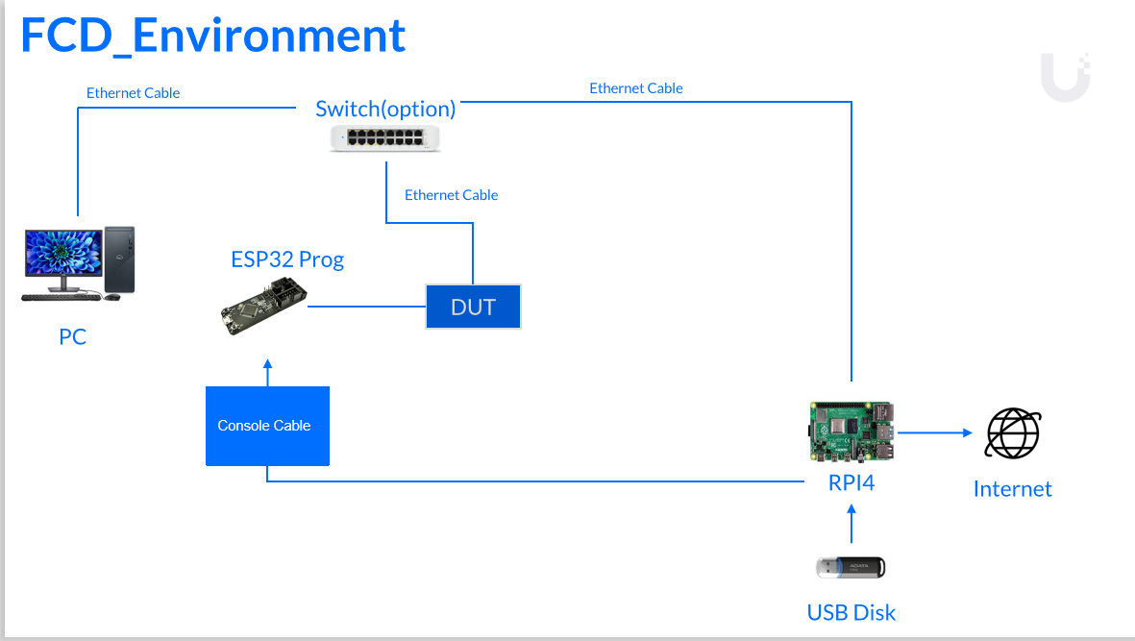

+ Load FCD program: Install the main program to manage the process of downloading and installing firmware as well as initial configuration for the device.

- Main function of FTU station:

Set up enviroment and configure MAC to test function

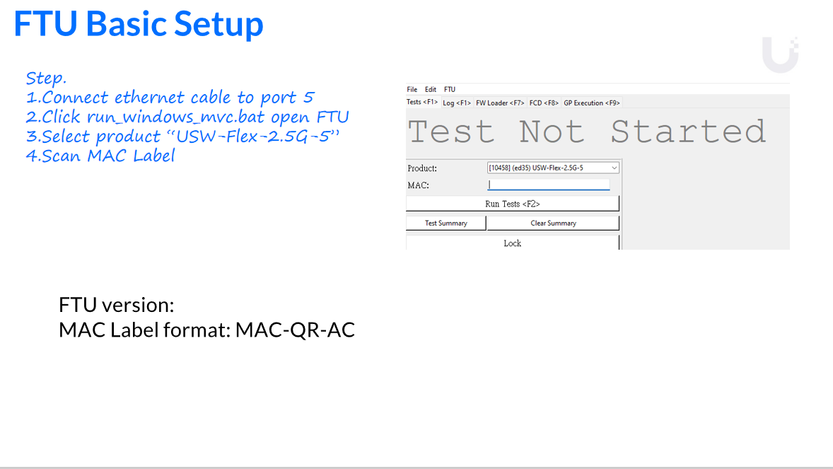

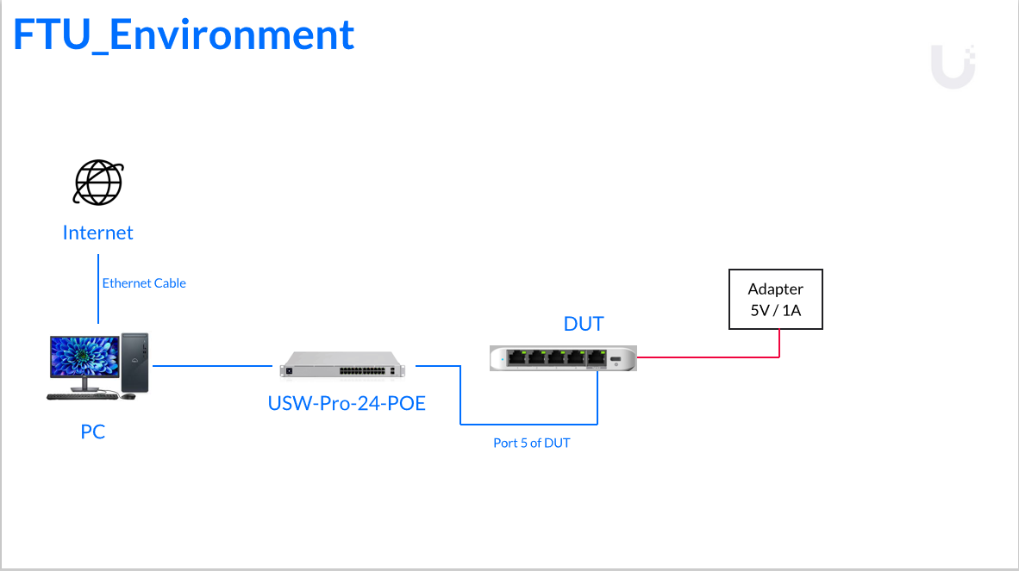

- After that, Run Info Test to check MAC, QR code, Bom .... of DUT

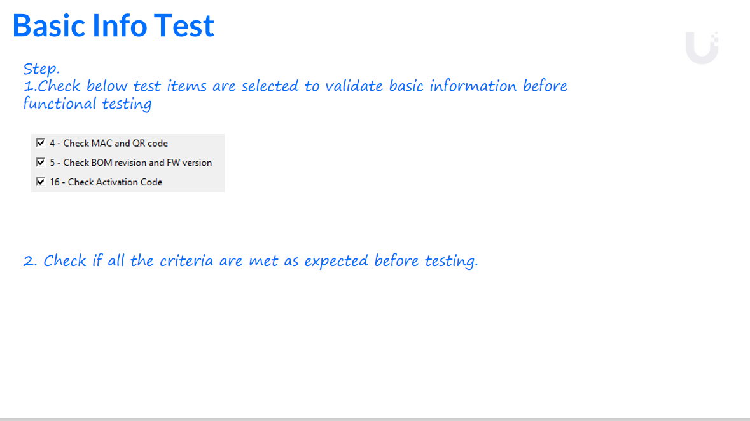

+ Test “Reset Button”

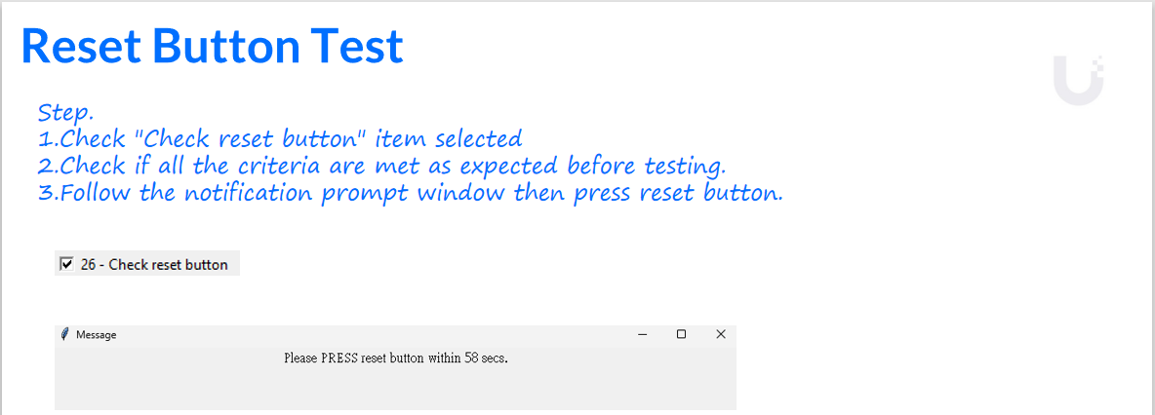+ Burn-in Testing for Switching Power is a common production step for switching power supplies designed for computers and servers. During this process, the power supplies are placed in extreme temperature and voltage conditions to verify their operation and reliability. The goal is to ensure that the product continues to function correctly throughout its service life.

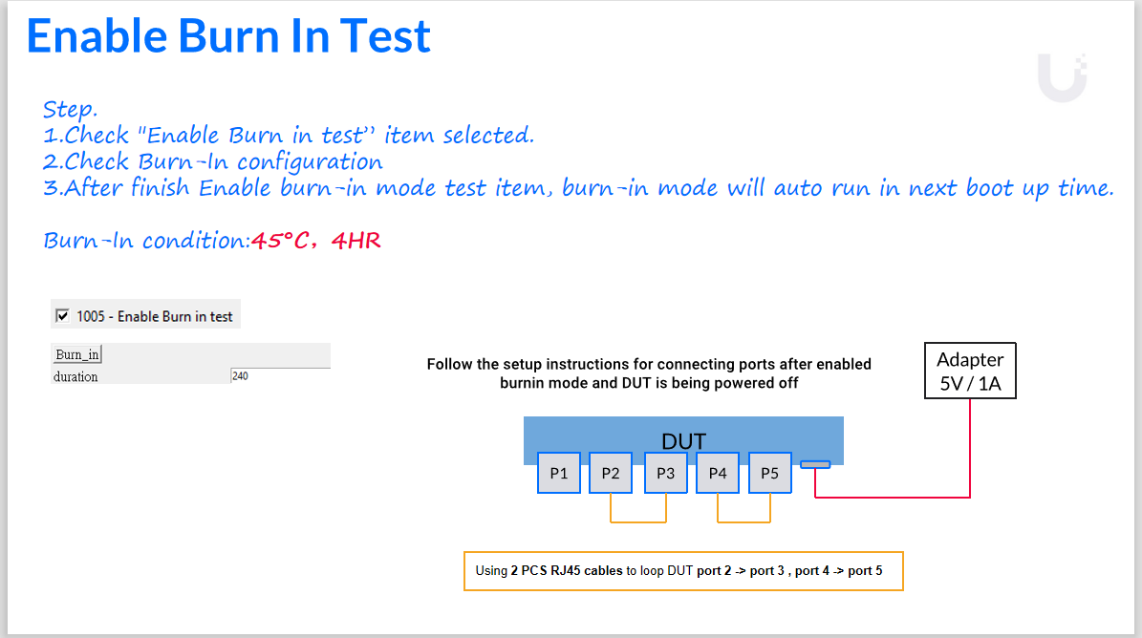



+ Check LED

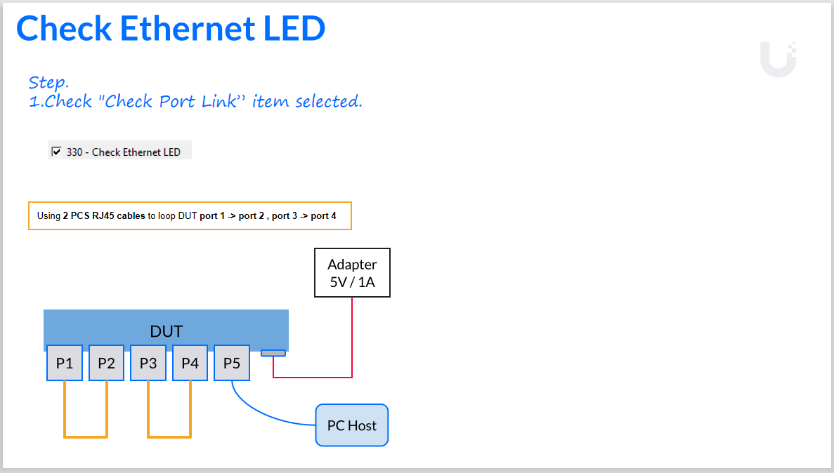



+ Nustream testing is method that focuses on evaluating the initial failure rate of electronic components. Components are subjected to conditions of temperature and voltage beyond normal levels to induce early failures.

