HPE0-J68
162 cau hoi - Topic dump ExamTopics

Cau 1
Dap an: B
Refer to the exhibit.
You are configuring a new HPE array and verifying properties of a set of volumes.
Which RAID level is used on the VMwareDatastores-GF volume?
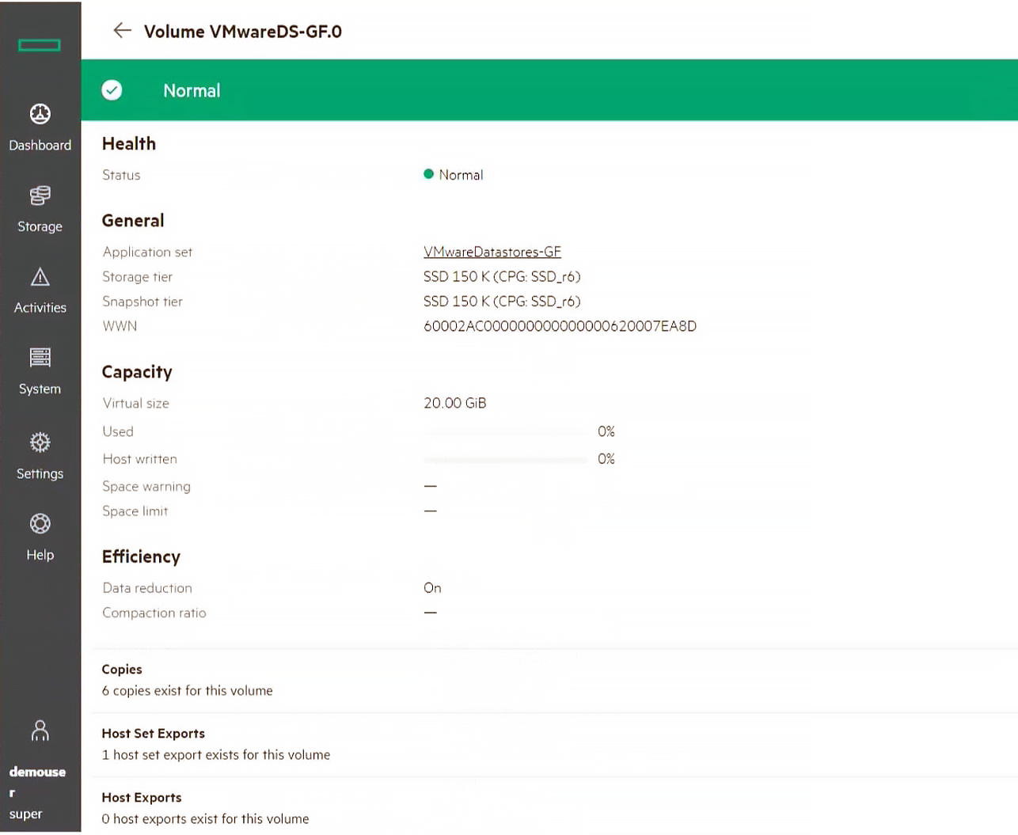
A. RAID 0
B. RAID 6 ✓
C. Triple Parity+
D. RAID 5
- Binh luan:
very old questions, there are no such questions anymore
rai6 if look from naming Datastore.
Exam already replaced by a new one.
SSD_r6 -> RAID6
RAID 6

Cau 2
Dap an: D, E
You have proposed that a customer replace their legacy SAN switches with new В-Series switches. They are concerned about the management of all the devices, so you have included SANnav in the proposal.
What are the benefits of SANnav that you should emphasize to this customer? (Choose two.)
A. It runs in a dedicated JVM
B. It offers automated SPOCK validation
C. It runs in a browser
D. It provides a global View ✓
E. It provides fine-grain visibility into Storage Fabrics (FC + Ethernet) ✓
- Binh luan:
C & D are correct answers.
HPE states the SANnav is a browser-based UI and it has a Global View that provides a comprehensive view of a SAN environment that spans multiple SANnav Management Portal instances
HPE SANnav Management Software is the next-gen SAN management application suite for HPE B-series Fibre Channel SAN environments. It consists of SANnav Management Portal Software and SANnav Global View Software. SANnav Management Portal builds the foundation for an autonomous SAN with a modernized and simple browser-based UI to monitor and streamline common workflows, such as configuration, zoning, deployment, troubleshooting, and reporting. SANnav Global View enables visualization of health, per
D and E are correct
D and E are correct, while it does not run in a browser. Broadcom has some extension switches that are ethernet aware and part of the StorFabric portfolio.

Cau 3
Dap an: A
A customer has completely virtualized their datacenter with VMware. You propose a SimpliVity solution to replace their aging hardware.
Which SimpliVity features should you emphasize in your presentation? (Choose two.)
A. It uses native hypervisor management tools for management ✓
B. It utilizes the Storage Management Utility for management and monitoring
C. It utilizes a unified ASIC for performance
D. It includes deduplication and backup capabilities
E. It provides S3 file access
- Binh luan:
HPE Simplivity plugin for vCenter allows for management from vCenter and HPE Simplivity includes dedupe (A and D)
using HPE Simplivity plugin for vcenter
Should be A instead of B
Why B but not A?

Cau 4
Dap an: B, F
You want to deploy Recovery Manager Central to a customer environment.
How can you accomplish this? (Choose two.)
A. Install RMC on top of the virtual or physical RHEL system using the GUI wizard
B. Deploy an RMC virtual appliance to Microsoft Hyper-V hypervisor ✓
C. Deploy RMC on top of the virtual CentOS system using the CLI
D. Deploy RMC on top of the virtual CentOS system using the GUI wizard
E. Install RMC on the top of the virtual or physical RHEL system using the CLI
F. Deploy an RMC virtual appliance to VMware ESXi hypervisor ✓
- Binh luan:
HPE Recovery Manager Central can be deployed as a VM on either HyperV or VMware ESXi

Cau 5
Dap an: B
A customer uses Veeam to backup their entire datacenter.
Which Veeam feature allows them to recover a single email from their Exchange server?
A. Changed block tracking
B. Explorer for Storage Snapshots ✓
C. Data Mover Service
D. SureBackup
- Binh luan:
Veeam Explorers to let you restore items from applications including Microsoft Active Directory, Microsoft Exchange, Microsoft SharePoint, Microsoft SQL Server, Oracle, and PostgreSQL

Cau 6
Dap an: A
Refer to the exhibit.
You are designing a new Primera solution and demonstrating performance numbers to the customer. The customer reviews the configuration and requests a change to the configuration that will increase Random Write IOPS.
Which action will satisfy the customer request?
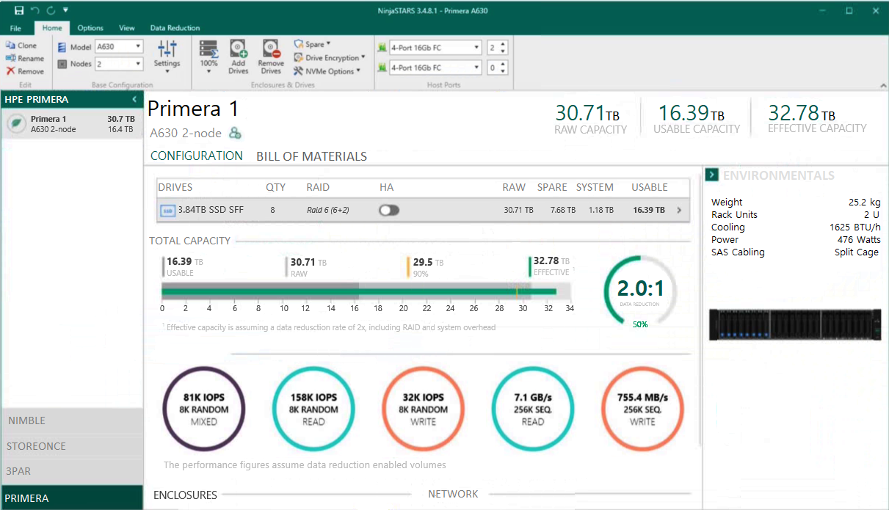
A. Add more disks of smaller capacity ✓
B. Upgrade the HPE Primera base model
C. Change to larger SSDs
D. Add more FC Ports
- Binh luan:
B is true
Upgrading the HPE Primera base node to a higher model will increase performance and in turn increase IOPS
A is true
B is also True, checked in NinjaStars ! :)
A is true,

Cau 7
Dap an: A, D
Which of the following are part of the SimpliVity Data Virtualization Platform architecture? (Choose two.)
A. Presentation Layer ✓
B. User Management Layer
C. Security Layer
D. Data Management Layer ✓
- Binh luan:
The HPE Simplivity DVP (Data Virtualization Platform) architecture is broken up into two parts: the Presentation layer and the Data Management layer

Cau 8
Dap an: A
A customer is implementing a new high performance database environment.
What type of storage should you recommend?
A. scale-out storage ✓
B. object store
C. system-defined storage
D. network-attached storage
- Binh luan:
Scale out storage is good for expansion of existing systems as opposed to upgrading in place systems.

Cau 9
Dap an: D
You are designing a new enterprise array solution. The customer is interested in a caching tier that provides extremely low-latency and persistent storage at the same time. They also need to support more than 500GB.
Which technology should you recommend?
A. DRAM
B. SRAM
C. NVMe SCM
D. NAND SSD ✓
- Binh luan:
C - NVMe SCM
NVMe SCM is Storage Class Memory that delivers low latency and persistent memory.

Cau 10
Dap an: D
A customer is implementing an SAP HANA environment and is looking for an alternative to an entirely in-memory database.
Which storage technology should you recommend?
A. SAS SSD
B. NVMe SSD
C. NVMe SCM
D. Intel Optane ✓
- Binh luan:
Intel Optane is persistent memory

Cau 11
Dap an: N/A
HOTSPOT -
You need to create an N:M relationship between VMware hypervisors and virtual volumes with the least amount of administrative overhead.
Click the option where you can create a group of VMware hypervisors for volumes provisioning.
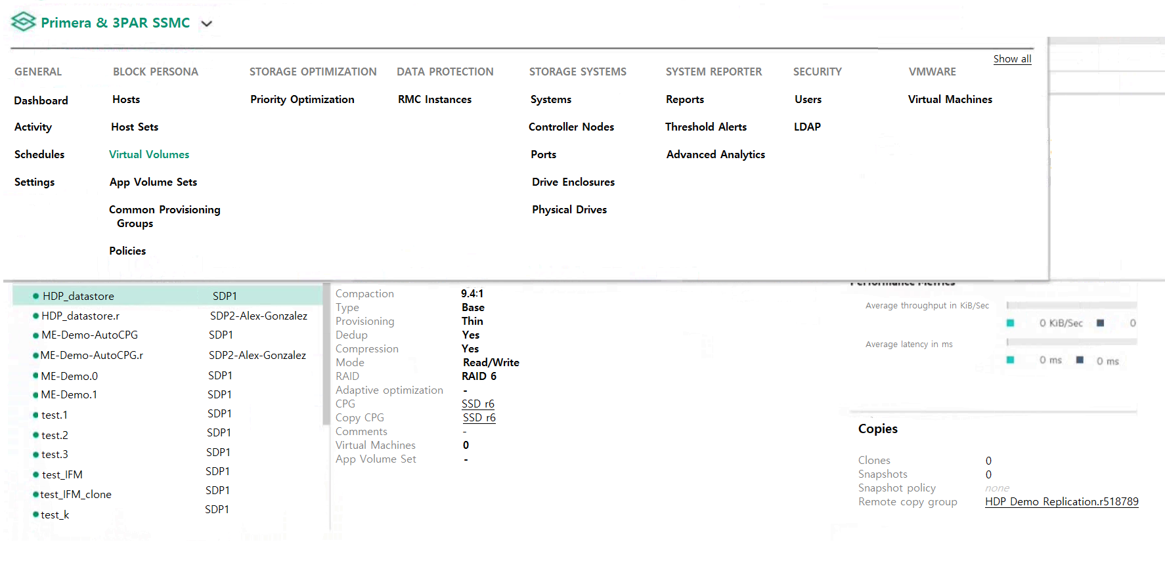
- Binh luan:
"Host Sets" is correct.
CPG is for disks, not host groups. The correct answer is Host Sets.

Cau 12
Dap an: D
Which tool is used to determine current compaction ratios on Primera arrays?
A. WebUI
B. Storage Management Utility (SMU)
C. NinjaStars
D. SSMC System Reporter ✓
- Binh luan:
A is true
A - is True.
HPE Primera Management Console:
This is the primary interface for managing and monitoring your Primera array. You can check various metrics, including compaction ratios, for the storage system through the console's storage analytics and performance reporting tools.

Cau 13
Dap an: C
A customer wants to make a full copy replica of a database to use for performance testing.
Which technology should they use to create the copy?
A. deduplication
B. snapshot
C. clone ✓
D. synthetic full
- Binh luan:
C would be right
In HP storage terminology, a clone would be an independent copy of the original volume. That is, the data blocks are not shared. In case of a snapshot they could be shared. Changed data blocks in a snapshot after the time the snapshot was taken would be independent of the original volume.
C is true

Cau 14
Dap an: B
A customer implemented the HPE StoreEver MSL6480 Tape Library.
Which HPE Software can the system administrator use to check the health of the library and monitor its utilization?
A. OneView
B. StoreServe TapeAssure Advanced ✓
C. StoreEver Data Verification
D. InfoSight
- Binh luan:
HPE Tape Assure Advanced monitors the health and performance of tape drives and cartridges.

Cau 15
Dap an: A
A customer environment includes:
- 10 DL380 Gen8 servers in a VMware Cluster
- 2 MSA storage arrays
- 2 8GB b-series fibre channel switches
The customer needs to replace their environment because it is end of life. They have limited budget. The customer is primarily concerned with management because they have limited IT staff, and they want to move away from fibre channel.
Which HPE Storage should you recommend?
A. HPE Primera ✓
B. HPE XP8
C. HPE Nimble dHCI
D. HPE StoreOnce
- Binh luan:
They want to move away from fibre channel, so it should be HPE Nimble dHCI
C is true

Cau 16
Dap an: A, B
You are designing an HPE MSA iSCSI for a customer.
Which components are typically part of the solution? (Choose two.)
A. Drives ✓
B. SFPs ✓
C. Service Processor
D. All-inclusive Multi-system software
E. Switch zones

Cau 17
Dap an: C
A customer is planning to upgrade their HF40 controllers to support additional I/O requirements.
To which model can they upgrade to meet their new requirements?
A. AF60
B. AF40
C. HF60 ✓
D. HF40C
- Binh luan:
HF60 has better performance than HF40
C is true
i think C is true

Cau 18
Dap an: N/A
HOTSPOT -
A customer has a Nimble HF40 and needs to create a support ticket.
Click the option in the InfoSight portal where the customer can perform this task.
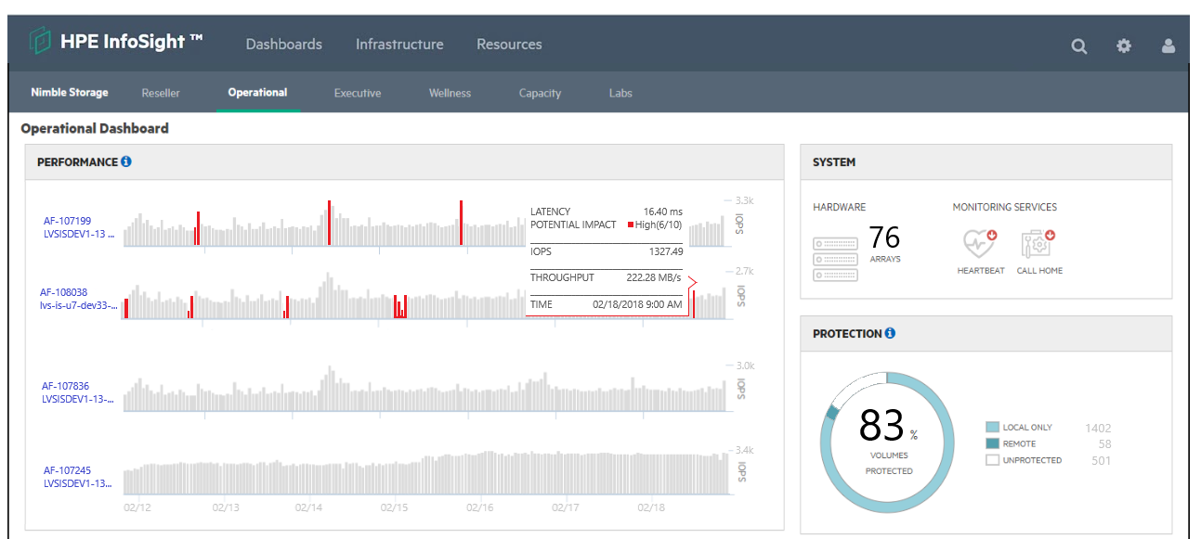
- Binh luan:
1. From the InfoSight Main Menu ( ), go to Resources > Support.
2. Click New Case.
3. Select the severity from the Severity list.
4. Type in a brief summary of the problem including as much information as possible.
While you type, suggestions are presented below the text field.
After you click out of the Summary field, article titles appear on the right side of the screen.
5. Optional: Click one of the article suggestions to read the article.
6. Type in a description of the issue, including as m
Not 100% sure, but I think you can create a case from Wellness tab - https://infosight.hpe.com/InfoSight/media/cms/active/public/pubs_InfoSight_User_Guide_for_HPE_Alletra_6000__HPE_Nimble_Storage_2.pdf
Infosight looks different, but you have to open a support case under Resources->General->InfosightSupport

Cau 19
Dap an: D
A customer is planning to replace their existing LTO-6 tape library with a new HPE StoreEver MSL2024 tape library. They want to reuse their existing LTO-6 tape cartridges for reads and writes.
What is the latest tape drive technology that will provide backward compatibility?
A. LTO8
B. LTO5
C. LTO6
D. LTO7 ✓
- Binh luan:
LTO7 can read and write LTO6 tapes.
LTO8 can only read LTO 6 tapes
For me it is D
Correction, D. LTO-7 is correct because question mentioned "Read and Write" capabilities.
A. LTO8
LTO8 caompatible LTO7 LTO6

Cau 20
Dap an: N/A
DRAG DROP -
Refer to the exhibit.
You create two snapshots of a thin provisioned base volume in an HPE Primera. One snapshot is read only and the other is read-write. A write occurs at the location shown in in the diagram.
Place the actions on the left into the order they are taken on the right.
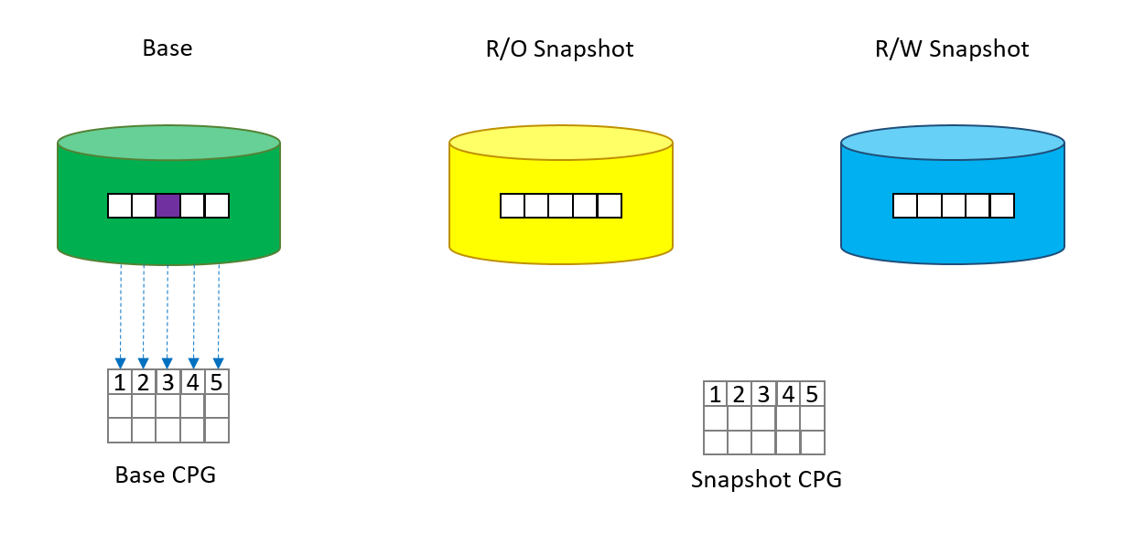
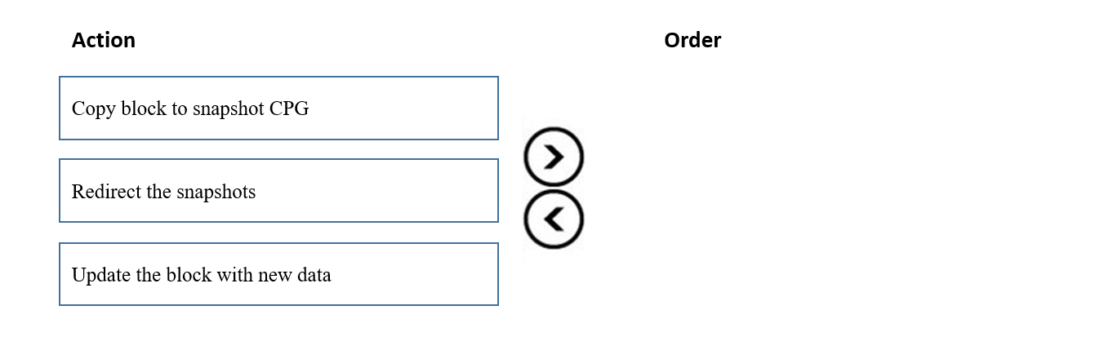
- Binh luan:
It's Copy --> Redirect --> Update - from the study guide.
https://www.hpe.com/psnow/doc/a00097607enw
Page 19

Cau 21
Dap an: A
A customer asks you for a recommendation on setting up their new StoreOnce appliance. They plan to use NetBackup and need the highest performance setup they can get. Their local hosts are connected via FC and the rest are connected via a WAN.
Which backup target type should you recommend?
A. VTL ✓
B. S3
C. CIFS
D. Catalyst
- Binh luan:
Which One to Choose?
If you're looking for the highest performance, deduplication efficiency, and scalability: StoreOnce Catalyst is the clear choice.
If you're dealing with legacy systems that require tape emulation or using traditional backup software that expects tape libraries: StoreOnce VTL might be the better fit.
Since you mentioned you plan to use NetBackup, which integrates seamlessly with StoreOnce Catalyst, I would recommend StoreOnce Catalyst for your setup. It will give you the be
CATALYST D

Cau 22
Dap an: N/A
HOTSPOT -
You are handing over the installed array to customer. The customer wants to review the amount of HDDs and SSDs in the system.
Click the relevant menu option where the front panel of the head shelf can be visualized.
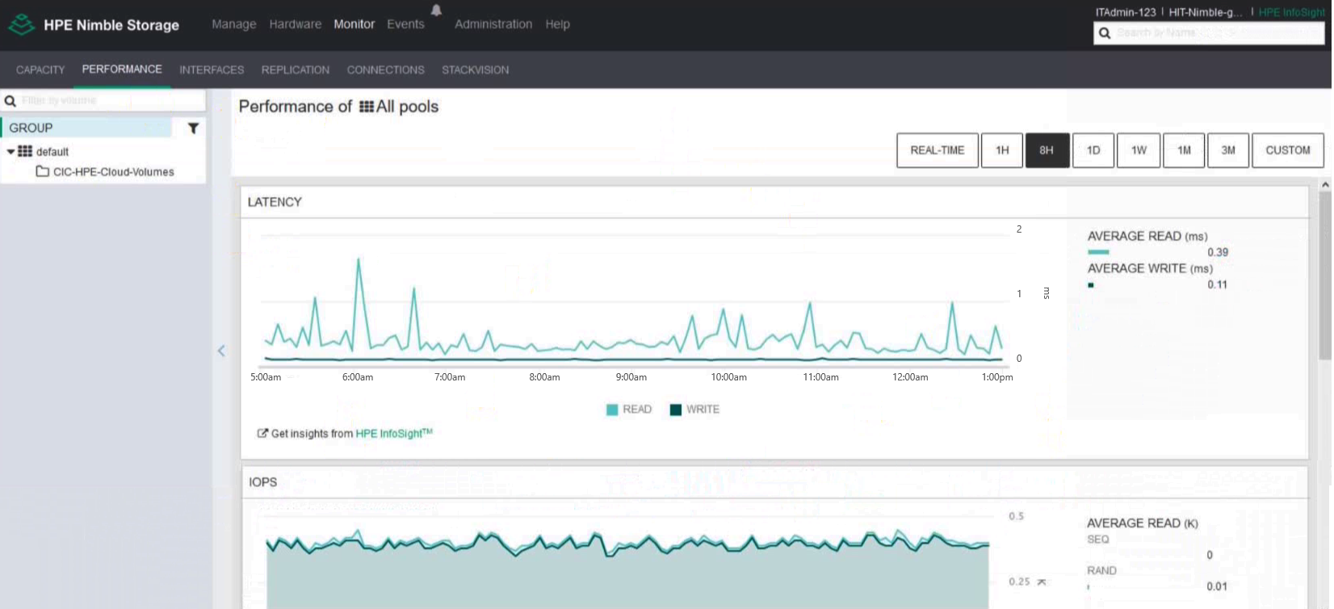
- Binh luan:
On menu bar "Hardware"

Cau 23
Dap an: D
A customer successfully implemented an HPE Primera solution.
Which tool can be used to verify performance counters, such as IOPS, match customer requirements?
A. NinjaCrawler
B. OneView
C. Recovery Manager Central
D. Primera on-node management GUI ✓

Cau 24
Dap an: C
A customer successfully implemented an HPE Primera solution.
Which tool can be used to verify achieved savings from deduplication and compression in the customer solution?
A. NinjaSTARS
B. 3PAR Service Processor
C. NinjaCrawler ✓
D. StoreServ System Management Console
- Binh luan:
The Ninja Crawler is a tool used to scan and analyze storage environments to gather detailed information about data usage, file system structures, and deduplication opportunities. In the context of HPE storage solutions, such as HPE StoreOnce or HPE Primera, Ninja Crawler is particularly helpful in identifying data that can be optimized through deduplication and compression.
Answer is C
The correct answer is Ninja Crawler
The correct answer is Ninja Crawler

Cau 25
Dap an: C
A customer has the following requirements for a storage solution:
- VMware environment
- 20 ТВ of standard business data
- 400 TB of video archive files
- 10 GB iSCSI connectivity
They are most concerned with the cost of the solution.
Which HPE storage solution offers the lowest cost while meeting the customer requirements?
A. HPE Nimble
B. HPE SimpliVity
C. HPE Primera ✓
D. HPE MSA
- Binh luan:
lowest cost -> HPE MSA "D"
MSA is lower cost

Cau 26
Dap an: B
You are proposing a StoreOnce solution to a customer that has always used tape for a backup target.
What should you suggest to ensure that the StoreOnce deduplication is correctly sized?
A. StoreOnce timeless storage
B. DDAnalyzer ✓
C. proof of concept with StoreOnce VSA
D. OCA
- Binh luan:
DD analyser is wrong. This is a tool to check ENC Data Domain
For me C is correct
For me it's C. proof of concept with StoreOnce VSA

Cau 27
Dap an: A
A customer is purchasing an HPE MSA 2050 for a branch office. They will use it for critical data services. The customer is concerned that 64 snapshots will not be adequate as they grow.
What can be added to the array to address the customer’s concerns?
A. Advanced Data Services Suite license ✓
B. All-inclusive Multi-system license
C. Virtual Copy license
D. Adaptive Optimization license
- Binh luan:
a. ADS Lics will enable 512 snapshots, and will answer the customer concern
A. Advanced Data Services Suite license
A is correct
A is the correct answare
Answer is A

Cau 28
Dap an: A, D
You have proposed a Primera array to a customer for new primary storage. The customer currently has an older 3PAR array that they will continue to use moving forward. The customer would like high availability configured.
Which RMC Peer Copy pre-requisites do you need to point out to the customer? (Choose two.)
A. No license is required ✓
B. 2-port 10 Gb Ethernet Adapter (NIC) is required
C. 4-port 1 Gb Ethernet Adapter (NIC) is required in each array
D. RMC 6.2 is required ✓
E. Target drive type must match source drive type
- Binh luan:
A and D are the correct answers
A and D are the correct answers

Cau 29
Dap an: C
Which protocol can be used for accessing StoreOnce VTL target from Veeam?
A. FC
B. NFSv4
C. iSCSI ✓
D. SMBv3
- Binh luan:
The VTL features of StoreOnce rely on the iSCSI protocol

Cau 30
Dap an: C, D
Which StoreOnce Gen4 features are included with the system software without additional licenses? (Choose two.)
A. Encryption
B. Cloud Bank
C. Catalyst ✓
D. VTL/NAS replication ✓
E. Flexible I/O HBAs
- Binh luan:
in Oca they mark them with 0 cost, the correct is A and C
HPE states that StoreOnce Gen4 features available without a license are Catalyst and Replication.

Cau 31
Dap an: A, E
You are proposing a new Nimble solution to a customer that recently experienced data loss in their existing storage array.
Which features of the Nimble array should you emphasize to your customer to address their concerns? (Choose two.)
A. quick RAID rebuild ✓
B. deduplication
C. compression
D. encryption
E. triple party ✓
- Binh luan:
A and E are the correct

Cau 32
Dap an: B
Which tool is used to configure an HPE MSA 2052?
A. InfoSight
B. SMU ✓
C. CMC
D. SSMC
- Binh luan:
The correct answer is SMU

Cau 33
Dap an: N/A
DRAG DROP -
Match the feature to the appropriate C-Series DCNM license type.
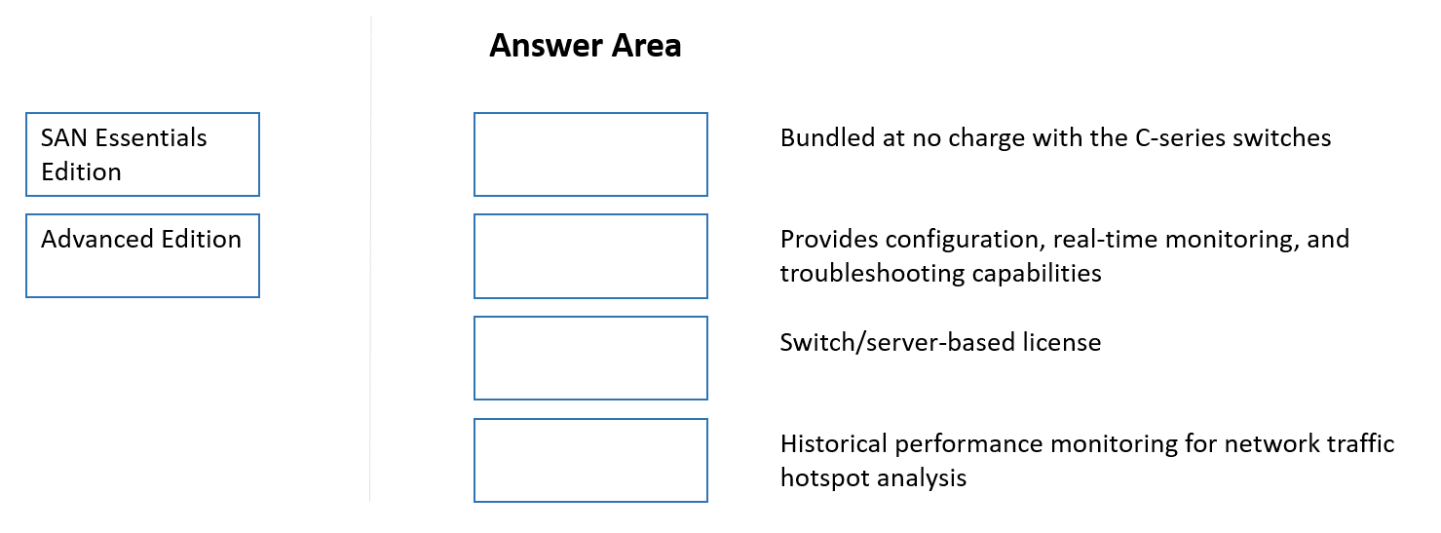

Cau 34
Dap an: B
A customer has a VMware environment running vSphere 6.5. They are running DL380 Gen10 servers with HPE 82Q adapters connected through a HPE SN3000B switch to a Nimble HF40. They plan to upgrade the hypervisor.
What should they use to identify the latest firmware and compatibility information?
A. SAN Health Diagnostics
B. SPOCK ✓
C. OneView
D. SAN Design Reference Guide

Cau 35
Dap an: N/A
DRAG DROP -
Match the MSA architecture components with their descriptions.
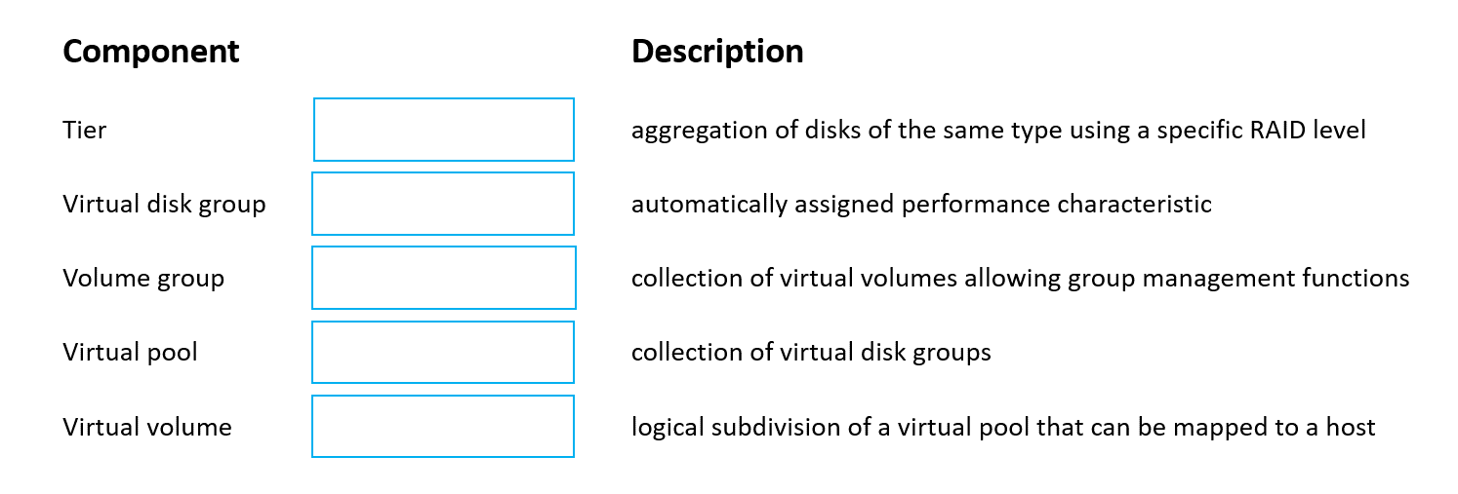
- Binh luan:
The Virtual Volume and Tier need to be swapped.
It is
Virtual Disk group
Tier
Volume Group
Virtual pool
Virtual Volume

Cau 36
Dap an: B
A customer needs a centralized solution for storing departmental data to be accessed by Windows-based laptops and other personal devices.
Which solution should you recommend?
A. Block storage, directly accessed over FC
B. Block storage, directly accessed over SAS ✓
C. Object storage, accessed over S3 connector
D. File-oriented storage, accessed over SMB
- Binh luan:
D. file level

Cau 37
Dap an: C
You deployed and configured an all-flash Nimble array. The customer wants to attach their Windows-based server to the array.
Which HPE tool can you use on the host server to make the integration easier?
A. StorServe Management Console
B. Channel bonding
C. Connection Manager ✓
D. Centralized Management Console

Cau 38
Dap an: D
A small company has recently purchased an MSA and two B-series SN3000B switches. In an effort save money, they installed the solution themselves. They call you complaining they can now see the multiple volumes on the MSA after creating just a single volume.
What should you advise them to do?
A. Enable Smart SAN on the MSA 2052
B. Set volume’s tier affinity to Performance
C. Enable zoning on the SN3000B switches
D. Enable MPIO on their host ✓

Cau 39
Dap an: A, B
A customer is deploying a new StoreOnce VSA solution.
How can the necessary storage capacity be added to the VSA? (Choose two.)
A. Verify sufficient capacity LTUs are available ✓
B. Add a new virtual hard disk to the virtual machine ✓
C. The Cloud bank container needs to be configured once the VSA boots
D. The Cloud bank container needs to be configured from the vCenter client
- Binh luan:
Cloud bank need a license

Cau 40
Dap an: N/A
DRAG DROP -
A customer wants to implement a new storage network, but wants to retain the ability to connect with legacy fiber channel-based components.
Drag the appropriate component to each box on the diagram to design a new storage network.
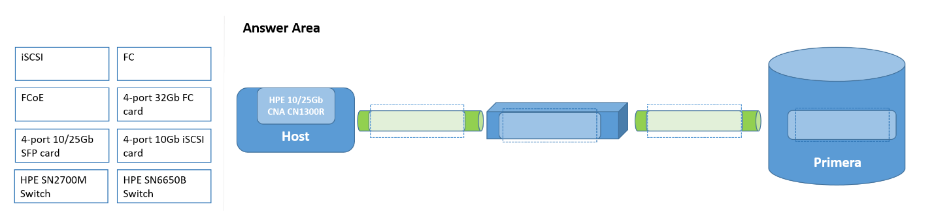
- Binh luan:
FC -> HPE SN6650B -> FC -> 4-Port 32GB FC card
it has to be
FCoE --> HPE SN6650B --> FC --> 4 Port 23GB FC
FCoE over a FC switch :) maybe it should be iSCSI over the SN2700M switch, however doubtfull if that is supported.

Cau 41
Dap an: B
A customer currently runs MSA 2040 SAS storage system with SFF drives. They are planning a hardware refresh. The customer is using virtual pools only, and is concerned about problematic data migration to the new platform.
How can the update to MSA2050 be performed?
A. Peer migration license must be purchased for the online migration
B. Peer migration license must be purchased for the offline migration ✓
C. Existing drives can be moved to the new system; both systems need to be online
D. Existing drives can be moved to the new system; both systems need to be offline
- Binh luan:
Additional info
Important
• The HPE MSA 1050/2050/2052 storage system only supports Virtual Disk Groups. If you have existing Linear Disk Group that you need preserved, go to the section entitled “Preserving Linear Data” before continuing the upgrade.
• During the upgrade, the storage system will be powered down and all HPE MSA 1040/2040/2042 array enclosures will be replaced with HPE MSA 1050/2050/2052 array enclosures.
• Existing drives will be removed from the HPE MSA 1040/1050/2040/2042 arra
D is the corect one

Cau 42
Dap an: C
You are installing an HPE 3PAR StoreServ solution and need to integrate the array with the 3rd party monitoring application customer is using.
Which technology can be configured at 3PAR to support forwarding events from the array to the customer’s monitoring application?
A. IPMI
B. NTP
C. SNMPv3 ✓
D. DMI

Cau 43
Dap an: B, C
Which actions can be done within InfoSight Cross-Stack Analytics for VMware and Hyper-V? (Choose two.)
A. View replication policies
B. Find noisy neighbors ✓
C. Locate inactive VMs ✓
D. Modify administrative privileges
E. Review backup schedules

Cau 44
Dap an: N/A
DRAG DROP -
Match each address with the associated address type.
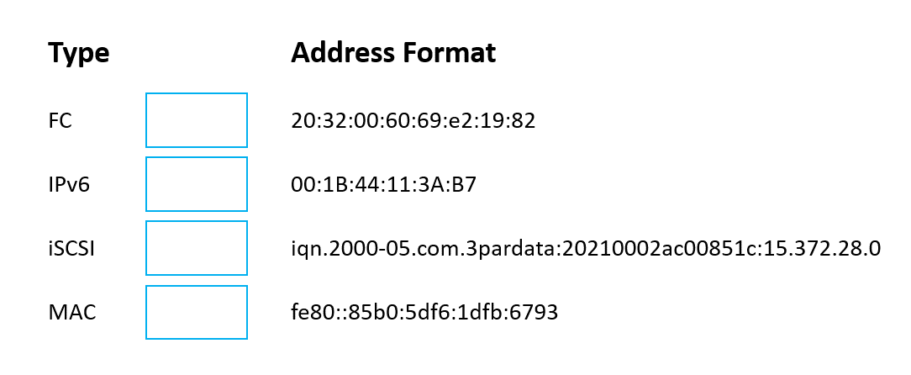
- Binh luan:
Swap the FC & MAC address.
FC and MAC not in place

Cau 45
Dap an: A
A customer purchased a StoreOnce 3620 earlier in the year and has decided to add a 10GBase-Т adapter to it, which the customer sourced elsewhere and installed themselves. They complain that the new adapter is not configurable.
What is the most likely reason for this issue?
A. The StoreOnce software requires updating ✓
B. Secure boot must be enabled in the BIOS to securely enable HBAs
C. The customer failed to install a License to Use (LTU) for it
D. The StoreOnce needs to connect to InfoSight to validate the adapter authenticity

Cau 46
Dap an: C
You are designing a new storage environment for a customer. They need good performance, but need to keep costs to a minimum.
They have a very limited staff, and staff is concerned about learning new technologies. You plan to recommend a Nimble HF20 solution.
Which storage connectivity components should you recommend?
A. FlexFabric switches, Nimble iSCSI card. FC adapters for servers
B. FC switches, Nimble FC card, FC adapters for servers
C. Ethernet switches, Nimble iSCSI card, dedicated NICs for servers ✓
D. Ethernet switches, Nimble FC card, dedicated FC for servers

Cau 47
Dap an: C
A customer runs their core application on an aging HPE 3PAR StoreServ 20000 Storage array. The application requires 100% availability.
Which HPE storage solution should you recommend?
A. Nimble
B. Nimble dHCI
C. Primera ✓
D. MSA

Cau 48
Dap an: D
You are asked to review an installation plan for a new Primera storage array. The array will go into an existing environment that has been in production for over 4 years. It includes:
- C7000s with Gen8 blades
- 8Gb Brocade switches
- a 3PAR 7400
- an MSA that is used as a backup target
What should you use to find appropriate installation and planning guides?
A. SAF Analyze and Collector
B. Information Library
C. NinjaSTARS
D. SPOCK ✓

Cau 49
Dap an: A
You are designing a new HPE 3PAR StoreServ solution.
Which HPE tool allows editing the Customer Intent Document and adding specific instructions for packing?
A. One Config Advanced ✓
B. SAF Collect
C. NinjaSTARS
D. Storage Sizing Tool

Cau 50
Dap an: B
Refer to the exhibit.
A customer purchased a Primera C6S0 array to replace several older 3PAR arrays. They plan to upgrade the system as each 3PAP reaches the end of its lease. The initial sizing included 100TB effective capacity for an Oracle database environment.
The first 3PAR to come off lease has 100TB of VDI boot images that support thousands of users.
Which addition to the Primera should you recommend?
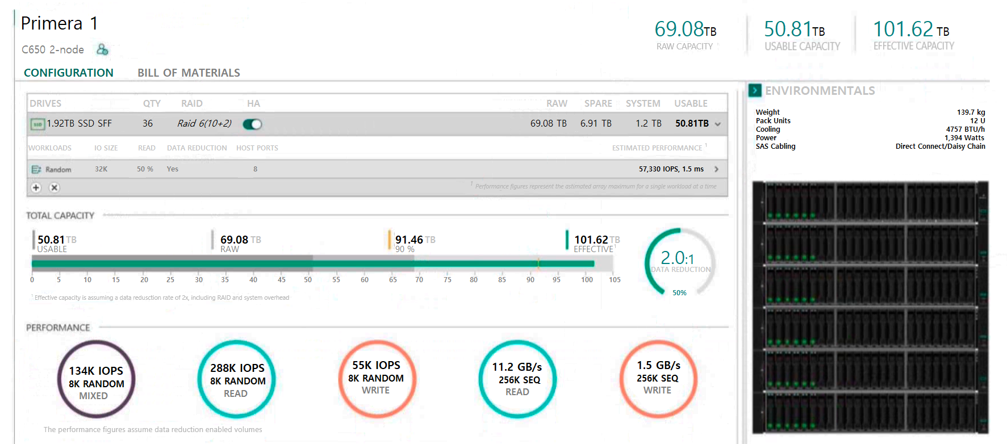
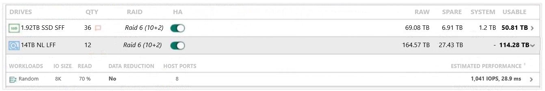
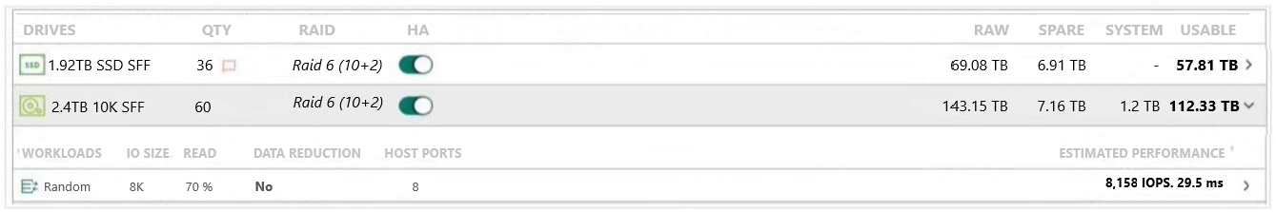
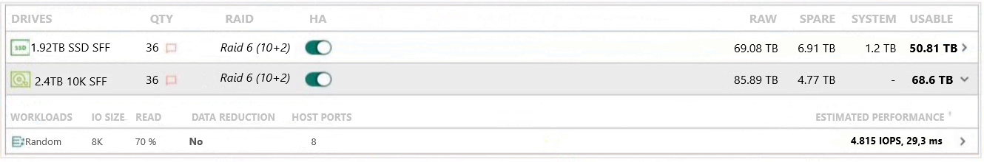
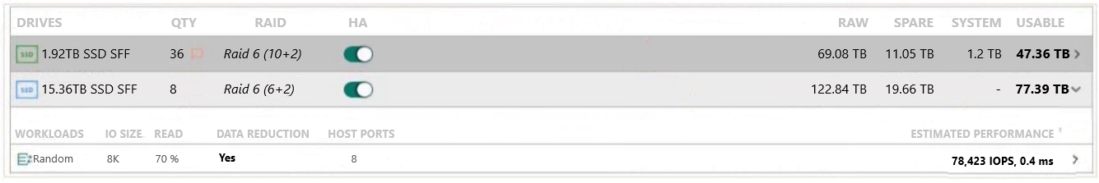
A. A.

B. B. ✓

C. C.

D. D.


Cau 51
Dap an: N/A
HOTSPOT -
You are configuring a new HPE 3PAR solution and need to create a new disk group with a defined RAID level.
Click the appropriate option where the RAID can be selected.
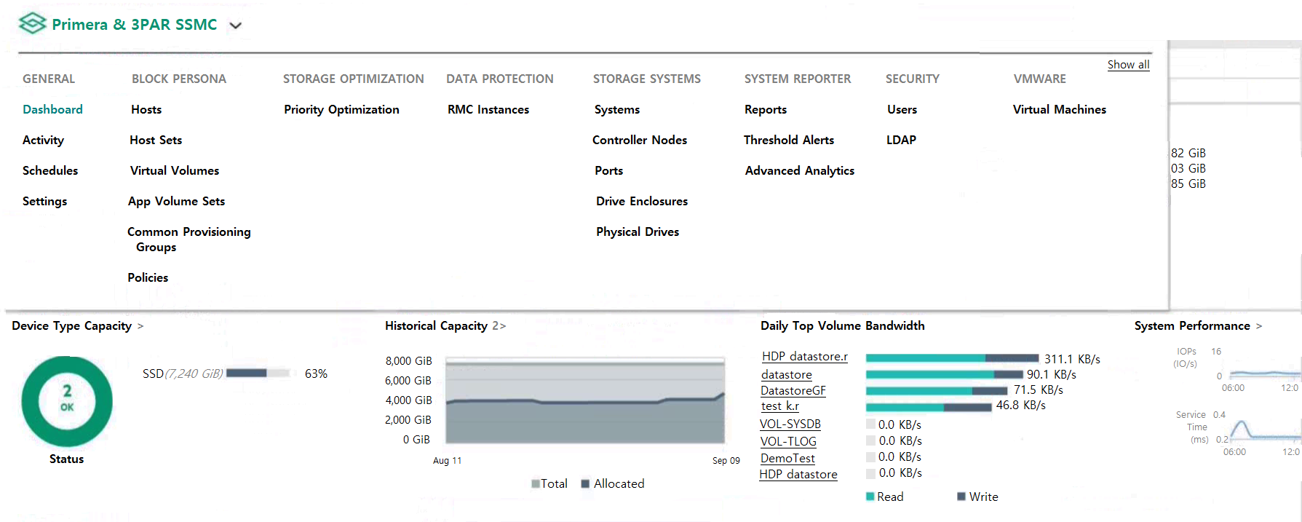
- Binh luan:
CPG is correct
CPG (Common Provisioning Group)
create a new disk group with a defined RAID level.

Cau 52
Dap an: A
Which feature allows HPE Primera, HPE Nimble, and HPE XP arrays to work with third-party management tools?
A. REST API ✓
B. Data Protection Manager (DPM)
C. StoreServe Management Console (SSMC)
D. Service Processor

Cau 53
Dap an: N/A
DRAG DROP -
Select the correct initiation option for each HPE Primera function.
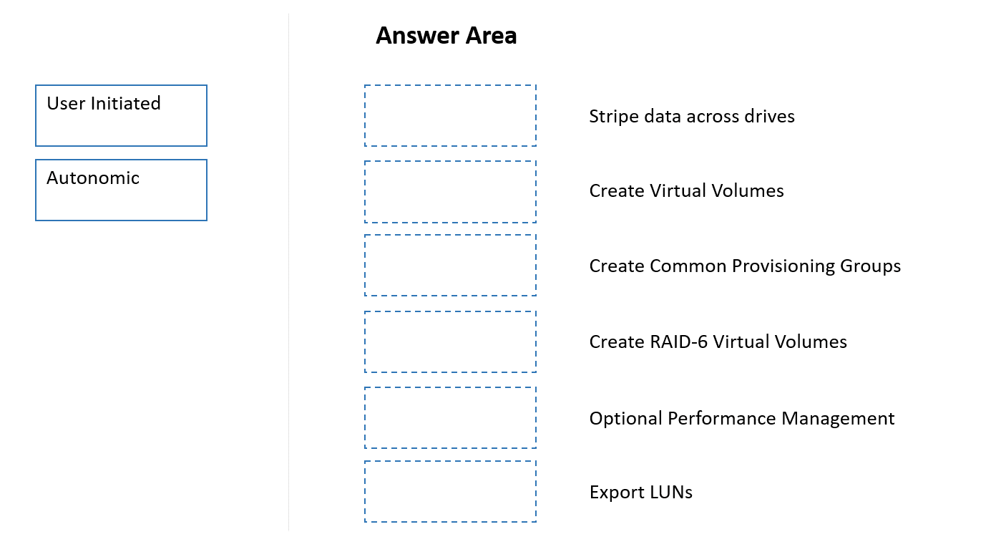

Cau 54
Dap an: C, E
What is the purpose of WWN in FC SAN? (Choose two.)
A. Identification of zone members
B. Identification of entities denied access to a volume
C. Identification of entities via Storage Name Server (SNS) ✓
D. Load balanced frame delivery
E. Forward translation of DNS entries ✓
- Binh luan:
Zoning - To identify zone members
Lun Masking - To identify entities permitted/dinied access to LUN resources withing an array
HPE PRESS
A,B correct

Cau 55
Dap an: A, E
You have proposed a Primera array to a customer for primary storage. The customer currently has an older HPE 3PAR array and will continue to use it moving forward. The customer would like high availability configured.
Which RMC Peer Copy pre-requisites do you need to point out to the customer? (Choose two.)
A. 4-port 1 Gb Ethernet Adapter (NIC) is required in each array ✓
B. Target drive type must match source drive type
C. 2-port 10 Gb Ethernet Adapter (NIC) is required in each array
D. Check that the 3PAR OS version is supported
E. Required license must be provided ✓
F. RMC 6.2
- Binh luan:
D and F are correct

Cau 56
Dap an: D
Which tool is used to provide centralized management of 3PAR and Primera arrays?
A. SMU
B. Primera UI
C. WebUI
D. SSMC ✓

Cau 57
Dap an: C, D
You need to deploy a Recovery Manager Central appliance and integrate it with a customer’s 3PAR system.
Which information must be collected from the customer in order to proceed with the installer? (Choose two.)
A. StoreOnce store name
B. vCenter IP address or hostname
C. HPE 3PAR used capacity ✓
D. IP address of the RMC ✓
E. NFS path
- Binh luan:
o deploy a Recovery Manager Central (RMC) appliance and integrate it with a customer's 3PAR system, the following two pieces of information are essential for the installer B and D
I'l go with B and D

Cau 58
Dap an: N/A
DRAG DROP -
Match each HPE storage solution to its use case.
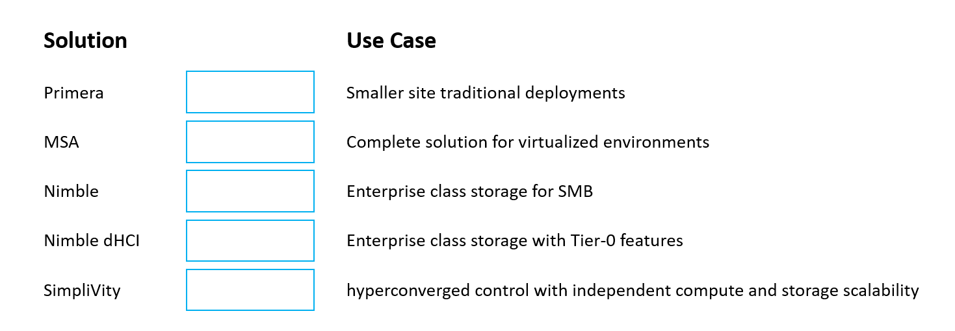
- Binh luan:
MSA
Simplivity
Nimble
Primera
dHCI, Because it states independent compute and storage
Swap Nimble and MSA

Cau 59
Dap an: C
What is the typical protocol used to access data from object storage?
A. FC
B. NVMe
C. HTTP ✓
D. iSCSI
- Binh luan:
C. HTTP is correct
The typical protocol used to access data from object storage is HTTP or REST APIs.
C is correct

Cau 60
Dap an: C
Based on the customer requirement for hybrid storage solution with fibre channel connectivity.
What would you need to consider when proposing HPE Alletra?
A. Alletra 5030 models and above is required for a hybrid with FC connectivity
B. Alletra 6000 flash to tier disk would need to be sufficient for the workload
C. Alletra 5000 flash to disk ratio would need to be sufficient for the workload ✓
D. Alletra 6030 models and above is required for a hybrid with FC connectivity
- Binh luan:
this correct is option C
This seems like a trick question. I'm tentatively choosing C.

Cau 61
Dap an: A
When adding a first 2140 4U All-Flash expansion shelf into your customer’s HPE Alletra 6000 array, what considerations should be taken?
A. The array model must be at least Alletra 6030 running array OS 6.1.2.0 and later ✓
B. Expansion shelf must be populated with same disk capacity as the head shelf
C. HPE Services rebalancing service must be ordered along the expansion shelf
D. 2x100GbE 2-port OCP Mezzanine adapter kit must be ordered along the expansion shelf

Cau 62
Dap an: B
How can an IT administrator access the HPE Alletra dHCI Stack Manager for managing their HPE Alletra dHCI solution?
A. From fabric manager
B. Via HTML5 VMware vSphere client ✓
C. From Alletra 9000 on-array Management UI
D. Via HPE Alletra 5000/6000 CLI
- Binh luan:
is designed to be managed from the same interface used for a VMware environment. The Stack Manager is a plugin that is automatically installed on the vCenter Server during the dHCI deployment. Once installed, it's accessible directly from the HTML5 VMware vSphere client

Cau 63
Dap an: D
The customer is using HPE GreenLake for Backup & Recovery. Which steps are necessary to define a Protection Policy in HPE GreenLake Data Services console?
A. Create iSCSI tunnel between array and d2d appliance
B. Define source and destination array
C. Define Hyper-V or vCenter server and snapshot frequency
D. Define the name of policy, scheduling and destination ✓

Cau 64
Dap an: D
Your customer has very low deduplication ratio of their Linux VMs farm which is hosted on a HPE Alletra 9000.
Which filesystem type could cause this?
A. EXT3
B. EXT4
C. XFS
D. Btrfs ✓
- Binh luan:
XFS is a high-performance journaling filesystem. However, due to its specific write behavior, it can be a problem for block-level deduplication technologies, like the ones used in HPE Alletra 9000

Cau 65
Dap an: B
Recommend a software stack for changing a backup platform that includes pay-per-use, supports backup of virtualized workloads provided by HPE GreenLake, offers low RPO in minutes, supports HPE Alletra 9000. and integrates with DSCC.
A. HPE GreenLake Backup and Recovery
B. Zerto ✓
C. Recovery Manager Central
D. Veeam Backup and Recovery
- Binh luan:
A-Hpe Greenlack Backup and Recovery

Cau 66
Dap an: B
A solution architect is explaining RBAC concepts behind the HPE GreenLake Platform. How can the customer manage users in HPE GreenLake Platform after creating new company account?
A. HPE Support must be used to create an administrator account for the organization.
B. The creator of the company account is automatically assigned to the Account Administrator role for the organization. ✓
C. Single company can only have one account.
D. The creator of the company account must create another account with Account Administrator role.
- Binh luan:
The answer is A.

Cau 67
Dap an: A
You have configured a performance alert with the following command:
“createsralertcrit port writeiops>10000,sumwrite_iops>50000 alert”
Which of the following options will trigger the alert?
A. If an array port has received more than 10 000 write IOPS and if the sum of all write IOPS for all ports exceeds 50 000 ✓
B. If an array port has received more than 10 000 write IOPS or if the sum of all write IOPS for all ports exceeds 50 000
C. If a host port has transferred more than 10 000 write IOPS and if the sum of all host write IOPS for all ports of that host exceed 50 000
D. If a host port has transferred more than 10 000 write IOPS or if the sum of all host write IOPS for all ports of that host exceed 50 000
- Binh luan:
B. Final answer.

Cau 68
Dap an: B
What is the maximum number of ISLs that can be combined to enhance the performance and availability of switch connections in a B-Series trunk group?
A. 6
B. 8 ✓
C. 4
D. 12
- Binh luan:
The maximum number of Inter-Switch Links (ISLs) that can be combined to form a single logical trunk group in an HPE B-Series (Brocade) SAN fabric is 8.

Cau 69
Dap an: A
You are required to create a configuration for pricing for a customer solution for a primary storage use case.
Which HPE tool can you utilize to create the required output?
A. OCA ✓
B. Ninja Stars
C. CloudPhysics
D. SAF

Cau 70
Dap an: C
Which SSD controller component is responsible for wear leveling?
A. DRAM
B. Processor
C. NAND memory controller ✓
D. SATA interface chip
- Binh luan:
The NAND memory controller is the component within the SSD controller responsible for managing the NAND flash memory, including:
Wear leveling: Ensures that write/erase cycles are evenly distributed across all memory cells to prevent premature failure.
Bad block management
Garbage collection
Error correction
It works closely with the Flash Translation Layer (FTL), which is part of the logic managed by the NAND controller.

Cau 71
Dap an: C
You’re starting to design a ToR network for a customer that will use it for iSCSI or NVMe-oF-TCP storage. The design requires a switch with a maximum of 48 ports and 10/25GB speed.
What is the best recommended switch for this scenario?
A. SN3700cM
B. SN2700M
C. SN2410M ✓
D. SN2410bM
- Binh luan:
Without a doubt, it's B. This came up in a recent lab I did.

Cau 72
Dap an: D
A solution architect is sizing the required capacity for an HPE Alletra 9000. Customer requirements include:
• 200TB base volumes
• Regular snapshots being taken every hour with one-week retention
• 10% daily change rate
How much capacity is needed for snapshots after one week?
A. 20TB
B. 200TB
C. 480TB
D. 140TB ✓
- Binh luan:
I'll go with C.

Cau 73
Dap an: C
What is the maximum number of 2140 4U All-Flash Array expansion shelves supported by the HPE Alletra 6030 storage?
A. 3
B. 4
C. 2 ✓
D. 1
- Binh luan:
Refer to cabling doc.
(Optional) Cable another expansion shelf to the array:For HPE Alletra 6010: You can connect only one expansion shelf.For HPE Alletra 6030, 6050, 6070, 6090: You can connect up to two expansion shelves

Cau 74
Dap an: B
Your customer currently uses a VMware-based Veeam backup proxy. They would like to perform a direct backup from their FC-connected Alletra 9000 array.
What could be the reason for the backup falling back to network mode?
A. Direct backup from an HPE Alletra 9000 array requires an Advanced Backup LTU
B. Direct backup from a FC-connected array is only available on physical server-based backup proxy ✓
C. VM-based backup proxy has not enough RAM and more must be assigned in VM properties
D. HPE Alletra 9000 storage array WS API connection timeout value must be increased
- Binh luan:
If I had to guess, I’d pick B based on the wording of the question.

Cau 75
Dap an: D
Your customer has asked you to add their new HPE Alletra 9000 array to HPE SSMC. What should be your next step?
A. Tell them the HPE Alletra 9000 does not support SSMC
B. Order HPE SSMC LTU to unlock the UI
C. Run “setysys ssmc 1” command to initialize the feature
D. Ensure WEB API is enabled, then add the system via SSMC Admin Console ✓
- Binh luan:
A - HPE StoreServ Management Console (SSMC) is the management tool for HPE 3PAR and HPE Primera arrays. The HPE Alletra 9000 is a newer generation of storage and has shifted to a different management architecture. It is managed by either the on-node UI for single-system management or the HPE Data Services Cloud Console (DSCC) for a unified, cloud-based experience. The HPE Alletra 9000 does not have the necessary compatibility to be added to SSMC
A correct

Cau 76
Dap an: A
Your customer would like to implement a data protection technology that will offer the lowest possible RPO and will protect from entire array failure.
Which technology should be used?
A. Synchronous replication ✓
B. Asynchronous replication
C. Snapshots
D. Disk-based backup

Cau 77
Dap an: D
Which Veeam feature allows you to automate validation of the backed up data?
A. On-Demand Sandbox
B. DataLabs
C. Explorer
D. SureBackup ✓

Cau 78
Dap an: B
How does HPE GreenLake for Block Storage perform VV and LD ownership?
A. VV LDs are shared across all nodes
B. VV LDs are owned by a single node ✓
C. VV LDs are shared based on system parameter “enh_ownership”
D. VV LDs are adaptively shared based on the array config

Cau 79
Dap an: C
Your customer is running out of space on their HPE StoreOnce while it appears there are barely any backups present.
Which of the following options could resolve this?
A. Configure backup application to run unmap when backup is expired
B. Trigger space reclamation via HPE StoreOnce local UI
C. Ensure HPE StoreOnce blackout windows allow housekeeping to run ✓
D. Run defragmentation via HPE StoreOnce CLI
- Binh luan:
Housekeeping window is required.
from the study guide

Cau 80
Dap an: A
How can the capacity of an HPE StoreOnce 3620 be expanded?
A. By adding disk enclosures ✓
B. By increasing internal drive capacity
C. By adding a 5660 in slave mode
D. By adding a 3620 in slave mode
- Binh luan:
Looks like A fits best.

Cau 81
Dap an: D
You are required to create a sizing based on an existing Vmware legacy configuration for a customer solution for a new HPE SimpliVity setup.
Which HPE tool can you utilize to create the required output?
A. OCA
B. Ninja Online
C. Cloud Physics
D. Ninja Stars ✓
- Binh luan:
Is C the consensus here? It seems right to me.

Cau 82
Dap an: B
Which type of host identification is used in an iSCSI-based SAN?
A. WWNN
B. IQN ✓
C. DCB
D. WWPN

Cau 83
Dap an: A
Your customer is interested in the HPE GreenLake for Block Storage Mission-critical service.
Which storage array hardware does this service use?
A. HPE Alletra 9000 ✓
B. HPE Alletra 6000
C. HPE XP8
D. HPE Alletra dHCI
- Binh luan:
Greenlake based is Alletra 9000/MPB10K.

Cau 84
Dap an: A
Which HPE system can benefit from storage class memory card?
A. HPE Alletra 6000 ✓
B. HPE Alletra 5010H
C. HPE StoreOnce
D. HPE Alletra 5030
- Binh luan:
SCM is supported on 6050,6070,6090

Cau 85
Dap an: B
The customer uses an HPE Alletra 6000 system and wants to create snapshots of selected volumes automatically at a specific schedule.
Which part of the web-based UI will you recommend for this operation?
A. Data Access
B. Data Protection ✓
C. Hardware
D. Performance Policy
- Binh luan:
On HPE Alletra 6000 arrays (and HPE Alletra 5000), managing snapshots and scheduled data copies is primarily handled by the Data Protection section of the management interface.
My answer: D.

Cau 86
Dap an: D
What information should be collected for creating a proper host entry within Data Ops Manager when using an HPE Alletra MP solution?
A. Data protection policy
B. LUN ID
C. HBA vendor
D. Port World Wide Name ✓

Cau 87
Dap an: A
Your customer would like to improve the security of their backups with HPE StoreOnce data-at-rest encryption. Which statement is true for this feature?
A. It must be enabled during creation of the backup device ✓
B. It can be tested for free as a part of a demo license
C. It is a hardware assisted feature
D. It is only supported by Catalyst Store
- Binh luan:
A seems like the most plausible answer, though [Other Option] is a clever distractor.

Cau 88
Dap an: A
What data access protocol does the HPE Alletra dHCI solution use between storage and compute layers?
A. NVMe-oF ✓
B. iSCSI
C. FC
D. NFS
- Binh luan:
Is C the consensus here? It seems right to me.

Cau 89
Dap an: C
How does HPE GreenLake for Block Storage perform write operations caching?
A. Data is stored in supercapacitor-protected RAM
B. Data is buffered in NVDIMM
C. Data goes directly to space based on NVMe ✓
D. Data is cached on DFC-hosted SSDs
- Binh luan:
Gotta say, D makes the most sense. It directly addresses the problem statement.

Cau 90
Dap an: C
The customer is performing an initial setup of an HPE Alletra 6000 system. Which user interface can you use to define initiators when configuring an HPE Alletra 6000 system?
A. Command “AddInitiator” in Host OS
B. Command “AddInitiator” in Nimble/Alletra CLI
C. Web-based Alletra UI ✓
D. Graphical VNC connection to Alletra system
- Binh luan:
Leaning toward B, but I'd be interested to hear arguments for the others.

Cau 91
Dap an: B
What HPE Alletra 9000 CLI command allows you to display real-time statistics on exported volumes including roundtrip time of an IO as seen by the system?
A. statvlun
B. srstatvlun ✓
C. srstatvv
D. statvv
- Binh luan:
I'm voting for A.

Cau 92
Dap an: B
Which statement is true regarding the connection of extra drive enclosures to the HPE Alletra 9000 storage array with an HPE Alletra 9000 NVMe-oF 100 GbE 2-port host bus adapter?
A. It offers a lower speed than built-in expansion ports and should be used with slower disks
B. It can only be used if the two 100 GbE built-in ports are already populated ✓
C. It must be installed on every node in the second HBA slot (slot 4)
D. Alternatively, it can be used for host connectivity.
- Binh luan:
• The HPE NVMe-oF 1000GbE 2-port adapter is an optional adapter that provides additional ports for NVMe drive
enclosure connectivity.
• The HPE NVMe-oF 1000GbE 2-port adapter allows the connection of up to four NVMe drive enclosures per node pair
(two connected to the 100GbE built-in ports, two connected to the NVMe-oF adapter).
• The HPE NVMe-oF 1000GbE 2-port adapter can be used only if the two 100GbE built-in ports are already populated.
• When used, one HPE NVMe-oF 1000GbE 2-port adapter mus

Cau 93
Dap an: D
Which cloud/object-storage provider can be used to deploy HPE StoreOnce VSA?
A. Scality ARTESCA
B. Microsoft Azure
C. Scality RING
D. Amazon AWS ✓
- Binh luan:
The cloud/object-storage provider that can be used to deploy HPE StoreOnce VSA (as a virtual machine instance in the cloud) is "B " Microsoft Azure

Cau 94
Dap an: B
Which product can you recommend as a SAN component for refreshing an iSCSI-based SAN that supports wire speed Ethernet, comes in a 1U fabric form with two independent switches, and supports 100GbE.
A. HPE M-series SN2010M
B. HPE M-series SN3700cM ✓
C. HPE B-series SN6500B
D. HPE B-series SN6700B
- Binh luan:
Pretty sure it's D. This pattern is very common.

Cau 95
Dap an: B
Which low-cost storage technology is suitable for long-term archiving?
A. RAM
B. Tape ✓
C. NVMe flash storage
D. Persistent Memory

Cau 96
Dap an: A
You are required to create a configuration including the sizing and performance values for a customer solution for Alletra MP.
Which HPE tool can you utilize to create the required output?
A. OCA ✓
B. Ninja Online
C. SAF
D. Ninja Stars

Cau 97
Dap an: B
Which SAN topology will result in E Port type at the SAN switch?
A. Routed fabric
B. Meshed fabric ✓
C. Arbitrated loop
D. Point-to-point

Cau 98
Dap an: B
Which HPE storage array offers the ability to survive any three disks failing at the same time?
A. HPE XP
B. HPE Alletra 5000 ✓
C. HPE GreenLake for Block Storage MP
D. HPE Alletra 9000

Cau 99
Dap an: D
Which HPE storage family should you recommend for a hybrid array, utilizing both SSD and HDD media, supporting 512TiB of raw storage and centralized cloud-based management?
A. HPE GreenLake for Block
B. HPE Alletra 6000
C. HPE XP8
D. HPE Alletra 5000 ✓

Cau 100
Dap an: B
Which UI should be recommended to identify elevated latency and the root causes across host, storage, or SANs on an HPE Alletra 9000 storage array?
A. HPE Data Services Cloud Console
B. HPE InfoSight ✓
C. HPE Alletra 9000 UI
D. HPE Alletra 9000 CLI
- Binh luan:
My initial thought is B, and after re-reading, I'm sticking with it.

Cau 101
Dap an: C
Your customer would like you to prepare an upgrade plan that includes adding extra disks to their HPE GreenLake for Block Storage array to boost performance optimization. What would be the optimal minimum upgrade?
A. 1 SSD per enclosure
B. 2 SSDs per system
C. 2 SSDs per enclosure ✓
D. 1 SSD per system

Cau 102
Dap an: C
Which statement regarding the deduplication process on HPE StoreOnce is true?
A. It is only available for Catalyst Store
B. It requires an extra license
C. It is applied on a per-VTL/NAS/Catalyst Store basis ✓
D. It can be disabled at any time
- Binh luan:
It's definitely B. This is a classic exam scenario.

Cau 103
Dap an: C
What is the maximum set size value that can be manually set for an HPE GreenLake for Block Storage system equipped with two enclosures/cages, considering a high availability (HA) level for a drive/disk?
A. 8+2
B. 5+1
C. 10+2 ✓
D. 6+2
- Binh luan:
It can't be [Option X] because of [reason]. It can't be [Option Y] because... So it must be D.

Cau 104
Dap an: D
In discussion with a customer, you are asked about a solution that would support 100G iSCSI connectivity. To which product is this topic related to?
A. MSA 2062
B. Alletra 6030
C. Alletra MP 16-core
D. Alletra 9060 ✓

Cau 105
Dap an: B
For optimizing HPE StoreOnce Catalyst Store settings by enabling fixed-block chunking, which backup solution is this setting applicable to?
A. HPE SimpliVity backup
B. Veeam B&R ✓
C. CommVault
D. HPE Data Protector

Cau 106
Dap an: B
Which of the following statements describes the encryption capabilities of the HPE Alletra 5000?
A. It only supports data at rest encryption
B. It is hardware based and requires DAR capable disks ✓
C. It supports data in flight encryption for async replication
D. It supports data in flight encryption for synchronous replication

Cau 107
Dap an: C
Which low-latency protocol should you recommend for a local flash-based drive connected directly to PCIe, eliminating the performance penalty of an array controller?
A. FATA
B. SATA
C. NVMe ✓
D. SAS
- Binh luan:
This feels like a 50/50 between two options. I'll go with D.

Cau 108
Dap an: D
Which backup target will achieve protection from ransomware attacks by decreasing the opportunity for backups to become encrypted?
A. NAS backup repository
B. DAS backup repository
C. Exported RW storage snapshot
D. Catalyst Store backup repository ✓

Cau 109
Dap an: C
A solution architect is sizing the required capacity for an HPE Alletra 9000. Customer requirements include:
• 100TB base volumes
• 168 snapshots a week
• 15% daily change rate
How much capacity is needed for snapshots after one week?
A. 15TB
B. 1680TB
C. 105TB ✓
D. 700TB

Cau 110
Dap an: B
Which statement regarding controller nodes on the HPE Alletra 9000 series is true?
A. Each controller node can connect to all 48 drives in the enclosure.
B. Nodes 0 + 1 are in the low 2U positions and use the bottom 24 drives. ✓
C. HPE Alletra 9060 supports up to two controller nodes.
D. All four nodes are required for HPE Alletra 9080 to operate
- Binh luan:
B. Nodes 0 + 1 are in the low 2U positions and use the bottom 24 drives: Not accurate—nodes access all drives, not just a subset.
C. HPE Alletra 9060 supports up to two controller nodes: The 9060 model supports up to four nodes, not just two.
D. All four nodes are required for HPE Alletra 9080 to operate: The system can operate with fewer nodes; four are not strictly required.
Is B the consensus here? It seems right to me.

Cau 111
Dap an: B
What is the maximum number of host-facing PCIe expansion slots available in a HPE Alletra 6030 system?
A. 2
B. 6 ✓
C. 4
D. 3

Cau 112
Dap an: B
Which of the following statements is true regarding your customer’s support status when moving from an HPE StoreOnce backup appliance to HPE GreenLake Backup and Recovery?
A. The HPE StoreOnce appliance is currently not supported
B. The HPE StoreOnce appliance can be shared with other backup applications ✓
C. The HPE StoreOnce appliance can be only used as an on-Premises Protection Store copy target
D. The HPE StoreOnce appliance connectivity is currently FC-only
- Binh luan:
The correct statement is C the HPE StoreOnce appliance can be only used as an on-Premises Protection Store copy target

Cau 113
Dap an: B
Select the correct description of RTO.
A. Maximum amount of acceptable data loss in the event a disaster occurs
B. Maximum elapsed time allowed to complete the recovery of application processing ✓
C. A set of policies, tools, and procedures to enable the recovery or continuation of vital technology infrastructure
D. A property that enables a system to continue operating properly

Cau 114
Dap an: B
The customer is deploying a new HPE Alletra dHCI Storage. Select a correct statement related to HPE Storage Setup Manager:
A. vCenter connectivity configuration is a mandatory step in the setup process in SSM
B. The setup process includes setting up an IP addressing ✓
C. A new user account must be created
D. HPE SSM requires connectivity to HPE GreenLake platform

Cau 115
Dap an: D
How many alerts can be configured when setting up performance alerts on HPE Alletra 9000?
A. 193
B. 48
C. 32
D. 64 ✓
- Binh luan:
D , the maximum number of user-defined performance alerts that can be configured on an HPE Alletra 9000 (which shares architecture with HPE Primera and 3PAR) is a specific system limit. Based on the documented limits for the array's operating system (which is inherited from 3PAR OS)

Cau 116
Dap an: B
Which of the following actions should be performed if your customer cannot deploy vVols on their HPE GreenLake for Block Storage?
A. Order a RAM upgrade pack
B. Update the OS to release 3 (10.3) or higher ✓
C. Run the “setsys vVol 1” command on the array CLI
D. Acquire a VMware Suite LTU

Cau 117
Dap an: C
Which of the following components will need to be updated manually when performing an Intelligent (One-Click) Update on HPE Alletra dHCI?
A. HPE Storage Connection Manager
B. VMware ESXi
C. VMware vCenter ✓
D. Array OS

Cau 118
Dap an: B
Recommend a software stack for a backup platform change that supports on-premise deployment, direct backups from Linux and Windows systems, NAS protocol support for the backup repository, and integration with HPE StoreOnce.
A. HPE GreenLake Backup and Recovery
B. Veeam Backup and Recovery ✓
C. Zerto
D. Recovery Manager Central
- Binh luan:
Looks like B fits best.

Cau 119
Dap an: A
What are the benefits of the Persistent Cache feature?
A. Automatic write cache remirroring in case of partner-node failure ✓
B. Internal validation of checksum for data kept in cache
C. Ability of cache to retain content without power
D. Ability to relocate a cache module to a new array to keep private keys

Cau 120
Dap an: C
You need to create a new volume on when multiple arrays are present.
Which HPE storage management feature will assist?
A. Welcome center
B. Data Ops Manager
C. Intent based provisioning ✓
D. Block Storage admin

Cau 121
Dap an: A
Select the correct statement regarding the interoperability of different drive interfaces.
A. SATA drives can be connected to the SAS backplane ✓
B. NVMe only supports 15K enterprise-class disks
C. SAS drives can be connected to SATA backplane
D. NVMe drives can be connected to SATA backplane

Cau 122
Dap an: A
In discussion with a customer, you are asked about a solution that would have maximum of iSCSI ports per array.
To which product is this topic related to?
A. HPE Alletra Storage MP В10240 ✓
B. HPE Alletra Storage MP B10140
C. HPE Alletra Storage MP B10130
D. HPE Alletra Storage MP B10120

Cau 123
Dap an: C
Which type of cluster provides zero RTO and zero RPO?
A. Failover cluster
B. Single node cluster
C. Stretched cluster ✓
D. HA and DRS cluster

Cau 124
Dap an: C
Your customer would like to learn more about the Synthetic backup method.
What defines this backup type?
A. It skips deleted data blocks by checking the filesystem journal history of operations
B. It reads the entire data set from the backed-up source including unchanged and changed data
C. It consolidates a full backup from data already in the backup target with subsequent incremental data ✓
D. It utilizes a filter driver on the OS level to backup only changed data and new data writes

Cau 125
Dap an: A
Which Data Center Bridging (DCB) component communicates key parameters between the server and switch?
A. DCBX ✓
B. PFC
C. ETS
D. ECN

Cau 126
Dap an: D
What is the maximum set size value supported by HPE Alletra Storage MP B10000 system equipped with two enclosures/cages. considering a high availability (HA) level for a drive/disk?
A. 5+1
B. 6+2
C. 8+2
D. 10+2 ✓

Cau 127
Dap an: B
Which of the following statements is true regarding optimizing HPE StoreOnce backup configuration?
A. Schedule multiple backup / replication / housekeeping activities to run in parallel
B. Configure a large block size (mm 256 KB) in backup application ✓
C. Configure a single multiplexed backup stream m the backup application
D. Add optional RAM upgrade kit and enable it in Hardware section of UI

Cau 128
Dap an: B
What is a true statement regarding HPE StoreOnce appliances?
A. HPE StoreOnce appliances use D3940 storage modules for additional capacity
B. HPE StoreOnce appliances utilize the components of HPE ProLiant hardware ✓
C. HPE StoreOnce Gen4+ appliances utilize the components of HPE Apollo hardware
D. HPE StoreOnce Gen4+ appliances only use NVMe drives

Cau 129
Dap an: C
What are the potential optimizations for decreasing the time for a Veeam synthetic full backup process on HPE StoreOnce?
A. Enable Backup Accelerator option in backup job
B. Switch to Virtual Tape Library target
C. Switch to HPE StoreOnce Catalyst Store target ✓
D. Install SSD upgrade onto HPE StoreOnce

Cau 130
Dap an: A, B
Your customer is interested in HPE Alletra Storage MP B10000. The customer questions the capabilities of monitoring when using cloud-based management.
Which two types of performance-related information can be displayed in a graph format, within Data Ops Manager, without further configuration? (Choose two.)
A. Top volume sets by read IOPS ✓
B. Top host ports by write throughput ✓
C. SAP HANA OLTP requests per second
D. Top SAN switches by read IOPS
E. Top SAN switches by latency

Cau 131
Dap an: D
On an HPE Alletra Storage MP B10000 array, which UI should be recommended to identify elevated latency and the root causes across host, storage, or SANs?
A. HPE Alletra Storage MP B10000 CLI
B. HPE Alletra Storage MP B10000 UI
C. HPE Block Storage (DSCC)
D. HPE Data Ops Manager (DSCC) ✓

Cau 132
Dap an: D
What is the maximum number of controller nodes that HPE Alletra Storage MP B10000 will scale to?
A. 2
B. 3
C. 4
D. 8 ✓
- Binh luan:
HPE Alletra Storage MP B10000 has been validated to scale to, as described in the document's Release 4 (R4) details, is 4

Cau 133
Dap an: A
Which product supports data immutability?
A. HPE StoreOnce ✓
B. HPE Storage Server Alletra 4110
C. HPE SimpliVity
D. HPE MSA

Cau 134
Dap an: C
Which HPE storage solution family should you recommend for an enterprise end-to-end NVMe array, supporting 600TiB of raw storage and centralized cloud-based management supported by Windows Server 2025?
A. HPE MSA 2070
B. HPE Storage Server 4140
C. HPE Alletra Storage MPX10000 ✓
D. HPE Alletra Storage MP B10140
- Binh luan:
HPE Alletra Storage MP B10140 (or the switched B10240) is the superior choice because it is explicitly the modern end-to-end NVMe Block Storage solution in the HPE portfolio, designed for centralized cloud-based management.

Cau 135
Dap an: C
What is the minimal configuration for Alletra MP B10000 redundant connectivity for four HPE ProLiant Gen11 servers as Vmware vSphere8 hosts?
A. One HPE Alletra Storage MP 10/25GbE 4-port Host Bus Adapter per node for a direct connect to a host.
B. Two HPE Alletra Storage MP 32/64Gb 4-port Fibre Channel Host Bus Adapter per node for a direct connect to a host
C. Two HPE Alletra Storage MP 1Q/25GbE 4-port Host Bus Adapter per node for a direct connect to a host ✓
D. One HPE Alletra Storage MP 32/64Gb 4-port Fibre Channel Host Bus Adapter per node for a direct connect to a host.
- Binh luan:
To achieve redundancy and support connectivity for four servers running VMware vSphere as hosts using iSCSI (implied by 10/25GbE HBA), the configuration must ensure that the storage has multiple paths and enough ports to handle the potential host connections

Cau 136
Dap an: D
Which technology checks if the data in an incoming page from a host matches any page of data that has been written before?
A. Data packing
B. Zero detection
C. Compression
D. Deduplication ✓

Cau 137
Dap an: A
On an HPE Alletra Storage MP B10000 array, what is the amount of expansion shelves to automatically achieve RAID6: 4+2 with HA level of cage?
A. 2 ✓
B. 3
C. 4
D. 5

Cau 138
Dap an: A
Which data resiliency technology still provides data in case a whole node in a cluster fails?
A. RAIN ✓
B. Hot-plug drives
C. JBOD
D. RAID

Cau 139
Dap an: D
Which HPE storage array uses accelerated write-through architecture that eliminates the need for write cache mirroring and write cache battery backup?
A. HPE SimpliVity
B. HPE Alletra Storage Server 4110
C. HPE MSA Gen7 Storage
D. HPE Alletra Storage MP В10000 ✓

Cau 140
Dap an: D
You want to enhance security against hacking attempts through user interfaces by enabling dual/multi-factor authentication. Which HPE product UI supports this feature?
A. HPE SimpliVity OVC
B. HPE MSA Gen7 UI
C. HPE StoreOnce UI
D. HPE Alletra Storage MP B10000 UI ✓

Cau 141
Dap an: D
Your customer has asked you to add their new HPE Alletra Storage MP B10000 array. What should be your next step?
A. Use cli and issue nodeupdate
B. Download the updates from HPE support portal and upload iso files to local UI
C. Whitelist updates for the array in InfoSight portal
D. Use Data Ops Manager to initialize the update ✓

Cau 142
Dap an: D
Which HPE Alletra Storage MP B10000 management option allows you to set up performance alerts?
A. Local UI
B. CLI
C. Data Services Cloud Console Block Storage
D. Data Services Cloud Console Data Ops Manager ✓

Cau 143
Dap an: C
Which technology provides a low-latency storage tier suitable for caching?
A. Persistent Memory
B. SAS SSD
C. NVMe flash storage ✓
D. Enterprise SAS 15K

Cau 144
Dap an: D
Which statement is true regarding the connection of extra drive enclosures to an HPE Alletra Storage MP B10000 storage array with a 100 GbE 2-port OCP adapter?
A. The ports are used for RCIP connectivity
B. The ports are used for frontend NVMe/TCP connectivity
C. The ports are used for iSCSI connectivity
D. The ports are used for RoCEv2 backend connectivity ✓

Cau 145
Dap an: C
The customer is using Veeam and HPE Alletra Storage MP B10000 array.
What is a consideration?
A. Veeam can restore a virtual machine only from snapshot created in Veeam
B. Veeam restores the virtual machine from the snapshot to the original location only
C. Veeam can restore a virtual machine from a snapshot created outside of Veeam ✓
D. Veeam restores the virtual machine from the snapshot to the new location only

Cau 146
Dap an: C
Select the correct statement regarding HPE best practices for HPE Alletra Storage MP B10120 configuration.
A. The amount of TLC NVMe drives is 6 as a minimal configuration
B. The amount of QLC NVMe drives is 8 as a minimal configuration
C. The upgrades of QLC NVMe drives needs to be groups of 4 ✓
D. The upgrades of TLC drives can be in increments of 1

Cau 147
Dap an: A
What source of data you should leverage during the restore to recover data after a ransomware attack when using Veeam backup, HPE Alletra Storage MP B10000 storage-array snapshots as well as HPE StoreOnce solutions?
A. HPE StoreOnce immutable catalyst backup ✓
B. HPE Alletra Storage MP B10000 array snapshot
C. Veeam Backup & Replication backup
D. HPE StoreOnce NAS target backup

Cau 148
Dap an: D
The customer requires a hybrid storage solution with fibre channel connectivity.
What do you need to consider when proposing an HPE Storage solution?
A. HPE Alletra Storage MP B10000 can use TLC media as performance tier
B. HPE Alletra 5000 flash to disk ratio would need to be sufficient for the workload
C. HPE Alletra Storage MP B10000 can use QLC media as standard tier
D. Alletra 5030 models and above is required for a hybrid with FC connectivity ✓

Cau 149
Dap an: B
Which target emulation on an HPE StoreOnce 3660 has the highest performance?
A. NAS NFS
B. Catalyst High ✓
C. Catalyst Low
D. VTL

Cau 150
Dap an: B
How many simultaneous component failures does HPE Alletra Storage MP B10140 tolerate with 8 drives?
A. Two power supplies
B. Three NVMe drives ✓
C. One controller node
D. One expansion shelf

Cau 151
Dap an: D
Which HPE Alletra Storage MP B10000 UI allows you to display top volume paths by read latency?
A. One View
B. InfoSight
C. Local UI
D. Data Ops Manager ✓

Cau 152
Dap an: B
Which statement comparing different NAND flash types is correct?
A. Multi-level cell (MLC) implementation of NAND flash brings higher cost than Single-level cell (SLC) flash
B. Multi-level cell (MLC) implementation of NAND flash brings lower cost than Single-level cell (SLC) flash ✓
C. Single-level cell (SLC) implementation of NAND flash is significantly slower than Three-level cell (TLC) flash
D. Single level cell (SLC) implementation of NAND flash is significantly slower than Multi level cell (MLC) flash

Cau 153
Dap an: C
Your customer is interested in an HPE iSCSI storage solution with the highest availability guarantee.
Which HPE storage model should you choose?
A. HPE SimpliVity
B. HPE Solutions with Qumulo
C. HPE Alletra Storage MP B10000 ✓
D. HPE Alletra Storage MP X10000

Cau 154
Dap an: D
The customer requests a new primary array system. Requirements include active/active architecture, end-to-end NVMe and scalability over 2PiB.
What is the most cost-effective solution for this customer?
A. HPE MSA Gen7 Storage
B. HPE Alletra Storage MP В10000
C. HPE Alletra Storage Server 4140
D. HPE Alletra Storage MP X10000 ✓

Cau 155
Dap an: C
Which statement regarding controller nodes on the HPE Alletra Storage MP B10140 series is true?
A. Nodes 0 + 1 + 2 + 3 support up to 48 drives in 4U rack space
B. Nodes 0 + 1 support up to 2 expansion shelves in 6U rack space
C. Nodes 0 + 1 support up to 48 drives in 4U rack space ✓
D. Nodes 0 + 1 support up to 24 drives in 2U rack space

Cau 156
Dap an: B
For self-installation of an HPE Alletra Storage MP B10000, what information resource would you recommend for accessing installation instructions?
A. HPE InfoSight
B. HPE Welcome Center ✓
C. HPE SPOCK
D. HPE QuickSpecs Online

Cau 157
Dap an: B
Which statement about the HPE Alletra Storage MP B10000 is correct?
A. It uses MLC SSD SATA media
B. It can use both TLC and QLC media in different CPG's ✓
C. It uses QLC SAS media
D. It uses TLC SSD NVMe media

Cau 158
Dap an: D
You have worked with a client for over 10 years. The client would like to know more about HPE Alletra Storage MP B10000 subscription options.
What is the maximum subscription term option for HPE Alletra Storage MP B10000?
A. 3 years
B. 5 years
C. 7 years
D. 10 years ✓

Cau 159
Dap an: B
You want to improve the deduplication ratio of a client's MS SQL VMs farm hosted on an HPE Alletra Storage MP B10000.
What steps should you take?
A. Ensure the datastore-hosting VV has encryption disabled
B. Ensure the guest OS is using multiples of 16 kiB al oration units ✓
C. Enable deduplication on the storage system level
D. Run a database alignment optimization

Cau 160
Dap an: B
What is the maximum number of host-facing expansion slots available in an HPE Alletra Storage MP B10140 system?
A. 1
B. 2 ✓
C. 3
D. 4

Cau 161
Dap an: C
Which HPE system can benefit from QLC media?
A. HPE MSA2070
B. HPE StoreOnce
C. HPE Alletra Storage MP B10200 ✓
D. HPE Alletra 4120

Cau 162
Dap an: B
What is the maximum number of SSDs supported by an HPE Alletra Storage MP B10120 system running OS version 10.4.2?
A. 24
B. 48 ✓
C. 72
D. 96

