MS-700
382 cau hoi - Topic dump ExamTopics

Cau 1
Dap an: B
You work as a Systems Administrator for your company. The company has recently purchased a subscription to Microsoft 365.
All users in your company have a Microsoft 365 E3 license.
You are in the process of configuring Microsoft Teams.
You need to configure Microsoft Teams to ensure that users within your company can collaborate with users in a partner company. You plan to create guest accounts for users in the partner company.
Users with Guest accounts must not be able to invite other guests.
Only users in the partner company must be able to collaborate with your users by using Microsoft Teams.
Which of the following should you configure?
A. The external sharing settings in the SharePoint Admin Center.
B. The external collaboration settings in Azure Active Directory. ✓
C. The Anonymous users can join a meeting setting the in the Teams Meeting Settings.
D. The Global Meeting Policy in the Teams Admin Center.
- Binh luan:
I guess this question is absolete by now, as settings in AAD external access changed?
They are now:
Guest invite settings
-Anyone in the organization can invite guest users including guests and non-admins (most inclusive)
-Member users and users assigned to specific admin roles can invite guest users including guests with member permissions
-Only users assigned to specific admin roles can invite guest users
-No one in the organization can invite guest users including admins (most restrictive)
Azure AAD now Entra. Not actual Question. But answer is B.
By configuring the external collaboration settings in Azure Active Directory, you can control the permissions and restrictions for guest users, including preventing them from inviting other guests. This ensures that only the specified partner company users can collaborate with your users in Microsoft Teams.
Microsoft Entra admin center > Identity > External Identities > External collaboration settings > Guest invite settings
Answer is B
Passed exam on 02-apr-2024 with a score of 839. Many questions were in the exam, but even the ones that weren't are easily answered if you can pass this test exam. 54 questions in total, one case study and one closed off question section. No simulations.

Cau 2
Dap an: C
You work as a Systems Administrator for your company. The company has recently purchased a subscription to Microsoft 365.
All users in your company have a Microsoft 365 E3 license.
You are in the process of configuring Microsoft Teams.
You enable Guest access in Microsoft Teams to allow users in your company to collaborate with external users.
A company security policy states that guest users should not be able to use their cameras during Microsoft Teams meetings. Company users should be able to use their cameras during Microsoft Teams meetings.
You need to configure Microsoft Teams to meet the security requirement.
Which of the following actions should you perform in the Microsoft Teams Admin Center?
A. Configure the External access settings in Org-wide settings.
B. Configure the Teams settings in Org-wide settings.
C. Configure the Guest access settings in Org-wide settings. ✓
D. Configure the Audio & Video settings in the default Meeting Policy
- Binh luan:
In my opinion the correct answer is C.
The correct option is in the Teams Admin Center, under users, select "Guest Access". From there, below the meeting options, you can turn off "IP Video" for guest.
Agreed - https://admin.teams.microsoft.com/company-wide-settings/guest-configuration - IP Video = Off
Thanks for posting the documentation link.
Answer is C. Under new Teams layout navigate to: Settings & policies > Global (Org-Wide default) settings > Guest Access > In the meeting section toggle the Video Conferencing off. Video conferencing - Turn this setting On to allow guests to use video in their calls and meetings. "https://learn.microsoft.com/en-us/microsoftteams/set-up-guests#configure-guest-access-in-the-teams-admin-center"
Video conferencing - Turn this setting On to allow guests to use video in their calls and meetings.
https://learn.microsoft.com/en-us/microsoftteams/set-up-guests#configure-guest-access-in-the-teams-admin-center
Why not D? because it will disable camera for company user also therefore it make it more complex as we have to create and assign policy to each company group or user to allow camera.

Cau 3
Dap an: C
You work as a Microsoft 365 Administrator for your company. All users have Microsoft 365 licenses.
Users frequently collaborate by using private chats in Microsoft Teams.
You need to ensure that a single user is unable to permanently delete private chats.
Which of the following should you configure?
A. The user's Microsoft 365 license options in the Microsoft 365 Admin Center.
B. A meeting policy in Microsoft Teams.
C. A litigation hold on the user's mailbox. ✓
D. A Sensitivity Label in the Security & Compliance Admin Center.
- Binh luan:
Answer C is correct.
To preserver electronically store information (ESI), you can put selected users or all users on legal hold to make sure that all message interchange are discoverable by the organization's compliance manager or teams admins.
This has to be done in the Microsoft 365 Compliance center, creating a case to set the legal hold.
Answer is correct...
Answer is B. Under new Teams layout navigate to: Settings & policies > Global (Org-Wide default) settings > Messaging > Delete Chat/Delete sent messages toggle options are present.
Answer C is correct
A ideia da retenção de litígio é não permitir a exclusão das informações, neste caso da pergunta, as conversas privadas.
Como o Teams é um front end ele não armazena nada, tudo ficar armazenado em algum serviço da nuvem da Microsoft, para entender melhor as dependências do Teams acesse ( https://learn.microsoft.com/pt-br/training/modules/explore-teams/5-architecture)
Quando um usuário conversa em particular, essas mensagem são armazenada na Mailbox do usuário, e dentro do Centro Administrativo d

Cau 4
Dap an: A
You work as a Systems Administrator for your company. The company has departments named Sales, Accounts, Research and Production.
The company has recently purchased a subscription to Microsoft 365.
All users in your company have a Microsoft 365 E3 license.
You are in the process of configuring Microsoft Teams. You plan to create a team for each of the company departments.
All users have the Microsoft Teams desktop client installed.
You need to ensure that the Research team is labelled as Confidential when viewed in the Microsoft Teams client.
Which of the following actions should you perform?
A. Configure and publish a Sensitivity Label in the Security & Compliance admin center. ✓
B. Configure and publish a Retention Label in the Security & Compliance admin center.
C. Configure a Teams policy in the Microsoft Teams admin center.
D. Configure the Meeting Settings in the Microsoft Teams admin center.
- Binh luan:
ANSWER IS CORRECT, OPTION A
In the Security & Compliance Center, you can configure and publish a Sensitivity Label, that you can applied during a team creation. Sensitivity labels allow Teams admin to protect and regulate access to sensitive organizational content, the benefit of using it is that their policies are automatically enforced end-to-end. A team owner can change the sensitivity label and the privacy setting of the team at any time by editing the Team.
Answer is A
I believe the new approach in applying sensitivity labels is being done in Microsoft Entra ID, whether you are about to create a new group or existing one.
Did you appear for the exam recently?
Configure and publish a Sensitivity Label in the Security & Compliance admin center.

Cau 5
Dap an: B
You work as a Systems Administrator for your company. The company has departments named Sales, Accounts, Research and Production.
The company has a subscription to Microsoft 365. All users in your company have a Microsoft 365 E5 license.
You have configured a Team for each of the departments.
Currently, users in any department can use Microsoft Teams to communicate with users from any other department.
You need to configure the environment to ensure that users in the Research team can only communicate with other users in the Research team by using Microsoft
Teams.
What should you do?
A. Configure a Teams Meeting policy.
B. Configure Information Barrier policies. ✓
C. Configure an App Protection policy.
D. Configure Conference Bridges.
- Binh luan:
Answer is correct, option B "Configure Information Barriers"
With Information barriers you can define policies that are designed to prevent certain segments of users from communicating with each other or allow specific segments to communicate only with certain other segments. When you define policies for information barriers, you will work with user account attributes such as department. With this you can prevent unauthorized collaboration.
Am unsure or do not feel good about option B being the correct response.
The slightly reworded question is "constrain the users of the Research department to use only the Teams app to communicate with their colleagues in the Research department". It's not asking them to stop communicating with other departments.
Answer is correct. Mr Nel and Mr Moseki, please note.
option B - Configure Information Barrier
Agreed - B is correct.

Cau 6
Dap an: D
You work as a Systems Administrator for your company. The company has several departments.
The company has a subscription to Microsoft 365. All users in your company have a Microsoft 365 E5 license.
You have configured a Team for each of the departments.
You need to ensure that you are notified if a user creates a new Team by using the Create a Team option in the Microsoft Teams client.
Which of the following actions should you perform?
A. Configure the External Collaboration settings in the Azure Active Directory admin center.
B. Configure a supervision policy in the Security & Compliance admin center.
C. Configure an eDiscovery Case in the Security & Compliance admin center.
D. Configure an alert policy in the Security & Compliance admin center. ✓
- Binh luan:
D is more or less correct but it's changed now isn't an ALERT POLICY but instead an ACTIVITY ALERTS under Policies&rules in the SECURITY portal
D is correct. Source : https://docs.microsoft.com/en-us/microsoft-365/compliance/alert-policies?view=o365-worldwide
There is plenty of policy that you can use to prevent abusive usage.
Configure an alert policy in the Security & Compliance admin center. is correct
Answer is correct.
correct answer is D

Cau 7
Dap an: A
You work as a Systems Administrator for your company. The company has a subscription to Microsoft 365.
All users in your company have a Microsoft 365 E5 license.
A user named User1 has the Microsoft Teams desktop client on his Windows 10 client computer.
User1 reports several problems when using Microsoft Teams.
You need to view the debug logs on User1's computer.
Which of the following actions should you perform to generate the debug logs?
A. Press the following key combination: Ctrl+Alt+Shift+1. ✓
B. Right click on the Teams icon and select Get Logs.
C. Use Windows Event Viewer and browse to the Application Log.
D. Run a Usage report in the Teams admin center.
- Binh luan:
This question could be confusing considering that we have two options to get client logs.
One is clicking the MS Teams icon in the system tray and select "Get logs" (this works for MacOS and Windows).
In another hand we have the option to press (in windows) CTRL + Alt + Shift + 1. (In MacOS) Option + Command + Shift + 1.
In the question is not specifiying the Teams in the icon system try and either the operative system. In my opinion both answer A and B should be correct. I have to choose one,
Yes, there are two ways. But the specifically asked to view "debug logs". So the keyboards shortcut is most appropriate answer.
Desktop and media logs are required only by MS support. These 2 requires getting logs through system tray MS Teams icon. Debug is gotten through the keyboard combinations
answer is correct. :https://docs.microsoft.com/en-us/microsoftteams/log-files
A and B seem to do the exact same thing. Exact same log files are generated.

Cau 8
Dap an: C
Your company has a subscription to Microsoft 365. All users in your company have a Microsoft 365 E5 license.
All users use Microsoft Teams for collaboration.
A manager wants to be able to view the Microsoft Teams usage reports.
You need to assign the manager permission to view the usage reports. The solution must use the principle of least privilege.
Which of the following actions should you perform?
A. Assign the Teams Communications Administrator role to the manager.
B. Assign the Security Administrator role to the manager.
C. Assign the Reports Reader role to the manager. ✓
D. Assign the Compliance Manager role to the manager.
- Binh luan:
C is correct!
checked with Reports Reader rights, correct answer is C
The correct answer is C. With reports reader access they can access the information they need and nothing more, which follows the security rule of least priviledge.
I think this is referring to the Usage reports in the O365 admin center, not the ones in Teams admin.
There’s something missing here.
According to MS “ You must be either a global admin, ***global reader and reports reader***, or Teams service admin to view the reports in Teams admin center”
There is an “and” requiring both roles, and yet “C” is the closest answer …..

Cau 9
Dap an: C
You work as a Systems Administrator for your company. The company has a subscription to Microsoft 365. All users in your company have a Microsoft 365 E5 license.
All users in the company use Microsoft Teams for collaboration.
Users report that a team has been deleted in Microsoft Teams. The team was available yesterday.
You need to restore the deleted team.
Which tool should you use?
A. The Microsoft Teams admin center
B. The Microsoft Teams client app
C. The Azure Active Directory admin center ✓
D. The Exchange Online admin center
- Binh luan:
Answer is correct, tested on my own enviroment, however consider the following:
With the proper admin roles you can either restore a deleted group from Azure Active Directory Center or Microsoft 365 Admin Center within the first 30 days after deletion (soft deletion time), consider this if you have either one of the two options, if you have both, I would select Microsoft 365 Admin Center, considering the least privilege, it is easier to have access to 365 admin center than AAD.
Apparently the ow
https://docs.microsoft.com/en-us/learn/modules/create-manage-teams/08-archive-delete-restore-team
Tricky though, because all this link gives you is AzureAD cmdlets to connect to the Azure Admin Center. Yes, you can do both, but the above link doesn't specifically say you can use the AAD GUI.
This is a question that speaks to an OLDER VERSION of Teams. You can now access deleted teams from within the Teams Admin Center > Manage teams > Actions (upper right corner) > View deleted teams. HOWEVER, for the test... the answer is still C.
restoring deleted group only possible in entra admin center or m365 admin center
groups > deleted group > restore group

Cau 10
Dap an: C
Your company has a subscription to Microsoft 365. All users in your company have a Microsoft 365 E5 license.
All users use Microsoft Teams for collaboration.
An Office 365 group contains 300 users including 50 guest accounts. A Microsoft Team has been created from the group.
You need to ensure that the group contains only members and guest accounts that require access to the group. Any members or guest accounts that are either inactive or no longer require access to the group should be removed. The solution must ensure that group membership is validated every month.
Which of the following should you configure?
A. A Conditional Access policy
B. A Supervision policy
C. An Access Review ✓
D. A Teams policy
- Binh luan:
https://docs.microsoft.com/en-us/azure/active-directory/governance/create-access-review
Access Review meets the condition
C is correct Answer
correct answer is C
Answer is correct...

Cau 11
Dap an: B
You work as a Systems Administrator for your company. The company has a subscription to Microsoft 365 and all users have a Microsoft 365 E3 license.
The company network includes Windows Server 2019 servers that host a Virtual Desktop Infrastructure (VDI).
All company users use the Microsoft Teams desktop client in non-persistent virtual desktops.
Microsoft has released an update to the Microsoft Teams client that includes several new features.
You need to ensure that all virtual desktop users are able to use the updated Microsoft Teams clients.
Which of the following actions should you perform?
A. Configure the Teams Upgrade Policy with the Upgrade to Teams setting.
B. Uninstall the Microsoft Teams MSI package from the VM image and install the latest version. ✓
C. Configure a Group Policy Object to deploy the latest version of the Microsoft Teams client.
D. Configure Windows Updates on the servers hosting the VDI.
- Binh luan:
B) Seems correct.
"With per-machine installation, automatic updates is disabled. This means that to update the Teams app, you must uninstall the current version to update to a newer version. With per-user installation, automatic updates is enabled. For most VDI deployments, we recommend you deploy Teams using per-machine installation.
To update to the latest Teams version, start with the uninstall procedure followed by latest Teams version deployment."
https://docs.microsoft.com/en-us/microso
the real reason B is right is because In a non-persistent VDI setup, user environments are reset to a default state at each logon. This means that software updates or changes need to be applied to the base VM image, so they are present in each new user session.
B:
For a non-persistent setup, the Teams desktop app must be installed per-machine to the golden image. This ensures an efficient launch of the Teams app during a user session. To learn more, see the Install or update the Teams desktop app on VDI section.
https://learn.microsoft.com/en-us/microsoftteams/teams-for-vdi
Answer is correct. Mr Nel and Mr Moseki, please note. This is the correct way.
B is correct Answer

Cau 12
Dap an: D
You work as a Systems Administrator for your company. The company has several departments including a Research and Development department.
The company has a subscription to Microsoft 365. All users in your company have a Microsoft 365 E5 license.
You have configured a Team for each of the departments.
The Research & Development team has a channel named Design. The company plans to work with an external contractor to help design a new product. You have created a guest account for the contractor.
The contractor reports that he is unable to post to the Design channel.
You need to enable the contractor to post to the Design channel.
Which of the following actions should you perform?
A. Configure the Global Meeting policy in the Microsoft Teams admin center.
B. Configure the external collaboration settings in Azure Active Directory.
C. Configure the Default Teams App Permission policy in the Microsoft Teams admin center.
D. Configure the Guest Access settings in the Microsoft Teams admin center. ✓
- Binh luan:
Now in Users->Guest Access
Just tested, the answer is correct, option D: Configure the Guest Access settings in the Microsoft Teams admin center.
In Microsoft Teams Admin Center, go to users, and select "Guest Access", here in the Messaging, you can turn on or off setting for guests in chats or channel conversations.
D is correct Answer
correct answer is D
Answer is correct...

Cau 13
Dap an: B, C
You work as a Systems Administrator for your company. The network includes an Active Directory domain and 200 client computers that run Windows 10. All client computers are joined to the on-premises Active Directory domain and registered with Azure Active Directory.
The company has a Microsoft 365 subscription that includes Microsoft Intune. All client computers are enrolled in Microsoft Intune.
You need to deploy the Microsoft Teams client to the client computers.
Which two of the following deployment methods could you use? (Choose two).
A. Configure a Conditional Access policy in Azure Active Directory.
B. Configure an app in Microsoft Intune. ✓
C. Configure an Active Directory Group Policy Object (GPO). ✓
D. Configure an app registration in Azure Active Directory.
E. Configure a Collection in Azure Active Directory.
- Binh luan:
B and C are correct. see https://docs.microsoft.com/en-us/troubleshoot/windows-server/group-policy/use-group-policy-to-install-software
Correct
B and C are correct
B y C es correcto.
Perfecto

Cau 14
Dap an: B, E
You work as a Systems Administrator for your company. The company has several departments.
The company has a subscription to Microsoft 365. All users in your company have a Microsoft 365 E3 license.
You have configured a Team for each of the departments. Each team includes several guest accounts for external contractors.
A security policy has the following requirements:
✑ Contractors must not be able to create channels in Microsoft Teams.
✑ Contractors must not be able to update channels in Microsoft Teams.
You need to implement the security policy.
Which two of the following actions would meet the requirement? (Choose two)
A. Run the Get-AzureADGroup and Set-AzureADGroup PowerShell cmdlets.
B. Configure the Guest Access settings in the Microsoft Teams admin center. ✓
C. Modify the default Meeting policy.
D. Modify the Meeting settings.
E. Run the Get-Team and Set-Team PowerShell cmdlets. ✓
- Binh luan:
The answer is correct and actually makes sense. First of all in the Teams Guest Access menu we allow guest users (because we presumably haven't done it yet). Second - using Set-Team cmdlet with AllowGuestCreateUpdateChannels - False settind we disallow guest users to create/update channels. See more here: https://docs.microsoft.com/en-us/powershell/module/teams/set-team?view=teams-ps
Not sure if the answer is correct.
This setting is in the Teams Desktop App.
Manage team > Settings > Guest permissions > Allow guest to create and update channels tick box.
So the owner(s) of a team can do this.
Good to know it is there as well, they might later add a version of the question asking for that or giving that as an option
E is correct is B is not as In Guest Access setting there is no option for channels.
https://learn.microsoft.com/en-us/microsoftteams/set-up-guests
But we can also define this setting in Teams Admin Center
Navigate to Teams > Manage Teams
Select the team and go to Settings
Under Guest permissions, disable:
✅ Create and update channels
✅ Delete channels
or
In Microsoft Desktop Team App
E is correct. I don't agree with B since the question mentions that the team already includes guests so I don't see why we should go to Guest Access Settings

Cau 15
Dap an: C
You work as a Systems Administrator for your company. The company has a subscription to Microsoft 365. The company has 300 users and all users have a
Microsoft 365 E3 license.
All users in the company use Microsoft Teams for collaboration.
The company has hired a new technician to help with the management of Microsoft Teams.
You need to assign a security role to the new technician to ensure that he can perform the following tasks for all users:
✑ Access, monitor, and troubleshoot call quality and reliability using data displayed in the Call Quality Dashboard (CQD).
✑ Use the advanced troubleshooting toolset to troubleshoot call quality issues.
Which of the following roles should you assign to the technician? The solution must minimize the assigned permissions.
A. Teams Communications Support Specialist
B. Teams Communications Administrator
C. Teams Communications Support Engineer ✓
D. Teams Service Administrator
- Binh luan:
Teams Communications Support Engineer is the right answer, 100% correct, that means C
The key word is ADVANCED when talking about troubleshooting tools. Those tools are only available to the Teams Communications Support Engineer vs the Specialist.
It is definitely C
Use the advanced troubleshooting toolset to troubleshoot call quality issues.
should be Teams Communications Support Engineer
https://docs.microsoft.com/en-US/azure/active-directory/roles/permissions-reference?WT.mc_id=365AdminCSH

Cau 16
Dap an: B
You work as a Systems Administrator for your company. The company has a main office in New York and 20 branch offices in North America. Some of the branch offices are in locations with low bandwidth Internet connectivity.
The company has a Microsoft 365 subscription. All users in the company have a Microsoft 365 E3 license.
All users in the main office use Microsoft Teams for collaboration.
You want to roll out Microsoft Teams to all branch office users. However, you are concerned about the branch offices Internet connectivity.
You plan to test Microsoft Teams call quality with test users in the branch offices.
Which of the following tools should you use to view the packet loss during Microsoft Teams calls to the branch offices?
A. Microsoft Teams Usage Report
B. Microsoft Teams Call Quality Dashboard. ✓
C. Microsoft Teams Device Usage Report
D. Microsoft Network Testing Companion
- Binh luan:
Answer is correct, option B:
"Microsoft Teams Call Quality Dashboard (CQD) gives you a network-wide view of call quality across your organization. Use CQD information to help you identify and fix problems. First, Set up CQD. Then read Manage call and meeting quality in Teams."
https://docs.microsoft.com/en-us/microsoftteams/monitor-call-quality-qos
It's B.
D is a trick question as the tool's new name is "Microsoft Teams Network Assessment Tool" and even that tool does not test for call quality, only network call performance and network call connectivity in general. While you would use this tool for pre-planning, to really gauge call quality, you need the CQD.
Microsoft Teams Network Assessment Tool
https://www.microsoft.com/en-us/download/details.aspx?id=103017
Microsoft Teams Call Quality Dashboard (CQD)
https://learn.microsoft.com/en-
Answer should be D.
My reasoning is the company is still in the roll-out phase of MS Teams. To check the internet bandwidth of the local offices, they first have to test using the Network Testing Companion the actual real-time bandwidth available and other metrics like latency, jitter, packet loss. If these metrics show subpar numbers, then the company will first have to upgrade the internet connectivity infrastructure and then roll-out MS Teams. They can start rolling out the Teams platform st
Missed the link related to actual usage of the Network Testing Companion:
https://windowsmanagementexperts.com/how-to-run-microsoft-teams-network-testing-companion/how-to-run-microsoft-teams-network-testing-companion.htm
Incorrect, the Network testing companion does not test during Teams calls:
"Which of the following tools should you use to view the packet loss during Microsoft Teams calls". The answer is B

Cau 17
Dap an: A
You work as a Systems Administrator for your company. The company has a subscription to Microsoft 365. All users in your company have a Microsoft 365 E3 license.
Most users currently use Microsoft Teams for collaboration. However, several users still use Microsoft Skype for Business Online for collaboration.
You plan to migrate all users to Microsoft Teams.
You need to configure the environment to ensure that Microsoft Teams is downloaded and installed in the background for all Microsoft Skype for Business users.
Which of the following actions should you perform?
A. Configure the Teams upgrade settings in the Microsoft Teams admin center. ✓
B. Configure the External access settings in the Microsoft Teams admin center.
C. Configure an App Setup policy in the Microsoft Teams admin center.
D. Configure an App Permission policy in the Microsoft Teams admin center.
- Binh luan:
https://docs.microsoft.com/en-us/microsoftteams/setting-your-coexistence-and-upgrade-settings
In the Microsoft Teams admin center, in the left navigation, go to Org-wide settings > Teams upgrade.
1. At the top of the Teams upgrade page, modify the following options as desired.
- Set the Coexistence mode.
-- Set whether to Download the Teams app in the background for Skype for Business users. This setting silently downloads the Teams app for users running Skype for Business on Windows. It is hon
Correct answer A!
Seems to be outdated. Coexisting mode is no longer available as far as I know.
Settings say "Some of these settings for your organization have been set by Microsoft and can't be changed"
Teams Admin Center> Teams>Teams upgrade settings>App preferences Download the teams app in the background for skype fr business users
Correct answer A
A is CORRECT

Cau 18
Dap an: B
You work as a Systems Administrator for your company. The company has recently purchased a subscription to Microsoft 365. All users in your company have a
Microsoft 365 E5 license.
You have deployed Microsoft Teams to all users in the company. Several teams and channels have been configured.
External contractors can access Microsoft Teams using guest accounts.
You need to configure the environment to ensure that no files containing malware can be opened from Microsoft Teams channels by either company users or external contractors.
Which of the following should you configure?
A. Sensitivity labels.
B. Advanced Threat Protection ✓
C. Protected Identity Management
D. Conditional Access policy
- Binh luan:
ATP is correct.
Defender for Office 365 at least plan 1 should be correct answer, I think
B correct although it is no longer called ATP.
B is a correct
Sensitivity Label stamp the document and protect while sharing. Option C & D are related to Identity & Access Protection\Management.
So the right Answer is B, ATP.

Cau 19
Dap an: B
You work as a Systems Administrator for your company. The company has a subscription to Microsoft 365. The company has 300 users and all users have a
Microsoft 365 E3 license.
All users in the company use Microsoft Teams for collaboration.
The company has hired a new technician to help with the management of Microsoft Teams.
You need to assign a security role to the new technician to ensure that he can perform the following tasks for all users:
✑ Manage meetings, including meeting policies and configurations.
✑ Manage voice, including calling policies and phone number inventory and assignment.
Which of the following roles should you assign to the technician? The solution must minimize the assigned permissions.
A. Teams Communications Support Specialist
B. Teams Communications Administrator ✓
C. Teams Communications Support Engineer
D. Teams Service Administrator
- Binh luan:
https://docs.microsoft.com/en-us/MicrosoftTeams/using-admin-roles
"Teams Communications Administrator"
>Manage meetings, including meeting policies, configurations, and conference bridges.
>Manage voice, including calling policies and phone number inventory and assignment."
B is correct
Roles like policy governanace require ful ladmin priviliedge, thus B is correct.
https://learn.microsoft.com/pt-br/microsoftteams/using-admin-roles#teams-roles-and-capabilities%20Suporte%20TC%20S
"The solution must minimize the assigned permissions" Whenever I see this I think Communications Support Engineer and/or Specialist. Teams Communications Administrator will let you "manage calling and meetings features within the Teams service." Key word meetings features. Communications Support Engineer and/or Specialist main purpose is to Troubleshoot communications issues.

Cau 20
Dap an: D
You work as a Systems Administrator for your company. The company has a subscription to Microsoft 365. All users in the company have a Microsoft 365 E3 license.
All users use Microsoft Skype for Business Online for collaboration.
You plan to migrate all users to Microsoft Teams.
You need to ensure that users can use both Microsoft Skype for Business Online and Microsoft Teams during the migration period.
You need to configure the Teams upgrade settings to ensure that users receive chats and calls in Skype for Business but use Microsoft Teams for group collaboration and meeting scheduling.
Which of the following coexistence modes should you configure?
A. Islands
B. Skype for Business only
C. Skype for Business with Teams collaboration
D. Skype for Business with Teams collaboration and meetings ✓
E. Teams only
- Binh luan:
D is correct
D is Correct.
Skype for Business with Teams collaboration and meetings - Use this setting if you want your users to use Skype for Business in addition to using Teams for group collaboration (channels) and Teams meetings.
https://learn.microsoft.com/en-us/microsoftteams/setting-your-coexistence-and-upgrade-settings
D is correct
Correct Answer is "D"
It has to include meetings, it's not only about teams collaborations, so D is correct

Cau 21
Dap an: A
You work as a Systems Administrator for your company. The company has a main office in New York and 20 branch offices in North America. Some of the branch offices are in locations with low bandwidth Internet connectivity.
The company has a Microsoft 365 subscription. All users in the company have a Microsoft 365 E3 license.
All users use Microsoft Teams for collaboration.
You deploy Quality of Service (QoS) due to branch office users reporting occasional poor call quality when using Microsoft Teams.
You need to confirm that QoS is being applied at the branch offices.
Which of the following should you use?
A. Microsoft Network Monitor ✓
B. Microsoft Network Testing Companion
C. Microsoft Teams Device Usage Report
D. Microsoft Teams Call Quality Dashboard
- Binh luan:
Answer A is correct since we must check if the DSCP value has been set, which is not present in the CQD, see https://techcommunity.microsoft.com/t5/microsoft-teams/call-quality-dashboard-and-qos/m-p/1756178
https://cloudbrothers.info/en/optimize-your-microsoft-teams-traffic-with-qos-on-a-unifi-usg/
https://docs.microsoft.com/en-us/microsoftteams/qos-in-teams#validate-your-qos-implementation
I agree. Validate your QoS implementation: For QoS to be effective, the DSCP value set by the GPO needs to be present at both ends of a call. By analyzing the traffic generated by the Teams client, you can verify that the DSCP value isn’t changed or stripped out when the Teams workload traffic moves through the network. Preferably, you capture traffic at the network egress point. You can use port mirror
Network Monitor is outdated:
"Network Monitor is the archived protocol analyzer and is no longer under development. Microsoft Message Analyzer is the replacement for Network Monitor. For more details, see Microsoft Message Analyzer Operating Guide."
Source:
https://docs.microsoft.com/en-us/windows/client-management/troubleshoot-tcpip-netmon
It looks like, relative to MMA below, Microsoft Network Monitor is alive and available. Given it's a protocol analyzer, I would say answer A is valid. https://docs.microsoft.com/en-us/windows-hardware/drivers/portable/using-the-netmon-tool

Cau 22
Dap an: C
You work as a Microsoft 365 Administrator for your company. All users have Microsoft 365 E3 licenses.
All users use Microsoft Skype for Business Online for collaboration.
You plan to migrate all users to Microsoft Teams.
You need to ensure that users can use both Microsoft Skype for Business Online and Microsoft Teams during the migration period.
You need to configure the Teams upgrade settings to ensure that users can use Skype for Business for chats and calls only.
Which of the following PowerShell cmdlets should you run?
A. Grant-CsTeamsUpgradePolicy -PolicyName SfBWithTeamsCollabAndMeeting
B. Grant-CsTeamsUpgradePolicy -PolicyName Islands
C. Grant-CsTeamsUpgradePolicy -PolicyName SfBWithTeamsCollab ✓
D. Grant-CsTeamsUpgradePolicy -PolicyName SfBonly
- Binh luan:
Correct answer - SfBWithTeamsCollabAndMeetings
Skype for Chats and Calls ONLY -> Meetings with Teams -> SfBWithTeamsCollabAndMeetings
Keeps Skype for Business as the primary app for chat and calling
Enables Teams only for collaboration features like channels and file sharing
Prevents users from using Teams for calls or chats, which is exactly what you want during the transition
"chats and calls ONLY" A shouldn't be correct because meetings is not included, so the correct one is C
No, if you look in the docs there is clear difference:
SfBWithTeamsCollab = Calling, chat functionality and meeting scheduling in the Teams app are disabled.
SfBWithTeamsCollabAndMeetings = Calling and chat functionality in the Teams app are disabled.
https://learn.microsoft.com/en-us/powershell/module/skypeforbusiness/grant-csteamsupgradepolicy?view=skype-ps

Cau 23
Dap an: A
You work as a Systems Administrator for your company. The company has a main office in New York and 20 branch offices in North America. Some of the branch offices are in locations with low bandwidth Internet connectivity.
The company has a Microsoft 365 subscription. All users in the company have a Microsoft 365 E3 license.
All users in the main office use Microsoft Teams for collaboration.
You want to roll out Microsoft Teams to all branch office users. However, you are concerned about the branch offices Internet connectivity. You need to verify that the branch offices have enough bandwidth to support audio and video conferencing using Microsoft Teams.
Which of the following should you use?
A. Microsoft Network Planer ✓
B. Microsoft Teams Call Quality Dashboard.
C. Microsoft Network monitor
D. Microsoft Network Testing Companion
- Binh luan:
Network Planner will show the bandwidth utilization
spelling mistake in answer. Should be "Planner"
To verify whether each branch office has sufficient network performance for Teams audio/video, you need a tool that runs real connectivity and media-quality tests from those locations (measuring things like UDP connectivity, packet loss, latency, and jitter).
Network Planner (in the Teams admin center under Planning > Network planner) is specifically designed to calculate network/bandwidth requirements for deploying Teams (including audio and video conferencing) across physical locations/sites based on user counts, WAN/Internet details, and usage personas.
It can generate reports and calculate bandwidth requirements per site, which is exactly what you need to verify whether each branch office has sufficient bandwidth before rollout.
A is correct. The question states that you "you want to roll out MS Teams" which means we're in the pre-deployment stage still.

Cau 24
Dap an: C
You work as a Systems Administrator for your company. The company has recently purchased a subscription to Microsoft 365.
All users in the company have a Microsoft 365 E3 license.
You plan to deploy Microsoft Teams to all company users.
You need to ensure that only company managers can create teams in Microsoft Teams.
Which of the following should you do first?
A. Add all the managers to a Microsoft Team.
B. Add all the managers to a universal distribution group.
C. Add all the managers to an Office 365 group. ✓
D. Add all the managers to a universal security group.
- Binh luan:
I think it should be O365 Group
Selectos Answer: C
Microsoft 365 Group
"Universal" security groups are only available in on premise AD
Listen to this guy, C is correct in this scenario. There ain't no such thing as a Universal Security Group in 365 and no mention of On-Premis AD here anyway.
make sense
D is functionally correct, but the wording should be updated to "security group" for clarity in Microsoft 365 cloud-only environments.

Cau 25
Dap an: B
You work as a Systems Administrator for your company. The company has a subscription to Microsoft 365. All users in your company have a Microsoft 365 E3 license.
All users use Microsoft Skype for Business Online for collaboration.
You plan to migrate all users to Microsoft Teams.
You need to configure the environment to ensure that users can use both Microsoft Skype for Business Online and Microsoft Teams during the migration period.
You configure the Skype for Business with Teams Collaboration coexistence mode.
Which of the following statements is true?
A. Users receive chats and calls and schedule meetings in Skype for Business.
B. Users receive chats and calls and schedule meetings in Skype for Business but use Teams for group collaboration. ✓
C. Users receive chats and calls in Skype for Business but use Teams for group collaboration and meeting scheduling.
D. Users use Teams as their only communication and collaboration tool.
- Binh luan:
B is correct.
Skype for Business with Teams Collaboration
Use this mode to introduce Teams in your environment while you continue to use your existing investment in Skype for Business. Leave Skype for Business unchanged for chat, calling, and meeting capabilities. Add Teams collaboration capabilities:
Teams and channels.
Access to files in Microsoft 365 or Office 365.
Applications. Teams communications capabilities—private chat, calling, and scheduling meetings.
Teams private chat, calling, an
Skype for Business with Teams Collaboration
Use this mode to introduce Teams in your environment while you continue to use your existing investment in Skype for Business. Leave Skype for Business unchanged for chat, calling, and meeting capabilities. Add Teams collaboration capabilities:
Teams and channels.
Access to files in Microsoft 365 or Office 365.
Applications. Teams communications capabilities—private chat, calling, and scheduling meetings.
https://learn.microsoft.com/en-us/microsoftteam
When you configure Skype for Business with Teams Collaboration coexistence mode, users continue to use Skype for Business for chat and calling, but they begin using Microsoft Teams for group collaboration (like teams and channels) and meeting scheduling. This mode is designed to ease users into Teams by introducing its collaboration and meeting features while retaining Skype for Business for direct communication
copilot saying its c. The correct answer is: C. Users receive chats and calls in Skype for Business but use Teams for group collaboration and meeting scheduling.
🔄 Why this is true: When you configure Skype for Business with Teams Collaboration coexistence mode:
Users continue to use Skype for Business for 1-on-1 chat and calling.
Users begin using Microsoft Teams for:
Group collaboration (channels, files, conversations).
Scheduling and joining meetings (including Teams meetings).
🎯 This c
SfBWithTeamsCollab
(on-premises only) A user runs both Skype for Business and Teams side by side. This user:
Has the functionality of a user in SfBOnly mode.
Has Teams enabled only for group collaboration (Channels); chat/calling/meeting scheduling are disabled.
https://learn.microsoft.com/en-us/microsoftteams/migration-interop-guidance-for-teams-with-skype#detailed-mode-descriptions

Cau 26
Dap an: C
You work as a Systems Administrator for your company. The company has recently purchased a subscription to Microsoft 365.
All users in the company have a Microsoft 365 E3 license.
The company has a large Sales department. You plan to deploy Microsoft Teams to users in the Sales department.
You need to create a team in Microsoft Teams for the Sales department users. Users should automatically be added to the team when they join the Sales department. Users who leave the Sales department should automatically be removed from the team.
Which of the following actions should you perform first?
A. Create a dynamic distribution group and configure a membership rule for the group.
B. Create an Azure Active Directory security group and add the Sales users to the group.
C. Create an Office 365 group and configure a membership rule for the group. ✓
D. Create a new team by using the New-Team PowerShell cmdlet.
- Binh luan:
There is no dynamic distribution group, C is correct because it the first step you do.
then membership rule will be dynamic user.
Stop this confusion: Here it is:
Dynamics Distribution Group is only used to create an email address with dynamic membership based on attributes (like any regular Distribution List). JUST FOR EMAIL.
Office 365 Group, is for things such as Microsoft Teams. This can be used for other collaboration platforms as well. Just make sure you put "Dynamic" as the type of membership.
Dynamic Distibution group adds/removes users to/from group based on a set attribute. When a user's profile matches to "Sales Dept." he/she automatically becomes member of that group and when leaves the group by losing the department title attribute, user also gets removed from the department group. So, correct answer 100% sure is A.
should be C
https://www.youtube.com/watch?v=Y6nRoKj8ZQE
In exam 31/03/2023

Cau 27
Dap an: A, D
You work as a Systems Administrator for your company. The company has a subscription to Microsoft 365. All users in your company have a Microsoft 365 E3 license.
All users use Microsoft Teams for collaboration.
A company security policy has the following requirement:
✑ All files used in personal chats or team collaborations must be retained for a minimum of one year.
You need to configure a retention policy to meet the security requirement.
Which two locations should you apply the retention policy to? (Choose two)
A. OneDrive accounts ✓
B. Exchange email
C. Teams chat
D. SharePoint sites ✓
E. Teams channel messages
- Binh luan:
correct
https://learn.microsoft.com/es-es/microsoft-365/compliance/retention-policies-teams?view=o365-worldwide
I fully agree since we are talking about TEAMS and not in generel about sharepoint and onedrive. We want that TEAMS collaboration messages should be retained in Sharepoint sites (for channels) and TEAMS chat messages should be retained in Onedrive. If we would enable Sharepoint and Onedrive in our retention policy, then ALL messages, not only from Teams, will be retained, what is NOT what we want here.
To meet the security requirement of retaining files used in personal chats or team collaborations for a minimum of one year, you should apply a retention policy to both Teams chat and Teams channel messages.
Teams chat: Retention policies can be applied to individual conversations or entire chat history in Teams, so that any files shared in personal chats will be retained for the required time period.
Teams channel messages: Retention policies can be applied to entire channel conversations, so
To satisfy the requirement of retaining all files (files are stored in either one drive or sharepoint) used in personal chats and team collaborations for at least one year hence AD is the answer. Those whose are opting CE is only able to store chat and not files.

Cau 28
Dap an: C
You work as a Systems Administrator for your company. The company has a subscription to Microsoft 365. All users in your company have a Microsoft 365 E3 license.
All users use Microsoft Skype for Business Online for collaboration.
You plan to deploy Microsoft Teams phones to all users.
A company policy has the following requirements for the Microsoft Teams phones:
✑ The screen saver must be enabled and configured to start after 60 seconds.
✑ Screen capture must be enabled.
You need to configure the Microsoft Teams phones to meet the policy requirements.
Which of the following actions should you perform?
A. Configure the Teams settings under Org-wide settings in Microsoft Teams admin center.
B. Configure a Teams App Setup policy in the Microsoft Teams admin center.
C. Deploy a configuration profile in the Microsoft Teams admin center. ✓
D. Configure a Teams policy in the Microsoft Teams admin center.
- Binh luan:
Correct.
TAC -> Devices -> IP Phones -> Configuration Profiles -> Device Settings
Seems that they moved this to TAC--> Teams Devices --> phones --> configuration profiles --> Add --> device settings.
The correct option is D. Configure a Teams policy in the Microsoft Teams admin center. A Teams policy allows administrators to control various settings for Teams users in the organization, including screen saver and screen capture settings. In the Microsoft Teams admin center, you can create and manage Teams policies, assign them to specific users or user groups, and ensure that they are applied consistently across the organization to meet the company policy requirements.
D. Configure a Teams policy in the Microsoft Teams admin center.
In order to configure the Teams phones to meet the policy requirements, you should create a Teams policy in the Microsoft Teams admin center. Within the policy, you can configure settings such as screen saver and screen capture.
You can use the "Device settings" option in the Microsoft Teams admin center under "Teams policies" to configure the settings for the Teams phones.
You can then assign this policy to the desired users or g
Source: https://learn.microsoft.com/en-us/microsoftteams/devices/device-management#use-configuration-profiles-in-teams

Cau 29
Dap an: A
You work as a Systems Administrator for your company. The company has a subscription to Microsoft 365. All users in your company have a Microsoft 365 E3 license.
All users use Microsoft Teams for collaboration.
Users in the company frequently invite external users to Microsoft Teams meetings.
Users report that when the guests join the meetings, they have to wait in the lobby until they are admitted by the meeting organizer.
You need to configure the system to ensure meeting participants join the meeting directly without waiting in the lobby.
What should you do?
A. Configure the Automatically admit users to Everyone setting in the global meeting policy. ✓
B. Configure the Automatically admit users to Everyone in your organization setting in the global meeting policy.
C. Enable the Allow Meet now in channels setting in the global meeting policy.
D. Enable the Allow Meet now in private meetings setting in the global meeting policy.
- Binh luan:
If you go to Teamd Admin Center; Meetings -> Policies -> Global (Org-default) -> Participants&Guest -> Automatically admit people. From there you can select people in my organization and guests.
This is still valid
It is A.
“Everyone” includes People in my “Organization and Guests”.
It’s an inclusive option. Had they included, “Everyone in the organization and guests”, they both would be correct.
Setting “Everyone” also Forces the “Allow dial-in users to bypass the lobby” to be enabled (grayed out as enabled).
It just is

Cau 30
Dap an: C
You work as a Microsoft 365 Administrator for your company. All users have Microsoft 365 E3 licenses.
All users use Microsoft Teams for collaboration.
A company security policy has the following requirements:
✑ Meeting presenters must be unable to share their entire screen in meetings.
✑ Meeting presenters must be able to share a single application window in meetings.
You need to configure the system to meet the security requirements.
Which of the following actions should you perform?
A. Modify the Meeting Settings.
B. Modify the default Live Events policy.
C. Modify the default Meeting policy. ✓
D. Modify the Live Events Settings.
- Binh luan:
TAC>Meetings>Meeting policy>Content Sharing>Screen sharing mode>Single App
correct answer is C
Answer is correct...
ok, ignore previous. "Settings" and "Policies"
what is difference between "meeting settings" and "default meetings settings" ? hmm

Cau 31
Dap an: B, D
You work as a Systems Administrator for your company. The company has a subscription to Microsoft 365. All users in your company have a Microsoft 365 E3 license.
All users use Microsoft Teams for collaboration.
You need to prevent all users except managers from sending messages marked as Urgent.
Managers must be able to send messages marked as Urgent.
Which two of the following actions should you perform? (Choose two)
A. Configure a new Permission policy and apply it to the managers.
B. Configure a new Messaging policy and apply it to the managers. ✓
C. Modify the default Permission policy.
D. Modify the default Messaging policy. ✓
- Binh luan:
B and D are correct. Default Messaging policy needs to be restricted. And a separate policy that allows it for Managers.
B and D are seems correct.
Correct B and D
https://support.microsoft.com/en-us/office/mark-a-message-as-important-or-urgent-in-teams-ea99d5b6-1317-4550-8d75-86ff14cd4462?wt.mc_id=teamsadmincentercsh&ui=en-us&rs=en-001&ad=us
correct answer is BD

Cau 32
Dap an: A
You work as a Systems Administrator for your company. The company has a subscription to Microsoft 365. All users in your company have a Microsoft 365 E3 license.
All users use Microsoft Teams for collaboration.
Sales users in the company frequently invite potential customers to Microsoft Teams meetings. The potential customers do not have guest accounts.
Sales users report that the potential customers are unable to join the meetings.
You need to configure the system to enable the potential customers to join the meetings.
What should you do?
A. Enable the Anonymous users can join a meeting in the Meeting settings. ✓
B. Configure the Automatically admit users to Everyone setting in the global meeting policy.
C. Enable the Allow guest access in Teams in the Org-wide settings.
D. Configure the Automatically admit users to Everyone in your organization setting in the global meeting policy.
- Binh luan:
A is correct.
A. Enable the Anonymous users can join a meeting in the Meeting settings.
Enabling this setting allows users who are not signed in to a Microsoft account or not part of your organization to join meetings as guests, which is essential for potential customers who do not have guest accounts.
A is correct.
A is correct.
https://learn.microsoft.com/en-us/microsoftteams/anonymous-users-in-meetings
B/D have to do with you can bypass the lobby
C speaks of guest access but the external users are NOT guests so this does not apply.
A is correct; < The potential customers - do not - have guest accounts. >

Cau 33
Dap an: C
You work as a Systems Administrator for your company. The company has a subscription to Microsoft 365 that includes Phone System. All users in your company have a Microsoft 365 E3 license.
All users use Microsoft Teams for collaboration.
A user reports that he is unable to make phone calls from his Microsoft Teams client. The user reports he is unable to access the dial pad in Microsoft Teams.
Other users are able to make calls from Microsoft Teams.
You verify that the user has a license for Phone System.
You need to enable the user to make calls from Microsoft Teams.
Which of the following actions should you perform?
A. Modify the App Permission policy.
B. Configure a SIP address for the user.
C. Enable the user's account for Enterprise Voice. ✓
D. Assign a Configuration Profile to the user.
- Binh luan:
C. You would need to provision Enterprise Voice. The following link also explains this
https://techcommunity.microsoft.com/t5/microsoft-teams/teams-calling-dial-pad-missing/m-p/388686
so nice explanation :) thx
I wonder if everyone has the same experience....Despite reading the document from Microsoft Learn, it seems that everything is new to me...i have to guess for most of the questions...
https://learn.microsoft.com/en-us/microsoftteams/troubleshoot/teams-conferencing/no-dial-pad
Based on the article https://learn.microsoft.com/en-us/skypeforbusiness/skype-for-business-hybrid-solutions/plan-your-phone-system-cloud-pbx-solution/enable-users-for-enterprise-voice-online-and-phone-system-voicemail, we may need to enable Phone System voice services.

Cau 34
Dap an: B
You work as a Systems Administrator for your company. The company has a subscription to Microsoft 365. All users in your company have a Microsoft 365 E3 license.
All users use Microsoft Teams for collaboration.
Users in the Marketing department often host live events in Microsoft Teams for large audiences.
Users report that Internet performance is poor during the live events. You discover that the live events consume a large amount of Internet bandwidth.
You need to reduce the Internet bandwidth consumed during the live events.
Which of the following should you configure?
A. Microsoft Phone System.
B. An Enterprise Content Delivery Network (eCDN) provider. ✓
C. Cloud Video Interop
D. A SIP provider.
- Binh luan:
B. Is the correct Answer you need SDN or eCDN for Live Events.
Microsoft eCDN is a first-party, standalone offering that optimizes network performance for live video streaming and distribution within an enterprise.
https://learn.microsoft.com/en-us/ecdn/how-to/enable-microsoft-ecdn-for-your-tenant
correct answer is B
TAC > Meetings > Live event settings > Third-party video distribution providers
https://docs.microsoft.com/en-US/microsoftteams/teams-live-events/configure-teams-live-events#configure-a-third-party-video-distribution-provider
Answer is correct...

Cau 35
Dap an: A
You work as a Systems Administrator for your company. The company has a subscription to Microsoft 365. All users in your company have a Microsoft 365 E3 license.
All users use Microsoft Teams for collaboration.
A company security policy has the following requirements:
✑ All users except Team owners must be prevented from deleting sent messages
✑ Team owners must be able to delete sent messages
✑ All users must be prevented from editing sent messages
You need to configure Microsoft Teams to meet the security requirements. The solution must minimize the number of policies configured.
What should you configure?
A. The default Messaging policy only. ✓
B. The default Messaging policy and one additional Messaging policy.
C. The default Messaging policy and two additional Messaging policies.
D. The default Messaging policy and the default Meeting policy.
- Binh luan:
A is correct. All three settings are available in global messaging policy.
A correct. All can be done in 1 Global (Org-wide default) messaging policy.
Owners can delete sent messages ON
Delete sent messages OFF
Edit sent messages OFF
Default Messaging Policy: Configure this to prevent deleting and editing sent messages. Assign this to all users except Team owners.
Additional Messaging Policy: Create a new policy that allows deleting sent messages but still prevents editing. Assign this to Team owners only.
This setup ensures:
Minimum number of policies (just one additional).
Clear separation of permissions based on role (owner vs. member).
Compliance with the security policy.
❌ Why the other options are incorrect:
A: Only o
Yes, you can configure a 3 under one policy, but that would only apply to that owner or user. therefore. The "editing" portion here is where the additional policy would come into play. To allow an owner or user the ability to edit, you will need to have that policy apply to that user/owner. Since Microsoft Teams Messaging policies are assigned per user, not based on role (e.g., owner vs. member) within a team.
Here’s why: To meet the given requirements, we can use Messaging policies in Microsoft Teams. These policies allow you to control settings related to message deletion and editing.

Cau 36
Dap an: B
You work as a Systems Administrator for your company. The company has a subscription to Microsoft 365. All users in your company have a Microsoft 365 E5 license.
You plan to deploy Microsoft Phone System.
You need to configure the phone system with four unique greetings. The unique greetings will be used as follows:
✑ One unique greeting will be used during office hours (Monday to Friday 09:00 to 17:00)
✑ One unique greeting will be used outside office hours (Monday to Friday 17:00 to 09:00)
✑ One unique greeting will be used during weekends.
One unique greeting will be used during national holidays (for example, Easter and Christmas).
You need to configure the system to meet the requirements.
What is the minimum number of auto attendants you need to configure?
A. 1
B. 2 ✓
C. 3
D. 4
- Binh luan:
You can't do 4 unique greetings on 1 IVR. You can do 3.
In hours, out of hours and Holidays. You would need a second IVR for a unique weekend greeting. This should be B
Agreed!
not anymore. you can do all in just one AA
All 4 greetings are made during setup for AA.1 AA is correct
Not all 4 are Unique. You could use the same announcement for off-hours and weekends, but you cannot specify a separate announcement. So AA is not correct.

Cau 37
Dap an: D
You work as a Systems Administrator for your company. The company has a subscription to Microsoft 365. All users in your company have a Microsoft 365 E3 license.
You plan to host live events in Microsoft Teams.
You discover that external users are unable to access the live events. Company users and users with guest accounts are able to access the live events.
You need to configure the system to allow external users without guest accounts to access the live events.
Which of the following should you configure?
A. The External Access Org-wide settings
B. The default Meeting policy
C. The Live events settings
D. The default Live events policy ✓
- Binh luan:
Yes. In the teams admin center, Meetings > Live events policies > “who can join scheduled events”
Options are:
Everyone
Everyone in the org.
Specific users or groups
The answer is D.
C is the correct option because Live events settings allow you to configure external access for users without guest accounts, enabling them to join the live events.
d is correct but only after A is done.
D, Who can join scheduled live events -> Set to Everyone.

Cau 38
Dap an: C
You work as a Systems Administrator for your company. The company has a subscription to Microsoft 365. The company has 1,000 users. All users in your company have a Microsoft 365 E3 license.
Approximately 400 of the users currently use Microsoft Teams for collaboration. The other 600 users use Microsoft Skype for Business Online for collaboration.
You plan to migrate all users to Microsoft Teams over the next three months. The coexistence mode is currently set to Islands.
You need to ensure that company users do not miss chat messages sent by other company users.
What should you do?
A. Ensure that all users are signed in to either Microsoft Skype for Business or Microsoft Teams.
B. Change the coexistence mode to Teams only.
C. Ensure that all users have both Microsoft Skype for Business and Microsoft Teams installed and are signed in to both applications. ✓
D. Change the coexistence mode to Skype for Business with Teams collaboration.
- Binh luan:
Right answer
In this coexistence mode, called Islands, each of the client applications operates as a separate island. Skype for Business talks to Skype for Business, and Teams talks to Teams. Users are expected to run both clients at all times and can communicate natively in the client from which the communication was started
n Islands mode, chat routing is split — Teams chats go only to Teams, Skype chats go only to Skype — so users will miss messages unless they constantly monitor both apps.
Simply having both apps installed and signed in (C) is not enough — the service decides where each message goes, and it won’t deliver it to both.
Skype for Business with Teams collaboration mode forces all chats and calls to Skype for Business for everyone, ensuring no missed chats during migration, while still allowing Teams f
B is the best option as changing the coexistence mode to Teams only ensures all users are using Teams as the single platform for collaboration, preventing any missed chat messages between users.
yes, B would be the best in the ideal environment but since have 3 months to migrate everyone over (maybe everyone isn't ready to migrate over fully yet) and the coexistence mode is already set to islands (run both programs simultaneously). You will need to have both programs installed.
This is the situation for the environment I currently work in, we need to keep both apps active.

Cau 39
Dap an: B
You work as a Systems Administrator for your company. The company has a subscription to Microsoft 365. All users in your company have a Microsoft 365 E3 license.
You have been migrating users from Microsoft Skype for Business Online to Microsoft Teams over the last two months. Most users are now using Microsoft
Teams.
The coexistence mode is currently set to Islands.
You plan to change the coexistence mode to Teams Only to force all users to use Microsoft Teams.
You need to ensure that if any users have online meetings scheduled to use Skype for Business, the meetings are converted to use Microsoft Teams.
Which of the following actions should you perform?
A. Modify the default Meeting policy in the Microsoft Teams admin center.
B. Run the Start-CsExMeetingMigration PowerShell cmdlet. ✓
C. Run the Set-CsTeamsUpgradeConfiguration PowerShell cmdlet.
D. Run the Set-CsTeamsMeetingConfiguration PowerShell cmdlet.
- Binh luan:
MMS is triggered in each of the following cases:
-When a user is migrated from on-premises to the cloud
-When an admin makes a change to the user’s audio conferencing settings
-When the user's mode in TeamsUpgradePolicy is set to either TeamsOnly or SfBWithTeamsCollabAndMeetings (using either Powershell or the Teams Admin Portal)
-When you use the PowerShell cmdlet, Start-CsExMeetingMigration
So technically MMS already gets triggered when the user is switched to Teams Only. But hey, to be certa
B:
https://learn.microsoft.com/en-us/powershell/module/skype/start-csexmeetingmigration?view=skype-ps
"
MMS is designed to eliminate the need for users to run the Meeting Migration Tool to update their Skype for Business and Microsoft Teams meetings
"
Strange question and very uncomplete in lack of more details than just running a command...but yeah, the command "Start-CsExMeetingMigration" is right.
@Seb1979 MMS stands for Meeting Migration Service
B is correct

Cau 40
Dap an: D
You work as a Systems Administrator for your company. The company has recently purchased a subscription to Microsoft 365. All users in your company have a
Microsoft 365 E3 license.
You are in the process of configuring Microsoft Teams.
Users in the Marketing department frequently organize events such as trade shows. Organizing an event requires the management of bookings for several resources involved in the event.
You want to add the Microsoft Bookings app to the Microsoft Teams client for the users in the Marketing department.
Which of the following actions should you perform?
A. Configure a custom Configuration Profile that applies to the Marketing users.
B. Configure a custom Teams app Permission policy that applies to the Marketing users.
C. Configure a custom Teams upgrade policy that applies to the Marketing users.
D. Configure a custom Teams app Setup policy that applies to the Marketing users. ✓
- Binh luan:
https://learn.microsoft.com/en-us/microsoftteams/teams-app-setup-policies
It's B. With app permission policies, Teams admin control what apps are available to each user in their organizationhttps://learn.microsoft.com/en-us/microsoftteams/app-policies
Sorry, it's D. After reading the question again, they only want to make this app visible in Teams. By default all apps are available and using a setup policy you can make visible in the Teams client (making it easier for the users to find it)
Configurar uma política de permissão de aplicativo do Teams personalizada (opção B) não é necessário, pois os usuários do departamento de Marketing já possuem a licença do Microsoft 365 E3, que inclui o Microsoft Bookings.
D is correct.
Per default, all apps are allowed in a tennant.
I read nothing about only certain apps being allowed, so i only have do "add the Bookings app". And for this, you havt to configure the app Setup policy

Cau 41
Dap an: A
You work as a Systems Administrator for your company. The company has recently purchased a subscription to Microsoft 365. All users in your company have a
Microsoft 365 E3 license.
You are in the process of configuring Microsoft Teams.
You need to restrict the companies that users can communicate with to five supplier companies. You have a list of email domains used by the supplier companies.
Which of the following actions should you configure?
A. The External access settings. ✓
B. The Guest access settings.
C. A Messaging policy.
D. The Org-wide Teams settings.
- Binh luan:
Now it is: Users - External access
A - Org-wide settings -> External access (Add a domain and allow them)
Trick question, it's the external access settings under Org-wide settings, so answer A.
A is correct
A is correct

Cau 42
Dap an: D
You work as a Systems Administrator for your company. The company has a subscription to Microsoft 365. All users in your company have a Microsoft 365 E5 license.
All users use Microsoft Teams for collaboration. Several teams and channels have been configured.
A team used by users in the Product Design department contains guest accounts. External Designers work with users in the Product Design department and access the team and channels using the guest accounts.
The external designers report that they are unable to access files used in Microsoft Teams meetings or chats.
You need to enable the external designers to access the files.
Which of the following actions should you perform?
A. Modify the Guest access settings in Microsoft Teams.
B. Modify the External access settings in Microsoft Teams.
C. Modify the default Meeting policy in Microsoft Teams.
D. Configure the External Sharing settings in Microsoft SharePoint Online. ✓
- Binh luan:
All teams created are also provisioned with corresponding SharePoint online sites. SharePoint online controls external access to Teams on a document access level (under SharePoint admin center > Policies > Sharing > External sharing).
D:
https://learn.microsoft.com/en-us/microsoft-365/solutions/collaborate-as-team?view=o365-worldwide
The provided answer is correct. Raven can also confirm this.
D is correct
correct answer is D

Cau 43
Dap an: B
You work as a Systems Administrator for your company. The company has recently purchased a subscription to Microsoft 365. All users in your company have a
Microsoft 365 E3 license.
All users use Microsoft Teams for collaboration. Several teams and channels have been configured.
You need to configure Microsoft Teams to ensure that users within your company can collaborate with users in a partner company. You need to ensure that only external users with the email domain of the partner company can send emails to the team channels.
Which of the following actions should you perform?
A. Modify the list of Accepted Domains in the Exchange Online admin center.
B. Modify the Email integration options in the Org-wide Teams settings in the Microsoft Teams admin center. ✓
C. Modify the Org-wide Guest access settings in the Microsoft Teams admin center.
D. Modify the Organization options in the Org-wide Teams settings in the Microsoft Teams admin center.
- Binh luan:
Since the interface has changed, it will go to TAC->Teams->Team settings->Email Integration
Still Valid
Answer is correct.
Under Teams Setting in Teams Admin Center, you see Email integration option and you can keep adding external domain SMTP address in Accept channel email from field.
TAC -> Teams -> Teams Settings -> Email Integration -> Accept channel email from these SMTP domains
Just a small hint: You can also define this setting per individual channel:
1. Go to Teams
2. Select a chanel
3. Right-click the channel -> get email address
4. Click advanced settings

Cau 44
Dap an: B
You work as a Systems Administrator for your company. The company has a subscription to Microsoft 365 that includes Phone System. All users in your company have a Microsoft 365 E3 license.
You plan to configure an auto attendant. The auto attendant will have a nested auto attendant. The nested auto attendant will be used to provide a second-level menu that the first-level auto attendant can connect calls to depending on the option selected by the caller.
You need to configure the auto attendants and required resources.
Which of the following actions should you perform?
A. Create two auto attendants then create one resource account.
B. Create one resource account then create two auto attendants. ✓
C. Create two auto attendants then create two resource accounts.
D. Create two resource accounts then create two auto attendants.
- Binh luan:
D is correct as you will need the resource account while you create the AA.
A Resource Account for each Auto attendant or Call queue that directly answers calls. Nested auto attendants or call queues that receive calls from an auto attendant or call queue that has already answered the call don't require a resource account.
https://learn.microsoft.com/en-us/microsoftteams/plan-auto-attendant-call-queue#prerequisites
The answer is B.
From: https://learn.microsoft.com/en-us/microsoftteams/plan-auto-attendant-call-queue#prerequisites
"A Resource Account for each Auto attendant or Call queue that directly answers calls. Nested auto attendants or call queues that receive calls from an auto attendant or call queue that has already answered the call don't require a resource account."
https://learn.microsoft.com/en-us/microsoftteams/create-a-phone-system-auto-attendant?tabs=general-info
Nested Auto attendants and Call queues (auto attendants and call queues that do not directly answer phone calls) no longer require a Resource Account and associated licensing.
Existing configurations that use Resource Accounts will continue to function and remain fully supported. A combination of both methods can be used at the same time.

Cau 45
Dap an: D
You work as a Systems Administrator for your company. The company has recently purchased a subscription to Microsoft 365. All users in the company have a
Microsoft 365 E3 license.
All users in the company use Microsoft Teams for collaboration.
The company has a large Sales department. A distribution group named Sales contains all the user accounts of the users in the Sales department.
You need to create a team in Microsoft Teams for the Sales department users. You want to minimize administrative effort by creating the Team from the Sales group.
What should you do first?
A. Configure a membership rule for the group.
B. Convert the group to a universal security group.
C. Convert the group to a global security group.
D. Convert the group to an Office 365 group. ✓
- Binh luan:
DL can be converted to O365 group
Indeed correct my good sir.
D is correct
D indeed
correct answer is D

Cau 46
Dap an: A
You work as a Systems Administrator for your company. The company has recently purchased a subscription to Microsoft 365.
All users in your company have a Microsoft 365 E3 license.
You are in the process of configuring Microsoft Teams.
A company security policy states that users must not be able to add apps to Microsoft Teams.
You need to configure Microsoft Teams to meet the security requirement.
What should you configure?
A. The global app permission policy. ✓
B. The global Teams policy.
C. The Org-wide Teams settings.
D. The global app setup policy.
- Binh luan:
The answer should be A "The global app permission policy".
App Setup policies allow you to control what apps are pinned, but not prevent users from adding other apps
TAC->Teams apps -> Permision policies -> edit Global -> Microsoft apps (change to Bloc all apps)
Agreed
Agreed the answer is A
Yes, I verified and the answer is A

Cau 47
Dap an: A
You work as a Microsoft 365 Administrator for your company. All users have Microsoft 365 E5 licenses.
All users use Microsoft Teams for collaboration.
You upload a custom app to Microsoft Teams. The custom app will be used by all users in the company.
You need to ensure that the custom app appears at the top of the app bar in Microsoft Teams.
Which of the following actions should you perform?
A. Configure the global app setup policy. ✓
B. Create a configuration profile.
C. Configure the global app permission policy.
D. Configure the global Teams policy.
- Binh luan:
A of course
Answer "A" correct.
A is correct
Modify the Global App Setup Policy, add the app to the Pinned App List and place it in position 1 in the pinned app list.
correct answer is A

Cau 48
Dap an: C
You work as a Systems Administrator for your company. The company has a subscription to Microsoft 365. All users in your company have a Microsoft 365 E5 license.
The company has several departments. You have configured a private team for each of the departments.
You configure an additional private team named Managers. The Managers team will contain all departmental managers.
You need to ensure that the Managers team is not viewable in the Suggested Teams list.
What should you do?
A. Modify the member permissions for the Managers team.
B. Configure a new app permission policy.
C. Modify the Team discovery options for the Managers team. ✓
D. Select the Hide option for the Managers team.
- Binh luan:
Recently Microsoft changed this, now the discoverability option does not show under the “edit team” options. Private teams are always hidden from the directory and public teams are always shown. All documentation related to discoverability has been removed
So whats the answer?
The question is obsolete and therefor not valid anymore. Most likely this will not be at the exam.
Why is Microsoft playing around with the options and moving it around in different areas. Once set in a location, leave it as it is and add new stuff-not change existing stuff. This is like tracking Covid numbers - constantly changing every day!
...because Micrsooft sometimes add additional categoriesm which fit better to the options

Cau 49
Dap an: B
You work as a Systems Administrator for your company. The company has a subscription to Microsoft 365. All users in your company have a Microsoft 365 E5 license.
All users in the company use Microsoft Teams for collaboration.
A developer in the company is developing a custom app to be used in Microsoft Teams.
The developer wants to test the app in Microsoft Teams before releasing the app for use by all company users. The developer has a .zip file containing an app package for the custom app.
You need to enable the developer to upload the app to Microsoft Teams for testing. The app must available to the developer only in Microsoft Teams.
What should you do?
A. Modify the global app setup policy.
B. Configure an app setup policy that applies to the developer only. ✓
C. Modify the global app permission policy.
D. Configure an app permission policy that applies to the developer only.
- Binh luan:
I think this is correct.
This is also known as side loading. This setting determines if a user can upload a custom app package in the Teams app. Turning it on lets you create or develop a custom app to be used personally or across your organization without having to submit it to the Teams app store. Uploading a custom app also lets you test an app before you distribute it more widely by only assigning it to a single user or group of users.
https://docs.microsoft.com/en-us/microsoftteams/platform/concepts/build-and-test/prepare-your-o365-tenant#enable-custom-teams-apps-and-turn-on-custom-app-uploading
I think it should be D.
I think it should be D.
This is controlled by an App Permission Policy in the Microsoft Teams admin center. Specifically:
You create a custom App Permission Policy that:
Allows uploading of custom apps
Restricts other unnecessary app permissions
You assign that policy to the developer only, so no one else can upload custom apps.
App setup policy for the developer controls what apps are pinned or pre-install apps for the user but doesn’t control permissions to upload custom apps.

Cau 50
Dap an: C, D
You plan to deploy Microsoft Teams to a remote location.
You perform a network readiness assessment for Microsoft Teams by using the Network Testing Companion.
Which two tests are included in the assessment? Each correct answer presents part of the solution.
NOTE: Each correct selection is worth one point.
A. trace route information
B. video quality tests
C. open and blocked ports ✓
D. audio quality tests ✓
E. Quality of Service (QoS) validation
- Binh luan:
The Network Testing Companion includes the following two tests as part of the network readiness assessment for Microsoft Teams:
Video quality tests (B): These tests evaluate the performance and quality of video calls within Microsoft Teams. They assess factors such as latency, jitter, and packet loss to ensure optimal video communication.
Audio quality tests (D): Similar to video quality tests, audio quality tests focus on evaluating the performance and clarity of audio calls in Teams. They he
The two tests included in the network readiness assessment for Microsoft Teams using the Network Testing Companion are:
C. Open and blocked ports: This test checks whether the necessary ports required for Microsoft Teams are open and accessible or if they are blocked, which could hinder the proper functioning of the application.
E. Quality of Service (QoS) validation: This test assesses the Quality of Service settings on the network to ensure that Microsoft Teams can deliver a reliable and hig
Right, Connectivity firstly and then the Audio Quality Test
A. trace route information
B. video quality tests
The Network Testing Companion for Microsoft Teams includes two tests that are used to assess network readiness for deploying Teams:
A. trace route information: This test provides information on the route that network traffic takes between the user's device and the Teams service. This information can be used to identify network bottlenecks and other issues that could affect performance.
B. video quality tests: This test measures the quality of
>ChatGPT
Bro, seriously?

Cau 51
Dap an: B
Your company has a Microsoft 365 subscription.
When making voice calls from Microsoft Teams, users report poor call quality at specific times of the day.
You need to verify whether Quality of Service (QoS) is being applied to the calls.
What should you use?
A. the Microsoft Teams client
B. Microsoft Call Quality Dashboard ✓
C. Network Testing Companion
D. Network Monitor
- Binh luan:
Answer is definitely D, also documented here: https://docs.microsoft.com/en-us/microsoftteams/qos-in-teams#validate-your-qos-implementation
CQD is mentioned there only for helping too decide if the port rannge needs to be adjusted.
Repeat of question 34:
https://www.examtopics.com/exams/microsoft/ms-700/view/23/
Not any more.
I think the keywords in the question are "specific times of the day"
AI answer is.
To verify whether Quality of Service (QoS) is being applied to the calls, you should use B. Microsoft Call Quality Dashboard. This tool provides rich set of reports, including call quality at different times of the day, and can help you troubleshoot call quality issues in Microsoft Teams. It also allows you to check if QoS policies are being applied correctly. The other options are not specifically designed for t
To verify whether Quality of Service (QoS) is being applied to the voice calls made from Microsoft Teams, you should use option C, Network Testing Companion. This tool allows you to assess the network conditions and test the connection quality specifically for Microsoft Teams. By using Network Testing Companion, you can analyze the network performance, including metrics like latency, jitter, and packet loss, which can affect call quality. It will help you determine if QoS is being applied correc

Cau 52
Dap an: C
Your company has 200 users.
You plan to upgrade all the users from Microsoft Skype for Business Online to Microsoft Teams. Phone System with Teams must be enabled for all users.
You need to recommend a coexistence mode for the Microsoft Teams upgrade policy.
Which mode should you recommend?
A. Skype for Business with Teams collaboration
B. Islands
C. Teams only ✓
D. Skype for Business with Teams collaboration and meetings
- Binh luan:
"Using Phone System with Teams is only supported when the user is in TeamsOnly mode."
Source: https://docs.microsoft.com/en-us/microsoftteams/cloud-voice-landing-page
For an organization that is upgrading to Teams, the ultimate goal is to move all users to TeamsOnly mode. Using Phone System with Teams is only supported when the user is in TeamsOnly mode.
Using Teams Phone is only supported when the user is in TeamsOnly mode.
https://learn.microsoft.com/en-us/microsoftteams/cloud-voice-landing-page#migrate-your-existing-voice-solution-to-teams
Island mode: "Default configuration. Allows a single user to evaluate both clients side by side. Chats and calls can land in either client, so users must always run both clients." Source: https://learn.microsoft.com/en-us/powershell/module/skype/grant-csteamsupgradepolicy?view=skype-ps
I suspect a bogus question that is missing information as to where they want meetings hosted. Islands and Teams Only aren't Co-existance modes, and you can apply Phone System to accounts well in advance, and should, of migrating users to Teams Only.

Cau 53
Dap an: A
Note: This question is part of a series of questions that present the same scenario. Each question in the series contains a unique solution that might meet the stated goals. Some question sets might have more than one correct solution, while others might not have a correct solution.
After you answer a question in this section, you will NOT be able to return to it. As a result, these questions will not appear in the review screen.
Your company has a Microsoft 365 subscription that uses an Azure Active Directory (Azure AD) tenant named contoso.com.
You need to prevent guest users in the tenant from using cameras during Microsoft Teams meetings.
Solution: From Microsoft Teams admin center, you modify the Guest access settings.
Does this meet the goal?
A. Yes ✓
B. No
- Binh luan:
yeah allow ip video is in TAC > Guest Users...
Answer is A -- Guest access setting --> Video conferencing - Turn this setting On or off to allow guests to use video in their calls and meetings.
Anwser is No. Guest access --> Video conferencing - Turn this setting On or off to allow guests to use video in their calls and meetings.
A is correct. Guest Access -> Meeting -> Video conferencing (turn it off)
No, modifying the Guest access settings in the Microsoft Teams admin center won't specifically allow you to prevent guest users from using cameras during Teams meetings. The Guest access settings primarily control the overall permissions and capabilities of guest users within the Teams environment, such as their ability to create and manage teams, channels, and chat.
To achieve the goal of preventing guest users from using cameras during Teams meetings, you would need to utilize more granular s

Cau 54
Dap an: N/A
HOTSPOT -
You have a Microsoft 365 subscription that contains the users shown in the following table.
In Microsoft Teams, User3 creates a new team named Team1.
User1 configures the Groups Expiration settings as shown in the following exhibit.
For each of the following statements, select Yes if the statement is true. Otherwise, select No.
NOTE: Each correct selection is worth one point.
Hot Area:
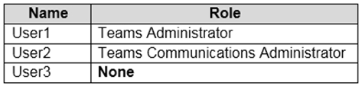
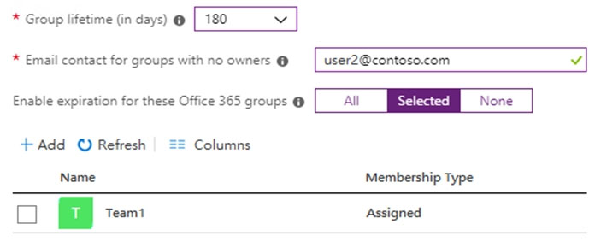
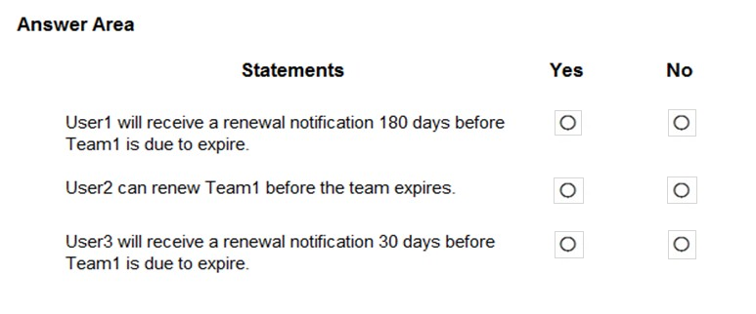
- Binh luan:
Correct. No, No, Yes. User 3 will get the renewal notification, as they created the Team they are the Team1 owner.
On exam March 2023
User1 will receive a renewal notification 180 days before Team1 expires No
User2 can renew Team1 before expiration Yes
User3 will receive a renewal notification 30 days before Team1 expires No
Jim Trott from the Vicar of Dibley confirmed that these answers are correct
30 days before the group expires, the group owners (or the email addresses that you specified for groups that don't have an owner) will receive an email allowing them to easily renew the group. If they don't renew it, they'll receive another renewal email 15 days before expiration. If they still haven't renewed it, they will receive one more email notification the day before expiration.

Cau 55
Dap an: B
Note: This question is part of a series of questions that present the same scenario. Each question in the series contains a unique solution that might meet the stated goals. Some question sets might have more than one correct solution, while others might not have a correct solution.
After you answer a question in this section, you will NOT be able to return to it. As a result, these questions will not appear in the review screen.
Your company has a Microsoft 365 subscription that uses an Azure Active Directory (Azure AD) tenant named contoso.com.
You need to prevent guest users in the tenant from using cameras during Microsoft Teams meetings.
Solution: From Microsoft Teams admin center, you modify the External sharing settings.
Does this meet the goal?
A. Yes
B. No ✓
- Binh luan:
You modify Guest Access in TAC not External Access or sharing - > Org-Wide Settings > Guest Access > Allow ip video > ON
There is no such thing as External Sharing in the TAC., Or you have External Access or You have Guest access. The correct location to do this is the Guest Access tab in the Teams Admin Center.
correct answer is B
Duplicate question. Same as question #5
I mean OFF :) default is ON so need to modify that

Cau 56
Dap an: C
You have a Microsoft 365 subscription and an on-premises Active Directory domain that syncs by using Azure AD Connect.
You need to change the Membership type of a group from Assigned (static) to Dynamic User.
What should you use?
A. Active Directory Users and Computers
B. the Microsoft Teams client
C. the Azure Active Directory admin center ✓
D. the Microsoft Teams admin center
- Binh luan:
This IS correct. to make this change in Azure AD admin center, click on the group, then properties, and toggle the membership type from Assigned to Dynamic user. This group would have been initially created in Microsoft 365 admin center with the Microsoft 365 group type.
It is only modified in AAD with the membership type settings.
Remember that for Dynamic Membership you require an AAD P1 license. That means the configuration of Dynamic Membership is an AAD thing, not an on premise AD thing.
Answer C is correct. This is done in Azure AD.
Don’t let the Azure AD Connect (AD sync) confuse you.
definitely answer is A, group was created on-prem, any changes to the group need to be done on-prem as well. Test it yourself :)
There is no dynamic groups in on-prem AD, you can only achive this on prem by scheduled powershell script.
Microsoft 365 Dynamic Group with Group Writeback is the desired object.

Cau 57
Dap an: N/A
HOTSPOT -
You have a Microsoft 365 E5 subscription that contains a hybrid deployment of Microsoft Skype for Business Server and a user named User1.
You need User1 to perform a tenant readiness assessment for Skype for Business upgrade by using Advisor for Teams.
Which two additional licenses should you assign to User1? To answer, select the appropriate settings in the answer area.
NOTE: Each correct selection is worth one point.
Hot Area:
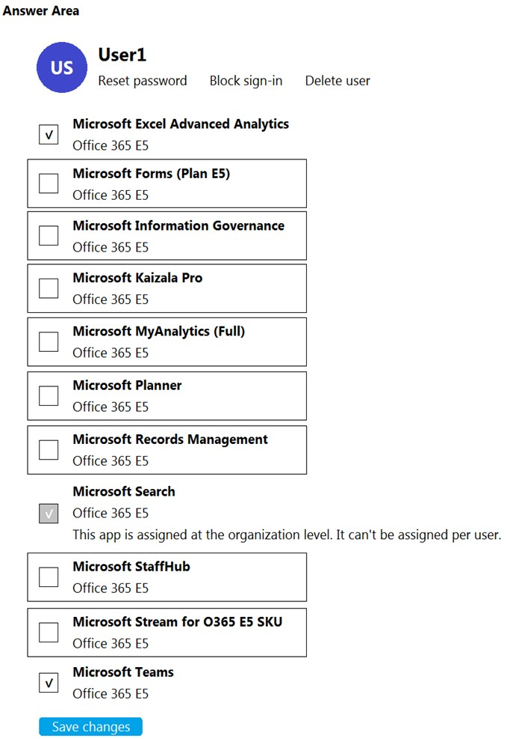
- Binh luan:
Answer is correct, You need Teams, Forms, and Planner licenses are required to use Advisor for Teams.
https://docs.microsoft.com/en-us/microsoftteams/use-advisor-teams-roll-out
Right.
According to MS “ Teams, Forms, and Planner licenses are required to use Advisor for Teams. However, you don't have to be a Teams admin to use Advisor for Teams - anybody in your organization can use it. ”
https://docs.microsoft.com/en-us/microsoftteams/use-advisor-teams-roll-out
Answer is correct
When creating a Deployment team for Chat, Teams, Channels and apps tasks are created so they can be assigned to that deployment team. Forms can then also be used to create survey's for user feedback
https://docs.microsoft.com/en-us/microsoftteams/use-advisor-teams-roll-out#using-advisor-for-teams

Cau 58
Dap an: N/A
HOTSPOT -
You have a Microsoft Teams team named Team1.
Team1 is deleted accidentally.
How should you complete the PowerShell script? To answer, select the appropriate options in the answer area.
NOTE: Each correct selection is worth one point.
Hot Area:
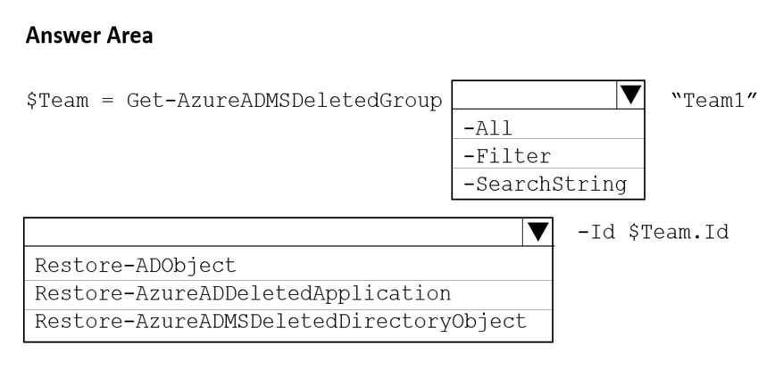
- Binh luan:
Appears to be correct:
https://docs.microsoft.com/en-us/powershell/module/azuread/get-azureadmsdeletedgroup?view=azureadps-2.0
https://docs.microsoft.com/en-us/powershell/module/azuread/restore-azureadmsdeleteddirectoryobject?view=azureadps-2.0
On exam june 2023
On exam March 2023
On exam Feb 2023
Did you got the same case study or different??

Cau 59
Dap an: C
You have a Microsoft Office 365 subscription that contains a user named User1.
You need to ensure that User1 can view Analytics & reports in the Microsoft Teams admin center. The solution must use the principle of least privilege.
Which role should you assign to User1?
A. Teams Communication support specialist
B. Skype for Business administrator
C. Global reader ✓
D. Global administrator
- Binh luan:
The correct answer is: C. Global reader
✅ Explanation:
To allow User1 to view Analytics & reports in the Microsoft Teams admin center while following the principle of least privilege, the Global reader role is the most appropriate choice.
Global reader: Grants read-only access to all administrative features across Microsoft 365, including Teams analytics and reports.
It does not allow making changes, which aligns with the least privilege principle.
❌ Why not the others?
A. Teams Communication
To allow User1 to view Analytics & reports in the Microsoft Teams admin center, and follow the principle of least privilege, you should assign:
Teams Communications Support Specialist
This role provides:
Read-only access to Call Analytics
Access to Teams usage reports
Just enough permissions to view reports without granting unnecessary admin control.
Global reader
Can view everything in all admin centers but gives TOO MUCH visibility for a simple reporting need.
Global administrator
Full access
Reports Reader
Users with this role can view usage reporting data and the reports dashboard in Microsoft 365 admin center and the adoption context pack in Fabric and Power BI. A user assigned to the Reports Reader role can access only relevant usage and adoption metrics. They don't have any admin permissions to configure settings or access the product-specific admin centers like Exchange.
https://learn.microsoft.com/en-us/entra/identity/role-based-access-control/permissions-reference#reports-rea
difficult to say what the right answer is. The aim of the question is, you need to ensure that user1 can view Analytics and Reports.
Global Reader has access to the Teams Admin Center and can see Analytics and Reports with the sub-items Usage Reports and Call Quality Dashboards.
Teams Communication support specialist also has access to the Teams Admin Center and also sees Analytics and Reports, but only with the sub-item Call Quality Dashboards.
Regarding least privilege and that we only know
https://learn.microsoft.com/en-us/microsoftteams/teams-analytics-and-reports/teams-reporting-reference#how-to-access-the-reports
To access the reports, you must be assigned one of the following roles:
Global administrator.
Teams or Skype for Business administrator.
Global reader (only tenant-level aggregate and no per-user or team data).

Cau 60
Dap an: B
Your company uses Microsoft Teams.
All the teams used by the company's legal department must meet the following compliance requirements:
✑ Each team must expire 365 days after it is created.
✑ All team content must be deleted when the team expires.
✑ An administrator must be able to restore deleted team content for 30 days.
What should you do?
A. From the Microsoft 365 compliance center, create a retention policy.
B. From the Azure Active Directory admin center, configure Microsoft 365 Groups expiration. ✓
C. From the Microsoft 365 admin center, modify the Office 365 group settings.
D. From the Microsoft Teams admin center, modify the team's policy.
- Binh luan:
Answer is correct!
https://learn.microsoft.com/en-us/microsoft-365/solutions/microsoft-365-groups-expiration-policy?view=o365-worldwide
The answer is correct but the link is kinda misleading. This explains it more clearly: " An administrator will have to enable the expiration policy and set the properties for it to take effect. To enable it, go to Azure Active Directory > Groups > Expiration."
https://docs.microsoft.com/en-US/microsoftteams/network-planner

Cau 61
Dap an: A, D
You have a Microsoft 365 subscription that uses Microsoft Teams. All users are assigned Microsoft Office 365 Enterprise E3 license.
You need to ensure that the users can join scheduled meetings by dialing a toll-free phone number.
Which two add-on licenses should you assign to the users? Each correct answer presents part of the solution.
NOTE: Each correct selection is worth one point.
A. Communication Credits ✓
B. Microsoft 365 Phone System - Virtual User
C. Microsoft 365 Domestic Calling Plan
D. Microsoft 365 Audio Conferencing ✓
E. Common Area Phone
- Binh luan:
On Exam Feb 2023
Right from the Microsoft Learn module for MS-700 course "Plan for Teams licensing":
Communication Credits provide a monthly pool of minutes that can also be used for PSTN phone calls, if all your Calling Plan minutes get used before the beginning of the next month.
If you want toll-free numbers for Audio Conferencing, auto attendants, or call queues, you'll need to set up Communications Credits.
A and D.
A&D
If you want to use toll-free numbers with Microsoft Teams, you need to set up Communications Credits. Microsoft recommends that you set up Communications Credits for your Microsoft Teams Calling Plan (Domestic, International, or Pay-As-You-Go) and Audio Conferencing users who need to dial out to any destination. Some destinations may not be included in your Calling Plans or Audio Conferencing subscriptions.
From: https://learn.microsoft.com/en-us/microsoftteams/set-up-communications-credits
A & D. It says toll free so you will need communications credit. Virtual user licenses are for resource accounts

Cau 62
Dap an: N/A
HOTSPOT -
You have a Microsoft 365 subscription that uses Microsoft Teams.
You plan to deploy collaboration bars for Microsoft Teams.
You need to manage built-in software and firmware updates for the collaboration bars. The solution must use the principle of least privilege.
Which updates can be applied automatically, and which role is required to perform manual updates for the collaboration bars? To answer, select the appropriate options in the answer area.
NOTE: Each correct selection is worth one point.
Hot Area:
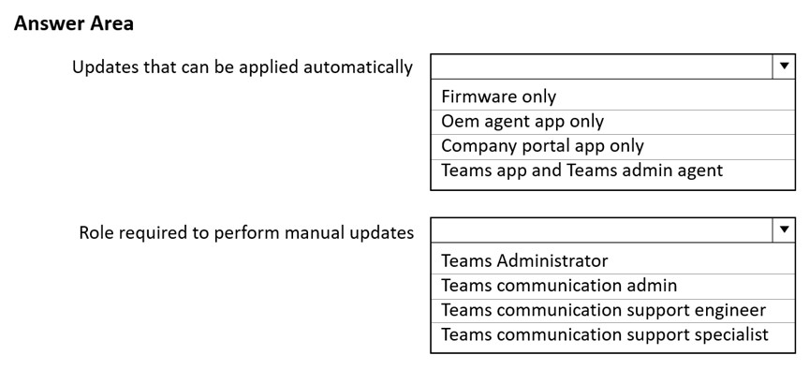
- Binh luan:
Was on the exam 1/3/23
On test 28.04.2023 (I'm not a bot you can trust me :D) - Go for the high upvoted answers in discussion :)
you are repeating yourself so yes. you are a bot. :D
was on exam july 2025
On Exam Feb 2023

Cau 63
Dap an: A
You plan to implement Microsoft Teams for 300 users.
For the first stage of the deployment, you will enable the following features:
✑ Audio
✑ Video
✑ Screen sharing
Users will be prevented from using the following features:
✑ File sharing
✑ PSTN calling
✑ Conference audio
✑ Conference video
✑ Conference screen sharing
You need to calculate how much network bandwidth is required for the first-stage deployment.
What should you use?
A. Network Planner ✓
B. Network Assessment Tool
C. Advisor for Teams
D. Bandwidth Utilization Analyzer
- Binh luan:
True, because Network Planner: "Generate reports and calculate bandwidth requirements for Teams usage."
answer is A
Answer is correct.

Cau 64
Dap an: B
You have a Microsoft 365 subscription that uses Microsoft Teams and contains the groups shown in the following table.
Which groups can be converted into a team?
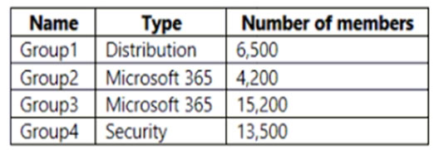
A. Group1 only
B. Group2 only ✓
C. Group4 only
D. Group2 and Group3 only
E. Group1, Group2, Group3, and Group4
- Binh luan:
Key words: “Converted”
- Maximum *size* of distribution list, security group or Microsoft 365 group that can be **imported** in to a team 3,500
- Maximum number of members in a **Microsoft 365** group that can be **converted** to a team 10,000
So only M365 groups can be converted and only those with less than 10k members.
Technically Group1 could be ugraded to a M365 group and then sed group could be made into a Team.
Answer is B. Group 2.
https://learn.microsoft.com/en-us/microsoftteams/limits-specifications-teams
Maximum size of distribution list, security group or Microsoft 365 group that can be imported in to a team 3,500
Maximum number of members in a Microsoft 365 group that can be converted to a team 10,000
Answer is BC
Number of members in a team 25,000
Number of owners per team 100
Number of org-wide teams allowed in a tenant 5
Number of members in an org-wide team 10,000
Sorry Answer is D group 2 and group 3

Cau 65
Dap an: N/A
HOTSPOT -
You are reviewing the planned implementation of information barriers for your company.
You run the following command.
You activate the information barrier policies.
For each of the following statements, select Yes if the statement is true. Otherwise, select No.
NOTE: Each correct selection is worth one point.
Hot Area:
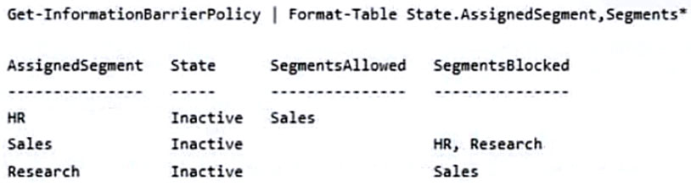
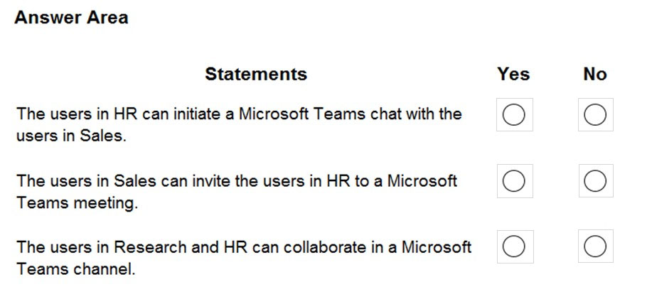
- Binh luan:
YNN - The last option would be blocked as "Allow policies allow one segment to communicate with only certain other segments."
Could we assume HR will be able to just INITIATE a chat with Sales but Sales won't be able to answer it? (because there is no allowed policy from Sales to HR segment)
After searching i found this
Information barriers only supports two-way communication and collaboration restrictions. For example, a scenario where Marketing can communicate and collaborate with Day Traders, but Day Traders cannot communicate and collaborate with Marketing isn't supported.
https://learn.microsoft.com/en-us/microsoft-365/compliance/information-barriers?view=o365-worldwide
So after looking back at the answers that are available... The answers are No to All. There is no bidirecti
Not supported not automatically means that it isn´t functional.
I think you need to test it to know what really happens. If it is not functional I would agree with you.
Box 1 is only aksing if HR can INITIATE a chat with Sales. From the HR's IB policy, it is definitely YES. While Sales may NOT be able to reply HR messages because of Sales' IB policy. But this is not what the question is asking for. So, Box 1 should be YES.

Cau 67
Dap an: C
You have a Microsoft 365 subscription that uses Microsoft Teams.
When a user creates a new team, the user sees the templates shown in the following exhibit.
You need to ensure that the user sees only the Manage a Project template.
What should you do?
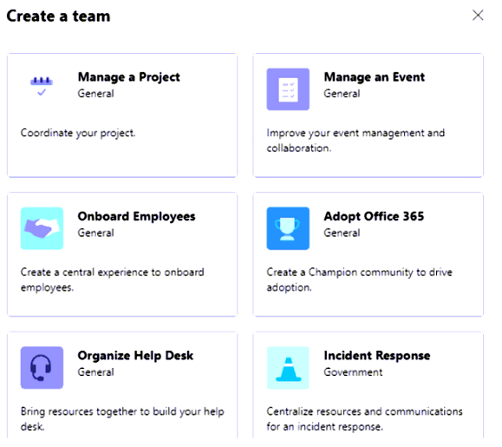
A. From the Microsoft Teams admin center, modify the team templates.
B. From PowerShell, modify the team templates.
C. From the Microsoft Teams admin center, modify the templates policies. ✓
D. From PowerShell, modify the Teams policies.
- Binh luan:
C is the answer
Answer C results in only modifying the template itself, not in its availability/visibility to a user when creating a site. In my opinion, only PS cmdlet Grant-SPOSiteDesignRights would do the trick:
https://learn.microsoft.com/en-us/sharepoint/dev/declarative-customization/site-design-scoping
The provided answer is correct.
C - Correct answer

Cau 68
Dap an: D
Your company uses Microsoft Teams.
A URL protection report shows many Blocked and clicked through actions.
You need to prevent users from clicking through to blocked URLs.
Which type of policy should you configure?
A. Anti-spam
B. Anti-phishing
C. Safe Attachments
D. Safe Links ✓
- Binh luan:
Safe Links (Defender for O365) is the correct one, as it is the only MS365 security module that is responsible for protecting URLs.
https://learn.microsoft.com/en-us/microsoft-365/security/office-365-security/safe-links-about?view=o365-worldwide#safe-links-settings-for-microsoft-teams
Microsoft Teams: Safe Links protection for links in Teams conversations, group chats, or from channels is controlled by Safe Links policies.
Safe Links is a feature in Defender for Office 365 that provides URL scanning and rewriting of inbound email messages in mail flow, and time-of-click verification of URLs and links in email messages, Team
D. Safe Links
URLs - Links, answer is pretty obvious ;)

Cau 69
Dap an: N/A
HOTSPOT -
You have a Microsoft 365 subscription that uses Microsoft Teams.
You have a team named Project1 that contains the users shown in the following table.
You create a Microsoft 365 groups expiration policy that has the following configurations:
✑ Group lifetime (in days): 180
✑ Email contact for groups with no owners: Admin1
✑ Enable expiration for these Microsoft 365 groups: Project1
The group expiration for Project1 is May 31, 2022.
Which users will be notified to renew Project1, and when the users will receive their first renewal notification? To answer, select the appropriate options in the answer area.
NOTE: Each correct selection is worth one point.
Hot Area:
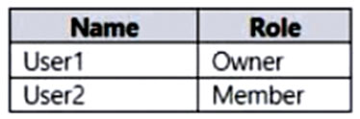
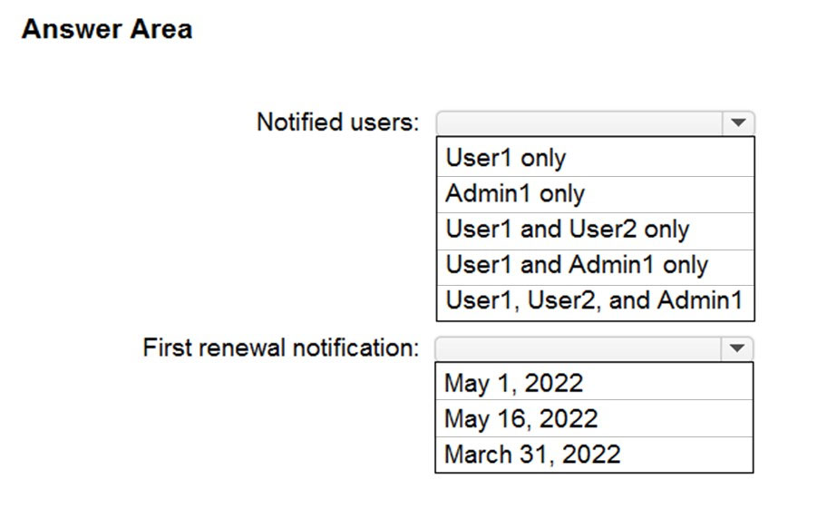
- Binh luan:
Answer:
- User 1 only: Renewal notifications are emailed to group owners 30 days, 15 days, and one day prior to group expiration. Project1 has User1 as owner so this user will receive a renewal notification and not Admin1. Admin 1 would only receive the renewal notifications if Project1 team was without an owner.
- May 1, 2022: First renewal notification will take place 30 days prior to group expiration.
correct,
User 1 only: only group owners can be notified
May 1: 30 days before, 15 days before, and 1 day before.

Cau 70
Dap an: N/A
DRAG DROP
-
Your company uses Teams.
All users are assigned a Microsoft 365 E3 license.
You need to purchase add-on licenses that will enable the following features for the Teams environment:
• Microsoft Purview Information Barriers
• Data loss prevention (DLP) for Teams chat and channel messages
• Safe attachments for Microsoft SharePoint, OneDrive, and Teams
Which add-on license should you purchase for each feature? To answer, drag the appropriate licenses to the correct features. Each license may be used once, more than once, or not at all. You may need to drag the split bar between panes or scroll to view content.
NOTE: Each correct selection is worth one point.
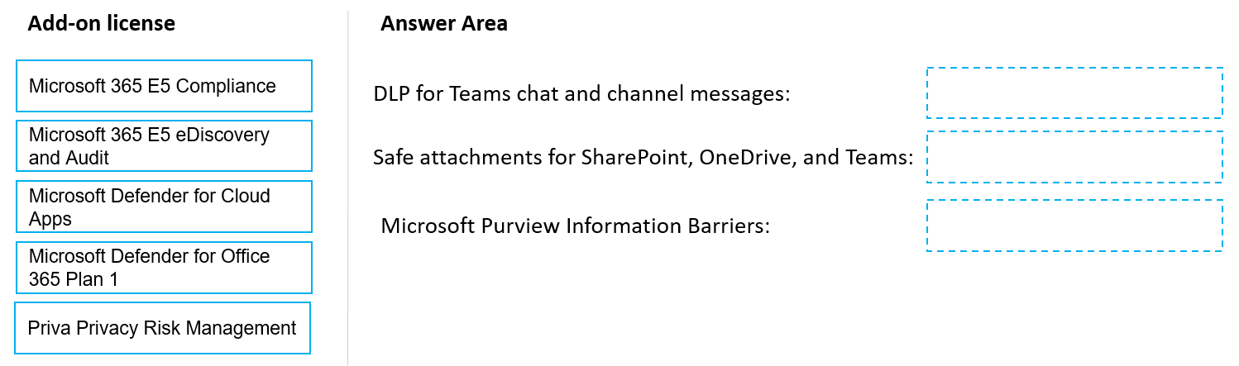
- Binh luan:
On the exam 06/23
on the exam late dec/2022
On exam 10/26/23
Answer is correct. Followed the link shared by "unbelievable".
https://learn.microsoft.com/en-us/office365/servicedescriptions/microsoft-365-service-descriptions/microsoft-365-tenantlevel-services-licensing-guidance/microsoft-365-security-compliance-licensing-guidance
All the answers are in here:
https://learn.microsoft.com/en-us/office365/servicedescriptions/microsoft-365-service-descriptions/microsoft-365-tenantlevel-services-licensing-guidance/microsoft-365-security-compliance-licensing-guidance

Cau 71
Dap an: N/A
HOTSPOT
-
You have a Microsoft 365 subscription that uses Microsoft Teams to collaborate with guest users.
You need to use monthly active users (MAU) billing and access reviews to monitor the team membership of the guest users.
Which additional licenses should you assign, and what should you do to enable MAU billing? To answer, select the appropriate options in the answer area.
NOTE: Each correct selection is worth one point.
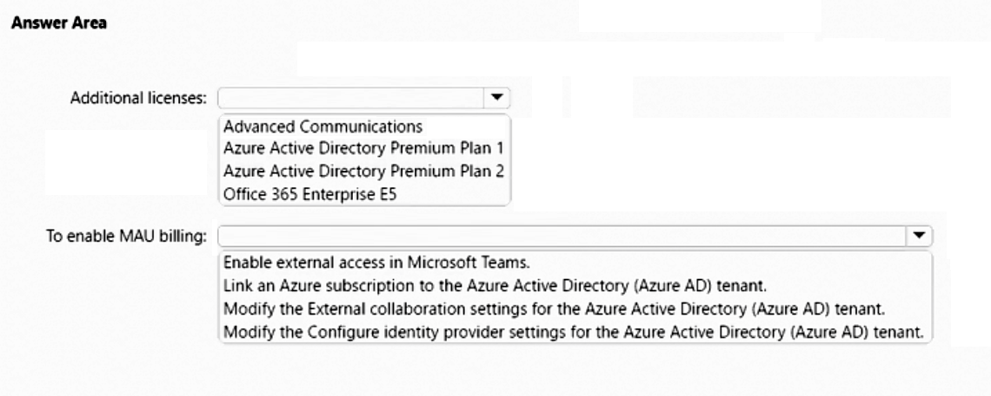
- Binh luan:
Correct answer is :
Azure AD Premium Plan 2 (This will make sure you get Access Review feature as well as MAU billing. With P1 you wont get Access Review but can get MAU billing. )
An Azure AD tenant must be linked to a resource group within an Azure subscription for proper billing and access to MAU features.
Access Review is an Azure AD Premium plan 2 feature, so I would say Azure AD Premium plan 2 answer : https://learn.microsoft.com/en-us/azure/active-directory/governance/access-reviews-overview#license-requirements
Regarding second one, I agree link Azure subscription : https://learn.microsoft.com/en-us/azure/active-directory/external-identities/external-identities-pricing
confusing as E5 also include P2 access review, cmiiw
Depends which e5 you are looking at. office 365 e5 is different than microsoft 365 e5. (m365 has azure ad premium p2 whereas o365 e5 doesnot).
"Your first 50,000 MAUs per month are free for both Premium P1 and Premium P2 features."
https://learn.microsoft.com/en-us/azure/active-directory/external-identities/external-identities-pricing

Cau 72
Dap an: B
You have a Microsoft 365 E5 subscription that uses Teams.
When you attempt to create a new sensitivity label for Teams, you discover that the Groups & sites option is unavailable as shown in the following exhibit.
You need to be able to select Groups & sites when you create the sensitivity label.
Which cmdlet should you run?
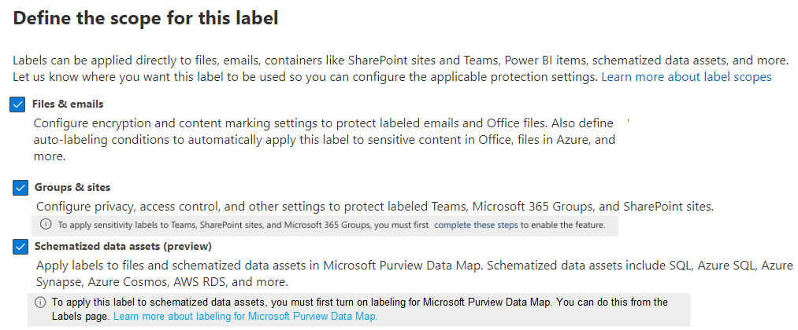
A. Set-UnifiedGroup
B. Set-AzureADDirectorySetting ✓
C. Set-CsTeamsEnhancedEncryptionPolicy
D. Set-SPOSiteOffice365Group
- Binh luan:
Was on the exam 2/16/23
Azure AD and MSOnline PowerShell modules are deprecated as of March 30, 2024.
If you have this Question after this date, the correct answer is
Update-MgBetaDirectorySetting
b is correct
https://learn.microsoft.com/en-us/azure/active-directory/enterprise-users/groups-assign-sensitivity-labels
Set-AzureADDirectorySetting -Id $grpUnifiedSetting.Id -DirectorySetting $Setting
To understand the command:
$Setting["EnableMIPLabels"] = "True"

Cau 73
Dap an: N/A
SIMULATION
-
Please wait while the virtual machine loads. Once loaded, you may proceed to the lab section. This may take a few minutes, and the wait time will not be deducted from your overall test time.
When the Next button is available, click it to access the lab section. In this section, you will perform a set of tasks in a live environment. While most functionality will be available to you as it would be in a live environment, some functionality (e.g. copy and paste, ability to navigate to external websites) will not be possible by design.
Scoring is based on the outcome of performing the tasks stated in the lab. In other words it doesn’t matter how you accomplish the task, if you successfully perform it, you will earn credit for that task.
Labs are not timed separately, and this exam may have more than one lab that you must complete. You can use as much time as you would like to complete each lab. But you should manage your time appropriately to ensure that you are able to complete the lab(s) and all other sections of the exam in the time provided.
Please not that once you submit your work by clicking the Next button within a lab, you will NOT be able to return to the lab.
You may now click next to proceed to the lab.
Username and password.
Use the following login credentials as needed:
To enter your username, place your cursor in the Sign in box and click on the username below.
To enter your password, place your cursor in the Enter password box and click on the password below.
Microsoft 365 Username:
admin@XXXXXXXXXXX.onmicrosoft.com
Microsoft 365 Password: XXXXXXXXXXXX
If the Microsoft 365 portal does not load successfully in the browser, press CTRL-K to reload the portal in a new browser tab.
The following information is for technical support purposes only:
Lab Instance: 26178313
-
Task 3
-
Adele Vance is a member of your company’s technology adoption team.
You need to provide only Adele with the ability to turn on and off Teams preview features.
To complete this task, sign in to the Microsoft 365 portal.
- Binh luan:
Does MS-700 exam contain simulation labs like this?
Updated solution: TAC - Settings & policies - Tab "Custom policies for users & groups" - Teams update management - Add - Name policy (eg. "Preview features On") - set "Show Teams preview features" to "On for everyone" - Save; Select policy - assign users - choose user - Save; Important: also go to TAC - Settings & policies - Tab "Global org-wide default settings" - Teams update management - set "Show Teams Preview features" to "Off" so that only the users with the policy assigned have the previe
This appears to have changed, since the Show Teams preview features now has a drop-down menu with Off, Users can opt in, On for users in Current Channel(Preview) and On for everyone.
Which of the options are correct??
For me if you should on and off now correct is „Users can opt in”

Cau 74
Dap an: N/A
SIMULATION
-
Please wait while the virtual machine loads. Once loaded, you may proceed to the lab section. This may take a few minutes, and the wait time will not be deducted from your overall test time.
When the Next button is available, click it to access the lab section. In this section, you will perform a set of tasks in a live environment. While most functionality will be available to you as it would be in a live environment, some functionality (e.g. copy and paste, ability to navigate to external websites) will not be possible by design.
Scoring is based on the outcome of performing the tasks stated in the lab. In other words it doesn’t matter how you accomplish the task, if you successfully perform it, you will earn credit for that task.
Labs are not timed separately, and this exam may have more than one lab that you must complete. You can use as much time as you would like to complete each lab. But you should manage your time appropriately to ensure that you are able to complete the lab(s) and all other sections of the exam in the time provided.
Please not that once you submit your work by clicking the Next button within a lab, you will NOT be able to return to the lab.
You may now click next to proceed to the lab.
Username and password.
Use the following login credentials as needed:
To enter your username, place your cursor in the Sign in box and click on the username below.
To enter your password, place your cursor in the Enter password box and click on the password below.
Microsoft 365 Username:
admin@XXXXXXXXXXX.onmicrosoft.com
Microsoft 365 Password: XXXXXXXXXXXX
If the Microsoft 365 portal does not load successfully in the browser, press CTRL-K to reload the portal in a new browser tab.
The following information is for technical support purposes only:
Lab Instance: 26178313
-
Task 10
-
You need to set Microsoft SharePoint as the only cloud storage option for all teams.
To complete this task, sign in to the Microsoft 365 portal.
- Binh luan:
The Answer is wrong. you should do this in TAC > Teams Settings>Files> all options turn off
The question states "To complete this task, sign in to the Microsoft 365 portal"
nwmc is correct
Agreed. I have no idea what the suggested answer is trying to accomplish based on the question.
Do you had this question in a real exam situation? Maybe you have no access to the TAC, but only the Teams Client. If you have access to the TAC, I would agree with you.

Cau 75
Dap an: N/A
SIMULATION
-
Please wait while the virtual machine loads. Once loaded, you may proceed to the lab section. This may take a few minutes, and the wait time will not be deducted from your overall test time.
When the Next button is available, click it to access the lab section. In this section, you will perform a set of tasks in a live environment. While most functionality will be available to you as it would be in a live environment, some functionality (e.g. copy and paste, ability to navigate to external websites) will not be possible by design.
Scoring is based on the outcome of performing the tasks stated in the lab. In other words it doesn’t matter how you accomplish the task, if you successfully perform it, you will earn credit for that task.
Labs are not timed separately, and this exam may have more than one lab that you must complete. You can use as much time as you would like to complete each lab. But you should manage your time appropriately to ensure that you are able to complete the lab(s) and all other sections of the exam in the time provided.
Please not that once you submit your work by clicking the Next button within a lab, you will NOT be able to return to the lab.
You may now click next to proceed to the lab.
Username and password.
Use the following login credentials as needed:
To enter your username, place your cursor in the Sign in box and click on the username below.
To enter your password, place your cursor in the Enter password box and click on the password below.
Microsoft 365 Username:
admin@XXXXXXXXXXX.onmicrosoft.com
Microsoft 365 Password: XXXXXXXXXXXX
If the Microsoft 365 portal does not load successfully in the browser, press CTRL-K to reload the portal in a new browser tab.
The following information is for technical support purposes only:
Lab Instance: 26178313
-
Task 11
-
You need to restrict external Teams communication for both calling and personal chat to only organizational users that use the microsoft.com domain.
To complete this task, sign in to the Microsoft 365 portal.
- Binh luan:
https://learn.microsoft.com/en-us/microsoftteams/trusted-organizations-external-meetings-chat?WT.mc_id=TeamsAdminCenterCSH&tabs=organization-settings#organization-settings-and-user-policies-for-external-access
Should select block only specific external domains
Correct, from TAC>Users>External Access you allow specific domains

Cau 76
Dap an: N/A
SIMULATION
-
Please wait while the virtual machine loads. Once loaded, you may proceed to the lab section. This may take a few minutes, and the wait time will not be deducted from your overall test time.
When the Next button is available, click it to access the lab section. In this section, you will perform a set of tasks in a live environment. While most functionality will be available to you as it would be in a live environment, some functionality (e.g. copy and paste, ability to navigate to external websites) will not be possible by design.
Scoring is based on the outcome of performing the tasks stated in the lab. In other words, it doesn’t matter how you accomplish the task, if you successfully perform it, you will earn credit for that task.
Labs are not timed separately, and this exam may have more than one lab that you must complete. You can use as much time as you would like to complete each lab. But you should manage your time appropriately to ensure that you are able to complete the lab(s) and all other sections of the exam in the time provided.
Please not that once you submit your work by clicking the Next button within a lab, you will NOT be able to return to the lab.
You may now click next to proceed to the lab.
Username and password.
Use the following login credentials as needed:
To enter your username, place your cursor in the Sign in box and click on the username below.
To enter your password, place your cursor in the Enter password box and click on the password below.
Microsoft 365 Username:
admin@XXXXXXXXXXX.onmicrosoft.com
Microsoft 365 Password: XXXXXXXXXXXX
If the Microsoft 365 portal does not load successfully in the browser, press CTRL-K to reload the portal in a new browser tab.
The following information is for technical support purposes only:
Lab Instance: 26178313
-
Task 12
-
You need to create a Microsoft 365 group named TeamsAdmin that can manage Teams Phone configurations without being able to manage teams and channels.
To complete this task, sign in to the Microsoft 365 portal.
- Binh luan:
I think the role should be Team Communication Administrator or Teams Telephony Administrator (least privilege)
365 group cannot be assigned to an administrative role, you havo to create a security group and then assign teams device administrator
I'm only able to do this in "Microsoft Entra admin center"
You create the O365 group and make sure you choose YES under "Microsoft Entra roles can be assigned to the group"
Then you're able to click on the group settings and click "Assigned Roles" and assign Teams Device Administrator. Holy smokes, anyone know where we can get some updated exams??
Can find Teams device admin role only in AAD console but 365 console. Do not know what I am doing wrong.
I don't fully understand the answers , can anyone simplify it ?
Thanks

Cau 77
Dap an: N/A
DRAG DROP
-
You have a Microsoft 365 E5 subscription that uses Microsoft Teams.
You need to ensure that the users in your organization can communicate with external users who use Teams for personal use.
How should you complete the PowerShell cmdlets? To answer, drag the appropriate values to the correct targets. Each value may be used once, more than once, or not at all. You may need to drag the split bar between panes or scroll to view content.
NOTE: Each correct selection is worth one point.
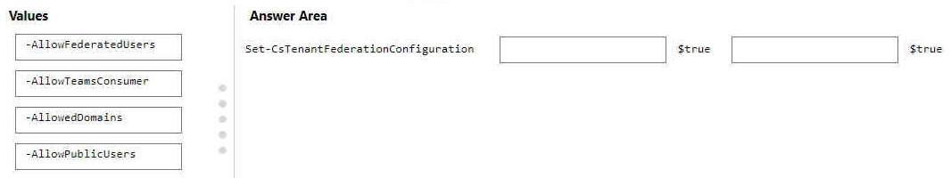
- Binh luan:
TeamsConsumer is needed for Teams personal accounts:
https://erik365.blog/2021/11/12/how-to-enable-teams-business-users-to-chat-with-teams-personal-accounts/
But firstly you need to enable AllowFederatedUsers
Correct, however the order should not matter https://learn.microsoft.com/en-us/powershell/module/skype/set-cstenantfederationconfiguration
That’s right:
-AllowFederatedUsers: When set to True (the default value) users will be potentially allowed to communicate with users from other domains. If this property is set to False then users cannot communicate with users from other domains
-AllowTeamsConsumer: Allows federation with people using Teams with an account that's not managed by an organization.
Not valid here would be:
-AllowPublicUsers: When set to True (the default value) users will be potentially allowed to communicate wi
Set-CsTenantFederationConfiguration -AllowTeamsConsumer $true -AllowPublicUsers $true
OR
Set-CsTenantFederationConfiguration -AllowPublicUsers $true -AllowTeamsConsumer $true
Explaination :
Set-CsTenantFederationConfiguration -->enable and disable federation with other domains and federation with public providers.
-AllowPublicUsers -->When set to True (the default value) users will be potentially allowed to communicate with users who have accounts on public IM and presence providers such as W
I'd go for -AllowPublicUsers and -AllowTeamsConsumers given the "personal use" requirement.

Cau 78
Dap an: C
You have a Microsoft 365 E3 subscription that uses Microsoft Teams.
You plan to deploy 20 conference phones that will support Direct Routing and one-touch join for Teams calendar meetings.
Which type of license do you require for each phone?
A. Common Area Phone
B. Microsoft 365 Business Standard
C. Microsoft Teams Rooms Standard ✓
D. Microsoft 365 E3
- Binh luan:
Common Area Phone is no more exist, Now is Microsoft Teams Shared Devices.
and TSD including Phone System.
I am pretty sure the answer should be Teams Room Standard license. (Although the correct name is Teams Room Basic.)
In the following link about Common Area Phone licenses, it states "For a more complete meeting room experience, including audio conferencing, consider purchasing a dedicated Teams Rooms license with a Teams Rooms device instead."
https://learn.microsoft.com/en-us/microsoftteams/set-up-common-area-phones
"The Teams Rooms Basic license includes scheduling, joining meetings, content
Should be Teams Phone or E5 or Microsoft Teams Shared Devices (old Common Area Phone)
Microsoft Teams Rooms Basic licenses aren't supported on and won't work with Teams Phone devices. An account with a Basic license assigned will be blocked from sign in.
Teams Shared Devices,
To deploy conference phones that support Direct Routing and one-touch join for Teams calendar meetings, you would require the Common Area Phone license for each phone.
The Common Area Phone license is specifically designed for devices like conference phones, lobby phones, and shared devices that are not associated with a specific user. It provides the necessary capabilities for these devices to connect to Microsoft Teams, including the ability to make and receive calls, access voicemail, and jo

Cau 79
Dap an: N/A
DRAG DROP
-
Your company has a trading department and a research department.
The company purchases a Microsoft 365 E5 subscription.
You plan to deploy Microsoft 365 E5 licenses to all users.
You need to block communication between the users in the trading department and the users in the research department.
Which four actions should you perform in sequence? To answer, move the appropriate actions from the list of actions to the answer area and arrange them in the correct order.
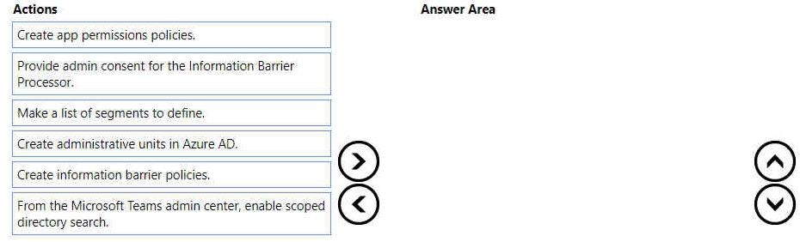
- Binh luan:
STEP1: Prerequisites (among others):
- Scoped directory search
- Admin consent for IB in Microsoft Teams
STEP2: Segment users in your organization
STEP 3: Create IB policies
STEP 4: Apply IB policies
STEP 5: Configuration for information barriers on SharePoint and OneDrive
…….
It would be great if you answer them according to the questions as your answers does not reflect the options.
the given answers are correct. They havent given you all the options, but what they have given seems to be the right order according to the link from nwmc
https://learn.microsoft.com/en-us/microsoft-365/compliance/information-barriers-policies?view=o365-worldwide
To effectively block communication between users in the trading department and the research department, follow these steps in sequence:
1. **Make a list of segments to define**:
Identify the specific user groups (segments) that need to be separated. For example, create segments for the trading department and the research department.
2. **Create information barrier policies**:
Information barrier policies allow you to restrict communication and collaboration between specific groups of users. De
https://learn.microsoft.com/en-us/microsoft-365/compliance/information-barriers-policies?view=o365-worldwide

Cau 80
Dap an: N/A
DRAG DROP
-
You have a Microsoft 365 E5 subscription that contains a Microsoft Teams team named Confidential.
You need to ensure that guest users cannot be added to the Confidential team.
How should you complete the PowerShell script? To answer, drag the appropriate values to the correct targets. Each value may be used once, more than once, or not at all. You may need to drag the split bar between panes or scroll to view content.
NOTE: Each correct selection is worth one point.
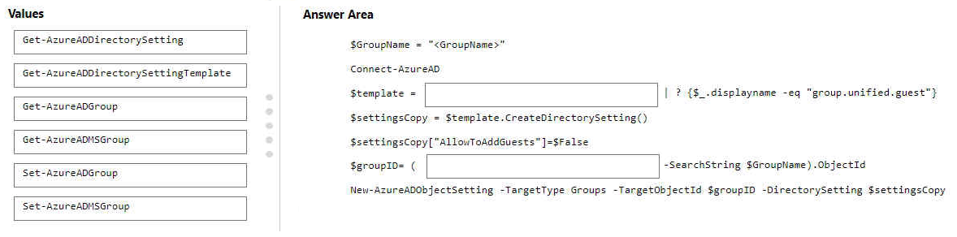
- Binh luan:
Get-AzureADDirectorySettingTemplate and Get-AzureADGroup:
$GroupName = "<GroupName>"
Connect-AzureAD
$template = Get-AzureADDirectorySettingTemplate | ? {$_.displayname -eq "group.unified.guest"}
$settingsCopy = $template.CreateDirectorySetting()
$settingsCopy["AllowToAddGuests"]=$False
$groupID= (Get-AzureADGroup -SearchString $GroupName).ObjectId
New-AzureADObjectSetting -TargetType Groups -TargetObjectId $groupID -DirectorySetting $settingsCopy
https://learn.microsoft.com/en-us/microsoft-36
Second answer is wrong, should be Get-AzureADGroups (as shown below and confirmed in link)
First Blank: Get-AzureADDirectorySettingTemplate
Second Blank: Get-AzureADGroup
The answer should be, this is an absurd question, which I'm looking up on the internet if I ever need to do it, and will never remember a month after I've passed. But thx for the answer Carlos.
The answer should be "Get-AzureADDirectorySettingTemplate" and "Get-AzureADGroup"

Cau 81
Dap an: B, C
You have a Microsoft 365 subscription named contoso.com that uses Microsoft Teams.
You need to ensure that Microsoft Teams users can perform the following tasks:
• Search for customers that use Skype (Consumer).
• Start a Skype chat with the customers.
Which two actions should you perform? Each correct answer presents part of the solution.
NOTE: Each correct selection is worth one point.
A. From the Microsoft Teams admin center, turn on guest access.
B. From the Microsoft Teams admin center, turn on external access. ✓
C. Add a _sipfederationtls SRV record to the contoso.com DNS domain. ✓
D. Add a _sipinternaltls SRV record to the contoso.com DNS domain.
E. From the Azure portal, configure Azure AD B2C.
- Binh luan:
B and C
On exam 31/03/2023
On exam 30-March-2023
B and C:
SRV _sipfederationtls._tcp.<sipdomain>
_sipfederationtls._tcp.contoso.com External Access Edge FQDN
Access1.contoso.com Used for Federation and public IM connectivity
B and C are the correct answers.
Correct me if I'm wrong. I don't have exact details but this is the closest answers to this question.
B. From the Microsoft Teams admin center, turn on external access.
D. Add a _sipinternaltls SRV record to the contoso.com DNS domain.
You need to turn on external access in the Microsoft Teams admin center to allow users to communicate with Skype consumers. You also need to add a _sipinternaltls SRV record to the contoso.com DNS domain to allow Skype consumers to find and communicate with users on your organization's domain.
This will allow your teams users to search for customers that use Skyp

Cau 82
Dap an: N/A
HOTSPOT
-
You have a Microsoft 365 subscription that uses Microsoft Teams.
You need to analyze the following:
• The call and meeting quality of individual users
• The call and meeting quality trends of your company
What should you use? To answer, select the appropriate options in the answer area.
NOTE: Each correct selection is worth one point.
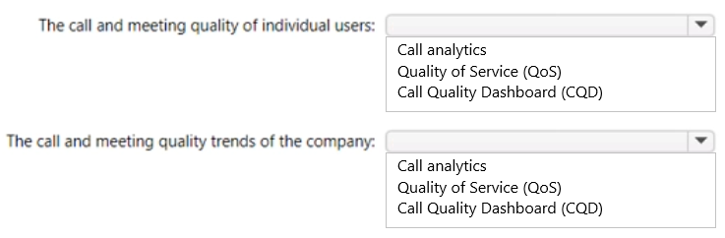
- Binh luan:
On test 01/27/2023
Looks Correct:
Call Analytics - Call & Meetings - Individuals
QOS - Troubleshooting network
CQD - Call & Meetings - Org Wide
Can see what call analytics looks like here.
https://learn.microsoft.com/en-us/microsoftteams/use-call-analytics-to-troubleshoot-poor-call-quality#where-to-find-per-user-call-analytics
Correct, see link
https://learn.microsoft.com/en-us/microsoftteams/monitor-call-quality-qos
the answers are correct https://learn.microsoft.com/en-us/microsoftteams/quality-of-experience-review-guide

Cau 83
Dap an: A
Your company uses Microsoft Teams.
You are assigned the Groups Administrator role.
You discover that you cannot create an expiration policy in Microsoft 365.
You need to create the expiration policy. The solution must use the principle of least privilege.
What should you do first?
A. Upgrade the Azure AD license. ✓
B. Modify the global (Org-wide default) app permission policy.
C. Request the Global Administrator role.
D. Purchase a Microsoft Defender for Identity license.
- Binh luan:
Configuring and using the expiration policy for Microsoft 365 groups requires you to possess but not necessarily assign Microsoft Entra ID P1 or P2 licenses for the members of all groups to which the expiration policy is applied. For more information, see Getting started with Microsoft Entra ID P1 or P2.
Groups Administrator ---- Members of this role can create/manage groups, create/manage groups settings like naming and expiration policies, and view groups activity and audit reports.(as of Mar
Group administrator can already create expiration policies
Groups Administrator role can manage/create the expiration policy.
So the answer is: A. Upgrade the Azure AD license.
https://learn.microsoft.com/en-us/microsoft-365/solutions/microsoft-365-groups-expiration-policy?view=o365-worldwide
See link by Nico 282 : You are assigned group administrator, so you are allowed to set retentions. The other requirement is an AzureAD license.
https://techcommunity.microsoft.com/t5/microsoft-365-groups/introducing-the-groups-admin-role/m-p/978995

Cau 84
Dap an: N/A
HOTSPOT
-
Your company uses Microsoft Teams and has the users shown in the following table.
You plan to use Call Quality Dashboard (CQD) to monitor call and meeting quality.
You need to ensure that CQD displays current network and tenant data in reports.
Which action should be performed, and which user can perform the action? To answer, select the appropriate options in the answer area.
NOTE: Each correct selection is worth one point.
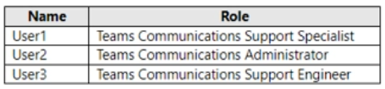
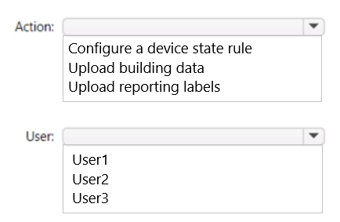
- Binh luan:
Teams Communications Administrator => Upload and update CQD building data
https://learn.microsoft.com/en-us/microsoftteams/using-admin-roles
Answer Looks good
https://learn.microsoft.com/en-us/microsoftteams/using-admin-roles

Cau 85
Dap an: D
You have a Microsoft 365 E3 subscription that contains 500 users. All the users have computers that run Windows 10 and are joined to Azure AD.
You need to generate a report that identifies which documents the users copied from Microsoft Teams to USB devices.
What should you do first?
A. Create a custom data loss prevention (DLP) policy.
B. Assign the Enterprise Mobility + Security E5 add-on to each user.
C. Onboard the Windows 10 computers to Endpoint data loss prevention (Endpoint DLP).
D. Assign the Microsoft 365 E5 compliance add-on to each user. ✓
- Binh luan:
I'm changing my mind: Here's a new analysis after reading all of the Microsoft documentation.
The E3 license does not include the Data Loss Prevention (DLP) functionality to monitor file transfer from Teams to USB. You need to have the E5 license of Microsoft 365 to use this feature. However, the E3 license includes other security and compliance features such as Azure Active Directory Premium P1 and Microsoft Defender for Office 365.
To monitor file transfer from Teams to USB devices, you can
With Endpoint DLP, you can monitor and control the data transfers between the computers and USB devices.
But Microsoft 365 E3 subscription does not include Endpoint DLP
So the answer is D(It is first thing to do)
To access and use Endpoint DLP functionality, you must have one of these subscriptions or add-ons.
Microsoft 365 E5
Microsoft 365 A5 (EDU)
Microsoft 365 E5 compliance
Microsoft 365 A5 compliance
Microsoft 365 E5 information protection and governance
Microsoft 365 A5 information protection and governance
therefore the answer is D
Endpoint data loss prevention (Endpoint DLP) allows you to monitor and protect sensitive data on your organization's Windows 10 computers. By onboarding the Windows 10 computers to Endpoint DLP, you can enable the necessary monitoring and detection capabilities to identify when users copy documents from Microsoft Teams to USB devices. This will help you track any potential data loss or unauthorized data transfers.
Once the Windows 10 computers are onboarded to Endpoint DLP, you can set up appro
E3 DLP capabilities cannot control access to a USB drive - that is endpoint DLP which is enabled by E5 Compliance or ME5.

Cau 87
Dap an: N/A
HOTSPOT
-
You have a Microsoft 365 subscription that uses Teams and contains a domain named contoso.com.
A user named user1@contoso.com uses a Teams Rooms device named room@contoso.com and a Microsoft Surface Hub named hub@contoso.com.
You need to configure hub@contoso.com to meet the following requirements:
• Room@contoso.com and hub@contoso.com must join meetings simultaneously.
• User1 must be able to configure the video settings of the Surface Hub.
How should you complete the XML file? To answer, select the appropriate options in the answer area.
NOTE: Each correct selection is worth one point.
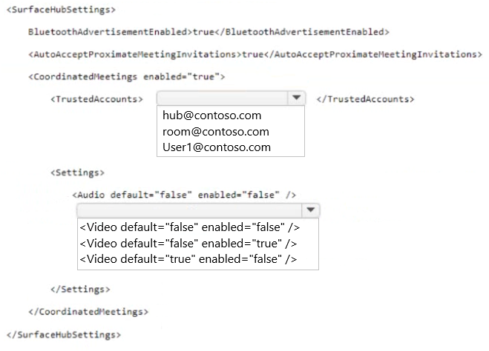
- Binh luan:
ThrustedAccounts should be room@contoso.com:
https://learn.microsoft.com/en-us/microsoftteams/rooms/xml-config-file
"This is a comma-separated list of UPNs for each Teams Rooms device or Surface Hub that the device should accept meeting join requests from, or to which meeting join requests should be sent."
Coordinated meetings configures multiple devices to join the same meeting and how the peripherals need to behave when they do. It's not driven from the user but from the room touchpanel.
Should be room, since the question is asking you to configure for hub...
<TrustedAccounts> This is a comma-separated list of UPNs for each Teams Rooms device or Surface Hub that the device should accept meeting join requests from, or to which meeting join requests should be sent.
Accepted values: string
TrustedAccounts must be room@contoso.com
In the url is the same scenario and configuration:
https://learn.microsoft.com/en-us/microsoftteams/rooms/surface-hub-manage-config
<CoordinatedMeetings> <TrustedAccounts>
This is a comma-separated list of UPNs for each Teams Rooms device or Surface Hub that the device should accept meeting join requests from, or to which meeting join requests should be sent.
Accepted values: string
https://learn.microsoft.com/en-us/microsoftteams/rooms/surface-hub-manage-config

Cau 88
Dap an: A, B
Your company has a Microsoft 365 subscription. All users are assigned a Microsoft 365 E3 license.
You need to implement information barriers between two groups of users.
Which two licensing add-ons provide the required functionality? Each correct answer presents a complete solution.
NOTE: Each correct selection is worth one point.
A. Compliance ✓
B. Insider Risk Management ✓
C. Microsoft Defender for Office 365
D. Communications Credits
- Binh luan:
Explanation:
Compliance (Correct):
Microsoft 365 Compliance features include tools for managing information barriers. These are designed to enforce ethical walls or communication restrictions between users to prevent conflicts of interest or unauthorized information sharing.
Information barriers rely on policies available under Microsoft 365 Compliance solutions.
Insider Risk Management (Correct):
This feature includes tools to help manage and enforce information barriers by monitoring and ana
IB required licensing as below:
1. Microsoft 365 E5/A5/G5
2. Microsoft 365 E5/A5/G5 Compliance
3. Microsoft 365 E5/A5/G5 Insider Risk Management
4. Office 365 E5/A5/G5
https://techcommunity.microsoft.com/t5/microsoft-teams-community-blog/ms-teams-security-amp-compliance-information-barrier-ib/ba-p/3594522
I'm agree with ChatGPT
A and C are the correct answer:
To implement information barriers between two groups of users in Microsoft 365, you need two licensing add-ons: Compliance and Microsoft Defender for Office 365.
The Compliance add-on provides advanced compliance features, including information barriers, which allow you to restrict communication and collaboration between certain groups of users to prevent conflicts of interest.
The Microsoft Defender for Office 365 add-on provides advance
Defender for O365 has nothing to do with information barriers. Info barriers are licensed by E5 Compliance or the Insider Risk sub-bundle.
A And B are the correct answer
https://learn.microsoft.com/en-us/microsoft-365/compliance/information-barriers-policies?view=o365-worldwide

Cau 90
Dap an: N/A
HOTSPOT
-
Your company uses Microsoft Teams.
You have a team named Team1.
You need to prevent users from posting animated images to Team1.
How should you complete the PowerShell cmdlet? To answer, select the appropriate options in the answer area.
NOTE: Each correct selection is worth one point.
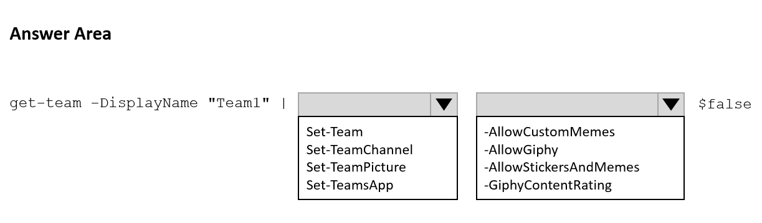
- Binh luan:
Should be -AllowGiphy $false?
https://support.microsoft.com/en-us/office/send-an-emoji-gif-or-sticker-in-teams-174248c9-e64d-4de1-9f41-3199cc0751ad
https://learn.microsoft.com/en-us/powershell/module/teams/set-team?view=teams-ps
On exam 30-March-2023
"Set-Team -AllowGiphy"
I don't know why. That's just the answer.
Was on my exam yesterday 8/24
In Microsoft Teams, GIPHY is a cloud-backed service that allows you to use GIFs (animated images) in your chat conversations.

Cau 91
Dap an: B
You have a Microsoft 365 E5 subscription that uses Microsoft Teams.
Users report that their presence information is available to external partners.
You need to ensure that the presence information is available only to the external partners on the users' contact lists.
What should you do?
A. From PowerShell, run Set-CsTenantFederationConfiguration AllowFederatedUsers $false.
B. From PowerShell, run Set-CsPrivacyConfiguration -EnablePrivacyMode $true. ✓
C. From the Microsoft Teams admin center, add the external partners to the Allow only specific external domains list.
D. From External collaboration settings in the Azure Active Directory admin center, configure Guest user access restrictions.
- Binh luan:
-EnablePrivacyMode
If True, gives users the opportunity to enable the advanced privacy mode. In advanced privacy mode, only people on your Contacts list will be allowed to view your presence information. If False, your presence information will be available to anyone in your organization. The default value is False.
https://learn.microsoft.com/en-us/powershell/module/skype/Set-CsPrivacyConfiguration?redirectedfrom=MSDN&view=skype-ps#-enableprivacymode
Applies to: Lync Server 2010, Lync Server 2013, Skype for Business Online, Skype for Business Server 2015, Skype for Business Server 2019
(there is no team in the applied section)
On exam 30-March-2023
On test 10/26/23
C is correct

Cau 92
Dap an: N/A
HOTSPOT
-
You have a Microsoft 365 subscription that uses Microsoft Teams.
You purchase three new Microsoft Teams display devices.
You need to provision the new devices remotely.
What information should you use to identify each device, and which file format should you use for the upload? To answer, select the appropriate options in the answer area.
NOTE: Each correct selection is worth one point.
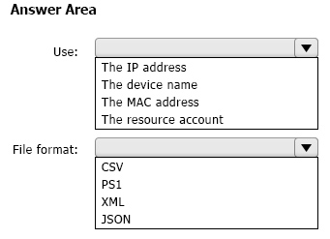
- Binh luan:
Complete the following steps to provision a new device.
Sign in to the Teams admin center.
Expand Teams Devices.
Select Provision new device from the Actions tab.
In the Provision new devices window, you can either add the MAC address manually or upload a CSV file.
Was on my exam 8-24
correct, MAC & CSV
https://learn.microsoft.com/en-us/microsoftteams/devices/remote-provision-remote-login#add-a-device-mac-address

Cau 93
Dap an: N/A
HOTSPOT
-
You have a Microsoft 365 subscription that uses Teams.
You plan to create a Teams policy that will provide users with the ability to participate in surveys by Microsoft.
How should you complete the PowerShell command? To answer, select the appropriate options in the answer area.
NOTE: Each correct selection is worth one point.
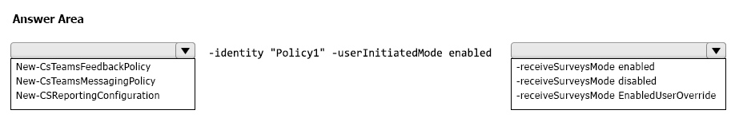
- Binh luan:
Why wouldn't the second answer be -receiveSurveysMode EnabledUserOverride?
A is correct.
New-CsTeamsFeedbackPolicy -identity "Policy1" -userInitiatedMode enabled -receiveSurveysMode enabled
Answer is correct.
https://learn.microsoft.com/en-us/powershell/module/skype/new-csteamsfeedbackpolicy?view=skype-ps

Cau 94
Dap an: N/A
HOTSPOT
-
You have a Microsoft 365 subscription that uses Teams.
You have two teams named Department1 and Department2.
You need to implement a security and compliance solution that meets the following requirements:
• Prevents the members of Department1 and Department2 from communicating with each other in Teams.
• Provides an alert if offensive language is used during a Teams chat.
Which Microsoft Purview feature should you use for each requirement? To answer, select the appropriate options in the answer area.
NOTE: Each correct selection is worth one point.
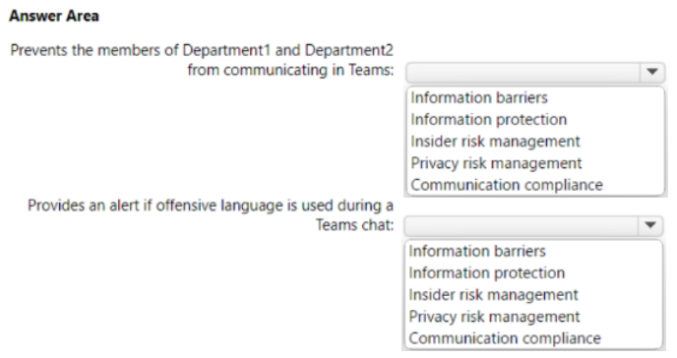
- Binh luan:
Correct,
to provide alert for inappropriate text, you can go to Purview Admin Center > Communication Compliance > Policies > Create Policy > Detect inappropriate text.
Agree with provided answer.
https://learn.microsoft.com/en-us/microsoft-365/compliance/communication-compliance?view=o365-worldwide

Cau 95
Dap an: D
Your company uses Teams.
Users often use Teams mobile apps to make and receive calls.
You change the display name for a user named User1.
User1 reports that their previous name still appears when they receive incoming calls in the Teams mobile app.
You need to ensure that the updated display name for User1 appears.
What should you do?
A. Collect and review the Debug logs.
B. Run the Sync-CsOnlineApplicationInstance cmdlet.
C. From the Microsoft 365 admin center, run self-help diagnostics.
D. Clear the Microsoft Teams client cache on the mobile phone. ✓
- Binh luan:
easy one, if error happened on your teams client, just relogin or clear the cache. work everytime XD

Cau 96
Dap an: N/A
HOTSPOT
-
Your company has offices in New York and Seattle.
You have a Microsoft 365 subscription that uses Teams.
You plan to assess network connectivity and make recommendations to optimize connectivity from each office to Teams.
You run the Microsoft 365 network connectivity test tool at both offices and produce the results shown in the following table.
For each of the following statements, select Yes if True. Otherwise select No.
NOTE: Each correct selection is worth one point.
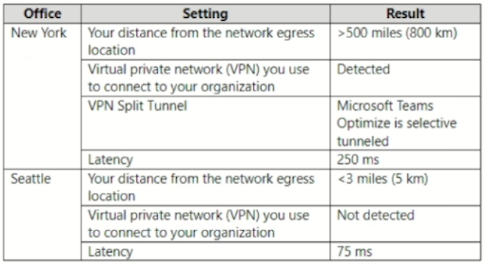
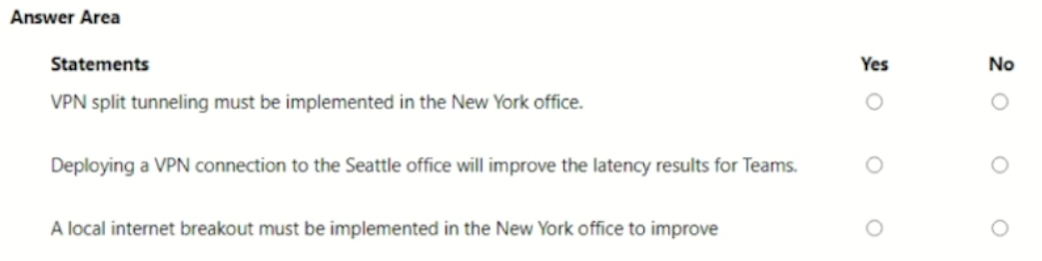
- Binh luan:
1. YES:
-If you're working remotely and need to access resources on your organization's network while also using the internet for other tasks, split tunneling can be beneficial.
-In situations where you have limited bandwidth available, split tunneling can help optimize network performance.
2. NO:
-If your original internet connection is already slow, deploying a VPN might not improve latency significantly. The VPN can only work with the speed provided by your internet service.
3. YES:
-Implemen
2.
*In summary, while deploying a VPN can introduce some additional latency due to encryption overhead, it can potentially improve latency by optimizing routing paths.
It could be positive or negative but from the most case, VPN affect your internet connection to be slower. Correct me if I'm wrong
No, No, Yes
Statement 1: VPN Split Tunneling in New York - No
The results show "Microsoft Teams Optimize is selective tunneled"
This means split tunneling is already implemented for Teams traffic
No additional action needed for VPN split tunneling
Statement 2: VPN for Seattle - No
Seattle currently has no VPN and 75 ms latency (acceptable)
Seattle's network egress is <3 miles (optimal)
Adding a VPN would increase latency, not improve it
VPNs add overhead and can route traffic through distant l

Cau 97
Dap an: N/A
HOTSPOT
-
You have a Microsoft 365 subscription that uses Teams. The subscription contains the users shown in the following table.
User3 owns a public team named Sales that contains two channels named Planning and Budgets.
You have the following custom blocked words list.
Project, Contoso, Group, Team
-
For each of the following statements, select Yes if True. Otherwise select No.
NOTE: Each correct selection is worth one point.
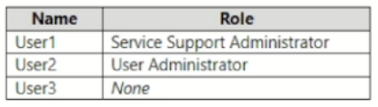
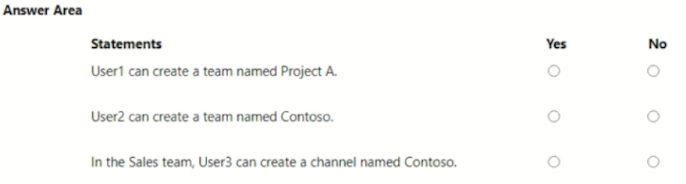
- Binh luan:
I believe the answer is No, Yes, Yes.
No - due to the blocked word list.
Yes - due to the users role exemption.
Yes - due to key word "channel", not a Team. Can't find any documentation that specifies the custom blocked word list applies to channels. Only states it is for Group and Team names.
https://learn.microsoft.com/en-us/microsoft-365/solutions/groups-naming-policy?view=o365-worldwide
i agree, No - due to the blocked word list.
Yes - due to the users administrator is except
Yes - due to key word "channel", not a Team.
See Admin Override: https://learn.microsoft.com/en-us/microsoft-365/solutions/groups-naming-policy?view=o365-worldwide
*this* is the correct answer! Also tested in sandbox. The "user admin" is a role that is exempt from naming policy.
NO, NO, YES
Blocked word list only affect someone when they're creating a Team... Channel is not affected. Those admin also has no exception for this policy.
The following are the list of administrator roles exempted from the group naming policy.
• Global admin
• Partner Tier 1 Support
• Partner Tier 2 Support
• User account admin

Cau 98
Dap an: A
Case study -
Overview -
Company Information -
ADatum Corporation is an energy company that has offices across North America and 3,000 employees.
Physical Locations -
ADatum has the offices shown in the following table.
Existing Environment -
Network Infrastructure -
The office in Calgary has a 1-Gbps internet circuit. The offices in San Diego and New York have 100-Mbps internet circuits. The field site in Edmonton has a 3-Mbps internet circuit.
Departments -
ADatum has the following departments:
• Information technology (IT)
• Project management
• Marketing
Microsoft 365 and Tenants Environment
ADatum recently purchased a Microsoft 365 E5 subscription that has the Microsoft Teams Domestic Calling Plan add-on. All users are assigned Microsoft 365 E5 and Microsoft Teams Domestic Calling Plan licenses and Calling Plans is deployed.
Azure AD has the default Cross-tenant access settings configured.
The Teams policies settings are configured as shown in the following exhibit.
The Teams client is deployed to a non-persistent Virtual Desktop Infrastructure (VDI) used by the project management department.
Allow guest access in Teams is set to Off.
The Microsoft Viva Connections app is deployed to all users.
Problem Statements -
ADatum identifies the following issues:
• An executive at the San Diego office reports that video drops during Teams meetings.
• The Edmonton field site has limited bandwidth, and users report poor audio during Teams calls and meetings.
• Users in the project management department report that they cannot give or take control during Teams calls and meetings while sharing their VDI desktop.
Planned Changes -
ADatum plans to implement the following changes:
• Configure the media bit rate settings for the users at the Edmonton field site. The settings must apply only to the user while they are at the site, but NOT when they are at a different office.
• Create a Teams channel to enable the project management department to collaborate with the IT department on a device upgrade project.
• Implement a pilot rollout of Operator Connect for the users in the New York office. A port re-quest was accepted already.
• Create a Teams channel for the marketing department for external collaboration.
• Rename the Viva Connections icon as Start portal.
Technical Requirements -
ADatum identifies the following technical requirements:
• The marketing department requires that all the files shared by using Teams remain available for at least three years after deletion.
• The marketing department must be able to apply a watermark to content and video shared dur-ing Teams meetings.
• All users require indefinite access to training videos recorded in Teams by the IT department.
• All access to Teams and shared resources must use the principle of least privilege.
• Guest access must remain disabled.
You need to ensure that file sharing during Teams chats meets the technical requirements of the marketing department.
What should you do?
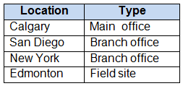
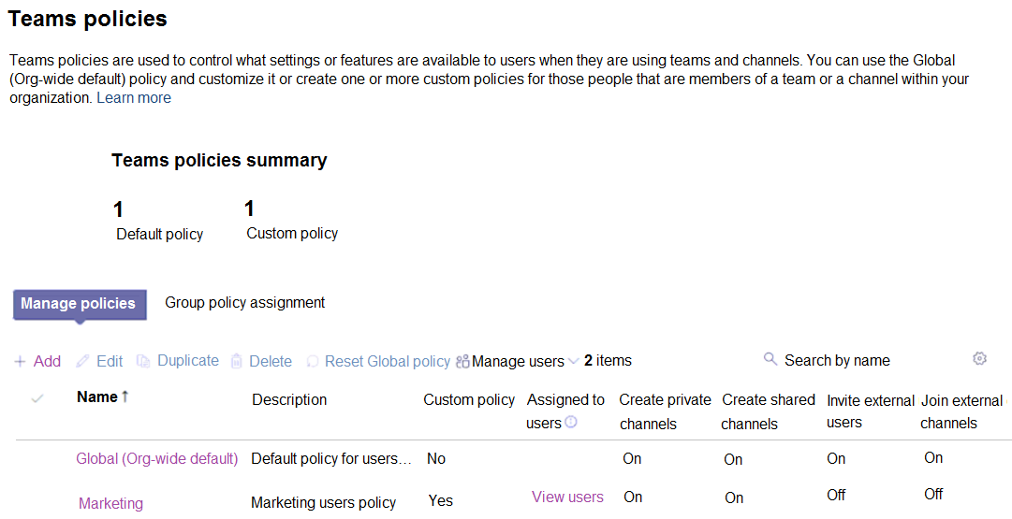
A. Create a retention policy for the SharePoint sites location. ✓
B. Enable Customer Lockbox.
C. Create a retention policy for Teams chats.
D. Create a data loss prevention (DLP) policy for Teams chat and channel messages.
E. Create a retention policy for the OneDrive accounts location.
- Binh luan:
Where Files Are Stored in Teams:
Location Storage
Files shared in Teams chats OneDrive (sender's account)
Files shared in Teams channels SharePoint
Why Option E is Correct:
When users share files in Teams chat (1:1 or group chat), those files are stored in the user's OneDrive account
To retain these files for 3 years after deletion, you need a retention policy targeting OneDrive accounts
This ensures files remain in the Preservation Hold Library even after users delete them
We need a retention policy for files shared during Teams chats, not for files shared in Teams channels.
Files, shared in Teams chats, are stored in the senders onedrive.
Files shared in Teams channels , are stored in the sharepoint site of the team.
So, the answer is e, because of the keyword teams chats
ChatGPT says the same, but you might be right. Sharepoint is for files shared in the team like channels, if I understand well. This seems to be more related to files shared in chat, which is stored in onedrive for the user.
"All files shrared by using Microsoft Teams". Well, files shared in a chat are stored in one drive, and files shred in a Team are stored in SharePoint. I guess A is the better answer.
The marketing department has two technical requirements:
Data retention and watermarks. The only answer that applies to either of these requirements is A.
Teams is an overlay for Sharepoint files, therefore the Sharepoint file retention policy applies here.
There is not an answer that applies to the watermark technical requirement.
More on watermarks - https://learn.microsoft.com/en-us/microsoftteams/watermark-meeting-content-video#:~:text=Configure%20watermarks,-For%20watermarks%20to&text=In%20

Cau 99
Dap an: A
Case study -
Overview -
Company Information -
ADatum Corporation is an energy company that has offices across North America and 3,000 employees.
Physical Locations -
ADatum has the offices shown in the following table.
Existing Environment -
Network Infrastructure -
The office in Calgary has a 1-Gbps internet circuit. The offices in San Diego and New York have 100-Mbps internet circuits. The field site in Edmonton has a 3-Mbps internet circuit.
Departments -
ADatum has the following departments:
• Information technology (IT)
• Project management
• Marketing
Microsoft 365 and Tenants Environment
ADatum recently purchased a Microsoft 365 E5 subscription that has the Microsoft Teams Domestic Calling Plan add-on. All users are assigned Microsoft 365 E5 and Microsoft Teams Domestic Calling Plan licenses and Calling Plans is deployed.
Azure AD has the default Cross-tenant access settings configured.
The Teams policies settings are configured as shown in the following exhibit.
The Teams client is deployed to a non-persistent Virtual Desktop Infrastructure (VDI) used by the project management department.
Allow guest access in Teams is set to Off.
The Microsoft Viva Connections app is deployed to all users.
Problem Statements -
ADatum identifies the following issues:
• An executive at the San Diego office reports that video drops during Teams meetings.
• The Edmonton field site has limited bandwidth, and users report poor audio during Teams calls and meetings.
• Users in the project management department report that they cannot give or take control during Teams calls and meetings while sharing their VDI desktop.
Planned Changes -
ADatum plans to implement the following changes:
• Configure the media bit rate settings for the users at the Edmonton field site. The settings must apply only to the user while they are at the site, but NOT when they are at a different office.
• Create a Teams channel to enable the project management department to collaborate with the IT department on a device upgrade project.
• Implement a pilot rollout of Operator Connect for the users in the New York office. A port re-quest was accepted already.
• Create a Teams channel for the marketing department for external collaboration.
• Rename the Viva Connections icon as Start portal.
Technical Requirements -
ADatum identifies the following technical requirements:
• The marketing department requires that all the files shared by using Teams remain available for at least three years after deletion.
• The marketing department must be able to apply a watermark to content and video shared dur-ing Teams meetings.
• All users require indefinite access to training videos recorded in Teams by the IT department.
• All access to Teams and shared resources must use the principle of least privilege.
• Guest access must remain disabled.
You need to implement the planned change for the Edmonton field site.
What should you create?


A. a network roaming policy ✓
B. a voice routing policy
C. a calling policy
D. a meeting policy
E. a messaging policy
- Binh luan:
https://learn.microsoft.com/en-us/microsoftteams/network-roaming-policy
This policy enables you to assign settings to network sites. The Teams client will dynamically pick up the settings based on which network site it connects to. When the Teams client signs in from a network site with a roaming policy assigned, that policy will be used. If there is no policy assigned, the values set in the meeting policy will be used.
The TeamsNetworkRoamingPolicy contains the following parameters:
AllowIPV
https://learn.microsoft.com/en-us/microsoftteams/network-roaming-policy

Cau 100
Dap an: A
Your company uses Teams.
You have a team named Team1.
You need to prevent guest users from accessing files in Team1. The solution must NOT affect external collaboration with any other teams.
What should you do?
A. From the SharePoint admin center, edit the External sharing settings for the associated site. ✓
B. From the Microsoft Entra admin center, configure the External collaboration settings for guest users.
C. From the Microsoft Entra admin center, create a Conditional Access policy.
D. From the Microsoft Teams admin center, set external access to Block all external domains.
E. From the Microsoft Teams admin center, set Allow guest access in Teams to Off.
- Binh luan:
A is correct
The correct answer is A. From the SharePoint admin center, edit the External sharing settings for the associated site.Why: Targeted control: It allows you to restrict access specifically for Team1's files without globally affecting external collaboration in other teams.
SharePoint-level control: Files in Teams are stored in SharePoint sites, so managing sharing at the SharePoint level provides granular control over file permissions.

Cau 101
Dap an: B
Note: This question is part of a series of questions that present the same scenario. Each question in the series contains a unique solution that might meet the stated goals. Some question sets might have more than one correct solution, while others might not have a correct solution.
After you answer a question in this section, you will NOT be able to return to it. As a result, these questions will not appear in the review screen.
Your company has a Microsoft 365 subscription that uses an Azure Active Directory (Azure AD) tenant named contoso.com.
You need to prevent guest users in the tenant from using cameras during Microsoft Teams meetings.
Solution: From Microsoft Teams admin center, you modify the External access settings.
Does this meet the goal?
A. Yes
B. No ✓
- Binh luan:
B (no) is correct. From the MS Teams Admin center, you modify the Users > Guest access settings, where you can toggle Video conferencing, select Screen sharing options, and toggle Meet now in channels. This is not available in External access settings.
Completely agree. A is not correct.
It is No,
It is No, the same as : T2Q8, The correct solutions are in T1Q2 andT2Q53.
B is the correct answer

Cau 102
Dap an: D, E
Your company uses Teams.
All users are assigned a Microsoft 365 E3 license.
You need to recommend a license that will enable the use of information barriers (IBs) in Teams.
What are two licenses that you can recommend? Each correct answer presents a complete solution.
NOTE: Each correct selection is worth one point.
A. the Microsoft Teams Premium add-on
B. the Priva Privacy Risk Management add-on
C. Microsoft 365 Business Standard
D. Microsoft 365 E5 ✓
E. the Microsoft 365 E5 Compliance add-on ✓
- Binh luan:
Ans DE
https://aka.ms/M365EnterprisePlans
(official link for all microsoft license as of 4March,2025)
Microsoft 365 E5: This comprehensive suite includes IBs as a core feature, removing the need for additional add-ons.
Microsoft 365 E5 Compliance add-on: If you already have Microsoft 365 E3 licenses, this add-on specifically provides IBs functionality without upgrading to the full E5 suite.

Cau 103
Dap an: D
You have a Microsoft 365 subscription that uses Microsoft Teams.
You need to prevent users from creating private channels.
What should you do?
A. Modify the Teams settings.
B. Create a messaging policy.
C. Create an app permission policy.
D. Create a Teams policy. ✓
- Binh luan:
andwer is D, teams policy -> create private channels
Use policies to control which users in your organization are allowed to create private channels. Once you've set the policies, team owners can turn off or turn on the ability for members to create private channels in the Settings tab for a team.
In my opinion it's A (TAC - Settings & policies - Tab "global org-wide default settings" - Teams - Turn off "Create private channels" - Save)
D is the right answer
https://learn.microsoft.com/en-US/microsoftteams/teams-policies#channel-policies
I am sure you don't want to edit the settings for every user seperataly.

Cau 104
Dap an: B, C
Your company has a Microsoft Office 365 subscription.
Users in the company’s sales department frequently invite guest users to meetings.
You need to ensure that when the sales department users invite guest users to meetings, the guest users are admitted by default. The solution must only apply to the sales department users.
Which two actions should you perform? Each correct answer presents part of the solution.
NOTE: Each correct selection is worth one point.
A. In the global meeting policy, set Automatically admit users to Everyone.
B. Create a new meeting policy and set Automatically admit users to Everyone. ✓
C. Apply the policy to the sales department users. ✓
D. In the global meeting policy, set Automatically admit users to People in your organization.
- Binh luan:
B and C are the correct answers as you have to create a new policy and apply the new policy to users in the sales department
only applying to the sales team while maintaining appropriate security and control for other departments within your organization.

Cau 105
Dap an: N/A
DRAG DROP
-
Your company uses Teams.
You have a team named Accounting that is deleted accidentally.
You need to use PowerShell to restore the Accounting team.
How should you complete the PowerShell script? To answer, drag the appropriate values to the correct targets. Each value may be used once, more than once, or not at all. You may need to drag the split bar between panes or scroll to view content.
NOTE: Each correct selection is worth one point.
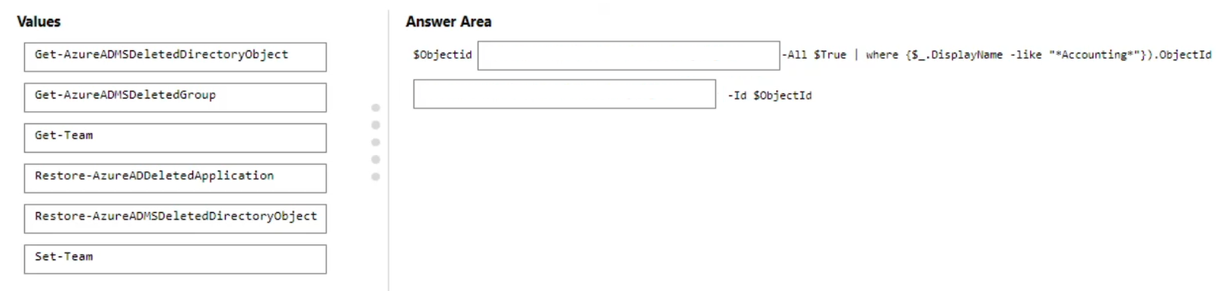
- Binh luan:
get-azureadmsdeletedgroup and
restore-azureadmsdeleteddirectoryobject
https://learn.microsoft.com/en-us/powershell/module/azuread/get-azureadmsdeletedgroup?view=azureadps-2.0
https://learn.microsoft.com/en-us/powershell/module/azuread/restore-azureadmsdeleteddirectoryobject?view=azureadps-2.0
How is the listed answer right? Isn't Get just to display information? Why wouldn't the second part of this answer be one of the Restore commands?
You are right, the second answer provided is wrong.
Correct answers:
get-azureadmsdeletedgroup and
restore-azureadmsdeleteddirectoryobject

Cau 106
Dap an: N/A
HOTSPOT
-
Your company has the following departments:
• Marketing
• Information technology (IT)
The company uses Teams.
You need to recommend an access solution that meets the following requirements:
• The marketing department must collaborate with an external consultant by using a Microsoft PowerPoint presentation stored in the General channel of a new team.
• The IT department must be able to communicate with external consultants by using a private Teams chat and Teams calls.
Which type of access should you recommend for each department? To answer, select the appropriate options in the answer area.
NOTE: Each correct selection is worth one point.
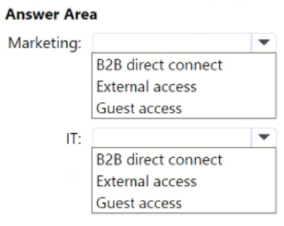
- Binh luan:
B2B is only for shared channels. The second asnwer should be External collaboration.
https://learn.microsoft.com/en-us/entra/external-id/b2b-direct-connect-overview
Correct: Marketing: Guest Access
Reason: Guest Access is specifically designed for collaboration with external users on specific teams and channels within your organization. It allows them to access files, participate in chats, and join meetings within the designated team or channel. This aligns perfectly with the marketing department's need to collaborate on a PowerPoint presentation in a team's General channel.
IT: External Access
Reason: External Access enables communication with external use
Marketing: Guest access = Full team membership with file access
IT: External access = Chat and calls only, no file/team access

Cau 107
Dap an: N/A
HOTSPOT
-
You have a Microsoft 365 E5 subscription that uses Teams.
A user reports that a team named Team1 is missing and is no longer accessible.
You discover that an administrator deleted Team1 accidentally.
You need to restore Team1.
How many days do you have to restore Team1, and which portal should you use? To answer, select the appropriate options in the answer area.
NOTE: Each correct selection is worth one point.
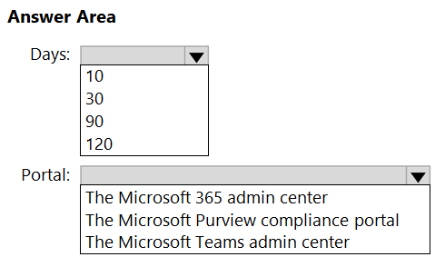
- Binh luan:
I think the correct answer is 30 days and MS Teams admin center
Pretty sure you can restore the team from both M365 Admin and Teams Admin center...
You have 30 days to restore a deleted team. After 30 days, the team and its associated data are permanently deleted and cannot be recovered.
Microsoft 365 admin center to restore the deleted team.
Steps to Restore the Team:
Go to the Microsoft 365 admin center.
Navigate to Groups > Deleted groups.
Find and select the team (group) you want to restore.
Click on Restore group.
Team Admin Centre to restore the deleted team.
Steps :-
Go to teams admin center
Navigate to Teams > Managed Teams
On the
Restore deleted teams
To restore a deleted team in the Teams admin center, do the following:
Go to the Teams Admin center > Teams > Manage teams.
Expand Actions menu on the top right corner, click View deleted teams.
Select the team that you want to restore from the list, and then click Restore. You can also select multiple teams and restore them.
Source: https://learn.microsoft.com/en-us/microsoftteams/manage-teams-in-modern-portal
Timeframe for Restoration:
You have 30 days to restore a deleted team. After 30 days, the team and its associated data are permanently deleted and cannot be recovered.
Portal to Use:
You should use the Microsoft 365 admin center to restore the deleted team.
Steps to Restore the Team:
Go to the Microsoft 365 admin center.
Navigate to Groups > Deleted groups.
Find and select the team (group) you want to restore.
Click on Restore group.
By following these steps within the 30-day window, you can

Cau 108
Dap an: N/A
HOTSPOT
-
Your company has the users shown in the following table.
The company uses Teams.
You have Teams update policies configured as shown in the following table.
The Teams update policies are assigned to departments as shown in the following table.
For each of the following statements, select Yes if True. Otherwise select No.
NOTE: Each correct selection is worth one point.
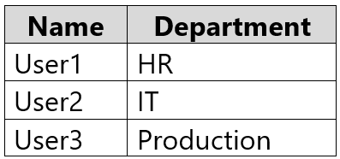
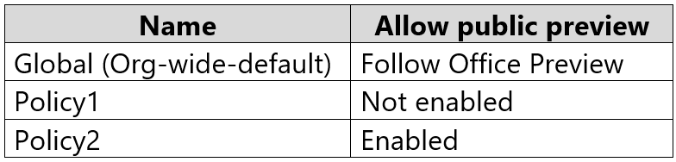
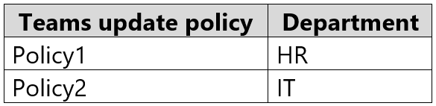
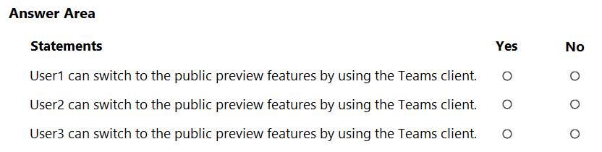
- Binh luan:
No, Yes, Yes. User 3 can enable public preview:
On for users in Current Channel (Preview) (default)
This default option turns on Teams Public preview features for any user enrolled in Office Current Channel (Preview).
Users enrolled in Office Current Channel (Preview) can't turn off Teams Public preview.
https://learn.microsoft.com/en-us/microsoftteams/public-preview-doc-updates?tabs=new-teams-client
No yes no, user3: Follow Office Preview
This default option will automatically enable Teams Public Preview features for any user enrolled in Current Channel (Preview).
There are no additional actions required by the end-user.
NO-YES-YES
User1 can switch to the public preview features by using the Teams client: NO
Explanation: User1's policy (Policy1) explicitly disables public preview features, overriding the Global policy's "Follow office preview" setting. Therefore, User1 cannot access public preview features, even though the Global policy would usually allow it.
User2 can switch to the public preview features by using the Teams client: YES
Explanation: User2's policy (Policy2) explicitly enables public preview f
I don't think that is correct, if only user enrolled in Current Channel (Preview) for office updates to align with , otherwise No.
• Follow Office Preview (default)
o This default option will automatically enable Teams Public Preview features for any user enrolled in Current Channel (Preview).
o There are no additional actions required by the end-user.
• Enabled
o This option enables Teams Public Preview - regardless of whether a user is enrolled in Current Channel (Preview).
o The end-user mus
Is the answer correct?

Cau 109
Dap an: B
You have a Microsoft 365 subscription.
You plan to implement Teams.
You need to confirm the location of the Teams service workload for data at rest.
What should you configure in the Microsoft 365 admin center?
A. the Data sources tab in Search & intelligence
B. the Organization profile tab in Org settings ✓
C. the Overview tab in Service health
D. the Security & privacy tab in Org settings
- Binh luan:
Selected Answer: B
settings>org settings>organization profile>Data Location>MS Teams
https://admin.microsoft.com/Adminportal/Home#/Settings/OrganizationProfile/:/Settings/L1/DataLocationList
C is correct

Cau 110
Dap an: N/A
DRAG DROP
-
Your company uses Microsoft Teams.
You are planning the governance strategy for Microsoft Teams. All tasks must be performed by a user who will be assigned the Global admin role and will not be a team owner.
You need to identify which tools to use for the following tasks:
• Archive a team.
• Restore a deleted team.
• Permanently delete a team.
Which tool should you identify for each task? To answer, drag the appropriate tools to the correct tasks. Each tool may be used once, more than once, or not at all. You may need to drag the split bar between panes or scroll to view content.
NOTE: Each correct selection is worth one point.
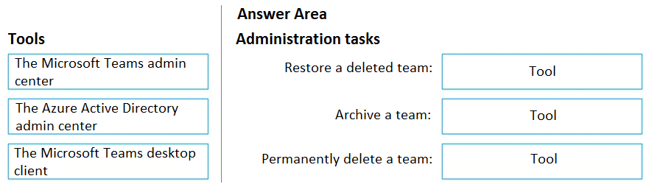
- Binh luan:
Azure AD to restore a team NOT Teams Admin Center.
We can restore deleted teams in TAC if you go to Teams -> Manage teams -> click on 'Actions' in the upper-right corner -> View deleted teams -> tick at the team you want to restore -> Restore. I have confirmed this in my test tenant.
This is correct
To accomplish each compliance task in Microsoft Teams, you would use the following tools:
Restore a deleted team:
Microsoft Teams admin center > Teams > Action > View Deleted Teams > select the desired team, and then choose the "Restore" option.
OR
Microsoft Entra ID Portal > Groups > Deleted Groups > Restore Group
(A team is attached to a group and when we delete a team its 365group will also gets deleted. So, if we restore the group the team will also be restored.)
Archive a team:
Microsoft
Everything can be done in Teams admin center.
https://learn.microsoft.com/en-us/microsoftteams/manage-teams-in-modern-portal

Cau 111
Dap an: N/A
HOTSPOT
-
You have a Microsoft 365 E5 subscription that uses Teams.
You need to recommend a security solution for Teams users. The solution must meet the following requirements:
• Detect risks, such as unfamiliar sign-ins and atypical travel.
• Enforce multi-factor authentication (MFA) when risky sign-ins are detected.
What should you include in the recommendation, and which portal should you use? To answer, select the appropriate options in the answer area.
NOTE: Each correct selection is worth one point.
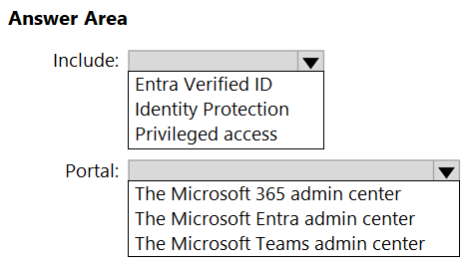
- Binh luan:
looks like a new question. Answer is correct. See below....
https://learn.microsoft.com/en-us/entra/id-protection/overview-identity-protection
https://learn.microsoft.com/en-us/entra/id-protection/howto-identity-protection-configure-mfa-policy
Isn't it Conditional Access which is still the MS Entra Admin Centre

Cau 113
Dap an: N/A
HOTSPOT
-
You have a Microsoft 365 E5 subscription that uses Teams.
You need to ensure that users are prompted for multi-factor authentication (MFA) when they access Teams from outside the corporate network.
Which type of policy should you configure, and which portal should you use? To answer, select the appropriate options in the answer area.
NOTE: Each correct selection is worth one point.
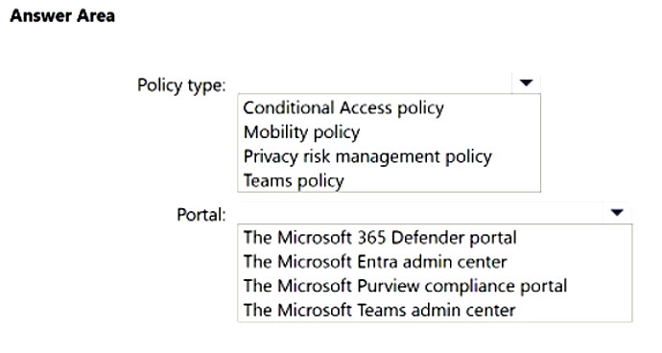
- Binh luan:
Conditional Access Policy in Entra admin center
https://learn.microsoft.com/en-us/entra/identity/conditional-access/policy-all-users-mfa-strength#create-a-conditional-access-policy
Yeah Conditional access policy can be setup from Entra Admin portal to enforce MFA.

Cau 114
Dap an: N/A
HOTSPOT
-
Your company has two offices in Canada and Australia.
You have a Microsoft 365 subscription that uses Teams.
A user named User1 moves from the Canada office to the Australia office.
You need to use PowerShell to move data at rest to Australia for User1.
How should you complete the PowerShell command? To answer, select the appropriate options in the answer area.
NOTE: Each correct selection is worth one point.
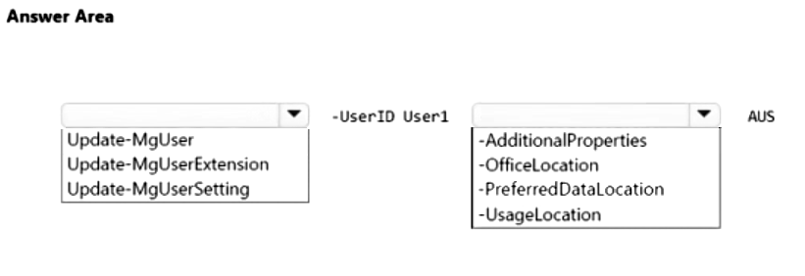
- Binh luan:
Looks good!

Cau 115
Dap an: N/A
HOTSPOT
-
You have a Microsoft 365 subscription that uses Teams.
You have a team named Project1.
You need to deploy a compliance solution for Project1. The solution must meet the following requirements:
• Detect conversations between project users that might relate to insider trading.
• Monitor for exfiltration activities, and then send alerts.
What should you use for each requirement? To answer, select the appropriate options in the answer area.
NOTE: Each correct selection is worth one point.
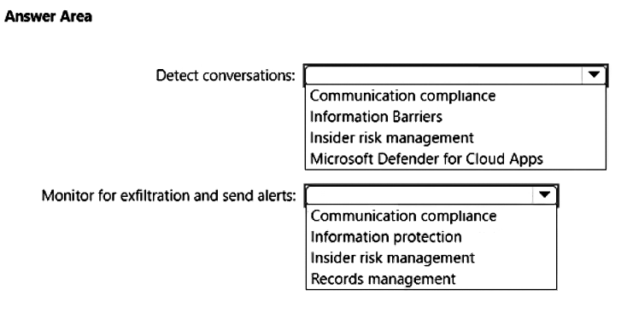
- Binh luan:
I would say: a. communication compliance https://learn.microsoft.com/en-us/purview/communication-compliance-teams#:~:text=Microsoft%20Teams%20and%20Microsoft%20Purview%20Communication%20Compliance and Insider Risk https://learn.microsoft.com/en-us/purview/insider-risk-management-activities#:~:text=Investigate%20insider%20risk%20management%20activities
Detect conversations: Communication compliance
Monitor for exfiltration + alerts: Insider risk management
Communication Compliance
Insider Risk Management
I would say: a. communication compliance
I believe the correct answer for the first box is communication compliance: https://learn.microsoft.com/en-us/purview/communication-compliance

Cau 116
Dap an: N/A
SIMULATION
-
You need to ensure that content on Microsoft SharePoint Online sites can be shared only with new and existing guest users.
To complete this task, sign in to the Microsoft 365 portal.

Cau 117
Dap an: B
You have a Microsoft 365 E5 subscription that uses Teams and contains the users shown in the following table.
You create a group naming policy to enforce a consistent naming convention for Teams names.
Which users are exempt from the group naming policy restrictions?
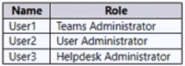
A. User1 only
B. User2 only ✓
C. User3 only
D. User1 and User3 only
E. User1, User2, and User3
- Binh luan:
Correct answer
https://learn.microsoft.com/en-us/entra/identity/users/groups-naming-policy#roles-and-permissions

Cau 118
Dap an: B
Your company has three divisions. Each division has a Microsoft 365 E5 subscription and its own Microsoft Entra ID instance. All the divisions use Teams for collaboration and communication.
You need to recommend a seamless collaboration solution between all the divisions. The solution must support the following:
• Search for users
• Free/busy status for Teams meetings
• Collaboration on files stored in Teams
What should you include in the recommendation?
A. guest access
B. a multitenant organization ✓
C. shared channels
D. external access
- Binh luan:
Key Word - "its own Microsoft Entra ID instance"
The multitenant organization scenario occurs when an organization has more than one tenant instance of Microsoft Entra ID.
https://learn.microsoft.com/en-us/entra/identity/multi-tenant-organizations/overview
Key Word - "its own Microsoft Entra ID instance"
The multitenant organization scenario occurs when an organization has more than one tenant instance of Microsoft Entra ID.
https://learn.microsoft.com/en-us/entra/identity/multi-tenant-organizations/overview

Cau 119
Dap an: C
You have a Microsoft 365 E5 subscription that includes Teams.
You need to ensure that only existing guest user accounts can access Teams files. New guest users must be restricted from accessing files in Teams.
What should you do?
A. From the Microsoft Teams admin center, configure the Guest access settings.
B. From the Microsoft Teams admin center, configure the External access settings.
C. From the SharePoint admin center, configure the Sharing settings. ✓
D. From the Microsoft Entra admin center, configure the External collaboration settings.
- Binh luan:
In sharepoint admin > policies > Sharing Move the bar to “existing guess”
C is correct
D. From the Microsoft Entra admin center, configure the External collaboration settings.
Explanation:
To ensure that only existing guest users can access Teams files and prevent new guest users from being added or accessing content, you need to configure external collaboration settings in Microsoft Entra ID (formerly Azure AD).
In the Microsoft Entra admin center:
Go to External Identities > External collaboration settings.
Set the option to "Only allow existing guests" or disable guest invitat

Cau 120
Dap an: B
Note: This question is part of a series of questions that present the same scenario. Each question in the series contains a unique solution that might meet the stated goals. Some question sets might have more than one correct solution, while others might not have a correct solution.
After you answer a question in this section, you will NOT be able to return to it. As a result, these questions will not appear in the review screen.
You have a Microsoft 365 subscription that includes Teams. The subscription contains a user named User1.
You are deploying 10 new Teams devices.
You need to ensure that User1 can restart the Teams devices remotely.
Solution: You assign the Teams Communications Support Engineer role to User1.
Does this meet the goal?
A. Yes
B. No ✓
- Binh luan:
Need Team Device admin role
https://learn.microsoft.com/en-us/microsoftteams/devices/device-management
B

Cau 121
Dap an: A
Note: This question is part of a series of questions that present the same scenario. Each question in the series contains a unique solution that might meet the stated goals. Some question sets might have more than one correct solution, while others might not have a correct solution.
After you answer a question in this section, you will NOT be able to return to it. As a result, these questions will not appear in the review screen.
You have a Microsoft 365 subscription that includes Teams. The subscription contains a user named User1.
You are deploying 10 new Teams devices.
You need to ensure that User1 can restart the Teams devices remotely.
Solution: You assign the Teams Administrator role to User1.
Does this meet the goal?
A. Yes ✓
B. No
- Binh luan:
A Teams Administrator can restart devices remotely so this should be A
Both Teams Device Admin and Teams Aministrator can be used. Still the answer is A. YES
https://learn.microsoft.com/en-us/microsoftteams/teams-administrative-units
Answer: A. Yes
Explanation:
Assigning the Teams Administrator role to User1 does meet the goal.
The Teams Administrator role includes permissions to:
Manage all aspects of Microsoft Teams, including Teams devices.
Restart Teams devices remotely via the Teams admin center.
Configure device settings, update firmware, and monitor device health.
This role provides the necessary access for User1 to manage and restart the 10 new Teams devices.
To manage devices, such as change device configuration, restart devices, manage updates, or view device and peripheral health, you need to be assigned one of the following Microsoft 365 admin roles:
Teams Service admin
Teams Device admin
https://learn.microsoft.com/en-us/microsoftteams/devices/device-management
(Team service admin role might be deprecated or might be added into Team Admin role )
But as of 4March,2025 Teams admin has no authority on team devices
https://learn.microsoft.com/en-us
I work with Teams, and I know MS Learn told one, in pracitce is second. As I tested (now) using Teams Admin role I can restart Device (needed Pro license for Teams Rooms)

Cau 122
Dap an: B
Note: This question is part of a series of questions that present the same scenario. Each question in the series contains a unique solution that might meet the stated goals. Some question sets might have more than one correct solution, while others might not have a correct solution.
After you answer a question in this section, you will NOT be able to return to it. As a result, these questions will not appear in the review screen.
You have a Microsoft 365 subscription that includes Teams. The subscription contains a user named User1.
You are deploying 10 new Teams devices.
You need to ensure that User1 can restart the Teams devices remotely.
Solution: You assign the Teams Communications Administrator role to User1.
Does this meet the goal?
A. Yes
B. No ✓
- Binh luan:
Role Can Restart Devices?
Teams Administrator ✅ Yes
Teams Device Administrator ✅ Yes
Global Administrator ✅ Yes
Teams Communications Administrator ❌ No
Teams Communications Support Engineer ❌ No
Teams Communications Support Specialist ❌ No

Cau 123
Dap an: A
Note: This question is part of a series of questions that present the same scenario. Each question in the series contains a unique solution that might meet the stated goals. Some question sets might have more than one correct solution, while others might not have a correct solution.
After you answer a question in this section, you will NOT be able to return to it. As a result, these questions will not appear in the review screen.
You have a Microsoft 365 subscription that includes Teams. The subscription contains a user named User1.
You are deploying 10 new Teams devices.
You need to ensure that User1 can restart the Teams devices remotely.
Solution: You assign the Teams Device Administrator role to User1.
Does this meet the goal?
A. Yes ✓
B. No
- Binh luan:
To manage devices, such as change device configuration, restart devices, manage updates, or view device and peripheral health, you need to be assigned one of the following Microsoft 365 admin roles:
Teams Service admin
Teams Device admin
https://learn.microsoft.com/en-us/microsoftteams/devices/device-management
(Team service admin role might be deprecated or might be added into Team Admin role )
But as of 4March,2025 Teams admin has no authority on team devices
https://learn.microsoft.com/en-us
A is correct!

Cau 125
Dap an: N/A
HOTSPOT
-
You have a Microsoft 365 E5 subscription that uses Teams.
You need to create a Teams Update policy named Policy1. The solution must meet the following requirements:
• Provide users with the ability to turn new Teams client features on and off.
• Ensure that the Try the new Teams toggle is unavailable.
How should you configure each setting for Policy1? To answer, select the appropriate options in the answer area.
NOTE: Each correct selection is worth one point.
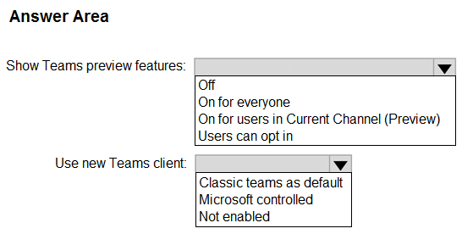
- Binh luan:
Show Teams preview features: Users can opt in
Use new Teams client: Not enabled

Cau 126
Dap an: B, D
You have a Microsoft 365 E5 subscription that has Teams Premium licenses, The subscription contains an Azure Virtual Desktop deployment that has a session host named Host.
You plan to install the Teams for virtual desktop infrastructure (VDI) client on Host.
You need to identify which Teams features will be unavailable to Host.
Which two features should you identify? Each correct answer presents a complete solution
NOTE: Each correct selection is worth one point.
A. end-to-end encryption
B. background blur ✓
C. live captions
D. custom meeting backgrounds ✓
E. multi-window
- Binh luan:
Stil is on Syllabus!
I go with A, E.
Ans BD
but as of February 11, 2025, MS-700 has removed "Plan and configure Teams for VDI" from its syllabus.
https://learn.microsoft.com/en-us/credentials/certifications/resources/study-guides/ms-700#change-log
-Background blurring is not supported in any virtual configuration due to the load the the blurring effect adds to the platform.
-Custom meeting backgrounds for organizations.
https://learn.microsoft.com/en-us/microsoftteams/new-teams-vdi-requirements-deploy
https://iad634.evolveip.net/display/EIQ/MS+Teams+Guidance+for+Virtual+Environments
Since the Premium license includes end-to-end encryption, the correct answers should be B. Background blur and D. Custom meeting backgrounds, I think.
”Notes: Linux users aren't able to use this feature.
Background effects aren't available if you're using Teams through optimized virtual desktop infrastructure (VDI).”
https://support.microsoft.com/en-us/office/change-your-background-in-microsoft-teams-meetings-f77a2381-443a-499d-825e-509a140f4780

Cau 127
Dap an: N/A
HOTSPOT
-
You have a Microsoft 365 subscription that contains an Azure Virtual Desktop deployment.
You install the Teams for virtualized desktop infrastructure (VDI) client on Azure Virtual Desktop session hosts.
You need to ensure that media optimization is configured for the session hosts.
How should you complete the registry key? To answer, select the appropriate options in the answer area.
NOTE: Each correct selection is worth one point.
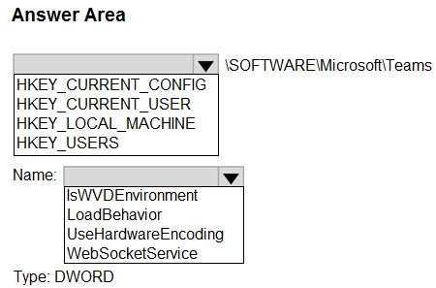

Cau 129
Dap an: N/A
HOTSPOT
-
You have a Microsoft 365 E5 subscription that includes Teams.
A user named User1 reports that their Teams client displays the Try the new Teams toggle.
You need to ensure that the toggle is unavailable in the Teams client of User1.
How should you complete the PowerShell cmdlets? To answer, select the appropriate options in the answer area.
NOTE: Each correct selection is worth one point.
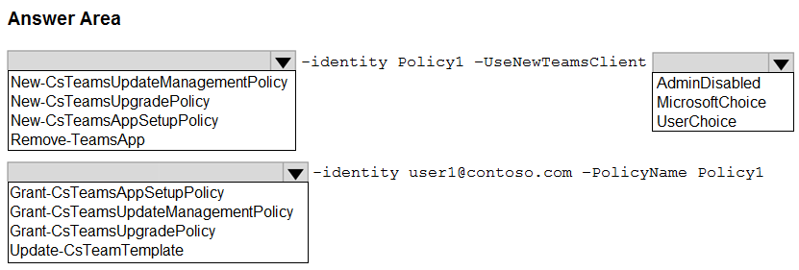

Cau 130
Dap an: A, D
You have a Microsoft 365 subscription that contains an Azure Virtual Desktop deployment. The Azure Virtual Desktop deployment contains a session host named Host.
You install the Remote Desktop WebRTC Redirector Service and the Teams for virtual desktop infrastructure (VDI) client on Host.
You need to configure the WebRTC Redirector Service to only support content sharing from an application window.
Which two actions should you perform? Each correct answer presents part of the solution,
NOTE: Each correct selection is worth one point.
A. Set the DisableRAILScreensharing registry key value to 1. ✓
B. Set the UseHardwareEncoding registry key value to 1.
C. Set the ShareClientDesktop registry key value to 0.
D. Set the ShareClientDesktop registry key value to 1. ✓
E. Set the DisableRAILAppSharing registry key value to 1.
- Binh luan:
Set DisableRAILScreenSharing = 1 and ShareClientDesktop = 0 (blocks desktop sharing so only app-window sharing is supported).
Correct.
https://learn.microsoft.com/en-us/azure/virtual-desktop/teams-on-avd
https://learn.microsoft.com/en-us/azure/virtual-desktop/teams-on-avd#enable-content-sharing-for-teams-for-remoteapp
Don't Know the correct ans but as of February 11, 2025, MS-700 has removed "Plan and configure Teams for VDI" from its syllabus.
https://learn.microsoft.com/en-us/credentials/certifications/resources/study-guides/ms-700#chttps://www.examtopics.com/discussions/microsoft/view/151373-exam-ms-700-topic-2-question-130-discussion/#hange-log
A&c is correct answer
Don't Know the correct ans but as of February 11, 2025, MS-700 has removed "Plan and configure Teams for VDI" from its syllabus.
https://learn.microsoft.com/en-us/credentials/certifications/resources/study-guides/ms-700#change-log

Cau 131
Dap an: N/A
HOTSPOT
-
You have a Microsoft 365 E5 subscription that contains a virtualized desktop infrastructure (VDI). The VDI contains a virtual machine named Host1 that runs Windows Server 2019.
You need to install the Teams for VDI client on Host1.
Which runtime component should you install on Host1 first, and what should you use to install the Teams for VDI client? To answer, select the appropriate options in the answer area.
NOTE: Each correct selection is worth one point.
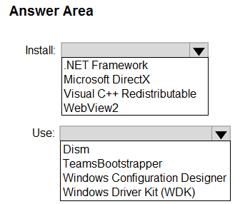
- Binh luan:
looks correct:
https://learn.microsoft.com/en-us/microsoftteams/new-teams-vdi-requirements-deploy
Don't Know the correct ans but as of February 11, 2025, MS-700 has removed "Plan and configure Teams for VDI" from its syllabus.
https://learn.microsoft.com/en-us/credentials/certifications/resources/study-guides/ms-700#change-log
Its not mentioning if its the classic teams client or the new teams , If its the classic client then it should be Visual C++

Cau 132
Dap an: D
You have a Microsoft 365 E5 subscription that includes Teams. The subscription contains a user named User1 that is an owner of a team named Team1. Team1 contains members that include guest user accounts.
You need to ensure that User1 provides a quarterly confirmation for all the guest users that have a legitimate business need for membership to Team1.
What should you do?
A. From the Microsoft Teams admin center, configure the External access settings.
B. From the Microsoft Entra admin center, configure the External collaboration settings.
C. From the Microsoft Teams admin center, configure the Guest access settings.
D. From the Microsoft Entra admin center, configure the Access reviews settings. ✓
- Binh luan:
Access reviews settings is the correct ans
Correct
https://learn.microsoft.com/en-us/entra/id-governance/access-reviews-overview

Cau 133
Dap an: N/A
HOTSPOT
-
You have a Microsoft 365 subscription that contains an Azure Virtual Desktop deployment. The Azure Virtual Desktop deployment contains a session host named Host1.
You install the Remote Desktop WebRTC Redirector Service and the Teams for virtual desktop infrastructure (VDI) client on Host1.
You need to ensure that your webcam delivers the highest quality video for Teams calls.
How should you complete the registry key? To answer, select the appropriate options in the answer area.
NOTE: Each correct selection is worth one point.
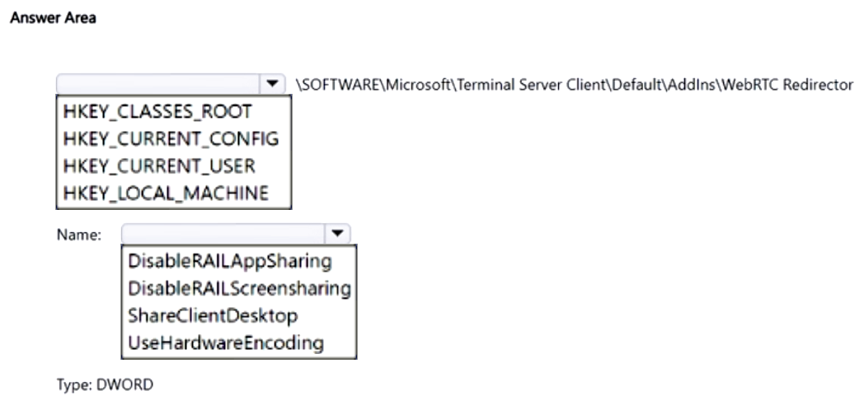
- Binh luan:
HKEY_LOCAL_MACHINE — UseHardwareEncoding — DWORD (enable hardware encoding for best webcam video quality).
It has to be HKEY_LOCAL_MACHINE and NOT HKEY_CURRENT_USER because local machine makes it global. And of course UseHardwareEncoding.
As of February 11, 2025, MS-700 has removed "Plan and configure Teams for VDI" from its syllabus.
https://learn.microsoft.com/en-us/credentials/certifications/resources/study-guides/ms-700#change-log
https://learn.microsoft.com/en-us/azure/virtual-desktop/teams-on-avd
Local machine and UseHardwareEncoding
Answer is correct. Refer to following site.
https://learn.microsoft.com/en-us/azure/virtual-desktop/teams-on-avd
"Enable hardware encode for Teams on Azure Virtual Desktop"

Cau 134
Dap an: N/A
HOTSPOT
-
You have a Microsoft 365 subscription that uses Teams. The subscription contains the users shown in the following table.
You need to implement a solution to test and validate public preview features for Teams.
Which users can implement the solution, and which settings should be configured? To answer, select the appropriate options in the answer area.
NOTE: Each correct selection is worth one point.
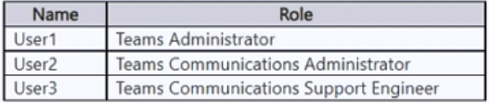
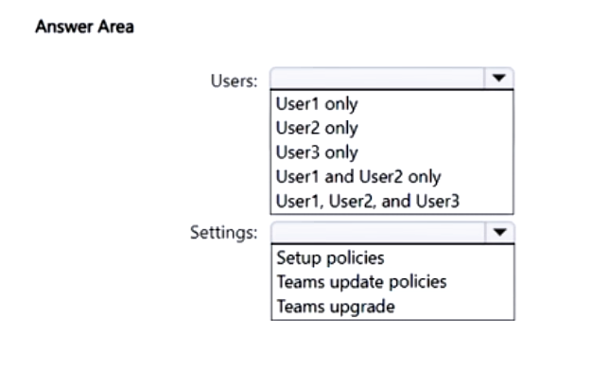

Cau 135
Dap an: N/A
HOTSPOT
-
You have a Microsoft 365 subscription that uses Teams and contains the teams shown in the following table.
You need to deploy an access solution that meets the following requirements:
• The members of Team1 must be prevented from adding guest accounts to the team.
• After every quarter, the owners of Team2 must review guest access and remove guests that no longer require access to the team.
What should you configure for each team? To answer, select the appropriate options in the answer area.
NOTE: Each correct selection is worth one point.
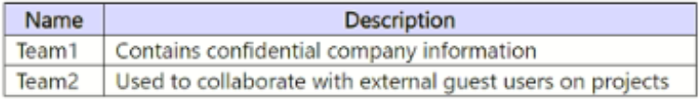
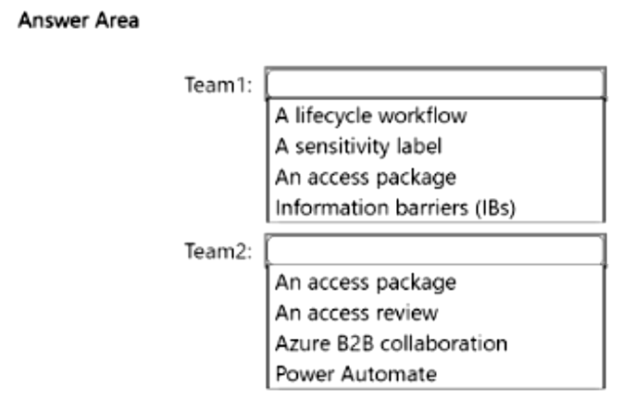
- Binh luan:
Sensitive labels
Access Review
Team1: A sensitivity label
Team2: An access review
Team1:
- a Lifecycle workflow
* Has nothing to do with guest users.
- A sensitivity label
* This will help enforce restrictions on who can add guests to Team1 and ensure that members cannot add guest accounts, as sensitivity labels can include policies to protect sensitive information.
- An access package
* an access package is not suitable for Team1 in this scenario because access packages are primarily used to manage access rights for a group
I the first one answer is wrong. It should be -- Team1: A sensitivity label --

Cau 136
Dap an: B, C
Your company has a Microsoft Office 365 subscription.
Users in the company’s sales department frequently invite guest users to meetings.
You need to ensure that when the sales department users invite guest users to meetings, the guest users are admitted by default. The solution must only apply to the sales department users.
Which two actions should you perform? Each correct answer presents part of the solution.
NOTE: Each correct selection is worth one point.
A. In the global meeting policy, set Who can bypass the lobby to Everyone.
B. Create a new meeting policy and set Who can bypass the lobby to Everyone. ✓
C. Apply the policy to the sales department users. ✓
D. In the global meeting policy, set Who can bypass the lobby to People in my organization.

Cau 137
Dap an: N/A
HOTSPOT
-
You have a Microsoft 365 subscription.
You have a virtualized desktop infrastructure (VDI) that contains the virtual machines shown in the following table.
You need to install the Teams for VDI client on the virtual machines. The solution must support audio/video (AV) optimization.
Which virtual machines support the Teams for VDI client, and what should you do to enable AV optimization? To answer, select the appropriate options in the answer area.
NOTE: Each correct selection is worth one point.
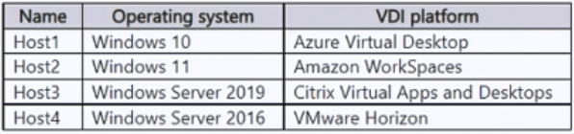
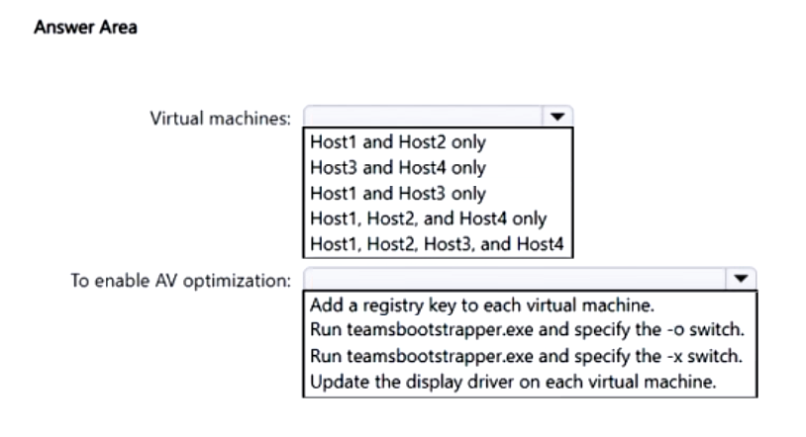
- Binh luan:
I think host1 and host3
Run Teams_windows_x64.msi with the -o switch
- Windows 10.0.19041 or higher (excluding Windows 10 LTSC for Teams desktop app)
- Windows Server 2016 is NOT supported.
„WorkSpaces doesn't have the Teams optimization like other VDI platforms. While it may work, there may be situations where the experience is poor.”
So host1 and host3
You can force Teams into AV mode using this registry key:
[HKEY_LOCAL_MACHINE\SOFTWARE\Microsoft\Teams]
"IsWVDEnvironment"=dword:00000001"

Cau 138
Dap an: A
You have a Microsoft 365 E3 subscription.
You have a conference room that contains a Teams Rooms device named Device1. Device1 is assigned a Teams Rooms Basic license.
You need to ensure that you can restart Device1 from a remote location.
What should you do?
A. Assign Device1 a Teams Rooms Pro license. ✓
B. Assign Device1 a Microsoft 365 E5 license.
C. Enroll Device1 in Microsoft Intune.
D. Join Device1 to Microsoft Entra.
- Binh luan:
The Teams Rooms Pro license also provides advanced management features like remote device management, conditional access policies, and detailed device analytics.
https://learn.microsoft.com/en-us/microsoftteams/rooms/rooms-licensing
Correct.
You need Pro for remote management
https://learn.microsoft.com/en-us/microsoftteams/rooms/rooms-licensing

Cau 139
Dap an: N/A
HOTSPOT
-
You have a Microsoft 365 E5 subscription.
You purchase a new Teams Rooms device.
You need to create a Microsoft 365 resource account named Room1 for the device. The solution must ensure that Room1 automatically accepts meeting invitations.
How should you complete the PowerShell command? To answer, select the appropriate options in the answer area.
NOTE: Each correct selection is worth one point.
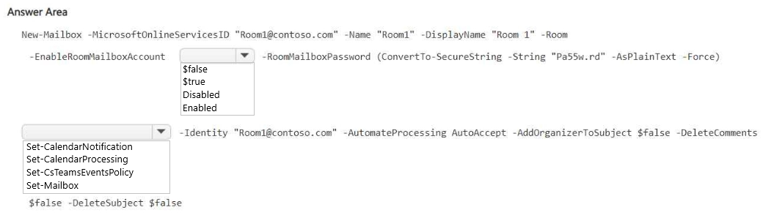
- Binh luan:
EnableRoomMailboxAccount: <Boolean>
The EnableRoomMailboxAccount parameter specifies whether to enable the disabled user account that's associated with this room mailbox. Valid values are:
$true: The disabled account that's associated with the room mailbox is enabled. You also need to use the RoomMailboxPassword with this value. The account is able to log in and access the room mailbox or other resources.
$false: The account that's associated with the room mailbox is disabled. The account is not

Cau 140
Dap an: N/A
HOTSPOT
-
Your company has a marketing department and a sales department.
You have a Teams deployment.
You need to recommend an infrastructure that meets the following requirements:
• Users in the sales department must share system audio.
• Users in the marketing department must upload custom backgrounds.
• Whenever possible, the virtual desktop infrastructure (VDI) must be prioritized to save costs.
What should you include in the recommendation for each department? To answer, select the appropriate options in the answer area.
NOTE: Each correct selection is worth one point.
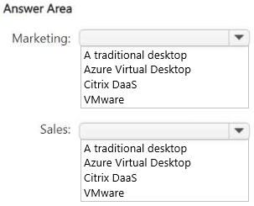
- Binh luan:
Marketing uses Custom Backgrounds this and other effects on the VDIs is blocked they need a traditional Desktop.
Sales could use Azure VDI.

Cau 141
Dap an: N/A
HOTSPOT
-
You have a Microsoft Office 365 E5 subscription that uses Teams.
You need to recommend a solution to automatically remove inactive guest users from a team. The solution must minimize costs.
What should you include in the recommendation? To answer, select the appropriate options in the answer area.
NOTE: Each correct selection is worth one point.
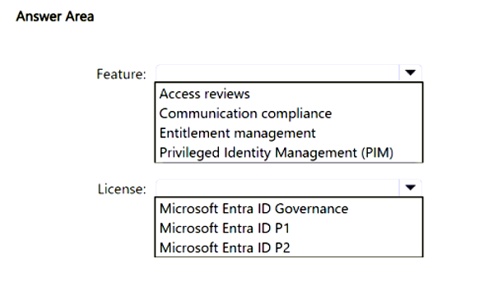
- Binh luan:
The key here is “Microsoft 365 E5 subscription” which means that they already have Microsoft Entra ID P2 included, and this license has “Access reviews”, which is what the company needs to fulfil the requirements.
Correct Answer:
- Access Review
- Microsoft Entra ID P2

Cau 142
Dap an: N/A
HOTSPOT
-
You have a Microsoft 365 E5 subscription that includes Teams.
You are planning a Teams deployment for a new branch office in London that contains the resources shown in the following table.
The office has network bandwidth available for Teams as shown in the following table.
You have Teams bandwidth requirements for the resources as shown in the following table.
For each of the following statements, select Yes if True. Otherwise select No.
NOTE: Each correct selection is worth one point.
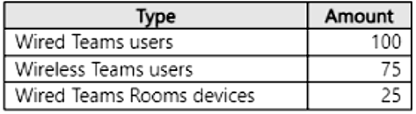
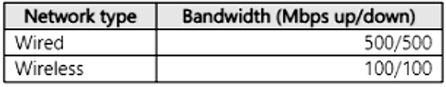
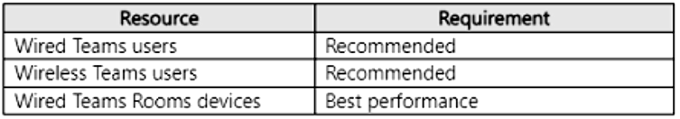
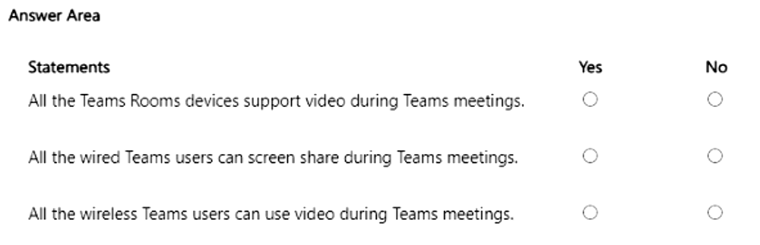

Cau 143
Dap an: A, B
You have a Microsoft 365 subscription that contains a Citrix Virtual Apps and Desktops deployment.
You plan to install the Teams for virtual desktop infrastructure (VDI) client on virtual machines.
You need to identify which Teams features are unavailable to the Citrix environment.
Which two features should you identify? Each correct answer presents a complete solution.
NOTE: Each correct selection is worth one point.
A. Multitenant Multi-Account ✓
B. Channels 2.0 ✓
C. sharing toolbar pinning/unpinning
D. screen sharing from chat
E. Give/Take control

Cau 144
Dap an: N/A
HOTSPOT
-
You have an Azure Virtual Desktop deployment.
You have a Teams deployment.
You deploy the Teams for virtual desktop infrastructure (VDI) client on an Azure Virtual Desktop session host and configure the registry settings as shown in the following exhibit.
Use the drop-down menus to select the answer choice that completes each statement based on the information presented in the graphic.
NOTE: Each correct selection is worth one point.
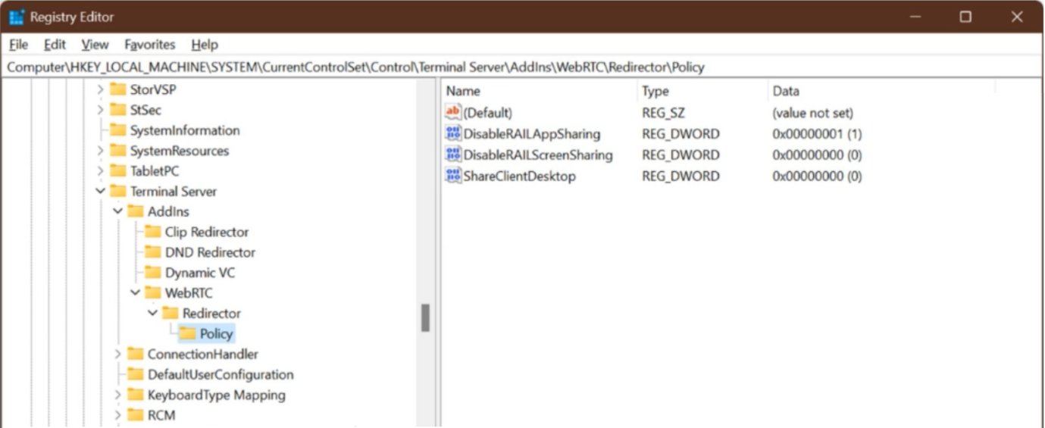
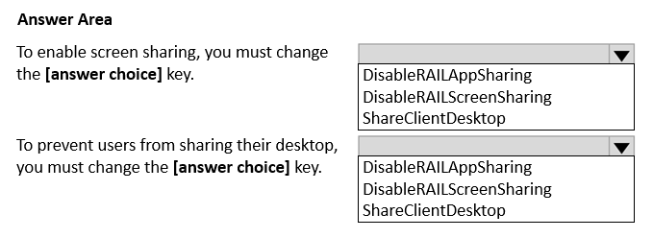
- Binh luan:
Enable screen sharing: DisableRAILAppSharing
Prevent desktop sharing: ShareClientDesktop

Cau 146
Dap an: N/A
DRAG DROP
-
You have a Teams deployment that contains a Teams Rooms Pro subscription.
A consultant deploys a Teams Rooms on Windows device named Boardroom1.
You need to ensure that the consultant can complete the sign-in process for Boardroom1 without access to a username and password.
Which three actions should you perform in sequence? To answer, move the appropriate actions from the list of actions to the answer area and arrange them in the correct order.
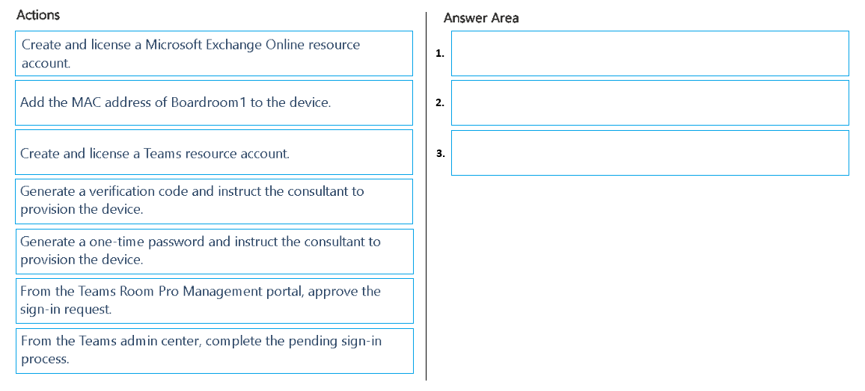
- Binh luan:
1.Create and license a Teams resource account
2.Generate a verification code and instruct the consultant to provision the device
3.From the Teams Room Pro Management portal, approve the sign-in request

Cau 147
Dap an: A
You have a Microsoft 365 E5 subscription that includes Teams.
You need to identify app data for a specific date and time range for the following:
• Teams apps that were installed on or removed from a Teams client
• Teams apps that were added to or removed from the Microsoft Teams app catalog
What should you do?
A. From Compliance Manager, search the audit log. ✓
B. From the Microsoft Teams admin center, review Teams usage reports.
C. From Microsoft Teams apps in the Microsoft 365 admin center, review the App usage report.
D. From the Microsoft Entra admin center, search the audit log.
- Binh luan:
A is correct & the explanation of HBR_1973 as well
To find the installation and removal history for Teams client apps and catalog apps within a specific date and time range, use the Microsoft Purview Audit solution by navigating to Solutions > Audit, selecting the desired date and time range, and then searching for relevant events related to app installations and uninstalls from the audit logs

Cau 148
Dap an: B
You have a Microsoft 365 E5 subscription.
You need to deploy video conferencing equipment to meeting rooms. The solution must meet the following requirements:
• Meet the device compliance requirements specified in Microsoft Intune.
• Support Intelligent Speaker.
• Support Operator Connect.
• Minimize costs.
Which type of license should you assign to each phone?
A. Teams Rooms Pro
B. Microsoft 365 E5 ✓
C. Teams Shared Device
D. Microsoft 365 E3
E. Teams Rooms Basic
- Binh luan:
it is easy. A: Teams Rooms Pro
A — Teams Rooms Pro (needed for Intune compliance, Intelligent Speaker, and Operator Connect).
Teams Room Basic does not support Intelligent Speaker.
The answer is Teams Rooms Pro. Basic does not support Operator Connect (Teams Phone) or Intelligent Speaker. It's also not supported to give a suite license to a room anymore - gotta be Teams Room Basic or Pro (the answer is PRO)
AI-overzicht
+3
To minimize costs while meeting the requirements of device compliance (Intune), Intelligent Speaker support, and Operator Connect, you should assign a Teams Rooms Basic license to each meeting room phone. While a Pro license also meets these requirements, the Basic license offers a more cost-effective solution for single-system meeting rooms and fulfills all the given criteria.
Here's why:
Meeting Room Compliance:
Both Teams Rooms Basic and Teams Rooms Pro licenses include the

Cau 149
Dap an: N/A
HOTSPOT
-
You have a Microsoft 365 subscription that contains an Azure Virtual Desktop deployment. The Azure Virtual Desktop deployment contains the resources shown in the following table.
You install the Teams for virtual desktop infrastructure (VDI) client on Host1. Media optimization is NOT configured.
You need to ensure that audio during a Teams meeting is redirected to a user's local device.
Which RDP Property setting should you configure, and to which resource should you apply the setting? To answer, select the appropriate options in the answer area.
NOTE: Each correct selection is worth one point.
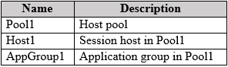
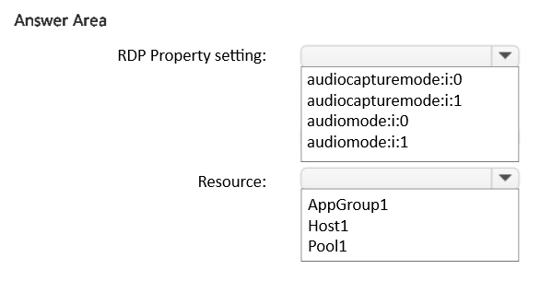
- Binh luan:
audiomode:i:0 — Pool1 (redirect meeting audio to the local device via host pool RDP properties).

Cau 150
Dap an: A
You have a Microsoft E5 subscription that uses Teams.
You need to configure a policy to block specific words from being used as part of the name of new teams.
Which type of policy should you configure?
A. group naming policy ✓
B. team templates policy
C. communication compliance policy
D. terms of use (ToU) policy
- Binh luan:
You should configure a Group Naming Policy in Microsoft Entra ID to block specific words from being used in new Microsoft Teams names. This policy allows you to enforce naming conventions, including blocking prohibited terms in group names and aliases, which applies to Microsoft 365 Groups, the underlying structure for Microsoft Teams.

Cau 151
Dap an: D
You have a Microsoft 365 subscription and a Teams Phone deployment.
You purchase 50 certified Teams devices to be used as common area phones.
To the subscription, you upload a file that contains the MAC address of each device.
You need to ensure that field technicians can provision each device.
What should you configure?
A. an app setup policy
B. a Teams IP Phone policy
C. a configuration profile
D. verification codes ✓

Cau 152
Dap an: D
You have a Microsoft 365 subscription that contains an Azure Virtual Desktop deployment.
You plan to install the Teams for virtualized desktop infrastructure (VDI) client on Azure Virtual Desktop session hosts.
You need to ensure that media optimization is configured for Teams.
Which registry key should you configure on each session host?
A. HKEY_CURRENT_USER\SOFTHARE\Microsoft\Teams
Name: IsWVDEnvironment -
Data/Value: 0
B. HKEY_LOCAL_MACHINE\SYSTEM\CurrentControlSet\Control\Terminal Server\AddIns\WebRTC Redirector\Policy
Name: ShareClientDesktop -
Data/Value: 0
C. HKEY_CURRENT_USER\SYSTEM\CurrentControlSet\control\Terminal Server\AddIns\WebRTC Redirector\Policy
Name: ShareClientDesktop -
Data/Value: 1
D. HKEY_LOCAL_MACHINE\SOFTWARE\Microsoft\Teams
Nome: IsWVDEnvironment -
Data/Value: 1 ✓
- Binh luan:
To ensure Media Optimization is configured for Microsoft Teams on an Azure Virtual Desktop session host, set the registry key HKEY_LOCAL_MACHINE\SOFTWARE\Microsoft\Teams to IsWVDEnvironment with a DWORD value of 1. This registry entry informs the Teams client that it is running in a virtualized environment, allowing it to utilize WebRTC redirection for better performance during calls.
Registry Key Details
Path: HKEY_LOCAL_MACHINE\SOFTWARE\Microsoft\Teams
Name: IsWVDEnvironment
Type: DWORD
Value:

Cau 153
Dap an: A
You have a Microsoft 365 E5 subscription that uses Teams.
You have a team named Team1 that contains guest users.
You need to ensure that the members of Team1 are prevented from sharing sensitive information with the guest users during Teams private chats or in Teams channels.
Which type of policy should you configure?
A. data loss prevention (DLP) policy ✓
B. messaging policy
C. information barrier policy
D. sensitivity label policy
- Binh luan:
DLP cares about what data is being shared, not who is talking to whom. Prevent certain users or groups from communicating with each other.
DLP cares about what data is being shared, not who is talking to whom. Information Barriers - Prevent certain users or groups from communicating with each other.
You should configure a Data Loss Prevention (DLP) policy to prevent Team1 members from sharing sensitive information with guest users in Microsoft Teams private chats or channels. This policy will automatically detect and prevent messages containing sensitive information from being sent to external guests, thus protecting your organization's data.

Cau 154
Dap an: D
You have a Teams deployment.
You have a conference room that contains a Teams Rooms for Windows device named Device1.
You need to customize the default meeting layout configuration for Device1.
Which file should you modify?
A. Configuration.json
B. Settings.json
C. Persistent.conf
D. SkypeSettings.xml ✓
- Binh luan:
You should modify the Microsoft Teams Rooms XML configuration file (SkypeSettings.xml) to customize the default meeting layout for a Teams Rooms for Windows device like Device1. This file allows for remote deployment of various settings, including the default meeting experience, by adding specific XML elements for single or dual display modes, such as <DefaultFoRExperience> or <SingleFoRDefaultContentLayout>.
https://learn.microsoft.com/en-us/microsoftteams/rooms/xml-config-file

Cau 155
Dap an: B, D
Your company has the offices shown in the following table.
You have a Teams deployment.
You need to apply bandwidth restrictions for Teams users in the Buffalo office. The solution must meet the following requirements:
• The media bit rate must be 2 maximum of 1 Mbps.
• Users that travel between the offices must have access to high-quality video while in the New York office.
Which two features should you configure? Each correct answer presents part of the solution.
NOTE: Each correct selection is worth one point.
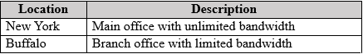
A. a calling policy
B. a meeting policy ✓
C. a Teams update policy
D. a network roaming policy ✓
E. Network planner
- Binh luan:
B & D are correct
Source: https://learn.microsoft.com/en-us/microsoftteams/network-roaming-policy
To apply bandwidth restrictions and ensure high-quality video for traveling users, you should configure a Teams meeting policy with a media bit rate limit of 1 Mbps for the Buffalo office, and you should implement Quality of Service (QoS) on the network equipment for high-priority Microsoft Teams traffic, such as video, to ensure consistent quality for users regardless of their office location.

Cau 156
Dap an: D
You have a Microsoft 365 E5 subscription that includes Teams.
When a user named User1 downloads and installs the new Teams desktop client on a Windows 10 device, the user receives the following error message:
"We've run into an issue."
You need to ensure that User1 can install the new Teams desktop client.
What should you do?
A. Clear the cache of the Teams desktop client.
B. Download and install the ASP.NET Core Runtime.
C. Start the Teams desktop client by using elevated permissions.
D. Download and install the WebView2 Runtime. ✓

Cau 157
Dap an: D
You have a Microsoft 365 subscription.
You have a virtual desktop infrastructure (VDI) that contains Azure virtual machines as session hosts.
You need to upgrade the session hosts to the new Teams client by running teamsbootstrapper.exe. The solution must minimize the amount of bandwidth used during the installation of the client.
Which installer should you use?
A. a PKG file
B. Microsoft 365 apps
C. a standalone executable
D. the MSIX package ✓

Cau 158
Dap an: D
You have a Microsoft 365 subscription.
You plan to implement Teams.
You need to recommend a solution to assess the current environment and identify configurations that must be updated to support Teams meetings and online conferences.
What should you include in the recommendation?
A. Network planner
B. the Microsoft 365 Assessment tool
C. Microsoft Office Deployment Tool (ODT)
D. Teams advisor ✓

Cau 159
Dap an: N/A
HOTSPOT
-
You have a Teams deployment.
An administrator named Admin1 plans to deploy Teams to a new branch office named Branch1.
You need to assign a role to Admin1 and recommend the tool to use to perform the following tasks:
• Calculate the bandwidth requirements based on the WAN link capacity and the number of users in Branch1.
• Generate a report that contains the calculated results.
The solution must follow the principle of least privilege.
What should you do? To answer, select the appropriate options in the answer area.
NOTE: Each correct selection is worth one point.
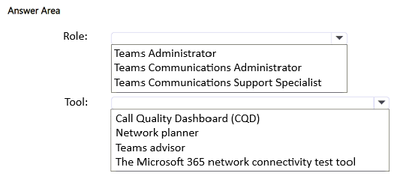
- Binh luan:
Answers are correct.
"To use Network planner, you must be a Global Administrator, Teams Administrator, or Teams Communications Administrator." And Communication admin has the least privilege out of these 3
MS Source: https://learn.microsoft.com/en-us/microsoftteams/network-planner

Cau 160
Dap an: C
You have a Teams deployment.
You change the display name and profile photo of a user named User1.
You need to ensure that the changes are displayed as soon as possible in the new Teams client for User1.
What should you do?
A. Run the Microsoft Support and Recovery Assistant.
B. Run the self-help diagnostics tool.
C. Clear the Teams client cache. ✓
D. Clear the web browser cache.

Cau 1
Dap an: A
Your company has a Microsoft 365 subscription.
You have a Microsoft Teams team named Sales that is set to Private.
Users report that they can view the Sales team from a list of suggested teams.
You need to hide the team from the list of suggested teams.
What should you do from the Microsoft Teams client?
A. Modify the Team discovery settings. ✓
B. Select the Hide team option.
C. Modify the team privacy settings.
D. Modify the team member permissions.
- Binh luan:
A doesn't exist.
B just hides the team from your own view, not from everyone.
C is correct, just verified by locating a private team in my org that i'm not a member of and seeing if i could find it from the "join team" in the client. I could not
C is wrong, Sales is already a private team. This is outdated question, answear A was ok but Microsoft changed that all private teams are now not discoverable
I think the question is no longer relevant since discovery settings no longer exist and all private teams are hidden from non-members
https://learn.microsoft.com/en-us/microsoftteams/teams-policies?WT.mc_id=TeamsAdminCenterCSH#discoverteams
Team discovery
Team discovery is a team-level setting that controls how members of the organization can find and join the team. To manage discovery settings for a team, go to the Team settings > Permissions.
Team discovery has three states:
Hidden — unless members are invited to the team, they can’t find it
Members can join after approval — the team is visible and members can request to join
Open to members — the team is visible and members can join it right away
https://help.miro.com/hc/en-u

Cau 2
Dap an: B
Note: This question is part of a series of questions that present the same scenario. Each question in the series contains a unique solution that might meet the stated goals. Some question sets might have more than one correct solution, while others might not have a correct solution.
After you answer a question in this section, you will NOT be able to return to it. As a result, these questions will not appear in the review screen.
You have a Microsoft 365 subscription that contains several Microsoft SharePoint Online sites.
You need to ensure that the content stored in a SharePoint modern team site named Sales is available from Microsoft Teams. The solution must ensure that when a new channel is added to a team, a folder for the channel is created in the Sales site.
Solution: From a team, you add a tab for the Sales site.
Does this meet the goal?
A. Yes
B. No ✓
- Binh luan:
Adding the site as a Tab will not guarantee that a new folder is added when a channel is created. To do that requires that the SharePoint site be converted to a Team. https://support.office.com/en-us/article/Create-a-Microsoft-Team-from-SharePoint-545973b6-c38f-426a-b2b6-16405a561628
So the answer should be B.
The answer is A. The team is already a modern sharepoint site. "You need to ensure that the content stored in a SharePoint modern team site named Sales is available from Microsoft Teams."
The complete statement is: "You need to ensure that the content stored in a SharePoint modern team site named Sales is available from Microsoft Teams. The solution must ensure that when a new channel is added to a team, a folder for the channel is created in the Sales site."
If you remove part, of course, it will change the meaning.
Therefore, I understand it should be "B" (NO), as birdman said "Adding the site as a Tab will not guarantee that a new folder is added when a channel is created."
Changing my mind here... it's A indeed :)

Cau 4
Dap an: A
Note: This question is part of a series of questions that present the same scenario. Each question in the series contains a unique solution that might meet the stated goals. Some question sets might have more than one correct solution, while others might not have a correct solution.
After you answer a question in this section, you will NOT be able to return to it. As a result, these questions will not appear in the review screen.
You have a Microsoft 365 subscription that contains several Microsoft SharePoint Online sites.
You need to ensure that the content stored in a SharePoint modern team site named Sales is available from Microsoft Teams. The solution must ensure that when a new channel is added to a team, a folder for the channel is created in the Sales site.
Solution: From the Sales site, you use the Create a Team option.
Does this meet the goal?
A. Yes ✓
B. No
- Binh luan:
The Answer should be A. This will create a Team that uses the Sales site as storage.
Correct, this should be A.
I agree the answer is A. https://office365atwork.com/teams/connect-microsoft-teams-with-sharepoint-site/
Again tested and working. Answer is yes.
Answer A - YES is the correct one.
As stated in the first solution: Ceating a SP Team Site does not create a Team, so you need to create a team with the option provided in SP Team Site to create a team or use Teams client to create a new team from O365 group greated for the SP site.

Cau 5
Dap an: B
Note: This question is part of a series of questions that present the same scenario. Each question in the series contains a unique solution that might meet the stated goals. Some question sets might have more than one correct solution, while others might not have a correct solution.
After you answer a question in this section, you will NOT be able to return to it. As a result, these questions will not appear in the review screen.
You have a Microsoft 365 subscription that contains several Microsoft SharePoint Online sites.
You need to ensure that the content stored in a SharePoint modern team site named Sales is available from Microsoft Teams. The solution must ensure that when a new channel is added to a team, a folder for the channel is created in the Sales site.
Solution: From PowerShell, you run the Set-AzureADGroup cmdlet.
Does this meet the goal?
A. Yes
B. No ✓
- Binh luan:
B Set-AzureADGroup cmdlet works in the Security context with the Security group type. Teams, instead, relies on Microsoft 365 group type.
the cmdlet has nothing to do with the scenario, basically No. Thats for security groups, according to my own understanding
correct answer is B
https://docs.microsoft.com/en-us/powershell/module/azuread/set-azureadgroup?view=azureadps-2.0
Set-AzureADGroup have nothing to do with this...

Cau 6
Dap an: N/A
HOTSPOT -
You have a Microsoft 365 tenant that uses Microsoft Skype for Business on-premises.
You plan to upgrade to Microsoft Teams in stages based on groups. The features required by each group are shown in the following table.
How should you configure the upgrade policy for the groups? To answer, select the appropriate options in the answer area.
NOTE: Each correct selection is worth one point.
Hot Area:
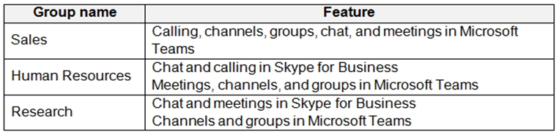
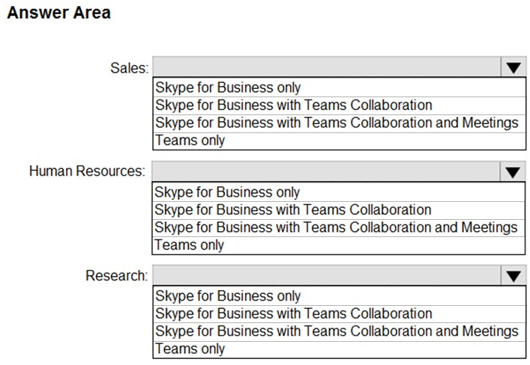
- Binh luan:
Key words to focus on:
Channels and groups = Collaboration
Sales-> Teams Only; HR-> SfB with Teams Collaboration and Meetings; Research->SfB with Teams Collaboration
On Test 29.03.22
On Test 18.01.22
correct

Cau 7
Dap an: N/A
HOTSPOT -
Your company has a Microsoft 365 subscription.
The company's only messaging policy is a global messaging policy configured as shown in the following exhibit.
Use the drop-down menus to select the answer choice that completes each statement based on the information presented in the graphic.
NOTE: Each correct selection is worth one point.
Hot Area:
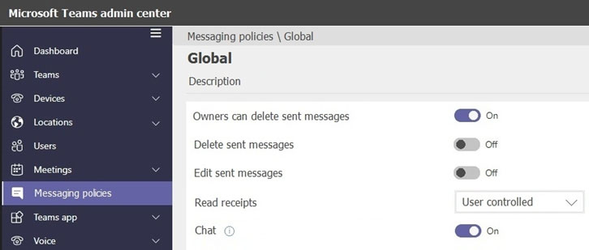
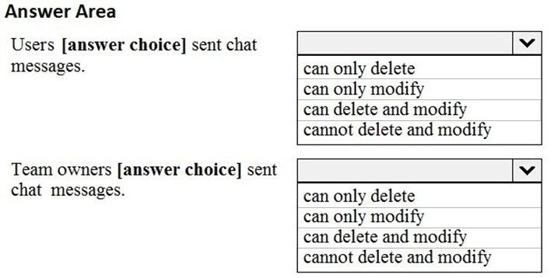
- Binh luan:
Testing this, appears that owners can delete and modify sent messages.
yes correct , Teams owner can delete and modify , just tested
the provided answer for the second part is wrong
Be sure that your policy settings are already in place. No editing is possible for owner if policy is fully applied!
WRONG - owner is not able to modify sent messages whether they are theirs or someone elses! Can only delete as tested in Sandbox and two Teams desktop clients. The answers provided are correct. Stop upvoting this.
The answer is correct. Tested it on 7/7/21
Owners can only delete messages sent by other teams members but
can edit and delete their own messages.

Cau 8
Dap an: N/A
HOTSPOT -
You have a Microsoft 365 E5 subscription that uses Microsoft Teams and a hybrid deployment of Microsoft Skype for Business Server.
Coexistence mode in Microsoft Teams is set to Islands.
Coexistence mode is configured for three users named User1, User2, and User3 as shown in the following table.
The Skype for Business user accounts are homed as shown in the following table.
For each of the following statements, select Yes if the statement is true. Otherwise, select No.
NOTE: Each correct selection is worth one point.
Hot Area:
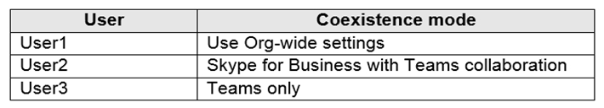
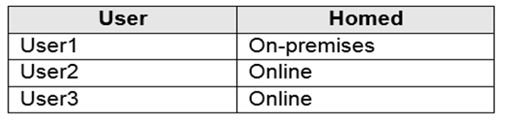
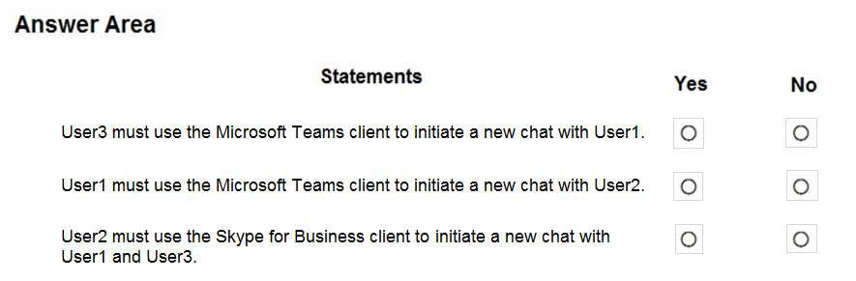
- Binh luan:
Correct: Yes | No | Yes
Why:
Yes > User3 coexistence mode is Teams only. The User can only use Teams for a new Chat with User1.
No > User1 coexistence mode is Islands. User1 can you SfB for a new chat with User2.
Yes > User2 coexistence mode means "Teams private chat, calling, and scheduling meetings are off by default in this mode."
Correct : Yes | No | NO
Why:
Yes (OK) > User3 coexistence mode is Teams only. The User can only use Teams for a new Chat with User1.
No (OK) > User1 coexistence mode is Islands. User1 can you SfB for a new chat with User2.
NOOOO > User 2 cannot chat with User 3 with SFB because, user 3 is in "Teams Only" mode
As you said, in "Skype for Business with Teams Collaboration" mode, "Teams private chat, calling, and scheduling meetings are OFF by default in this mode".
https://docs.microsoft.com/fr-
Incorrect. 3 is Yes. Teams can chat with SfB. A teams only user that sends a chat to a SfB user will receive the message in SfB. The SfB user sends a message to Teams only user will receive the message in Teams.
3 YES.
User2 SfBwithCollab will freely communicate 1:1 with U1 SfBonPREM and U3 TeamsOnly client by means of Interop gateway.
See an informative table here https://youtu.be/2eQ6s547fF0?t=2650
3. Is Yes, I am in teams only mode and can still communicate with orgs who are using Skype.

Cau 9
Dap an: N/A
HOTSPOT -
Your company uses Microsoft Skype for Business Online and Microsoft Teams.
All Skype for Business Online users can make and receive PSTN calls. Microsoft Teams is configured for PSTN calls.
You plan to upgrade the Skype for Business Online users to Microsoft Teams.
The Teams upgrade settings are configured as shown in the Teams upgrade exhibit. (Click the Teams upgrade tab.)
You apply TeamsUpgradePolicy to the user accounts of the company's R&D and human resources (HR) departments by using the coexistence modes shown in the following table.
For each of the following statements, select Yes if the statement is true. Otherwise, select No.
NOTE: Each correct selection is worth one point.
Hot Area:
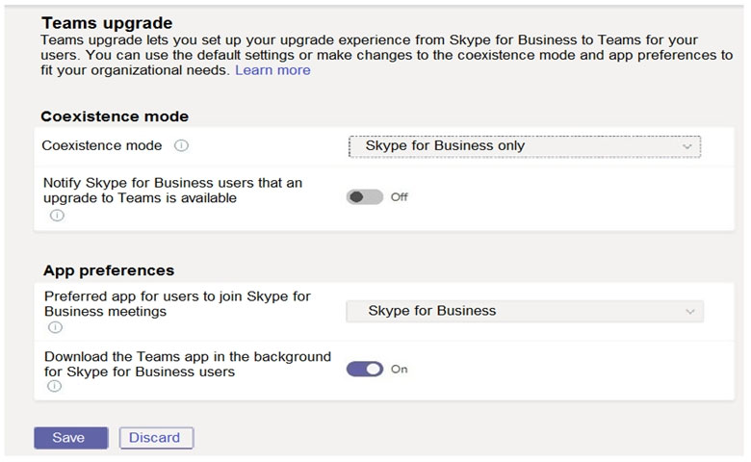
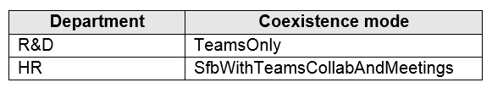
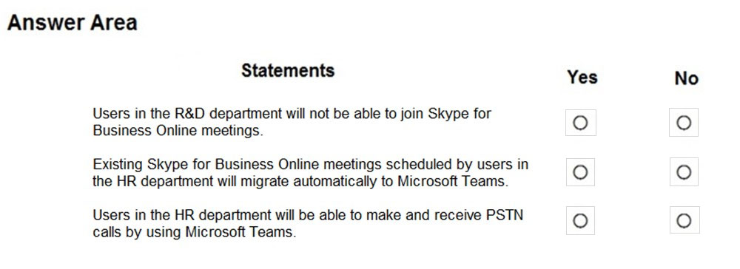
- Binh luan:
Answer is correct.
1. **Users in the R&D department will not be able to join Skype for Business Online meetings** - **Yes**, this is true. The coexistence mode for the R&D department is set to "TeamsOnly", which means they will only be able to use Microsoft Teams.
2. **Existing Skype for Business Online meetings scheduled by users in the HR department will migrate automatically to Microsoft Teams** - **No**, this is not true. The coexistence mode for the HR department is set to "SfbwithTeamsCollab and Meetings",
I assume it is not valid anymore. Coexistance mode is disabled by Micrososft.
https://docs.microsoft.com/en-us/skypeforbusiness/audio-conferencing-in-office-365/setting-up-the-meeting-migration-service-mms
When you use the on-premises admin tools (either Move-CsUser or the Admin Control Panel) to move a user to the cloud, existing meetings are automatically moved to the cloud and converted to TeamsOnly. With mode=TeamsOnly or mode= SfBWithTeamsCollabAndMeetings.
On Test 29.03.22

Cau 10
Dap an: A, E
Your company is upgrading from Microsoft Skype for Business Online to Microsoft Teams.
The company's Microsoft Teams upgrade policy is set to Islands coexistence mode. The company plans to maintain the coexistence mode for several months.
Several users report that they receive email messages about missed chat conversations.
You need to recommend a solution to ensure that all the users receive chat messages.
Which two actions should you recommend? Each correct answer presents part of the solution.
NOTE: Each correct selection is worth one point.
A. Install the Microsoft Teams clients on all the computers that run the Skype for Business client. Instruct the users to sign in to both client applications. ✓
B. Instruct the users to modify the permissions in the Microsoft Teams client.
C. Modify the global app setup policy.
D. Modify the global app permission policy.
E. Install the Skype for Business client on all the computers that run the Microsoft Teams client. Instruct the users to sign in to both client applications. ✓
- Binh luan:
A & E. The global app permission policy has nothing to do with it...
I agree with A&E.
https://docs.microsoft.com/en-us/microsoftteams/teams-and-skypeforbusiness-coexistence-and-interoperability
In this coexistence mode, called Islands, each of the client applications operates as a separate island. Skype for Business talks to Skype for Business, and Teams talks to Teams. Users are expected to run both clients at all times and can communicate natively in the client from which the communication was initiated. As such, there's no need for interoperability in Islands
This is the setup i currently work in, so can confirm this is the case.
A & E
Users need to be signed in to both apps.
correct answer is AE

Cau 11
Dap an: B, C, D
Your company has a Microsoft 365 subscription.
You need to ensure that users from a partner company named Contoso, Ltd. can collaborate with your company's users in teams. The solution must ensure that the Contoso users can exchange chat messages in channels.
Which three actions should you perform before you add the Contoso users to teams? Each correct answer presents part of the solution.
NOTE: Each correct selection is worth one point.
A. From the Services & add-ins settings in the Microsoft 365 admin center, set Let group members outside the organization access group content to On.
B. From the Guest access settings in the Microsoft Teams admin center, set Allow guest access in Microsoft Teams to On. ✓
C. From the External collaboration settings in the Azure Active Directory admin center, add Contoso's domain to the list of target domains. ✓
D. From the External access settings in the Microsoft Teams admin center, add Contoso's domain to the Allowed list of domains. ✓
E. From the External collaboration settings in the Azure Active Directory admin center, set Guest users permissions are limited to No.
F. From the Services & add-ins settings in the Microsoft 365 admin center, set Let group owners add people outside the organization to groups to On.
- Binh luan:
guys. step by step. from this link https://docs.microsoft.com/en-us/microsoftteams/guest-access-checklist Step 1 says "In the Teams admin center, select Org-Wide settings > Guest access. Set the Allow guest access in Microsoft Teams switch to On." so that's B Step 3 says "Make sure that the Let group members outside the organization access group content check box is selected. If this setting is not selected, guests won't be able to access any group content." so that's A Step 3 also says "Make su
ABF are the correct answers. I agree.
Confusing but : only exchanging Chat messages in Channels can be used by adding guests without External - to setup Guest - those 3 steps A,B and F are necessary, but CDE are unnecessary. It doesn't say that only this domain , so domain restrictions are unnecessary.
https://docs.microsoft.com/en-us/microsoftteams/guest-access-checklist BCF should be the answer.
Check option C again and you'll notice why C can't be a correct option. "...add Contoso to the list of target domains". how correct is that?

Cau 12
Dap an: A, E
Your company has a Microsoft 365 subscription.
You recently set the company's Microsoft Teams upgrade policy to Teams only coexistence mode.
A user reports that several online meetings are configured to use Microsoft Skype for Business.
You need to convert the online meetings in the user's calendar to use Microsoft Teams.
What are two possible ways to achieve the goal? Each correct answer presents a complete solution.
NOTE: Each correct selection is worth one point.
A. From PowerShell, run the Start-CsExMeetingMigration cmdlet and specify the -identity parameter. ✓
B. Run the Skype for Business Meeting Migration tool.
C. From the Microsoft Teams admin center, modify the meeting policy.
D. From PowerShell, run the Set-CsTeamsUpgradeConfiguration cmdlet.
E. From the Microsoft Teams admin center, modify the Microsoft Teams upgrade policy. ✓
- Binh luan:
AE is correct. There are 4 ways to trigger the Meeting Migration Service. these are items 3 and 4 from the list at this link:
https://docs.microsoft.com/en-us/skypeforbusiness/audio-conferencing-in-office-365/setting-up-the-meeting-migration-service-mms
B is NOT correct. This tool updates SfB meetings with new links etc, but has nothing to do with migrating to Teams.
https://support.microsoft.com/en-us/office/meeting-update-tool-for-skype-for-business-and-lync-2b525fe6-ed0f-4331-b533-c31546fcf4
AE is correct. I agree with you
The PowerShell in A is correct for sure and it took me a while to find that second setting, but I found it here: https://www.youtube.com/watch?v=GdGqyS72cn8&feature=emb_logo
Users > user > account > Teams upgrade > edit > Migrate this user's meetings to Teams set to ON.
Agreed! Taking a look at those two provided links confirms that.
AB
A: Meeting Migration Service (MMS) is a Skype for Business service that runs in the background and automatically updates Skype for Business and Microsoft Teams meetings for users. MMS is designed to eliminate the need for users to run the Meeting Migration Tool to update their Skype for Business and Microsoft Teams meetings. Also, with Start-CsExMeetingMigration cmdlet, you can start a meeting migration manually.
https://docs.microsoft.com/en-us/skypeforbusiness/audio-conferencing-in-office-3

Cau 14
Dap an: A
You have a Microsoft Office 365 subscription.
You plan to upgrade from Microsoft Skype for Business to Microsoft Teams.
You use the following workloads in Skype for Business:
✑ Audio/video conferencing
✑ Dial-in conferencing
✑ Enterprise Voice
✑ Persistent Chat
✑ Chat
You need to ensure that users can evaluate Microsoft Teams while maintaining PSTN calling by using the Skype for Business client.
Which coexistence mode should you use?
A. Islands ✓
B. Skype for Business with Teams collaboration
C. Skype for Business only
D. Meetings First
- Binh luan:
A. Why? You need to ensure that users can evaluate Microsoft Teams = FULL set of features that Teams normally offer. Islands allow for both clients to work independently as well as retain PSTN calls in SfB:
"To avoid a confusing or regressed Skype for Business experience, the Skype for Business handles the following integrations that aren't handled in Teams Islands mode:
External (federated) communications.
PSTN voice services and voice applications, Office integration.
HID controls for USB dev
The answer is D, please note that coexistence mode "Meeting first" is also know as S4BWithTeamsCollaborationAndMeetings, in this mode, users will use Teams to schedule and conduct their meetings. Private chat and calling remain on Skype for Business. this is what the question is about, to retain PSTN functionality within S4B.
You are correct. I believe they are looking for this answer, they are only conserned about the PSTN functionality which is what Meeting First (S4BWithTeamsCollaborationAndMeetings) gives you
Because this mode keeps PSTN calling/Enterprise Voice in Skype for Business, while letting users evaluate Teams for chat/channels/collaboration.
D is correct: Doc says "if you have significant Skype for Business Server on-premises assets with a complex Enterprise Voice deployment, but want your users to enjoy modern meetings as quickly as possible, you might want to evaluate using the Skype for Business with Teams Collaboration and Meetings mode, also known as Meetings First." which is S4BWithTeamsCollaborationAndMeetings,

Cau 15
Dap an: N/A
DRAG DROP -
Your company has a Microsoft 365 E5 subscription.
You need to configure Microsoft Teams to meet the following requirements:
✑ All new teams must include the Wiki app and the Planner app.
✑ Users in specific groups must be prevented from creating private channels.
✑ Only users in the company's IT department must have early access to the unreleased features of Microsoft Teams.
What should you configure for each requirement? To answer, drag the appropriate settings to the correct requirements. Each setting may be used once, more than once, or not at all. You may need to drag the split bar between panes or scroll to view content.
NOTE: Each correct selection is worth one point.
Select and Place:
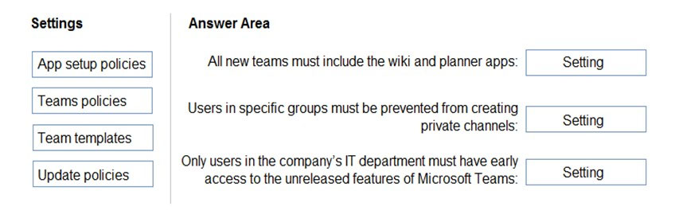
- Binh luan:
All new teams must include the Wiki app and the Planner app. - Team Templates.
App setup policies do not apply to teams, only to users.
Correct
https://techcommunity.microsoft.com/t5/microsoft-teams-blog/create-teams-quickly-with-templates-in-microsoft-teams/ba-p/1394163
exactly !
Another reason why Setup Policy is wrong: just read the description: "Choose which apps and messaging extensions you want installed in your users' personal Teams environment,"...but the question is talking about TEAMS !!
On exam 04-Mar-2022

Cau 16
Dap an: N/A
HOTSPOT -
You have a Microsoft 365 subscription that uses Microsoft Teams and contains a user named User1.
You have the following Microsoft Team templates:
✑ Manage an Event
✑ Manage a Project
✑ Quality and Safety
✑ Onboard Employees
You have the Microsoft Teams template policies shown in the following table.
The Templates policy settings for User1 are configured as shown in the following exhibit.
For each of the following statements, select Yes if the statement is true. Otherwise, select No.
NOTE: Each correct selection is worth one point.
Hot Area:
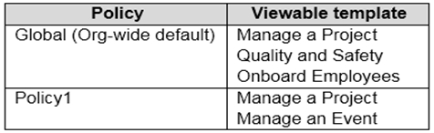
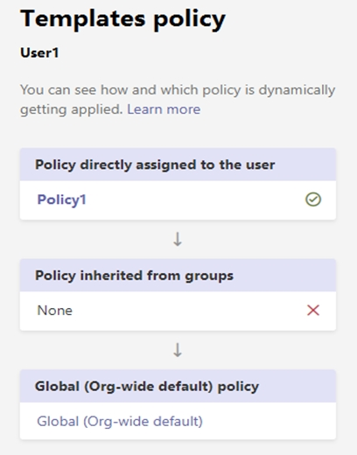
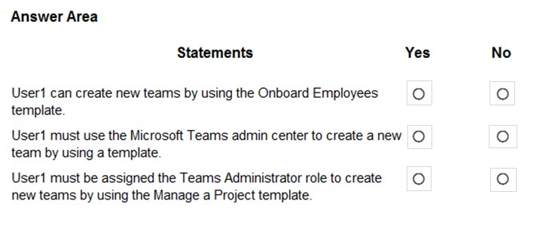
- Binh luan:
I believe all option for user1 is NO meaning Answer is NO, NO, NO. Read following article for affected Team Template policy when directly assigned for the user.
https://docs.microsoft.com/en-us/microsoftteams/assign-policies
This is also my interpretation, policies will not be aggregated throughout the assigned policies chain, its on a first match basis. Therefore answers should be NO NO NO
Correct. The directly assigned group takes precedence over org wide. Answer is no no no
NO - NO - NO
https://docs.microsoft.com/en-us/microsoftteams/assign-policies

Cau 17
Dap an: C, E
You have a Microsoft 365 subscription.
You create an org-wide team named Team1. Users named User1 and User2 are the owners of Team1.
You need to configure Team1 to meet following requirements:
✑ Ensure that only User1 and User2 can create new posts in the General channel.
✑ Prevent @mentions for the org-wide team members.
Which two actions should you perform from the Microsoft Teams client? Each correct answer presents part of the solution.
NOTE: Each correct selection is worth one point.
A. From the Team1 settings, clear Give members the option to edit their messages.
B. From the General Channel settings of Team1, set the channel moderation preference to Anyone can post; show alert that postings will notify everyone (recommended for large teams).
C. From the General Channel settings of Team1, set the channel moderation preference to Only owners can post messages. ✓
D. From the Team1 settings, disable all the Fun stuff settings.
E. From the Team1 settings, set Show members the option to @team or @[team name] to Off. ✓
- Binh luan:
Fun Stuff settings :D
Troll alert, hahaha
c and e correct
Switch off @team and @[team name] mentions
Press the ellipsis … next to the team name > manage team
Press the settings tab > expand @mentions
There are two options checked:
Show members the option to @team or @[team name] (this will send a notification to everyone on the team)
Give members the option to @channel or @[channel name]. This will notify everyone who’s shown the mentioned channel in their channel lists.
This question was on my test today, 07/23/24
Weird one, the general channel doesn't support moderation. As per https://support.microsoft.com/en-au/office/change-moderator-roles-and-settings-in-a-channel-in-microsoft-teams-6ac54758-3440-4f6a-9bd5-cebf97cb7ea6
Note: Channel moderation is available for standard channels on Teams for desktop or web. It's not available for the general channel or private channels.

Cau 19
Dap an: C
Your company has a Microsoft 365 subscription.
The Microsoft 365 tenant uses a domain named contoso.com.
You need to ensure that team channels can receive email only from users in the company and email addresses that use an email domain named @fabrikam.com.
What should you modify?
A. the External collaboration settings in the Azure Active Directory admin center
B. the list of accepted domains in Microsoft Exchange Online
C. the Teams settings ✓
D. the global teams policy
- Binh luan:
C is the right answer. Org-wide setting- >Teams Settings->Email integration
C is the right answer.Org-wide settings---teams settings--email integration.
The setting for Email integration is in Teams Settings NOT Teams Policy
There are 3 ways to complete this requirement.
1. Via Teams Admin Center --> Teams settings --> Email integration --> Users can send emails to a channel email address: ON &
Accept channel email from these SMTP domains: fabrikam.com.
2. Via Teams Client: "To limit who can send email to your channel, go to the channel name, select More options More options button > Get email address, and then select the advanced settings link. From there, you can manage who's able to access the email address for
To limit who can send email to your channel, go to the channel name, click More options More options button > Get email address, then click the advanced settings link.

Cau 21
Dap an: A, B, C
Your company has a Microsoft 365 subscription.
You need to ensure that only the members of the company's IT group can create private channels.
Which three actions should you perform? Each correct answer presents part of the solution.
NOTE: Each correct selection is worth one point.
A. Modify the global teams policy. ✓
B. Assign the members of the IT group to the policy. ✓
C. Create a custom teams policy. ✓
D. Run the Set-TeamsChannel cmdlet.
E. Modify the global messaging policy.
F. Create a custom messaging policy.
- Binh luan:
Correct Answer ABC
Clarification for answer A. - "Set creation of private channel to 'Off' in the global policy" would be more precise "Modify the global Teams policy".
Repeat of question 35:
https://www.examtopics.com/exams/microsoft/ms-700/view/23/
Correct Answer is ABC
Correct answer is ABD
On Exam 28.02.22

Cau 22
Dap an: N/A
HOTSPOT -
You have a Microsoft 365 subscription.
You need to configure the following for all users:
✑ Prevent the use of third-party apps in Microsoft Teams.
✑ Configure the Microsoft Teams app navigation bar.
The solution must minimize administrative effort.
What should you do? To answer, select the appropriate options in the answer area.
NOTE: Each correct selection is worth one point.
Hot Area:
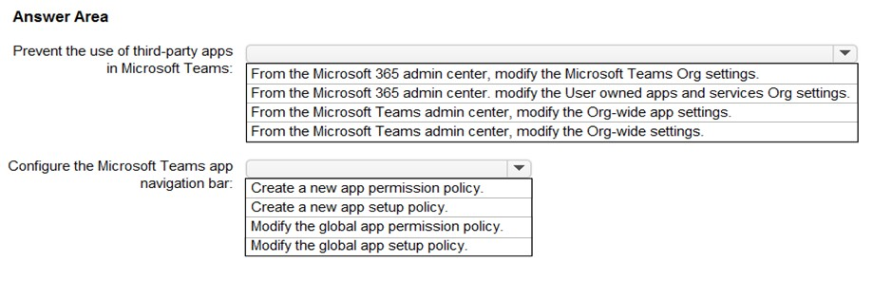
- Binh luan:
Now under Manage apps --> Org-wide --> Toggle Third party apps on or off
I'm guessing this is a legacy question or trick question, Teams | Teams Apps | Manage App, and then Org-Wide App settings in the upper left, or Teams | Teams Apps | Permission Policies, Global
On Test 29.03.22
Correct. Teams app->Manage app-> upper right click org-wide app setting
On Test 18.01.22

Cau 23
Dap an: D
Your network contains an on-premises Active Directory domain that syncs to a Microsoft 365 subscription.
From the Microsoft Teams client, you create a new team named Sales.
You need to ensure that the team includes all users in the company's sales department. The solution must ensure that the new employees hired for the sales department are added automatically to the team.
Which tool should you use to configure the membership of the Sales group?
A. Active Directory Users and Computers
B. the Microsoft 365 admin center
C. Azure AD Connect
D. the Azure Active Directory admin center ✓
- Binh luan:
Yes D should be correct. Static groups can be changed to dynamic groups in the AAD Admin Center.
Answer is D as you can change the static group to dynamic once you've synced from on-premise AD to AzureAD. Then you create an expression under the dynamic rules. I.e. if the user's department field contains the word "Sales" then it'll automatically add them.
You cannot edit synced group using Azure Ad. Only can edit it on prem ad. So cannot convert synced group to dynamic group using Azure ad. Also on prem dynamic cannot be sync to Azure ad. So in this question user creates team using team client so the gorup should be ms 365 group in Azure Ad. Users are synced to Azure ad. We convert ms 365 group to dynmanic group create a query based on departmet and add synced users to Sales group using Azure Ad admin center. The answer is D
correct answer is D
On Test 18.01.22

Cau 24
Dap an: C
You have a Microsoft Office 365 subscription.
You need to prevent guest users from deleting channels from a Microsoft Teams team.
What should you use?
A. the Microsoft Teams admin center
B. the Azure portal
C. the Microsoft Teams client ✓
D. the Microsoft 365 security center
- Binh luan:
for the godsake both are correct! How Microsoft value what is the best option is like the third Fatima's secret
I think it's about least privileged, so in that case C because it's for only 1 team.
C should be answer. The question was for a Microsoft team. just one team.. if the questions is for all teams then A would be the answer
I would say C because nowhere is it stated that you are a global admin or even have access to the Teams Admin Center. The only way to do it then is via the Teams client.
Very annoying question, it's in here at least twice and gives a different answer. Both the TAC and the Teams client will work.

Cau 25
Dap an: B
Note: This question is part of a series of questions that present the same scenario. Each question in the series contains a unique solution that might meet the stated goals. Some question sets might have more than one correct solution, while others might not have a correct solution.
After you answer a question in this section, you will NOT be able to return to it. As a result, these questions will not appear in the review screen.
Your company has a Microsoft 365 subscription.
You need to prevent temporary employees from using the private chat feature in Microsoft Teams.
Solution: You create a meeting policy and assign the policy to the users.
Does this meet the goal?
A. Yes
B. No ✓
- Binh luan:
Teams policy - create private channels on/off - nope
Meeting policies are for meetings - nope
Messaging policy - Chat on/off - Yes
However, it looks like it will toggle off chat for the user that it is assigned to, for not just private chats, but across the board. Doesn't seem like a real world solution, but it would prevent private chats. I am wondering if this is the correct answer, due to the "Chat permission role" settings option in the messaging policy.
You could use "Role-based chat per
No, it should be messaging policy
indeed, meeting policy doesn't apply here
correct answer is B
Admin Center, on the left pane click Settings then click Services & add-ins, and click Microsoft Teams: This will bring up the settings for Microsoft Teams: Expand Messaging, and for Allow users to chat privately click the switch to turn off.

Cau 26
Dap an: B
Note: This question is part of a series of questions that present the same scenario. Each question in the series contains a unique solution that might meet the stated goals. Some question sets might have more than one correct solution, while others might not have a correct solution.
After you answer a question in this section, you will NOT be able to return to it. As a result, these questions will not appear in the review screen.
Your company has a Microsoft 365 subscription.
You need to prevent temporary employees from using the private chat feature in Microsoft Teams.
Solution: You create a teams policy and assign the policy to the users.
Does this meet the goal?
A. Yes
B. No ✓
- Binh luan:
/// TEAMS POLICY - Channels ///
/// MESSAGING POLICY - Chats ///
/// MEETING POLICY - meetings ///
simply clever
clear !
Thanks for the explanation, it helps me remember stuff at all times. :)
I was wondering if there was one of these break downs floating about

Cau 27
Dap an: A
Note: This question is part of a series of questions that present the same scenario. Each question in the series contains a unique solution that might meet the stated goals. Some question sets might have more than one correct solution, while others might not have a correct solution.
After you answer a question in this section, you will NOT be able to return to it. As a result, these questions will not appear in the review screen.
Your company has a Microsoft 365 subscription.
You need to prevent temporary employees from using the private chat feature in Microsoft Teams.
Solution: You create a messaging policy and assign the policy to the users.
Does this meet the goal?
A. Yes ✓
B. No
- Binh luan:
From M43S
/// TEAMS POLICY - Channels ///
/// MESSAGING POLICY - Chats ///
/// MEETING POLICY - meetings ///
I just tested this in my test tenant. I created a custom message policy and turned off chat and assigned that policy to my test account and suddenly is the Chat option in the pinned apps gone.
Answer is A.
the answer makes sense as messaging is closely related to private chatting
Correct
correct answer is A

Cau 28
Dap an: A
Your company has a Microsoft Office 365 subscription.
All users can create private channels.
You need to prevent specific users from creating private channels.
What should you create from the Microsoft Teams admin center?
A. a Teams policy ✓
B. a meeting policy
C. a setup policy
D. a permission policy
- Binh luan:
/// TEAMS POLICY - Channels ///
/// MESSAGING POLICY - Chats ///
/// MEETING POLICY - meetings
A:
We need to create a Teams Policy, that prevents Users from creating Private Channels, then apply it to users we want to prevent from creating Private channels
100% A
Answer is:A
On Test 18.01.22

Cau 29
Dap an: B
Your company has a Microsoft 365 subscription.
You need to prevent only users in the company's research department from deleting chat messages.
What should you do first from the Microsoft Teams admin center?
A. Configure the Meeting settings.
B. Create a new messaging policy. ✓
C. Modify the global messaging policy.
D. Create a new meeting policy.
- Binh luan:
/// TEAMS POLICY - Channels ///
/// MESSAGING POLICY - Chats ///
/// MEETING POLICY - meetings ///
Correct
Answer is B
Answer is B
First!!!
I would first modify existing policy to block delete.

Cau 30
Dap an: A
You are a Microsoft Teams administrator for your company.
The company creates a new Microsoft Teams app named App1. A developer packages App1 as a ZIP file.
You need to ensure that App1 can be uploaded as a ZIP package to Microsoft Teams.
Which Apps setting should you turn on?
A. Allow uploading custom apps. ✓
B. Enable new external apps by default.
C. Enable default apps.
D. Allow external apps in Microsoft Teams.
- Binh luan:
Teams apps > Setup Policies > Global>Toggle Upload custom apps to the On position
https://docs.microsoft.com/en-us/microsoftteams/platform/concepts/build-and-test/prepare-your-o365-tenant#enable-custom-teams-apps-and-turn-on-custom-app-uploading
ANSWER IS A
Answer is A
A is correct
And how would you allow to do that?
Assign the policy for the developer and make sure that the setup policy is allowed to upload custom apps.

Cau 31
Dap an: B, D
Your company has a Microsoft 365 subscription that uses Microsoft Teams.
You purchase an app named App1 from the Microsoft Teams Store.
You need to add App1 to the Microsoft Teams client for a specific group of users.
Which two actions should you perform from the Microsoft Teams admin center? Each correct answer presents part of the solution.
NOTE: Each correct selection is worth one point.
A. From the Meeting settings, modify the Network settings.
B. From App setup policies, create a new app setup policy. ✓
C. From App setup policies, modify the global app setup policy.
D. From the properties of each user, edit the assigned policies. ✓
E. From the Teams settings, modify the Devices settings.
- Binh luan:
Getting alot of repeated questions after payment.
oh yes, this is weird.
Exactly
Seems to have been corrected, which is understandable given how old your post is.
B,D IS CORRECT

Cau 32
Dap an: A
Your company has a Microsoft 365 subscription.
An administrator reports that teams were deleted accidentally today.
You need to restore the teams as quickly as possible.
Which cmdlets should you run?
A. Get-AzureADMSDeletedGroup and Restore-AzureADMSDeletedDirectoryObject ✓
B. Get-Team and Restore-ADObject
C. Get-AzureADMSDeletedGroup and Restore-ADObject
D. Get-AzureADGroup and Restore-AzureADMSDeletedDirectoryObject
E. Get-Team and Restore-AzureADMSDeletedDirectoryObject
- Binh luan:
A
https://docs.microsoft.com/en-us/powershell/module/azuread/get-azureadmsdeletedgroup?view=azureadps-2.0-preview
https://docs.microsoft.com/en-us/powershell/module/azuread/restore-azureadmsdeleteddirectoryobject?view=azureadps-2.0-preview
B\C: Restore-ADObject is for traditional on prem AD.
D: Get-AzureADGroup is used for active group.
E: You need to get the group ID that was deleted first before you can restore the correct group.
This answer is correct.
Correct answer !!!
Agree, A
https://docs.microsoft.com/en-us/azure/active-directory/users-groups-roles/groups-restore-deleted

Cau 33
Dap an: E
Your company has a Microsoft Office 365 subscription that contains default policies only.
The company has the departments and teams shown in the following table.
You need to recommend which policies must be created to meet the following requirements:
✑ Users in the HR department must be prevented from sending messages marked as Urgent.
✑ Users in the finance department must be able to send messages marked as Urgent.
✑ Users in the finance department must be able to delete sent messages.
The solution must only affect the HR department users and the finance department users.
What is the minimum number of policies you should recommend creating?
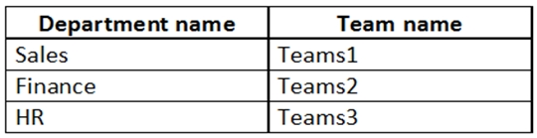
A. two messaging policies
B. one messaging policy and one permission policy
C. one permission policy only
D. two permission policies
E. one messaging policy only ✓
- Binh luan:
Finance depart is already covered under Default
So you need just one messaging policy
"The solution must only affect the HR department users and the finance department users."
So what about Sales then?
Default messaging policy applied to Sales Dept.
Actually i would go with E on this question, because the requirements for the finance department are already met by default with the Global Messaging policy, so you would only need to create a policy for the HR department
So since the default policy is in place, you create an additional messaging policy. Therefore, minimum of 2 policies are created

Cau 34
Dap an: N/A
HOTSPOT -
Your company has a Microsoft Teams deployment that contains a team named HR Taskforce. The members of HR Taskforce are shown in the HR Taskforce exhibit.
The members of a private channel named Staff Reviews are shown in the Members exhibit.
The files in the Staff Reviews channel are shown in the Files exhibit.
For each of the following statements, select Yes if the statement is true. Otherwise, select No.
NOTE: Each correct selection is worth one point
Hot Area:
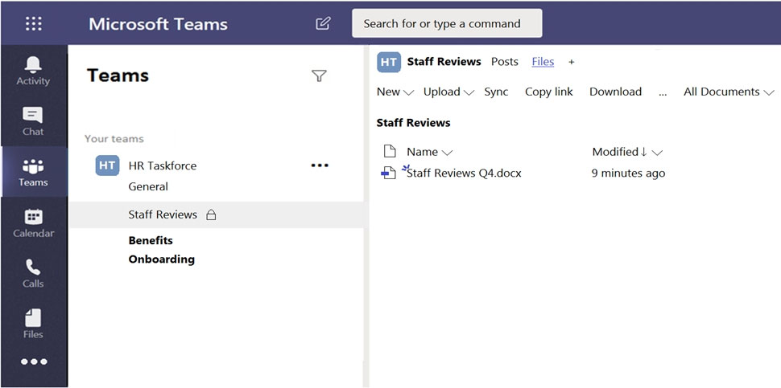
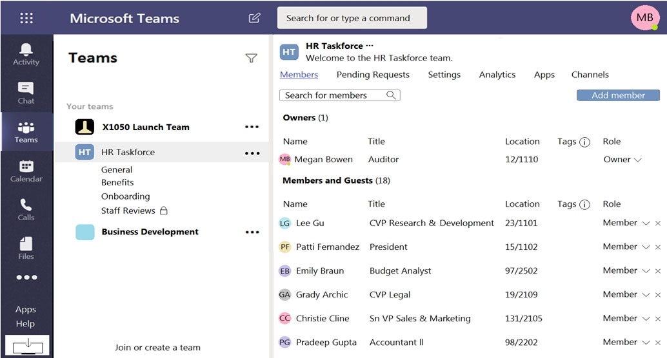
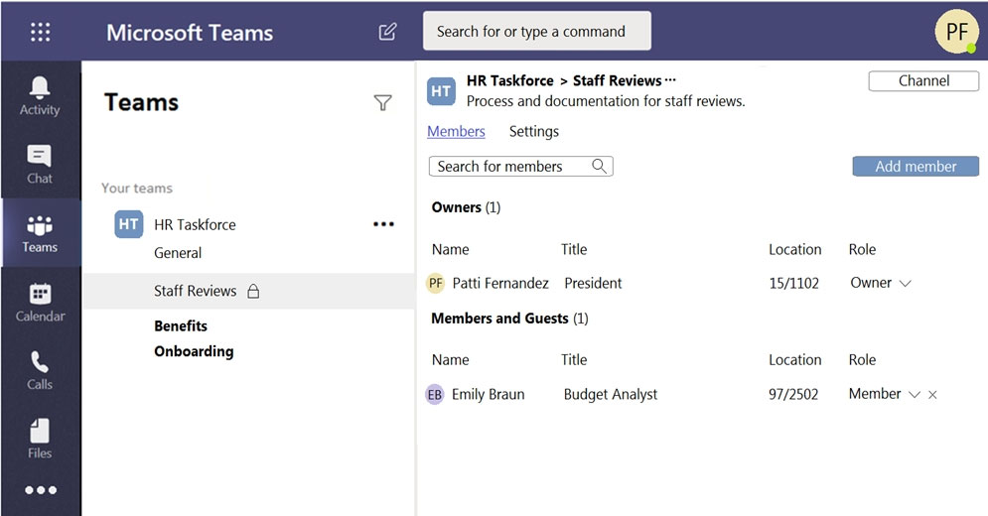
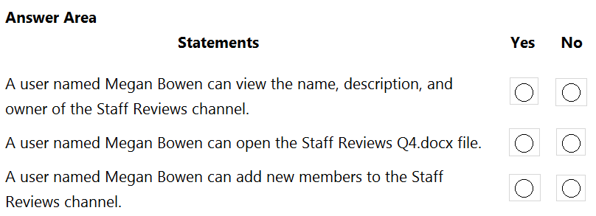
- Binh luan:
yes,no,no
Owner will not see private channel in the left navigation sidebar, but can enter the team's settings and then see all active and deleted channels, the channel type and the owers of private channels
Wow...A team owner can not see the members of a private channel in a team they own...I must keep that in mind...
I tested in my test tenant about files. I have the owner of private team named A and a channel created by owner B. The owner A can see and modify the file created by B. Why did u select NO in the second question about the file ? Thanks.
YES,NO,NO
Answer is correct Yes , No , No.
Just tested this in the lab.

Cau 35
Dap an: N/A
HOTSPOT -
You have a Microsoft 365 subscription that contains a group named Group1.
You need to configure Group1 to meet the following requirements:
✑ Users must not be permitted to pin apps to the Microsoft Teams app bar.
✑ Only the Chat, Teams, and Calendar apps must appear on the Microsoft Teams app bar.
Which policy type should you create and which PowerShell cmdlet should you run to assign the policy? To answer, select the appropriate options in the answer area.
NOTE: Each correct selection is worth one point.
Hot Area:
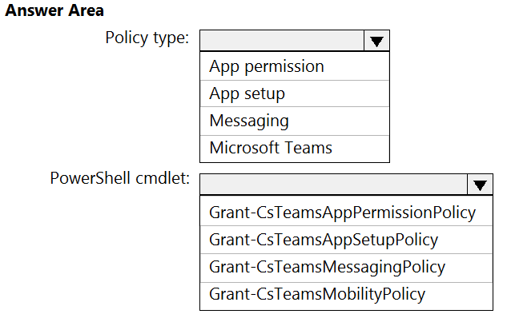
- Binh luan:
This one makes sense, create a custom app setup policy, then grant it to the users in Group1
https://docs.microsoft.com/en-us/microsoftteams/teams-app-setup-policies#edit-an-app-setup-policy
https://docs.microsoft.com/en-us/powershell/module/skype/grant-csteamsappsetuppolicy?view=skype-ps
App permission does not exist anymore, that is moved to manage apps. Given answers are correct.
customisation and configuration are setup features. this alone rules out all of the wrong answer choices

Cau 36
Dap an: B
Note: This question is part of a series of questions that present the same scenario. Each question in the series contains a unique solution that might meet the stated goals. Some question sets might have more than one correct solution, while others might not have a correct solution.
After you answer a question in this section, you will NOT be able to return to it. As a result, these questions will not appear in the review screen.
Your company has a Microsoft 365 subscription.
You need to prevent temporary employees from using the private chat feature in Microsoft Teams.
Solution: You create an app permission policy and assign the policy to the users.
Does this meet the goal?
A. Yes
B. No ✓
- Binh luan:
/// TEAMS POLICY - Channels ///
/// MESSAGING POLICY - Chats ///
/// MEETING POLICY - meetings ///
Messaging policy
Answer is B
duh...
Messaging policy - not app policy. Answer is correct.

Cau 37
Dap an: C
Your company has a Microsoft 365 subscription that contains 200 Microsoft Teams users and 20 teams.
You discover that several teams do NOT have an owner.
You need to ensure that you receive a notification when a team is missing an owner.
What should you do?
A. From the Microsoft Teams admin center, modify the Teams settings.
B. From PowerShell, run the Set-Team cmdlet.
C. From the Azure Active Directory admin center, modify the group expiration settings. ✓
D. From PowerShell, run the Add-AzureADMSLifecyclePolicyGroup cmdlet.
- Binh luan:
Ans. is C
"Provide an email address where expiration notifications should be sent when a group has no owner"
https://docs.microsoft.com/en-us/azure/active-directory/enterprise-users/groups-quickstart-expiration#set-group-expiration
Answer is C
the key phrase here is "receive a notification". this should point you to group expiration settings
Trick question - Answer is C - However, Expiration settings does not have an option to notify you if a team is missing a owner. You will still have to go find the teams without owners.
Confirm C

Cau 38
Dap an: B
Your company has a Microsoft 365 subscription that uses Microsoft Office 365 E5 licenses and Azure Active Directory Premium Plan 1 licenses.
You have a team named Sales that contains all the users in the company's sales department.
You hire several new users in the sales department.
You discover that the new employees are never added to the team.
You need to ensure that when new sales department users are hired, they are added automatically to the team.
What should you do?
A. From the Microsoft Teams client, modify the settings of the Sales team.
B. From the Azure Active Directory admin center, modify the membership type of the Sales group. ✓
C. From the Microsoft Teams admin center, modify the properties of the Sales team.
D. From the Microsoft 365 admin center, modify the settings of the Sales group.
- Binh luan:
B is correct, You change the group Type to dynamic,
Go to Azure Active Directory admin center --> Groups --> Membership type --> modify group membership type from Assigned to Dynamic user.
Answer is B.
automatically to the team = Dynamic (but the attribute(s) needs value indie of course)
B. you change the type to dynamic
Agree with B

Cau 39
Dap an: N/A
HOTSPOT -
You have a Microsoft 365 subscription.
You need to create a new Microsoft Teams team named Human Resources that meets the following requirements:
✑ All join requests must be approved by an owner of the team.
✑ The URL for the Microsoft SharePoint Online site of the team must be /sites/HR.
✑ Two users named jane@contoso.com and bob@contoso.com must be assigned as team owners.
How should you complete the PowerShell command? To answer, select the appropriate options in the answer area.
NOTE: Each correct selection is worth one point.
Hot Area:
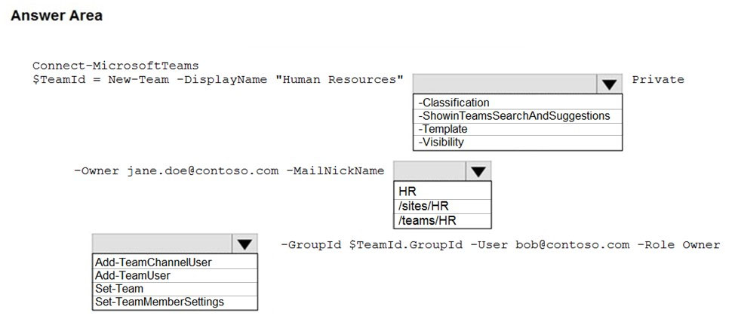
- Binh luan:
Second part of answer HR is correct. There is setting in Sharepoint admin-> site creation -> Select Site creation under Teams . Then it will take /Teams instead of /Sites before /HR
The second one must be very confusing, but the answer is HR so site in SharePoint would be named HR. If we choose /sites/HR, site in SharePoint would be Sites-HR
On Test 14.04.22
On Test 29.03.22
Given answer should be correct, as @chan2013 stated: https://docs.microsoft.com/en-US/sharepoint/manage-site-creation

Cau 40
Dap an: N/A
HOTSPOT -
You have a Microsoft 365 subscription that contains a user named User1.
You have a custom policy named AppPolicy that has the following configurations:
✑ Allow all apps published by Microsoft.
✑ Allow only specified third-party apps.
✑ Block all custom apps.
You need to assign AppPolicy to User1.
How should you complete the PowerShell command? To answer, select the appropriate options in the answer area.
NOTE: Each correct selection is worth one point.
Hot Area:
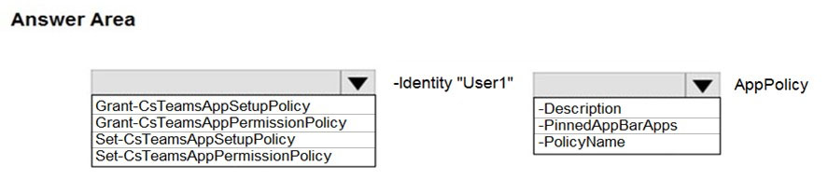
- Binh luan:
Set-Cs cmdlets are used to make a change to an actual policy
Grant-Cs cmdlets are used to assign per-user policies to people or groups of people.
Ran this command on Powershell, it is the correct answer
Looks like it has to be grant-CsTeamsAppSetupPolicy as the permission policies page and has been removed from team admin
Does this still exist now that Manage app's have been set as default?
Assigning = "Grant-" in PowerShell. Because it is talking about blocking and allowing apps, it is permission related.

Cau 41
Dap an: D
You have a Microsoft 365 E5 subscription that is linked to an Azure Active Directory (Azure AD) tenant. The tenant contains the groups shown in the following table.
You need to create a new team by using the Microsoft Teams client.
Which group can you use to create the new team?
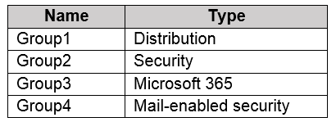
A. Group4
B. Group1
C. Group2
D. Group3 ✓
- Binh luan:
It allows only Microsoft 365 Group to create a team so the correct answer is D
It allows only Microsoft 365 Group to create a team so the correct answer is D
On Test 18.01.22
D is correct
The link in the solution point to the answer C.
Could someone confirm it?

Cau 42
Dap an: C
Your company has a Microsoft 365 subscription.
The company's global app permission policy is configured as shown in the following exhibit.
Users report that they can view the list of available third-party apps from the Microsoft Teams client.
You need to ensure that the Who app is the only visible app from the Microsoft Teams client.
What should you modify?
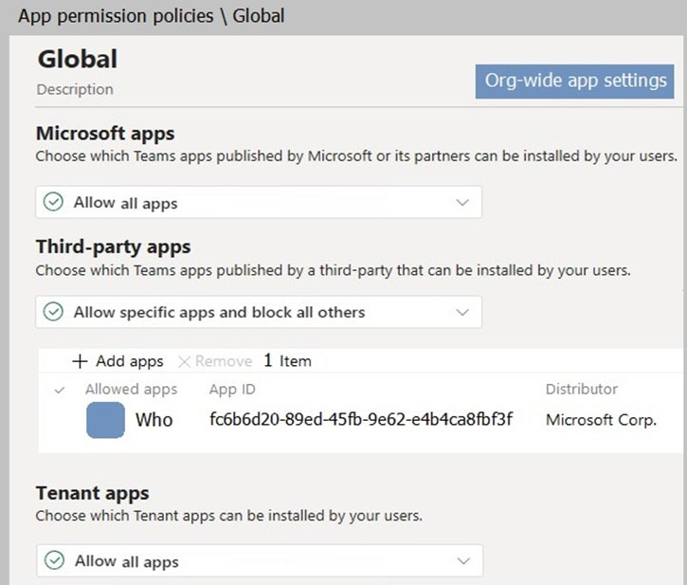
A. the Org-wide app settings
B. the global app permission policy
C. the global app setup policy ✓
D. the global teams policy
- Binh luan:
In the screenshot, App Permission policies, Global, third party apps are already set to "Allow specific apps and block all others", and the Who app is added, so it is not the app permission policy.
The question states:
"Users report that they can view the list of available third-party apps from the Microsoft Teams client"
Key word, they can "view" them
I think we are looking at the Pinned apps, in the global app setup policy. (2nd area that needs configured)
https://docs.microsoft.com/en-us/
Correct.
Correct answer is A. After adding Allowed apps under Third Party apps, go to "Org-wide app settings" then turn off "Allowed third-party apps". This will block all third party apps except the app that was allowed under "App permission policies" > "Third-party apps". Now, users can see the allowed third party app ONLY in the teams client and install it.
*then turn off "Allow third-party apps"
Sorry, I think this is a BUG.

Cau 43
Dap an: N/A
HOTSPOT -
Your company has a Microsoft Office 365 subscription.
The company has three departments. Each department contains a group as shown in the following table.
You plan to create a team for each group.
You need to ensure that a team can be created for each group. The solution must minimize administrative effort.
What should you do to each group? To answer, select the appropriate options in the answer area.
NOTE: Each correct selection is worth one point.
Hot Area:
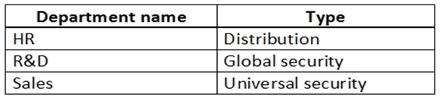
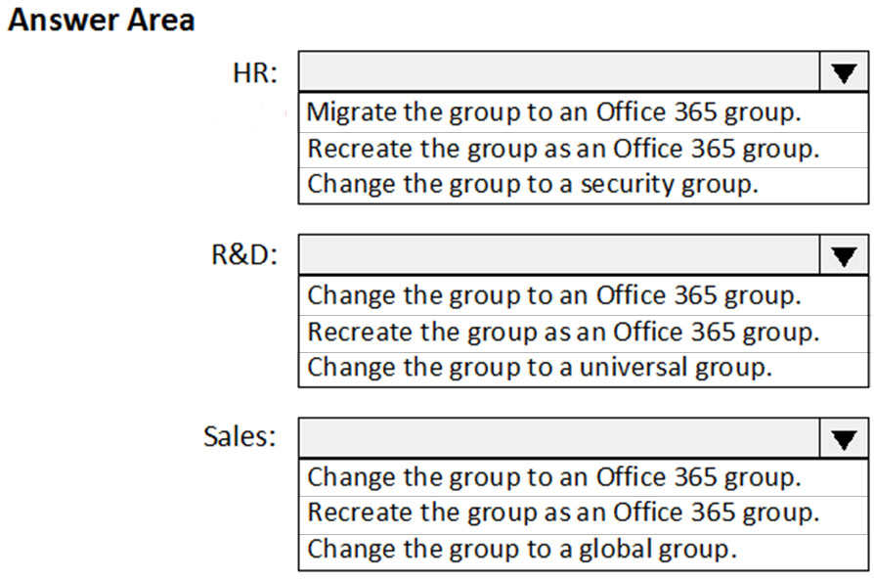
- Binh luan:
HR is a Distribution Group which can be changed/converted to an Office 365 Group
R&D is a security group so it can be changed. Universal Group is another type of security group. Only option left it to recreate the group.
Sales is the same as R&D. Global Group is another type of security group.
Office 365 Groups are not security groups and cannot be created from security groups.
Please correct me if any of this is inaccurate.
Thanks, very clear and structured answer
Security groups cannot be upgraded. (Global security or Universal security):
https://docs.microsoft.com/en-us/microsoft-365/admin/manage/upgrade-distribution-lists?view=o365-worldwide#which-distribution-lists-cant-be-upgraded
The DL can be upgraded:
https://docs.microsoft.com/en-us/microsoft-365/admin/manage/upgrade-distribution-lists?view=o365-worldwide
Answer makes sense. A DL is quite close to an M365 group, security groups are different.
Office 365 has distribution lists not groups . exchange on prem has distribution groups.
global and universal groups are active directory constructs
all groups would need to be recreated

Cau 44
Dap an: N/A
DRAG DROP -
Your company has a custom Microsoft Teams app named App1.
You need to deploy App1. The solution must ensure that App1 appears as the first item on the app bar of the Microsoft Teams client.
Which four actions should you perform in sequence? To answer, move the actions from the list of actions to the answer area and arrange them in the correct order.
Select and Place:
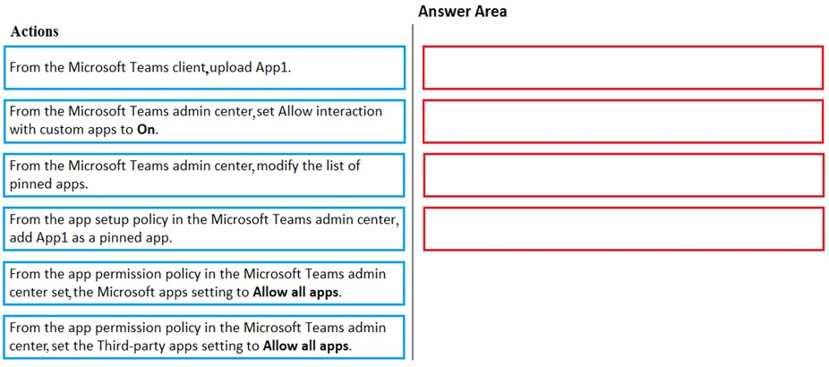
- Binh luan:
2 1 4 3 is correct order on the left side.
This question is probably outdated.
First step is to set "Allow all apps" at Custom apps in Global App permission policy
Where is the option to upload custom custom apps in app setup policy?
The version is too old? Here is my list accordingly
turn on the allow interaction with the custom apps org-wide app settng
turn on the upload custom apps setting in the global app setup policy
upload the app
create a new app setup setup policy to pin the app in the bar for teams
Correct!
The setting in the first response seems to be updated to "Upload Custom Apps", while it's the same thing.

Cau 45
Dap an: N/A
HOTSPOT -
You have a Microsoft 365 E5 subscription that contains a Microsoft Teams team named Sales Team. Sales Team contains the members shown in the following table.
You create a channel named Sales Project and configure the Channel moderation settings as shown in the following exhibit.
For each of the following statements, select Yes if the statement is true. Otherwise, select No.
NOTE: Each correct selection is worth one point.
Hot Area:
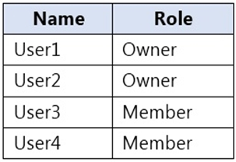
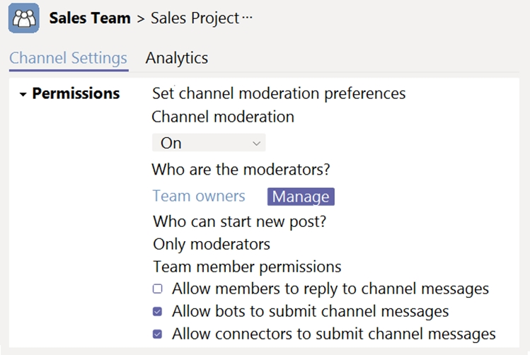
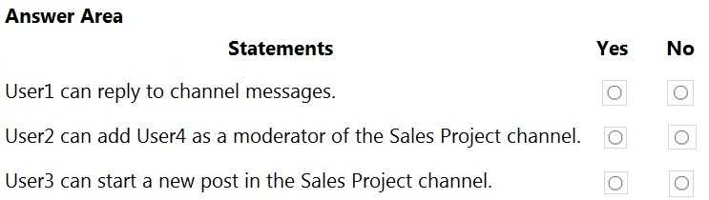
- Binh luan:
1 Yes - User1 is an owner, so User1 can reply to channel messages
2 Yes - User2 is an owner, so User2 can add moderators
3 No - Only moderators can start a new post, User3 is a member, not a moderator
For the n°2 is yes because User2 can add User 4 as owner then User4 become also moderator (so he is not Member + Moderator) correct?
YES YES NO
Correct

Cau 46
Dap an: D
Your company has a Microsoft 365 subscription.
You have a team that uses the following dynamic rule.
(user.department -contains "Sales" -or user.department
-contains "Marketing") -and (user.userType -Contains "Guest")
-and (user.country -eq "US")
Which user will be included in the group?
A. A guest user in a department named Global Sales that has the country attribute set to US.
B. A member user in a department named Marketing Division that has the country attribute set to US.
C. A member user in a department named Marketing/Sales that has the country attribute set to US.
D. A guest user in a department named US Marketing Division that has the country attribute set to US. ✓
- Binh luan:
Both A and D are correct
the are both right
Department: Contains "Sales".
User Type: Guest.
Country: US.
Conclusion: Meets all criteria. Included.
Department: Contains "Marketing".
User Type: Guest.
Country: US.
Conclusion: Meets all criteria. Included.
as other have said i think the other question has A set to USA
Answer is D, it is a guest user, Marketing is contained and the "US" matches
Agreed.
Both A and D match 'US'.

Cau 47
Dap an: C, E
Your company has a Microsoft 365 subscription.
The company has a group named Sales.
You need to configure Microsoft Teams for the Sales group. The solution must meet the following requirements:
✑ Ensure that only the Activity, Shifts, Chat, and Calling apps are always visible in the app bar of the Microsoft Teams client.
✑ Prevent only the users in the company's sales department from adding other apps to Microsoft Teams.
Which two actions should you perform for the Sales group? Each correct answer presents part of the solution.
NOTE: Each correct selection is worth one point.
A. Modify the global app setup policy.
B. Modify the global app permission policy.
C. Create an app setup policy. ✓
D. Modify the org-wide Teams settings.
E. Create an app permission policy. ✓
- Binh luan:
CE because it only needs to impact Sales group
A and E
"Ensure that only the Activity, Shifts, Chat, and Calling apps are always visible in the app bar of the Microsoft Teams client"
(for everyone, Global app setup policy)
Edit the Global app setup policy, Pin the Apps, save
"Prevent only the users in the company sales department from adding other apps to Microsoft Teams"
(prevent adding Apps, for a sales group, not everyone)
Create a custom permission policy, then apply it to the sales Group. (2 steps, the answer is missing the second st
"You need to configure Microsoft Teams for the Sales group."
A is incorrect. Doing A will impact the entire organization. The goal is to only impact Sales.
Microsoft is changing this to Mange apps: https://learn.microsoft.com/en-us/microsoftteams/app-centric-management#:~:text=Use%20app%20centric%20management%20to%20manage%20apps
Many tenants are already converted

Cau 48
Dap an: C
Your company has a Microsoft 365 subscription.
The company uses Microsoft Teams.
You need to ensure that only Microsoft apps can be used in Microsoft Teams.
What should you do from the Microsoft Teams admin center?
A. From the global app setup policy, disable the Upload custom apps setting.
B. From the Org-wide app settings, disable the Allow interaction with custom apps setting.
C. From the Org-wide app settings, disable the Allow third party or custom apps setting. ✓
D. From the global app permission policy, disable the Allow All Apps setting for Microsoft apps.
- Binh luan:
this should be C
Agree, probably the assumption is the Custom app is turned off by default. I dont remember turning it off but in my setup currently its turned off. In all cases C should be given as the right answer if someone answers.
Out of date. There is no permission policy
This question is out of date
C. From the Org-wide app settings, disable the Allow third party or custom apps setting.
option c is an or... not an and
which implies that not both will be true - so this doesnt work imo
i feel like im missing something..

Cau 49
Dap an: D
You have a Microsoft Office 365 subscription.
You discover that apps from a third-party publisher have security issues.
You need to block all apps from the publisher.
What should you use in the Microsoft Teams admin center?
A. Org-wide app settings
B. Policy packages
C. Permission policies
D. Manage apps ✓
- Binh luan:
Team admin centre -> manage apps->select app that needs to be blocked. D is correct
I might be wrong, but... it saies that all apps "from the publisher" should be blocked. This implies that a block should be put on the publisher name/ID in order to hinder further apps from this publisher. Under manage apps one can only block specific apps. The other possible answers are no good, so it is probably the correct/best answer.
You can filter by Publisher, then manually disable the apps under that publisher. I did it and was easy to disable apps based on the publisher
I agree. Permission policy allows you to accomplish the same, but it's not as easy as manage apps. Although you can still filter based on publisher in permission policy. Messing around with permission policies could get messy if you have a complex environment. That's why manage apps is easier and at a global level.
sorry but why can't i use permission policies?

Cau 50
Dap an: N/A
HOTSPOT -
You have a Microsoft Office 365 subscription.
You need to meet the following requirements:
✑ Pin specific apps to the Microsoft Teams app bar.
✑ Prevent users from installing third-party apps published in the Teams app store.
✑ Prevent users from pinning apps to the Microsoft Teams app bar.
What should you use to meet each requirement? To answer, select the appropriate options in the answer area.
NOTE: Each correct selection is worth one point.
Hot Area:
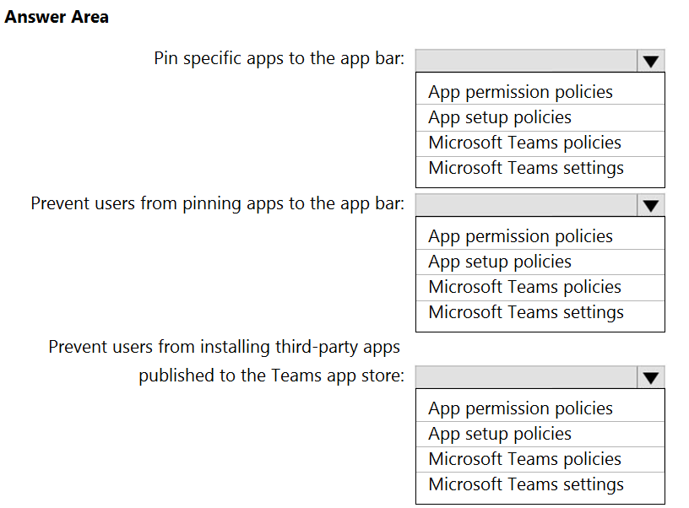
- Binh luan:
The second should be app permission policy (taking in account the old way of this). By permission policies you control which apps are ALLOWED TO INSTALL/PIN. The setup policies help you to manage users’ team client (the apps used on them).
Out of date, there is no App Permission policy now. It has been moved to Manage apps
For App Permission Policy, I believe the updated answer should be Teams apps>Manage apps> Org-wide app settings
Correct
On Exam 28.02.22

Cau 51
Dap an: N/A
HOTSPOT -
You are a Microsoft Teams administrator for your company.
You have the Org-wide app settings shown in the App Settings exhibit. (Click the App Settings tab.)
The company's global app permission policy is configured as shown in the Permission Policy exhibit. (Click the Permission Policy tab.)
The company's global app setup policy is configured as shown in the Setup Policy exhibit. (Click the Setup Policy tab.)
For each of the following statements, select Yes if the statement is true. Otherwise, select No.
NOTE: Each correct selection is worth one point.
Hot Area:
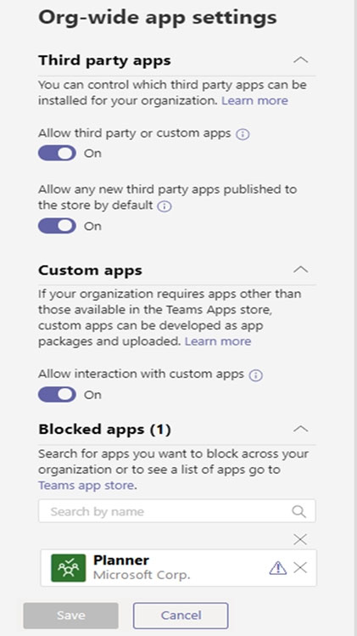
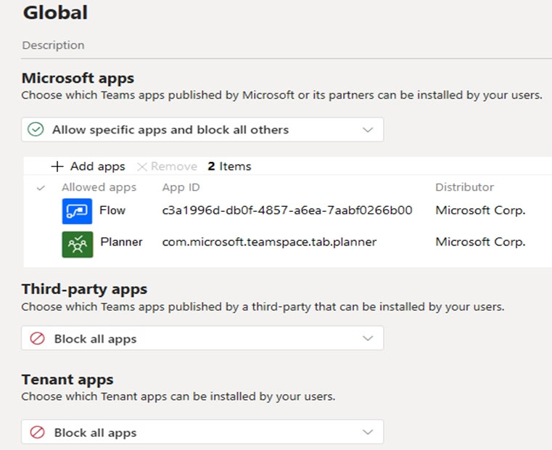
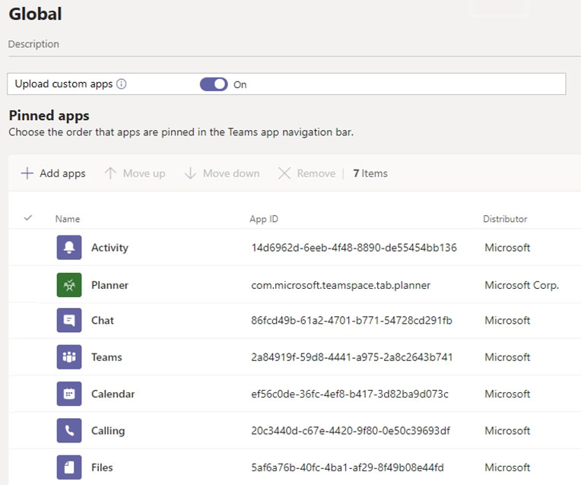
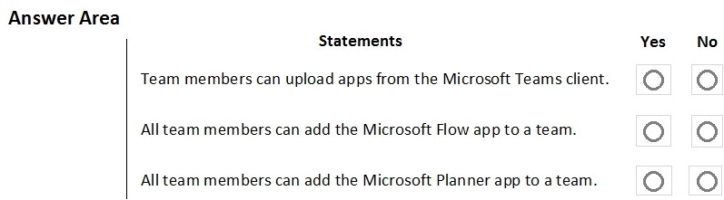
- Binh luan:
" org wide app settings override the global policy and any custom policies that you create and sign to users"
Y/Y/N is correct. However, the screenshots are very old, and the options have changed in the current admin center.
Answer is correct. Org wife overrides planner which makes it a blocked app even though in the policy it's allowed
Y|N|Y because org-wide settings override the global policy
Org-wide settings override global policy, and any custom policies that you assign to users

Cau 52
Dap an: C, D
Your company has a Microsoft 365 subscription that contains three groups named HR, Marketing, and Sales.
You need to configure the Microsoft Teams desktop client. The solution must meet the following requirements:
✑ Members of the HR group must be prevented from pinning apps to their app bar.
✑ Members of the Marketing group must have the Microsoft Planner app pinned to their app bar.
✑ Members of the Sales group must not be affected by policies applied to the Marketing and HR groups.
Which two actions should you perform? Each correct answer presents part of the solution.
NOTE: Each correct selection is worth one point.
A. Modify the global app setup policy.
B. Modify the global app permission policy.
C. Create an app setup policy for HR. ✓
D. Create an app setup policy for Marketing. ✓
E. Create an app permission policy for Marketing.
F. Create an app permission policy for HR.
- Binh luan:
Members of the HR group must be prevented from pinning apps to their app bar.
"Allow user pinning to off"
(Step 2 not in question, apply policy to HR group)
Members of the Marketing group must have the Microsoft Planner app pinned to their app bar.
"Allow user pinning to On, Add the app, configure the pinned apps"
(Step 2 not in question, apply policy to Marketing group)
Because you created custom policies, and applied them to only the specified groups, the Sales group will not be effected
ht
Does this mean the shown answer is correct?
Yes it is. Anything realated to pinning is App Setup Policy, in this case 2 custom policies
- Members of the HR group must be prevented from pinning apps to their app bar - this would require a separate App setup policy for HR - (which is C)
- Members of the Marketing group must have the Microsoft Planner app pinned to their app bar - this would require a separate App setup policy for Marketing - (which is D)
- Members of the Sales group must not be affected by policies applied to the Marketing and HR groups - Sales would remain under the Global (Org-Wide default) App setup policy so
C & D are correct

Cau 53
Dap an: N/A
HOTSPOT -
Your company has a Microsoft 365 E5 subscription.
You plan to create a team that will automatically include all new and existing users at the company.
You need to identify which role-based access control (RBAC) role is required to create the team, and which tool must be used to create the team. The solution must use the principle of least privilege.
What should you identify? To answer, select the appropriate options in the answer area.
NOTE: Each correct selection is worth one point.
Hot Area:
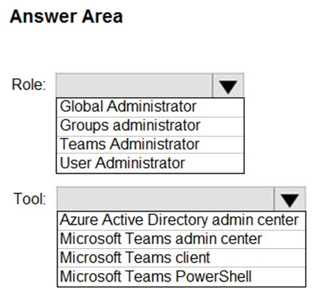
- Binh luan:
Only global admins can create an organization-wide team by using the Teams client.
Not true, just tested. I am Teams Admin but not Global Admin. I can create an org wide team from Teams Client. Desktop App
Then documentation here must not have caught up if that is the case https://learn.microsoft.com/en-us/microsoftteams/create-an-org-wide-team#create-an-organization-wide-team
Only global admins can create an organization-wide team by using the Teams client. If your organization limits creating teams to using PowerShell, the recommended workaround is to add your global admins to the security group of users who can create a team.
In the documentation it is written that only Global admin can create Org-wide team but when I tried with a nuw account having only team admin role i can able to create org-wide team from that account.

Cau 54
Dap an: N/A
HOTSPOT -
You have a Microsoft 365 subscription that uses Microsoft Teams and contains the users shown in the following table.
You have a team named Sales that is configured as shown in the following table.
The Sales team contains the channels shown in the following table.
For each of the following statements, select Yes if the statement is true. Otherwise, select No.
NOTE: Each correct selection is worth one point.
Hot Area:
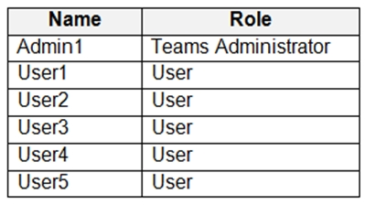
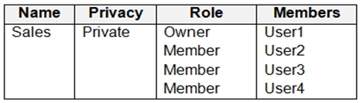
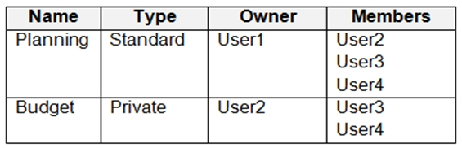
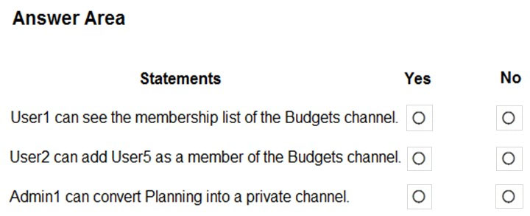
- Binh luan:
Yes - No - No
Yes - Team owners can see membership lists of private channels. They cannot view or interact with the private channel unless they are also members.
No - User 5 is not a member of the parent Team, so they can't be added to the private channel until they are added to the team first.
No - Tested this, admins can create private channels from TAC, but they cannot convert existing standard channels to private.
Correction after testing. No - No - No. Team owners can only view the owner of a private channel and delete the channel.
Agree. NNN
Cannot convert a standard channel to a private channel.https://support.microsoft.com/en-us/office/standard-private-or-shared-channels-in-microsoft-teams-de3e20b0-7494-439c-b7e5-75899ebe6a0e
No-No-No
1st No
Team owners can see the names of all private channels in their team and can also delete any private channel in the team. (A deleted private channel can be restored within 30 days after it's deleted). Team owners can't see the files in a private channel or the conversations and member list of a private channel unless they are members of that private channel.
2nd No
User 5 is not member of the team, only members of the team and guest can be added to private channels
3rd No
Admin ca

Cau 55
Dap an: C
You have a Microsoft 365 subscription that uses Microsoft Teams.
You need to ensure that only the following apps are available in the Microsoft Teams app store:
✑ Lists
✑ Project
✑ Bulletins
✑ OneNote
✑ PowerApps
The solution must minimize administrative effort.
What should you do?
A. Configure the Org-wide app settings
B. From the Manage apps page, block unapproved apps
C. Configure the global (Org-wide default) app permission policy ✓
D. Configure the global (Org-wide default) app setup policy
- Binh luan:
Correct, "Allow specific apps dand blocks all others"
Answer C is correct.
Go to TAC --> Permission policies --> Make sure Third-party apps and Custom apps are set to "Block all apps". For Microsoft apps choose Allow specific apps and block all others --> Add Lists, Projects, Bulletins, OneNote and PowerApps to the list.
This has been changed. Now it is in Manage Apps instead of Permission Policies.
No longer relevant. The Teams "Permission policies" redirect you to "Manage Apps". TAC --> Permission policies, and then click the "Open Manage Apps" from the page displayed. The only option.

Cau 56
Dap an: N/A
HOTSPOT -
You have a Microsoft Office 365 subscription.
You need to meet the following requirements:
✑ Pin specific apps to the Microsoft Teams app bar.
✑ Prevent users from installing third-party apps published in the Teams app store.
✑ Prevent users from pinning apps to the Microsoft Teams app bar.
What should you use to meet each requirement? To answer, select the appropriate options in the answer area.
NOTE: Each correct selection is worth one point.
Hot Area:
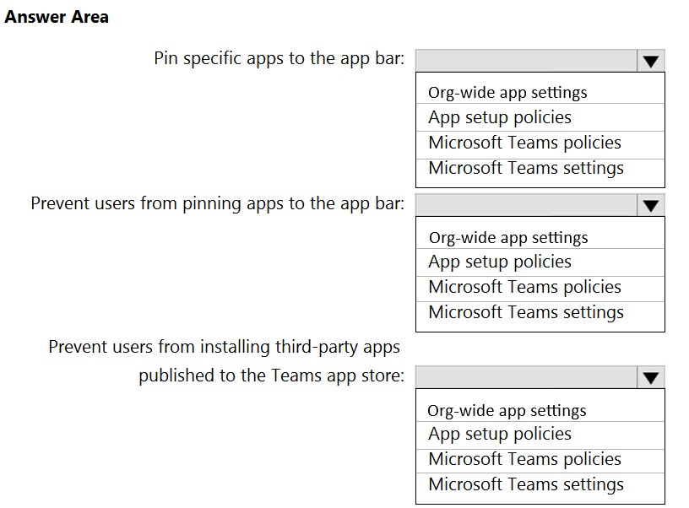
- Binh luan:
Looks like correct answer
question 50 on page 12 is the same with different answer??
App Permission policies could be used to accomplish same thing.
App setup policies govern pinning/preventing from pinning and installing apps for users
Preventing users from installing apps is a permission policy
Org-wide app setting is above Permissions policies in hierarchy.
If Org-wide app settings for Third party apps is disabled, Third party apps can't be installed by users. Even if you turn on Org-wide app settings, enable all third party apps in Permission policies and than turn off Org-wide app settings, the Third party apps will still be blocked.

Cau 58
Dap an: C
You have a Microsoft 365 subscription that uses Microsoft Teams and contains the groups shown in the following table.
You create a new team named Project1.
Which groups can be added to Project1?
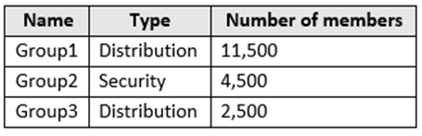
A. Group1 only
B. Group2 only
C. Group3 only ✓
D. Group1 and Group3 only
E. Group1, Group2, and Group3
- Binh luan:
Maximum size of distribution list, security group or Microsoft 365 group that can be imported in to a team: 3.500
Maximum number of members in a Microsoft 365 group that can be converted to a team: 10.000
https://learn.microsoft.com/en-us/microsoftteams/limits-specifications-teams
Answer is C
Technically none! You need to convert distribution group to O365 group first!
Answer is C.
Max size of distribution list = 3500 ,also You will need to convert a Distribution group to an M365 group first for it to be then converted to a team.
tested, i cant add any group to the team.
Why not D?

Cau 59
Dap an: N/A
DRAG DROP -
You have a Microsoft 365 subscription that uses Microsoft Teams and contains three users named User1, User2, and User3.
You need to configure Microsoft Teams to meet the following requirements:
✑ Prevent User1 and User2 from creating private channels.
✑ Ensure that User3 can control who can create private channels.
✑ Minimize administrative effort.
Which three actions should you perform in sequence? To answer, move all actions from the list of actions to the answer area and arrange them in the correct order.
NOTE: More than one order of answer choices is correct. You will receive credit for any of the correct orders you select.
Select and Place:
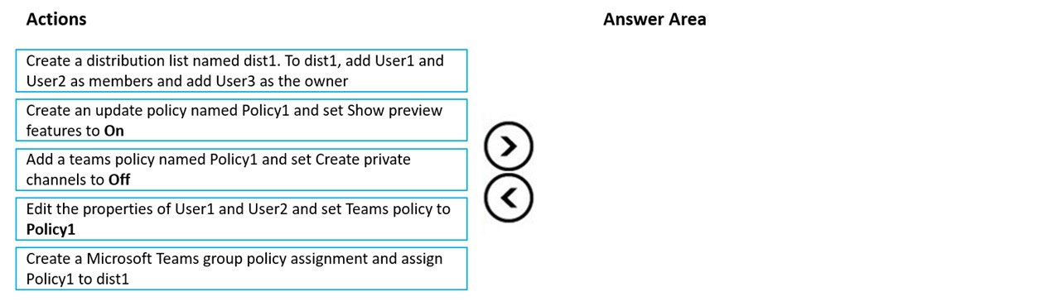
- Binh luan:
on exam 26-Nov-2022
Answer is correct. Tested this in lab.
The sequence is correct Create the DL >Create teams Policy with private channel creation set to OFF>Via group policy assignment (Teams policies)assign it to the DL group.
Who ever is in the DL is prohibited from creating private channels and the owner of the dl can decide which members can be added or removed from the DL
How user3 will control if policy applied on team ??
User3 is owner of dist1, so he can add or remove user from dist1.
Why does it matter for the 1st and 2nd to be like that it can be other way around as well?

Cau 60
Dap an: A, B
You have a Microsoft 365 subscription that uses Microsoft Teams.
You have a team named R&D_Projects.
You need to prevent guest users from being invited to R&D_Projects. The guest users must be able to be invited to other teams.
What are two ways to block guest access to the R&D_Projects team? Each correct answer presents a complete solution.
NOTE: Each correct selection is worth one point.
A. Apply a sensitivity label to the R&D_Projects team. ✓
B. From Azure PowerShell, run the New-AzureADObjectSetting cmdlet. ✓
C. Configure a Microsoft 365 group expiration policy.
D. From the Microsoft Teams admin center, disable guest access.
E. From the Microsoft 365 admin center, disable guest access.
- Binh luan:
100% correct answer is A & B.
Answer is A & B - Method 1: Apply a Sensitivity Label to the R&D_Projects Team
A. Apply a sensitivity label to the R&D_Projects team.
Sensitivity labels can be used to apply specific settings to Microsoft 365 groups and Teams, including controlling guest access.
Method 2: Use Azure AD Settings via PowerShell
B. From Azure PowerShell, run the New-AzureADObjectSetting cmdlet.
Using Azure AD Object Settings, you can configure specific settings for individual groups. The New-AzureADObjectSetting
**D. From the Microsoft Teams admin center, disable guest access.**
In the Microsoft Teams admin center, you can manage guest access on a per-team basis. You can go to the settings of the R&D_Projects team and disable guest access. This will prevent guest users from being invited to the R&D_Projects team, but they can still be invited to other teams where guest access is enabled.
Please note that options B, C, and E are not correct in this context:
- **B.** The `New-AzureADObjectSetting` cmdlet
By using D you change the global settings which will affect everything
C,D,E seems wrong, you still need the guest user access, hence A,B is correct

Cau 61
Dap an: A
Note: This question is part of a series of questions that present the same scenario. Each question in the series contains a unique solution that might meet the stated goals. Some question sets might have more than one correct solution, while others might not have a correct solution.
After you answer a question in this section, you will NOT be able to return to it. As a result, these questions will not appear in the review screen.
You have a Microsoft 365 subscription that contains several Microsoft SharePoint Online sites.
You need to ensure that the content stored in a SharePoint modern team site named Sales is available from Microsoft Teams. The solution must ensure that when a new channel is added to a team, a folder for the channel is created in the Sales site.
Solution: From the Sales site, you use the Add Microsoft Teams link.
Does this meet the goal?
A. Yes ✓
B. No
- Binh luan:
Answer is Yes.
A channel will be linked as a subfolder when a team is created from within sharepoint site.
By using the "Add Microsoft Teams" link from the Sales SharePoint Online modern team site, you can connect the site to a Microsoft Team. When a SharePoint site is linked to a Microsoft Team:
Integration with Teams:
The content from the Sales SharePoint document library becomes accessible from the "Files" tab in Microsoft Teams.
Folder Creation for Channels:
When a new channel is added in the connected Microsoft Team, a corresponding folder is automatically created in the Documents library of th
This question really really confused me. I had to go to SharePoint admin center and create a SharePoint site from scratch and choose "Team site" which apparently has nothing to do with Microsoft Teams lol so it's misleading. Then after it's been created, you can click on the site and you'll see "Would you like to add ‎Microsoft Teams‎ to this group?" and you can click "Add Teams" which will make a Microsoft Team with the Team name of the SharePoint site, and add existing members of SharePoint si
Tested it real environment.
A Teams Team is created when using the add teams link in the sharepoint site.
Creating a new channel in the team also creates a new folder within the sharpoint site.
The correct answer is B. No.
Using the "Add Microsoft Teams link" option from the Sales site does not automatically create a folder for the new channel in the Sales site. It adds a link to the Sales site from within Microsoft Teams, but it does not fulfill the requirement of creating a folder for each new channel in the Sales site. To achieve the goal, you would need to set up a channel in Microsoft Teams and then link it to an existing SharePoint document library or create a new one, which wou

Cau 62
Dap an: D
You have a Microsoft 365 subscription that uses Microsoft Teams and contains a Microsoft 365 group named Group1.
The subscription has the Teams policy shown in the following exhibit.
You need to ensure that the members of Group1 can create private channels. The solution must use the principle of least privilege.
What should you do first?
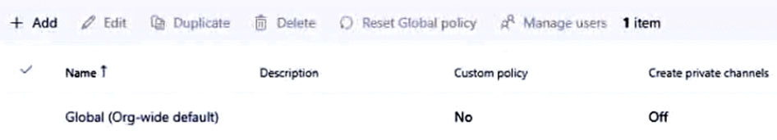
A. Modify the Teams settings for the subscription.
B. Create a team template.
C. Modify the Global (Org-wide default) policy and set Create private channels to On.
D. Create a Teams policy that has Create private channels set to On. ✓
- Binh luan:
Easy one
From https://learn.microsoft.com/en-us/microsoftteams/policy-assignment-overview#which-policy-takes-precedence
If a user is directly assigned a policy (...), that policy takes precedence.
It's D
I thought that Global (Org-wide default) will override settings, no?
"You need to ensure that the members of Group1 can create private channels.", not all users

Cau 63
Dap an: A
You have a Microsoft 365 E5 subscription that uses Microsoft Teams.
You create a team named SalesProject.
You need users to be added automatically to the team based on their department attribute.
What should you do?
A. From the Azure Active Directory admin center, change the Membership type setting of SalesProject. ✓
B. From the Azure Active Directory admin center, change the Group type setting of SalesProject.
C. From the Microsoft 365 admin center, modify the settings of SalesProject.
D. From the Microsoft Teams admin center, modify the settings of SalesProject.
- Binh luan:
For sure A.
Should be "Membership type":
https://learn.microsoft.com/en-us/entra/identity/users/groups-change-type#change-the-membership-type-for-a-group
Correto é A
Change to Dynamic in Azure AD
Membership type needs to be changed from Assigned to Dynamic user. This can be achieved in Azure Active Directory admin center by going to Groups and than select the group that you want to change the membership type.
Answer is A.

Cau 64
Dap an: N/A
HOTSPOT -
You have a Microsoft 365 E5 subscription that uses Microsoft Teams and contains three users named User1, User2, and User3.
The Teams upgrade settings for the organization are configured as shown in the following exhibit.
The Coexistence mode settings for the users are configured as shown in the following table.
For each of the following statements, select Yes if the statement is true. Otherwise, select No.
NOTE: Each correct selection is worth one point.
Hot Area:
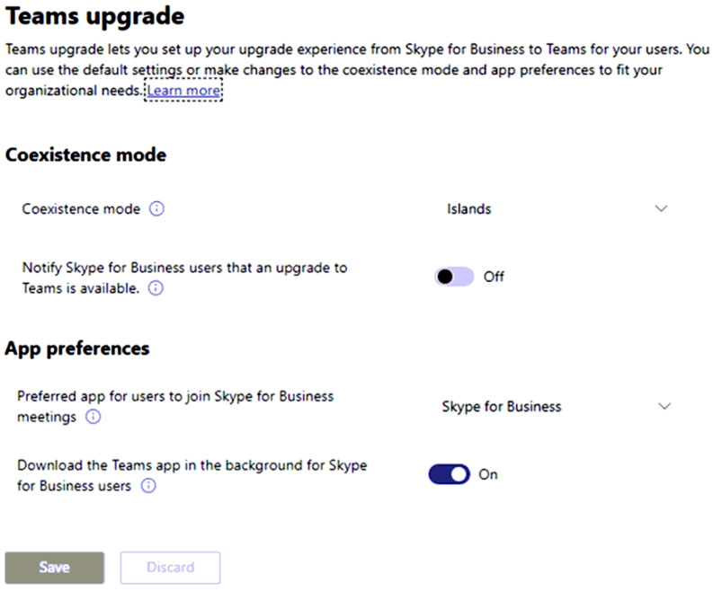
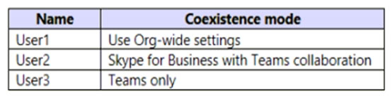
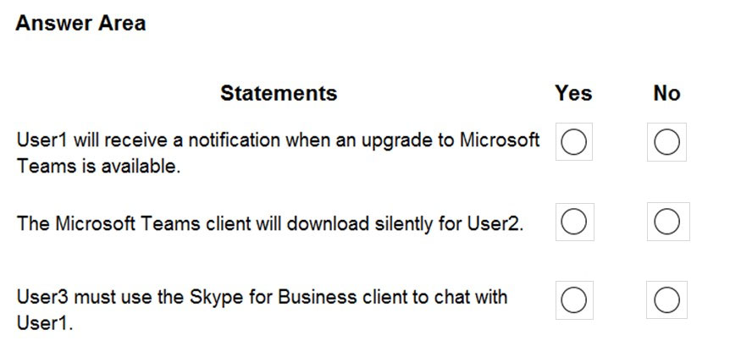
- Binh luan:
No Yes No
No, yes, yes - user 3 is in teams only mode - question 3 is about a chat, not a meeting
How is User 3 going to use Skype for Business to chat with User1 when they are in Teams Only mode though?
No | Yes | No,

Cau 65
Dap an: C
You have a Microsoft 365 subscription that uses Microsoft Teams and contains a distribution group named Group1 and a team named Project1.
You add Group1 to Project1.
100 new members are added to Group1.
When will the membership of Project1 will be updated to reflect the changes to the group membership?
A. Automatically and immediately
B. Automatically after 24 hours
C. Only when the group is re-added manually to Project1 ✓
- Binh luan:
I think it is not correct here. You don't add the group to a Team, but members of that group. so it is one time sync. After you update membership - you need to re-add that group.
(as long as Teams is not associated with a dynamic group, but it is not mean that full Team membership is dynamic)
It seems youre right. I tried myself with my lab but did not get the expected result though. Instead I found the page below.
https://techcommunity.microsoft.com/t5/microsoft-teams/distribution-list-to-add-to-teams-group/m-p/1700891
You are right. When you add a dist list to a team its just an easy way to bulk add users. it's not dynamic. if you look at membership after doing so you will see names of users not the dist list name
f you add or remove team members outside of Teams (by using the Microsoft 365 admin center, Microsoft Entra ID, or Exchange Online PowerShell), it can take up to 24 hours for changes to be reflected in Teams.
Question must have a typo or an error of sorts
You can use the membership of a distribution LIST to add them to a Team, this is a 1 time add and DOES NOT get updated as the distribution LIST gets updated.
https://answers.microsoft.com/en-us/msteams/forum/all/adding-a-distribution-list-to-an-existing/6fc133ab-3c56-4b94-ade1-c07a1cfee525
In order for the answer to be correct they must be talking about using a DYNAMIC group for a Tems group membership, this can/does indeed get updated once every

Cau 66
Dap an: N/A
HOTSPOT -
You need to install the Microsoft Viva Connections application in Microsoft Teams for a specific group.
How should you complete the PowerShell cmdlets? To answer, select the appropriate options in the answer area.
NOTE: Each correct selection is worth one point.
Hot Area:
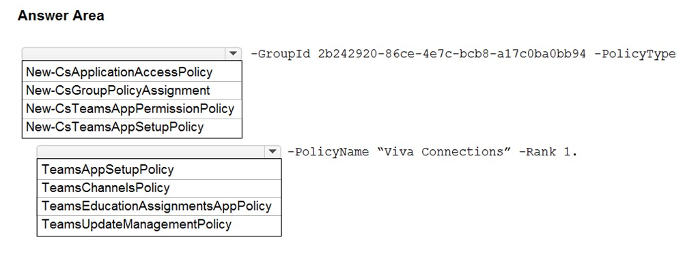
- Binh luan:
Ans is correct
Reference:
https://docs.microsoft.com/en-us/microsoftteams/assign-policies-users-and-groups
https://docs.microsoft.com/en-us/microsoftteams/teams-app-setup-policies
Oh sorry since there are no discussion on this I just went with the reveal solution but passed by exam :D

Cau 67
Dap an: B, D
You have a Microsoft 365 subscription that uses Microsoft Teams.
The subscription is configured to display de-identified names in all reports.
You need to publish reports on the usage of teams in the subscription. The solution must include only reports that support de-identified names.
Which two reports can you use? Each correct answer presents a complete solution.
NOTE: Each correct selection is worth one point.
A. Teams live event usage
B. Teams user activity ✓
C. PSTN blocked users
D. Teams usage ✓
E. Teams device usage
- Binh luan:
B and D is correct.
On exam 31/03/2023
B | D | E
https://learn.microsoft.com/en-us/microsoftteams/teams-analytics-and-reports/teams-reporting-reference
"Enabling this setting will de-identify user, group, and site name information in the Teams user activity report, Teams device usage report, and Teams usage report."
Enabling this setting will de-identify user, group, and site name information in the Teams user activity report, Teams device usage report, and Teams usage report. Starting September 1, 2021, this setting is enabled by default for everyone as part of our ongoing commitment to help protect important information and enable companies to support their local privacy laws.
Reference: https://learn.microsoft.com/en-us/microsoftteams/teams-analytics-and-reports/teams-reporting-reference
Correct answers is B , D & E
Enabling this setting will de-identify user, group, and site name information in the Teams user activity report, Teams device usage report, and Teams usage report.
reference:https://learn.microsoft.com/en-us/microsoftteams/teams-analytics-and-reports/teams-reporting-reference as of 21/03/2023
Correct
"Enabling this setting will de-identify user, group, and site name information in the Teams user activity report, Teams device usage report, and Teams usage report"
(device usage report is not an expected answer here)
https://learn.microsoft.com/en-us/microsoftteams/teams-analytics-and-reports/teams-reporting-reference

Cau 68
Dap an: B
You have a Microsoft 365 E5 subscription that uses Microsoft Teams.
You need to identify which percentage of meetings include video.
What should you use?
A. the Teams device usage report
B. Productivity Score Meetings insights ✓
C. the Teams usage report
D. the Teams user activity report
- Binh luan:
Correct, but now is called Microsoft Adoption Score
B is correct. checked it in microsoft 365 admin center. You can find it under: https://admin.microsoft.com/#/adoptionscore/meetings
scroll down to something like "Meetings by type, with proven methods in Microsoft Teams"
There you have somethin like "using videos" with a graphic showing the amount and if you scroll over it the percentage as well
the answer is D. when you run the report check the Video Time (minutes) Box on the column which will give you the result. https://learn.microsoft.com/en-us/microsoftteams/teams-analytics-and-reports/user-activity-report
The mentioned document confirms it is B.
https://learn.microsoft.com/en-us/microsoft-365/admin/adoption/meetings?view=o365-worldwide
The only report that has anything to do with meetings specific to video is the Adoption Score meeting insights, formerly known as Productivity Score. Tested in labs.

Cau 69
Dap an: C
You have a Microsoft 365 subscription that uses Microsoft Teams and contains a user named User1. User1 has a Windows 10 device that has the Teams desktop client installed.
The Teams desktop client has the notification settings shown in the following exhibit.
User1 reports that he does NOT receive alerts for Teams activities on his device.
What should you do to ensure that User1 receives Teams alerts?
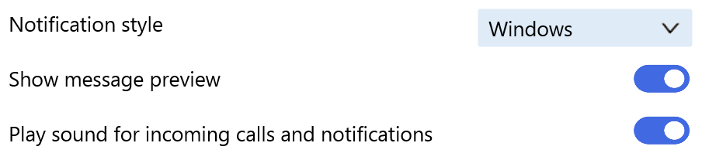
A. From the Settings app, modify the Focus assist settings.
B. From the Microsoft Teams client change Teams and channels notifications to All activity.
C. From the Settings app, modify the Notifications & actions settings. ✓
D. From the Microsoft Teams admin center, modify the Messaging policies settings.
- Binh luan:
Correct Answer is C.
https://support.microsoft.com/en-us/office/change-your-notifications-style-in-teams-0da93820-93d0-4da3-86b6-fc28d19908e3
Note: This article has done its job, and will be retiring soon. To prevent "Page not found" woes, we're removing links we know about. If you've created links to this page, please remove them, and together we'll keep the web connected.
I think the answer is B.
Ensure @mentions is set to Banner and feed, Replies is set to Banner, and Likes and reactions is set to Banner and feed.
You will need to edit your settings for Teams and Channels.
Nope, if the Teams client is set to send notifications through Windows 10's banners and you're not getting notifications, you have to fix/allow them in Windows 10, which would be using the posted answer, C
Doing what you're suggesting might also solve the issue, but it is not an answer option

Cau 70
Dap an: B
You have a Microsoft 365 E5 subscription that uses Teams.
You need to ensure that all the files in Teams channels are stored for at least one year after the files are deleted.
What should you do?
A. Enable Customer Lockbox.
B. Create a retention policy for Microsoft SharePoint sites. ✓
C. Create an Audit retention policy.
D. Create a data loss prevention (DLP) policy for Teams chat and channel messages.
- Binh luan:
B is correct
B is correct
Given is Correct.
You can use a retention policy to retain data from chats and channel messages in Teams, and delete these chats and messages.
https://learn.microsoft.com/en-us/microsoft-365/compliance/retention-policies-teams?view=o365-worldwide

Cau 71
Dap an: C
You have a Microsoft 365 subscription that uses Microsoft Teams.
Users report that when they attempt to add a third-party app named App1 to the Microsoft Teams client they receive the following message: "App1 needs permission to access resources in your organization that only an admin can grant. Please ask an admin to grant permission to this app before you can use it".
You need to ensure that the users can add App1 without receiving the message.
What should you do in the Microsoft Teams admin center?
A. Create a new app permission policy.
B. Modify the Org-wide app settings.
C. Modify the Org-wide permissions for App1. ✓
D. Create a new app setup policy.
- Binh luan:
Seems to be correct. TAC - Manage Apps - Select the App - Permissions
Review and accept permissions for company
https://learn.microsoft.com/en-us/microsoftteams/app-permissions-admin-center
this is org wide app settings now on manage apps page .... no ,more permissions policies

Cau 72
Dap an: N/A
HOTSPOT
-
You have a Microsoft 365 subscription that uses Microsoft Teams.
You have a team named Project1 that contains the members shown in the following table.
Project1 contains the channels shown in the following table.
You need to identify which users can be added as a channel moderator, and which channels support moderation.
What should you identify? To answer, select the appropriate options in the answer area.
NOTE: Each correct selection is worth one point.
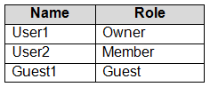
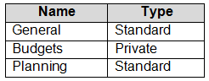
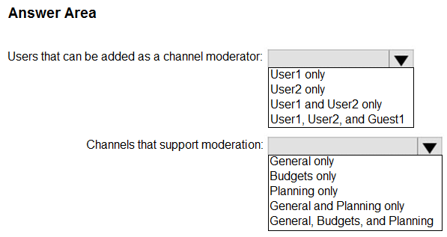
- Binh luan:
General channel has no moderation. So, Planning only
Go to a general channel and select manage channel... you will see moderation is on automatically. All other standard channels have the option to enable moderation. Still both have moderation. General channel is a standard channel. I wish people would upvote only when they know the answer not just to "Like" the comment
You have to look at the type of channel and not the names therefore there are two standard channels, and both can be moderated.
Currently private channels can not be moderated too. Checked at my own team
general is the name of the channel and the channel type is Standard please note that

Cau 73
Dap an: C
You have a Microsoft Office 365 subscription.
You need to prevent guest users from deleting channels from a Microsoft Teams team.
What should you use?
A. the Microsoft Teams admin center
B. the Microsoft 365 admin center
C. the Microsoft Teams client ✓
D. the Azure Active Directory admin center
- Binh luan:
A
From the the Microsoft Teams admin center -> Manage Teams->Select a Team-> edit "Settings" tab, and you can find the enable/disable "Guests can delete channels" option under "Guest permissions"
I'm wrong ?
Yep, I see it there.
This is possible within both:
Teams Admin Center via Teams > Manage Teams > Settings Tab > Guest Permissions
Teams Client > find the Team your are looking for > ellipsis ... > Manage team > Settings > Guest Permissions
I would go with A, purely because the MS-700 exam, is related to the Teams Admin role.
I think it's C because we are talking only about one specific team.
Answer A, confirmed VERROMA78's comment.

Cau 74
Dap an: N/A
SIMULATION
-
Please wait while the virtual machine loads. Once loaded, you may proceed to the lab section. This may take a few minutes, and the wait time will not be deducted from your overall test time.
When the Next button is available, click it to access the lab section. In this section, you will perform a set of tasks in a live environment. While most functionality will be available to you as it would be in a live environment, some functionality (e.g. copy and paste, ability to navigate to external websites) will not be possible by design.
Scoring is based on the outcome of performing the tasks stated in the lab. In other words it doesn’t matter how you accomplish the task, if you successfully perform it, you will earn credit for that task.
Labs are not timed separately, and this exam may have more than one lab that you must complete. You can use as much time as you would like to complete each lab. But you should manage your time appropriately to ensure that you are able to complete the lab(s) and all other sections of the exam in the time provided.
Please not that once you submit your work by clicking the Next button within a lab, you will NOT be able to return to the lab.
You may now click next to proceed to the lab.
Username and password.
Use the following login credentials as needed:
To enter your username, place your cursor in the Sign in box and click on the username below.
To enter your password, place your cursor in the Enter password box and click on the password below.
Microsoft 365 Username:
admin@XXXXXXXXXXX.onmicrosoft.com
Microsoft 365 Password: XXXXXXXXXXXX
If the Microsoft 365 portal does not load successfully in the browser, press CTRL-K to reload the portal in a new browser tab.
The following information is for technical support purposes only:
Lab Instance: 26178313
-
Task 8
-
You need to enable shared channel collaboration with microsoft.com. The solution must meet the following requirements:
• Users must be able to participate in shared channels created by microsoft.com.
• Users must be able to invite Microsoft contacts to shared channels created by users at your company.
To complete this task, sign in to the Microsoft 365 portal.
- Binh luan:
How to do that you have very pretty showed here: https://www.youtube.com/watch?v=rE_QTfkOtnc
Microsoft 365 guest sharing settings reference:
https://learn.microsoft.com/en-us/microsoft-365/solutions/microsoft-365-guest-settings?view=o365-worldwide#microsoft-365-groups
As per link below, this will require guest access to be turned on for SharePoint and M365 groups (these settings are enabled by default) but just in case they have been changed & a policy needs to be amended or a new policy created.
https://learn.microsoft.com/en-us/microsoft-365/solutions/collaborate-teams-direct-connect?view=o365-worldwide

Cau 75
Dap an: N/A
SIMULATION
-
Please wait while the virtual machine loads. Once loaded, you may proceed to the lab section. This may take a few minutes, and the wait time will not be deducted from your overall test time.
When the Next button is available, click it to access the lab section. In this section, you will perform a set of tasks in a live environment. While most functionality will be available to you as it would be in a live environment, some functionality (e.g. copy and paste, ability to navigate to external websites) will not be possible by design.
Scoring is based on the outcome of performing the tasks stated in the lab. In other words it doesn’t matter how you accomplish the task, if you successfully perform it, you will earn credit for that task.
Labs are not timed separately, and this exam may have more than one lab that you must complete. You can use as much time as you would like to complete each lab. But you should manage your time appropriately to ensure that you are able to complete the lab(s) and all other sections of the exam in the time provided.
Please not that once you submit your work by clicking the Next button within a lab, you will NOT be able to return to the lab.
You may now click next to proceed to the lab.
Username and password.
Use the following login credentials as needed:
To enter your username, place your cursor in the Sign in box and click on the username below.
To enter your password, place your cursor in the Enter password box and click on the password below.
Microsoft 365 Username:
admin@XXXXXXXXXXX.onmicrosoft.com
Microsoft 365 Password: XXXXXXXXXXXX
If the Microsoft 365 portal does not load successfully in the browser, press CTRL-K to reload the portal in a new browser tab.
The following information is for technical support purposes only:
Lab Instance: 26178313
-
Task 9
-
You need to deploy the Microsoft Viva Connections app to Teams and install the app as the first item on the app bar of the Teams client for all users.
To complete this task, sign in to the Microsoft 365 portal.
- Binh luan:
https://www.youtube.com/watch?v=_btoo_DFyTI

Cau 76
Dap an: E
You have a team in Microsoft Teams named Team1 that has the channels shown in the following table.
Which channels support moderation?
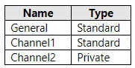
A. Channel1 only
B. Channel1 and Channel2 only
C. General only
D. Channel2 only
E. General and Channel1 only ✓
- Binh luan:
Option A it is correct.
https://support.microsoft.com/en-us/office/change-moderator-roles-and-settings-in-a-channel-6ac54758-3440-4f6a-9bd5-cebf97cb7ea6
"Note: Channel moderation is available for standard channels on Teams for desktop or web. It's not available for the general channel or private channels."
I have tested it on a Teams. In General Channel not exist moderation options
There is literally a section called moderation in General Channel setting. It does not have to be enabled like in additional standard channels you create but moderation is still available.
To be more precise, channel NAMED "General" (which is default channel) doesn't allow moderation (just give it a try).
You can modify the channel permissions so only owners can post, providing similar functionality. That's not the same as moderation though, that's definitely not supported for the general channel.
Channel moderation is supported on General Channel as it is a standard channel.

Cau 77
Dap an: N/A
HOTSPOT
-
Your company uses Teams.
You have the following teams:
• Accounting
• Project Management
• Information Technology
You plan to create new channels.
You need to recommend channel types to meet the following requirements:
• Only the managers on the Accounting team must have access to collaborate on annual reports.
• The Project Management team must be able to collaborate with the Information Technology team on a network refresh project.
Which channel type should you recommend for each team? To answer, select the appropriate options in the answer area.
NOTE: Each correct selection is worth one point.
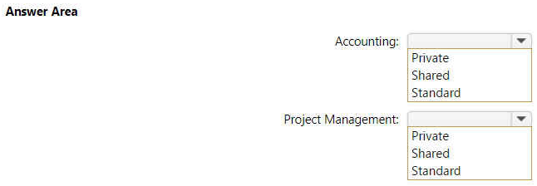
- Binh luan:
Correct
https://learn.microsoft.com/en-us/microsoftteams/shared-channels

Cau 78
Dap an: N/A
HOTSPOT
-
You have a Microsoft 365 subscription that uses Teams and contains the users shown in the following table.
You have the messaging policies shown in the following table.
The messaging policies are assigned as shown in the following table.
For each of the following statements, select Yes if the statement is true. Otherwise, select No.
NOTE: Each correct selection is worth one point.
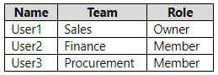
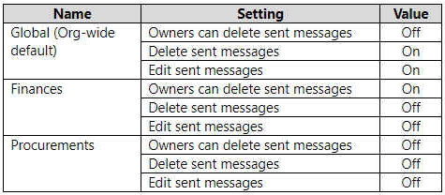
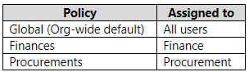
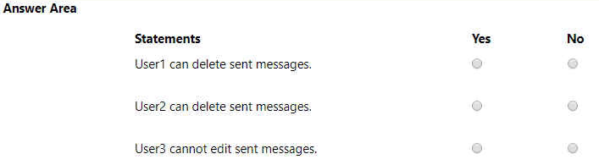
- Binh luan:
Answer should be N,N,Y
User1 can delete sent messages: No, owners cannot delete sent chats in the Org-Wide policy.
User2 can delete sent messages: No, members cannot delete sent chats in Finance policy.
User3 cannot edit sent messages: Yes, members cannot edit sent chats in Procurement policy.
Yes , No Yes seems the right one.
It looks like you were caught out as well as me... User 1 is the Owner & it shows under the Org-Wide policy that Owners cannot delete sent messages.
N-N-Y is the correct answers
YNY
First yes, because user1 can delete his own messages.
Owners can delete sent messages - Enable this setting to allow owners to delete messages or posts sent by users, excluding their own. To allow owners to delete their own sent messages, activate the Delete Sent Messages setting.
https://learn.microsoft.com/en-us/microsoftteams/settings-policies-reference

Cau 79
Dap an: N/A
HOTSPOT
-
You have a Teams deployment that contains the following teams:
• Marketing
• Sales
You plan to create new channels to meet the following requirements:
• The Sales team must collaborate on customer reviews.
• The Marketing team must collaborate with the Sales team on a product rollout.
You need to recommend which types of channels to use for the teams.
What should you recommend for each team? To answer, select the appropriate options in the answer area.
NOTE: Each correct selection is worth one point.
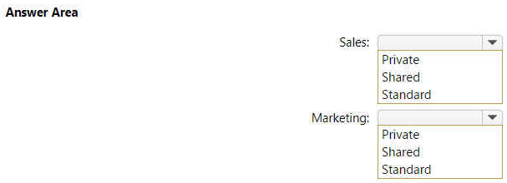
- Binh luan:
Sales- Standard, Marketing - Shared
It was never specified that only a small number of people inside the Sales team can see the Customer Reviews. it was implied that everyone inside the Sales team can look at customer reviews. hence it should be standard channel
I think the first one is standard because everyone in Teams Sales has to be part of the Customer's Reviews Channel.
Standard,
Shared,
Standard ok, why not private the second?
bcz Marketing team must collaborate with the Sales team
Private channel is used for interaction bets users in the team itself and shared channel is used for interacting with another teams

Cau 80
Dap an: N/A
HOTSPOT
-
You have a Microsoft 365 subscription that uses Teams.
You have a template to create a team named Team1.
You need to modify the template so that only Team1 owners can delete channels and messages.
How should you complete the template? To answer, select the appropriate options in the answer area.
NOTE: Each correct selection is worth one point.
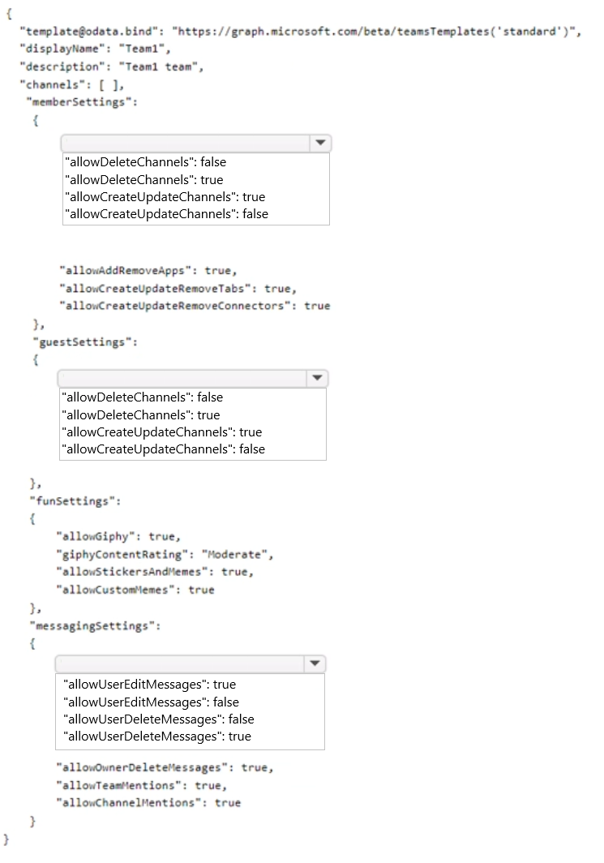
- Binh luan:
owners should be able to delete by default so this given answer looks correct. They have also set the owners already in the message section to true

Cau 81
Dap an: N/A
HOTSPOT
-
You have a Microsoft 365 subscription that uses Microsoft Teams and contains a user named User1 and three groups named Group1, Group2, and Group3. User1 is a member of Group1, Group2, and Group3.
The subscription has the meeting policies shown in the following table.
The meeting policies are assigned to groups as shown in the following table.
For each of the following statements, select Yes if the statement is true. Otherwise, select No.
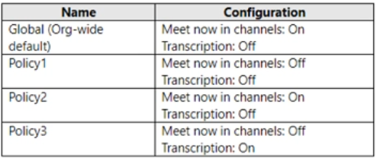
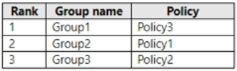
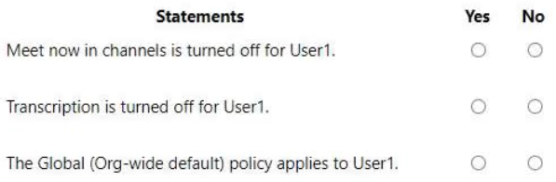
- Binh luan:
Correct : When you assign a policy to a group, you specify a ranking for the group assignment. This ranking is used to determine which policy a user should inherit as their effective policy if the user is a member of two or more groups and each group is assigned a policy of the same type.
The group assignment ranking is relative to other group assignments of the same type. For example, if you're assigning a calling policy to two groups, set the ranking of one assignment to 1 and the other to 2,
Additional support here:
https://learn.microsoft.com/en-us/microsoftteams/assign-policies-users-and-groups#precedence-rule
yes rank1
If a user doesn't have a policy directly assigned to them and is a member of two or more groups and each group has a policy of the same type assigned to it, the user inherits the policy of the group assignment that has the highest ranking.
https://learn.microsoft.com/en-us/microsoftteams/assign-policies-users-and-groups#precedence-rules
I think the asnwer should be Y, Y, N as In Teams the most restrictive policy apllies and in policy 1 and 2 transcriptions is off.

Cau 82
Dap an: N/A
HOTSPOT
-
You have a Microsoft 365 subscription that uses Teams and contains the users shown in the following table.
You have a private team named Sales that contains the members shown in the following table.
The Sales team contains the channels shown in the following table.
For each of the following statements, select Yes if the statement is true. Otherwise, select No.
NOTE: Each correct selection is worth one point.
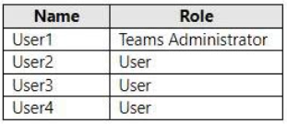
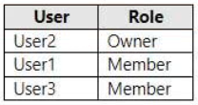
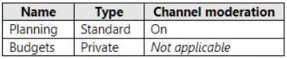
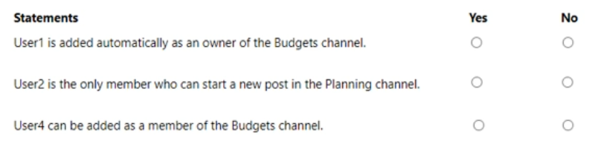
- Binh luan:
Correct Answer is No, Yes, No.
The scenario presented only mentions that channel moderation is ON .
So if you turn "channel moderation" only "ON" and do not make any configuration change, per default moderator are only "Team owner". And only moderators can start a new post.
Should it be N N N?
The Channel moderation can be both owner and members.
if you turn "channel moderation" only "ON" and do not make any configuration change, per default moderator are only "Team owner". And only moderatores can start a new post.
lab01 is right its only Teams owners, who can moderate by default. But the question here might be missing an image of that particular part too. This seems too loose even for a MS exam question.
-User one (Teams Administrator) is not added as owner to channel's automatically: No
-Since no configs, only user2 (Owner) can post in Planning channel: Yes
-User4 is not a member of the Team, so can't be added to the Budgets Channel: No

Cau 83
Dap an: D
Your company uses Teams Calling Plans.
When a user places a Teams call to an ambulance service, you need to ensure that a notification is also sent to the main receptionist of the company.
What should you configure?
A. a caller ID policy
B. a calling policy
C. a voice routing policy
D. an emergency calling policy ✓
- Binh luan:
It´s correct
https://learn.microsoft.com/en-us/microsoftteams/what-are-emergency-locations-addresses-and-call-routing
"You use a Teams emergency calling policy (TeamsEmergencyCallingPolicy) to configure who should be notified during an emergency call and how they are notified: chat only, conferenced in and muted, or conferenced in and muted but with the ability to unmute. You can also specify an external PSTN number of a user or group to call and join the emergency call. Note that the PSTN par

Cau 84
Dap an: N/A
DRAG DROP
-
Your company uses Microsoft Teams and has an auto attendant named AA1.
A user named User1 has a phone number of 613-555-1234.
You need to assign the phone number to AA1.
Which three actions should you perform in sequence in the Microsoft Teams admin center? To answer, move the appropriate actions from the list of actions to the answer area and arrange them in the correct order.
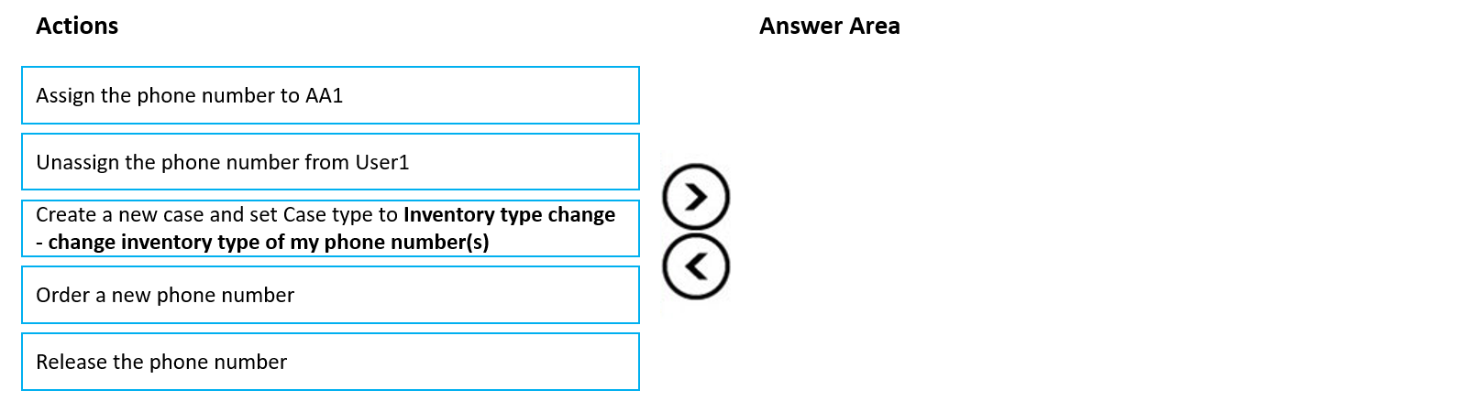
- Binh luan:
The answer seems to be correct.
Logically thinking it should be as below
- unassign the user number
- convert the user number to service number
- assign the service number to AA
To convert the user number to service number key steps are as below
1. go to TAC>Voice>Phone numbers
2.Create a new case
3. In case type select "Inventory type change- change inventory type of my phone number(s)
4.Then in "Convert to" field select "service number"
Once case is actioned the user number will appear as se
Thank goodness Microsoft finally gave administrators the ability to switch number type in TAC now!

Cau 85
Dap an: N/A
DRAG DROP
-
You have a Microsoft 365 E5 subscription that uses Teams.
The sales department at your company requires that a toll-free number appear at the top of a list of numbers on Microsoft Outlook invites to Teams meetings.
Which four actions should you perform in sequence? To answer, move the appropriate actions from the list of actions to the answer area and arrange them in the correct order.
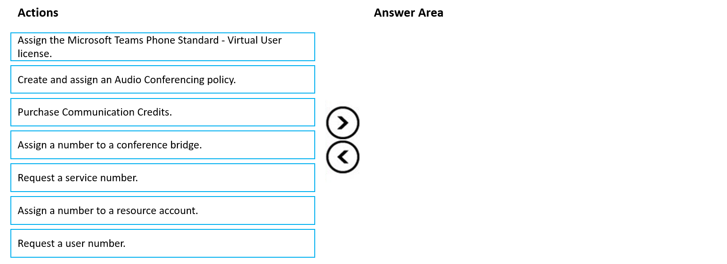
- Binh luan:
To provide toll-free conference bridge phone numbers and to support conferencing dial-out to international phone numbers, you must set up Communications Credits for your organization.
Communication credits are rquired when setting up Audio conferencing:
https://learn.microsoft.com/en-us/microsoftteams/what-are-communications-credits
Service phone numbers for Calling Plans:
https://learn.microsoft.com/en-us/microsoftteams/getting-service-phone-numbers
Set up Audio Conferencing for Microsoft Tea
1. Purchase communication credits:
• Communication credits are required for purchasing and assigning service numbers.
2. Request a service number:
• After purchasing communication credits, you can request a service number that includes a toll-free number.
3. Assign a number to a conference bridge:
• Once you have obtained a service number, you need to assign it to a conference bridge.
4. Create and assign an audio conferencing policy:
• Finally, create an audio conferencing policy that includes

Cau 86
Dap an: N/A
HOTSPOT
-
You have a Microsoft 365 subscription named contoso.com that uses Microsoft Teams and contains the users shown in the following table.
In Azure Active Directory (Azure AD), the External collaboration settings are configured as shown in the exhibit. (Click the Exhibit tab).
Allow guest access in Teams is set to On.
You have a team named Project1 that contains the users shown in the following table.
Both User1 and User3 are owners of a team named Project1. User2 is a member of Project1.
For each of the following statements, select Yes if the statement is true. Otherwise, select No.
NOTE: Each correct selection is worth one point.
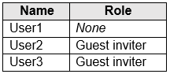
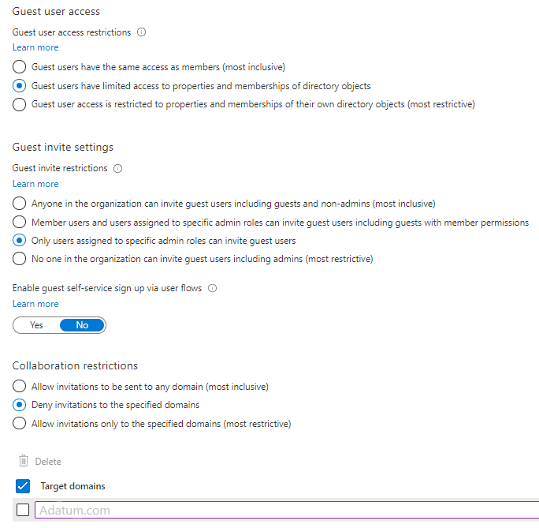
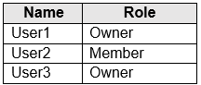
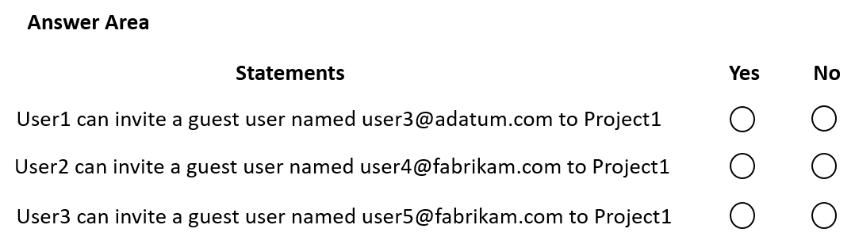
- Binh luan:
Should be N/Y/Y
the give answer is correct... NNY, because Guest inviter role can be added but you need to be an an owner of the team too. the settings are in O365 here at tenant level..
Go to your Microsoft Office 365 Admin Center
Go to Settings > Services & Add-Ins > Office 365 Groups
Turn on the settings for Let Group Members Outside The Organization Access Group Content and Let Group Owners Add People Outside The Organization To Groups
https://learn.microsoft.com/en-us/microsoft-365/solutions/limit-who-can-invite-guests?view=o365-worldwide
I think you don't need to be also owner
User 2 as a member of the Team (which wasnt specified as private) and with a Guest inviter role should be able to invite guests to the team
NNY
Guest Inviter can’t add user to group only invite so can’t add user to Project1 https://learn.microsoft.com/en-us/entra/identity/role-based-access-control/permissions-reference#guest-inviter

Cau 87
Dap an: N/A
HOTSPOT
-
You have a Microsoft 365 subscription that uses Microsoft Teams.
You have the users shown in the following table.
You have a team named Project1 that contains the users shown in the following table.
Which user can archive Project1, and which tool should be used to perform the task? To answer, select the appropriate options in the answer area.
NOTE: Each correct selection is worth one point.
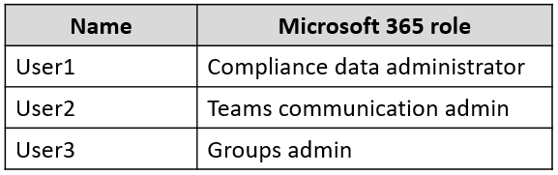
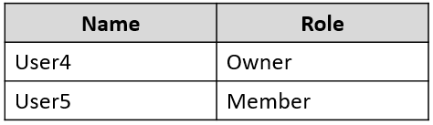
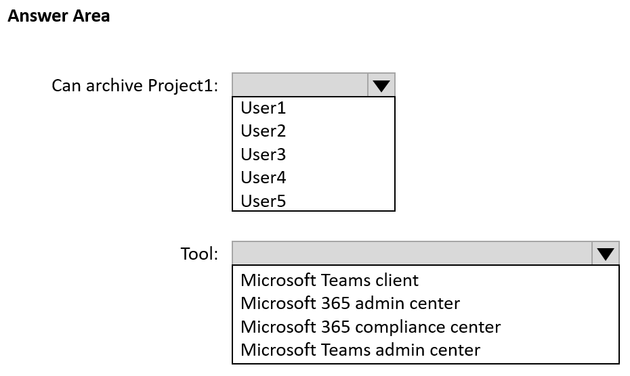
- Binh luan:
Team Owner can archive using the Teams Client:
https://support.microsoft.com/en-au/office/archive-or-restore-a-team-dc161cfd-b328-440f-974b-5da5bd98b5a7
There is no indicator that user 4 is an admin. So, how can he access the Admin center? Teams client is here the correct one
Correct answers:
User4
Microsoft Teams Client
https://learn.microsoft.com/en-us/microsoftteams/archive-or-delete-a-team :
Over time, a team created in Microsoft Teams might fall out of use or you might want to archive or delete a team at the end of a project. If you're a Microsoft Teams admin, follow the steps in this article to archive or delete a team that's no longer needed. (If you're a team owner, you can also archive a team.)....
and the link for the owner is:
https://support.microsoft.
Correct! There is no indicator that user 4 is an admin. So, how can he access the Admin center? Teams client is here the correct one.
Can archive Project1: User4
Tool: Microsoft Teams client

Cau 88
Dap an: N/A
HOTSPOT
-
You have a Microsoft 365 subscription that contains the users shown in the following table.
The subscription contains the Microsoft Teams teams shown in the following table.
You need to identify how many additional org-wide teams you can create in the subscription, and which users can create the org-wide teams?
What should you identify? To answer, select the appropriate options in the answer area.
NOTE: Each correct selection is worth one point.
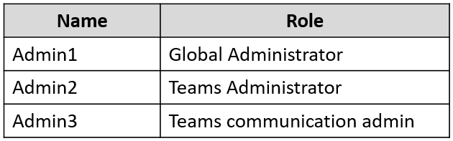
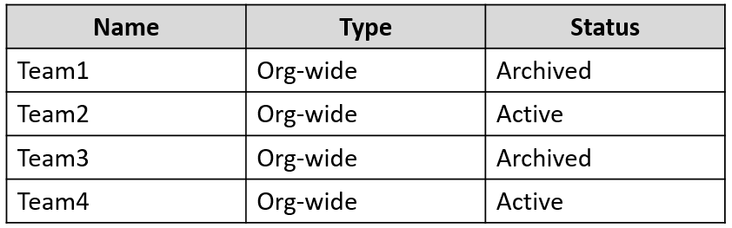
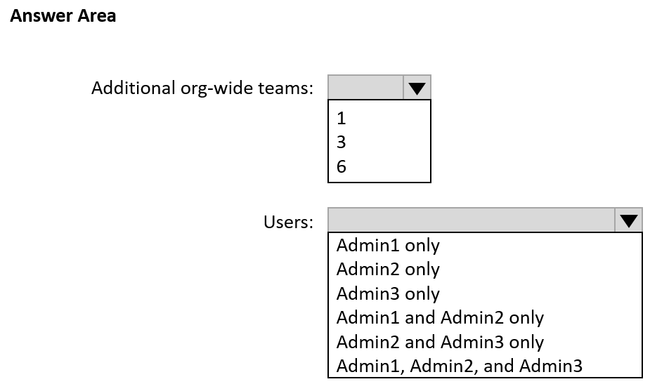
- Binh luan:
"Only global admins can create org-wide teams and currently an org-wide team is limited to organizations with no more than 10,000 users. There's also a limit of five org-wide teams per tenant. If these requirements are met, global admins will see Org-wide as an option when they select to build a team From scratch when creating a team."
https://learn.microsoft.com/en-us/microsoftteams/create-an-org-wide-team
The "Fine Print" in the Documentation
While the introduction highlights Global Admins, if you scroll down to the "Membership, roles, and settings" section of that same official Microsoft page (Create an org-wide team), it states:
"When an organization-wide team is created, all Global administrators and Teams administrators are added as team owners..."
Why can I create an org wide team if I am only Teams admin then? I just tested.
This is correct!!

Cau 89
Dap an: A
You have a Microsoft 365 E5 subscription that uses Microsoft Teams and contains the resources shown in the following table.
You need to configure the subscription to meet the following requirements:
• App1 must be pinned only to the Teams desktop client of the users in Group1.
• App2 must be pinned only to the Teams desktop client of the users in Group2.
What should you do in the Microsoft Teams admin center?
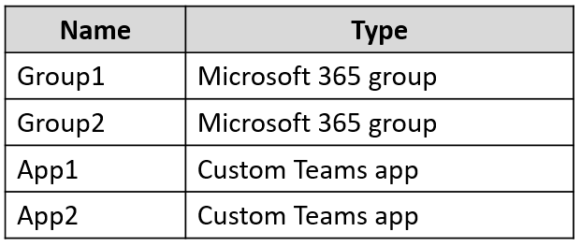
A. Create app setup policies. ✓
B. Create app permission policies.
C. Modify the global (Org-wide default) app permission policy.
D. Modify the global (Org-wide default) app setup policy.
- Binh luan:
App setup policies for pinning apps.
Create individual App Setup Policies

Cau 90
Dap an: C
You have a Microsoft 365 subscription.
In Microsoft Teams, you create a new private team named Team1 and add a user named User1 as a member.
User1 attempts to add members to Team1 and reports that approval is required.
You need to ensure that User1 can add members to Team 1 without requiring approval.
What should you do?
A. Configure a new Microsoft Teams policy.
B. Configure guest access.
C. Configure User1 as an owner of Team1. ✓
D. Assign the Teams Communications Support Specialist role to User1.
- Binh luan:
correct
If the team is private, a member needs to request in order to invite a new member. Not true if it is a public team.
agree answer is C.
correct
Correct

Cau 91
Dap an: C
Your company uses Microsoft Teams.
You have a team named Team1 that has the channels shown in the following table.
You plan to enable channel moderation for the channels.
Which channels support channel moderation?
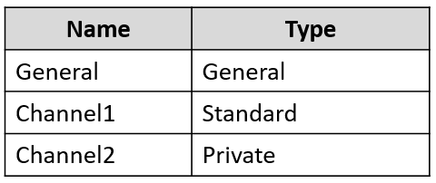
A. General and Channel1 only
B. Channel2 only
C. Channel1 only ✓
D. Channel1 and Channel2 only
E. General, Channel1, and Channel2
F. General only
- Binh luan:
Channel moderation is available for standard channels on Teams for desktop or web. It's not available for the general channel or private channels.
https://support.microsoft.com/en-us/office/change-moderator-roles-and-settings-in-a-channel-6ac54758-3440-4f6a-9bd5-cebf97cb7ea6
I think it was not. But when i check the teams client now you can clearly see a more limited Moderation setting there. Go check yourself. Hopefully this question is not in the exam.
Channel moderation is a feature in Microsoft Teams that can be enabled for **Standard** channels.
this feature is **not available** for **General** channels and **Private** channels.
the correct answer is **C. Channel1 only**.
Note: Channel moderation is available for standard channels on Teams for desktop or web. It's not available for the general channel or private channels.
https://support.microsoft.com/en-au/office/change-moderator-roles-and-settings-in-a-channel-in-microsoft-teams-6ac54758-3440-4f6a-9bd5-cebf97cb7ea6
I think the question is wrong. There is NO "General" type channel, channel types include Standard, Shared, and Private, but NOT "General". The default General channel has type Standard. And General channel does support channel moderation. So, if the question has correct General channel type Standrad, answer is A. Otherwise, chose C.

Cau 92
Dap an: A
Note: This question is part of a series of questions that present the same scenario. Each question in the series contains a unique solution that might meet the stated goals. Some question sets might have more than one correct solution, while others might not have a correct solution.
After you answer a question in this section, you will NOT be able to return to it. As a result, these questions will not appear in the review screen.
You have a Microsoft 365 subscription that contains several Microsoft SharePoint Online sites.
You need to ensure that the content stored in a SharePoint modern team site named Sales is available from Microsoft Teams. The solution must ensure that when a new channel is added to a team, a folder for the channel is created in the Sales site.
Solution: From the Microsoft Teams client, you create a new team and select From a group or team.
Does this meet the goal?
A. Yes ✓
B. No
- Binh luan:
A is correct - You can create from an existing 0365 group/team, use the create a team option, or add a microsoft team link
i believe you are right:
When you create a new team from scratch, a new SharePoint site is created and connected to the team.
When you create a new team from an existing Microsoft 365 group, the team is connected to the SharePoint site associated with the group.
When you add Teams to an existing SharePoint site, that site is connected to the new team.
When you create a new private or shared channel, a new SharePoint site is created and connected to that channel.
B. No
Creating a new team from an existing group or team in Microsoft Teams does not automatically connect it to a specific SharePoint site. The SharePoint site and the Teams team operate somewhat independently, even though they can be connected.
To meet your goal, you would need to create a new team in Teams directly from the existing SharePoint site.
This way, the SharePoint site and the Teams team are connected. When a new channel is added to the team, a corresponding new folder is created
Answer is B.No.
I thought A. first but got to know I was wrong as I tested it.
When the team is created in the stated way, it does not have it show the content of the site. When the linking is initiated on Sharepoint site, the content is available on Teams.
When you create a new team from an existing Microsoft 365 group, the team is connected to the SharePoint site associated with the group.
https://learn.microsoft.com/en-us/SharePoint/teams-connected-sites

Cau 93
Dap an: N/A
DRAG DROP
-
You have a Microsoft 365 subscription that uses Microsoft Teams.
You need to identify the following information:
• The number of chat messages sent during the past 30 days
• The number of messages posted in specific channels during the past 90 days
Which reports should use? To answer, drag the appropriate reports to the correct pieces of information. Each report may be used once, more than once, or not at all. You may need to drag the split bar between panes or scroll to view content.
NOTE: Each correct selection is worth one point.
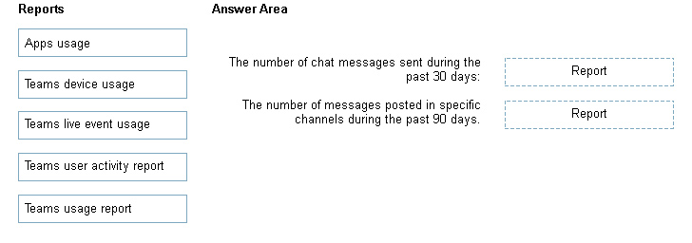
- Binh luan:
Correct

Cau 94
Dap an: C
Your company is releasing a Request for Proposal (RFP) and is collaborating with four vendors. Each vendor must communicate with the company, but the vendors must NOT be able to communicate with each other in channel posts.
The company must communicate internally about vendor specifics without the vendors having access to these communications.
You need to create teams and channels in Microsoft Teams to support the communication requirements. The solution must minimize the number of teams.
What should you do?
A. Create one team that has one private channel per vendor. Use the General channel for internal communications.
B. Create two teams per vendor. Use one team per vendor for internal communications.
C. Create one team per vendor. Use a private channel for internal communications. ✓
D. Create one team that has two private channels per vendor. Use one of the private channels per vendor for internal communications.
- Binh luan:
Correct is C.
Both A and D are wrong, because if there is only one team for all vendors, all vendors will necessarily have access to the Generel channel and can communicate to each other in the General channel, which is not what we want.
B is too many teams, which also is not what we want to achieve.
The solution must minimize the number of teams.
A. Create one team that has one private channel per vendor. Use the General channel for internal communications.
Here’s why:
Creating one team with a private channel for each vendor ensures that vendors cannot communicate with each other in channel posts, as private channels are only accessible to the members added to them.
Using the General channel for internal communications allows the company to discuss vendor specifics without the vendors havi
to be added to private channels you must be a member of the team... which give users access to general channel... vendors could then communicate with each other which is not allowed.... This is prob a job for shared channels but no option here.
I would go for choice D. Smallest amount of teams to create.
A. Create one team that has one private channel per vendor. Use the General channel for internal communications.
-> Vendors are accessible to the General channel. This should not be the answer.
B. Create two teams per vendor. Use one team per vendor for internal communications.
-> 8 teams to be created. Too many.
C. Create one team per vendor. Use a private channel for internal communications.
-> 4 teams to be created though keep the
D. Create one team that has two private channels per vendor. Use one of the private channels per vendor for internal communications.
-> 1 team with 8 channels. Can keep all the 4 private channels off from the vendors. The other 4 channels are supposed to be for communication with each vendor.

Cau 95
Dap an: N/A
DRAG DROP
-
Your company uses Teams.
You need to configure Teams apps to meet the following requirements:
• Block members of a team named Sales from installing custom apps.
• Pin apps in a specific order on the Teams app bar.
Which settings should you configure to meet each requirement? To answer, drag the appropriate settings options to the correct requirements. Each settings option may be used once, more than once, or not at all. You may need to drag the split bar between panes or scroll to view content.
NOTE: Each correct selection is worth one point.
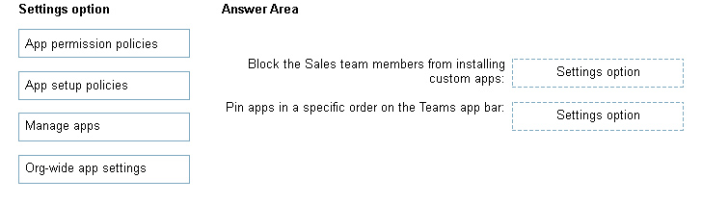
- Binh luan:
Manage Apps, App Set-up policies. App Permission Policies has been moved to Manage
Apps.
In set-up policies you can enabled UPLOADING cusotm apps but be carweful. this is not the same as INSTALL. which is found in MAnage Apps > Actions > Org Wide App Settings
sorry its only for sales so the answer is Manage Apps not ORG WIDE app settings
correct

Cau 96
Dap an: N/A
DRAG DROP
-
Your company uses Teams and deploys the Yammer Communities app to all users.
The communications department at the company needs you to replace the image on the Teams app bar for the Communities app.
Which three actions should you perform in sequence? To answer, move the appropriate actions from the list of actions to the answer area and arrange them in the correct order.
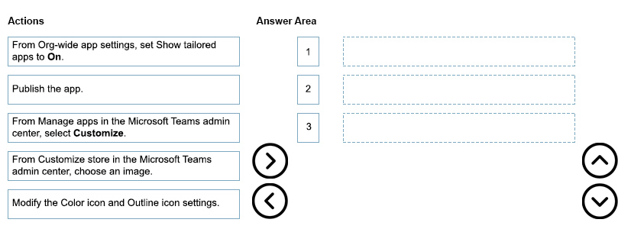
- Binh luan:
Correct https://learn.microsoft.com/en-us/microsoftteams/customize-apps
looks correct to me

Cau 97
Dap an: N/A
HOTSPOT
-
Your company uses Microsoft Teams.
All users are assigned a Microsoft 365 E3 license.
You need to purchase add-on licenses that provide the following:
• The ability to add a logo to the meeting lobby
• Automatic protection against malicious links posted in chats
Which add-on license should you obtain for each requirement? To answer, select the appropriate options in the answer area.
NOTE: Each correct selection is worth one point.
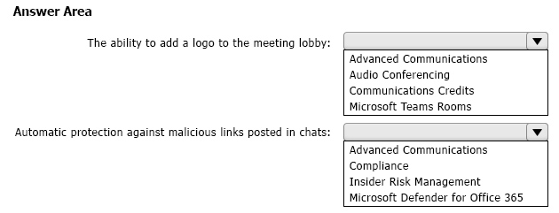
- Binh luan:
Correct:
Ability to Add a Logo to the Meeting Lobby:
The ability to add a logo to the meeting lobby in Microsoft Teams is typically associated with the Advanced Communications add-on. This add-on includes features like Large Meeting Support, Meeting Lobby, and other advanced meeting capabilities.
Automatic Protection Against Malicious Links in Chats:
Protection against malicious links is often a part of the security features provided by Microsoft Defender for Office 365 (formerly known as Off
Advanced communication has been replaced by Teams Premium license

Cau 98
Dap an: C
You have a Microsoft Office 365 subscription.
You need to prevent guest users from deleting channels from a Microsoft Teams team.
What should you use?
A. the Azure portal
B. the Microsoft Purview compliance portal
C. the Microsoft Teams PowerShell module ✓
D. the Azure Active Directory Module for Windows PowerShell
- Binh luan:
correct: Set-Team-GuestSetting -GroupId <TeamId> -DeleteChannelsAllowed $false

Cau 100
Dap an: A
Your company uses Teams.
You are assigned the Teams Communications Support Specialist role.
You need to be assigned a role that will enable you to publish a new app to the Teams apps page. The solution must follow the principle of least privilege.
Which role should be assigned to you?
A. Teams Administrator ✓
B. Cloud Application Administrator
C. Application Administrator
D. Office Apps Administrator
- Binh luan:
The correct answer is A.
Even though there is a Cloud Application Administrator role in Azure Active Directory (now called Entra), that role cannot access the Teams Admin Center with priviledges to make changes.
https://learn.microsoft.com/en-us/microsoftteams/using-admin-roles
Yep it is A
Answer: A
The rest are not roles for Teams.
There is no Cloud Application Administrator in Teams
I looked in Role assignments in 365 admin center and there's a "Cloud Application Adminstrator" role.

Cau 101
Dap an: N/A
HOTSPOT
-
Case study
-
Overview
-
Company Information
-
ADatum Corporation is an energy company that has offices across North America and 3,000 employees.
Physical Locations
-
ADatum has the offices shown in the following table.
Existing Environment
-
Network Infrastructure
-
The office in Calgary has a 1-Gbps internet circuit. The offices in San Diego and New York have 100-Mbps internet circuits. The field site in Edmonton has a 3-Mbps internet circuit.
Departments
-
ADatum has the following departments:
• Information technology (IT)
• Project management
• Marketing
Microsoft 365 and Tenants Environment
ADatum recently purchased a Microsoft 365 E5 subscription that has the Microsoft Teams Domestic Calling Plan add-on. All users are assigned Microsoft 365 E5 and Microsoft Teams Domestic Calling Plan licenses and Calling Plans is deployed.
Azure AD has the default Cross-tenant access settings configured.
The Teams policies settings are configured as shown in the following exhibit.
The Teams client is deployed to a non-persistent Virtual Desktop Infrastructure (VDI) used by the project management department.
Allow guest access in Teams is set to Off.
The Microsoft Viva Connections app is deployed to all users.
Problem Statements
-
ADatum identifies the following issues:
• An executive at the San Diego office reports that video drops during Teams meetings.
• The Edmonton field site has limited bandwidth, and users report poor audio during Teams calls and meetings.
• Users in the project management department report that they cannot give or take control during Teams calls and meetings while sharing their VDI desktop.
Planned Changes
-
ADatum plans to implement the following changes:
• Configure the media bit rate settings for the users at the Edmonton field site. The settings must apply only to the user while they are at the site, but NOT when they are at a different office.
• Create a Teams channel to enable the project management department to collaborate with the IT department on a device upgrade project.
• Implement a pilot rollout of Operator Connect for the users in the New York office. A port re-quest was accepted already.
• Create a Teams channel for the marketing department for external collaboration.
• Rename the Viva Connections icon as Start portal.
Technical Requirements
-
ADatum identifies the following technical requirements:
• The marketing department requires that all the files shared by using Teams remain available for at least three years after deletion.
• The marketing department must be able to apply a watermark to content and video shared dur-ing Teams meetings.
• All users require indefinite access to training videos recorded in Teams by the IT department.
• All access to Teams and shared resources must use the principle of least privilege.
• Guest access must remain disabled.
You need to implement the planned changes for the marketing department and the project management department. The solution must meet the technical requirements.
Which type of channel should you use for each department? To answer, select the appropriate options in the answer area.
NOTE: Each correct selection is worth one point.


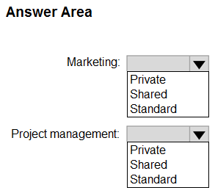
- Binh luan:
Shouldn't the Project Management team be Shared? "Create a Teams channel to enable the project management department to collaborate with the IT department on a device upgrade project."
Marketing: Must be a shared Channel
Project management: Can be a shared channel or a standard channel in a new team
Should be shared - shared. Otherwise question 103 makes no sense either.
Why both shared?
it department is not an external collaboration
i think both will be shared as Channel can be shared directly with other teams and external collab. only available in shared team

Cau 102
Dap an: N/A
DRAG DROP
-
Case study
-
Overview
-
Company Information
-
ADatum Corporation is an energy company that has offices across North America and 3,000 employees.
Physical Locations
-
ADatum has the offices shown in the following table.
Existing Environment
-
Network Infrastructure
-
The office in Calgary has a 1-Gbps internet circuit. The offices in San Diego and New York have 100-Mbps internet circuits. The field site in Edmonton has a 3-Mbps internet circuit.
Departments
-
ADatum has the following departments:
• Information technology (IT)
• Project management
• Marketing
Microsoft 365 and Tenants Environment
ADatum recently purchased a Microsoft 365 E5 subscription that has the Microsoft Teams Domestic Calling Plan add-on. All users are assigned Microsoft 365 E5 and Microsoft Teams Domestic Calling Plan licenses and Calling Plans is deployed.
Azure AD has the default Cross-tenant access settings configured.
The Teams policies settings are configured as shown in the following exhibit.
The Teams client is deployed to a non-persistent Virtual Desktop Infrastructure (VDI) used by the project management department.
Allow guest access in Teams is set to Off.
The Microsoft Viva Connections app is deployed to all users.
Problem Statements
-
ADatum identifies the following issues:
• An executive at the San Diego office reports that video drops during Teams meetings.
• The Edmonton field site has limited bandwidth, and users report poor audio during Teams calls and meetings.
• Users in the project management department report that they cannot give or take control during Teams calls and meetings while sharing their VDI desktop.
Planned Changes
-
ADatum plans to implement the following changes:
• Configure the media bit rate settings for the users at the Edmonton field site. The settings must apply only to the user while they are at the site, but NOT when they are at a different office.
• Create a Teams channel to enable the project management department to collaborate with the IT department on a device upgrade project.
• Implement a pilot rollout of Operator Connect for the users in the New York office. A port re-quest was accepted already.
• Create a Teams channel for the marketing department for external collaboration.
• Rename the Viva Connections icon as Start portal.
Technical Requirements
-
ADatum identifies the following technical requirements:
• The marketing department requires that all the files shared by using Teams remain available for at least three years after deletion.
• The marketing department must be able to apply a watermark to content and video shared dur-ing Teams meetings.
• All users require indefinite access to training videos recorded in Teams by the IT department.
• All access to Teams and shared resources must use the principle of least privilege.
• Guest access must remain disabled.
You need to implement the planned changes for Viva Connections.
Which three actions should you perform in sequence? To answer, move the appropriate actions from the list of actions to the answer area and arrange them in the correct order.


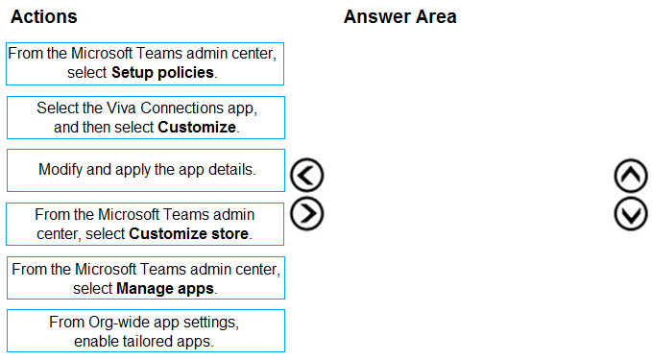
- Binh luan:
seems to be correct

Cau 103
Dap an: C, E
Case study -
Overview -
Company Information -
ADatum Corporation is an energy company that has offices across North America and 3,000 employees.
Physical Locations -
ADatum has the offices shown in the following table.
Existing Environment -
Network Infrastructure -
The office in Calgary has a 1-Gbps internet circuit. The offices in San Diego and New York have 100-Mbps internet circuits. The field site in Edmonton has a 3-Mbps internet circuit.
Departments -
ADatum has the following departments:
• Information technology (IT)
• Project management
• Marketing
Microsoft 365 and Tenants Environment
ADatum recently purchased a Microsoft 365 E5 subscription that has the Microsoft Teams Domestic Calling Plan add-on. All users are assigned Microsoft 365 E5 and Microsoft Teams Domestic Calling Plan licenses and Calling Plans is deployed.
Azure AD has the default Cross-tenant access settings configured.
The Teams policies settings are configured as shown in the following exhibit.
The Teams client is deployed to a non-persistent Virtual Desktop Infrastructure (VDI) used by the project management department.
Allow guest access in Teams is set to Off.
The Microsoft Viva Connections app is deployed to all users.
Problem Statements -
ADatum identifies the following issues:
• An executive at the San Diego office reports that video drops during Teams meetings.
• The Edmonton field site has limited bandwidth, and users report poor audio during Teams calls and meetings.
• Users in the project management department report that they cannot give or take control during Teams calls and meetings while sharing their VDI desktop.
Planned Changes -
ADatum plans to implement the following changes:
• Configure the media bit rate settings for the users at the Edmonton field site. The settings must apply only to the user while they are at the site, but NOT when they are at a different office.
• Create a Teams channel to enable the project management department to collaborate with the IT department on a device upgrade project.
• Implement a pilot rollout of Operator Connect for the users in the New York office. A port re-quest was accepted already.
• Create a Teams channel for the marketing department for external collaboration.
• Rename the Viva Connections icon as Start portal.
Technical Requirements -
ADatum identifies the following technical requirements:
• The marketing department requires that all the files shared by using Teams remain available for at least three years after deletion.
• The marketing department must be able to apply a watermark to content and video shared dur-ing Teams meetings.
• All users require indefinite access to training videos recorded in Teams by the IT department.
• All access to Teams and shared resources must use the principle of least privilege.
• Guest access must remain disabled.
You need to implement the planned changes for the marketing department.
Which two actions should you perform? Each correct answer presents part of the solution.
NOTE: Each correct selection is worth one point.


A. Set Invite external users to shared channels to On for the Global (Org-wide default) Teams policy.
B. From the Azure Active Directory admin center, configure the B2B direct connect outbound access settings for external users and groups.
C. From the Azure Active Directory admin center, configure the B2B direct connect inbound access settings for external users and groups. ✓
D. Set Join external shared channels to On for the Teams policy of the marketing department.
E. Set Invite external users to shared channels to On for the Teams policy of the marketing department. ✓
- Binh luan:
"B2B direct connect is a feature of Microsoft Entra External ID that lets you set up a mutual trust relationship with another Microsoft Entra organization for seamless collaboration. This feature currently works with Microsoft Teams shared channels. With B2B direct connect, users from both organizations can work together using their home credentials and a shared channel in Teams, without having to be added to each other’s organizations as guests. "
Resource link:
https://learn.microsoft.com/en-u
D. Set Join external shared channels to On for the Teams policy of the marketing department: This action would indeed allow users in the marketing department to join external shared channels, thereby enabling external collaboration.
E. Set Invite external users to shared channels to On for the Teams policy of the marketing department: Enabling this setting would allow users in the marketing department to invite external users to shared channels, facilitating collaboration with external partners
Assuming this question has been answered correctly, the previous question's answer cannot be right. The marketing channel is shared, not private

Cau 1
Dap an: N/A
HOTSPOT -
You have a Microsoft 365 subscription that has the licenses shown in the following table.
What is the maximum number of user phone numbers and toll-free service numbers you can acquire? To answer, select the appropriate options in the answer area.
NOTE: Each correct selection is worth one point.
Hot Area:
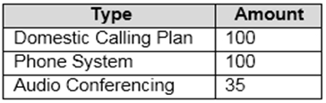
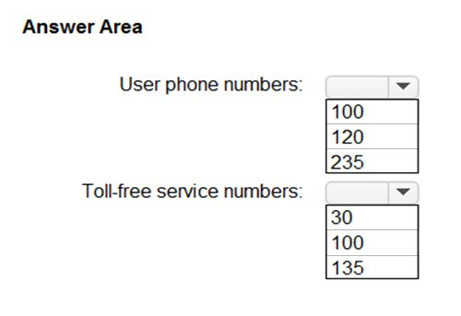
- Binh luan:
https://docs.microsoft.com/en-us/microsoftteams/how-many-phone-numbers-can-you-get
User (subscriber) number
The number of phone numbers is equal to the total number of Domestic Calling Plan and/or Domestic and International Calling Plan licenses multiplied by 1.1 + 10 additional phone numbers.
Toll-free service number (no logic, just hope to remember from the site)
If there are 1-25 licenses then 5 telephone numbers are given.
If there are 26-49 licenses then 10 telephone numbers are given.
If
great explanation, very clear, thx!
Forgot to add for the Toll-Free service Number:
The number of licenses is equal to the total number of Phone System and Audio Conferencing licenses.
what a boring...
call plan * 1.1 + 10
call plan /25 * 5 then select the most near value
1. For **User Phone Numbers**, you have 100 Domestic Calling Plan licenses. The calculation is indeed $$100 \times 1.1 + 10 = 110 + 10 = 120$$. Therefore, the maximum number of user phone numbers you can acquire is **120**.
2. For **Toll-free Service Numbers**, for 100-149 licenses, 30 phone numbers are given. So, the maximum number of toll-free service numbers you can acquire is indeed **30**.

Cau 2
Dap an: D
Your company uses Phone System.
A group of users make outbound calls on behalf of the company's billing department.
You need to ensure that when the users make the outbound calls, their numbers are replaced by a phone number that is associated to an existing call queue.
What should you do first?
A. Create a new calling policy and set Make private calls to On.
B. Create a new calling policy and set Inbound calls can be routed to call groups to On.
C. Create a new caller ID policy and set Replace caller ID to Anonymous.
D. Create a new caller ID policy and set Replace caller ID to Service number. ✓
- Binh luan:
correct
Answer is D
D is correct, yes.
Correct
Correct

Cau 3
Dap an: N/A
HOTSPOT -
You have a Microsoft Office 365 subscription.
All users are assigned a Calling Plan license.
You configure emergency calling.
The global emergency calling policy is configured as shown in the Emergency Calling exhibit. (Click the Emergency Calling tab.)
The global emergency call routing policy is configured as shown in the Emergency Call Routing exhibit. (Click the Emergency Call Routing tab.)
The network topology is configured as shown in the Network Topology exhibit. (Click the Network Topology tab.)
For each of the following statements, select Yes if the statement is true. Otherwise, select No.
NOTE: Each correct selection is worth one point.
Hot Area:
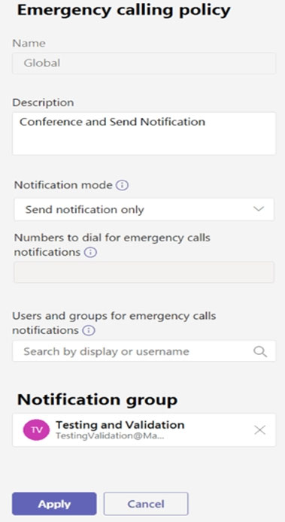
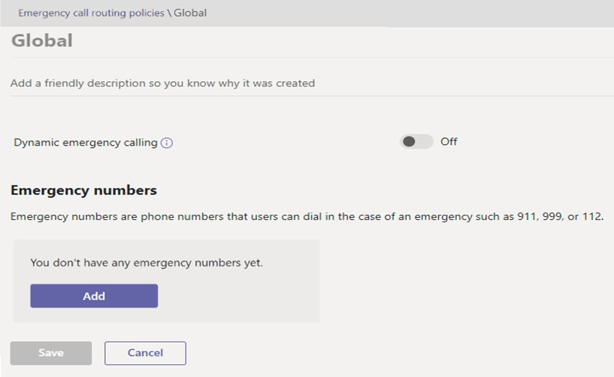
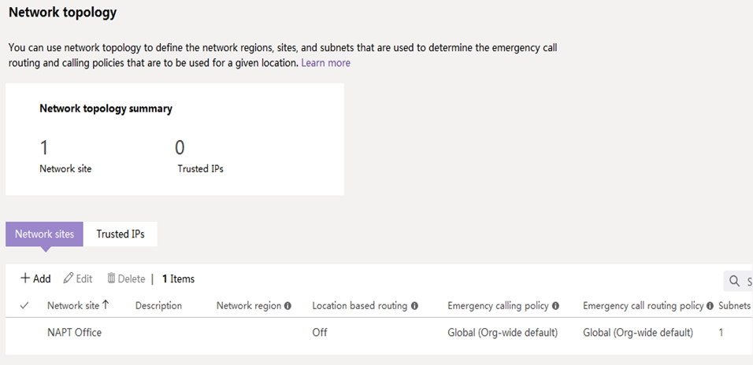
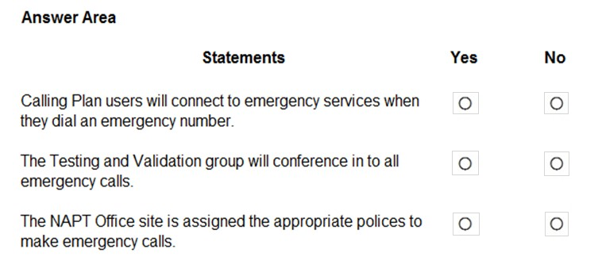
- Binh luan:
That answer is correct.
Yes - Emergency calling policies applies to calling plans. The global emergency calling policy will be used.
No - The Notification group will be notified not dialed in.
Yes - The NAPT office is assigned the Global Emergency calling policy.
Emergency call routing policy which applies to Direct routing is not relevant in this case.
Basically Emergency number is related to Direct Dial, and this case all users have calling plan licenses. So even we don't set emergency number, it can work normally.
So the answer should be correct.
that is a ridiculous question
No, No, No
1. **Calling Plan users will connect to emergency services when they dial an emergency number - No**
- The global emergency call routing policy is currently set to "Off" for dynamic emergency calling, and there are no emergency numbers listed. This means that Calling Plan users will not be able to connect to emergency services when they dial an emergency number.
2. **The Testing and Validation group will conference in to all emergency calls - No**
- The global emergency calling poli
On exam 26-Nov-2022

Cau 4
Dap an: B, C
You have a Microsoft 365 subscription that uses Microsoft Teams.
You plan to deploy Microsoft Teams voice.
Which two settings require a resource account? Each correct answer presents part of the solution.
NOTE: Each correct selection worth one point.
A. Call park policies
B. Auto attendant ✓
C. Call queues ✓
D. Emergency polices
E. Guest access
- Binh luan:
YES B and C is correct
In Microsoft Teams, a resource account is required for each auto attendant or call queue. Resource accounts may also be assigned telephone numbers. This is how you assign phone numbers to auto attendants and call queues allowing callers from outside Teams to reach the auto attendant or call queue.
The provided answer is correct.
Agreed B&C

Cau 5
Dap an: C
Your company has five offices. Each office has a unique phone number.
You plan to deploy Phone System to all the offices.
You need to ensure that each office has a unique greeting message for the weekdays and a unique greeting message for the weekends. The solution must minimize administrative effort.
What should you create?
A. one auto attendant that contains all five phone numbers
B. one call queue that contains all five phone numbers
C. five auto attendants that each contains one phone number ✓
D. five call queues that each contains one phone number
- Binh luan:
If each office has a different greeting and number, then i don't think a single AA will work. You would need an AA per office, because each has a different greeting (C)
Pay attention to question wording: unique greeting message for business hours and for after-hours. This can be done with a single AA, then put a menu together to redirect to 5 different office numbers. I think A is still a valid answer. No unique greeting per office requirement.
I agree with put 5 different numbers and 1 AA but the question does say "each office has a unique greeting message for the weekdays and a unique greeting message for the weekends"
I would read this as separate greetings for each office
You need to ensure that each office has a unique greeting message for the weekdays and a unique greeting message for the weekends.
I tend to think that the word UNIQUE relates more to offices than to weekdays as the latter is pretty obvious. The question sounds a bit ambiguous, though.
Ya this is completely incorrect. You need 5 AA because each office needs a UNIQUE greeting. UNIQUE means that each greeting is different from the other. Assuming the greeting will say something like " You have reached office 1 or you have reached office 2". If the question said it required a single greeting then 1 AA will work. The answer is 5 AA

Cau 6
Dap an: N/A
HOTSPOT -
Your company has a Microsoft 365 subscription. You add guest users to the organization.
The company's global live event policy is configured as shown in the following exhibit.
Use the drop-down menus to select the answer choice that completes each statement based on the information presented in the graphic.
NOTE: Each correct selection is worth one point.
Hot Area:
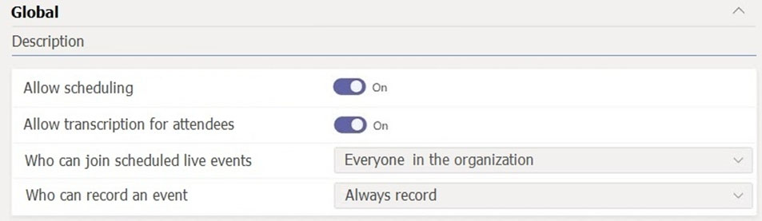
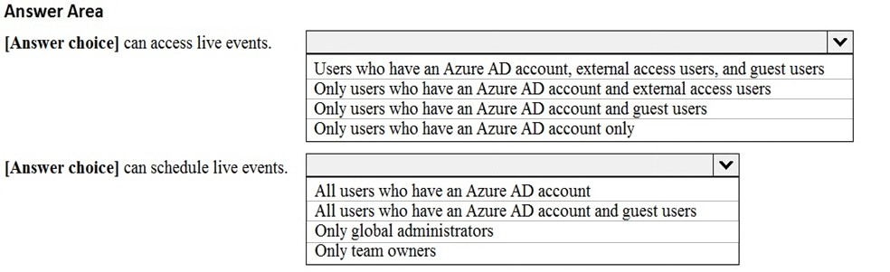
- Binh luan:
Correct.
In the live event settings the "Everyone in the organisation" also include Guest users!
"Everyone in the organization Users can create live events that people in your organization, including guest users added to your organization, can attend."
https://docs.microsoft.com/en-us/microsoftteams/teams-live-events/set-up-for-teams-live-events
A little more context:
"Everyone in the organization Users can create live events that people in your organization, including guest users added to your organization, can attend. Users can't create live events that are attended by anonymous users."
On exam 06/23
Right:
* Live Events Scheduling: Turning this on lets users in your organization create and schedule live events in Teams.
* Who can join scheduled live events: People in my organization Users can create live events that people in your organization, including guest users added to your organization, can attend.
Who can create a live event? Check out part "Who can create live events" in link below:
https://support.microsoft.com/en-us/topic/d077fec2-a058-483e-9ab5-1494afda578a
- a valid license
So given answer is correct.
- Full team membership in the org (can’t be a guest or from another org).

Cau 7
Dap an: B
Your company has a Microsoft 365 subscription.
The company has a main office in Chicago.
The company opens a new office in Toronto that has 500 users.
You need to ensure that the correct address is available to emergency responders.
What should you do?
A. Create a configuration profile and assign the profile to the device of each user.
B. Add an emergency address, and then modify the location for each phone number. ✓
C. Add an emergency address, and then modify the outbound calling setting for each user.
D. Create a calling policy and assign the policy to each user.
- Binh luan:
Adding an emergency address, and then modify the location for each phone number will do
What Maeli_144 said
In the United States, the emergency location is associated with the phone number when it's assigned to the user.
https://docs.microsoft.com/en-us/microsoftteams/assign-change-emergency-location-user
You need to ensure that the VDI solution users can use the new Microsoft Teams features.
I think this was intended for a different question. I have done that. :-)

Cau 8
Dap an: A, D
Your company has a Microsoft 365 subscription that uses Phone System and Calling Plans.
You plan to implement a toll phone number for the helpdesk.
You need to implement the following call features for the helpdesk phone number:
✑ Must include a greeting and hold music
✑ Must bypass menu options when a call is established to the helpdesk
What two resources should you create? Each correct answer presents part of the solution.
NOTE: Each correct selection is worth one point.
A. a call queue ✓
B. a call park
C. an auto attendant
D. a resource account ✓
E. a calling policy
- Binh luan:
A and D.
Auto attendant and call queue require a resource account to be associated in order to assign the phone number.
https://docs.microsoft.com/en-us/microsoftteams/create-a-phone-system-call-queue
'You don't directly associate a phone number to a call queue, instead the phone number is associated to a resource account. A call queue can be dialed directly or accessed by a selection on an auto attendant.'
Menu is only available for auto attendant, so therefore call queue does not have a menu
A&D - There is no requirement for an AutoAttendant. No menu specified.
A User calling a Toll Number (i.E. from PSTN) means a licensed Ressource Account is required that carries the phone Number and which is associated to a Call Queue.
The CQ has the features required (Greeting and music on Hold, no menu)
Resource account option is correct. But the bypass menu options is what is throwing me off. That’s pointing towards an auto attendant with an operator (help desk) configured. I do agree that help desk should be setup as a call queue, but what menu options are there in a call queue? There is no press 1 for this, press 2 for that.
So although I would set up the solution the same way, when asking for a menu, I think the answer should be resource account and auto attendant.
Reading it again “Must bypass menu options when a call is established to the helpdesk” might mean there shouldn’t be any menu options at all when calling the help desk. If that’s the intended meaning, then yes call queue and resource account is the correct answer.
A resource account is not a resource in itself...they ask for resources here...so I think it should be CQ and AA..

Cau 9
Dap an: N/A
HOTSPOT -
You have a Microsoft 365 subscription.
You need to create the call queues shown in the following table.
Which routing method should you configure for each call queue? To answer, select the appropriate options in the answer area.
NOTE: Each correct selection is worth one point.
Hot Area:
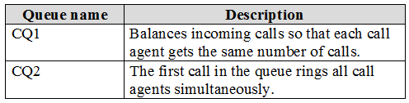
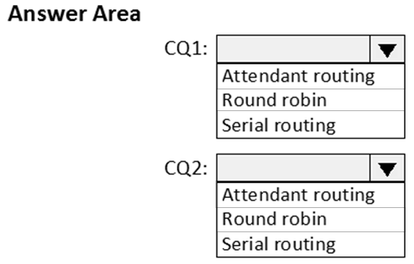
- Binh luan:
Attendant routing rings all agents in the queue at the same time. The first call agent to pick up the call gets the call.
Serial routing rings all call agents one by one in the order specified in the Call agents list. If an agent dismisses or does not pick up a call, the call will ring the next agent and will try all agents until it is picked up or times out.
Round robin balances the routing of incoming calls so that each call agent gets the same number of calls from the queue. This may be des
Answer is Correct
Attendant routing is first call in the queue rings all agents at the same time (Simultaneously)
Round robin - routing of incoming calls is balance so that each call gets the same numbers of call from the queue.

Cau 10
Dap an: D
Your company has a Microsoft 365 subscription.
You need to create an auto attendant from the Microsoft Teams admin center.
Which object must be associated to the auto attendant?
A. a conferencing bridge
B. a shared mailbox
C. a Calling Plan
D. a resource account ✓
- Binh luan:
Repeat of question 36:
https://www.examtopics.com/exams/microsoft/ms-700/view/23/
Answer is D
On Exam 28.02.22

Cau 11
Dap an: D
You plan to implement a pilot project on Phone System for 100 users.
The pilot project will use a Microsoft Calling Plan.
You need to ensure that the users can establish calls to the PSTN.
Which cmdlets should you run?
A. Set-AzureADUserLicense, Set-CSUser, and Set-AzureADUser
B. Grant-CsOnlineVoiceRoutingPolicy, Set-CsOnlineVoiceUser, and Set-CSUser
C. Set-AzureADUser, Grant-CsOnlineVoiceRoutingPolicy, and Set-CsOnlineVoiceUser
D. Set-AzureADUserLicense, Set-CsOnlineVoiceUser, and Set-CSUser ✓
- Binh luan:
Answer should be D - Calling Plans do not require a Voice Routing Policy, but an additional license:
Set-AzureADUserLicense - Used to apply PhoneSystem and Calling Plan license
Set-CsOnlineVoiceUser - Used to apply Microsoft Phone Number to the User
Set-CSUser - Enables the User for EnterpriseVoice
This man is correct! - Pilot program too, so you need to assign licenses first of course ;)
Correct is D - assign license, assign number and emergency location, enable for enterprise voice
I'm with you on this one, though the question (as is typical from Microsoft) is a little ambiguous in their awful wording. They say you need to make calls to THE PTSN, not THROUGH the PTSN so D seems to be correct.
Answer should be D with the selection provided.
But, the Set-CsOnllineVoiceUser & Set-CSUser cmdlet had been deprecated, and replaced by Set-CsPhoneNumberAssignment for phone number assignment and EV enabling.
So, this question should be updated with new PS cmdlets:
D: Set-AzureADUserLicense, Set-CsPhoneNumberAssignment

Cau 13
Dap an: B, C
Your company has a Microsoft Office 365 subscription.
Users in the company's sales department frequently invite guest users to meetings.
You need to ensure that when the sales department users invite guest users to meetings, the guest users are admitted by default. The solution must only apply to the sales department users.
Which two actions should you perform? Each correct answer presents part of the solution.
NOTE: Each correct selection is worth one point.
A. In the global meeting policy, set Automatically admit users to Everyone.
B. Create a new meeting policy and set Automatically admit users to Everyone. ✓
C. Apply the policy to the sales department users. ✓
D. In the global meeting policy, set Automatically admit users to Everyone in your organization.
- Binh luan:
CORRECT
It's too easy!
It's nice to have some easier questions in amongst the difficult ones :)
correct answer!!!

Cau 14
Dap an: N/A
HOTSPOT -
Your company has a Microsoft 365 subscription that uses Phone System.
You need to configure Microsoft Teams to meet the following requirements:
✑ Ensure that calls to the company's sales department are routed to multiple users in the sales department.
✑ Ensure that calls to the company's marketing department are routed to multiple users in the marketing department.
✑ Outside of business hours, ensure that calls from PSTN users receive a custom greeting.
✑ During business hours, ensure that calls from PSTN users can be received by the sales and marketing department users.
What is the minimum number of auto attendants and call queues you should configure to meet the requirements? To answer, select the appropriate options in the answer area.
NOTE: Each correct selection is worth one point.
Hot Area:
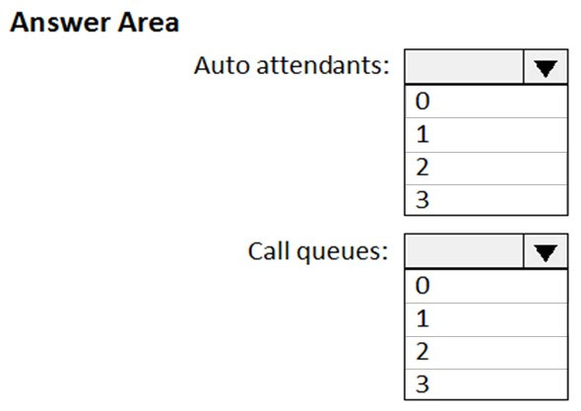
- Binh luan:
Auto attendant has time of day check. Call queues don’t. So 1 AA routes option press to 2call queues.
Minimum number of AA would be 1 and CQ 2, the AA can be configured with prompts that have the callers use DTMF to select different destinations. External callers dial the AA DID, the menu navigation provides options to press 1 for sales or press 2 for marketing.
on exam 26-Nov-2022
I can't read the reason for using the call queue.
Can you meet the requirements with a shared line?
t is 2 Queues and 1 AA. I was thinking possibly 2 AAs but you can have the single after hours message to represent the whole company so that requires only 1 AA

Cau 15
Dap an: N/A
HOTSPOT -
Your company has a Microsoft 365 subscription.
You need to configure Microsoft Teams to meet the requirements shown in the following table.
What should you configure for each requirement? To answer, select the appropriate options in the answer area.
NOTE: Each correct selection is worth one point.
Hot Area:
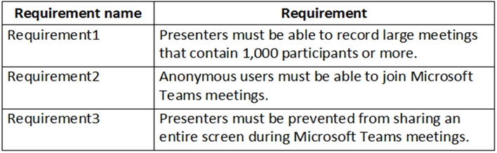
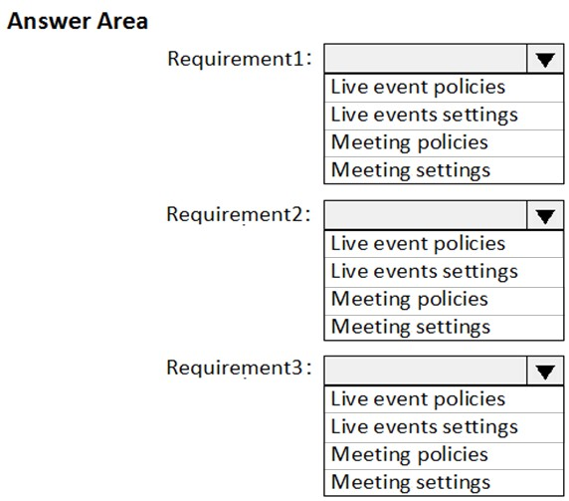
- Binh luan:
The key difference is:
Settings contain the minimum options such as Anonymous users join and app interaction, URLs, QoS, Third-party provider.
Policies contain most of the other options.
For me, it is the easiest way to remember and recognise the right way.
That is a good way to remember it! Settings are broad and general, Policies granular.
I checked too. Correct Answer
ffs... is there a point to people writing, "On the exam on 9/9/23" ???
Tell us which one you chose and why!
If you're studying and about to take the exam, it can be helpful to know that question is still being asked, since questions are rotated and some questions might be so old they no longer feature in exams currently, but that is just my take

Cau 16
Dap an: D
Your company has a Microsoft 365 subscription that contains a Microsoft Teams auto attendant.
Calls to the auto attendant will be redirected to a shared voicemail.
You need to create a group for the shared voicemail.
Which type of group should you create?
A. mail-enabled security
B. distribution
C. security
D. Microsoft 365 ✓
- Binh luan:
Correct!: Voicemail - the voice mailbox associated with a Microsoft 365 group that you specify.
https://docs.microsoft.com/en-us/microsoftteams/create-a-phone-system-auto-attendant
You can actually use more than just the M365 group. I use DL's all the time. The popup message say a Microsoft 365 group, but this is in fact false, and frankly stupid. I have yet to need a M365 Group and all the nonsense that comes with it, for delivering Voicemail. M365, Distribution Lists and Mail-enabled Security groups all work. Only Security groups don't. Essentially, if it's an group with an email address, it works.
D is correct. Microsoft 365 for sure.
On Exam 28.02.22
D - Microsoft Group: AA can redirect calls to voicemail - the voice mailbox associated with a Microsoft 365 group that you specify.

Cau 17
Dap an: N/A
HOTSPOT -
Your company has a Microsoft Office 365 subscription.
The company has offices in France, United States, and Belgium.
You plan to implement Phone System to meet the following requirements:
✑ The office in Belgium must use SIP trunks from the current telecommunication provider.
✑ The office in France must integrate the phone number range and an on-premises IP-PBX.
✑ The office in the United States must minimize the infrastructure required to deploy the planned Phone System.
You need to recommend which PSTN connectivity meets the requirements.
Which PSTN connectivity should you recommend for each office? To answer, select the appropriate options in the answer area.
NOTE: Each correct selection is worth one point.
Hot Area:
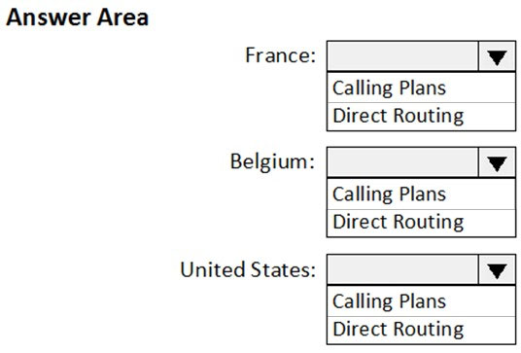
- Binh luan:
Answer is correct:
Direct Routing
Direct Routing
Calling Plans.
Nowadays there is the new feature 'Operator Connect', where a 3rd party SIP provider can deliver your PSTN connectivity, instead of having to buy this from Microsoft directly. So Belgium could use that. It's not an option in the answers though :-)
Yes this is true definitely good point.
...explained here:
https://docs.microsoft.com/en-us/microsoftteams/pstn-connectivity
Microsoft calling plans: Quickly procure and assign phone numbers or port existing phone numbers. Available in 18 countries.
Direct Routing: Use your existing telecommunications providers by directly connecting their Session Initiation Protocol (SIP) trunks to Microsoft Teams.

Cau 18
Dap an: B
Your company has a Microsoft 365 subscription.
A user invites an external user to join a Microsoft Teams meeting by using a Microsoft Outlook meeting invitation.
The external user cannot join the meeting.
You need to ensure that all external users can join Microsoft Team meetings.
What should you do from the Microsoft Teams admin center?
A. From Guest access in the Org-wide settings, set Allow guest access in Microsoft Teams to On.
B. Edit the Meeting settings and set Anonymous users can join a meeting to On. ✓
C. Edit the global meeting policy and set Allow scheduling private meetings to On.
D. Edit the live events policy and set Who can join live events to Everyone.
- Binh luan:
Ans is B : Go to the Meeting Settings Policy. This question came in the recent exam
B:Correct
A : allows the user access in teams , the question is limited to allowing user to join a teams meeting
c: irrelevant
d. there is no such setting in that menu
Go to the Meeting Settings Policy.
Correct answer is A, although org-wide settings as such does not exist anymore. Its under guest access now. This has to be set to On. Otherwise no external user can join whatever, even when the "anonymus users can join a meeting" is set to On. Besides: this is not an anonymus user, since the one is invited by email.
Second part of answer is correct and definitely HR
" The MailNickName parameter specifies the alias for the associated Office 365 Group. This value will be used for the mail enabled object and will be used as PrimarySmtpAddress for this Office 365 Group"
As per:
https://docs.microsoft.com/en-us/powershell/module/teams/new-team?view=teams-ps

Cau 19
Dap an: N/A
HOTSPOT -
Your company has a Microsoft 365 subscription that uses Phone System.
You need to configure the environment to meet the following requirements:
✑ Only users in the company's sales department must have Call forwarding and simultaneous ringing to external phone numbers set to Off.
✑ Only users in the marketing department must have Inbound calls can be routed to call groups set to Off.
✑ All outbound calls to the PSTN must use the auto attendant number as the caller ID.
What is the minimum number of policies that should be created? To answer, select the appropriate options in the answer area.
NOTE: Each correct selection is worth one point.
Hot Area:
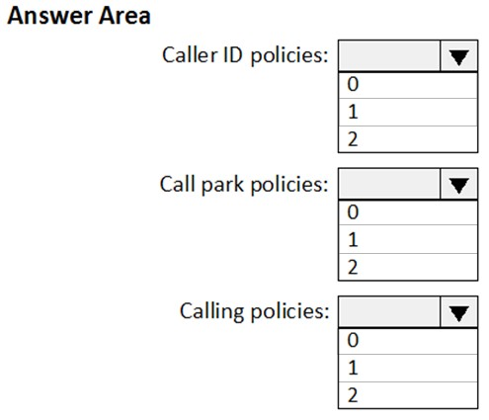
- Binh luan:
No need to create a new Caller ID Policy. Global (already existing) policy can be changed to provide Auto Attendant service number for outgoing calls. I think correct answer is 0,0,2.
Maybe one can say a policy is still required when you edit the global policy to 1 caller ID policy would be required in that sense.
Agree, Global Caller ID is required to change. The important word in question is "created". Global CallerID already exists.
Fair enough, but org-wide policies should be intact (ideally)
As industry best practices, create a custom policy to override an existing default global policy rather than editing or modifying the defaults. Exception is if the condition applies to everyone in the organization.

Cau 20
Dap an: B, E
Your company has a Microsoft 365 subscription.
A user named User5 cannot establish call from Microsoft Teams.
You review the Microsoft Teams client for User5 and discover that the dial pad is unavailable.
Other users at the company can establish calls successfully.
You need to ensure that User5 can establish calls.
Which two actions should you perform? Each correct answer represents part of the solution.
NOTE: Each correct selection is worth one point.
A. Modify the caller ID properties of User5.
B. Assign a Phone System license to User5. ✓
C. Assign a SIP address to User5.
D. Assign an app setup policy to User5.
E. Enable User5 for Enterprise Voice. ✓
- Binh luan:
Assign Phone System License and Enable user for Enterprise Voice
B and E is the solution here
B and E is the correct answer.
B & E are the correct answers
E should be automatically done when assigned the phone system license

Cau 21
Dap an: B
Your company has a Microsoft 365 subscription.
You need to customize meeting invitation emails to include the company logo.
What should you do in the Microsoft Teams admin center?
A. From Teams settings, modify the Email integration settings.
B. From Meeting settings, modify the Email invitation settings. ✓
C. From Meeting policies, create a new meeting policy and assign the policy.
D. From Meeting policies, modify the Global (Org-wide default) policy.
- Binh luan:
Correct. TAC -> Meetings -> Meeting settings -> Email invitation section.
Correct
correct

Cau 23
Dap an: A
You have a Microsoft 365 E5 subscription that contains a user named User1.
You need to change the default conferencing toll phone number for User1 by using the Microsoft Teams admin center.
What should you modify for User1?
A. the Account settings ✓
B. Calling policy
C. the Voice settings
D. Meeting policy
- Binh luan:
TAC--> Users --> Manage Users --> Audio Conference --> Default Conference toll-free phone number
Agreed
this one looks correct:
"In the Audio Conferencing pane, you can set the Toll number and, if allowed, the Toll-free number."
https://docs.microsoft.com/en-us/microsoftteams/manage-the-audio-conferencing-settings-for-my-organization-in-teams#set-the-phone-numbers-included-on-invites

Cau 24
Dap an: N/A
HOTSPOT -
You have a Microsoft 365 E5 subscription.
You plan to enable Phone System for Microsoft Teams.
You need to configure the following:
✑ On-hold music
✑ A greeting message
✑ Call forwarding and simultaneous ringing to external phone numbers
Which two settings should you configure? To answer, select the appropriate settings in the answer area.
NOTE: Each correct selection is worth one point
Hot Area:
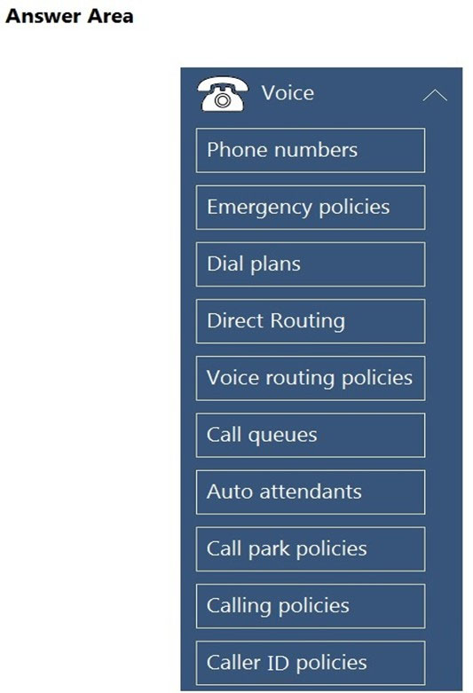
- Binh luan:
100% -- Call Queues and Call Policies
Auto Attendants allow you to set up a greeting message and configure call handling options, including call forwarding. You can define the behavior of calls, including forwarding and ringing settings.
Calling Policies control the calling features and behavior for users. Within the Calling Policies, you can configure settings related to simultaneous ringing to external phone numbers. This setting is usually controlled in the "Simultaneous Ringing" or similar section of the Calling Policy.....
also Auto Attendants, allows you to play a greeting message for incoming calls and route them based on various options, including playing on-hold music and forwarding calls to external phone numbers. It covers both the greeting and on-hold music needs.
sorry i meant calling policy here.
Agree as well

Cau 25
Dap an: N/A
HOTSPOT -
Your company has a Microsoft Office 365 subscription.
The assigned licenses are shown in the Licenses exhibit. (Click the Licenses tab.)
The available phone numbers are shown in the Phone numbers exhibit. (Click the Phone Numbers tab.)
For each of the following statements, select Yes if the statement is true. Otherwise, select No.
NOTE: Each correct selection is worth one point.
Hot Area:
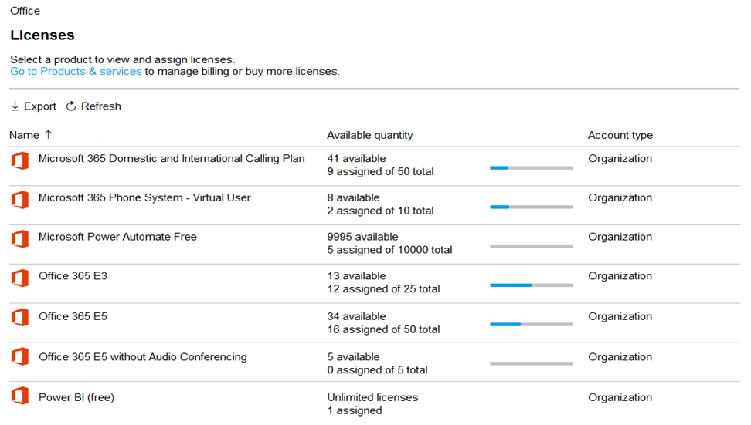
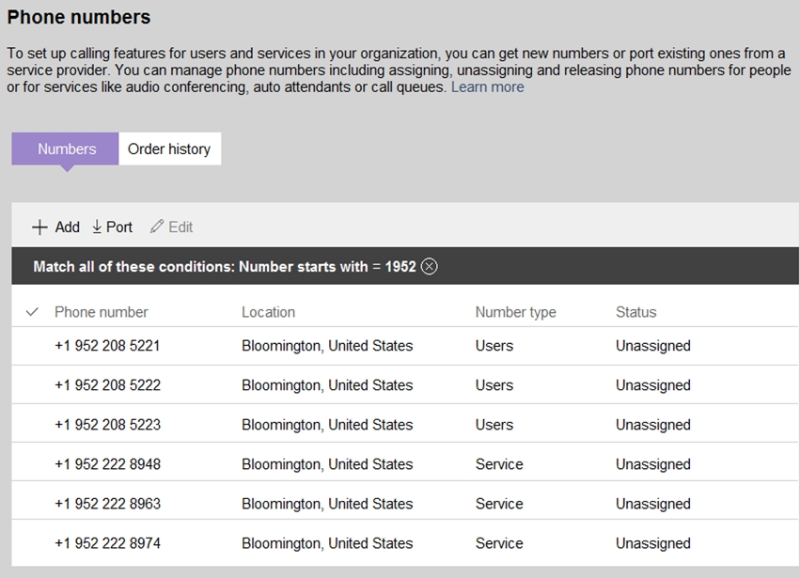
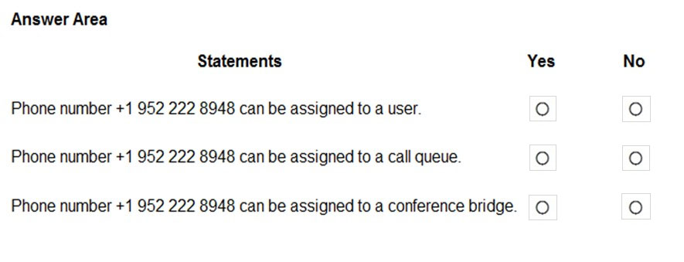
- Binh luan:
Technically you cannot assign number directly to call queue. You have to assign number to resource account and then add resource account to the call queue.
On Exam 28.02.22
Correct

Cau 26
Dap an: A, E
You have a Microsoft 365 subscription that contains two users named User1 and User2. The users are provisioned for Microsoft Teams calling.
User1 is on leave for two weeks.
You need to ensure that User2 is notified of all calls to User1 while User1 is away.
Which two actions should you perform? Each correct answer presents part of the solution.
NOTE: Each correct selection is worth one point.
A. From Voice, add User2 to group call pickup. ✓
B. From Voice, add User1 to group call pickup.
C. From Policies, modify the voice routing policy.
D. From the Microsoft Teams admin center, modify the settings of User2.
E. From the Microsoft Teams admin center, modify the settings of User1. ✓
- Binh luan:
Think of this as doing E then A
Nowadays only change of settings of User1 is required in Teams Admin Center. Configure within menu "Voice" that a call is immediately is being forward to User 2. While specifying the "Call forward type" to "Forward to a person", you can choose "Group call pickup" as well. However, a Group call pickup is ot required.
Why wouldn't you just set the voice call settings for user1 to forward to user2? Why create a group?
A we are perfectly agree, we need to be sure that User2 is memeber of the group of User1.
But for the rest I don't know Because, Yes you can modify User1 ... But in anycase, he is not available so Routing we don't car, it's not gonna call User1. End he comes back after 2 weeks ... So I don't really see the gain there?
I Agree with the answer

Cau 27
Dap an: B, E
You have a Microsoft 365 E5 subscription that has Phone System enabled for all Microsoft Teams users.
You need to configure the Phone System to meet the following requirements:
✑ Provide a virtual receptionist that connects callers to either a specific user or the help desk.
✑ Route calls to the help desk on a First in, First out (FIFO) order.
Which two resources should you create? Each correct answer presents part of the solution.
NOTE: Each correct selection is worth one point.
A. a call park policy
B. a call queue ✓
C. a voice routing policy
D. a group call pickup
E. an auto attendant ✓
F. a calling policy
- Binh luan:
answers are correct!
agree too
I’m agree , BE

Cau 29
Dap an: N/A
HOTSPOT -
You have a Microsoft 365 subscription that uses Microsoft Teams.
You need to meet the following requirements:
✑ Users must be able to join meetings by dialing a phone number.
✑ Users must be able to apply custom branded meeting lobbies.
✑ Auto attendants and call queues must be implemented.
Which Microsoft Teams feature should you configure for each requirement? To answer, select the appropriate options in the answer area.
NOTE: Each correct selection is worth one point.
Hot Area:
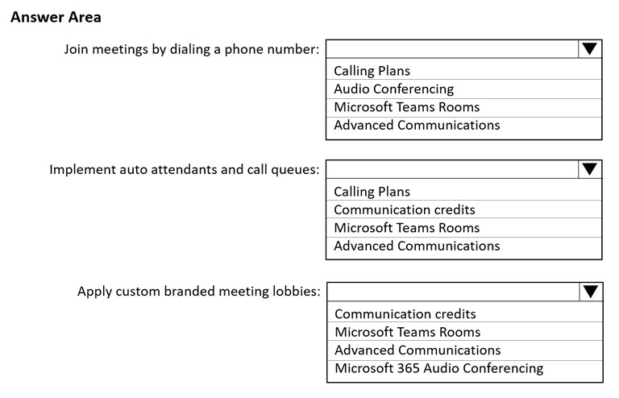
- Binh luan:
answer is correct:
1. To join meetings by dialing a phone number will be handled by audio conferencing
2. To have an auto attendant or call queue, we need min. 1 phone number, which is handled by calling plans
3. custom branded meeting lobbies are handled by an additional add-on, which must b e extra licensed -> advanced communication
on exam 27jan
On Exam 28.02.22

Cau 30
Dap an: N/A
DRAG DROP -
Your company has a Microsoft 365 subscription that uses Microsoft Teams.
The company has a team named Customer Support.
Guest users from outside the company regularly access the Customer Support team.
You need to configure the Guest access settings to meet the following requirements:
✑ Guest users must be able to view only a single application during screen sharing sessions.
✑ Guest users must be prevented from creating channels in Customer Support.
✑ Guest users must be admitted to meetings manually.
Which settings should you configure for each requirement? To answer, drag the appropriate settings to the correct requirements. Each setting may be used once, more than once, or not at all. You may need to drag the split bar between panes or scroll to view content.
Select and Place:
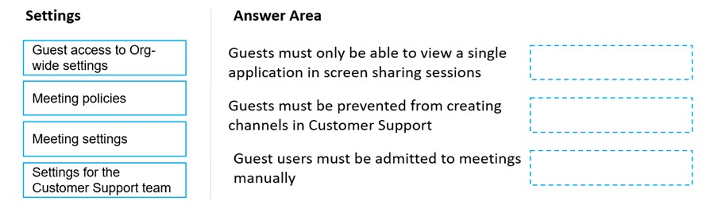
- Binh luan:
as of current date the correct answer is
Meeting Policies
Settings from customer support team
Meeting Policies
Should be guest access in org wide settings. It has now moved to users, guest access, screen sharing mode, single application.
yes its moved there
First should be MEETING POLICIY as there is no option to specify which user can see what on screen, we can only specify what the presenter can present on screen (entire screen, single application, no enabled).
Rest are correct
the first one should be meeting policies, because you can change what guest can view, only what your users are presenting to them.
The setting in guest access only controls how the guest users share their screen.

Cau 31
Dap an: C, D
You have a Microsoft 365 subscription that uses Microsoft Teams and contains a user named User1.
Microsoft Teams has a default conferencing toll phone number of +1 234 567-8910. The default number is assigned to User1.
You need to change the conferencing toll phone number assigned to User1. The solution must meet the following requirements:
• Update the existing meeting invites of User1 to use the new conferencing toll phone number.
• Ensure that other users in your company continue to use the default number.
Which two actions should you perform? Each correct answer presents part of the solution.
NOTE: Each correct selection is worth one point.
A. From PowerShell, run the Update-csTenantMeetingUrl cmdlet.
B. From the Azure Active Directory admin center, modify the Usage location of User1.
C. From the Microsoft Teams admin center, modify the Users settings of User1. ✓
D. From PowerShell, run the Start-CsEXMeetingMigration cmdlet. ✓
E. From the Microsoft Teams admin center, modify the default Bridge settings.
- Binh luan:
You are only updating one user, so wouldn't you update User1 account settings and run the update meeting cmd?

Cau 32
Dap an: N/A
SIMULATION
-
Please wait while the virtual machine loads. Once loaded, you may proceed to the lab section. This may take a few minutes, and the wait time will not be deducted from your overall test time.
When the Next button is available, click it to access the lab section. In this section, you will perform a set of tasks in a live environment. While most functionality will be available to you as it would be in a live environment, some functionality (e.g. copy and paste, ability to navigate to external websites) will not be possible by design.
Scoring is based on the outcome of performing the tasks stated in the lab. In other words, it doesn’t matter how you accomplish the task, if you successfully perform it, you will earn credit for that task.
Labs are not timed separately, and this exam may have more than one lab that you must complete. You can use as much time as you would like to complete each lab. But you should manage your time appropriately to ensure that you are able to complete the lab(s) and all other sections of the exam in the time provided.
Please not that once you submit your work by clicking the Next button within a lab, you will NOT be able to return to the lab.
You may now click next to proceed to the lab.
Username and password.
Use the following login credentials as needed:
To enter your username, place your cursor in the Sign in box and click on the username below.
To enter your password, place your cursor in the Enter password box and click on the password below.
Microsoft 365 Username:
admin@XXXXXXXXXXX.onmicrosoft.com
Microsoft 365 Password: XXXXXXXXXXXX
If the Microsoft 365 portal does not load successfully in the browser, press CTRL-K to reload the portal in a new browser tab.
The following information is for technical support purposes only:
Lab Instance: 26178313
-
Task 1
-
Your company is opening a branch office in Miami. The office uses a network range of 10.10.10.0/24.
You need to restrict Teams bandwidth to 1,000 Kbps for all the users working at the Miami office. The solution must NOT affect other offices.
To complete this task, sign in to the Microsoft 365 portal.
- Binh luan:
The question is not asking about just meeting, its should be bandwidth for all voice-related traffic.
1. TAC > Locations > Network Topology > Roaming Policies tab > Add > Create Roaming policy: set Media bit rate (Kbs): 1000. 2. Network Sites tab > Add > Network Roaming policy: select the policy that you created in step 1, add Subnets: 10.10.10.0/24 of Miami office.
Refer this section in following link: CONFIGURATION OF NETWORK ROAMING BANDWIDTH POLICY
https://www.myteamslab.com/2023/03/microsoft-teams-location-based.html#:~:text=Microsoft%20Teams%20Location%20Based%20Bandwidth%20Control%20(Network%20Roaming%20Policy),-Posted%20by%20James&text=Microsoft%20Teams%20now%20has%20the,feature%20called%20Network%20Roaming%20Policy.
The solutions is confusing. I cannot find anything about roaming in Meeting policies.
How many of lab questions usually shows up in the test

Cau 33
Dap an: N/A
SIMULATION
-
Please wait while the virtual machine loads. Once loaded, you may proceed to the lab section. This may take a few minutes, and the wait time will not be deducted from your overall test time.
When the Next button is available, click it to access the lab section. In this section, you will perform a set of tasks in a live environment. While most functionality will be available to you as it would be in a live environment, some functionality (e.g. copy and paste, ability to navigate to external websites) will not be possible by design.
Scoring is based on the outcome of performing the tasks stated in the lab. In other words, it doesn’t matter how you accomplish the task, if you successfully perform it, you will earn credit for that task.
Labs are not timed separately, and this exam may have more than one lab that you must complete. You can use as much time as you would like to complete each lab. But you should manage your time appropriately to ensure that you are able to complete the lab(s) and all other sections of the exam in the time provided.
Please not that once you submit your work by clicking the Next button within a lab, you will NOT be able to return to the lab.
You may now click next to proceed to the lab.
Username and password.
Use the following login credentials as needed:
To enter your username, place your cursor in the Sign in box and click on the username below.
To enter your password, place your cursor in the Enter password box and click on the password below.
Microsoft 365 Username:
admin@XXXXXXXXXXX.onmicrosoft.com
Microsoft 365 Password: XXXXXXXXXXXX
If the Microsoft 365 portal does not load successfully in the browser, press CTRL-K to reload the portal in a new browser tab.
The following information is for technical support purposes only:
Lab Instance: 26178313
-
Task 2
-
You need to configure only the Teams meeting invites of Allan Deyoung to first show a dial-in bridge number in Toronto, and then show a dial-in bridge number in Paris in the body of his invites.
To complete this task, sign in to the Microsoft 365 portal.
- Binh luan:
Create an Audio conferencing Policy with Toronto Rank 1 and Paris Rank 2 in the Numbers.
Assign the Policy to Allan Deyoung
This does not seem to work now

Cau 34
Dap an: N/A
SIMULATION
-
Please wait while the virtual machine loads. Once loaded, you may proceed to the lab section. This may take a few minutes, and the wait time will not be deducted from your overall test time.
When the Next button is available, click it to access the lab section. In this section, you will perform a set of tasks in a live environment. While most functionality will be available to you as it would be in a live environment, some functionality (e.g. copy and paste, ability to navigate to external websites) will not be possible by design.
Scoring is based on the outcome of performing the tasks stated in the lab. In other words, it doesn’t matter how you accomplish the task, if you successfully perform it, you will earn credit for that task.
Labs are not timed separately, and this exam may have more than one lab that you must complete. You can use as much time as you would like to complete each lab. But you should manage your time appropriately to ensure that you are able to complete the lab(s) and all other sections of the exam in the time provided.
Please not that once you submit your work by clicking the Next button within a lab, you will NOT be able to return to the lab.
You may now click next to proceed to the lab.
Username and password.
Use the following login credentials as needed:
To enter your username, place your cursor in the Sign in box and click on the username below.
To enter your password, place your cursor in the Enter password box and click on the password below.
Microsoft 365 Username:
admin@XXXXXXXXXXX.onmicrosoft.com
Microsoft 365 Password: XXXXXXXXXXXX
If the Microsoft 365 portal does not load successfully in the browser, press CTRL-K to reload the portal in a new browser tab.
The following information is for technical support purposes only:
Lab Instance: 26178313
-
Task 4
-
You need to add the following disclaimer as part of all Teams meeting invites:
“Disclaimer: This meeting may be recorded for quality and training purposes.”
To complete this task, sign in to the Microsoft 365 portal.

Cau 36
Dap an: N/A
SIMULATION
-
Please wait while the virtual machine loads. Once loaded, you may proceed to the lab section. This may take a few minutes, and the wait time will not be deducted from your overall test time.
When the Next button is available, click it to access the lab section. In this section, you will perform a set of tasks in a live environment. While most functionality will be available to you as it would be in a live environment, some functionality (e.g. copy and paste, ability to navigate to external websites) will not be possible by design.
Scoring is based on the outcome of performing the tasks stated in the lab. In other words, it doesn’t matter how you accomplish the task, if you successfully perform it, you will earn credit for that task.
Labs are not timed separately, and this exam may have more than one lab that you must complete. You can use as much time as you would like to complete each lab. But you should manage your time appropriately to ensure that you are able to complete the lab(s) and all other sections of the exam in the time provided.
Please not that once you submit your work by clicking the Next button within a lab, you will NOT be able to return to the lab.
You may now click next to proceed to the lab.
Username and password.
Use the following login credentials as needed:
To enter your username, place your cursor in the Sign in box and click on the username below.
To enter your password, place your cursor in the Enter password box and click on the password below.
Microsoft 365 Username:
admin@XXXXXXXXXXX.onmicrosoft.com
Microsoft 365 Password: XXXXXXXXXXXX
If the Microsoft 365 portal does not load successfully in the browser, press CTRL-K to reload the portal in a new browser tab.
The following information is for technical support purposes only:
Lab Instance: 26178313
-
Task 6
-
You need to configure a virtual receptionist for your company’s main office located at 1 Microsoft Way, Redmond. The solution must meet the following requirements:
• Callers must press 1 for the company directory to lookup by name.
• Callers must press 0 to hear the company address.
• Callers must be offered the same menu at all times.
To complete this task, sign in to the Microsoft 365 portal.
- Binh luan:
step 3 and 4 is exactly the same?
step 5 is not possible, there is no option to select Directory Search as "Redirect To" for a dial key.
This is a feature and you just enable this feature and then select option "Dial by Name".

Cau 37
Dap an: N/A
SIMULATION
-
Please wait while the virtual machine loads. Once loaded, you may proceed to the lab section. This may take a few minutes, and the wait time will not be deducted from your overall test time.
When the Next button is available, click it to access the lab section. In this section, you will perform a set of tasks in a live environment. While most functionality will be available to you as it would be in a live environment, some functionality (e.g. copy and paste, ability to navigate to external websites) will not be possible by design.
Scoring is based on the outcome of performing the tasks stated in the lab. In other words, it doesn’t matter how you accomplish the task, if you successfully perform it, you will earn credit for that task.
Labs are not timed separately, and this exam may have more than one lab that you must complete. You can use as much time as you would like to complete each lab. But you should manage your time appropriately to ensure that you are able to complete the lab(s) and all other sections of the exam in the time provided.
Please not that once you submit your work by clicking the Next button within a lab, you will NOT be able to return to the lab.
You may now click next to proceed to the lab.
Username and password.
Use the following login credentials as needed:
To enter your username, place your cursor in the Sign in box and click on the username below.
To enter your password, place your cursor in the Enter password box and click on the password below.
Microsoft 365 Username:
admin@XXXXXXXXXXX.onmicrosoft.com
Microsoft 365 Password: XXXXXXXXXXXX
If the Microsoft 365 portal does not load successfully in the browser, press CTRL-K to reload the portal in a new browser tab.
The following information is for technical support purposes only:
Lab Instance: 26178313
-
Task 7
-
You need to acquire a dedicated Microsoft dial-in bridge number from either 431 or 343 area codes in Canada.
To complete this task, sign in to the Microsoft 365 portal.
- Binh luan:
To acquire a dedicated Microsoft dial-in bridge number from either the 431 or 343 area codes in Canada, you can follow these steps:
• Log in to your Microsoft Teams admin center.
• Click on "Voice" from the left-hand menu, then click on "Phone numbers."
• Click on "Add" to add a new phone number.
• Select "Canada" as the country/region, Number type as Dedicated conference Bridge(toll) and then choose either the 431 or 343 area code.
• Choose "Microsoft" as a operator
• Enter the number of phone
https://learn.microsoft.com/en-us/microsoftteams/change-the-settings-for-an-audio-conferencing-bridge
Question Vague..when you say acquire phone numbers it means ordering a phone number that can be used for the conference bridge..

Cau 38
Dap an: N/A
HOTSPOT
-
You have a Microsoft 365 subscription that uses Microsoft Teams.
You need to create the resource accounts shown in the following table.
Which resource accounts require licenses, and which type of license is required? To answer, select the appropriate options in the answer area.
NOTE: Each correct selection is worth one point.
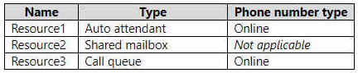
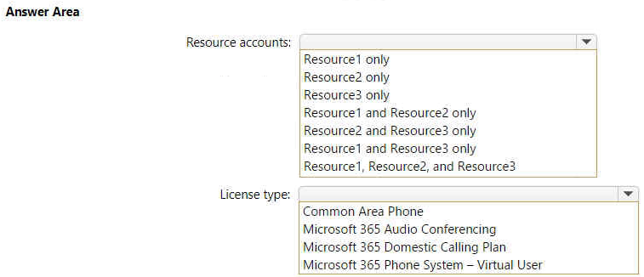
- Binh luan:
Resource1 and Resource3 only
Microsoft 365 Phone System - Virtual User
https://learn.microsoft.com/en-us/microsoftteams/teams-add-on-licensing/virtual-user
Previously, a Teams Phone Resource Account license (once known as a Virtual user license) was only required when assigning a phone number to a resource account. Now, all resource accounts must be assigned a Teams Phone Resource Account license, regardless of whether they'll be assigned a phone number or not.
Resource accounts that require licenses:
Resource 1 only (Auto attendant)
Resource 3 only (Call queue online)
Type of license required:
Microsoft 365 Phone System - Virtual User
For both CQs and AAs, you need to use a virtual user license to assign to the resource account
Resource1 and Resource3 only
Microsoft 365 Phone System – Virtual User
Resource 1 (AA) and Resource 3 (CQ) each need a Microsoft Teams Phone Resource Account license

Cau 39
Dap an: N/A
HOTSPOT
-
You have a Microsoft 365 subscription that uses Microsoft Teams.
You need to configure Microsoft Teams to meet the following requirements:
• Enable live transcription for meetings.
• Require that users record their name when they connect to a meeting by using a conferencing phone number.
What should you configure for each requirement? To answer, select the appropriate options in the answer area.
NOTE: Each correct selection is worth one point.
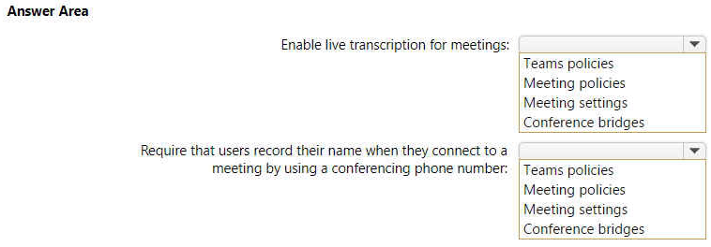
- Binh luan:
Live transcription:
https://answers.microsoft.com/en-us/msteams/forum/all/how-do-you-enable-transcribing-on-microsoft-teams/b99e3a80-e54d-4a82-9f6a-af200317a0d9
Record name:
https://learn.microsoft.com/en-us/microsoftteams/enable-users-to-record-their-name-when-they-join-a-meeting-in-teams
Correct Answer
Meeting policies > enable live transcriptions during meeting
Conference Bridges > Record names while joining a meeting

Cau 41
Dap an: B
You have a Microsoft 365 subscription that contains 300 users.
All the users have existing direct inward dial (DID) phone numbers.
You plan to implement Phone System in Microsoft Teams.
You need to migrate the users' DID phone numbers to Microsoft Teams.
What should you do?
A. From Voice in the Microsoft Teams admin center, select Phone numbers, and then select Add.
B. From the Microsoft Teams admin center, run the porting wizard. ✓
C. From the Microsoft Teams admin center, create a dial plan.
D. From the Microsoft 365 admin center, open a service request.
- Binh luan:
Love the wizard
Correct
https://learn.microsoft.com/en-us/microsoftteams/phone-number-calling-plans/transfer-phone-numbers-to-teams
Yes, you have to port the number

Cau 42
Dap an: B
Your network contains an Active Directory domain. The domain contains 1,000 computers that run Windows 11.
Your company uses Microsoft Teams.
You need to ensure that the computers can prioritize audio and video during Teams meetings.
From the Microsoft Teams admin center, you set Insert Quality of Service (QoS) markers for real-time media traffic to On.
What should you do next?
A. From Meeting settings in the Microsoft Teams admin center, configure the media port range to use any available ports.
B. From Group Policy Management, create a Group Policy setting to specify the DSCP values. ✓
C. From the Teams PowerShell module, create a network roaming policy.
D. From Meeting policies in the Microsoft Teams admin center, configure the Media bit rate (Kbs) setting.
- Binh luan:
Option B
https://learn.microsoft.com/en-us/microsoftteams/qos-in-teams
"Using port-based tagging, your network's router examines an incoming packet, and if the packet arrived using a certain port or range of ports, it identifies it as a certain media type and puts it in the queue for that type, adding a predetermined DSCP mark to the IP Packet header so other devices can recognize its traffic type and give it priority in their queue."
On exam 31/03/2023
B. In Group Policy Management, create a Group Policy setting to specify DSCP values.
By setting the Insert Quality of Service (QoS) markers for real-time media traffic as Enabled in the Microsoft Teams admin center, you allow Teams to automatically assign audio and video data packets with a Differentiated Services Code Point (DSCP) value. To ensure that computers prioritize real-time media traffic, you will need to create a Group Policy setting to specify the DSCP values. Thi
ChatGPT agrees with answer B
The answer has to be "B".
"A" states: "configure the media port range to use any available ports."
You don't want to configure it for any available ports...
In my opinion it should be A, as after activating QoS, we must select the port ranges for each real traffic in Meeting Settings (it automatically creates the related GPO).
Actually to check it’s working, firstly check that the GPO’s are crated, and then run the Network Monitor to ensure the ports are properly used.
Don’t need toncreate the GPO’s manually!

Cau 44
Dap an: N/A
HOTSPOT
-
Your company uses Microsoft Teams.
You have a meeting policy named Policy1 that is assigned to a group named Sales.
You need to ensure that all the meetings recorded by the Sales group are stored indefinitely.
How should you complete the PowerShell cmdlet? To answer, select the appropriate options in the answer area.
NOTE: Each correct selection is worth one point.
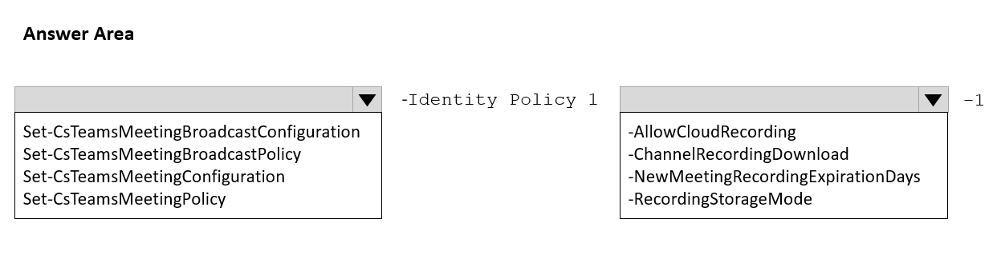
- Binh luan:
On test 01/26/2023
Answer is Correct.
Set-CsTeamsMeetingPolicy -Identity Policy1 -NewMeetingRecordingExpirationDays -1
https://learn.microsoft.com/en-us/powershell/module/skype/set-csteamsmeetingpolicy?view=skype-ps
-NewMeetingRecordingExpirationDays
Specifies the number of days before meeting recordings will expire and move to the recycle bin. Value can be from 1 to 99,999 days. Value can also be -1 to set meeting recordings to never expire.

Cau 45
Dap an: D
In the Microsoft Teams admin center, you attempt to add an emergency address as shown in the following exhibit.
You need to validate the address.
What should you do?
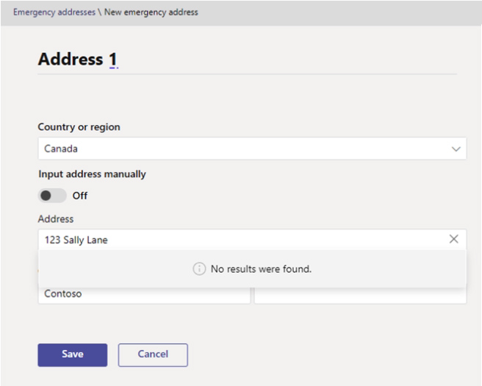
A. Provide the Emergency Location Identification Number (ELIN) associated with the emergency address.
B. Create an emergency call routing policy.
C. Create an emergency calling policy.
D. Specify the latitude and longitude of the location. ✓
- Binh luan:
Address Validation: To ensure accurate emergency response, Microsoft Teams requires precise location information.
Latitude and Longitude: These coordinates provide the most accurate way to pinpoint a location on the map, enabling emergency services to locate callers quickly and efficiently.
Steps to Validate an Emergency Address:
Access the Microsoft Teams admin center.
Navigate to Locations > Emergency addresses.
Click Add to create a new address.
Enter the address details, including street ad
Makes sense

Cau 46
Dap an: C
Your company uses Microsoft Teams.
The company has 10 corporate images.
You want to provide the images to users as custom backgrounds for Teams meetings.
You need to make the backgrounds available to Teams users.
What should you configure?
A. Teams settings
B. Meeting settings
C. Meeting policies ✓
D. Team templates
- Binh luan:
This setting is only available with Teams Premium. And in the current version, it under
Meetings-->Customization Policies.
B. Meeting settings
In the Microsoft Teams admin center, under Meetings > Meeting settings, there is a "Meeting customization" section where administrators can:
Upload custom background images for the organization
Make corporate branded backgrounds available to all Teams users
This is the tenant-wide location where you upload and manage organizational background images
it needs teams premium licence.
Answer: C
https://learn.microsoft.com/en-us/microsoftteams/custom-meeting-backgrounds
Es correcto, pero dentro de Políticas de reuniones, seleccionas Personalizar imágenes de reuniones, pero sólo se puede realizar la acción con Teams premium.

Cau 47
Dap an: D
Your company uses Microsoft Teams.
You need to configure an auto attendant that will use a Direct Routing phone number to receive incoming calls.
Which type of license do you require?
A. Microsoft 365 E3
B. Microsoft 365 Business Standard
C. the Advanced Communications add-on for Teams
D. Microsoft 365 Phone System - Virtual User ✓
- Binh luan:
Correct.
Auto Attendants and Call Queues that need a DID number assigned to it require a free Microsoft 365 Phone System - Virtual User license.
https://sbcconnect.com.au/pages/license-Requirements.html#:~:text=Auto%20Attendants%20and%20Call%20Queues%20that%20need%20a%20DID%20number,Phone%20System%20%2D%20Virtual%20User%20license.

Cau 48
Dap an: D
Your company uses Teams.
You plan to assign an enhanced encryption policy to enable end-to-end encryption for Teams calls.
Which features support end-to-end encryption for one-to-one Teams calls?
A. audio only
B. video only
C. chat only
D. audio and video only ✓
E. audio, video, and chat
- Binh luan:
During an end-to-end encrypted call, Teams secures the following features:
Audio
Video
Screen sharing
https://learn.microsoft.com/en-us/microsoftteams/teams-end-to-end-encryption

Cau 49
Dap an: A
You have a Microsoft 365 E5 subscription that includes a user named User1.
You need to assign User1 permissions to troubleshoot call analytics issues by using basic tools. Your solution must follow the principle of least privilege.
Which role should you assign to User1?
A. Teams communication support specialist ✓
B. Teams communication support engineer
C. Teams Administrator
D. Teams communication admin
- Binh luan:
Answer is correct.
Teams Communications Support Engineer: Troubleshoot communications issues within Teams by using advanced tools.
Teams Communications Support Specialist: Troubleshoot communications issues within Teams by using basic tools.
https://learn.microsoft.com/en-us/microsoftteams/using-admin-roles
correct

Cau 50
Dap an: D
Your company uses Teams.
A user reports that when they manually decline a Teams call, the call is NOT sent to their Teams voicemail.
Which setting should you configure?
A. Busy on busy when in a call
B. Manage delegates
C. Forward my calls
D. Calls ring me ✓
- Binh luan:
The "Calls ring me" option was part of older Teams settings, but in newer versions, Microsoft has changed the wording. Instead of "Calls ring me," you now have settings under Call handling and forwarding that control how calls behave.
Also,
Busy on busy during calls lets you configure how incoming calls are handled when a user is already in a call or conference or has a call placed on hold. New or incoming calls can be rejected with a busy signal or can be routed accordingly to the user's unans
To ensure that a manually declined Teams call is sent to the user's Teams voicemail, you need to configure the "Forward my calls" setting. This setting allows you to specify where calls should be forwarded when they are not answered, including sending them directly to voicemail.
Correct Answer:
C. Forward my calls
It must be Answer: D because Answer: A is only for users how are already in a call, the question was only for manuall desicions
Call me Ring.
By default in the Calling policies "Voicemail for Inbound calls" "Busy and Busy..." are set in "Let user decide"
So for redirect to Voicemail, you must using "Calls ring me" settings in Teams Client's Settings
i think your right... because it says when "they manually decline a Teams call" The default setting of the calling policy is Let users decide... one of those vague MS questions. Both are technically right, but you have to make so many assumptions

Cau 51
Dap an: B, D
Your company uses Teams.
You plan to deploy Teams to a branch office that has limited bandwidth.
Which two features can be used when the Teams client has a bandwidth restriction of 150 kilobit/s up and 150 kilobit/s down? Each correct answer presents a complete solution.
NOTE: Each correct selection is worth one point.
A. one-to-one screen sharing
B. one-to-one video ✓
C. screen sharing during meetings
D. audio during meetings ✓
E. video during meetings
- Binh luan:
https://learn.microsoft.com/en-us/microsoftteams/prepare-network#bandwidth-requirements
One to One video has a min requirement of 150 kilobit up/down
Audio meeting has a min requirement of 10 kilobit up/down
Screen shared during meeting: 250/250
Selected Answer: BD
https://learn.microsoft.com/en-us/microsoftteams/prepare-network#bandwidth-requirements
one-to-one screen sharing: 200/200
one-to-one video: 150/150
screen sharing during meetings: 250/250
audio during meetings: 10/10
video during meetings: 150/200
I think the questions reads which two features CAN'T be used with a limit of 150/150. That would make the answers correct. It may be a misspelling.
"Which two features can be used"

Cau 52
Dap an: B
Your company uses Teams.
All users are assigned a Microsoft 365 E5 license.
You need to purchase an add-on license that will enable the users to apply a sensitivity label to control the end-to-end encryption of highly sensitive Teams meetings.
Which add-on license should you purchase?
A. Priva Privacy Risk Management
B. Microsoft Teams Premium ✓
C. Audio Conferencing
D. Microsoft 365 E5 Security
E. Microsoft 365 E5 Compliance
- Binh luan:
B - Teams Premium
Users already are assigned with M365 E5
All needet features here are part of Teams Premium License:
https://learn.microsoft.com/en-us/MicrosoftTeams/enhanced-teams-experience#protected-meetings
Sensitivity labels are available as part of the preview release of Teams Premium, an add-on license that provides additional features to make Teams meetings more personalized, intelligent, and secure.
https://support.microsoft.com/en-us/office/sensitivity-labels-for-teams-meetings-2b244d1d-72d0-471e-8e58-c41079e190fb#:~:text=Sensitivity%20labels%20are%20available%20as,Premium%2C%20contact%20your%20IT%20admin.
Compliance is where you configure Sensitivity labels for Teams meetings
Teams Premium is the add-on license you need to have the ability to configure it.

Cau 53
Dap an: A
Your company uses Teams.
A user named User1 selects Forward my calls, and all incoming calls are forwarded to voicemail as shown in the following exhibit.
You need to ensure that User1 can change the destination of the forwarded calls.
What should you enable for User1?
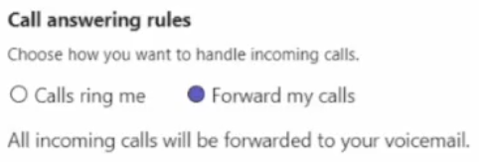
A. Busy on busy when in a call ✓
B. Enterprise Voice
C. Outbound calling
D. simultaneous ring
- Binh luan:
D. Timbre simultáneo (Simultaneous ringing)
Esta opción habilita que el usuario elija dónde más suenan las llamadas (otro número, delegado, grupo, etc.).
Es justamente lo que permite cambiar el destino de llamadas desviadas.
Note: If you don't see any options for simultaneous ring in your settings, it's likely you don't have an Enterprise Voice or Business Voice license. Also note that it can take up to 24 hours for changes in licenses to take effect.
From https://support.microsoft.com/en-gb/office/call-forwarding-call-groups-and-simultaneous-ring-in-microsoft-teams-a88da9e8-1343-4d3c-9bda-4b9615e4183e
Note: If you don't see any options for call forwarding in your settings, it's likely that you don't have an Enterprise Voice or Business Voice license. Also note that it can take up to 24 hours for changes in licenses to take effect.
Probably the question indicates that forwarding options have to appear as seen in the below.
https://support.microsoft.com/en-us/office/call-forwarding-call-groups-and-simultaneous-ring-in-microsoft-teams-a88da9e8-1343-4d3c-9bda-4b9615e4183e
Then B.Enterprise voice should be the answer.
From your link, the is a note as below.
Note: If you don't see any options for call forwarding in your settings, it's likely that you don't have an Enterprise Voice or Business Voice license.
Since we can see the call forwarding (as shown in teh screenshot), this means the Enterprise Voice license is already there. So it can't be B!
I would prefer D is correct!

Cau 54
Dap an: C
Case study -
Overview -
Company Information -
ADatum Corporation is an energy company that has offices across North America and 3,000 employees.
Physical Locations -
ADatum has the offices shown in the following table.
Existing Environment -
Network Infrastructure -
The office in Calgary has a 1-Gbps internet circuit. The offices in San Diego and New York have 100-Mbps internet circuits. The field site in Edmonton has a 3-Mbps internet circuit.
Departments -
ADatum has the following departments:
• Information technology (IT)
• Project management
• Marketing
Microsoft 365 and Tenants Environment
ADatum recently purchased a Microsoft 365 E5 subscription that has the Microsoft Teams Domestic Calling Plan add-on. All users are assigned Microsoft 365 E5 and Microsoft Teams Domestic Calling Plan licenses and Calling Plans is deployed.
Azure AD has the default Cross-tenant access settings configured.
The Teams policies settings are configured as shown in the following exhibit.
The Teams client is deployed to a non-persistent Virtual Desktop Infrastructure (VDI) used by the project management department.
Allow guest access in Teams is set to Off.
The Microsoft Viva Connections app is deployed to all users.
Problem Statements -
ADatum identifies the following issues:
• An executive at the San Diego office reports that video drops during Teams meetings.
• The Edmonton field site has limited bandwidth, and users report poor audio during Teams calls and meetings.
• Users in the project management department report that they cannot give or take control during Teams calls and meetings while sharing their VDI desktop.
Planned Changes -
ADatum plans to implement the following changes:
• Configure the media bit rate settings for the users at the Edmonton field site. The settings must apply only to the user while they are at the site, but NOT when they are at a different office.
• Create a Teams channel to enable the project management department to collaborate with the IT department on a device upgrade project.
• Implement a pilot rollout of Operator Connect for the users in the New York office. A port re-quest was accepted already.
• Create a Teams channel for the marketing department for external collaboration.
• Rename the Viva Connections icon as Start portal.
Technical Requirements -
ADatum identifies the following technical requirements:
• The marketing department requires that all the files shared by using Teams remain available for at least three years after deletion.
• The marketing department must be able to apply a watermark to content and video shared dur-ing Teams meetings.
• All users require indefinite access to training videos recorded in Teams by the IT department.
• All access to Teams and shared resources must use the principle of least privilege.
• Guest access must remain disabled.
Which license should you purchase to meet the technical requirements of the marketing department to apply a watermark?


A. Microsoft Priva Privacy Risk Management
B. Microsoft Priva Subject Rights Requests
C. Microsoft Teams Premium ✓
D. Microsoft Defender for Cloud Apps
- Binh luan:
Watermark is only available if you have a Teams Premium license.
https://support.microsoft.com/en-us/office/watermark-for-teams-meetings-a9166432-f429-4a19-9a72-c9e8fdf4f589

Cau 55
Dap an: C
Case study -
Overview -
Company Information -
ADatum Corporation is an energy company that has offices across North America and 3,000 employees.
Physical Locations -
ADatum has the offices shown in the following table.
Existing Environment -
Network Infrastructure -
The office in Calgary has a 1-Gbps internet circuit. The offices in San Diego and New York have 100-Mbps internet circuits. The field site in Edmonton has a 3-Mbps internet circuit.
Departments -
ADatum has the following departments:
• Information technology (IT)
• Project management
• Marketing
Microsoft 365 and Tenants Environment
ADatum recently purchased a Microsoft 365 E5 subscription that has the Microsoft Teams Domestic Calling Plan add-on. All users are assigned Microsoft 365 E5 and Microsoft Teams Domestic Calling Plan licenses and Calling Plans is deployed.
Azure AD has the default Cross-tenant access settings configured.
The Teams policies settings are configured as shown in the following exhibit.
The Teams client is deployed to a non-persistent Virtual Desktop Infrastructure (VDI) used by the project management department.
Allow guest access in Teams is set to Off.
The Microsoft Viva Connections app is deployed to all users.
Problem Statements -
ADatum identifies the following issues:
• An executive at the San Diego office reports that video drops during Teams meetings.
• The Edmonton field site has limited bandwidth, and users report poor audio during Teams calls and meetings.
• Users in the project management department report that they cannot give or take control during Teams calls and meetings while sharing their VDI desktop.
Planned Changes -
ADatum plans to implement the following changes:
• Configure the media bit rate settings for the users at the Edmonton field site. The settings must apply only to the user while they are at the site, but NOT when they are at a different office.
• Create a Teams channel to enable the project management department to collaborate with the IT department on a device upgrade project.
• Implement a pilot rollout of Operator Connect for the users in the New York office. A port re-quest was accepted already.
• Create a Teams channel for the marketing department for external collaboration.
• Rename the Viva Connections icon as Start portal.
Technical Requirements -
ADatum identifies the following technical requirements:
• The marketing department requires that all the files shared by using Teams remain available for at least three years after deletion.
• The marketing department must be able to apply a watermark to content and video shared dur-ing Teams meetings.
• All users require indefinite access to training videos recorded in Teams by the IT department.
• All access to Teams and shared resources must use the principle of least privilege.
• Guest access must remain disabled.
You need to resolve the issue reported by the project management department users.
What should you do?


A. Instruct the users to launch Teams and select Check for updates.
B. Uninstall the current Teams client, and then reinstall the latest version of the client.
C. From the Microsoft Teams admin center, create and assign a new meeting policy. ✓
D. From the Microsoft Teams admin center, modify the Meeting settings.
- Binh luan:
Answer is C. Give or Take control is not a NEW feature, so that would lock out A or B. It also is NOT in Meeting Settings, so D is out. "Participants can give or request control" is under Meeting Policies in the Content Sharing section. Has to be C.
Shouldn't be B? the Project management Team uses Teams from a VDI, and from there you need to uninstall and install to update.
I think I should be A.
Because in https://learn.microsoft.com/en-us/microsoftteams/teams-for-vdi
For steps on how to set policies to turn off Teams redirection, contact your virtualization provider. => Contact your vitualization provider, it's not asking to you to change the Meeting policies
But on the same page, it's written :
Important
Keep the Teams desktop app in your VDI environment up to date. Teams desktop app versions with release dates that are more than 90 days older than the current
If you currently run Teams without AV optimization in VDI and you use features that are not supported yet for optimization (such as Give and take control when app sharing), you have to set virtualization provider policies to turn off Teams redirection. This means that Teams media sessions won't be optimized. For steps on how to set policies to turn off Teams redirection, contact your virtualization provider.
https://learn.microsoft.com/en-us/microsoftteams/teams-for-vdi

Cau 56
Dap an: N/A
DRAG DROP
-
Case study
-
Overview
-
Company Information
-
ADatum Corporation is an energy company that has offices across North America and 3,000 employees.
Physical Locations
-
ADatum has the offices shown in the following table.
Existing Environment
-
Network Infrastructure
-
The office in Calgary has a 1-Gbps internet circuit. The offices in San Diego and New York have 100-Mbps internet circuits. The field site in Edmonton has a 3-Mbps internet circuit.
Departments
-
ADatum has the following departments:
• Information technology (IT)
• Project management
• Marketing
Microsoft 365 and Tenants Environment
ADatum recently purchased a Microsoft 365 E5 subscription that has the Microsoft Teams Domestic Calling Plan add-on. All users are assigned Microsoft 365 E5 and Microsoft Teams Domestic Calling Plan licenses and Calling Plans is deployed.
Azure AD has the default Cross-tenant access settings configured.
The Teams policies settings are configured as shown in the following exhibit.
The Teams client is deployed to a non-persistent Virtual Desktop Infrastructure (VDI) used by the project management department.
Allow guest access in Teams is set to Off.
The Microsoft Viva Connections app is deployed to all users.
Problem Statements
-
ADatum identifies the following issues:
• An executive at the San Diego office reports that video drops during Teams meetings.
• The Edmonton field site has limited bandwidth, and users report poor audio during Teams calls and meetings.
• Users in the project management department report that they cannot give or take control during Teams calls and meetings while sharing their VDI desktop.
Planned Changes
-
ADatum plans to implement the following changes:
• Configure the media bit rate settings for the users at the Edmonton field site. The settings must apply only to the user while they are at the site, but NOT when they are at a different office.
• Create a Teams channel to enable the project management department to collaborate with the IT department on a device upgrade project.
• Implement a pilot rollout of Operator Connect for the users in the New York office. A port re-quest was accepted already.
• Create a Teams channel for the marketing department for external collaboration.
• Rename the Viva Connections icon as Start portal.
Technical Requirements
-
ADatum identifies the following technical requirements:
• The marketing department requires that all the files shared by using Teams remain available for at least three years after deletion.
• The marketing department must be able to apply a watermark to content and video shared dur-ing Teams meetings.
• All users require indefinite access to training videos recorded in Teams by the IT department.
• All access to Teams and shared resources must use the principle of least privilege.
• Guest access must remain disabled.
You need to configure the pilot for the New York office.
Which three actions should you perform in sequence? To answer, move the appropriate actions from the list of actions to the answer area and arrange them in the correct order.


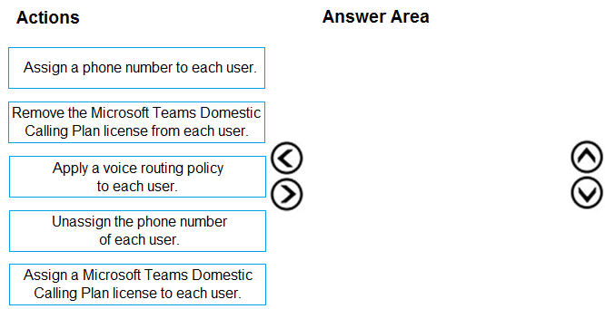
- Binh luan:
I think the third answer is wrong. Operator Connect does not need voice routing policies. Voice routing policy is required only for Direct Routing. Below URL mentions that when setting up Operator Connect, remove a voice routing policy.
https://learn.microsoft.com/en-us/microsoftteams/operator-connect-configure#step-2---remove-the-online-voice-routing-policy-associated-with-your-user
Answer provided is Correct, You have to Remove calling plan, as the New York office will have Operator Connect.
https://learn.microsoft.com/en-us/microsoftteams/operator-connect-plan

Cau 57
Dap an: N/A
HOTSPOT
-
Case study
-
Overview
-
Company Information
-
ADatum Corporation is an energy company that has offices across North America and 3,000 employees.
Physical Locations
-
ADatum has the offices shown in the following table.
Existing Environment
-
Network Infrastructure
-
The office in Calgary has a 1-Gbps internet circuit. The offices in San Diego and New York have 100-Mbps internet circuits. The field site in Edmonton has a 3-Mbps internet circuit.
Departments
-
ADatum has the following departments:
• Information technology (IT)
• Project management
• Marketing
Microsoft 365 and Tenants Environment
ADatum recently purchased a Microsoft 365 E5 subscription that has the Microsoft Teams Domestic Calling Plan add-on. All users are assigned Microsoft 365 E5 and Microsoft Teams Domestic Calling Plan licenses and Calling Plans is deployed.
Azure AD has the default Cross-tenant access settings configured.
The Teams policies settings are configured as shown in the following exhibit.
The Teams client is deployed to a non-persistent Virtual Desktop Infrastructure (VDI) used by the project management department.
Allow guest access in Teams is set to Off.
The Microsoft Viva Connections app is deployed to all users.
Problem Statements
-
ADatum identifies the following issues:
• An executive at the San Diego office reports that video drops during Teams meetings.
• The Edmonton field site has limited bandwidth, and users report poor audio during Teams calls and meetings.
• Users in the project management department report that they cannot give or take control during Teams calls and meetings while sharing their VDI desktop.
Planned Changes
-
ADatum plans to implement the following changes:
• Configure the media bit rate settings for the users at the Edmonton field site. The settings must apply only to the user while they are at the site, but NOT when they are at a different office.
• Create a Teams channel to enable the project management department to collaborate with the IT department on a device upgrade project.
• Implement a pilot rollout of Operator Connect for the users in the New York office. A port re-quest was accepted already.
• Create a Teams channel for the marketing department for external collaboration.
• Rename the Viva Connections icon as Start portal.
Technical Requirements
-
ADatum identifies the following technical requirements:
• The marketing department requires that all the files shared by using Teams remain available for at least three years after deletion.
• The marketing department must be able to apply a watermark to content and video shared dur-ing Teams meetings.
• All users require indefinite access to training videos recorded in Teams by the IT department.
• All access to Teams and shared resources must use the principle of least privilege.
• Guest access must remain disabled.
You need to configure a policy for the IT department to meet the technical requirements for training videos.
How should you complete the PowerShell cmdlet? To answer, select the appropriate options in the answer area.
NOTE: Each correct selection is worth one point.


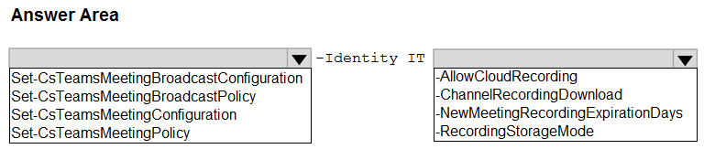
- Binh luan:
Correct
See Q44 https://www.examtopics.com/exams/microsoft/ms-700/view/33/

Cau 58
Dap an: C
Your company uses Teams.
You successfully port and assign an audio conferencing toll-free number to Microsoft.
You test the toll-free number and ensure that meetings are successful.
The next day, you receive reports that the toll-free number is no longer working, but local toll numbers still work.
You need to ensure that the toll-free number works.
What should you do?
A. Add the toll-free number to an Audio Conferencing policy.
B. Set Anonymous users and dial-in callers can start a meeting to On.
C. Add Communication Credits. ✓
D. Set the toll-free number as the default conference bridge.
- Binh luan:
Selected Answer: C
https://learn.microsoft.com/en-us/microsoftteams/what-are-communications-credits#:~:text=To%20use%20toll%2Dfree%20numbers%2C%20Communications%20Credits%20are%20required%20as%20these%20calls%20are%20billed%20per%20minute.
Add Communication Credits.
Adding the toll-free number to an Audio Conferencing policy ensures that the number is configured and included in the policy settings for audio conferencing. It's possible that the toll-free number was not included in the policy or that there might be a configuration issue.
However after doing somemore digging.....i am thinking it should be C. Add Communication Credits.
Toll-free numbers in Microsoft Teams require Communication Credits because the cost of the call is borne by the organization, not the caller. If the toll-free number stops working but local toll numbers are still functional, it’s likely that the organization has run out of Communication Credits. By adding more Communication Credits, you can ensure that the toll-free number continues to work. Ugh ty

Cau 60
Dap an: A
You have a Microsoft 365 E5 subscription that uses Teams.
A user named User1 reports that the recording button is unavailable during a Teams meeting.
You need to ensure that the recording button is available for User1.
What should you configure in the Microsoft Teams admin center?
A. Meeting policies ✓
B. Meeting templates
C. Meeting settings
D. Meeting template policies
- Binh luan:
As of feb 2025 , global policies and setting has combined together therefore we can also enable this setting in meeting global setting.
correct
To allow or prevent meeting recordings
1. In the Microsoft Teams admin center, expand Meetings.
2. Select Meeting policies.
3. Select the policy that you want to edit.
4. Turn Meeting recording On or Off.
5. Select Save.
With PowerShell, you configure the -AllowCloudRecording parameter in Set-CsTeamsMeetingPolicy.
https://learn.microsoft.com/en-us/microsoftteams/meeting-recording?tabs=meeting-policy

Cau 61
Dap an: D
You have a Microsoft 365 E5 subscription that uses Teams.
Your company requires that all inactive teams be deleted.
You need to identify teams that were inactive during the last 90 days.
What should you use?
A. Microsoft Adoption Score
B. Teams advisor
C. access reviews
D. the Teams usage report ✓
- Binh luan:
correct
Answer is correct.
There are three main options to find inactive teams
Activity Report with Power Shell
Microsoft Teams Usage Report in Office 365
Identifying inactive Teams using activity threshold
https://saketa.com/blog/identify-inactive-microsoft-teams-o365/

Cau 62
Dap an: D, E
You have a Microsoft 365 subscription that uses Microsoft Teams. All users are assigned an Microsoft 365 E3 license.
You need to ensure that the users can join scheduled meetings by dialing a toll-free phone number.
Which two add-on licenses should you assign to the users? Each correct answer presents part of the solution.
NOTE: Each correct selection is worth one point.
A. Microsoft Teams Rooms Pro
B. Microsoft Teams Domestic Calling Plan
C. Microsoft Teams Shared Devices
D. Communication Credits ✓
E. Microsoft 365 Audio Conferencing ✓
- Binh luan:
This is the same question as Topic2 Question #61
D. Communication Credits:
Communication Credits are used for paying toll-free and premium call charges associated with Audio Conferencing in Microsoft Teams.
E. Microsoft 365 Audio Conferencing:
Microsoft 365 Audio Conferencing allows users to dial in to Teams meetings using a phone, and it includes toll-free numbers.
Option B (Microsoft Teams Domestic Calling Plan) is not directly related to toll-free numbers. Calling Plans are typically associated with providing domestic calling capabilities

Cau 63
Dap an: N/A
SIMULATION
-
A company named Contoso, Ltd. plans to deploy Teams Phone with location-based emergency dialing.
You need to ensure that when users dial emergency numbers, the call is routed based on the user's current location.
You do NOT need to configure networks and locations at this time.
To complete this task, sign in to the Microsoft 365 portal.
- Binh luan:
Confirmed correct via labbing.

Cau 64
Dap an: N/A
SIMULATION
-
You need to ensure that when users join meeting by using a phone, they are prompted to record their name.
To complete this task, sign in to the Microsoft 365 portal.
- Binh luan:
Confirmed correct by labbing.

Cau 65
Dap an: N/A
SIMULATION
-
You need to prevent unauthenticated users from joining Teams meetings.
To complete this task, sign in to the Microsoft 365 portal.
- Binh luan:
Step 1 is wrong. The option to let users anonymously join a meeting is located in Meeting Settings and not in Meeting Policies.
Agreed, this should be under Meeting Policies!
The option is available under both meeting policies and new meeting settings (global meeting policy + meeting settings)
https://learn.microsoft.com/en-us/microsoftteams/settings-policies-reference

Cau 66
Dap an: N/A
SIMULATION
-
You need to ensure that users can perform the following actions:
• Record Teams calls and Teams meeting.
• Transcribe Teams calls and Teams meeting.
To complete this task, sign in to the Microsoft 365 portal.
- Binh luan:
1. Set Record and transcribe in Teams Meeting: TAC > Meetings > Meeting Policies > click Global (Org-wide default) > Meeting recording: On, Transcription: On.
2. Set Record and transcribe in Teams Calls: TAC > Voice > Calling Policies > click Global (Org-wide default) > Cloud recording for calling: On, Transcription: On.
Confirmed correct by labbing!

Cau 67
Dap an: N/A
SIMULATION
-
You need to prevent guest users from calling your company’s Teams users.
To complete this task, sign in to the Microsoft 365 portal.
- Binh luan:
A bit overkill?
Guest access > Calling > Make private calls > Off ?

Cau 68
Dap an: B
Your company has a Microsoft 365 subscription.
A user invites an external user to join a Microsoft Teams meeting by using a Microsoft Outlook meeting invitation.
The external user cannot join the meeting.
You need to ensure that all external users can join Microsoft Team meetings.
What should you do from the Microsoft Teams admin center?
A. From Guest access, set Allow guest access in Teams to On.
B. Edit the Meeting settings and set Anonymous users can join a meeting to On. ✓
C. Edit the global meeting policy and set Private meeting scheduling to On.
D. Edit the live events policy and set Who can join scheduled live events to Everyone.
- Binh luan:
Guest Access to Teams is enabled in the Guest Settings.
The Meeting Settings tab does not have Guest options in it.
The question is about Teams meetings, Private chats are not mentioned
The question does not mention a live event
Nop, the question is abount EXTERNAL and not GUEST.
The answer is B: Allow anonymous join to meetings.
B is the answer.

Cau 69
Dap an: N/A
DRAG DROP
-
Your company has a Microsoft 365 subscription that uses Microsoft Teams.
The company has a team named Customer Support.
Guest users from outside the company regularly access the Customer Support team.
You need to configure the Guest access settings to meet the following requirements:
• Guest users must be able to view only a single application during screen sharing sessions.
• Guest users must be prevented from creating channels in Customer Support.
• Guest users must be admitted to meetings manually.
Which settings should you configure for each requirement? To answer, drag the appropriate settings to the correct requirements. Each setting may be used once, more than once, or not at all. You may need to drag the split bar between panes or scroll to view content.
NOTE: Each correct selection is worth one point.
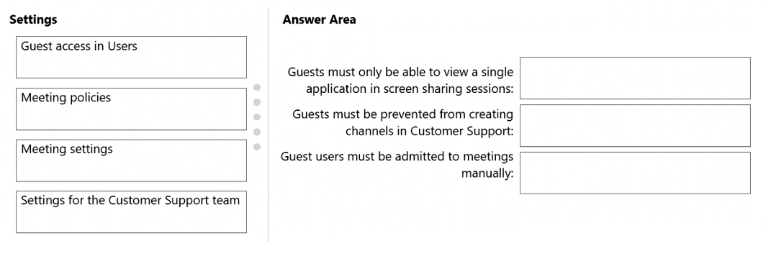
- Binh luan:
Meeting policies
Settings for the Customer Support team
Meeting policies
There's no setting that limits to what a user (guest or otherwise) can VIEW in a meeting. Only what can be shared. The only way to limit what a guest can view is to limit the ability of everyone. It has to be set in a Metting Policy. Limit screen sharing to "single application". That will accomplish the requirement of allowing guests to VIEW only a single application.
So it's what KILICASLAN1984 says:
Meeting policies
Settings for Customer Support team
Meeting policies

Cau 70
Dap an: B
You have a Microsoft 365 E3 subscription that uses Teams. The subscription contains an administrator named Admin1 that is assigned the Teams Administrator role.
Admin1 reports that he can assign default policy packages to users but cannot create and assign custom policy packages.
You need to ensure that Admin1 can create and assign custom policy packages in Teams.
What should you do?
A. For Admin1, run the Grant-CsUserPolicyPackage PowerShell cmdlet.
B. Assign a Teams Premium license to Admin1. ✓
C. For Admin1, run the Grant-CsGroupPolicyPackageAssignment PowerShell cmdlet.
D. Assign a Microsoft 365 E5 license to Admin1.
- Binh luan:
Answer is correct : https://learn.microsoft.com/en-us/microsoftteams/manage-policy-packages
Note: Custom policy packages requires Teams Premium.

Cau 71
Dap an: C
You have a Microsoft 365 E5 subscription that includes Teams.
All users are assigned the Teams Premium add-on license.
You need to schedule an event that supports 20,000 streaming participants and uses enterprise content delivery network (eCDN).
Which meeting template should you select?
A. Controlled-content meeting
B. Virtual appointment
C. Town hall ✓
D. Webinar
- Binh luan:
The answer is C. Town hall
Can be extended to 20,000 attendees with special request to Microsoft.
Webinar only supports up to 1000 attendees while Town Hall supports up to 20000 attendees with Teams Premium License.
https://learn.microsoft.com/en-us/microsoftteams/overview-meetings-webinars-town-halls

Cau 72
Dap an: N/A
DRAG DROP
-
You have a Microsoft 365 E5 subscription.
You plan to schedule the events shown in the following table.
Which meeting template should you use for each event? To answer, drag the appropriate templates to the correct events. Each template may be used once, more than once, or not at all. You may need to drag the split bar between panes or scroll to view content.
NOTE: Each correct selection is worth one point.
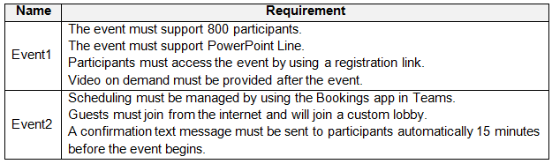
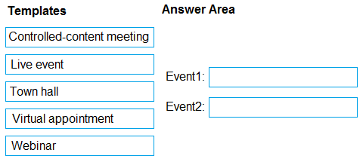
- Binh luan:
Correct.
Virtual Appointment:
https://support.microsoft.com/en-us/office/what-is-virtual-appointments-22df0079-e6d9-4225-bc65-22747fb2cb5f#:~:text=The%20Virtual%20Appointments%20app%20in,all%20in%20a%20single%20app.

Cau 74
Dap an: N/A
DRAG DROP
-
You have a Microsoft 365 E5 subscription that includes Teams.
You plan to deploy a common area Teams device named Device1 to a reception area.
Device1 must autodial a preconfigured number when the phone handset is picked up and restrict searching the company directory.
Which three actions should you perform in sequence? To answer, move the appropriate actions from the list of actions to the answer area and arrange them in the correct order.
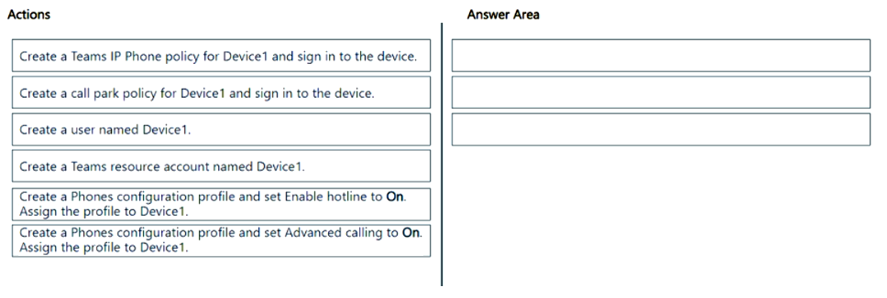
- Binh luan:
https://learn.microsoft.com/en-us/microsoftteams/phones/set-up-common-area-phones

Cau 75
Dap an: B
You have a Teams Phone deployment.
You discover that the Teams client cannot receive PSTN calls but can receive Teams calls.
You need to ensure that the Teams client can receive both PSTN and Teams calls.
What should you configure in the Teams client?
A. Manage call group
B. Redirect external phone calls ✓
C. Manage delegates
D. Forward all calls
- Binh luan:
Debe deshabilitarse para que el cliente reciba tanto llamadas PSTN como de Teams.

Cau 76
Dap an: N/A
HOTSPOT
-
You have a Teams deployment. The deployment contains a Teams Rooms device that has an account named Meetingroom1.
You need to configure Meetingroom1 to meet the following requirements:
• Meeting invites must be approved automatically if there are no conflict.
• Forwarded external meetings must be allowed.
How should you complete the PowerShell command? To answer, select the appropriate options in the answer area,
NOTE: Each correct selection is worth one point.
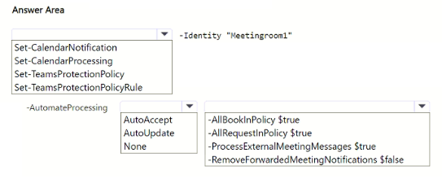

Cau 77
Dap an: C
You have a Microsoft 365 E5 subscription and use Microsoft Teams.
A user named User1 reports that the Redirect to a new number or contact option is unavailable in the Calls settings of the Teams client as shown in the following exhibit.
What is the cause of the missing option?
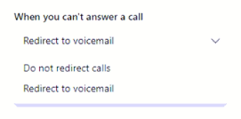
A. Enterprise Voice is sabes for User1.
B. Busy on busy during calls is enabled for User1.
C. Simultaneous ring is configured User1. ✓
D. A policy that limits calls to domestic only is applied to User1.
- Binh luan:
Even though the user has a Microsoft 365 E5 license (which includes Teams Phone), Enterprise Voice must be explicitly enabled on the user account.
Without Enterprise Voice enabled:
The user can still receive Teams-to-Teams calls
The user cannot redirect calls to an external number or contact
The option "Redirect to a new number or contact" is hidden from the client
This explains why only these options remain:
✅ Redirect to voicemail
✅ Do not redirect calls
❌ Redirect to a new number or contac
He doesn't can call

Cau 78
Dap an: D
You have a Teams deployment.
From Microsoft Call Quality Dashboard, you discover that internal calls are marked as outside.
You need to ensure that inside and outside calls are reported correctly.
What should you configure?
A. Tenant Data Upload
B. Roaming policies under Network topology
C. Network sites under Network topology
D. Trusted IPs under Network topology ✓
E. Voice routing policies
- Binh luan:
Trusted IPs is the answer to this.
D
In Microsoft Teams Call Quality Dashboard (CQD), if internal calls are being marked as outside, it means Teams can’t recognize the calls as coming from inside your corporate network.

Cau 79
Dap an: C
You have a Teams Phone deployment that contains the components shown in the following table.
You need to enable automated callback for callers who are on hold for more than 10 minutes.
What component should you modify?
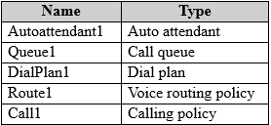
A. Autoattendant1
B. DialPlant1
C. Queue1 ✓
D. Route1
E. Call1
- Binh luan:
This is a Call Queue feature.
C
The feature for automated callback when a caller has been on hold too long is a Call Queue setting in Microsoft Teams Phone.

Cau 80
Dap an: N/A
HOTSPOT
-
You have a Teams Phone deployment.
You have an auto attendant named Autoattend1.
You need to configure Autoattend1 to meet the following requirements:
• Exclude a group named Group1 from the directory.
• Configure Dial key 1 to forward calls to a call queue.
What should you do for each requirement? To answer, select the appropriate options in the answer area.
NOTE: Each correct selection is worth one point.
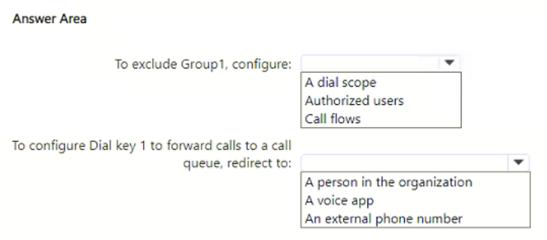

Cau 81
Dap an: B, E
You have a Microsoft 365 subscription that uses Teams.
You deploy Teams to a branch office that has limited internet bandwidth.
You need to configure policy settings to enforce network bandwidth restrictions only when Teams users are in the branch office.
Which two policies should you configure? Each correct answer presents part of the solution.
NOTE: Each correct selection is worth one point.
A. an Audio Conferencing routing policy
B. a meeting policy ✓
C. a voice routing policy
D. a calling policy
E. a network roaming policy ✓
- Binh luan:
B and E
Network roaming policy lets you enforce different bandwidth restrictions depending on the user's network location (so the limits only apply when in the branch office).
Meeting policy allows you to control video/audio bandwidth usage for Teams meetings (e.g., disabling video or limiting resolution to save bandwidth).

Cau 82
Dap an: N/A
HOTSPOT
-
Your company has a branch office in Seattle.
You have a Teams Phone deployment.
You need to create a policy to ensure that all the users in the Seattle office can use the same phone number for outbound calling.
How should you complete the PowerShell command? To answer, select the appropriate options in the answer area.
NOTE: Each correct selection is worth one point.
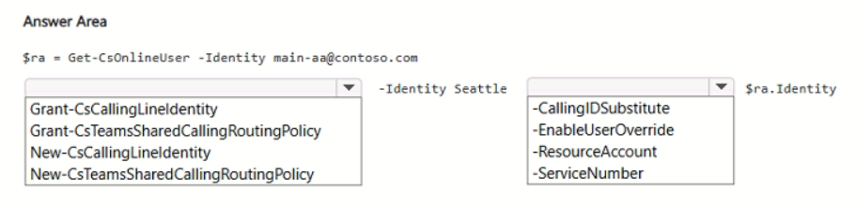
- Binh luan:
https://learn.microsoft.com/en-us/microsoftteams/shared-calling-setup#use-powershell

Cau 83
Dap an: D
You have a Microsoft 365 E5 subscription and use Microsoft Teams.
You plan to support meetings that use breakout rooms.
You need to recommend a breakout room solution that meets the following requirements:
• Supports 500 participants
• Supports content sharing and chat
What should you include in the recommendation?
A. town halls
B. webinars
C. live events
D. meetings ✓
- Binh luan:
D
Breakout rooms are only available in regular Microsoft Teams meetings, not in town halls, webinars, or live events.
Teams meetings can support up to 1,000 participants in interactive mode (and more in view-only mode) and allow content sharing and chat — so 500 participants is well within limits.

Cau 84
Dap an: N/A
DRAG DROP
-
You have a Microsoft 365 E5 subscription and use Microsoft Teams.
You plan to schedule the meetings shown in the following table.
Which type of meeting should you use for each meeting? To answer, drag the appropriate meeting types to the correct meetings. Each meeting type may be used once, more than once, or not at all. You may need to drag the split bar between panes or scroll to view content.
NOTE: Each correct selection is worth one point.
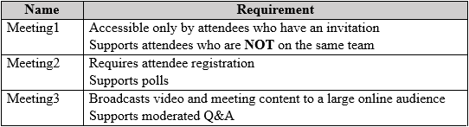
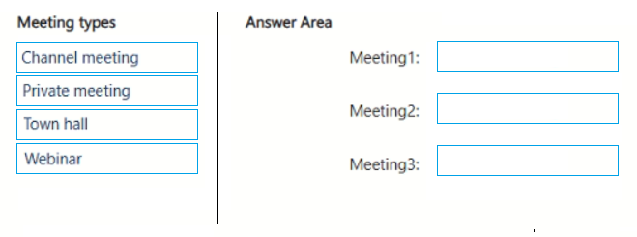

Cau 85
Dap an: N/A
HOTSPOT
-
You have a Teams deployment that contains a team named Team1 and the users shown in the following table.
User2 plans to schedule a product training event for the members of Team1. The event must support the following:
• Attendee registration
• Interactivity by using Q&A
• Microsoft 365 Copilot during and after the event
You need to recommend which type of meeting to create, and which users will require a Copilot license.
What should you recommend to User2? To answer, select the appropriate options in the answer area.
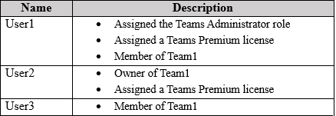
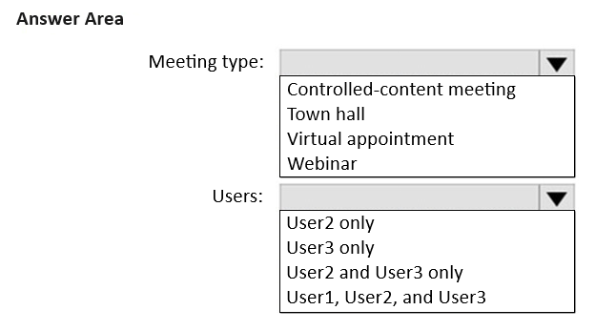
- Binh luan:
Every user, that wants to use Copilot functions during meetings needs a M365 Copilot License
https://learn.microsoft.com/en-us/microsoftteams/copilot-teams-transcription
All users need a Copilot license, since it isn't included with Teams Premium.
Meeting type: Webinar
Reason:
You need attendee registration → available in Webinars.
Q&A support → available in Webinars.
Microsoft 365 Copilot during and after the event → requires that presenters or organizers have a Copilot license.
Users who need Copilot license: User2 only
Reason:
Only User2 is the organizer (and presenter) of the event.
Attendees (like User3) do not need a Copilot license to attend — only to use Copilot themselves in their own tenant.
User1 is not involved in the

Cau 86
Dap an: B
You have a Teams Phone deployment that contains a resource account named Resource1 and an auto attendant named Attendant1.
You plan to use Resource1 to provide call answering functionality for Attendant1.
You need to ensure that Resource1 has a designated phone number.
What should you do?
A. From Active users in the Microsoft 365 admin center, select Resource1, and then select Devices.
B. From Resource accounts in the Microsoft Teams admin center, select Resource1, and then select Assign/unassign. ✓
C. From Active users in the Microsoft 365 admin center, select Resource1, and then select Manage contact information.
D. From Resource accounts in the Microsoft Teams admin center, select Add.
- Binh luan:
B To assign a phone number to a resource account (used for auto attendants or call queues), you must do this from the Microsoft Teams admin center, not from the Active Users page in Microsoft 365 admin center.

Cau 87
Dap an: N/A
HOTSPOT
-
Your company has a marketing department and a finance department.
You have a Teams deployment.
The marketing department plans to host a Teams session that has the following requirements:
• External attendees must by using a registration page.
• Attendees must be able to use Microsoft Whiteboard during the session.
The finance department plans to host a Teams session that has the following requirements:
• 1,500 attendees must be able to interact within a Q&A session.
• The session must use enterprise content delivery network (eCDN) integration.
Which type of meeting should you recommend for each department? To answer, select the appropriate options in the answer area.
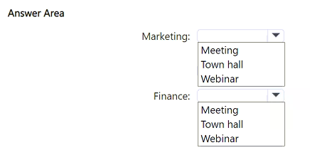
- Binh luan:
Given answer is correct
Marketing: Webinar ✅
Reason: Webinars in Teams support external attendee registration pages and Microsoft Whiteboard usage during the session.
Finance: Town hall ✅
Reason: Town halls support large audiences (up to 20,000), include Q&A functionality, and support enterprise content delivery network (eCDN) integration.

Cau 89
Dap an: N/A
HOTSPOT
-
Case study
-
This is a case study. Case studies are not timed separately. You can use as much exam time as you would like to complete each case. However, there may be additional case studies and sections on this exam. You must manage your time to ensure that you are able to complete all questions included on this exam in the time provided.
To answer the questions included in a case study, you will need to reference information that is provided in the case study. Case studies might contain exhibits and other resources that provide more information about the scenario that is described in the case study. Each question is independent of the other questions in this case study.
At the end of this case study, a review screen will appear. This screen allows you to review your answers and to make changes before you move to the next section of the exam. After you begin a new section, you cannot return to this section.
To start the case study
-
To display the first question in this case study, click the Next button. Use the buttons in the left pane to explore the content of the case study before you answer the questions. Clicking these buttons displays information such as business requirements, existing environment, and problem statements. If the case study has an All Information tab, note that the information displayed is identical to the information displayed on the subsequent tabs. When you are ready to answer a question, click the Question button to return to the question.
General Overview
-
Wingtip Toys is a manufacturing company that has 5,000 users, and locations across North America and Europe.
Departments
-
The company has the following departments:
• IT
• Sales
• Security
• Customer support
• Human resources (HR)
• Research and development (R&D)
Microsoft Office 365 Environment
All users are assigned a Microsoft 365 E5 license and are enabled for Microsoft Teams Phone.
Users in the R&D department are assigned a Teams Premium license.
Requirements
-
Call Handling Requirements
-
Wingtip Toys identifies the following call handling requirements:
• Inbound calls to the main telephone number of Wingtip Toys must be routed to the correct department by using an auto attendant.
• During holiday periods, the auto attendant must perform the following actions:
• Route customer support calls to the customer support department.
• Play a recorded message for calls to all the other departments, and then disconnect the call.
Meeting Requirements
-
Wingtip Toys identifies the following meeting requirements:
• Meetings that include users from the R&D department must have a watermark applied to screen sharing sessions.
• Once a quarter, the CEO of Wingtip Toys must host a live, online event that is attended by all users.
Governance Requirements
-
Wingtip Toys identifies the following governance requirements:
• New teams must meet the following requirements:
• The Team type setting must be set to Private.
• Users must be able to send emails to team channels.
• Team members must be prevented from deleting messages from team channels.
• Each team name must be validated against a list of blocked team names.
• Each team name must contain a prefix of GRP and the department name as a suffix.
• Team channels must include a pinned tab that displays the Wingtip Toys website.
• When a user creates a team, the team picture must be the logo of the user's department.
• The department manager of the user that creates the team must be assigned the Owner role for the team.
• The use of animated GIFs must be prevented in team channels.
Collaboration Requirements
-
Wingtip Toys identifies the following collaboration requirements:
• Fabrikam users must be able to join team channels hosted by Wingtip Toys.
• Wingtip Toys users must be prevented from joining team channels hosted by Fabrikam.
Monitoring Requirements
-
A notification must be sent to users in the IT department when a Teams Rooms system goes offline.
Pilot Project Requirements
-
Wingtip Toys is currently evaluating third-party call center apps that integrate with Teams. The security department mandates that all third-party apps be reviewed by a qualified analyst and comply with industry-standard frameworks.
User Issues
-
Wingtip Toys users report audio and video issues when accessing Teams meetings by using a web browser.
Business Requirements
-
Wingtip Toys identifies the following business requirements:
• Follow the principle of least privilege.
• Minimize administrative effort.
• Minimize costs.
You have the following PowerShell script.
For each of the following statements, select Yes if the statement is true. Otherwise, select No.
NOTE: Each correct selection is worth one point.
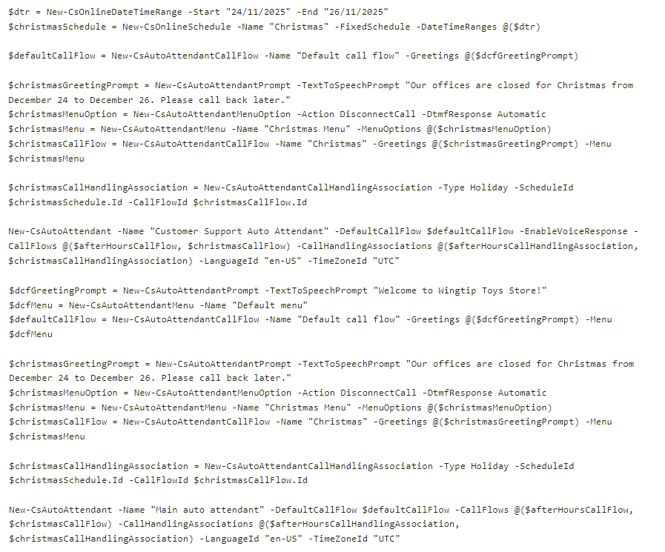
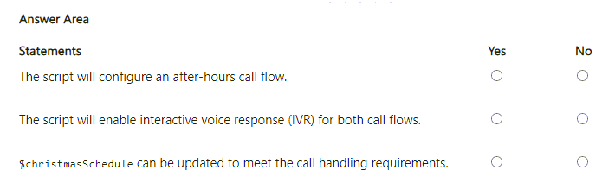

Cau 1
Dap an: D
You have a Microsoft 365 subscription that uses Microsoft Teams and contains a user named User1.
User1 reports that the Meeting recording button is missing from the Microsoft Teams client. The user cannot record meetings.
You need to ensure that User1 meets the prerequisites to record Microsoft Teams meetings.
What should you do?
A. From the Microsoft Teams admin center, use the Call Quality Dashboard (CQD).
B. From the Microsoft Teams admin center, use Teams advisor.
C. From the Microsoft 365 admin center, enter Diag: Missing Recording in the Need help? search box.
D. From the Microsoft 365 admin center, enter Diag: Meeting Recording in the Need help? search box. ✓
- Binh luan:
Tested.
Answer is D
From the Microsoft 365 admin center, enter Diag: >>>"Meeting Recording"<<<< in the Need help? search box.
why C and D is the same answer
Difference word, Missing and Meeting
wow good focus , you saved my answer thanks

Cau 2
Dap an: B
Note: This question is part of a series of questions that present the same scenario. Each question in the series contains a unique solution that might meet the stated goals. Some question sets might have more than one correct solution, while others might not have a correct solution.
After you answer a question in this section, you will NOT be able to return to it. As a result, these questions will not appear in the review screen.
Your company has 10 offices in North America and Europe.
The company has 5,000 users.
You plan to deploy Microsoft Teams for all the users.
You run a pilot project for the planned deployment.
You need to identify the network packet loss from the pilot computers to Microsoft Teams during calls.
Solution: You run the Network Testing Companion.
Does this meet the goal?
A. Yes
B. No ✓
- Binh luan:
Although the Network testing companion can be used to measure packet loss, it is for individual computer use. it would be cumbersome to need to install this on every computer that will be testing.
The call quality dashboard on the other hand, can generate reports on the call quality for all pilot computers, and would likely be the Microsoft preferred answer.
Will go with B if seen on exam.
I would say B as the Network Testing Companion is something I would run to test the environment/endpoints before rolling out Teams. CQD would be the go to after the deployment to determine Packet Loss
On Test 18.01.22
B is correct (i think) - this tool does help, but has to installed on individual machines using local admin privileges. A pilot deployment will consist of more than one user and will require a lot resource to deploy this tool on each computer. If the question stated for "one user" then you could use the tool.
B is correct

Cau 3
Dap an: B
Note: This question is part of a series of questions that present the same scenario. Each question in the series contains a unique solution that might meet the stated goals. Some question sets might have more than one correct solution, while others might not have a correct solution.
After you answer a question in this section, you will NOT be able to return to it. As a result, these questions will not appear in the review screen.
Your company has 10 offices in North America and Europe.
The company has 5,000 users.
You plan to deploy Microsoft Teams for all the users.
You run a pilot project for the planned deployment.
You need to identify the network packet loss from the pilot computers to Microsoft Teams during calls.
Solution: From the Microsoft Teams admin center, you select Analytics & reports.
Does this meet the goal?
A. Yes
B. No ✓
- Binh luan:
Call quality dashboard is now under Analytics & Reports
I agree. A seems to be correct.
I agree. A seems to be correct.
Need to click on CQD under Analytics to get the report.
selecting Analytics & reports is not enough as this is merely a category header. You need to click through to Call Quality Dashboard to be able to actually see anything.

Cau 4
Dap an: N/A
HOTSPOT -
Your company has a Microsoft 365 subscription.
You need to review the following information:
✑ The Rate My Call (RMC) data provided by users.
✑ The number of Microsoft Teams live event views from the past three months.
What should you use to view the information? To answer, select the appropriate options in the answer area.
NOTE: Each correct selection is worth one point.
Hot Area:
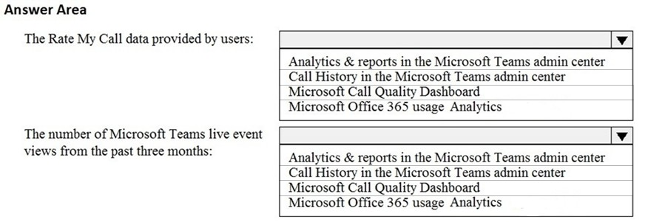
- Binh luan:
Correct
Both are under Analytics & reports:
1. Analytics & reports>CQD
2, Analytics & reports>Usage Reports
Correct. Part of the exam on 9 August 2022
Answer is correct
1. Analytics & reports -> CQD
2, Analytics & reports -> Usage Reports
Reference -
https://docs.microsoft.com/en-us/microsoftteams/teams-analytics-and-reports/teams-live-event-usage-report
https://docs.microsoft.com/en-us/microsoftteams/turning-on-and-using-call-quality-dashboard
1. CQD
2. Analytics & reports

Cau 5
Dap an: B
Note: This question is part of a series of questions that present the same scenario. Each question in the series contains a unique solution that might meet the stated goals. Some question sets might have more than one correct solution, while others might not have a correct solution.
After you answer a question in this section, you will NOT be able to return to it. As a result, these questions will not appear in the review screen.
Your company has 10 offices in North America and Europe.
The company has 5,000 users.
You plan to deploy Microsoft Teams for all the users.
You run a pilot project for the planned deployment.
You need to identify the network packet loss from the pilot computers to Microsoft Teams during calls.
Solution: From the Microsoft Teams admin center, you run the Network Planner.
Does this meet the goal?
A. Yes
B. No ✓
- Binh luan:
I just found the following link, the network planner appears to be used to determine bandwidth needs, not packet loss.
https://docs.microsoft.com/en-us/microsoftteams/tutorial-network-planner-example?tutorial-step=5
On Test 18.01.22
No, you should using CQD.
The network planner is used for deploying Teams:
https://docs.microsoft.com/en-us/microsoftteams/prepare-network
Network Companion Tool can help to analyze the network capability

Cau 6
Dap an: C
You have a Microsoft 365 subscription that contains a user named User1.
User1 experiences audio issues while sharing his screen during Microsoft Teams meetings.
You need to investigate whether the headset of User1 causes the issues.
Which report should you use?
A. Media reliability metrics
B. Customer endpoint information support
C. Quality of Experience ✓
D. Failure Drill Down
- Binh luan:
When investigating whether a specific user's headset is causing audio issues, you need a report that provides device/endpoint details. The Customer endpoint information support report shows:
✅ Audio capture device (microphone/headset) used
✅ Audio render device (speakers/headset) used
✅ Device driver information
✅ Device make and model
✅ Correlation between specific devices and audio quality issues
Audio quality and reliability for all clients and devices - Quality if Experience Report
Headset is a device so answer is correct
Correct

Cau 7
Dap an: B
You have a Microsoft 365 subscription that uses Microsoft Teams and contains a user named User.
You need to ensure that User1 can investigate call-quality issues and identify the following types of information:
Caller and recipient names -
✑ Device names and IP addresses
✑ The number and names of all meeting participants
The solution must use the principle of least privilege.
Which role should you assign to User1?
A. Teams Device Administrator
B. Teams communication support engineer ✓
C. Teams Administrator
D. Teams communication admin
- Binh luan:
It is B

Cau 8
Dap an: A
You have a Microsoft 365 E5 subscription.
You need to generate a report that provides the following information:
✑ How many users post and reply to channel messages
✑ The number of ad hoc meetings organized by a user
✑ The number of meetings a user has participated in
✑ The total video time of a user
Which report should you run?
A. Teams user activity ✓
B. Teams usage
C. Teams live event usage
D. Teams app usage
- Binh luan:
The report name is 'Teams user activity', and the question is about the name of the report. So will go with A
On exam 31/03/2023.
A is correct
Only the Teams user activity report can fulfill the requirements.
Answer is A
A is the correct because you have infor like Display Name / "post and reply to channel messages" in this report that you don't have the Teams usage.
"How many users post and reply to channel messages " should be under Teams usage rather than "Teams user activity".. so B for me

Cau 9
Dap an: N/A
HOTSPOT -
You have a Microsoft 365 subscription that uses Microsoft Teams and contains the users shown in the following table.
You have a team named Project1 that contains the members shown in the following table.
You need to monitor Project1 for the following administrative actions:
✑ The creation and deletion of channels
✑ Changing the role assignments of team members
Which users can monitor Project1, and which feature should the users use? To answer, select the appropriate options in the answer area.
NOTE: Each correct selection is worth one point.
Hot Area:
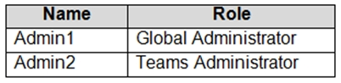
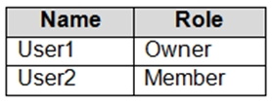
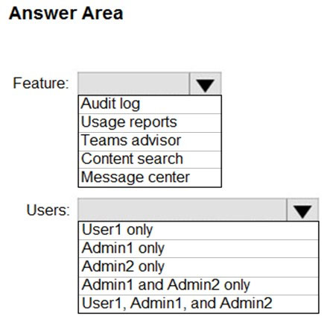
- Binh luan:
This is correct as the "Audit Log" would be used to identify:
✑ The creation and deletion of channels
✑ Changing the role assignments of team members
Admin1 is the only user with a role that would allow them permissions to access the "Audit Log" from the compliance centre.
Based on https://learn.microsoft.com/en-us/entra/identity/role-based-access-control/delegate-by-task#monitoring-and-health---audit-and-sign-in-logs-least-privileged-roles this is correct
MS101でも出ました。
On exam 27 Jan
on exam 26-Nov-2022

Cau 10
Dap an: B
You have a Microsoft 365 subscription that uses Microsoft Teams.
A user reports an error when he attempts to share his screen during meetings by using the Microsoft Teams Windows Desktop client.
You need to collect the Microsoft Teams client log files from the user's device.
What should you do?
A. From the Microsoft Teams client settings, select Disable GPU hardware acceleration.
B. Select Ctrl + Alt + Shift + 1. ✓
C. Select the Windows logo key + Alt + Shift +1.
D. From the Microsoft Teams client settings, select Enable logging for meeting diagnostics.
- Binh luan:
Debug, Desktop, and Media logs will be collected in one folder with the name MSTeams Diagnostics Log <local date and time>. This folder can be compressed and shared when you open a support request with Microsoft Support. The folder will contain folders for Desktop, Meeting (Media), and Debug (web). You can collect the files using the following keyboard shortcuts:
Ctrl + Alt + Shift + 1
confirmed that B is the correct answer. I just did this on my Teams client and logs were downloaded. Ctrl+Alt+Shift+1
Straight forward answer. D does not allow to collect log, B allows to collect log.
If there were two choices to select, then B and D.
Yes D for screen sharing issues, but they asking to collect logs, D along wouldn't create and download the logs.
Answer B
Media logs contain diagnostic data about audio, video, and screen sharing in Teams meetings. They are required for support cases that are linked to call-related issues.
Should be D
Media logging is turned off by default. To log diagnostic data for Teams meetings, users must turn on the option in the Teams client. Go to Settings > General, select the Enable logging for meeting diagnostics (requires restarting Teams) check box, restart Teams, and reproduce the issue.
Screen sharing could be media logs? In this case could be D?

Cau 11
Dap an: C
Users report poor quality during Microsoft Teams audio conferences.
You run a network trace during an audio conference from a user's device as shown in the following exhibit.
What causes the poor quality of the audio conferences?
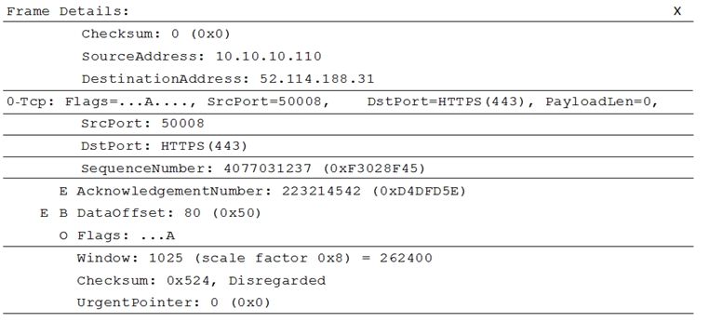
A. The source port range for audio is too narrow.
B. The source port for audio is above 50,000.
C. The UDP traffic is being limited. ✓
D. The TLS traffic is being limited.
- Binh luan:
If a frame has Sequence number and ACK, it means that the protocol is TCP and not UDP. (UDP doesn't have these in it's header)
-> C is correct, because Teams forces TCP only when UDP traffic is limited/blocked
This is correct! The output here is TCP instead of UDP.
yes, that's right.
Network trace is showing TCP traffic:
"TCP is considered a failback transport and not the primary transport you want for real-time media. The reason it’s a failback transport is due to the stateful nature of TCP. For example, if a call is made on a latent network and media packets are delayed, then packets from a few seconds ago—which are no longer useful—compete for bandwidth to get to the receiver, which can make a bad situation worse. This makes the audio healer stitch and stretch audio, res
But what does that actually mean? I'm finding a lot of these Microsoft Learn acticles are not thought out well and are littered with jargon. They assume too much of the learner. I have no idea what TCP is, or what 'failback transport' is, or for that matter what 'stateful nature' means.

Cau 12
Dap an: B
Your company has a Microsoft 365 subscription.
All users have a computer that runs Windows 10 and has Microsoft Teams installed.
A user reports the following issues:
✑ Users lose their connection during screen sharing.
✑ The user selection process takes too long to complete.
✑ The Microsoft Teams client crashes and restarts automatically.
You need to view the Microsoft Teams debug logs to troubleshoot the issues.
What should you do?
A. From the Microsoft Teams client, select F1. Open the ETL files in the %Appdata%\Microsoft\Teams\folder.
B. From the Microsoft Teams client, select Ctrl+Alt+Shift+1. Open the log files in the %Userprofile%\Downloads\ folder. ✓
C. From Event Viewer, open the Application log and filter the log for a keyword of MSTeams.
D. Right-click the Microsoft Teams icon in the application tray, and then select Get logs. Open Logs.txt in the %Appdata%\Microsoft\Teams\ folder.
- Binh luan:
Ctrl+Alt+Shift+1 is the shortcut for the debug logs. So B is the correct answer.
✑ Users lose their connection during screen sharing.
✑ The user selection process takes too long to complete.
✑ The Microsoft Teams client crashes and restarts automatically.
Therefore you need Debug logs --> B --> Ctrl + Alt + Shift + 1
D is Desktop logs and they provide
Desktop logs, also known as bootstrapper logs, contains log data that occurs between the desktop client and the browser. Like media logs, these logs are only needed if requested by Microsoft. The logs are text based and can b
B & D both are correct answers.
B is the correct answer.
downloads the files in C:\Users\username\Downloads\MSTeams Diagnostics Log 23_03_2023__9_00_36_pm.
Has three subfolders
1.desktop
2.meeting
3.web
Option D also does the same thing but D is not the answer as the download location folders given is not correct . Download location is same as option B
On Exam 28.02.22

Cau 13
Dap an: N/A
HOTSPOT -
You open the Microsoft Call Quality Dashboard as shown in the following exhibit.
Use the drop-down menus to select the answer choice that completes each statement based on the information presented in the graphic.
NOTE: Each correct selection is worth one point.
Hot Area:
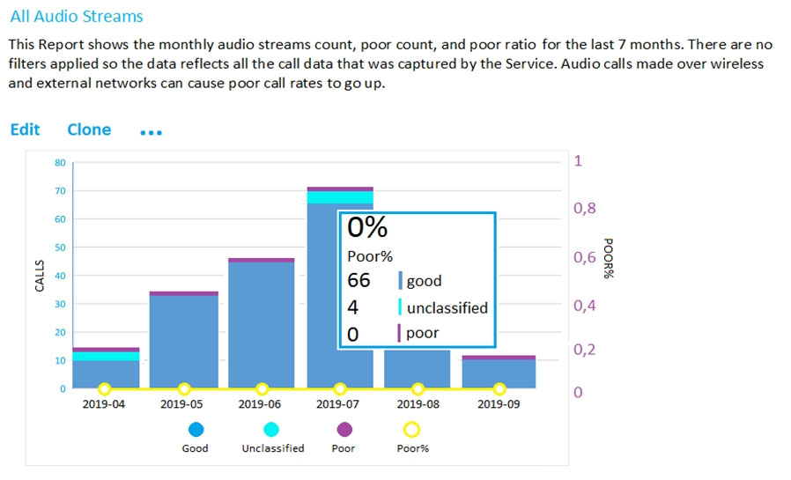
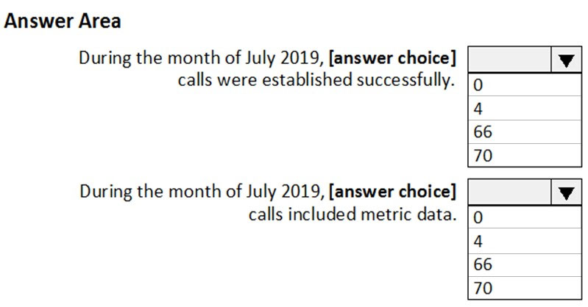
- Binh luan:
Good, poor, and unclassified calls
A call is categorized either as good, poor, or unclassified. Let's take a moment to talk about each one in more detail.
Good or poor: A good or poor call consists of a call that contains a complete set of service metrics, for which a full QoE report was generated and received by the service. Determining whether a stream is good or poor is described earlier in this guide.
Unclassified: An unclassified stream doesn't contain a full set of service metrics. These
Appreciated 🤡
Thank you, crystal clear, appreciate the info.
Wow, thanks for this explanation. That's perfect.
70 in total, 66 with metric data

Cau 14
Dap an: D
Your company has a Microsoft 365 subscription.
The company deploys Microsoft Teams for 5,000 users.
You need to generate a report that contains the following information:
✑ The number of active Microsoft Teams users during the last seven days.
✑ The number of active team channels during the last seven days.
Which usage reports should you run?
A. Teams device usage
B. Teams live event usage
C. Teams user activity
D. Teams usage ✓
- Binh luan:
The Teams usage report in the Microsoft Teams admin center gives you an overview of the usage activity in Teams, including the number of active users and channels
On Exam 28.02.22
sowieso
On test on 06/23
D is correct.

Cau 16
Dap an: A
Note: This question is part of a series of questions that present the same scenario. Each question in the series contains a unique solution that might meet the stated goals. Some question sets might have more than one correct solution, while others might not have a correct solution.
After you answer a question in this section, you will NOT be able to return to it. As a result, these questions will not appear in the review screen.
Your company has 10 offices in North America and Europe.
The company has 5,000 users.
You plan to deploy Microsoft Teams for all the users.
You run a pilot project for the planned deployment.
You need to identify the network packet loss from the pilot computers to Microsoft Teams during calls.
Solution: From the Microsoft Teams admin center, you review the Microsoft Call Quality Dashboard.
Does this meet the goal?
A. Yes ✓
B. No
- Binh luan:
I Would say: A: Yes.
Based on my understanding, by "Packet loss during Calls", they meant Measuring packet loss related to the Calls Flow, it's not about getting the measure in Real Time.
I believe they meant the packet loss is measured during the calls, but it is reviewed after the calls are finished. If this question appear on the exam, I would go with A.
They meant Measuring packet loss related to the Calls Flow, it's not about getting the measure in Real Time.
"DURING" the call
CQD provides quality summary reports that specifically identify Packet Loss:
https://docs.microsoft.com/en-us/microsoftteams/quality-of-experience-review-guide

Cau 17
Dap an: C
You have a Microsoft 365 subscription that uses Microsoft Teams.
You need to identify which teams were inactive during the past 90 days.
What should you use?
A. Teams advisor
B. the Teams user activity report
C. the Teams usage report ✓
D. the Office 365 Groups activity report
- Binh luan:
Why not the other options?
A. Teams advisor: This is a planning tool for Teams deployment, not for activity reporting.
B. Teams user activity report: This shows user-level activity, not team-level inactivity.
C. Teams usage report: This provides usage metrics but does not directly show which teams are inactive over a period.
Teams usage report only shows "active" teams, not "inactive"
The answer is correct

Cau 18
Dap an: D
You have a Microsoft 365 subscription that uses Microsoft Teams.
Users report poor call quality.
You need to identify whether Teams calls use TCP or UDP.
What should you review in the Microsoft Call Quality Dashboard?
A. Endpoint Reports
B. Reliability Reports
C. Quality Drill Down Reports
D. Quality of Experience Reports ✓
- Binh luan:
I think the answer is D, you can see TCP vs UDP usage on the right hand column in Quality of Experience, don't see anything like that in Quality Drill down section.
D looks correct to find it -->Quality of Experience--> Audio Quality-- Conference--> HTTP Proxy Usage--> TCP Usage
from here to the Moon it is :D Quality of Experience
To identify whether Teams calls are using TCP or UDP in the Microsoft Call Quality Dashboard, you should review the Quality of Experience Reports (option D). These reports provide detailed information on the quality of voice and video calls, including the network route used, packet loss, delay, and other metrics that can affect call quality. In these reports, you can identify whether calls are using UDP or TCP.
Correct answer is D .
https://learn.microsoft.com/en-us/MicrosoftTeams/quality-of-experience-review-guide

Cau 19
Dap an: B
Note: This question is part of a series of questions that present the same scenario. Each question in the series contains a unique solution that might meet the stated goals. Some question sets might have more than one correct solution, while others might not have a correct solution.
After you answer a question in this section, you will NOT be able to return to it. As a result, these questions will not appear in the review screen.
Your company has 10 offices in North America and Europe.
The company has 5,000 users.
You plan to deploy Microsoft Teams for all the users.
You run a pilot project for the planned deployment.
You need to identify the network packet loss from the pilot computers to Microsoft Teams during calls.
Solution: From the Microsoft Teams admin center, you review Usage reports.
Does this meet the goal?
A. Yes
B. No ✓
- Binh luan:
No, teams usqge report doesnt provide packetloss info

Cau 20
Dap an: B
You have a Microsoft 365 E5 subscription that uses Microsoft Teams.
Users report poor call quality.
You need to identify the source of the call quality issues and which locations are affected.
What should you do first?
A. Run the Teams user activity report.
B. Upload building data to the Call quality dashboard. ✓
C. Run the Teams device usage report.
D. Upload reporting labels for each location.
- Binh luan:
B
Correct B
In CQD >Quality of experience report category call Quality will give you break down by building or network
https://learn.microsoft.com/en-us/MicrosoftTeams/quality-of-experience-review-guide

Cau 21
Dap an: A, E
Your company has a Microsoft 365 subscription. The subscription contains 200 Microsoft Teams users and a team named IT Support that has 50 members.
You need to ensure that the caller ID for outbound PSTN calls from IT Support is the phone number of the company's IT helpdesk. The solution must minimize administrative effort.
Which two tools should you include in the solution? Each correct answer presents part of the solution.
NOTE: Each correct selection is worth one point.
A. the Microsoft Teams PowerShell module ✓
B. the Azure Active Directory (Azure AD) PowerShell for Graph module
C. the Call Quality Dashboard (CQD)
D. the Exchange Online PowerShell module
E. the Skype for Business admin center ✓
- Binh luan:
Same as topic 4, Q22
i think there is a more recent question in which SFB admin center is replaced with the TAC
Correct answer is A & E.
SFB Admin center is now gone but this question existed till SFB Admin center existed.
Exchange Online PowerShell is incorrect answer.
The solution should be caller ID policies, but If I had to choose two answers from here, I would choose A and E
Yes, we should clearly use the Exchange Powershell module to modify caller ID policies because reasons... /sarc

Cau 22
Dap an: B
Your company has a Microsoft 365 subscription that contains several teams.
The company’s security policy states that an administrator must be notified when a new team is created by using the Build a team from scratch option.
You need to configure the environment to meet the security policy requirement.
What should you do?
A. From the Microsoft Purview compliance portal, enable Communication compliance.
B. From the Microsoft Purview compliance portal, create an alert policy. ✓
C. From the Azure Active Directory admin center, create a protection notification.
D. From the Microsoft Teams admin center, modify the global teams policy.
- Binh luan:
for sure
B
https://learn.microsoft.com/en-us/microsoft-365/compliance/alert-policies?view=o365-worldwide

Cau 23
Dap an: C
You have a Microsoft 365 subscription that uses Teams.
You have 200 Teams devices that are managed by using Microsoft Intune.
You need to review real-time alerts when a Teams device goes offline.
What should you use to configure the alert?
A. the Teams device usage report
B. the Azure portal
C. a device state rule ✓
D. Microsoft Endpoint Manager
- Binh luan:
Correct. https://learn.microsoft.com/en-us/microsoftteams/alerts/device-health-status

Cau 24
Dap an: N/A
DRAG DROP
-
You have a Microsoft 365 subscription that uses Microsoft Teams.
You need to identify the following:
• The number of guest users on a team named Customer Support.
• Users that use the Teams mobile app for iOS.
Which reports should you run? To answer, drag the appropriate reports to the correct requirements. Each report may be used once, more than once, or not at all. You may need to drag the split bar between panes or scroll to view content.
NOTE: Each correct selection is worth one point.
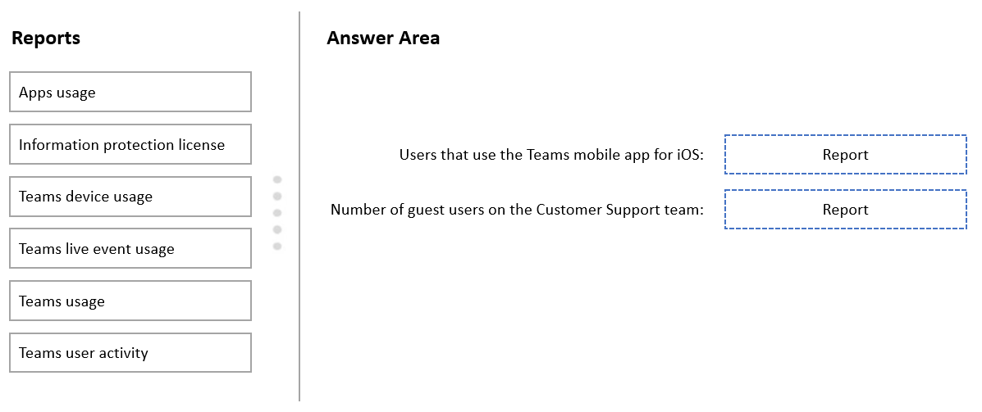
- Binh luan:
i think the first 1 is teams device usage
Correct answer for 1st answer is "Teams device usage". https://learn.microsoft.com/en-us/microsoftteams/teams-analytics-and-reports/device-usage-report
Teams device usage report
Teams usage activity report
https://learn.microsoft.com/en-us/microsoftteams/teams-analytics-and-reports/teams-reporting-reference
will 2nd answer will be Teams User activity?
For the First One Team Device Usage

Cau 25
Dap an: A
You have a Microsoft Office 365 subscription that contains a user named User1.
You need to ensure that User1 can view Usage reports in the Microsoft Teams admin center. The solution must use the principle of least privilege.
Which role should you assign to User1?
A. Usage Summary Reports Reader ✓
B. Skype for Business administrator
C. Global Reader
D. Teams Device Administrator
- Binh luan:
tested the answer is C. Global Reader
Usage Summary Reports Reader: This role grants access to aggregated, tenant-level Teams usage data. This means User1 can see overall trends and usage statistics but cannot access individual user or team data. This aligns with the principle of least privilege by providing the minimum necessary access to fulfill User1's task of viewing usage reports. Global Reader grants read-only access to almost all aspects of Microsoft 365, including user information, licenses, and security settings. It's far t
According https://learn.microsoft.com/en-gb/microsoftteams/teams-analytics-and-reports/teams-reporting-reference#how-to-access-the-reports
Ans : A
To allow User1 to view usage reports in the Microsoft Teams admin center while following the principle of least privilege, the Usage Summary Reports Reader role is the most appropriate. This role provides access to view usage reports across Microsoft 365, including Teams, without granting additional administrative permissions.
Global Reader:
While the Global Reader role can view all administrative features across Microsoft 365, it grants broader read-only access than necessary, violati
Please compare Global Reader and Usage Summary Reports Reader in the admin portal. And portal shows that Usage Summary Reports Reader has fewer privileges.

Cau 26
Dap an: D
Your company uses Teams.
A user named User1 cannot invite guest users to Teams.
What should you recommend using to identify the cause of the issue?
A. Microsoft Teams network Assessment Tool
B. Teams advisor
C. Microsoft 365 network connectivity test tool
D. self-help diagnostics ✓
- Binh luan:
stupid answers!
Ans : D
When a user cannot perform a specific action in Microsoft Teams, such as inviting guest users, self-help diagnostics in the Microsoft 365 Admin Center can be used to identify and resolve the issue. These diagnostics provide insights into configuration or policy settings that may be causing the problem.
D. self-help diagnostics
This tool can help diagnose and resolve common issues within Teams, including guest access problems.
https://learn.microsoft.com/en-us/microsoftteams/guest-access administrators can run a diagnostic tool in the Microsoft 365 admin center to validate that guest access is correctly configured for use in Teams.

Cau 27
Dap an: B
You deploy a Teams Rooms device named Device1.
You need to identify how many outbound meeting minutes were consumed during the last month by Device1.
Which report should you run?
A. Rate My Call Reports
B. Audio Conferencing dial-out usage ✓
C. Summary Reports
D. PSTN & SMS usage
- Binh luan:
looks like it's B
this is B
Answer is B: https://learn.microsoft.com/en-us/microsoftteams/audio-conferencing-dial-out-usage-report
Pretty sure this is B.
Shouldn't this be B?
https://learn.microsoft.com/en-us/microsoftteams/audio-conferencing-dial-out-usage-report

Cau 28
Dap an: B
You have a Microsoft 365 subscription that uses Teams.
Your company uses a license that includes 60 minutes of dial-out for Teams meetings.
You need to review the total costs of each meeting organizer for dial-out calls during meetings.
Which report should you review?
A. PSTN minute and SMS pools
B. Audio Conferencing dial-out usage ✓
C. PSTN and SMS usage
D. the Microsoft Call Quality Dashboard detailed report
E. the Microsoft Call Quality Dashboard summary report
- Binh luan:
Answer: B
https://learn.microsoft.com/en-us/microsoftteams/audio-conferencing-dial-out-usage-report

Cau 29
Dap an: N/A
HOTSPOT
-
Case study
-
Overview
-
Company Information
-
ADatum Corporation is an energy company that has offices across North America and 3,000 employees.
Physical Locations
-
ADatum has the offices shown in the following table.
Existing Environment
-
Network Infrastructure
-
The office in Calgary has a 1-Gbps internet circuit. The offices in San Diego and New York have 100-Mbps internet circuits. The field site in Edmonton has a 3-Mbps internet circuit.
Departments
-
ADatum has the following departments:
• Information technology (IT)
• Project management
• Marketing
Microsoft 365 and Tenants Environment
ADatum recently purchased a Microsoft 365 E5 subscription that has the Microsoft Teams Domestic Calling Plan add-on. All users are assigned Microsoft 365 E5 and Microsoft Teams Domestic Calling Plan licenses and Calling Plans is deployed.
Azure AD has the default Cross-tenant access settings configured.
The Teams policies settings are configured as shown in the following exhibit.
The Teams client is deployed to a non-persistent Virtual Desktop Infrastructure (VDI) used by the project management department.
Allow guest access in Teams is set to Off.
The Microsoft Viva Connections app is deployed to all users.
Problem Statements
-
ADatum identifies the following issues:
• An executive at the San Diego office reports that video drops during Teams meetings.
• The Edmonton field site has limited bandwidth, and users report poor audio during Teams calls and meetings.
• Users in the project management department report that they cannot give or take control during Teams calls and meetings while sharing their VDI desktop.
Planned Changes
-
ADatum plans to implement the following changes:
• Configure the media bit rate settings for the users at the Edmonton field site. The settings must apply only to the user while they are at the site, but NOT when they are at a different office.
• Create a Teams channel to enable the project management department to collaborate with the IT department on a device upgrade project.
• Implement a pilot rollout of Operator Connect for the users in the New York office. A port re-quest was accepted already.
• Create a Teams channel for the marketing department for external collaboration.
• Rename the Viva Connections icon as Start portal.
Technical Requirements
-
ADatum identifies the following technical requirements:
• The marketing department requires that all the files shared by using Teams remain available for at least three years after deletion.
• The marketing department must be able to apply a watermark to content and video shared dur-ing Teams meetings.
• All users require indefinite access to training videos recorded in Teams by the IT department.
• All access to Teams and shared resources must use the principle of least privilege.
• Guest access must remain disabled.
You need to troubleshoot the issues reported by the users in the San Diego office and the Edmonton field site.
What should you use for each office? To answer, select the appropriate options in the answer area.
NOTE: Each correct selection is worth one point.


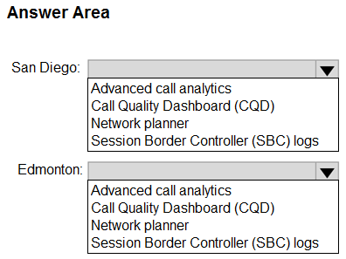
- Binh luan:
what does mean "Advanced Call Analitycs" ?
SanDiego - CQD
Edmonton - Network Planner
First off, what the heck is "Advanced Call Analytics" as it relates to Teams? Edmonton site has limited bandwidth (3 Mbps), so shouldn't we use network planner to determine if provided bandwidth is sufficient for Teams?
Shoud be:
San Diego: Call Quality Dashboard
Edmonton: Advanced Call Analytics
- https://learn.microsoft.com/en-us/microsoftteams/turning-on-and-using-call-quality-dashboard
- https://learn.microsoft.com/en-us/microsoftteams/monitor-call-quality-qos
Is it not?
San Diego: Call Quality Dashboard
Edmonton: Advanced Call Analytics

Cau 30
Dap an: D
You have a Microsoft Office 365 subscription that contains a user named User1.
You need to ensure that User1 can view Usage reports in the Microsoft Teams admin center. The solution must use the principle of least privilege.
Which role should you assign to User1?
A. Teams Administrator
B. Teams Communication Support Specialist
C. Teams Device Administrator
D. Global Reader ✓
- Binh luan:
Correct answer: D
For Teams Communications Support Specialist,
Can do these tasks
Troubleshoot communications issues within Teams by using basic tools.
Can access the following tools
1. Access user profile page for troubleshooting calls in Call Analytics. Can only view user information for the specific user being searched for.
2. Access, monitor, and troubleshoot tenant's call quality and reliability using data exposed in Call Quality Dashboard (CQD).
https://learn.microsoft.com/en-us/micros
I was skeptical but after assigning Teams Communication Support Specialist, I was not able to choose/find Usage Reports in TAC...

Cau 31
Dap an: N/A
DRAG DROP
-
Your company uses Teams.
Two users named User1 and User2 use the Teams client for Windows.
The users report the following issues:
• User1 reports that when attempting to sign in, the Teams client remains on the sign-in page.
• User2 reports receiving an error when attempting to screen share during a Teams meeting.
You need to troubleshoot the issues.
Which client-side log should you review for each user? To answer, drag the appropriate logs to the correct users. Each log may be used once, more than once, or not at all. You may need to drag the split bar between panes or scroll to view content.
NOTE: Each correct selection is worth one point.
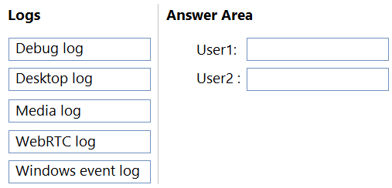
- Binh luan:
the answers look correct: Debug logs show Login, Connection requests to middle-tier services, Call/conversation and Media logs contain diagnostic data about audio, video, and screen sharing in Teams meetings.
See https://learn.microsoft.com/en-us/microsoftteams/log-files

Cau 33
Dap an: C
You have a Microsoft 365 subscription that uses Teams.
You need to upload network IP subnet information to call analytics.
What should you configure?
A. Voice application policies
B. Network topology
C. Reporting labels ✓
D. Notification & alerts
- Binh luan:
Reporting labels are used to give an IP subnet a name that links it to a physical location such as offices, buildings, or organizational sites within your organization.
https://learn.microsoft.com/en-us/microsoftteams/learn-more-about-site-upload
yes, looks correct here too: https://learn.microsoft.com/en-us/microsoftteams/set-up-call-analytics as you upload the reporting labels

Cau 34
Dap an: B
Your company uses Teams.
A user named User1 reports audio issues in meetings.
You suspect that the issues were caused by an audio device or audio device driver.
You need to identify which device and driver were used during past meetings.
What should you do in the Microsoft Teams admin center?
A. From Usage reports, review the Teams user activity report.
B. From Manage users, review the Meetings & Calls tab. ✓
C. From Manage users, review the Teams devices tab.
D. From Usage reports, review the Teams device usage report
- Binh luan:
The answer is B: Manage Users > Select User 1 > select meetings and calls tab > scroll down to past meetings > select the meeting ID > click on participant details tab > click on the start time. The window that opens shows the devices used and the associated drivers.
Usage reports only specifies which OS is used

Cau 35
Dap an: D
You have a Microsoft 365 E5 subscription.
You plan to use Teams.
You run the Microsoft 365 network connectivity test tool and generate a report.
You discover that the Microsoft Teams section of the report has a warning notification for media connectivity.
You suspect a firewall issue at the test location.
Which destination protocol and port range should you configure on the firewall?
A. UDP ports 50020 through 50059
B. TCP ports 3478 through 3481
C. UDP ports 50000 through 50019
D. UDP ports 3478 through 3481 ✓
- Binh luan:
100% UDP ports 3478 through 3481
Oops, I meant to select answer D.
UDP ports 3478 through 3481
UDP is used, instead of TCP
UDP ports 3478 through 3481, UDP for outbound:3478, 3479, 3480, 3481, TCP:443, 80. We are not open ports coming in, just out to access clouds from the local.

Cau 36
Dap an: E
You have a Microsoft 365 E5 subscription that uses Teams with Operator Connect.
You plan to deploy Teams conference phones that support PSTN calls and one-touch join for Teams calendar meetings.
Which license should you assign to each conference phone?
A. Microsoft 365 E5
B. Microsoft Teams Shared Device
C. Microsoft 365 Business Standard
D. Microsoft 365 E3
E. Teams Rooms Pro ✓
- Binh luan:
Correct answer should be B:
https://learn.microsoft.com/en-us/microsoftteams/phones/phones-for-teams#licenses-for-teams-devices
teams room pro is the correct answer
Teams Rooms Pro license: If you are using the audio-conferencing device in a small meeting room, you will need a Teams Rooms Pro license that will allow you to join audio meetings with one touch.
You have a Microsoft 365 E5 subscription that uses Teams with Operator Connect.
Why will the correct answer be the same as the question?
I think the answer is "E"
https://techcommunity.microsoft.com/t5/microsoft-teams-blog/how-to-deploy-teams-phone-devices/ba-p/3994979

Cau 37
Dap an: A
Your company uses Teams.
All users are assigned a Microsoft 365 F1 license.
You need to retain chats and files in Teams channels for at least one year after they are deleted.
What should you do first?
A. Assign the users a Microsoft 365 E3 license. ✓
B. Assign the users a Microsoft 365 F3 license.
C. From the Microsoft 365 admin center, enable Customer Lockbox.
D. From the Audit settings of the Microsoft Purview compliance portal, select Start recording user and admin activity.
- Binh luan:
Shouldn't it be B? Because it's cheaper than an E3 and the F3 includes Microsoft Purview Data Lifecycle Management, which allows to create retention policies
A and b should not be needed so D https://learn.microsoft.com/en-us/office365/servicedescriptions/microsoft-365-service-descriptions/microsoft-365-tenantlevel-services-licensing-guidance/microsoft-365-security-compliance-licensing-guidance#licensing-for-retention-label-policies
That don't make sense. Please remove
If the retention policy location is Microsoft Teams chats, channels, or private channels, then the following licenses also provide user rights. The retention or deletion period must be more than 30 days for the plans that are underlined:
Microsoft 365 E5/G5/A5/E3/G3/A3/F3/F1, Business Basic, Business Standard, and Business Premium
https://learn.microsoft.com/en-us/office365/servicedescriptions/microsoft-365-service-descriptions/microsoft-365-tenantlevel-services-licensing-guidance/microsoft-36
Since "files" are also included in the retention target, isn't there a lack of permissions?

Cau 39
Dap an: N/A
HOTSPOT
-
You have a Microsoft 365 subscription that uses Teams.
You need to create a custom policy named Policy1 that will disable the ability to send feedback and suggestions about Teams to Microsoft.
How should you complete the PowerShell command? To answer, select the appropriate options in the answer area.
NOTE: Each correct selection is worth one point.
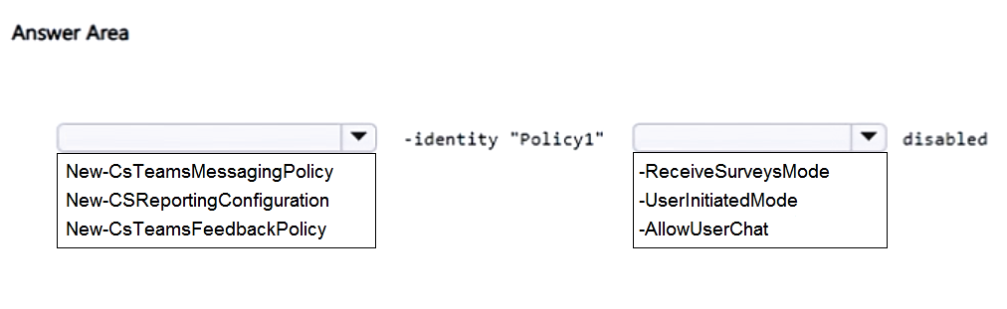

Cau 40
Dap an: C
You have a Microsoft 365 E5 subscription that includes Teams.
You need to recommend a solution to investigate actions that relate to the following Teams activities:
• A new team is created.
• A new channel is added to a team.
• A team member changes their role membership.
The solution must ensure that you can specify a start date and end date of the activities.
What should you include in the recommendation?
A. eDiscovery
B. Teams advisor
C. Microsoft Purview Audit ✓
D. Teams usage reports

Cau 41
Dap an: C
Your company uses Teams.
You are assigned the Teams Communications Support Specialist role.
You discover that you cannot read activity reports in the Microsoft 365 admin center.
You need to be assigned a role that will enable you to read the activity reports. The solution must follow the principle of least privilege.
Which role should be assigned to you?
A. Teams Administrator
B. Global Administrator
C. Teams Communications Administrator ✓
D. Teams Communications Support Engineer
- Binh luan:
Teams Communication Administrqtor
C https://learn.microsoft.com/en-us/microsoft-365/admin/activity-reports/activity-reports?view=o365-worldwide
Assigning the Teams Communications Support Engineer role is the correct choice because it provides access to activity reports without granting excessive permissions. This aligns with the principle of least privilege.
C is correct.
https://learn.microsoft.com/en-us/microsoft-365/admin/activity-reports/activity-reports?view=o365-worldwide#who-can-see-reports
https://learn.microsoft.com/en-us/microsoftteams/using-admin-roles

Cau 42
Dap an: D
You have a Microsoft 365 E5 subscription that includes Teams. All users are assigned the Teams Premium add-on license.
You have a team named Team1 that contains a channel named Quality.
You plan to monitor audio and video quality during meetings for a user named User1.
You need to ensure that the Quality channel receives a post whenever User1 experiences inbound packet loss that is greater than 5 percent during meetings.
What should you do?
A. Install the Microsoft Power BI connector for Call Quality Dashboard (CQD).
B. Configure a template policy.
C. Create a custom calling policy.
D. Configure an alert rule. ✓
- Binh luan:
To proactively monitor meeting quality in Microsoft Teams, you can configure rule-based notifications within the Teams admin center under "Notifications & Alerts > Rules". These rules allow you to monitor audio, video, and application sharing quality for specific users and receive alerts when predefined thresholds are met

Cau 43
Dap an: E
You have a Teams deployment.
You need to ensure that a user named User1 can perform the following tasks from the Call Quality Dashboard (CQD):
• Create new Microsoft Power BI reports that contain CQD data.
• View the IP addresses and MAC addresses of users.
• Upload office location details, including IP ranges.
The solution must follow the principle of least privilege.
Which role should you assign to User1?
A. Teams Communications Support Engineer
B. Teams Communications Support Specialist
C. Teams Administrator
D. Teams Telephony Administrator
E. Teams Communications Administrator ✓
- Binh luan:
E — Teams Communications Administrator
Teams Communications Support Engineer ✅
This role has access to advanced features in the Call Quality Dashboard (CQD), including:
Creating and editing Power BI reports with CQD data
Viewing IP and MAC addresses
Uploading office location data for location-based insights
Teams Communications Support Specialist cannot create Power BI reports, view IP/MAC addresses, or upload location data.
Teams Administrator This role has full admin access to Teams, including settings, policies, and teams manage
A. Teams Communications Support Engineer ====> cant upload locations
B. Teams Communications Support Specialist ====> no access to IP
C. Teams Administrator
D. Teams Telephony Administrator ===> no access to CQD
E. Teams Communications Administrator

Cau 44
Dap an: N/A
HOTSPOT
-
Your company has two branch offices named Branch1 and Branch2. The company uses Teams.
You plan to deploy Teams to the branch offices. The solution must meet the following requirements:
• Users in Branch1 must use only audio and video for meetings.
• Users in Branch2 must be able to enable Together Mode for meetings.
• Network bandwidth costs must be minimized.
What is the minimum bandwidth required for each branch office? To answer, select the appropriate options in the answer area.
NOTE: Each correct selection is worth one point.
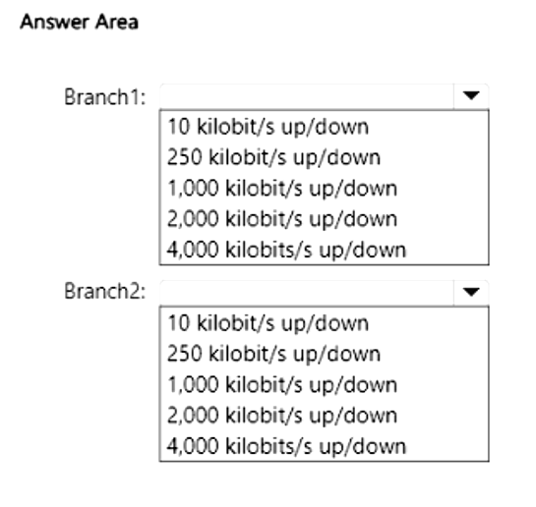
- Binh luan:
Branch1 → 250 kbps up/down
Branch2 → 2,000 kbps up/down
seems correct
https://learn.microsoft.com/en-us/microsoftteams/prepare-network

Cau 45
Dap an: A
You have a Teams deployment.
You deploy the new Teams client to users.
The users report that a third-party Teams store app fails to load.
You need to identity the cause of the issue.
What should you do?
A. Enable Extended diagnostics data for the new Teams client. ✓
B. Run the Microsoft 365 network connectivity test tool.
C. Run the Teams client in a browser and open the developer tools.
D. Run sfc.exe as an administrator.
- Binh luan:
I would not change it to A. Microsoft’s Teams app troubleshooting guidance says to use Developer Tools to troubleshoot app-load problems and inspect the Network tab plus the error response details when a Teams app fails to load. That is the direct way to identify the cause of a third-party Teams app loading failure.
Why A is tempting but not best: Extended diagnostics data/logging is about sending richer diagnostic data to Microsoft and collecting more logs; Microsoft specifically calls out tur
Enable Extended diagnostics data for the new Teams client.
Enabling extended diagnostics data provides detailed logs and information about the Teams client's operation, including app loading processes. This allows for a thorough investigation into why the third-party app is failing to load.

Cau 46
Dap an: N/A
HOTSPOT
-
You have a Microsoft 365 E5 subscription and use Microsoft Teams.
A user named User1 reports that when they use a new headset during meetings, the audio cuts in and out.
You instruct User1 to collect support files from their Teams client.
You discover that the audio debugging files are missing from the support files.
You need to ensure that User1 can collect the correct support files.
How should you complete the PowerShell command? To answer, select the appropriate options in the answer area.
NOTE: Each correct selection is worth one point.
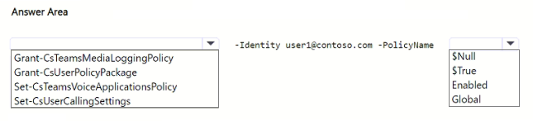

Cau 47
Dap an: A
Note: This section contains one or more sets of questions with the same scenario and problem. Each question presents a unique solution to the problem. You must determine whether the solution meets the stated goals. More than one solution in the set might solve the problem. It is also possible that none of the solutions in the set solve the problem.
After you answer a question in this section, you will NOT be able to return. As a result, these questions do not appear on the Review Screen.
You have a Teams deployment.
A user cannot sign in to Teams.
You need to run self-help diagnostics to troubleshoot the issue.
Solution: From Connectivity Tests in Microsoft Remote Connectivity Analyzer, you select Microsoft Teams.
Does this meet the goal?
A. Yes ✓
B. No
- Binh luan:
The Remote Connectivity Analyzer is literally built for self-help troubleshooting, not admin-level deep diagnostics.
Selecting Microsoft Teams in the tool will run:
Sign-in diagnostic
Token acquisition test
Service endpoint tests
So the proposed solution meets the stated goal.

Cau 48
Dap an: B
Note: This section contains one or more sets of questions with the same scenario and problem. Each question presents a unique solution to the problem. You must determine whether the solution meets the stated goals. More than one solution in the set might solve the problem. It is also possible that none of the solutions in the set solve the problem.
After you answer a question in this section, you will NOT be able to return. As a result, these questions do not appear on the Review Screen.
You have a Teams deployment.
A user cannot sign in to Teams.
You need to run self-help diagnostics to troubleshoot the issue.
Solution: From the Microsoft 365 admin center, you select Service health.
Does this meet the goal?
A. Yes
B. No ✓
- Binh luan:
Service Health in Microsoft 365 admin center shows the operational status of Microsoft services (Teams, Exchange, SharePoint, etc.).
It lists current outages, incidents, or advisories.
This is passive — it doesn’t run diagnostics.
If sign-in fails because of a global outage, Service health would alert you.
But if the issue is user-specific (credentials, device/network), Service Health won’t help — you need actual diagnostics.

Cau 49
Dap an: B
Note: This section contains one or more sets of questions with the same scenario and problem. Each question presents a unique solution to the problem. You must determine whether the solution meets the stated goals. More than one solution in the set might solve the problem. It is also possible that none of the solutions in the set solve the problem.
After you answer a question in this section, you will NOT be able to return. As a result, these questions do not appear on the Review Screen.
You have a Teams deployment.
A user cannot sign in to Teams.
You need to run self-help diagnostics to troubleshoot the issue.
Solution: From the Microsoft Teams admin center, you select Teams advisor.
Does this meet the goal?
A. Yes
B. No ✓
- Binh luan:
Teams advisor is for deployment planning.
Troubleshooting sign‑in issues requires tools like Microsoft 365 admin center's self‑diagnostics, Remote Connectivity Analyzer, or Teams logs — not Teams advisor.

Cau 50
Dap an: A, E
You have a Teams deployment.
You need to run different kinds of reports to gain insight into how your organization uses Teams.
Which two reports require a Teams Premium license? Each correct answer presents a complete solution.
NOTE: Each correct selection is worth one point.
A. Teams with the most external user and guest activity ✓
B. Inactive teams
C. Apps usage
D. Teams webinar usage
E. Advanced Virtual Appointments activity ✓
- Binh luan:
https://learn.microsoft.com/en-us/microsoft-365/frontline/advanced-virtual-appointments-activity-report?view=o365-worldwide&utm_source=chatgpt.com
https://support.microsoft.com/en-au/office/overview-of-microsoft-teams-premium-4b34cd18-fa16-4797-bae0-b96b13a54f52?utm_source=chatgpt.com
The answer is Inactive Teams and Teams with the most external user and guest activity
These need Premium

Cau 51
Dap an: N/A
HOTSPOT
-
You have a Microsoft 365 subscription that uses Teams.
You plan to deploy Teams to a branch office named Branch1.
You need to review Microsoft 365 network telemetry insights and estimate the required network bandwidth required for the deployment to Branch1.
What should you do for each requirement? To answer, select the appropriate options in the answer area.
NOTE: Each correct selection is worth one point.
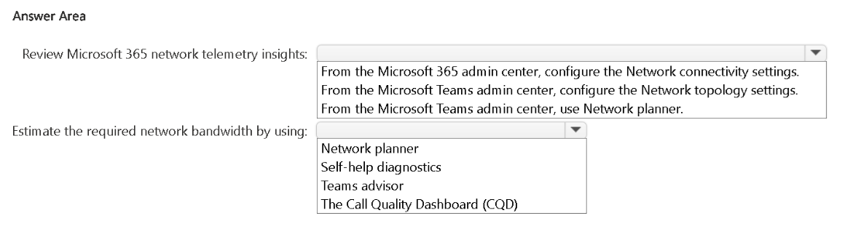
- Binh luan:
Review Microsoft 365 network telemetry insights:
➡ From the Microsoft 365 admin center, configure the Network connectivity settings.
Estimate the required network bandwidth by using:
➡ Network planner
https://learn.microsoft.com/en-us/microsoft-365/enterprise/microsoft-365-networking-overview?view=o365-worldwide
https://learn.microsoft.com/en-us/microsoftteams/network-planner

Cau 52
Dap an: A
You have a Teams deployment.
You deploy the new Teams client to users.
Some users report that the Teams Meeting add-in is missing from Microsoft Outlook after the deployment.
You need to ensure that Outlook has the Teams Meeting add-in.
What should you do?
A. Uninstall the Teams Meeting add-in and restart Teams and Outlook. ✓
B. Clear the Teams client cache,
C. Run the Teams client as an administrator.
D. Run sfc.exe.
- Binh luan:
https://learn.microsoft.com/en-us/troubleshoot/microsoftteams/meetings/resolve-teams-meeting-add-in-issues
https://learn.microsoft.com/en-us/troubleshoot/microsoftteams/meetings/teams-meeting-add-in-missing

Cau 53
Dap an: A
You have a Microsoft 365 E5 subscription and use Microsoft Teams.
A user reports a negative Teams meeting experience.
Your network team plans to troubleshoot the issue.
You need to provide the network team with the IP address information used during the meeting.
What should you use?
A. Call Analytics ✓
B. Microsoft Support and Recovery Assistant
C. Teams client debug logs
D. Teams client media logs
- Binh luan:
https://learn.microsoft.com/en-us/microsoftteams/use-call-analytics-to-troubleshoot-poor-call-quality

Cau 54
Dap an: D
You have a Teams deployment.
You start a meeting and enable the following settings:
• Enable Green room
• Provide CART Captions
• Enable end-to-end Encryption
• Anonymous users can join the meeting
What feature is no longer available during the meeting?
A. Raise hand
B. reactions
C. screen sharing
D. breakout rooms ✓
- Binh luan:
When you enable end-to-end encryption (E2EE) in Microsoft Teams meetings, several features become unavailable in order to maintain full encryption protection. According to Microsoft documentation, the following are restricted during E2EE:
Meeting recording
Transcription and captions (other than CART captions)
Breakout rooms
Together mode
Large gallery
Call transfer and consult features
Breakout rooms are not supported if you enable end to end encryption.

Cau 55
Dap an: N/A
DRAG DROP
-
You have a Microsoft 365 subscription.
You plan to deploy Teams to support Teams Phone and Teams meetings.
You need to assess the network environment to identity the following for the planned deployment:
• Common configurations that must be updated.
• Whether the IP address and port settings between the local network and Microsoft 365 are configured correctly.
What should you use? To answer, drag the appropriate tools to the correct requirements. Each tool may be used once, more than once, or not at all. You may need to drag the split bar between panes or scroll to view content.
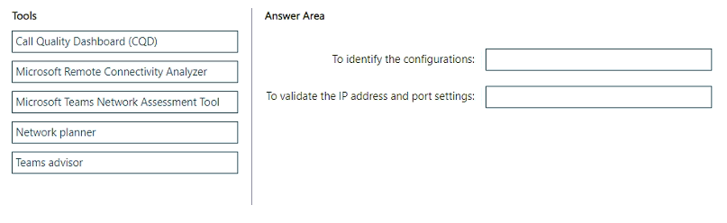
- Binh luan:
Sorry, This is the final correct answer:
dentify the configurations Teams Advisor
Validate the IP/port settings Microsoft Remote Connectivity Analyzer
To identify the configurations: Teams advisor
To validate the IP address and port settings: Microsoft Teams Network Assessment Tool
It's Teams Advisor for the first 1, Teams Network Assessment Tool for the second

