Exercise 1:
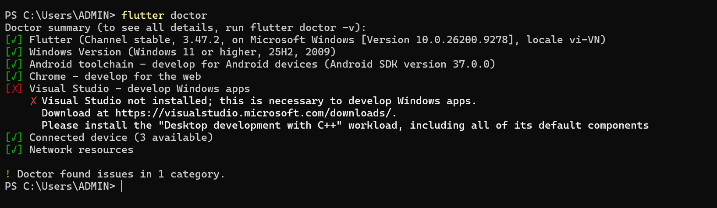
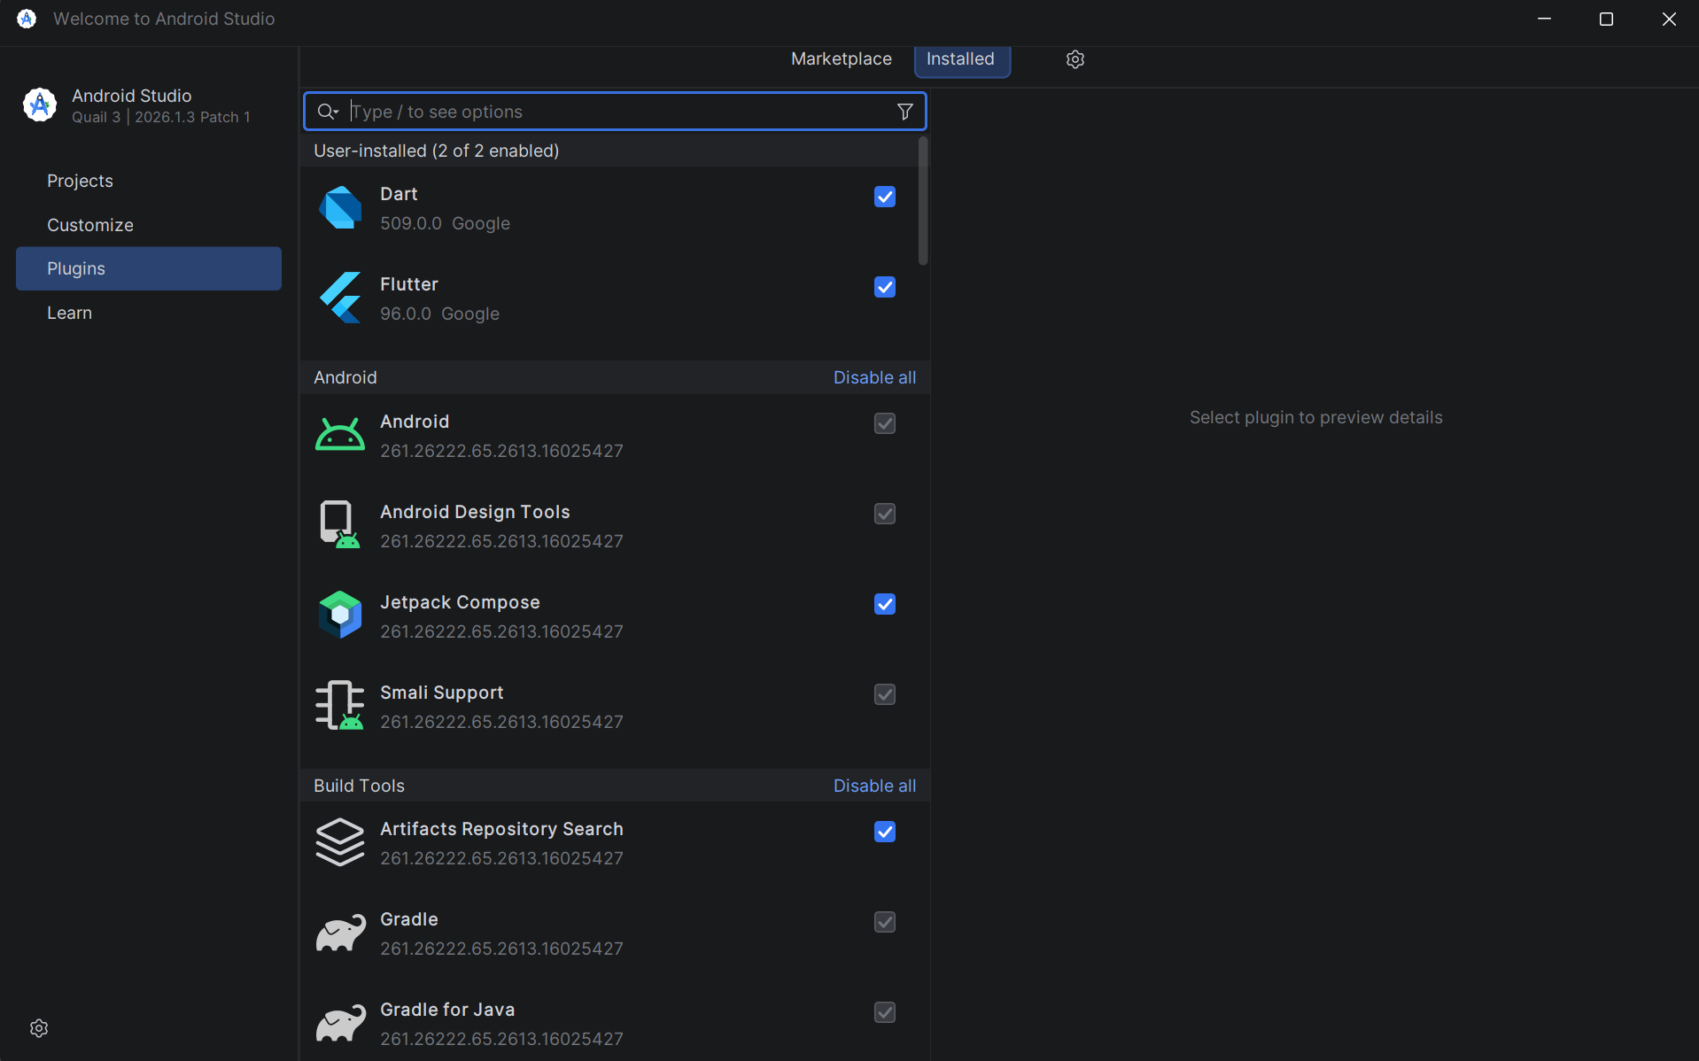

Exercise 2:
Create flutter project: hello_flutter_lab1
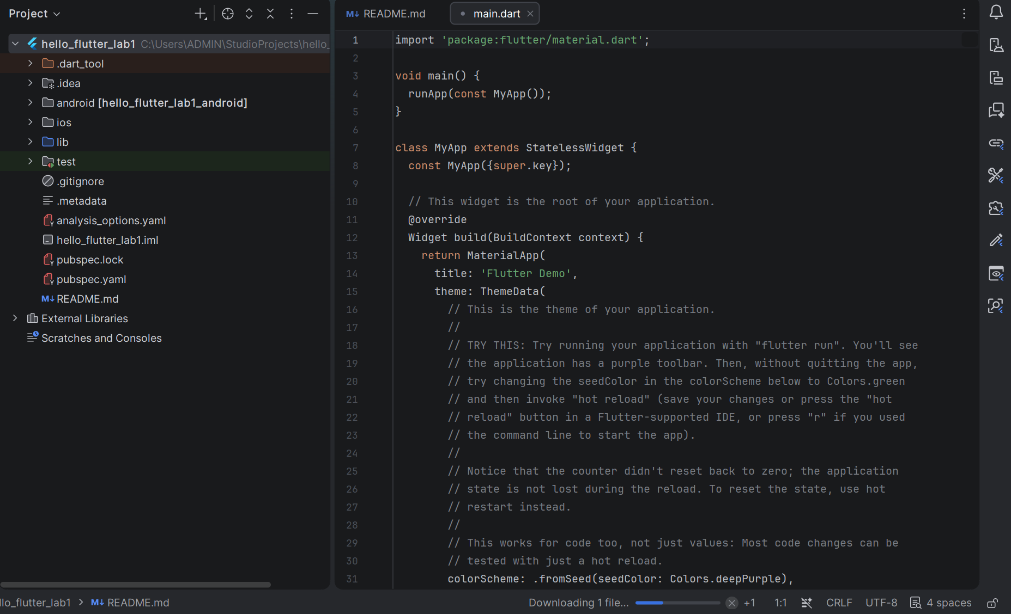

Running counter app
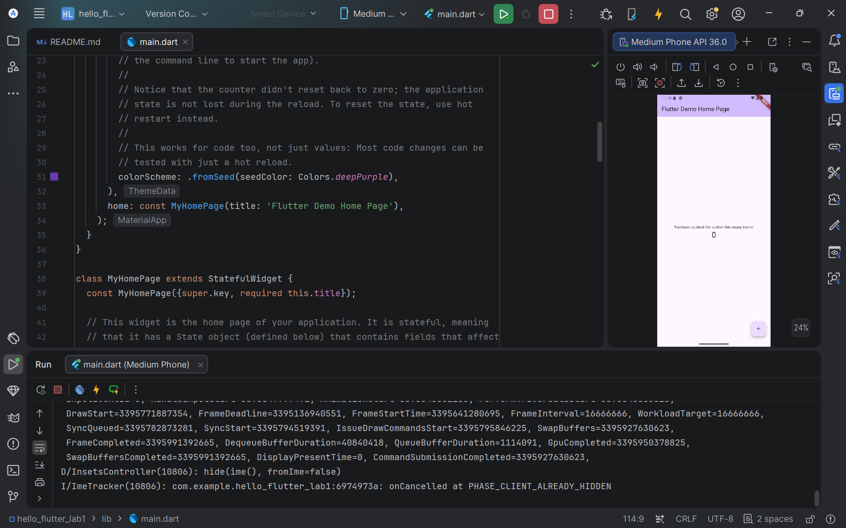

Hot reload:
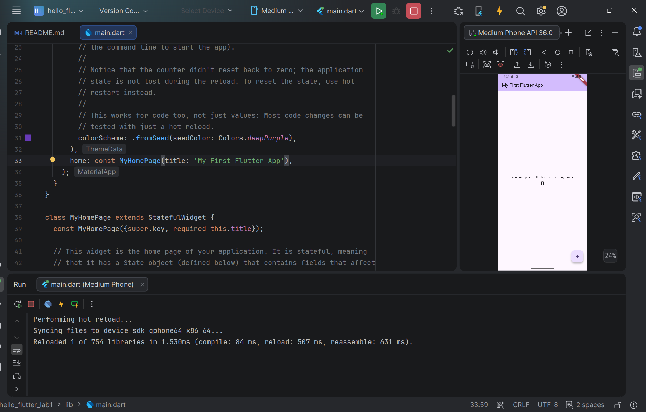

Exercise 3:
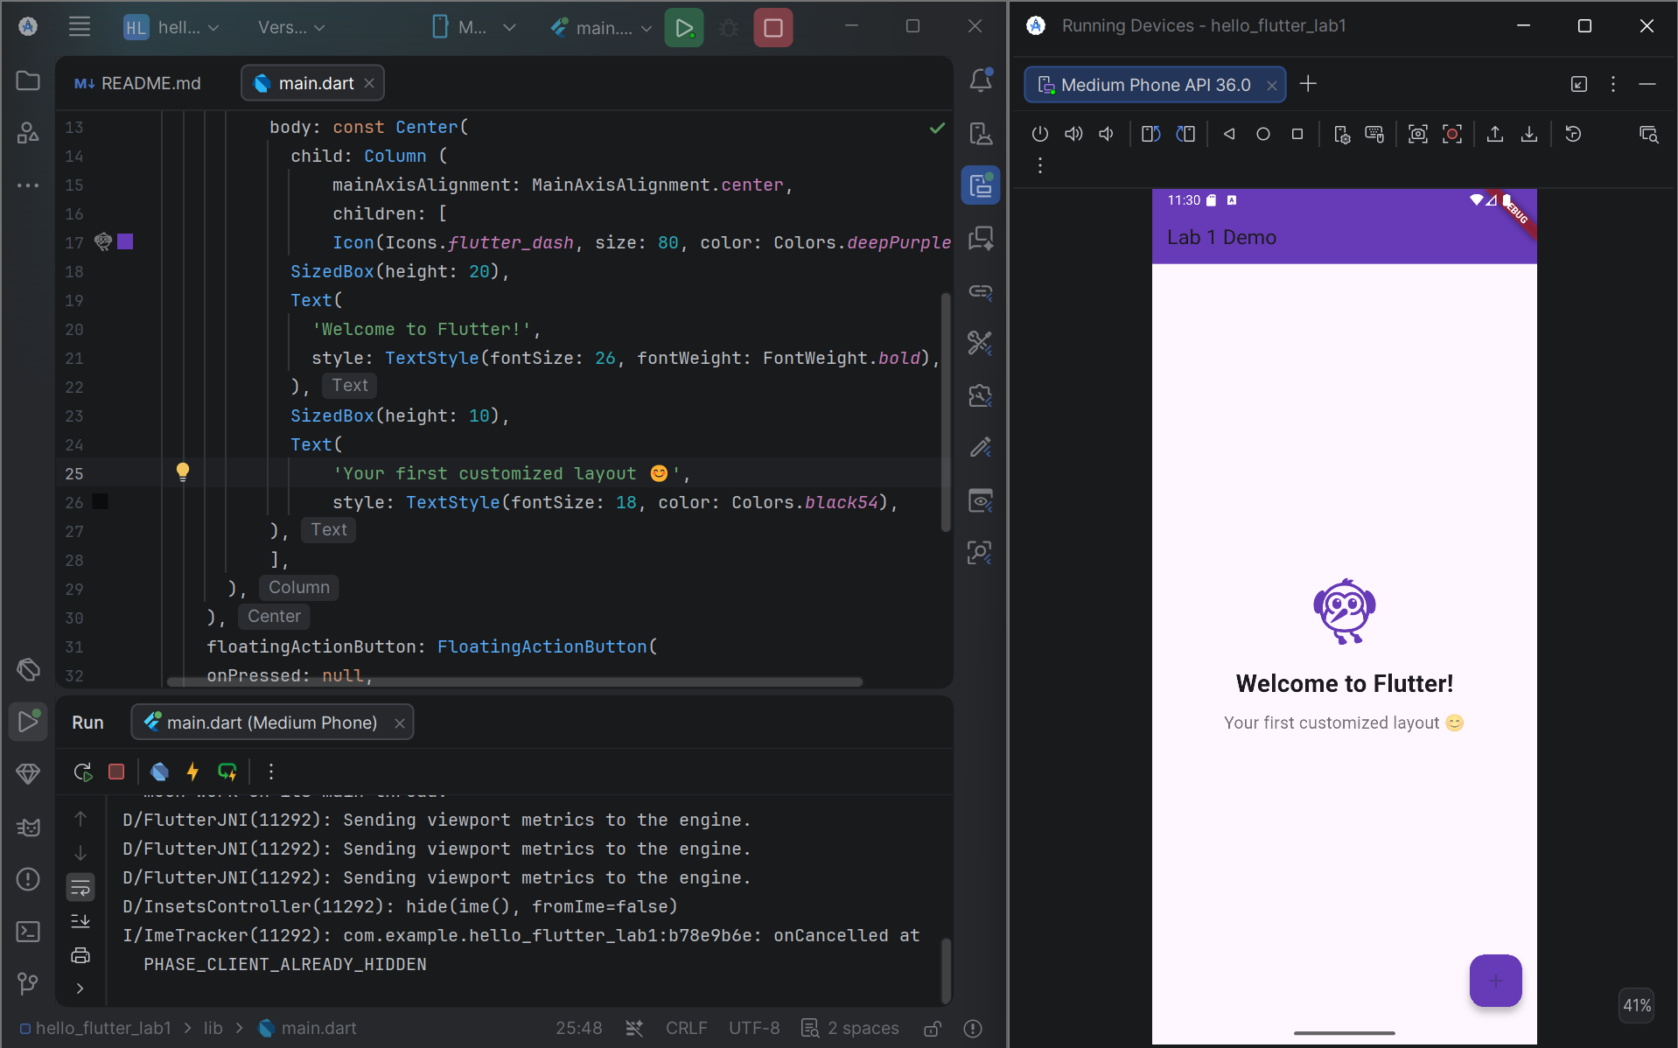
Modify colors/text and reload again:
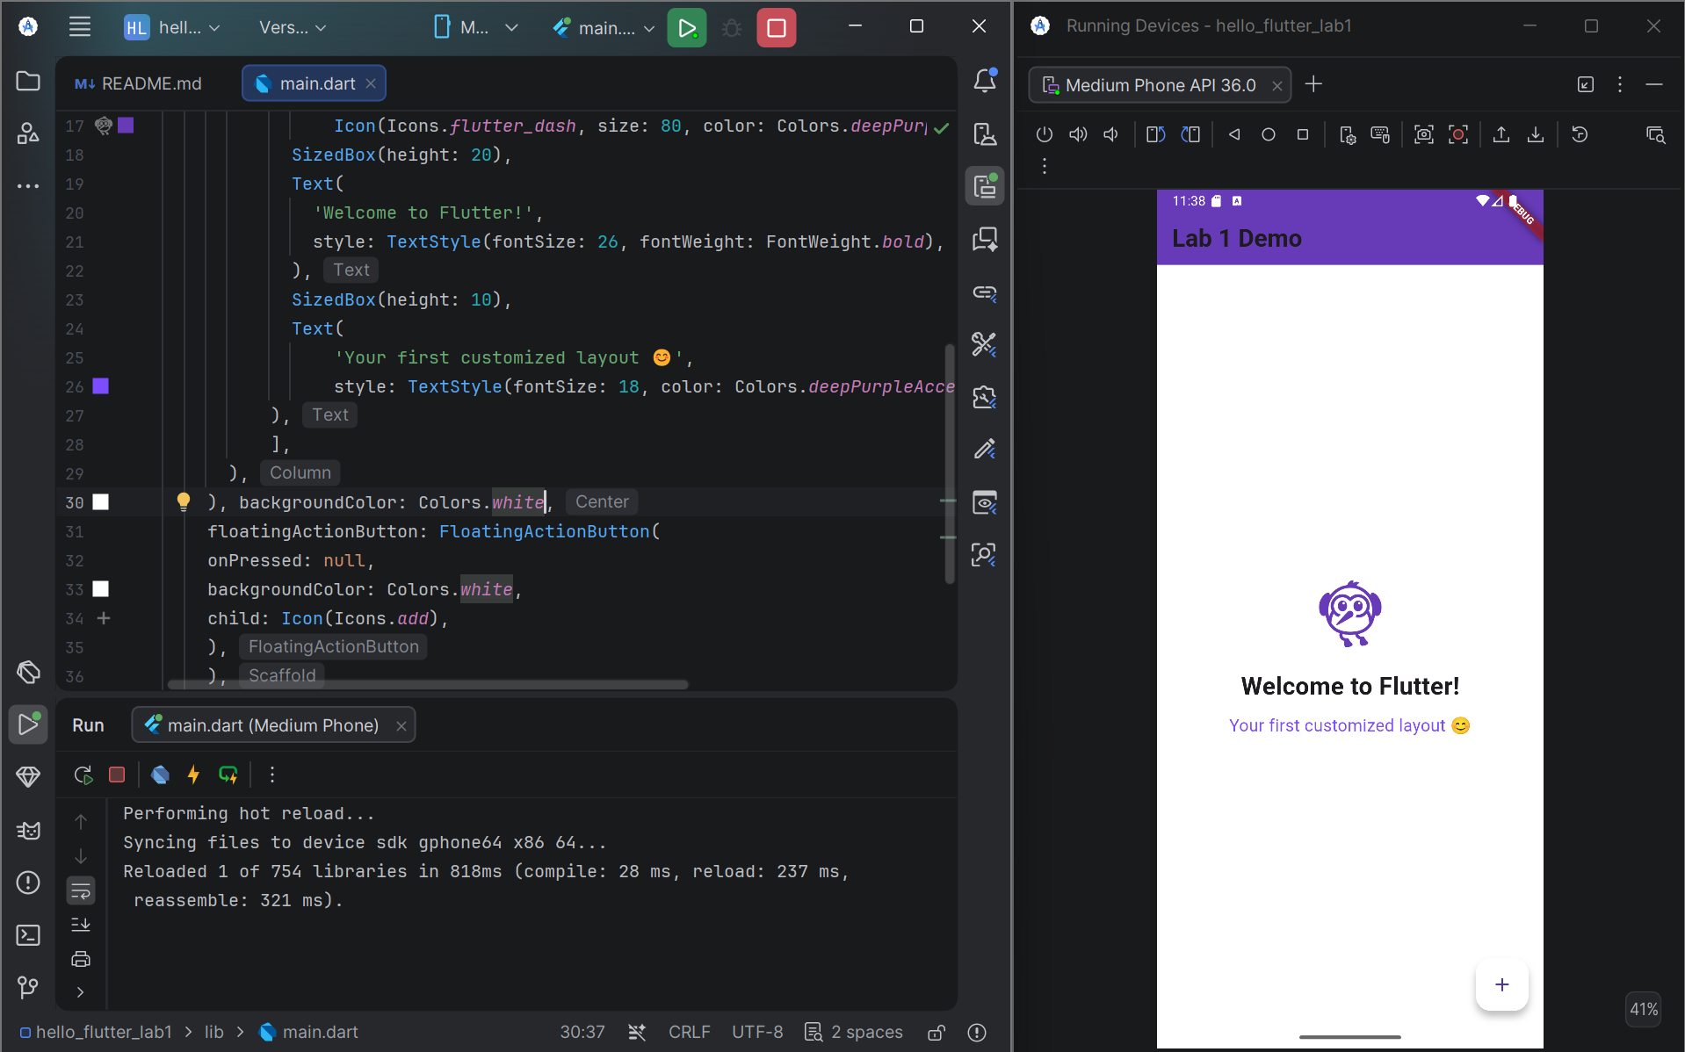

Exercise 4:
1. What is the purpose of the flutter doctor command?
flutter doctor is used to check whether the Flutter development environment is correctly configured. It checks Flutter SDK, Dart, Android SDK, connected devices, and other required development tools, and reports any problems that need to be fixed.
2. What file acts as the entry point of a Flutter application?
The lib/main.dart file acts as the entry point of a Flutter application. It contains the main() function, which is the first function executed when the application starts.
Example:
void main() {
runApp(const MyApp());
}
3. Explain the difference between Hot Reload and Hot Restart.
Hot Reload applies code changes to the running application without restarting the entire application. It usually preserves the current application state.
Hot Restart completely restarts the Flutter application and rebuilds the widget tree from the beginning. Therefore, the current application state is reset.
4. How does runApp() build the widget tree?
runApp() takes a widget as the root of the application and attaches it to the Flutter framework. Flutter then builds the widget tree starting from this root widget. The child widgets are recursively created from the parent widgets, forming the complete UI structure.
5. Describe how Flutter’s architecture enables cross-platform development.
Flutter uses a single codebase written mainly in Dart and provides its own widget framework and rendering system. The same Flutter application can be compiled and run on multiple platforms, such as Android, iOS, Windows, macOS, and Web. This allows developers to reuse most of the application code instead of developing a completely separate application for each platform.

