My First Markdown

David Nguyen

9/14/2019

Double space to go to next line  
Bold - **bold** **hello**  
Italics - *Italics* *hello*  
2nd way to Italics - *Italics*

# Title

## Subtitle

### Section title

#### Subsection title

* bullet list 1
* bullet list 2
* bullet list 3

1. Ordered List 1
2. Ordered List 2
3. Ordered List 3
4. Ordered List 1
5. Ordered List 2
6. Ordered List 3

ggplot(data = gapminder, aes(x = gdpPercap, y = lifeExp)) +  
 geom_point(aes(color=continent)) +  
 scale_x_log10()

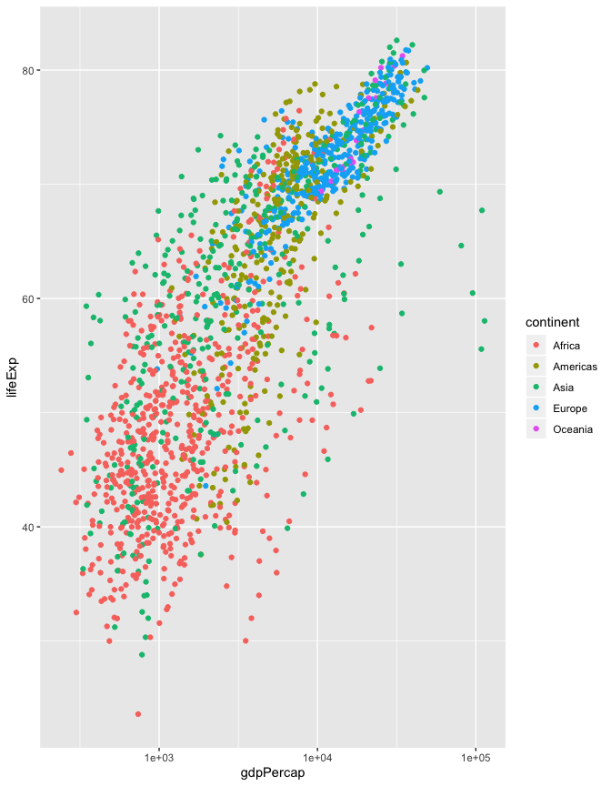

The mean life expectancy of Sweden is 76.177