BATTLES OF NEIGHBORHOODS

**I. INTRODUCTION TO BUSINESS**

This project is about analyzing two big financial cities in the world, which are City of Toronto in Canada and New York City in New York. In the project, we need to analyze the difference and similarity of these two cities. This analysis will be the foundation that is used to advise contractors to make decision about starting their own business. The project will have two parts, which is defined as:

1. Part 1: Comparison between City of Toronto and New York City.
2. Part 2: Advising contractors that which neighborhood is promising for them to open their own restaurant or office.

**II. ANALYZING AND DISCUSSION**

* Part 1 :

1. Desired Data:

- As we all know, for big cities in the developed country, its population is often high. The higher population will usually lead to many social problems. And the most serious social problems are crime and traffic. Therefore, in the first part, the desired data will be crime rate, the traffic collision, and population between two cities. In fact, these data will be really important to evaluate cities potential business and public safety.

1. Data Sources:

- City of Toronto crime data for each Borough is from Open Toronto.

- New York City crime data for each Borough is from Kaggle dataset

- New York City and City of Toronto population data from Kaggle and Wikipedia dataset respectively.

1. Data Comparison – Similarity and Dissimilarity

**Crime**

In the illustration below shows the rate of crime that can happen to one person in New York City and City of Toronto. In general, New York City crime rate is declined over the years. However it is different for City of Toronto crime rate since it is increasing from 2015 to 2018.

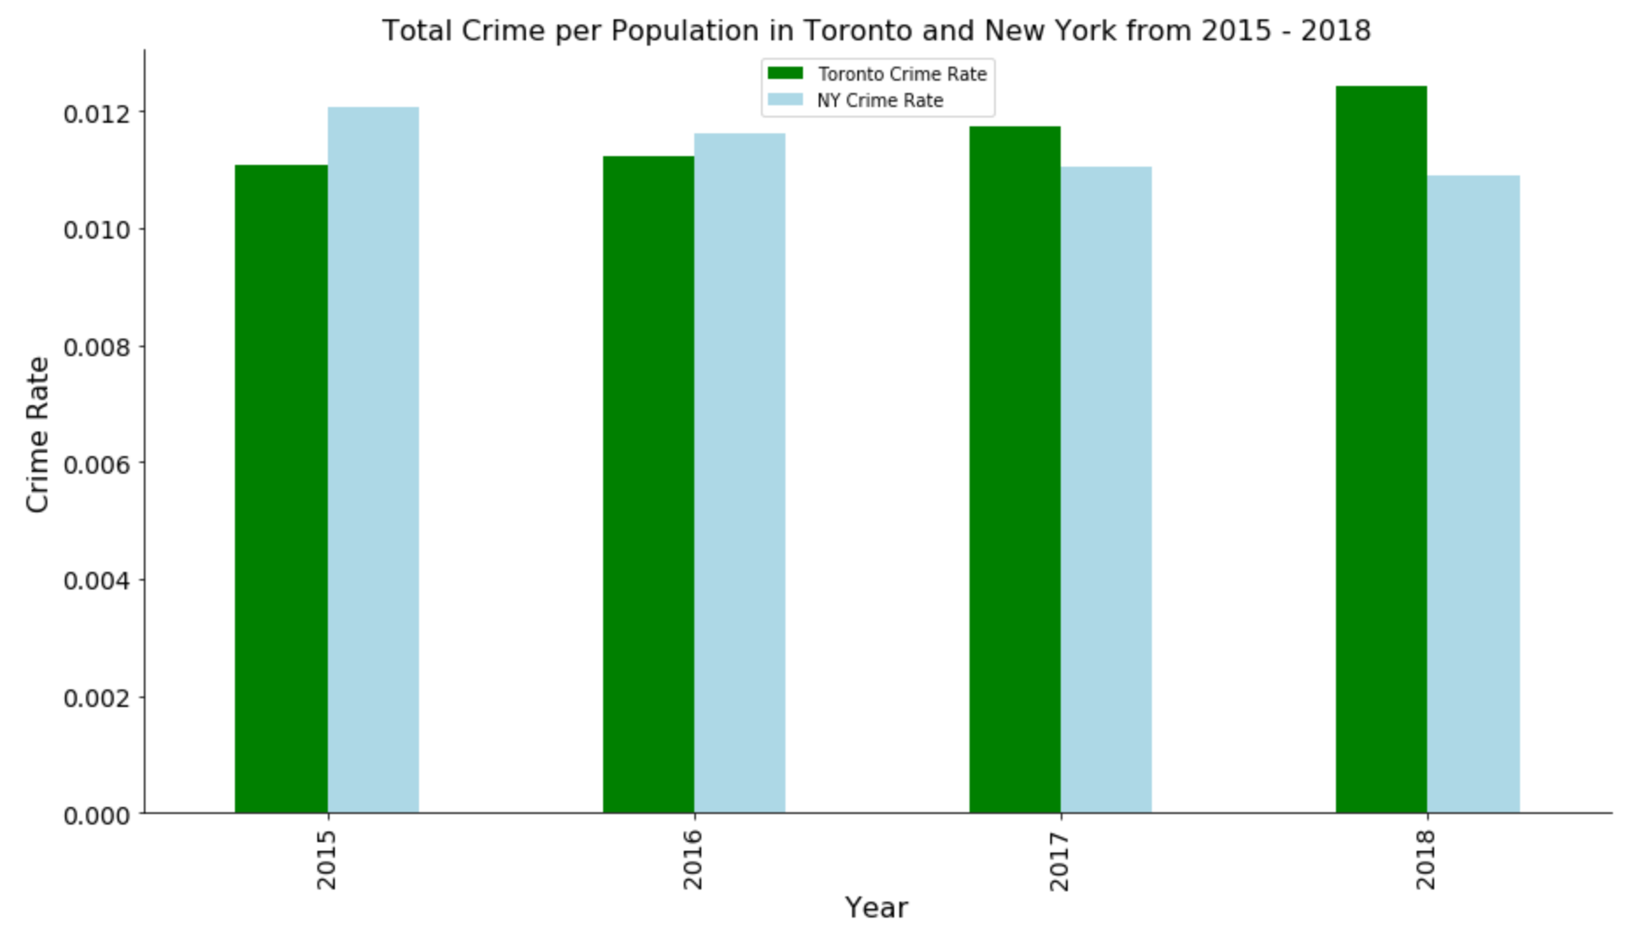

The illustration below show the number of crime occurred in one mile square of City of Toronto and New York City. As we can see, 1 mile of area, the number of crimes occurred in New York is higher than Toronto is significant. However, in another aspect, New York City crime density seems to decline slightly and City of Toronto crime density increases sightly also. Nonetheless, it is still too soon to predict that crime density of New York will be decreasing in the future. Because we need to know the previous years data in order to conclude strongly that crime density is decreasing or increasing. In overall, the crime density of New York City is high.

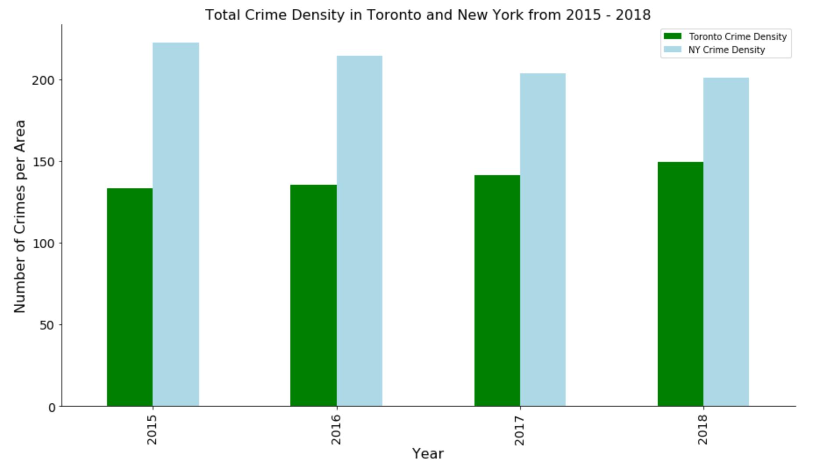

The illustration 3 below is the comparison about different categories of crime between two cities. As we discussed above, the most frequent occurrences crime in City of Toronto is assault, and the least occurrences is larceny theft. The others type of crimes in Toronto seems to appear significantly low. However, New York City has high crime rate for every perspective if we compare with City of Toronto. The top 3 crime rate for New York City is larceny theft, murder, and robbery.

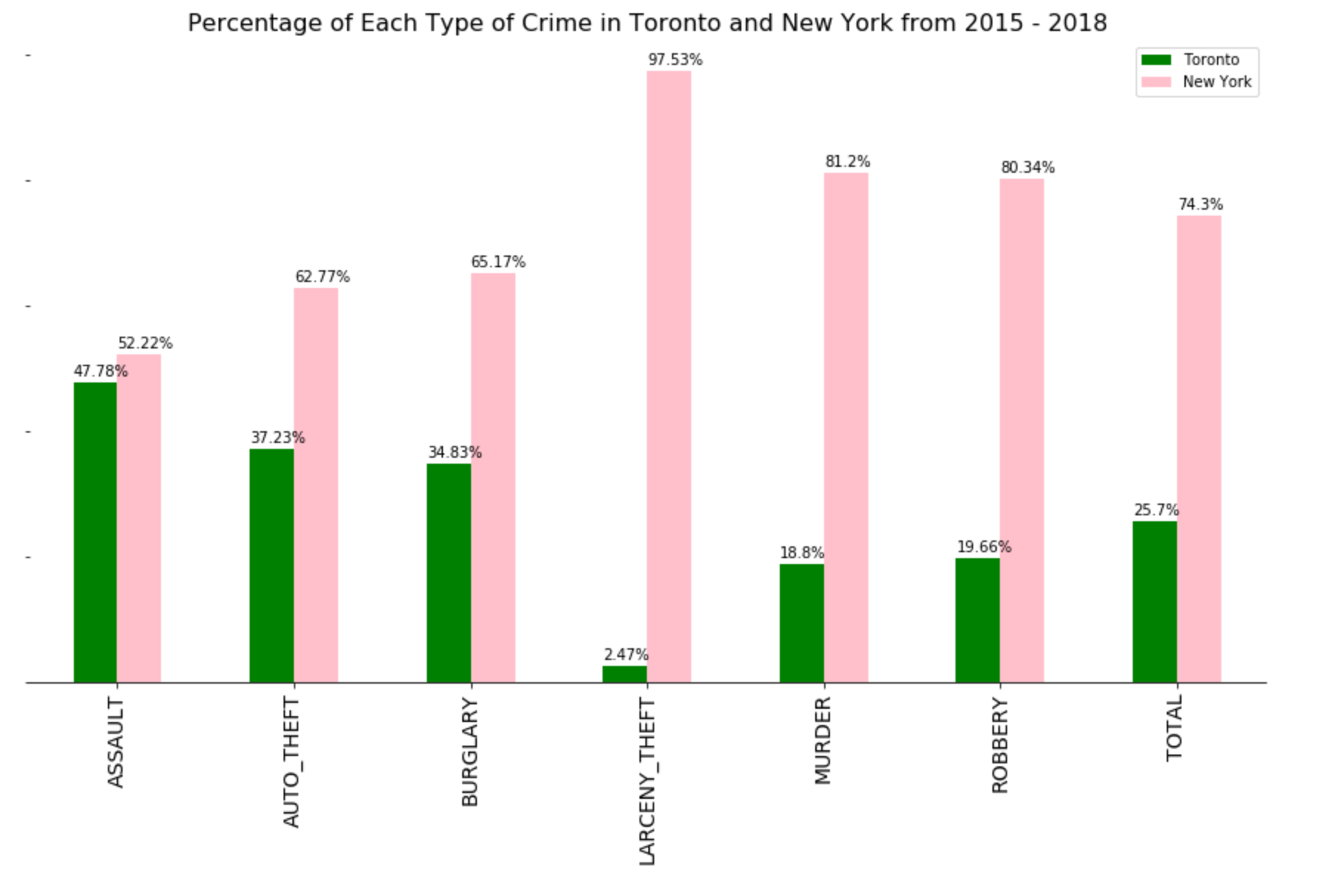

**Accident**

In illustration 4, it describes total of accidents that occurred in each borough of New York City. This comparison allows us see the traffic safety in for each borough from 2015 to 2017. As we all can see, Staten Island always has low number of accidents. Besides that, we can see that number of accident suddenly is low over all of New York City boroughs in 2017, esspecially Brooklyn. In general, 2017 needs to have further investigation because we need to know what traffic policy that make total number of accident is decreased significantly.

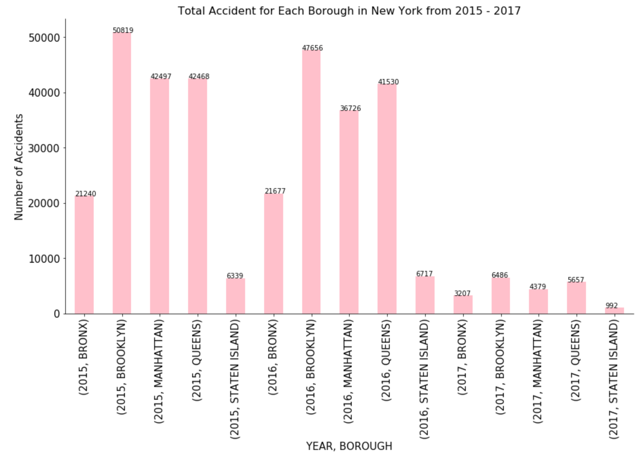

Unlike New York City, City of Toronto’s total accidents is remain steady from 2015 to 2017. However, its accident occurrences is remaining low, which is safe for living.

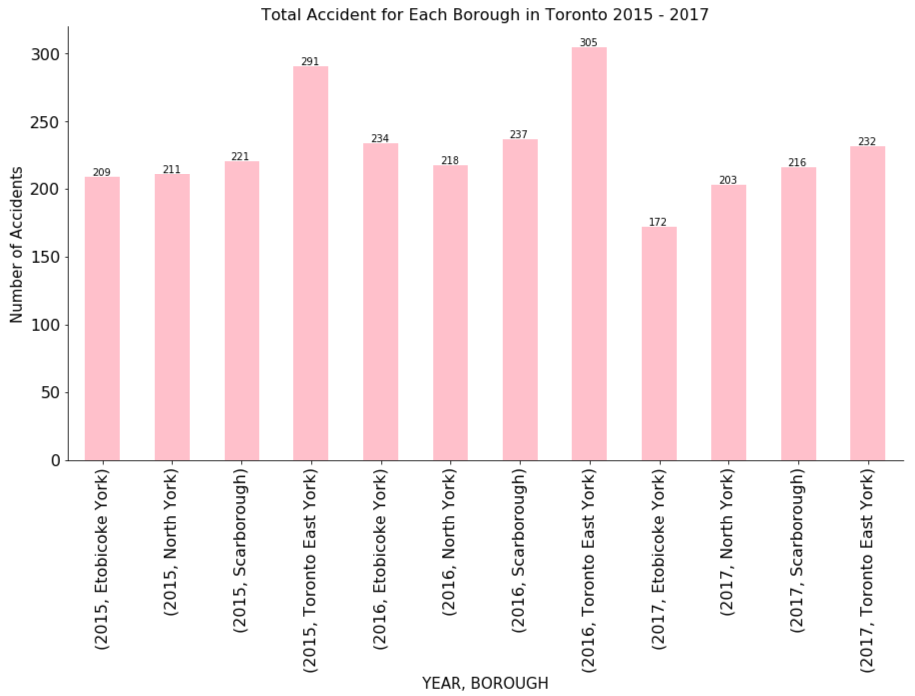

**Population**

As we all know, population is one of the key indicators to identify potential economics of a city or state. Prosper city or state usually tend to have higher population; however, it always contains other social problems such as crime, traffic, which are discussed above. In this section, we will discuss which boroughs of New York City and City of Toronto have high economic potential base on population. Besides that, we also can use these information to see if the theory about higher population will have better economic potential in part 2 of the report.

The illustration below shows that top 3 of highest population is Brooklyn, Queens, and Manhattan. The highest population is Brooklyn and it is about 2.7 millions people. The second place is Queens, which is about 2.3 million people. And Manhattan is about 1.7 million

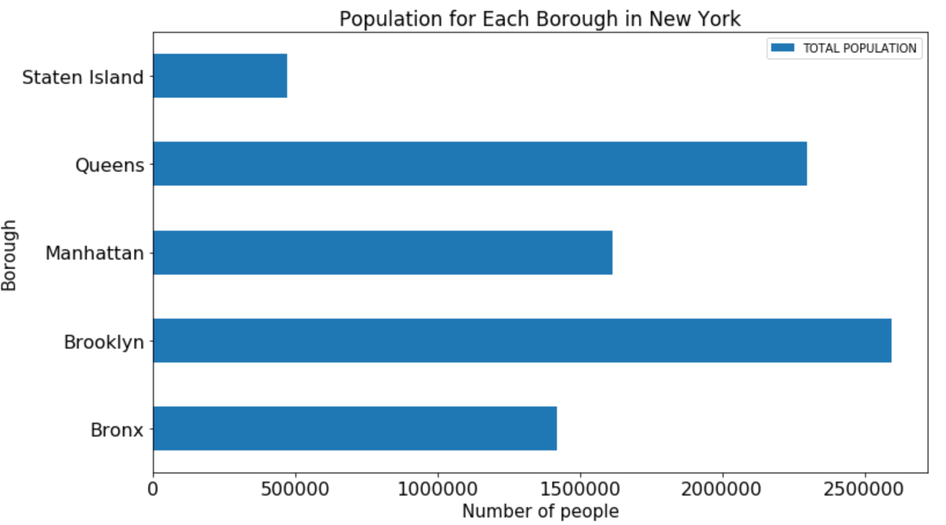

In the illustration below, it shows that Old Toronto, Scarborough, and North York are boroughs that have highest population. However, their population is still below 1 million and Old Toronto population is about 810,000. Therefore, Old Toronto might have high potential economics.

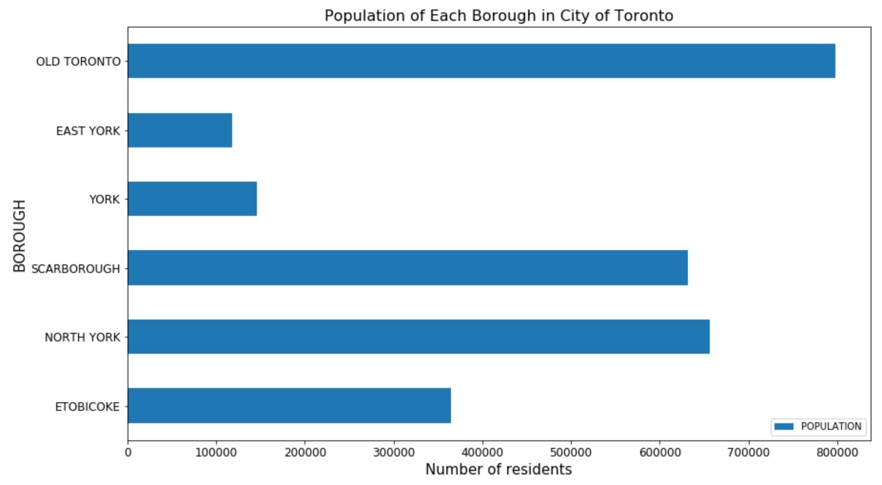

1. Conclusion

In general, the crime rate of the New York City and City of Toronto’s is quite similar; however, the crime density of New York City is higher than City of Toronto significantly even though it seems to decline over the years but its density is still high. In the traffic comparison, the number of accident that occur is high for New York and low for City of Toronto. For the population, the financial borough of New York City is Manhattan and for City of Toronto is Old Toronto, Old Toronto population is the highest of City of Toronto but Manhattan is not.

* Part 2 :

1. Desired Data

- New York City Census data. This data will be used to explore New York economic potentials

- Venues location data. This data is used to see which location that business owner should open their business.

- New York Borough and Neighborhoods location data. This data allow us have exact latitude and longitude.

1. Data Sources:

- New York City Census is from Kaggle dataset

- Venues location is from Foursquare.

- New York Borough and Neighborhoods from Cognitive Class.ai

1. City Selection

- New York City will be chosen city to open business because its population is high and its available data is popular.

1. Borough Selection – Income , Poverty, and Unemployment rate

- Before which neighborhoods will be the best one to open the business, we need to know which borough has the highest potential. These potentials will be determined by New York City income, poverty, and unemployment rates.

The first illustration of borough selection is average income for each borough in New York. In the illustration, average income of Manhattan is the about 85000 USD per year which is the highest in New York City. The second highest one is Staten Island and this is very surprised because Staten Island has lowest population.

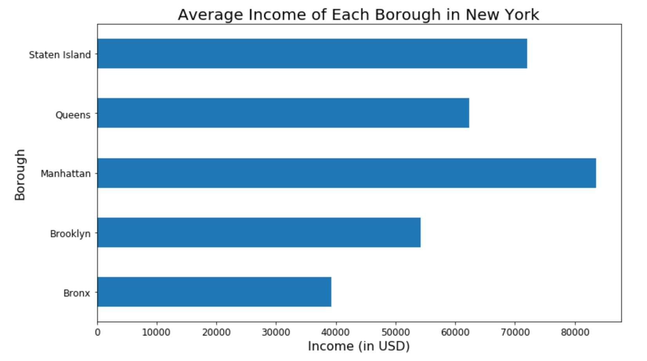

The table below shows the average income rate between boroughs. The Staten Island has highest income rate, which is about 0.152 USD/person and the second one is Manhattan is about 0.0518 USD/person. This result is really unexpected because as we all know that Manhattan is the financial capital of New York City.

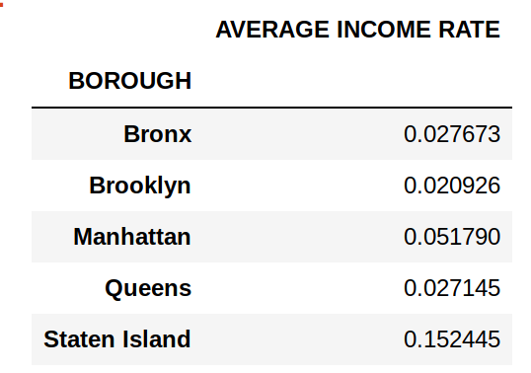

The next illustration is about poverty and unemployment for each boroughs in New York City. After exploring average income rate above, the percentage of poverty and unemployment show us clearly why Staten Island is the dominant borough in the New York City. Its poverty and unemployment percentage is the lowest one among boroughs. The highest poverty and unemployment percentage borough is Bronx. The illustration also shows that Manhattan is third place in five boroughs.

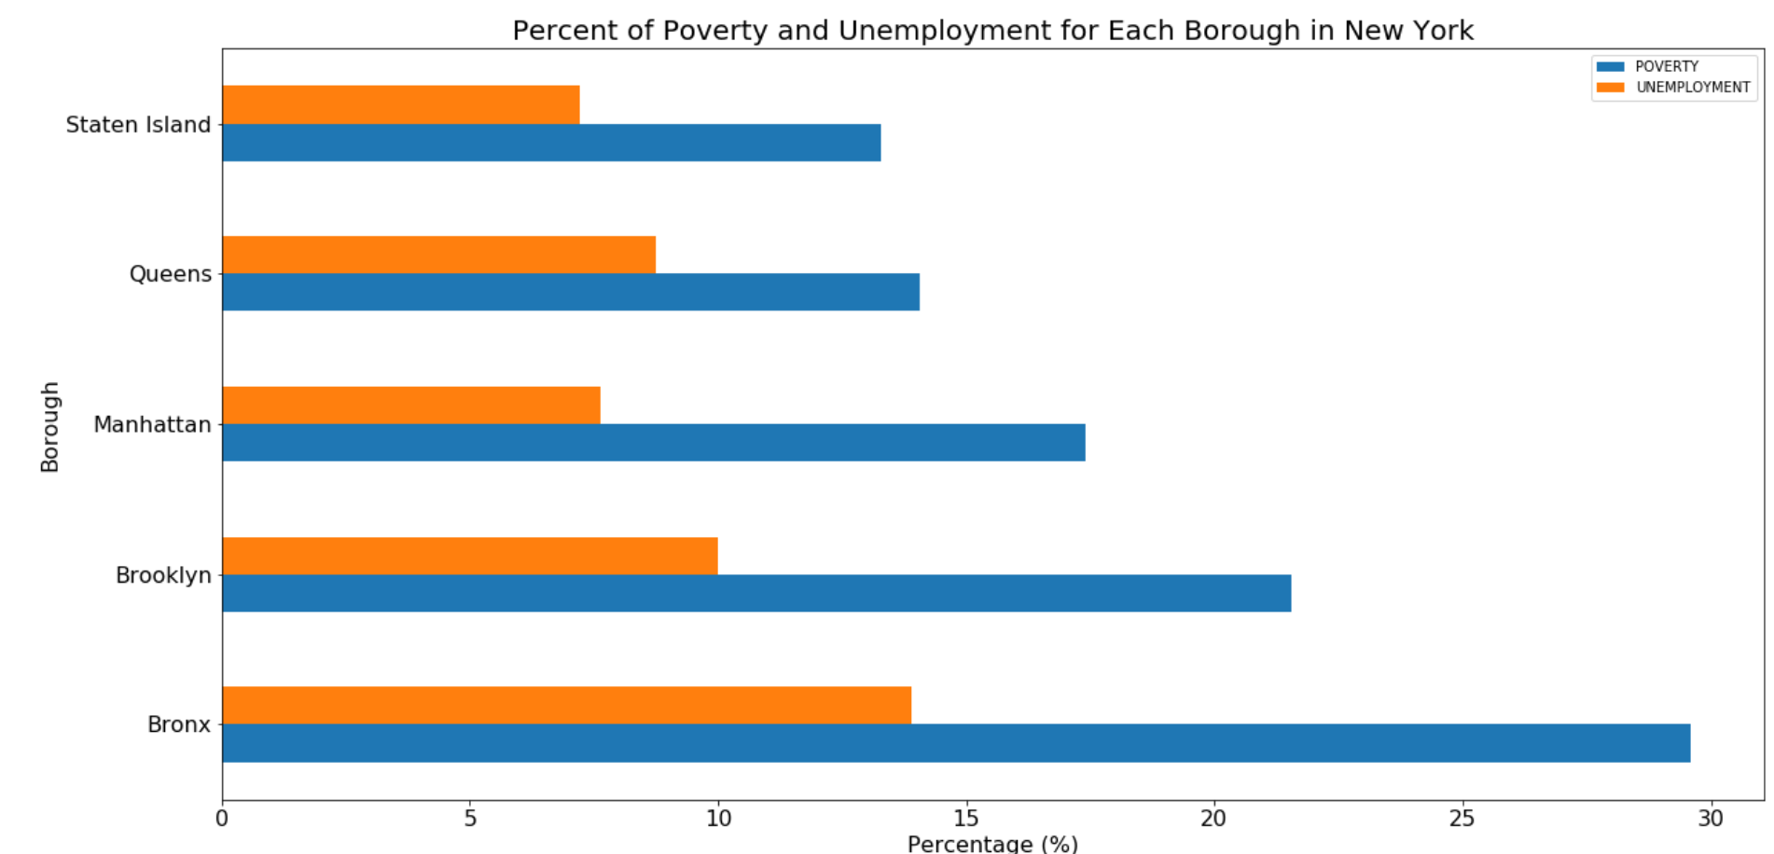

The illustration below is a reference about what type of jobs is the most population between boroughs. We will focus on Staten Island because it has highest average income. The illustration shows that the most popular type of jobs are professional and office. Staten Island has the highest percentage for office sector and second highest percentage for professional sector.

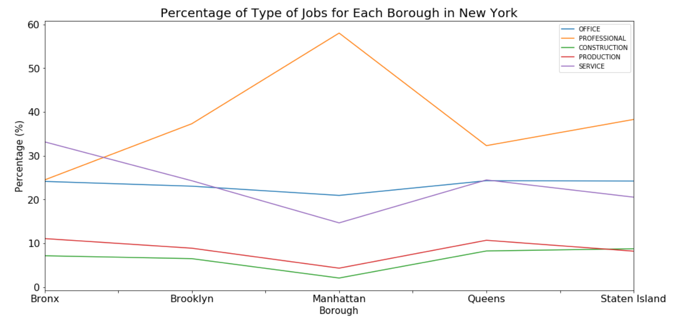

In conclusion of boroughs selection, the Staten Island seems to have the highest potential to open office or restaurant. This borough is chosen because it has highest potentials because its average income is higher and people might want to spend on eating out rather than self-cook. The next step is finding which neighborhood in Staten Island will be the perfect location to setup business by using K-clustering.

1. Model Development – K-clustering

- K- clustering is chosen because it can show the most common venues in the location and from that information, we can determine that if we should open restaurant or office. Besides that, the number of cluster will be used is five.

1. Neighborhood Selection

- The neighborhood for opening restaurant will be chosen is not the one has highest number of restaurants in the location because it is highly competitive and the owner also can not optimize their revenue based on game theory. In addition, for opening restaurant, we should look for location that has high number of supermarkets or markets nearby because it will allow restaurant maintain low cost food but high quality. For opening office, it will be the best to open office at location that has cafe shop, fast food or restaurants as common venues since it will be optimize the convenience.

Two illustrations below show that supermarket is the most common venues for Graniteville and Charleston neighborhood. Besides that, the number of restaurants in here is very low; therefore, these two neighborhoods will be a good option to open a restaurant. For opening office, there are two location that will optimize convenience for employees are Dongan Hills and Grant City. These two neighborhoods have fast food, bank, convenience store, restaurants surround them as top common venue. Therefore, it will be able to optimize convenience of your employees.

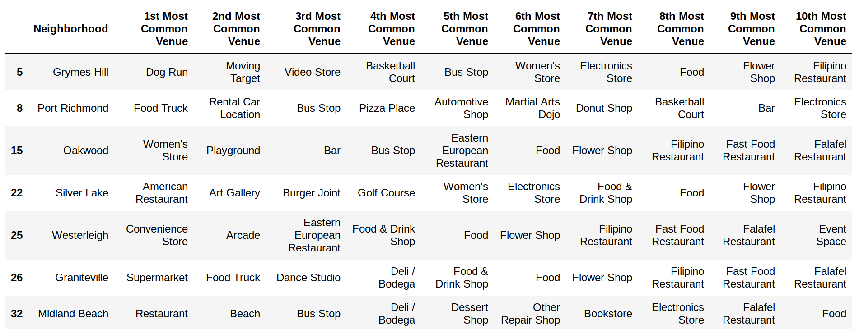

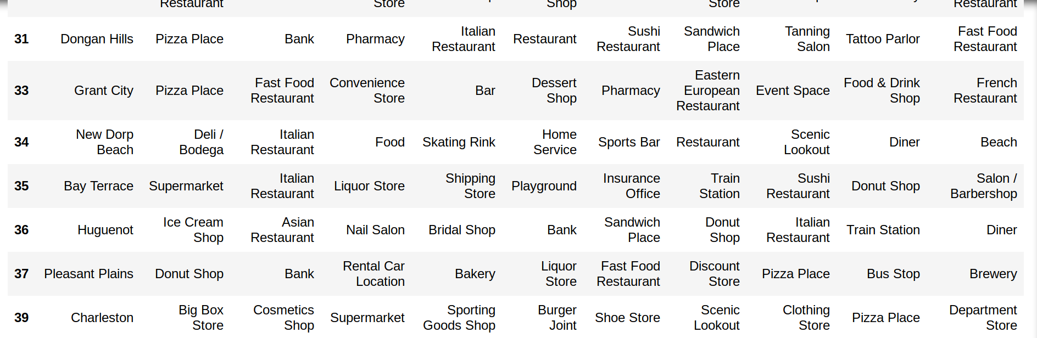

1. Conclusion

In conclusion, there are two options for opening restaurant and they are Graniteville and Charleston neighborhood. For opening office, we also have two options and they are Dongan Hills and Grant City, these two locations allow employees be comfortable during break because they have good options for lunch. As a result, the employees will be more productive since they feel comfortable.

**III. IMPROVEMENT**

In general, the project still need to have a lot of improvement. The first thing that need to improve is borough selection part. Although we know that we have average income for each borough but we do not know the rental price, living standard in order to determine if that borough has economic potential to open business.