

**ONLINE LEARNING WEBSITE**

**Software Design Specification**

– Hanoi, August 2022 –

Record of changeS

|  |  |  |  |
| --- | --- | --- | --- |
| Date | A* M, D | In charge | Change Description |
|  |  |  |  |
|  |  |  |  |
|  |  |  |  |
|  |  |  |  |
|  |  |  |  |
|  |  |  |  |
|  |  |  |  |
|  |  |  |  |
|  |  |  |  |
|  |  |  |  |
|  |  |  |  |
|  |  |  |  |
|  |  |  |  |

*A - Added M - Modified D - Deleted

**Table of Contents**

I. Overview 4

1. Code Packages 4

2. Database Design 4

a. Database Schema 4

b. Table Description 4

II. Code Designs 5

1. <Feature/Function Name1> 5

a. Class Diagram 5

b. Class Specifications 5

c. Sequence Diagram(s) 5

d. Database queries 6

2. <Feature/Function Name2> 6

# I. Overview

## 1. Code Packages

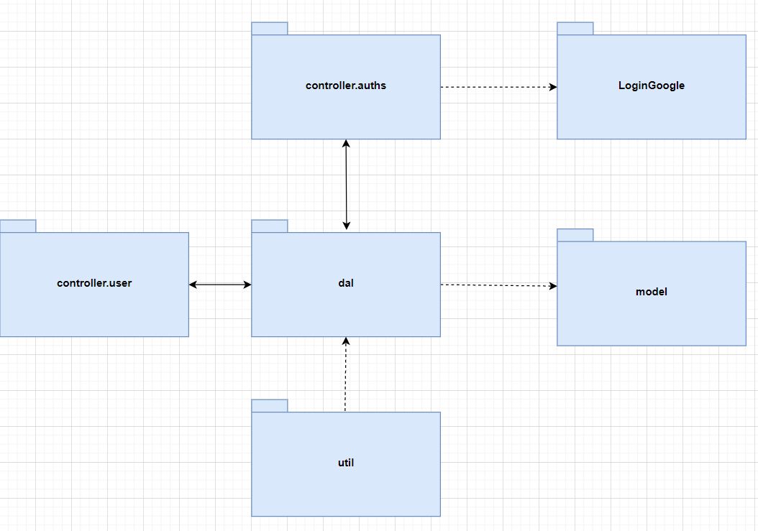

***Package descriptions***

|  |  |  |
| --- | --- | --- |
| **No** | **Package** | **Description** |
| *01* | *Dal* | *This component is used to get data directly FROM the database* |
| *02* | *Util* | *<Description of the package>* |
| *03* | *Model* | *This component includes interfaces used to receive data retrieved FROM the database and classes used to receive data* |
| *04* | *Controller.user* | *Acts as a go-between for the service layer and the view, passing on different input requests.* |
| *05* | *Controller.auths* | *This component for the service authorities, such as validate user name password, sign in, log out.* |
| *06* | *LoginGoogle* | *This component use to login page with Gmail.* |

## 2. Database Design

### a. Database Schema

### b. Table Description

|  |  |  |
| --- | --- | --- |
| **No** | **Table** | **Description** |
| *1* | *User* | *Information of the User in Online learning system* |
| *2* | *Discussion* | *The table store rate and discussion of user in Online learning system* |
| *3* | *Record* | *Storage practice date, mark of student when they finished a multiple choice practice of course.* |
| *4* | *Enroll* | *Store user's enrollment information for courses* |
| *5* | *Course* | *Information of the course in Online learning system* |
| *6* | *CommentCourse* | *The table store rate, question, and discussion of user in Online learning system* |
| *7* | *Quizz* | *The practice library of Online learning system* |
| *8* | *Question* | *The question library of Online learning system* |
| *9* | *Percentage* | *Store percentage of student when they finish a lesson* |
| *10* | *CommentLesson* | *The table store rate, question, and discussion of user in Online learning system* |
| *11* | *Lesson* | *Information of the lesson in Online learning system* |
| *12* | *Chapter* | *Information of the chapter in Online learning system* |
| *13* | *Image* | *The image library of Online learning system* |

# II. Code Designs

## 1. Register

### a. Class Diagram

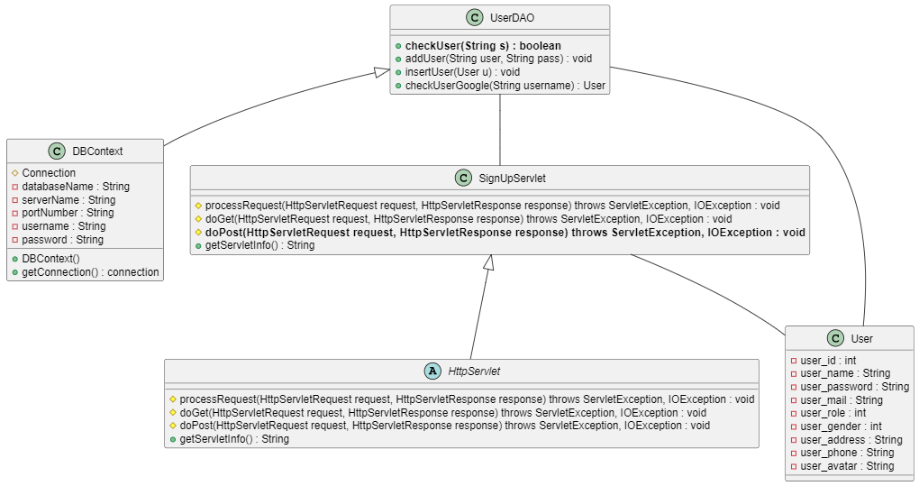

### b. Class Specifications

*SignUpServlet*

|  |  |  |
| --- | --- | --- |
| **No** | **Method** | **Description** |
| *01* | *doPost(HttpServletRequest request, HttpServletResponse response)* | *Get email, password and fullname from resgister form, check it and add to database* |
|  |  |  |

#### DBContext

|  |  |  |
| --- | --- | --- |
| **No** | **Method** | **Description** |
| *01* | *getConnection()* | *To connect with database* |
| *02* | *closeResultSet(ResultSet resultSet)* | *To close result set* |
| *03* | *closePreparedStatement(PreparedStatement preparedStatement)* | *To close prepared statement* |
| *04* | *closeConnection(Connection connection)* | *To close connection* |

***User***

|  |  |  |
| --- | --- | --- |
| **No** | **Method** | **Description** |
| *01* | *Constructors* | *Entity initialization* |
| *02* | *Getter* | *Get value of each attributes* |
| *03* | *Setter* | *Set value of each attributes* |

***UserDAO***

|  |  |  |
| --- | --- | --- |
| **No** | **Method** | **Description** |
| *01* | *ChechUser(String s)* | *Check if user name is exist or not* |
| *02* | *CheckUserGoogle*  *(String username )* | *Check google email is extisted or not in the system* |

### c. Sequence Diagram(s)

*[Provide the sequence diagram(s) for the feature, see the sample below]*

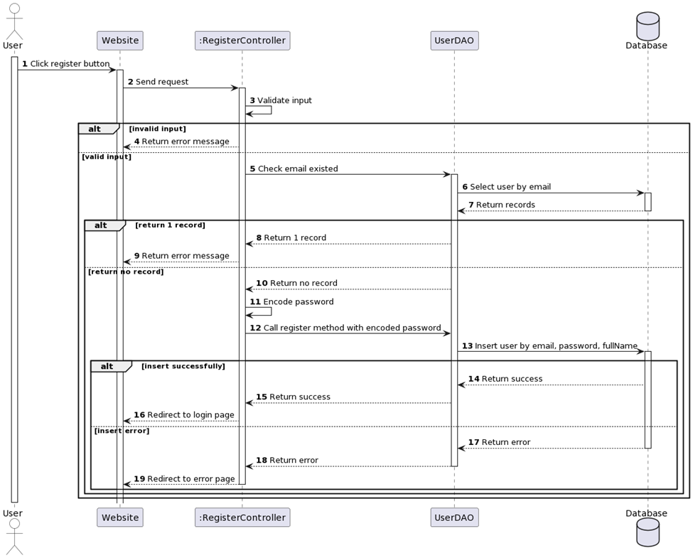

### d. Database Queries

INSERT INTO [dbo].[User]\n"

+ " ([user_name]\n"

+ " ,[user_mail]\n"

+ " ,[user_password]\n"

+ " ,[user_role]\n"

+ " ,[user_gender]\n"

+ " ,[user_address]\n"

+ " ,[user_phone]\n"

+ " ,[user_avatar])\n"

+ " VALUES\n"

+ " (?,?,?,?,?,?,?,?)

## 2. Login

### a. Class Diagram

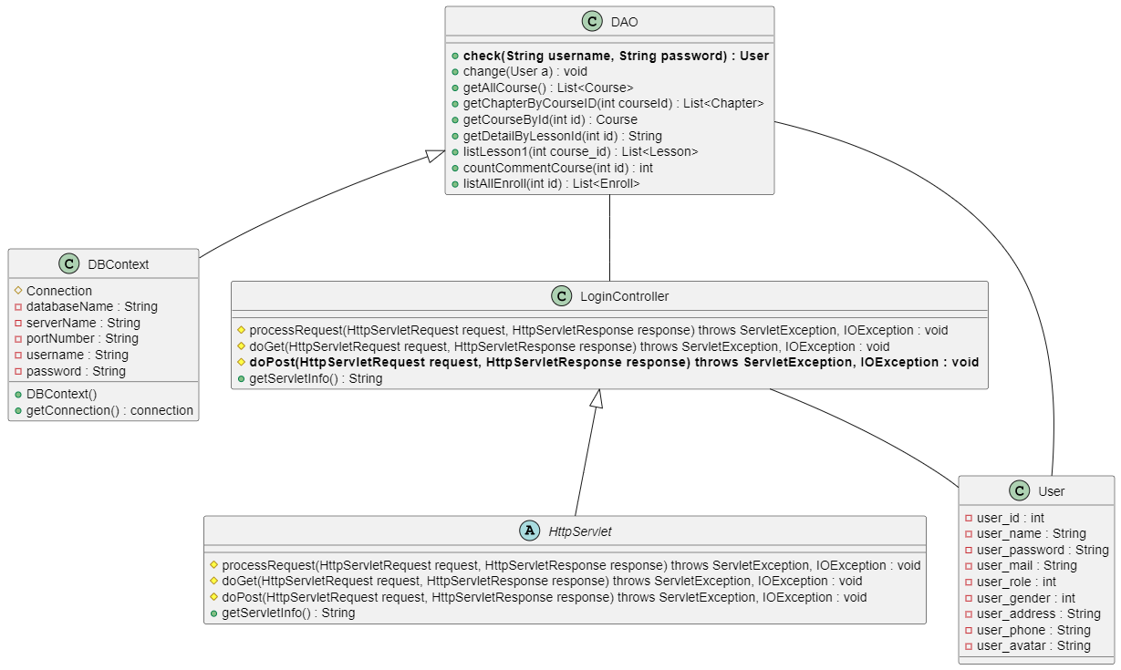

### b. Class Specifications

#### LoginController

|  |  |  |
| --- | --- | --- |
| **No** | **Method** | **Description** |
| *01* | *doPost(HttpServletRequest request, HttpServletResponse response)* | *Get email, password and fullname from resgister form, check it and add to database* |

#### DBContext

|  |  |  |
| --- | --- | --- |
| **No** | **Method** | **Description** |
| *01* | *getConnection()* | *To connect with database* |
| *02* | *closeResultSet(ResultSet resultSet)* | *To close result set* |
| *03* | *closePreparedStatement(PreparedStatement preparedStatement)* | *To close prepared statement* |
| *04* | *closeConnection(Connection connection)* | *To close connection* |

***User***

|  |  |  |
| --- | --- | --- |
| **No** | **Method** | **Description** |
| *01* | *Constructors* | *Entity initialization* |
| *02* | *Getter* | *Get value of each attributes* |
| *03* | *Setter* | *Set value of each attributes* |

***DAO***

|  |  |  |
| --- | --- | --- |
| **No** | **Method** | **Description** |
| *01* | *Check(String username, String password)* | *Check account in database to login* |

### c. Sequence Diagram(s)

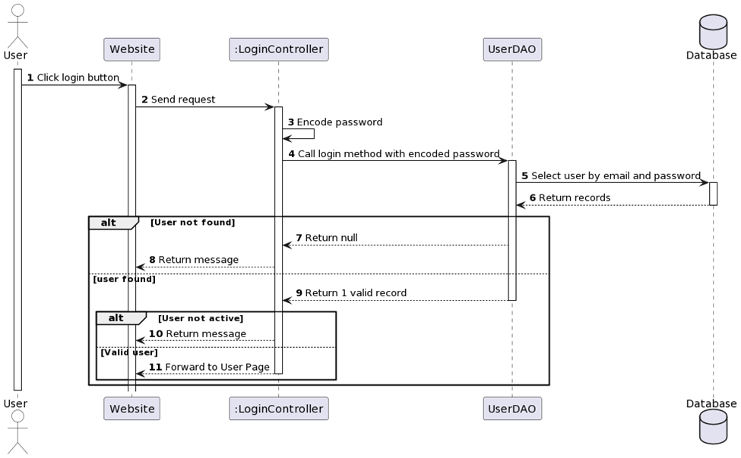

### d. Database Queries

SELECT [User_Id]\n"

+ " ,[user_name]\n"

+ " ,[user_password]\n"

+ " where user_name=? and user_password=?

## 3. Home page

### a. Class Diagram

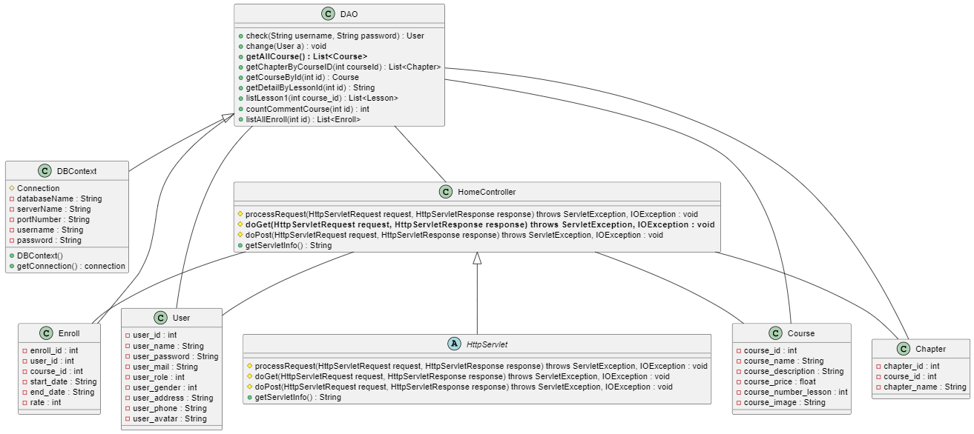

### b. Class Specifications

#### HomeController

|  |  |  |
| --- | --- | --- |
| **No** | **Method** | **Description** |
| *01* | *doGet(HttpServletRequest request, HttpServletResponse response)* | *List all courser from databse into homepage* |

#### DBContext

|  |  |  |
| --- | --- | --- |
| **No** | **Method** | **Description** |
| *01* | *getConnection()* | *To connect with database* |
| *02* | *closeResultSet(ResultSet resultSet)* | *To close result set* |
| *03* | *closePreparedStatement(PreparedStatement preparedStatement)* | *To close prepared statement* |
| *04* | *closeConnection(Connection connection)* | *To close connection* |

***User***

|  |  |  |
| --- | --- | --- |
| **No** | **Method** | **Description** |
| *01* | *Constructors* | *Entity initialization* |
| *02* | *Getter* | *Get value of each attributes* |
| *03* | *Setter* | *Set value of each attributes* |

***Enroll***

|  |  |  |
| --- | --- | --- |
| **No** | **Method** | **Description** |
| *01* | *Constructors* | *Entity initialization* |
| *02* | *Getter* | *Get value of each attributes* |
| *03* | *Setter* | *Set value of each attributes* |

***Course***

|  |  |  |
| --- | --- | --- |
| **No** | **Method** | **Description** |
| *01* | *Constructors* | *Entity initialization* |
| *02* | *Getter* | *Get value of each attributes* |
| *03* | *Setter* | *Set value of each attributes* |

***Chapter***

|  |  |  |
| --- | --- | --- |
| **No** | **Method** | **Description** |
| *01* | *Constructors* | *Entity initialization* |
| *02* | *Getter* | *Get value of each attributes* |
| *03* | *Setter* | *Set value of each attributes* |

***DAO***

|  |  |  |
| --- | --- | --- |
| **No** | **Method** | **Description** |
| *01* | *GetAllCourse(List<Course>)* | *Get all Cousre from database* |

### c. Sequence Diagram

### d. Database Queries

SELECT TOP (1000) [Course_id]\n"

+ " ,[course_name]\n"

+ " ,[course_description]\n"

+ " ,[course_price]\n"

+ " ,[course_number_lesson]\n"

+ " ,[course_image]\n"

+ " FROM [SWP-Project].[dbo].[Course]\n"

+ " where course_price =0

## 4. ChangePass

### a. Class Diagram

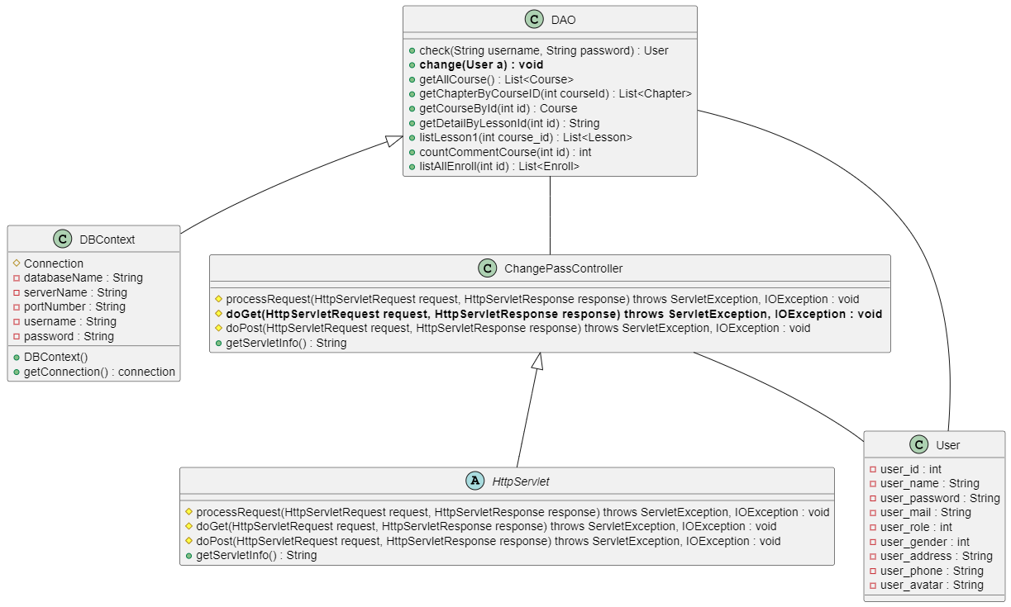

### b. Class Specifications

#### ChangePassController

|  |  |  |
| --- | --- | --- |
| **No** | **Method** | **Description** |
| *01* | *doGet(HttpServletRequest request, HttpServletResponse response)* | *Check user is existed or not, if not then you can change password* |

#### DBContext

|  |  |  |
| --- | --- | --- |
| **No** | **Method** | **Description** |
| *01* | *getConnection()* | *To connect with database* |
| *02* | *closeResultSet(ResultSet resultSet)* | *To close result set* |
| *03* | *closePreparedStatement(PreparedStatement preparedStatement)* | *To close prepared statement* |
| *04* | *closeConnection(Connection connection)* | *To close connection* |

***User***

|  |  |  |
| --- | --- | --- |
| **No** | **Method** | **Description** |
| *01* | *Constructors* | *Entity initialization* |
| *02* | *Getter* | *Get value of each attributes* |
| *03* | *Setter* | *Set value of each attributes* |

***DAO***

|  |  |  |
| --- | --- | --- |
| **No** | **Method** | **Description** |
| *01* | *Change(User a)* | *Check user in database to change password* |

### c. Sequence Diagram(s)

### d. Database Queries

UPDATE [dbo].[User]\n"

+ " SET \n"

+ " [user_password] = ?\n"

+ " WHERE user_name=?

## 5. CourseDetail

### a. Class Diagram

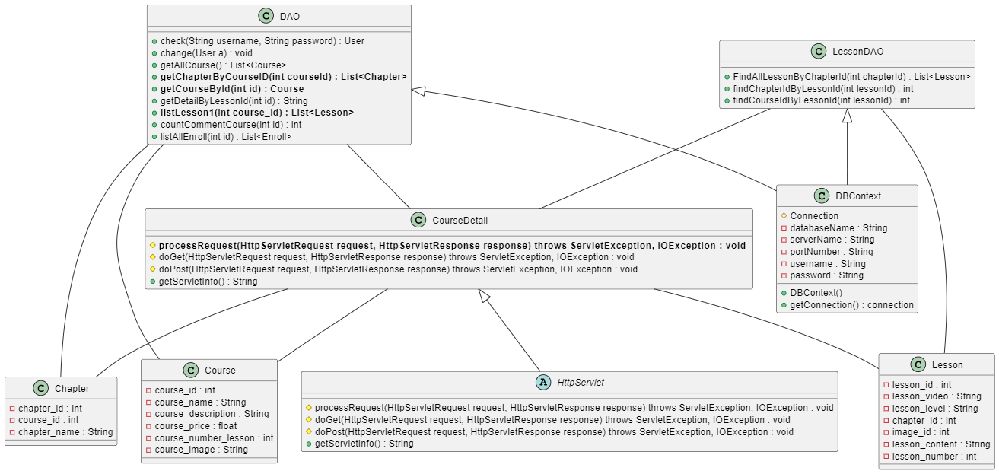

### b. Class Specifications

#### CourseDetail

|  |  |  |
| --- | --- | --- |
| **No** | **Method** | **Description** |
| *01* | *processRequest(HttpServletRequest request, HttpServletResponse response)* | *Get Course by id from database and show in page* |

#### DBContext

|  |  |  |
| --- | --- | --- |
| **No** | **Method** | **Description** |
| *01* | *getConnection()* | *To connect with database* |
| *02* | *closeResultSet(ResultSet resultSet)* | *To close result set* |
| *03* | *closePreparedStatement(PreparedStatement preparedStatement)* | *To close prepared statement* |
| *04* | *closeConnection(Connection connection)* | *To close connection* |

***Course***

|  |  |  |
| --- | --- | --- |
| **No** | **Method** | **Description** |
| *01* | *Constructors* | *Entity initialization* |
| *02* | *Getter* | *Get value of each attributes* |
| *03* | *Setter* | *Set value of each attributes* |

***Chapter***

|  |  |  |
| --- | --- | --- |
| **No** | **Method** | **Description** |
| *01* | *Constructors* | *Entity initialization* |
| *02* | *Getter* | *Get value of each attributes* |
| *03* | *Setter* | *Set value of each attributes* |

***Lesson***

|  |  |  |
| --- | --- | --- |
| **No** | **Method** | **Description** |
| *01* | *Constructors* | *Entity initialization* |
| *02* | *Getter* | *Get value of each attributes* |
| *03* | *Setter* | *Set value of each attributes* |

***DAO***

|  |  |  |
| --- | --- | --- |
| **No** | **Method** | **Description** |
| *01* | *getCourseById(int id)* | *Get course from database by id and display on website* |

### c. Sequence Diagram(s)

### d. Database Queries

SELECT [Course_id] ,[course_name] ,[course_description]\n"

+ " ,[course_price]\n"

+ " ,[course_number_lesson]\n"

+ " ,[course_image]\n"

+ " FROM [dbo].[Course]\n"

+ " where Course_id=?

## 6. Lesson Detail

### a. Class Diagram

### b. Class Specifications

***LessonServlet***

|  |  |  |
| --- | --- | --- |
| **No** | **Method** | **Description** |
| *01* | *doPost(HttpServletRequest request, HttpServletResponse response)* | *Get all lesson from course by FindAllLessonByChapterId* |
| *02* | *processRequest(HttpServletRequest request, HttpServletResponse response)* | *get a percentage at the end of a lesson* |

***DBContext***

|  |  |  |
| --- | --- | --- |
| **No** | **Method** | **Description** |
| *01* | *getConnection()* | *To connect with database* |
| *02* | *closeResultSet(ResultSet resultSet)* | *To close result set* |
| *03* | *closePreparedStatement(PreparedStatement preparedStatement)* | *To close prepared statement* |
| *04* | *closeConnection(Connection connection)* | *To close connection* |

***User***

|  |  |  |
| --- | --- | --- |
| **No** | **Method** | **Description** |
| *01* | *Constructors* | *Entity initialization* |
| *02* | *Getter* | *Get value of each attributes* |
| *03* | *Setter* | *Set value of each attributes* |

***Lesson***

|  |  |  |
| --- | --- | --- |
| **No** | **Method** | **Description** |
| *01* | *Constructors* | *Entity initialization* |
| *02* | *Getter* | *Get value of each attributes* |
| *03* | *Setter* | *Set value of each attributes* |

***Percentage***

|  |  |  |
| --- | --- | --- |
| **No** | **Method** | **Description** |
| *01* | *Constructors* | *Entity initialization* |
| *02* | *Getter* | *Get value of each attributes* |
| *03* | *Setter* | *Set value of each attributes* |

***LessonDAO***

|  |  |  |
| --- | --- | --- |
| **No** | **Method** | **Description** |
| *01* | *FindAllLessonByChapterId(int chapterId)* | *Get each lesson in each Chapter containing that lesson* |
| *02* | *getPercentageByUserID(int user_id)* | *Get the percentage each time the user finishes each lesson* |

### c. Sequence Diagram(s)

### d. Database Queries

- SELECT [lesson_id]\n"

+ " ,[lesson_video]\n"

+ " ,[lesson_level]\n"

+ " ,[chapter_id]\n"

+ " ,[image_id]\n"

+ " ,[lesson_content]\n"

+ " ,[lesson_number]\n"

+ " FROM [SWP-Project].[dbo].[Lesson] where chapter_id = ?

- SELECT *\n"

+ " FROM [SWP-Project].[dbo].[Percentage] where user_id =?

## 7. Enroll

### a. Class Diagram

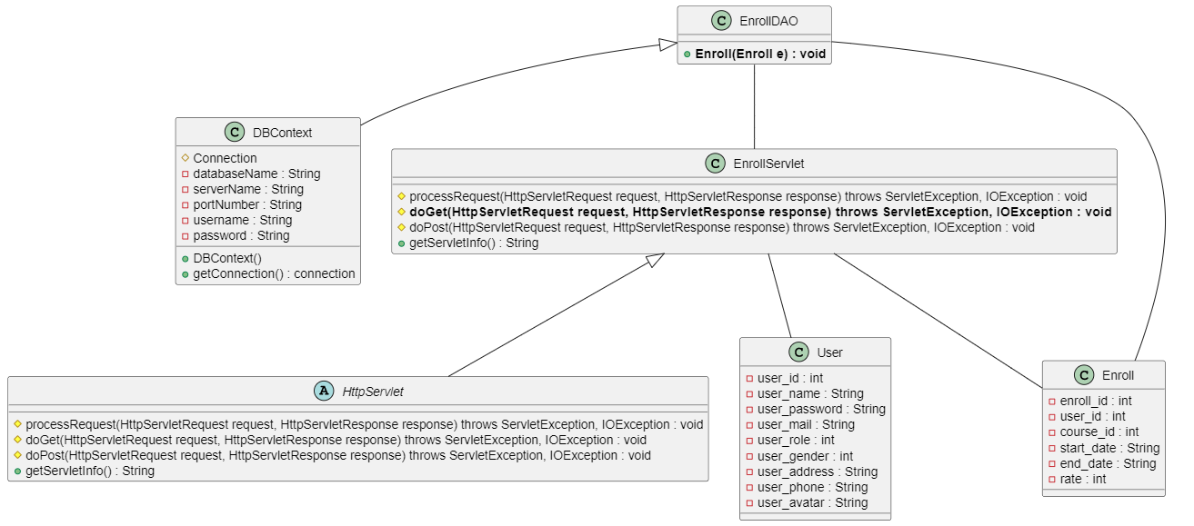

### b. Class Specifications

#### EnrollServlet

|  |  |  |
| --- | --- | --- |
| **No** | **Method** | **Description** |
| *01* | *doPost(HttpServletRequest request, HttpServletResponse response)* | *Enroll the user with the course* |

#### DBContext

|  |  |  |
| --- | --- | --- |
| **No** | **Method** | **Description** |
| *01* | *getConnection()* | *To connect with database* |
| *02* | *closeResultSet(ResultSet resultSet)* | *To close result set* |
| *03* | *closePreparedStatement(PreparedStatement preparedStatement)* | *To close prepared statement* |
| *04* | *closeConnection(Connection connection)* | *To close connection* |

***User***

|  |  |  |
| --- | --- | --- |
| **No** | **Method** | **Description** |
| *01* | *Constructors* | *Entity initialization* |
| *02* | *Getter* | *Get value of each attributes* |
| *03* | *Setter* | *Set value of each attributes* |

***Enroll***

|  |  |  |
| --- | --- | --- |
| **No** | **Method** | **Description** |
| *01* | *Constructors* | *Entity initialization* |
| *02* | *Getter* | *Get value of each attributes* |
| *03* | *Setter* | *Set value of each attributes* |

***EnrollDAO***

|  |  |  |
| --- | --- | --- |
| **No** | **Method** | **Description** |
| *01* | *Enroll(Enroll e)* | *Get Enroll of user with course* |

### c. Sequence Diagram(s)

### d. Database Queries

INSERT INTO [dbo].[Enroll]\n"

+ " ([user_id]\n"

+ " ,[course_id]) VALUES (?,?)”

## 8. Comment course

### a. Class Diagram

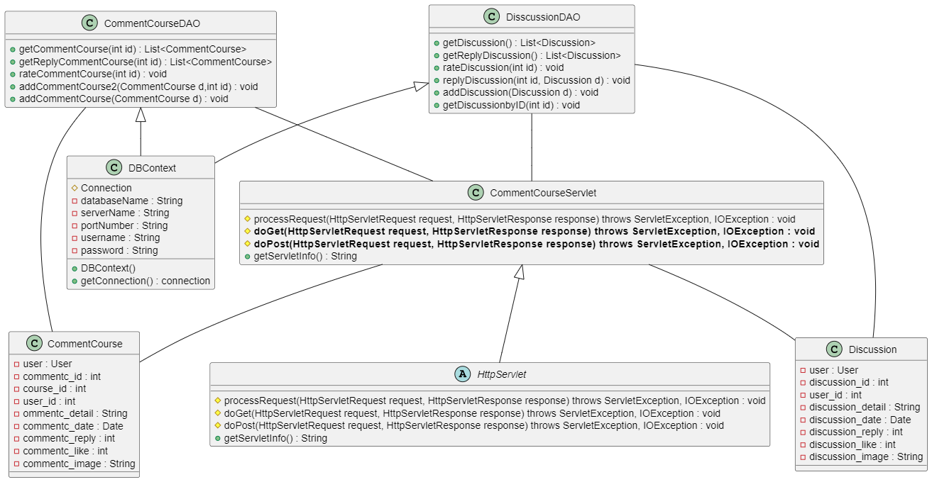

### b. Class Specifications

***CommentCourseServlet***

|  |  |  |
| --- | --- | --- |
| **No** | **Method** | **Description** |
| *01* | *doGet(HttpServletRequest request, HttpServletResponse response)* | *processing comments for the course* |
| *02* | *doPost(HttpServletRequest request, HttpServletResponse response)* | *processing discussion for the course* |

***DBContext***

|  |  |  |
| --- | --- | --- |
| **No** | **Method** | **Description** |
| *01* | *getConnection()* | *To connect with database* |
| *02* | *closeResultSet(ResultSet resultSet)* | *To close result set* |
| *03* | *closePreparedStatement(PreparedStatement preparedStatement)* | *To close prepared statement* |
| *04* | *closeConnection(Connection connection)* | *To close connection* |

***CommentCourse***

|  |  |  |
| --- | --- | --- |
| **No** | **Method** | **Description** |
| *01* | *Constructors* | *Entity initialization* |
| *02* | *Getter* | *Get value of each attributes* |
| *03* | *Setter* | *Set value of each attributes* |

***Discussion***

|  |  |  |
| --- | --- | --- |
| **No** | **Method** | **Description** |
| *01* | *Constructors* | *Entity initialization* |
| *02* | *Getter* | *Get value of each attributes* |
| *03* | *Setter* | *Set value of each attributes* |

***CommentDAO***

|  |  |  |
| --- | --- | --- |
| **No** | **Method** | **Description** |
| *01* | *getCommentCourse(int id)* | *Get Comment of user in CommentCourse* |
| *02* | *rateCommentCourse(int id)* | *handle the like for comments, the number of likes increases every time the like button is pressed* |

***DiscussionDAO***

|  |  |  |
| --- | --- | --- |
| **No** | **Method** | **Description** |
| *01* | *addDiscussion(Discussion d)* | *add details of discussion* |
| *02* | *replyDiscussion(int id, Discussion d)* | *reply to the user's discussion* |

### c. Sequence Diagram(s)

### d. Database Queries

- Select * from [CommentCourse] as CC\n"

+ " Join [User] as US on CC.[user_id] =US.User_Id\n"

+ " Join [Course] as CO on CC.course_id =CO.Course_id \n"

+ " where CC.comment_repply=0 and CO.Course_id=?

+ " UPDATE [dbo].[CommentCourse]\n"

+ " SET [comment_like] +=1 WHERE [comment_id]=?

+" INSERT INTO [dbo].[Discussion]\n"

+ " ([user_id] ,[discussion_detail ,[discussion_date] ,[discussion_image])\n"

+ " VALUES (?,?,?,?)

+ " INSERT INTO [dbo].[Discussion]\n"

+ " ([user_id] ,[discussion_detail] ,[discussion_date] ,[discussion_reply])\n"

+ " VALUES (?,?,?,?)"

## 9. Practice

### a. Class Diagram

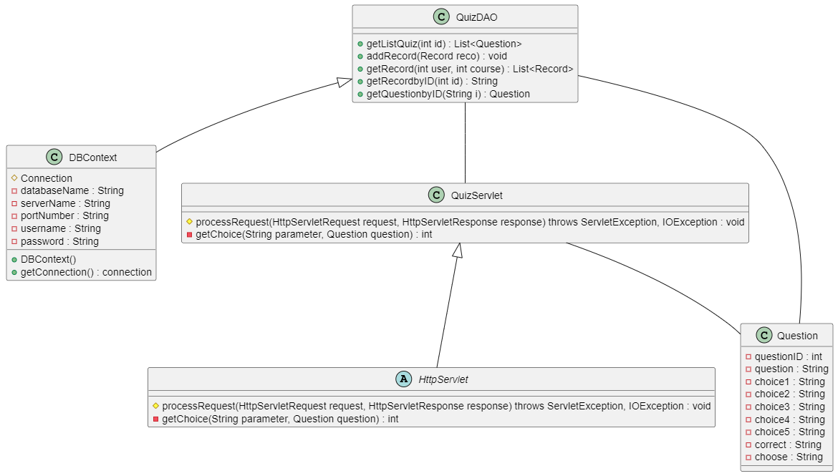

### b. Class Specifications

**QuizzServlet**

|  |  |  |
| --- | --- | --- |
| **No** | **Method** | **Description** |
| *01* | *getChoice(String parameter, Question question)* | *Get Question, choices and answer from database* |

**DBContext**

|  |  |  |
| --- | --- | --- |
| **No** | **Method** | **Description** |
| *01* | *getConnection()* | *To connect with database* |
| *02* | *closeResultSet(ResultSet resultSet)* | *To close result set* |
| *03* | *closePreparedStatement(PreparedStatement preparedStatement)* | *To close prepared statement* |
| *04* | *closeConnection(Connection connection)* | *To close connection* |

***Quizz***

|  |  |  |
| --- | --- | --- |
| **No** | **Method** | **Description** |
| *01* | *Constructors* | *Entity initialization* |
| *02* | *Getter* | *Get value of each attributes* |
| *03* | *Setter* | *Set value of each attributes* |

***QuizzDAO***

|  |  |  |
| --- | --- | --- |
| **No** | **Method** | **Description** |
| *01* | *getListQuiz(int id)* | *Get List of quizz from database* |

### c. Sequence Diagram(s)

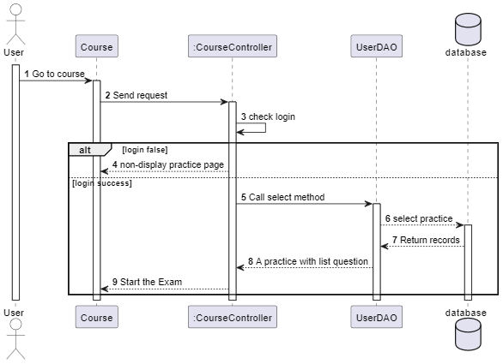

### d. Database Queries

Select TOP 30 * from Question as qe\n"

+ " Join [Quizz] as qi on qe.Question_id=qi.Question_id\n"

+ " where qi.Course_id=?\n"

+ " ORDER BY NEWID()

## 10. Mark report

### a. Class Diagram

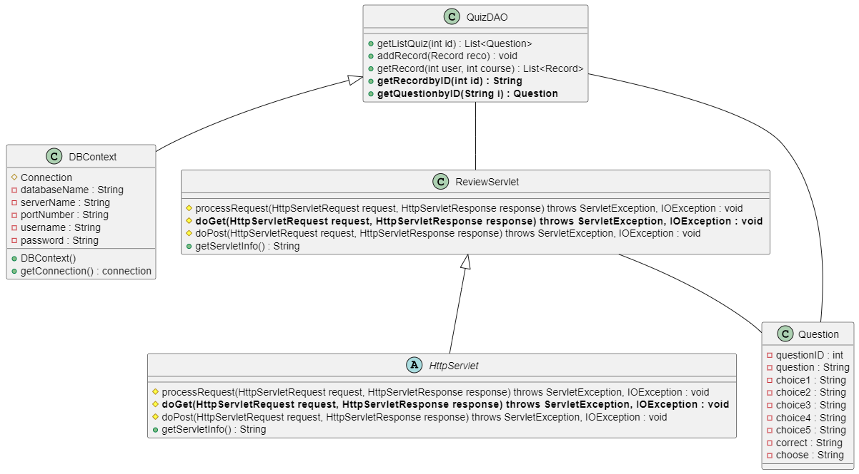

### b. Class Specifications

***ReviewServlet***

|  |  |  |
| --- | --- | --- |
| **No** | **Method** | **Description** |
| *01* | *doGet(HttpServletRequest request, HttpServletResponse response)* | *Get a list of questions and answers for review* |

**DBContext**

|  |  |  |
| --- | --- | --- |
| **No** | **Method** | **Description** |
| *01* | *getConnection()* | *To connect with database* |
| *02* | *closeResultSet(ResultSet resultSet)* | *To close result set* |
| *03* | *closePreparedStatement(PreparedStatement preparedStatement)* | *To close prepared statement* |
| *04* | *closeConnection(Connection connection)* | *To close connection* |

***Question***

|  |  |  |
| --- | --- | --- |
| **No** | **Method** | **Description** |
| *01* | *Constructors* | *Entity initialization* |
| *02* | *Getter* | *Get value of each attributes* |
| *03* | *Setter* | *Set value of each attributes* |

***QuizDAO***

|  |  |  |
| --- | --- | --- |
| **No** | **Method** | **Description** |
| *01* | *getRecordbyID(int id)* | *Get record of quizz to review* |

### c. Sequence Diagram(s)

### d. Database Queries

SELECT [record_id]\n"

+ " ,[user_id]\n"

+ " ,[Course_id]\n"

+ " ,[record_date]\n"

+ " ,[record_mark]\n"

+ " ,[recod_quizz]\n"

+ " FROM [dbo].[Record]\n"

+ " where [record_id]=?

## 11. Review answer

### a. Class Diagram

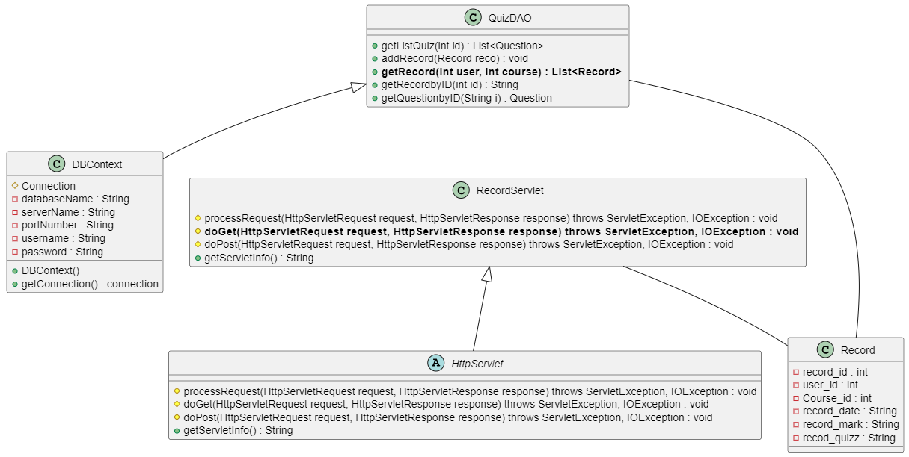

### b. Class Specifications

***RecordServlet***

|  |  |  |
| --- | --- | --- |
| **No** | **Method** | **Description** |
| *01* | *doGet(HttpServletRequest request, HttpServletResponse response)* | *Get the quizz's record* |

***DBContext***

|  |  |  |
| --- | --- | --- |
| **No** | **Method** | **Description** |
| *01* | *getConnection()* | *To connect with database* |
| *02* | *closeResultSet(ResultSet resultSet)* | *To close result set* |
| *03* | *closePreparedStatement(PreparedStatement preparedStatement)* | *To close prepared statement* |
| *04* | *closeConnection(Connection connection)* | *To close connection* |

***Question***

|  |  |  |
| --- | --- | --- |
| **No** | **Method** | **Description** |
| *01* | *Constructors* | *Entity initialization* |
| *02* | *Getter* | *Get value of each attributes* |
| *03* | *Setter* | *Set value of each attributes* |

***QuizzDAO***

|  |  |  |
| --- | --- | --- |
| **No** | **Method** | **Description** |
| *01* | *getRecord(int user, int course)* | *Get record of Quizz* |

### c. Sequence Diagram(s)

### d. Database Queries

Select * from Record \n"

+ "where Record.user_id=? and Record.Course_id=?

## 12. Discussion

### a. Class Diagram

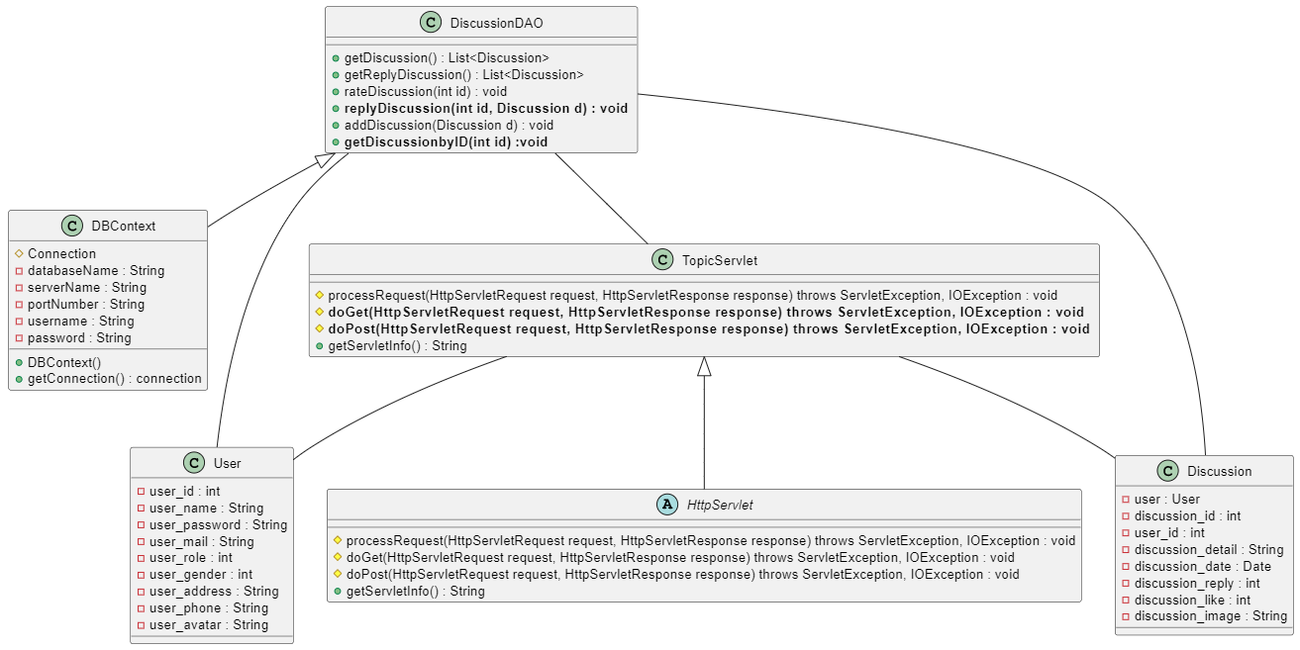

### b. Class Specifications

#### TopicServelet

|  |  |  |
| --- | --- | --- |
| **No** | **Method** | **Description** |
| *01* | *doGet(HttpServletRequest request, HttpServletResponse response)* | *Get discussion and reply of user* |
| *02* | *doPost(HttpServletRequest request, HttpServletResponse response)* | *Reply discussion with all discussion detail* |

#### DBContext

|  |  |  |
| --- | --- | --- |
| **No** | **Method** | **Description** |
| *01* | *getConnection()* | *To connect with database* |
| *02* | *closeResultSet(ResultSet resultSet)* | *To close result set* |
| *03* | *closePreparedStatement(PreparedStatement preparedStatement)* | *To close prepared statement* |
| *04* | *closeConnection(Connection connection)* | *To close connection* |

***User***

|  |  |  |
| --- | --- | --- |
| **No** | **Method** | **Description** |
| *01* | *Constructors* | *Entity initialization* |
| *02* | *Getter* | *Get value of each attributes* |
| *03* | *Setter* | *Set value of each attributes* |

***Discussion***

|  |  |  |
| --- | --- | --- |
| **No** | **Method** | **Description** |
| *01* | *Constructors* | *Entity initialization* |
| *02* | *Getter* | *Get value of each attributes* |
| *03* | *Setter* | *Set value of each attributes* |

***DiscussionDAO***

|  |  |  |
| --- | --- | --- |
| **No** | **Method** | **Description** |
| *01* | *getDiscussionbyID(int id)* | *Get Discussionof user by ID* |
| *02* | *getReplyDiscussion()* | *Get Reply Discussion of user* |
| *03* | *replyDiscussion(int id, Discussion d) {* | *Reply discussion with all discussion detail* |

### c. Sequence Diagram(s)

### d. Database Queries

- Select * from [Discussion] as DI\n"

+ " Join [User] as US on DI.[user_id] =US.User_Id\n"

+ " where DI.discussion_Id=?

- Select * from [Discussion] as DI\n"

+ "Join [User] as US on DI.[user_id] =US.User_Id\n"

+ "where DI.discussion_reply >0

- INSERT INTO [dbo].[Discussion]\n"

+ " ([user_id]\n"

+ " ,[discussion_detail]\n"

+ " ,[discussion_date]\n"

+ " ,[discussion_reply])\n"

+ " VALUES\n"

+ " (?,?,?,?)

## 13. Profile

### a. Class Diagram

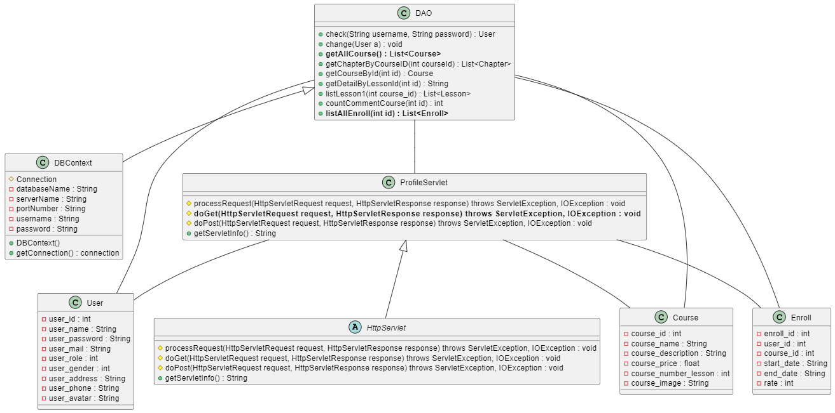

### b. Class Specifications

**ProfileServlet**

|  |  |  |
| --- | --- | --- |
| **No** | **Method** | **Description** |
| *01* | *doGet(HttpServletRequest request, HttpServletResponse response)* | *Get profile of course* |
|  |  |  |

***DBContext***

|  |  |  |
| --- | --- | --- |
| **No** | **Method** | **Description** |
| *01* | *getConnection()* | *To connect with database* |
| *02* | *closeResultSet(ResultSet resultSet)* | *To close result set* |
| *03* | *closePreparedStatement(PreparedStatement preparedStatement)* | *To close prepared statement* |
| *04* | *closeConnection(Connection connection)* | *To close connection* |

***User***

|  |  |  |
| --- | --- | --- |
| **No** | **Method** | **Description** |
| *01* | *Constructors* | *Entity initialization* |
| *02* | *Getter* | *Get value of each attributes* |
| *03* | *Setter* | *Set value of each attributes* |

***Course***

|  |  |  |
| --- | --- | --- |
| **No** | **Method** | **Description** |
| *01* | *Constructors* | *Entity initialization* |
| *02* | *Getter* | *Get value of each attributes* |
| *03* | *Setter* | *Set value of each attributes* |

***Chapter***

|  |  |  |
| --- | --- | --- |
| **No** | **Method** | **Description** |
| *01* | *Constructors* | *Entity initialization* |
| *02* | *Getter* | *Get value of each attributes* |
| *03* | *Setter* | *Set value of each attributes* |

***Enroll***

|  |  |  |
| --- | --- | --- |
| **No** | **Method** | **Description** |
| *01* | *Constructors* | *Entity initialization* |
| *02* | *Getter* | *Get value of each attributes* |
| *03* | *Setter* | *Set value of each attributes* |

***DAO***

|  |  |  |
| --- | --- | --- |
| **No** | **Method** | **Description** |
| *01* | *Change(User a)* | *Check user in database to change password* |

### c. Sequence Diagram(s)

### d. Database Queries

- GetAllCourse

SELECT TOP (1000) [Course_id]\n"

+ " ,[course_name]\n"

+ " ,[course_description]\n"

+ " ,[course_price]\n"

+ " ,[course_number_lesson]\n"

+ " ,[course_image]\n"

+ " FROM [SWP-Project].[dbo].[Course]\n"

+ " where course_price =0

- ListAllEnroll

SELECT TOP (1000) [Enroll_id]\n"

+ " ,[user_id]\n"

+ " ,[course_id]\n"

+ " ,[start_date]\n"

+ " ,[end_date]\n"

+ " ,[rate]\n"

+ " FROM [SWP-Project].[dbo].[Enroll]\n"

+ " where [user_id]=?

## 14. Search

### a. Class Diagram

### b. Class Specifications

**SearchCourseServlet**

|  |  |  |
| --- | --- | --- |
| **No** | **Method** | **Description** |
| *01* | *doGet(HttpServletRequest request, HttpServletResponse response)* | *Get name and description of course* |

**SearchLessonServlet**

|  |  |  |
| --- | --- | --- |
| **No** | **Method** | **Description** |
| *01* | *doGet(HttpServletRequest request, HttpServletResponse response)* | *Get name and description of Lesosn* |

**SearchChapterServlet**

|  |  |  |
| --- | --- | --- |
| **No** | **Method** | **Description** |
| *01* | *doGet(HttpServletRequest request, HttpServletResponse response)* | *Get name and description of Chapter* |

**DBContext**

|  |  |  |
| --- | --- | --- |
| **No** | **Method** | **Description** |
| *01* | *getConnection()* | *To connect with database* |
| *02* | *closeResultSet(ResultSet resultSet)* | *To close result set* |
| *03* | *closePreparedStatement(PreparedStatement preparedStatement)* | *To close prepared statement* |
| *04* | *closeConnection(Connection connection)* | *To close connection* |

***DAO***

|  |  |  |
| --- | --- | --- |
| **No** | **Method** | **Description** |
| *01* | *SearchChapterByName* | *Fine all Chapter where chapter name like what you want to search* |
| *02* | *SearchCourse* | *Fine all Course where chapter name like what you want to search* |
| *03* | *SearchLesson* | *Fine all lesson where chapter name like what you want to search* |

***Course***

|  |  |  |
| --- | --- | --- |
| **No** | **Method** | **Description** |
| *01* | *Constructors* | *Entity initialization* |
| *02* | *Getter* | *Get value of each attributes* |
| *03* | *Setter* | *Set value of each attributes* |

***Lesson***

|  |  |  |
| --- | --- | --- |
| **No** | **Method** | **Description** |
| *01* | *Constructors* | *Entity initialization* |
| *02* | *Getter* | *Get value of each attributes* |
| *03* | *Setter* | *Set value of each attributes* |

***Chapter***

|  |  |  |
| --- | --- | --- |
| **No** | **Method** | **Description** |
| *01* | *Constructors* | *Entity initialization* |
| *02* | *Getter* | *Get value of each attributes* |
| *03* | *Setter* | *Set value of each attributes* |

### c. Sequence Diagram(s)

### d. Database Queries

* SearchChapterByName:

SELECT [Chapter_id]\n"

+ " ,[course_id]\n"

+ " ,[chapter_name]\n"

+ " FROM [dbo].[Chapter]\n"

+ " where 1=1

* SearchCourse:

SELECT [Course_id]\n"

+ " ,[course_name]\n"

+ " ,[course_description]\n"

+ " ,[course_price]\n"

+ " ,[course_number_lesson]\n"

+ " ,[course_image]\n"

+ " FROM [dbo].[Course]\n"

+ " where 1=1

* SearchLesson:

SELECT [lesson_id]\n"

+ " ,[lesson_video]\n"

+ " ,[lesson_level]\n"

+ " ,[chapter_id]\n"

+ " ,[image_id]\n"

+ " ,[lesson_content]\n"

+ " ,[lesson_number]\n"

+ " FROM [dbo].[Lesson]\n"

+ " where 1=1

## 15. User Manage

### a. Class Diagram

### b. Class Specifications

***DBContext***

|  |  |  |
| --- | --- | --- |
| **No** | **Method** | **Description** |
| *01* | *getConnection()* | *To connect with database* |
| *02* | *closeResultSet(ResultSet resultSet)* | *To close result set* |

***UserDAO***

|  |  |  |
| --- | --- | --- |
| **No** | **Method** | **Description** |
| *01* | *checkUser* | *Check all users exist in database already.* |
| *02* | *CheckUserById* | *Check only user have their id* |
| *03* | *addUser* | *Add user to the database* |
| *05* | *CheckUserGoogle* | *Check user login with google (check email has exist)* |
| *06* | *GetAllUser()* | *Take all user from database to the system.* |

***UserManage***

|  |  |  |
| --- | --- | --- |
| **No** | **Method** | **Description** |
| *01* | *doGet(HttpServletRequest request, HttpServletResponse response)* | *Get list user from database to display in the screen.* |

***User***

|  |  |  |
| --- | --- | --- |
| **No** | **Method** | **Description** |
| *01* | *Constructors* | *Entity initialization* |
| *02* | *Getter* | *Get value of each attributes* |
|  |  |  |

### c. Sequence Diagram(s)

### d. Database Queries

- GET ALL USER:

SELECT [User_Id]\n"

+ " ,[user_name]\n"

+ " ,[user_mail]\n"

+ " ,[user_password]\n"

+ " ,[user_role]\n"

+ " ,[user_gender]\n"

+ " ,[user_address]\n"

+ " ,[user_phone]\n"

+ " ,[user_avatar]\n"

+ " ,[user_status]\n"

+ " FROM [dbo].[User]

## 16. Manage

### a. Class Diagram

### b. Class Specifications

***Manage***

|  |  |  |
| --- | --- | --- |
| **No** | **Method** | **Description** |
| *01* | *doGet(HttpServletRequest request, HttpServletResponse response)* | *Get name, gender, email,address,phone,tong in database and show on manage page* |

***DBContext***

|  |  |  |
| --- | --- | --- |
| **No** | **Method** | **Description** |
| *01* | *getConnection()* | *To connect with database* |
| *02* | *closeResultSet(ResultSet resultSet)* | *To close result set* |
| *03* | *closePreparedStatement(PreparedStatement preparedStatement)* | *To close prepared statement* |
| *04* | *closeConnection(Connection connection)* | *To close connection* |

***ThongTin***

|  |  |  |
| --- | --- | --- |
| **No** | **Method** | **Description** |
| *01* | *Constructors* | *Entity initialization* |
| *02* | *Getter* | *Get value of each attributes* |
| *03* | *Setter* | *Set value of each attributes* |

***DAOAdmin***

|  |  |  |
| --- | --- | --- |
| **No** | **Method** | **Description** |
| *01* | *numberOfStudent()* | *Check number of student* |
| *02* | *numberOfCourse()* | *Check number of course* |
| *03* | *numberOfEnroll()* | *Check number of enroll* |
| *04* | *getInfoCustomer()* | *Check all information of customer* |

### c. Sequence Diagram(s)

### Diagram Description automatically generatedd. Database Queries

*- numberOfStudent():*

*select count(u.User_Id) from [User] as u where u.user_role = 1*

*- numberOfCourse():*

*select count(Course_id) from [Course]*

*- numberOfEnroll():*

*select count(Enroll_id) from [Enroll]*

*- getInfoCustomer():*

select c.user_gender,c.user_name,c.user_mail,c.user_address,c.user_phone, d.tong from \n"

+ "(select u.User_Id,u.user_gender,u.user_name,u.user_mail,u.user_address,u.user_phone from \n"

+ "(select e.user_id from Enroll as e group by e.user_id) as a left join [User] as u on a.user_id=u.User_Id) as c ,\n"

+ "(select e.user_id, count(e.user_id) as tong from Enroll as e group by e.user_id) as d where c.User_Id=d.user_id

## 17. CourseManage

### a. Class Diagram

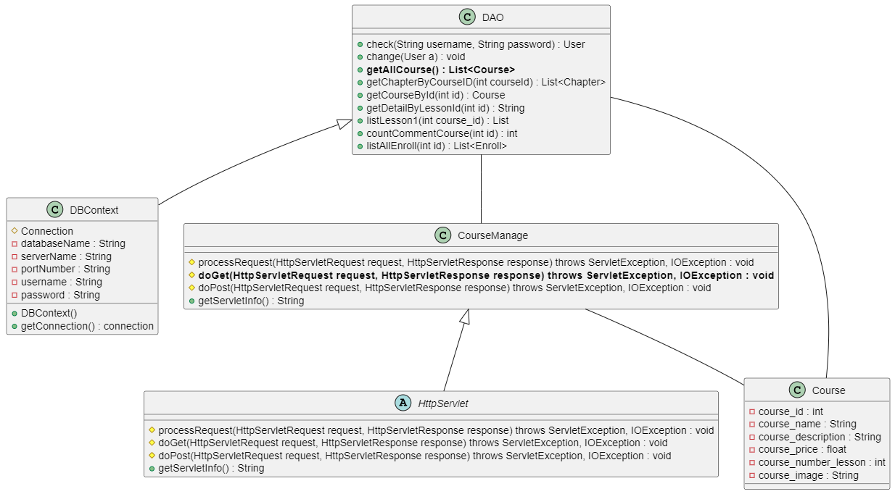

### b. Class Specifications

**CourseManage**

|  |  |  |
| --- | --- | --- |
| **No** | **Method** | **Description** |
| *01* | *doGet(HttpServletRequest request, HttpServletResponse response)* | *Get all course in database and show on courseManager page* |

***DBContext***

|  |  |  |
| --- | --- | --- |
| **No** | **Method** | **Description** |
| *01* | *getConnection()* | *To connect with database* |
| *02* | *closeResultSet(ResultSet resultSet)* | *To close result set* |
| *03* | *closePreparedStatement(PreparedStatement preparedStatement)* | *To close prepared statement* |
| *04* | *closeConnection(Connection connection)* | *To close connection* |

***Course***

|  |  |  |
| --- | --- | --- |
| **No** | **Method** | **Description** |
| *01* | *Constructors* | *Entity initialization* |
| *02* | *Getter* | *Get value of each attributes* |
| *03* | *Setter* | *Set value of each attributes* |

***DAO***

|  |  |  |
| --- | --- | --- |
| **No** | **Method** | **Description** |
| *01* | *getAllCourse()* | *Get all course from database and display on page* |

### c. Sequence Diagram(s)

### d. Database Queries

- getAllCourse():

SELECT TOP (1000) [Course_id]\n"

+ " ,[course_name]\n"

+ " ,[course_description]\n"

+ " ,[course_price]\n"

+ " ,[course_number_lesson]\n"

+ " ,[course_image]\n"

+ " FROM [SWP-Project].[dbo].[Course]\n"

+ " where course_price =0

## 18. LessonManager

### a. Class Diagram

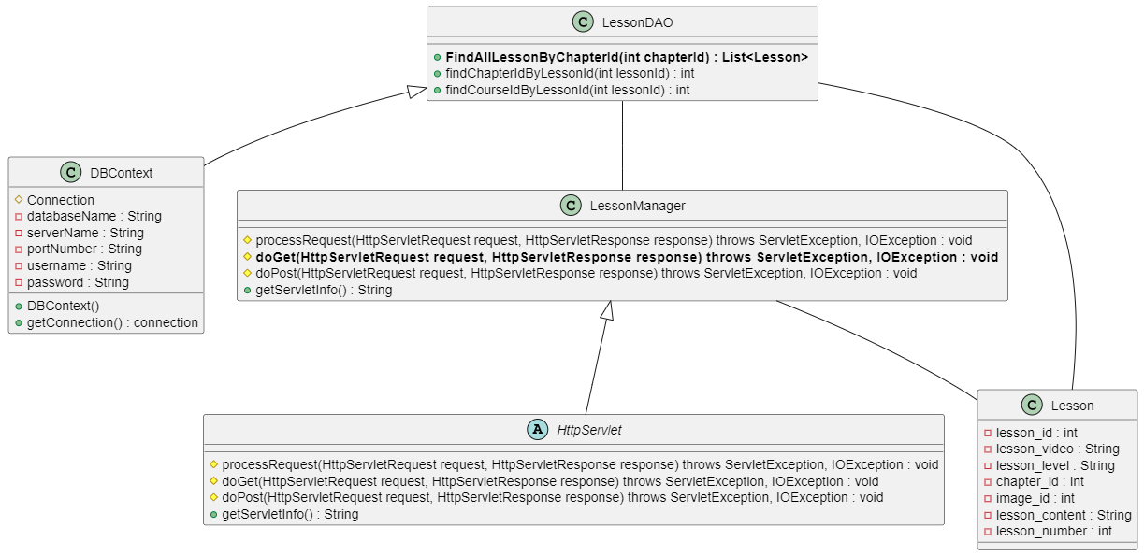

### b. Class Specifications

#### LessonManager

|  |  |  |
| --- | --- | --- |
| **No** | **Method** | **Description** |
| *01* | *doGet(HttpServletRequest request, HttpServletResponse response)* | *Get all lesson in database and show on lesson manager page* |

#### DBContext

|  |  |  |
| --- | --- | --- |
| **No** | **Method** | **Description** |
| *01* | *getConnection()* | *To connect with database* |
| *02* | *closeResultSet(ResultSet resultSet)* | *To close result set* |
| *03* | *closePreparedStatement(PreparedStatement preparedStatement)* | *To close prepared statement* |
| *04* | *closeConnection(Connection connection)* | *To close connection* |

***Lesson***

|  |  |  |
| --- | --- | --- |
| **No** | **Method** | **Description** |
| *01* | *Constructors* | *Entity initialization* |
| *02* | *Getter* | *Get value of each attributes* |
| *03* | *Setter* | *Set value of each attributes* |

***LessonDAO***

|  |  |  |
| --- | --- | --- |
| **No** | **Method** | **Description** |
| *01* | *FindAllLessonByChapterId(int chapterId)* | *Get each lesson in each Chapter containing that lesson* |

### c. Sequence Diagram(s)

### d. Database Queries

- FindAllLessonByChapterId(int chapterId):

SELECT [lesson_id]\n"

+ " ,[lesson_video]\n"

+ " ,[lesson_level]\n"

+ " ,[chapter_id]\n"

+ " ,[image_id]\n"

+ " ,[lesson_content]\n"

+ " ,[lesson_number]\n"

+ " FROM [SWP-Project].[dbo].[Lesson] where chapter_id = ?