0



**Online-learning**

**Software Requirement Specification**

**Group 6 – SE1642**

– Hanoi, February 2023 –

**Table of Contents**

I. Overview 4

1. Introduction 4

2. System Functions 5

3. Entity Relationship Diagram 6

II. Functional Requirements 7

1. Home 7

a. Screen home 7

b. Screen course 7

2. Course, Chapter 7

a. Screen course

**RECORD OF CHANGES**

|  |  |  |  |
| --- | --- | --- | --- |
| Date | A* M, D | In charge | Change Description |
| 12/Feb | M | KienPT | Modified a home page and database. |
| 12/Feb | A | DungNTK | Add more lesson into database and function of lesson and chapter in website. Modified data in database and front-end. |
| 12/Feb | A | VinhTD | Create a multiple-choice exam in each course |
| 12/Feb | A, M | DucNT | Add and modify question list and lesson list content into database |
| 12/Feb | A, M | KhangTD | Modified change password, and added a login with email. |

*A - Added M - Modified D - Deleted

# I. Overview

## 1. Introduction

The Online learning website is new website about learning programming language that help everyone learn easily from beginner to advanced. The website has many course free and exam after finish course for student improve and test their knowledge also the website has some purchase course, so we expected to evolve over several releases, ultimately connecting to the Internet ordering services for several local restaurants and to credit and debit card authorization services.

## 2. System Functions

#### a. Screen Flow

#### b. Screen Details

|  |  |  |  |
| --- | --- | --- | --- |
| **#** | **Feature** | **Screen** | **Description** |
| 1 | Course | Course Info | Show all information of course learn on website |
| 2 | Chapter | Chapter Info | Show all chapter of course and list out all lesson each chapter have. |
| 3 | Lesson | Lesson Info | Show all information of each lesson. After finishing a lesson website will remember that you have learned that lesson, if you have been already registered. |
| 4 | Rating website | Visitor comment | List out all comment and rating of web site when they go to the rating of website |
| 5 | Rating course | Visitor comment | List out all comment and rating of Course when they go to the rating of course |
| 6 | Lesson comment | Student comment | List out all comment and image of student under each lesson. |
| 7 | Login/register | Form login/register | Create a form to login and register, user can register and login with email. |
| 8 | Change password | Form to change password | Change password will ask about user name , old password and new pass word |
| 9 | User profile | Show all info of User | Show all information of user. |
| 10 | Update/delete User profile | Form update/delete for user | Create a form for user can change information in that. Have a submit button and a notification to user when they change their info. |
| 11 | Exam | A test with multiple choice | Only user who have account and learn course can do this exam. |
| 12 | Order List | Order information | List out all order information of customer and a payment detail. |
|  |  |  |  |

#### c. User Authorization

|  |  |  |  |  |
| --- | --- | --- | --- | --- |
| **Screen** | **Visitor** | **User** | **User VIP** | **Admin** |
| Home page | X | X | X | X |
| Course detail | X | X | X | X |
| View Rating course | X | X | X | X |
| Profile |  | X | X | X |
| Comment |  | X | X | X |
| Exam |  | X | X | X |
| Quiz |  |  | X | X |
| Order Detail |  | X | X | X |
| Add New Course |  |  |  | X |
| Update All Course |  |  |  | X |
| Managed Course |  |  |  | X |
| Delete Course |  |  |  | X |

## 3. Entity Relationship Diagram

**Entities Description**

|  |  |  |
| --- | --- | --- |
| **#** | **Entity** | **Description** |
| 1 | User | All profile information, acocunt and role of user |
| 2 | Discussion | A discussion about website and rating web |
| 3 | Course | Course detail (description of course , chapter,…) |
| 4 | Enroll | Information about user was enroll a course |
| 5 | Chapter | List all chapter of course |
| 6 | Lesson | A lesson of a course has a lesson content, lesson video. |
| 7 | Image | Store image of all lesson |
| 8 | Comment Lesson | List all comment or question of all users in a lesson.  User can like and answer another comment |
| 9 | Comment Course | List all comment or question of all users in a course.  User can rating, like and answer another comment |
| 10 | Question | Store all question of website. |

# II. Functional Requirements

## Register

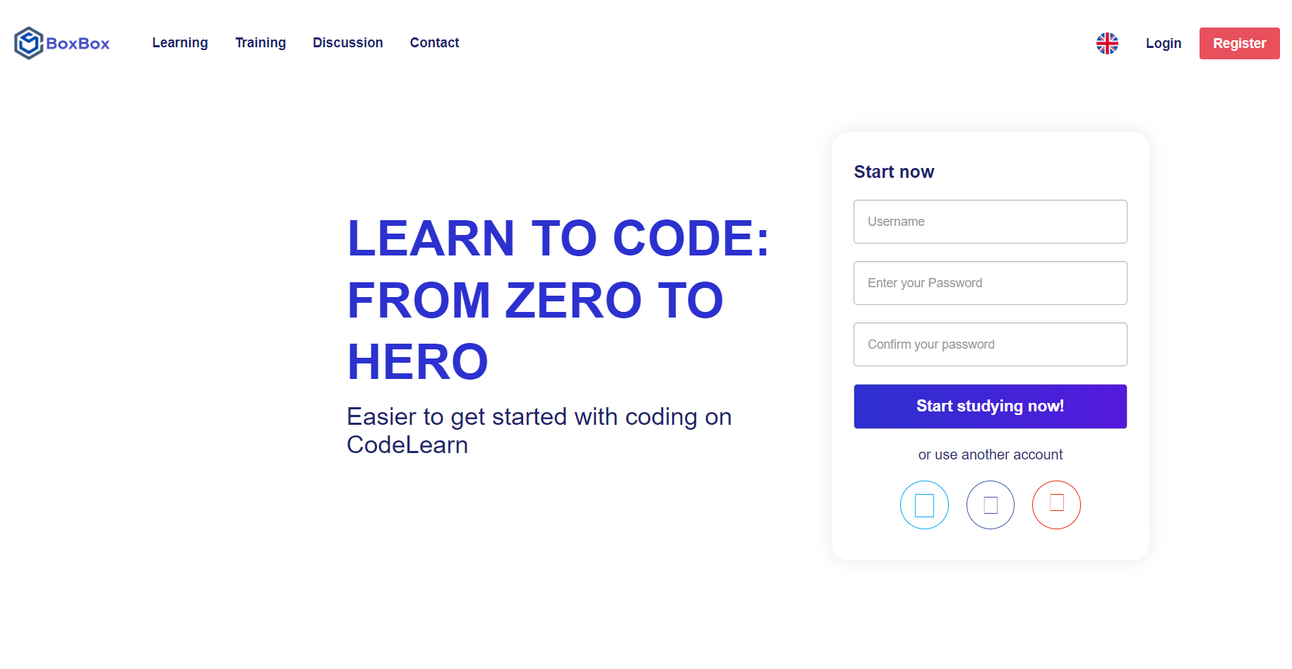

|  |  |  |  |
| --- | --- | --- | --- |
| **Use Case ID:** | **UC-01** | | |
| **Use Case Name:** | **Home page** | | |
| **Created By:** | **KhangTD** | **Created Date:** | **04/02/2023** |
| **Primary Actor:** | **User** | **Secondary Actors:** | **N/A** |
| **Description:** | User register account with email and password | | |
| **Trigger:** | N/A | | |
| **Preconditions:** | User access register page of the system. | | |
| **Post-Condition:** | * User successfully register accout of the system. * Redirect user to login page to login. | | |
| **Normal Flow:** | * User visits the website. * Click “Register” on the bottom of login form. * Input required fields. * Press the " Register " button. * The system displays the message and redirect to login page. | | |
| **Alternative Flow:** | N/A | | |
| **Exceptions:** | Register fail because email is currently existed in the system. | | |
| **Priority:** | High | | |
| **Frequency of Use:** | High | | |
| **Business Rules:** | N/A | | |
| **Other Information:** | N/A | | |
| **Assumptions:** | N/A | | |

## 2. Login

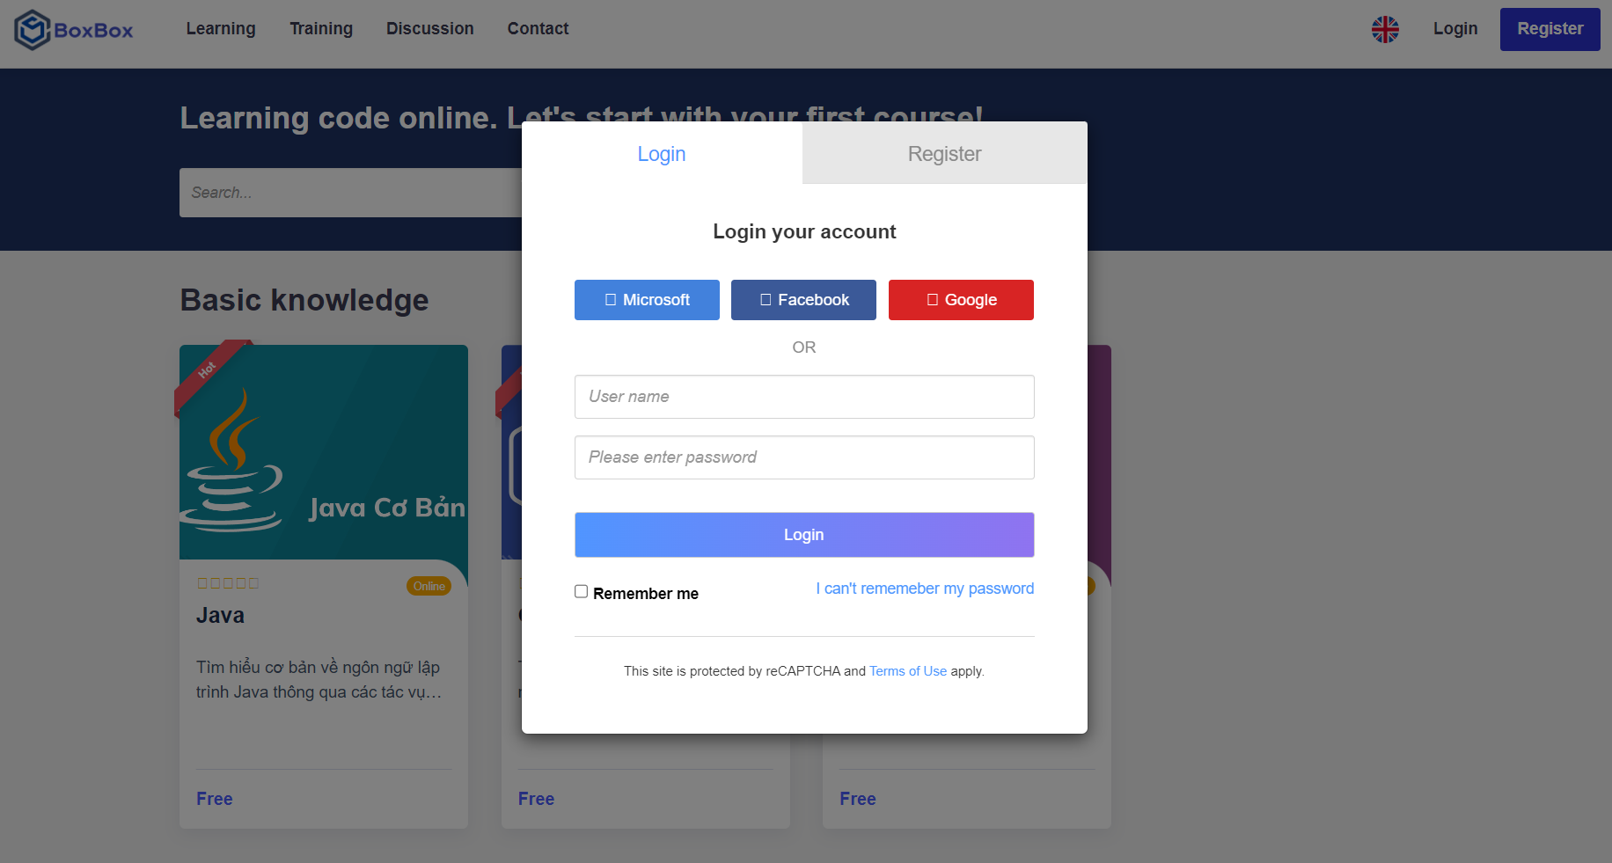

|  |  |  |  |
| --- | --- | --- | --- |
| **Use Case ID:** | **UC-02** | | |
| **Use Case Name:** | **Login** | | |
| **Created By:** | **KhangTD** | **Created Date:** | **04/02/2023** |
| **Primary Actor:** | **User** | **Secondary Actors:** | **N/A** |
| **Description:** | User login by email and password with correct captcha. | | |
| **Trigger:** | N/A | | |
| **Preconditions:** | * The user already has user’s account of the system | | |
| **Post-Condition:** | * User successfully logged into the system. * Display the correct interface with the user's role. | | |
| **Normal Flow:** | * User visits the website. * Input required fields and captcha code. * Press the "Login" button. * The system displays the user home page. | | |
| **Alternative Flow:** | N/A | | |
| **Exceptions:** | * Login failed because there is no account in the system. * Login failed because captcha code is not valid. | | |
| **Priority:** | High | | |
| **Frequency of Use:** | High | | |
| **Business Rules:** | N/A | | |
| **Other Information:** | N/A | | |
| **Assumptions:** | N/A | | |

## 3. Home

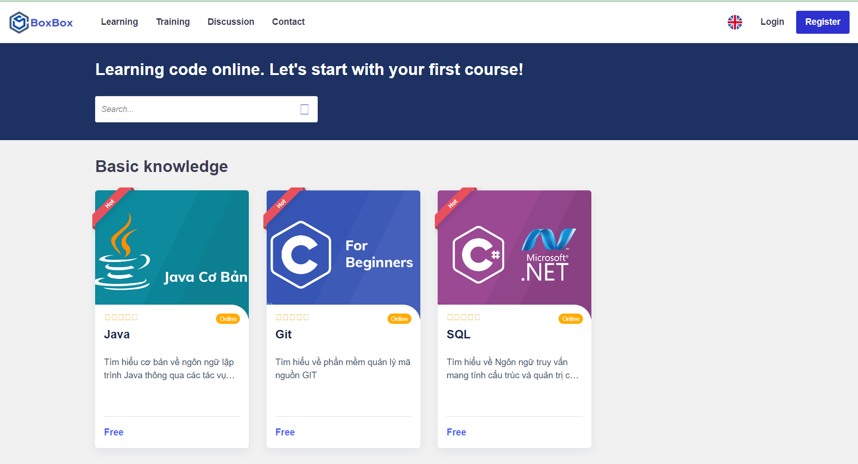

|  |  |  |  |
| --- | --- | --- | --- |
| **Use Case ID:** | **UC-03** | | |
| **Use Case Name:** | **Home page** | | |
| **Created By:** | **KienPT** | **Created Date:** | **04/02/2023** |
| **Primary Actor:** | **User** | **Secondary Actors:** | **N/A** |
| **Description:** | Provide information about your website, including its introduction, purpose, topics, and content provided on the website. | | |
| **Trigger:** | N/A | | |
| **Preconditions:** | The user successfully logged into the system | | |
| **Post-Condition:** | The system displays a list of course, introduction, purpose, topics and content provided on the website. | | |
| **Normal Flow:** | User visit website  Display home page | | |
| **Alternative Flow:** | N/A | | |
| **Exceptions:** | N/A | | |
| **Priority:** | Low | | |
| **Frequency of Use:** | High | | |
| **Business Rules:** | N/A | | |
| **Other Information:** | N/A | | |
| **Assumptions:** | N/A | | |

## Course information

|  |  |  |  |
| --- | --- | --- | --- |
| **Use Case ID:** | **UC-04** | | |
| **Use Case Name:** | **Chapter Detail** | | |
| **Created By:** | KhangTD | **Created Date:** | **05/02/2023** |
| **Primary Actor:** | **User** | **Secondary Actors:** | **N/A** |
| **Description:** | This page should list the available course words, including the course name, description, price, and duration of the course word. | | |
| **Trigger:** | N/A | | |
| **Preconditions:** | N/A | | |
| **Post-Condition:** | User must visit home page to view all course. | | |
| **Normal Flow:** | * User visits the website. * Press the Course name or course image. | | |
| **Alternative Flow:** | N/A | | |
| **Exceptions:** | N/A | | |
| **Priority:** | Low | | |
| **Frequency of Use:** | High | | |
| **Business Rules:** | N/A | | |
| **Other Information:** | N/A | | |
| **Assumptions:** | N/A | | |

## 5. Chapter Detail

|  |  |  |  |
| --- | --- | --- | --- |
| **Use Case ID:** | **UC-05** | | |
| **Use Case Name:** | **Chapter detail** | | |
| **Created By:** | **Dungntk + DucNT** | **Created Date:** | **04/02/2023** |
| **Primary Actor:** | **User** | **Secondary Actors:** | **N/A** |
| **Description:** | This page provides learning materials for courses. Materials may include videos, lectures. | | |
| **Trigger:** | N/A | | |
| **Preconditions:** | * Users must go to the course page first to see the chapter information | | |
| **Post-Condition:** | * List all chapter information: chapter name, and the number of lessons have in each chapter | | |
| **Normal Flow:** | * User visits the website. * Users go to the course page * View all chapter detail | | |
| **Alternative Flow:** | N/A | | |
| **Exceptions:** | N/A | | |
| **Priority:** | Low | | |
| **Frequency of Use:** | High | | |
| **Business Rules:** | N/A | | |
| **Other Information:** | N/A | | |
| **Assumptions:** | N/A | | |

## 6. change password

|  |  |  |  |
| --- | --- | --- | --- |
| **Use Case ID:** | **UC-06** | | |
| **Use Case Name:** | **Change password** | | |
| **Created By:** | **KhangTD** | **Created Date:** | **07/02/2023** |
| **Primary Actor:** | **User** | **Secondary Actors:** | **N/A** |
| **Description:** | User change password to authorities | | |
| **Trigger:** | N/A | | |
| **Preconditions:** | * Users must login to account and go to change password page | | |
| **Post-Condition:** | * Users must enter old password. * User must enter new password two time to verify correct new password want to change. | | |
| **Normal Flow:** | * User visits the website. * Users’ login to account * Users go to change password page | | |
| **Alternative Flow:** | N/A | | |
| **Exceptions:** | N/A | | |
| **Priority:** | High | | |
| **Frequency of Use:** | High | | |
| **Business Rules:** | N/A | | |
| **Other Information:** | N/A | | |
| **Assumptions:** | N/A | | |

## 7. Practice

|  |  |  |  |
| --- | --- | --- | --- |
| **Use Case ID:** | **UC-07** | | |
| **Use Case Name:** | **Practice** | | |
| **Created By:** | **VinhTD + KienPT** | **Created Date:** | **10/02/2023** |
| **Primary Actor:** | **User** | **Secondary Actors:** | **N/A** |
| **Description:** | The test page contains all the questions in the web's question library, to help students check what they have learned in the web. At the same time, it helps to assess the ability of students studying on the website. | | |
| **Trigger:** | N/A | | |
| **Preconditions:** | * Users must login to page and choose the course you want to take an exam. | | |
| **Post-Condition:** | * There will be a button to start practice. | | |
| **Normal Flow:** | * User visits the website. * Users register or login account. * Choose the course that you want to have a practice. | | |
| **Alternative Flow:** | N/A | | |
| **Exceptions:** | N/A | | |
| **Priority:** | High | | |
| **Frequency of Use:** | High | | |
| **Business Rules:** | N/A | | |
| **Other Information:** | N/A | | |
| **Assumptions:** | N/A | | |

## 8. Mark report

|  |  |  |  |
| --- | --- | --- | --- |
| **Use Case ID:** | **UC-08** | | |
| **Use Case Name:** | **Mark report** | | |
| **Created By:** | **VinhTD + KienPT** | **Created Date:** | **10/02/2023** |
| **Primary Actor:** | **User** | **Secondary Actors:** | **N/A** |
| **Description:** | This function will help student view the mark after they finished the multiple-choice exam. | | |
| **Trigger:** | N/A | | |
| **Preconditions:** | * Users must finish the practice. | | |
| **Post-Condition:** | * Users take part in the practice and finish the exam. | | |
| **Normal Flow:** | * User visits the website. * Users register or login account. * Choose the course that you want to have a practice. * Finish the practice of course. | | |
| **Alternative Flow:** | N/A | | |
| **Exceptions:** | N/A | | |
| **Priority:** | High | | |
| **Frequency of Use:** | High | | |
| **Business Rules:** | N/A | | |
| **Other Information:** | N/A | | |
| **Assumptions:** | N/A | | |

## 9. Correct answer report

|  |  |  |  |
| --- | --- | --- | --- |
| **Use Case ID:** | **UC-09** | | |
| **Use Case Name:** | Correct answer report | | |
| **Created By:** | **VinhTD + KienPT** | **Created Date:** | **10/02/2023** |
| **Primary Actor:** | **User** | **Secondary Actors:** | **N/A** |
| **Description:** | This function will help student view the correct and wrong answer when they finished exam and viewed mark. | | |
| **Trigger:** | N/A | | |
| **Preconditions:** | * Users must finish the practice. | | |
| **Post-Condition:** | * Users take part in the practice and finish the exam. | | |
| **Normal Flow:** | * User visits the website. * Users register or login account. * Choose the course that you want to have a practice. * Finish the practice of course. | | |
| **Alternative Flow:** | N/A | | |
| **Exceptions:** | N/A | | |
| **Priority:** | High | | |
| **Frequency of Use:** | High | | |
| **Business Rules:** | N/A | | |
| **Other Information:** | N/A | | |
| **Assumptions:** | N/A | | |

## 10. Profile

|  |  |  |  |
| --- | --- | --- | --- |
| **Use Case ID:** | **UC-10** | | |
| **Use Case Name:** | Profile | | |
| **Created By:** | **KhangTD** | **Created Date:** | **20/02/2023** |
| **Primary Actor:** | **User** | **Secondary Actors:** | **N/A** |
| **Description:** | Profile page will provide users with Profile Picture, Full Name, Gender, Date of Birth, Date of Birth, Email Address, Description of Yourself. | | |
| **Trigger:** | N/A | | |
| **Preconditions:** | * Users must login to accounts. | | |
| **Post-Condition:** | * Users take part in the practice and finish the exam. | | |
| **Normal Flow:** | * User visits the website. * Users register or login account. * Choose the profile of users. | | |
| **Alternative Flow:** | N/A | | |
| **Exceptions:** | N/A | | |
| **Priority:** | High | | |
| **Frequency of Use:** | High | | |
| **Business Rules:** | N/A | | |
| **Other Information:** | N/A | | |
| **Assumptions:** | N/A | | |

## 11. Discussion

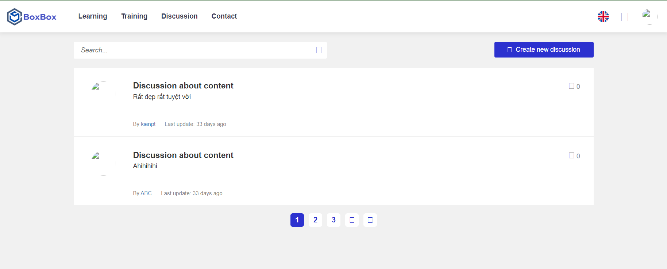

|  |  |  |  |
| --- | --- | --- | --- |
| **Use Case ID:** | **UC-11** | | |
| **Use Case Name:** | Discussion | | |
| **Created By:** | **KienPT** | **Created Date:** | **02/02/2023** |
| **Primary Actor:** | **User** | **Secondary Actors:** | **N/A** |
| **Description:** | The Comment author must fill out name, Users must be registered and logged in to comment, Enable threaded (nested) comments, Comments displayed with the comments at the top for each page. | | |
| **Trigger:** | N/A | | |
| **Preconditions:** | * Users must login to accounts. | | |
| **Post-Condition:** | * Users take part in the discussion page. | | |
| **Normal Flow:** | * User visits the website. * Users register or login account. * Go to discussion page. | | |
| **Alternative Flow:** | N/A | | |
| **Exceptions:** | N/A | | |
| **Priority:** | medium | | |
| **Frequency of Use:** | High | | |
| **Business Rules:** | N/A | | |
| **Other Information:** | N/A | | |
| **Assumptions:** | N/A | | |

## 12. Lesson

|  |  |  |  |
| --- | --- | --- | --- |
| **Use Case ID:** | **UC-12** | | |
| **Use Case Name:** | Lesson | | |
| **Created By:** | **DungNTK** | **Created Date:** | **01/02/2023** |
| **Primary Actor:** | **User** | **Secondary Actors:** | **N/A** |
| **Description:** | List out all information contained in each course that has been researched and synthesized from reliable sources and has been used by major universities in the curriculum. | | |
| **Trigger:** | N/A | | |
| **Preconditions:** | N/A | | |
| **Post-Condition:** | N/A | | |
| **Normal Flow:** | * User visits the website. * Users go to the course and chose the lesson that they want. | | |
| **Alternative Flow:** | N/A | | |
| **Exceptions:** | N/A | | |
| **Priority:** | low | | |
| **Frequency of Use:** | High | | |
| **Business Rules:** | N/A | | |
| **Other Information:** | N/A | | |
| **Assumptions:** | N/A | | |

## 13. Purchase course

|  |  |  |  |
| --- | --- | --- | --- |
| **Use Case ID:** | **UC-13** | | |
| **Use Case Name:** | Purchase course | | |
| **Created By:** | **DucNT** | **Created Date:** | **18/02/2023** |
| **Primary Actor:** | **User** | **Secondary Actors:** | **N/A** |
| **Description:** | A paid course is usually designed and developed to ensure higher teaching quality. It provides learners with high-quality study materials, in-depth lectures, and support from highly specialized instructors. | | |
| **Trigger:** | N/A | | |
| **Preconditions:** | * User must login account then paid for a purchase course. | | |
| **Post-Condition:** | * A payment will create for user to accept to buy purchase course. | | |
| **Normal Flow:** | * User visits the website. * Users’ login. * User paid for purchase course | | |
| **Alternative Flow:** | N/A | | |
| **Exceptions:** | N/A | | |
| **Priority:** | high | | |
| **Frequency of Use:** | High | | |
| **Business Rules:** | N/A | | |
| **Other Information:** | N/A | | |
| **Assumptions:** | N/A | | |

## 14. Video

|  |  |  |  |
| --- | --- | --- | --- |
| **Use Case ID:** | **UC-14** | | |
| **Use Case Name:** | Video for purchase course | | |
| **Created By:** | **DucNT** | **Created Date:** | **19/02/2023** |
| **Primary Actor:** | **User** | **Secondary Actors:** | **N/A** |
| **Description:** | A video is recorded by the instructor under each lesson to teach in-depth knowledge of the lesson. | | |
| **Trigger:** | N/A | | |
| **Preconditions:** | * User must have a purchase course. | | |
| **Post-Condition:** | * Users have a purchase course then will have a lecture in the form of a video for student. | | |
| **Normal Flow:** | * User visits the website. * Users’ login. * User paid for purchase course. * A lecture video under a lesson. | | |
| **Alternative Flow:** | N/A | | |
| **Exceptions:** | N/A | | |
| **Priority:** | high | | |
| **Frequency of Use:** | High | | |
| **Business Rules:** | N/A | | |
| **Other Information:** | N/A | | |
| **Assumptions:** | N/A | | |

## 15. Change Avatar

|  |  |  |  |
| --- | --- | --- | --- |
| **Use Case ID:** | **UC-15** | | |
| **Use Case Name:** | **Change avatar** | | |
| **Created By:** | **KienPT** | **Created Date:** | **27/02/2023** |
| **Primary Actor:** | **User** | **Secondary Actors:** | **N/A** |
| **Description:** | Update an avatar so that you can be recognized in the comments of the lock and beautify your feature. | | |
| **Trigger:** | N/A | | |
| **Preconditions:** | * User must login their account. | | |
| **Post-Condition:** | * Profile has a change avatar for user. | | |
| **Normal Flow:** | * User visits the website. * Users login to their account. * Users go to profile and change avatar. | | |
| **Alternative Flow:** | N/A | | |
| **Exceptions:** | N/A | | |
| **Priority:** | high | | |
| **Frequency of Use:** | High | | |
| **Business Rules:** | N/A | | |
| **Other Information:** | N/A | | |
| **Assumptions:** | N/A | | |

## 16. Change Profile

|  |  |  |  |
| --- | --- | --- | --- |
| **Use Case ID:** | **UC-16** | | |
| **Use Case Name:** | **Change profile** | | |
| **Created By:** | **KhangTD** | **Created Date:** | **25/02/2023** |
| **Primary Actor:** | **User** | **Secondary Actors:** | **N/A** |
| **Description:** | Update an information of user in profile such as username, user phone, user address, user email… | | |
| **Trigger:** | N/A | | |
| **Preconditions:** | * User must login their account. | | |
| **Post-Condition:** | * Profile has a change page for user. | | |
| **Normal Flow:** | * User visits the website. * Users’ login to their account. * Users go to profile and change their profile. | | |
| **Alternative Flow:** | N/A | | |
| **Exceptions:** | N/A | | |
| **Priority:** | high | | |
| **Frequency of Use:** | High | | |
| **Business Rules:** | N/A | | |
| **Other Information:** | N/A | | |
| **Assumptions:** | N/A | | |

## 17. Search

|  |  |  |  |
| --- | --- | --- | --- |
| **Use Case ID:** | **UC-16** | | |
| **Use Case Name:** | **Change profile** | | |
| **Created By:** | **VinhTD** | **Created Date:** | **25/02/2023** |
| **Primary Actor:** | **User** | **Secondary Actors:** | **N/A** |
| **Description:** | Search all information or detail of course. After search there will display a course that user want to find . | | |
| **Trigger:** | N/A | | |
| **Preconditions:** | * User search bar. | | |
| **Post-Condition:** | N/A | | |
| **Normal Flow:** | * User visits the website. * User search bar. * Website display the course user want to find. | | |
| **Alternative Flow:** | N/A | | |
| **Exceptions:** | N/A | | |
| **Priority:** | low | | |
| **Frequency of Use:** | High | | |
| **Business Rules:** | N/A | | |
| **Other Information:** | N/A | | |
| **Assumptions:** | N/A | | |

## 18. Static chart

|  |  |  |  |
| --- | --- | --- | --- |
| **Use Case ID:** | **UC-16** | | |
| **Use Case Name:** | **Change profile** | | |
| **Created By:** | **KhangTD** | **Created Date:** | **25/02/2023** |
| **Primary Actor:** | **User** | **Secondary Actors:** | **N/A** |
| **Description:** | Statistics of revenue parameters as well as the number of users coming to see the website according to the chart. | | |
| **Trigger:** | N/A | | |
| **Preconditions:** | * Admin | | |
| **Post-Condition:** | * admin rights | | |
| **Normal Flow:** | * admin rights. * Revenue and traffic statistics. | | |
| **Alternative Flow:** | N/A | | |
| **Exceptions:** | N/A | | |
| **Priority:** | high | | |
| **Frequency of Use:** | N/A | | |
| **Business Rules:** | N/A | | |
| **Other Information:** | N/A | | |
| **Assumptions:** | N/A | | |

## Manage Course

|  |  |  |  |
| --- | --- | --- | --- |
| **Use Case ID:** | **UC-04** | | |
| **Use Case Name:** | **Chapter Detail** | | |
| **Created By:** | KhangTD | **Created Date:** | **26/02/2023** |
| **Primary Actor:** | **User** | **Secondary Actors:** | **N/A** |
| **Description:** | This page should list the available course of website. Admin have a permission to change the information of course. | | |
| **Trigger:** | N/A | | |
| **Preconditions:** | N/A | | |
| **Post-Condition:** | Admin permission | | |
| **Normal Flow:** | N/a | | |
| **Alternative Flow:** | N/A | | |
| **Exceptions:** | N/A | | |
| **Priority:** | High | | |
| **Frequency of Use:** | Low | | |
| **Business Rules:** | N/A | | |
| **Other Information:** | N/A | | |
| **Assumptions:** | N/A | | |

## Manage User

|  |  |  |  |
| --- | --- | --- | --- |
| **Use Case ID:** | **UC-04** | | |
| **Use Case Name:** | **Chapter Detail** | | |
| **Created By:** | KhangTD | **Created Date:** | **26/02/2023** |
| **Primary Actor:** | **User** | **Secondary Actors:** | **N/A** |
| **Description:** | This page should list the available user of website. Admin has a permission to change the information of user. | | |
| **Trigger:** | N/A | | |
| **Preconditions:** | N/A | | |
| **Post-Condition:** | Admin permission | | |
| **Normal Flow:** | N/a | | |
| **Alternative Flow:** | N/A | | |
| **Exceptions:** | N/A | | |
| **Priority:** | High | | |
| **Frequency of Use:** | Low | | |
| **Business Rules:** | N/A | | |
| **Other Information:** | N/A | | |
| **Assumptions:** | N/A | | |