

**Online-learning**

**Software Requirement Specification**

**Group 6 – SE1642**

– Hanoi, February 2023 –

**Table of Contents**

I. Overview 4

1. Introduction 4

2. System Functions 5

3. Entity Relationship Diagram 6

II. Functional Requirements 7

1. Home 7

a. Screen home 7

b. Screen course 7

2. Course, Chapter 7

a. Screen course

**RECORD OF CHANGES**

|  |  |  |  |
| --- | --- | --- | --- |
| Date | A* M, D | In charge | Change Description |
| 12/Feb | M | KienPT | Modified a home page and database. |
| 12/Feb | A | DungNTK | Add more lesson into database and function of lesson and chapter in website. Modified data in database and front-end. |
| 12/Feb | A | VinhTD | Create a multiple-choice exam in each course |
| 12/Feb | A, M | DucNT | Add and modify question list and lesson list content into database |
| 12/Feb | A, M | KhangTD | Modified change password, and added a login with email. |

*A - Added M - Modified D - Deleted

# I. Overview

## 1. Introduction

The Online learning website is new website about learning programming language that help everyone learn easily from beginner to advanced. The website has many course free and exam after finish course for student improve and test their knowledge also the website has some purchase course, so we expected to evolve over several releases, ultimately connecting to the Internet ordering services for several local restaurants and to credit and debit card authorization services.

## 2. System Functions

#### a. Screen Flow

*[This part shows the system screens and the relationship among screens. You can draw the Screens Flow for the system in the form of diagram as below]*

#### b. Screen Details

|  |  |  |  |
| --- | --- | --- | --- |
| **#** | **Feature** | **Screen** | **Description** |
| 1 | Course | Course Info | Show all information of course learn on website |
| 2 | Chapter | Chapter Info | Show all chapter of course and list out all lesson each chapter have. |
| 3 | Lesson | Lesson Info | Show all information of each lesson. After finishing a lesson website will remember that you have learned that lesson, if you have been already registered. |
| 4 | Rating website | Visitor comment | List out all comment and rating of web site when they go to the rating of website |
| 5 | Rating course | Visitor comment | List out all comment and rating of Course when they go to the rating of course |
| 6 | Lesson comment | Student comment | List out all comment and image of student under each lesson. |
| 7 | Login/register | Form login/register | Create a form to login and register, user can register and login with email. |
| 8 | Change password | Form to change password | Change password will ask about user name , old password and new pass word |
| 9 | User profile | Show all info of User | Show all information of user. |
| 10 | Update/delete User profile | Form update/delete for user | Create a form for user can change information in that. Have a submit button and a notification to user when they change their info. |
| 11 | Exam | A test with multiple choice | Only user who have account and learn course can do this exam. |
| 12 | Order List | Order information | List out all order information of customer and a payment detail. |

#### c. User Authorization

|  |  |  |  |  |
| --- | --- | --- | --- | --- |
| **Screen** | **Visitor** | **User** | **User VIP** | **Admin** |
| Home page | X | X | X | X |
| Course detail | X | X | X | X |
| View Rating course | X | X | X | X |
| Profile |  | X | X | X |
| Comment |  | X | X | X |
| Exam |  | X | X | X |
| Quiz |  |  | X | X |
| Order Detail |  | X | X | X |
| Add New Course |  |  |  | X |
| Update All Course |  |  |  | X |
| Managed Course |  |  |  | X |
| Delete Course |  |  |  | X |

## 3. Entity Relationship Diagram

**Entities Description**

|  |  |  |
| --- | --- | --- |
| **#** | **Entity** | **Description** |
| 1 | User | All profile information, acocunt and role of user |
| 2 | Discussion | A discussion about website and rating web |
| 3 | Course | Course detail (description of course , chapter,…) |
| 4 | Enroll | Information about user was enroll a course |
| 5 | Chapter | List all chapter of course |
| 6 | Lesson | A lesson of a course has a lesson content, lesson video. |
| 7 | Image | Store image of all lesson |
| 8 | Comment Lesson | List all comment or question of all users in a lesson.  User can like and answer another comment |
| 9 | Comment Course | List all comment or question of all users in a course.  User can rating, like and answer another comment |
| 10 | Question | Store all question of website. |

# II. Functional Requirements

## 1. Home

### a. View home

**

* *This is the home page of my website learning online, everyone can join this page.*
* *List out all button and detail of home page.*

### b. View course

* *Show the course price and name taken from database*.
* *Get the image link from database and show out to the screen.*

## 2. Course, Chapter

### Screen

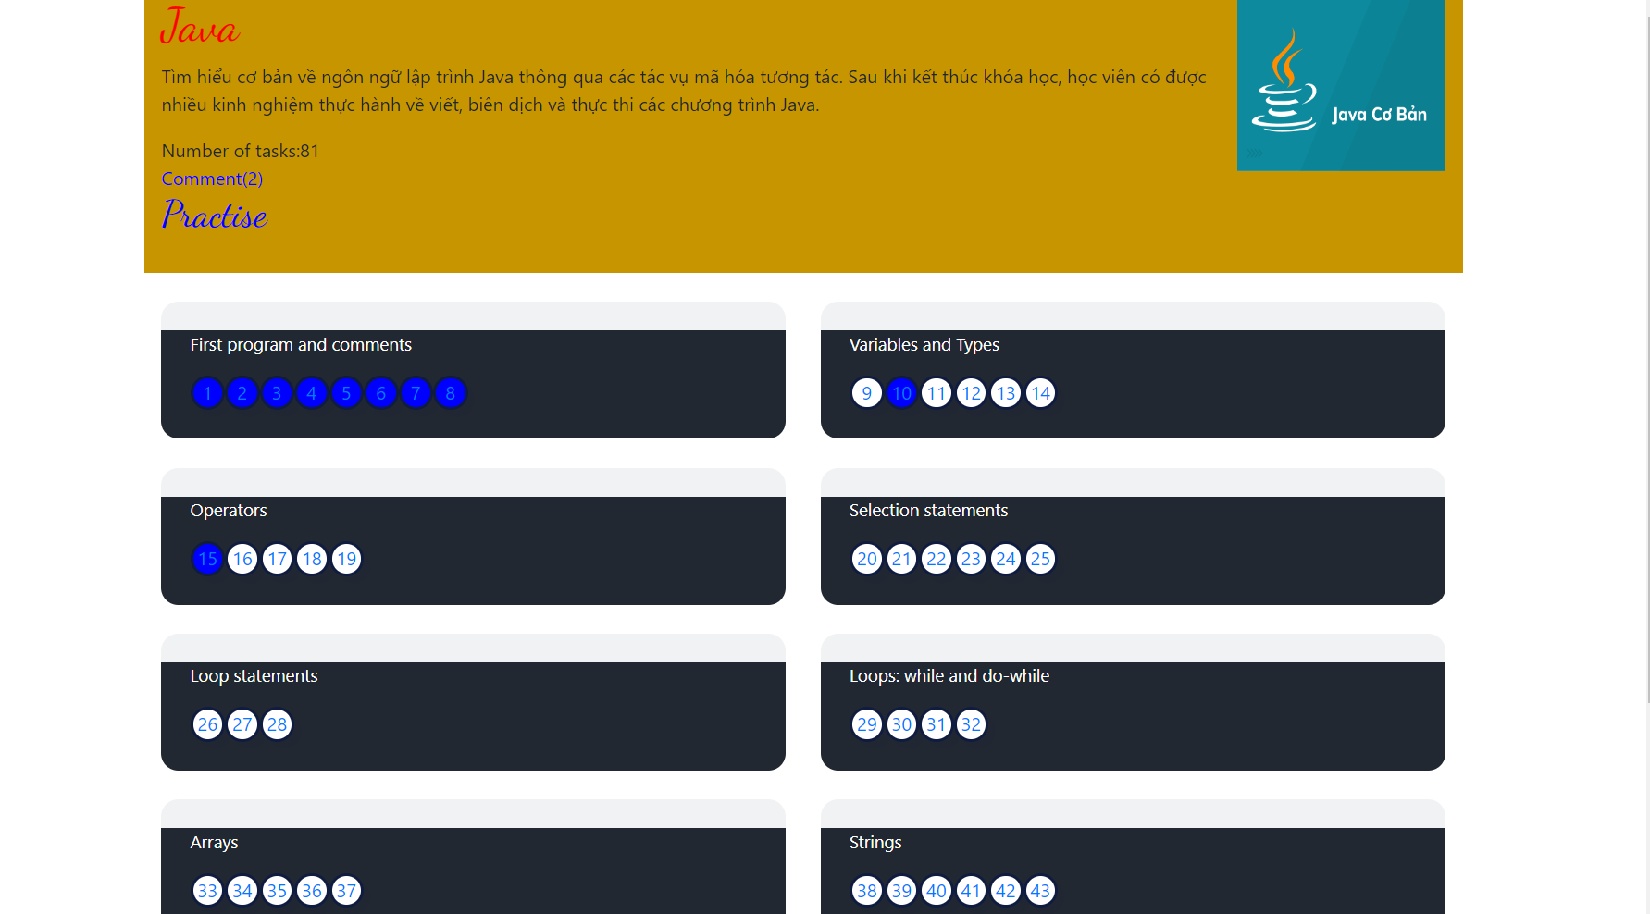

* *Screen show all detail about course: Course name, number of students enrol, number of reviews, rate, comment that course have.*
* *List out all chapter of course and number of lessons have in each chapter.*

### b. Percentage

* *Calculate the percentage of completion of the course.*
* *If student have been finished one lesson the page lesson will change color blue.*

## 3. Discussion, comment

### a. Screen

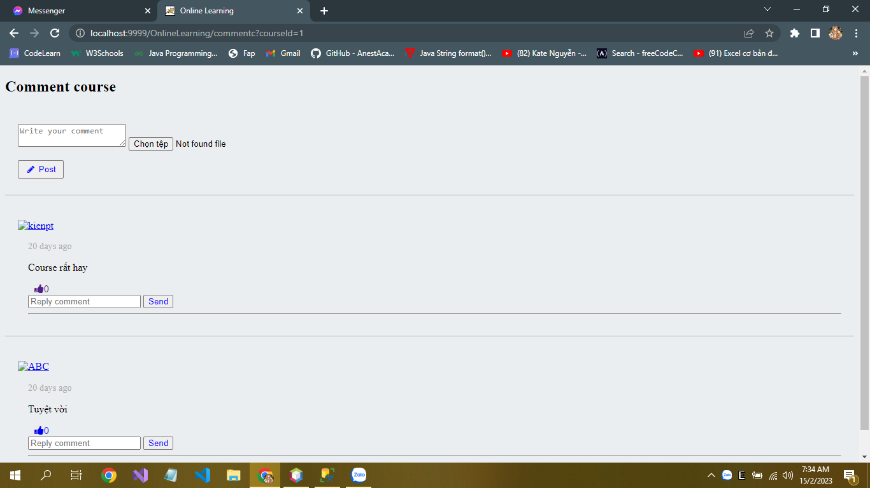

* *The screen lists out all comment and image and rate of user.*

### Post function

* *User can discussion in website by post a comment or image into page.*
* *User also can reply comment of other people .*
* *User can like another comment.*

## 4. Practice

### a. Screen

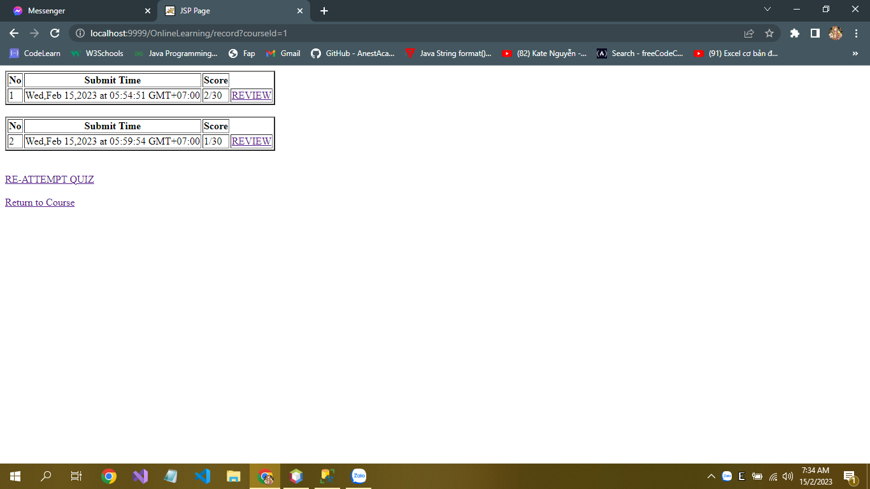

* *View all exams have been finish if this page.*
* *User can Attempt a multiple-choice exam of each course.*

### practice function

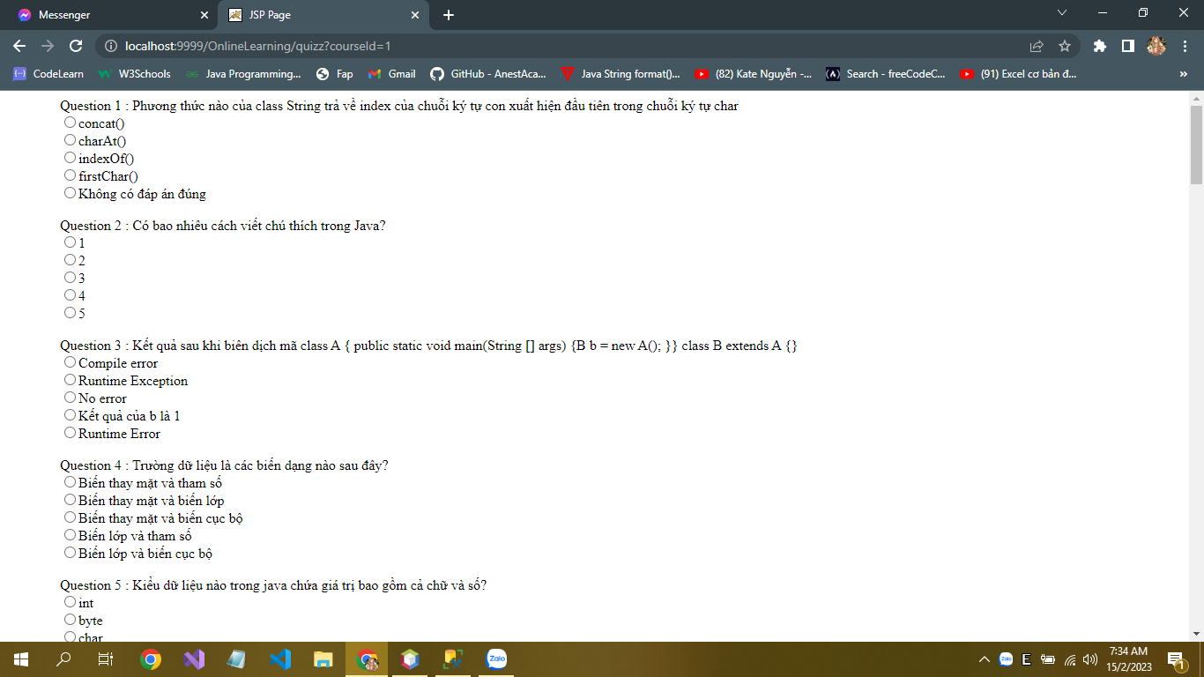

* *Users do a multiple-choice question which were taken from database.*
* *When finish the exam the data will load to database and print out the marks after that.*

### Review exam function

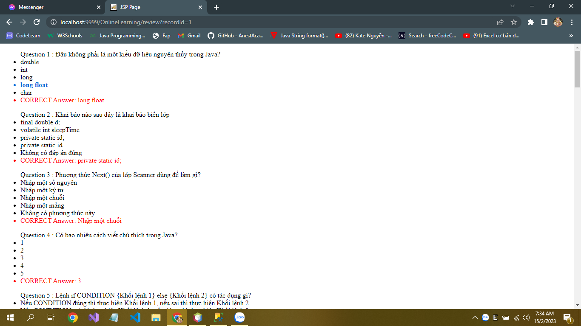

* *User check the marks in practice home and check the answer in the review exam.*
* *System will compare the answer of student with the correct answer and print out the screen.*

## 5. Lesson

### a. Screen

* *View all lesson detail a content, example, and image.*

### b. Button finish

* *After click finish the information that student has finish lesson will save into database.*