High Level architecture
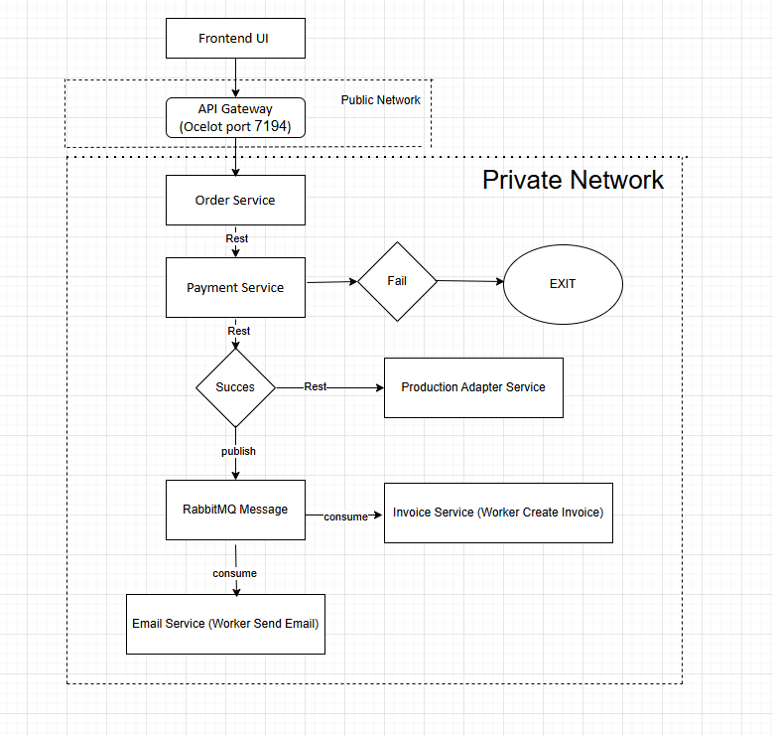

Explanation of the Architecture

1. Frontend UI → API Gateway
Client interacts with the system only through Ocelot Gateway.

2. Synchronous Operations (REST)
Order Service → Payment Service
Order Service → Production Adapter
These are synchronous request/response calls.

3. Asynchronous Operations (RabbitMQ)
After successful payment then OrderService publishes OrderPaidEvent
RabbitMQ stores & routes message
EmailService background worker consumes message, sends email asynchronously
InvoiceService background worker consumes message, creates invoice

Run RabbitMQ
docker run -d \
--name rabbitmq \
-p 5672:5672 \
-p 15672:15672 \
rabbitmq:3-management

