

**Milk shop for Pregnant mother and Babies**

**Software Requirement Specification**

–Ho Chi Minh, May 2024 –

Record of changeS

|  |  |  |  |
| --- | --- | --- | --- |
| Date | A* M, D | In charge | Change Description |
| 13/Apr | A | KienNT | Thêm mô tả chức năng Setting Details (II.1.a) |
|  |  |  |  |
|  |  |  |  |
|  |  |  |  |
|  |  |  |  |
|  |  |  |  |
|  |  |  |  |
|  |  |  |  |
|  |  |  |  |
|  |  |  |  |
|  |  |  |  |
|  |  |  |  |

*A - Added M - Modified D – Deleted

Definition and Acronyms

|  |  |
| --- | --- |
| **Acronym** | **Definition** |
| BR | Business Rule |
| ERD | Entity Relationship Diagram |
| UC | Use Case |
| FE | Major Feature |
| FR | Feature |
| UI | User Interface |
| HI | Hardware Interface |
| CI | Communications Interfaces |
| USE | Usability |
| FER | Performance |
| SEC | Security |
| AVL | Availability |
| REL | Reliability |
| DES | Design Constraint |

**Table of Contents**

I. Overview 4

1. Introduction 4

2. System Functions 5

3. Entity Relationship Diagram 6

II. Functional Requirements 7

1. <<Feature Name 1>> 7

a. <<Function Name 1>> 7

b. <<Function Name 2>> 7

2. <<Feature Name 2>> 7

# I. Overview

## 1. Product Background:

The Milk Shop for Pregnant Mothers and Babies in innovative online platform designed to cater to the unique nutritional needs of expecting mothers and their infants by providing a convenient, reliable, and comprehensive solution for purchasing high-quality milk products. Addressing the challenges of traditional shopping methods, this users-friendly platform offers a curated selection of specialized milk products, detailed product information, and expert recommendations. It targets pregnant mothers, new parents, and caregivers, offering benefits like personalized recommendations, secure payment options, real-time inventory updates, and order tracking. Additionally, the shop features expert blog and articles, enhancing customer confidence through credible information and transparent processes. By transforming the way these essential products are accessed, the Milk Shop saves time for busy parents and builds trust through its high-quality offerings and reliable delivery services.

Phần này dành cho khác(lát chuyển xuống):

The Milk Shop for Pregnant Mothers and Babies is a new software system designed to facilitate the online exchange of milk products tailored specifically for pregnant mothers and infants. The system aims to replace traditional in store purchases and telephones orders, providing a seamless online shopping experience for users. The platform will allow customers to browse, order, and arrange, delivery of milk products directly to their homes. The initial release will focus on core functionalities, with future updates planned to integrate with refund functional, broader online marketplaces and payment processing systems.

**2. Existing Systems**

2.1 Sữa Bột Tốt system:

- Brief description: Suabottot.com is an online platform dedicated to providing

high-quality baby milk powder products.

- Website: https://suabottot.com

- System actor:

* Guess
* Customers(logged in)
* Staff
* Administrators

- Feature:

* **Product Catalogue**: Displaying a range of baby milk powder products with detailed description, nutritional information, and pricing.
* **Product Recommendations**: Offering personalised recommendations based on the dietary needs, and preferences.
* **Subscription Option**: Allowing guests to sign up an account to make a delivery order, ensuring convenience(sales, tracking order, etc..)
* **Customer Reviews and Rating**: Enabling users to read and write reviews, sharing their experiences with different products to help others make informed decisions
* **Customer Support**: Providing responsive customer support via various channels(e.g Messenger, Zalo, Phone) to address inquiries, concerns, and provide assistance.

- Pros:

* **Trusted Quality**: Offering reputable and vetted baby milk powder from trusted brands, ensuring safety and reliability for parents and caregivers
* **Convenience**: Providing a convenient online platform for purchasing baby milk powder, with options for delivery to the user’s doorstep
* **Expert Guidance**: Offering expert guidance and educational resources (e.g Youtube) to help parents make informed decisions

- Cons:

* **Dependency on Delivery Services**: Relies on third party services, which may introduce delay or complication in the delivery process

- How this Informs the system:

* There is a system for calculating price, post, and design products

**3. Business Opportunity:**

Customers are in search of a complete solution that can swiftly furnish them with precise material costs, link them with trustworthy suppliers and contractors, and furnish live updates on construction advancement. This system not only aids customers in saving precious time but also boosts their assurance in selecting their ideal home. Employees also desire a system to aid them in grasping the housing requirements of clients better, enabling them to offer appropriate guidance and recommendations. Furthermore, the system will aid out staff in displaying finished projects to establish and trust for the company.

**4. Software Product Vision:**

For those who need to shop for powdered milk or ready-to-drink milk for appropriate ages of children or pregnant mothers, the internet website allows consumers to meet their needs. It allows users to choose dairy products that suit their needs based on their criteria. From the employee's perspective, the website has shared feedback from users who have made purchases and provides comprehensive models to promote the store's brand and enhance its growth. Unlike having to go to the store, customers who want to buy milk can sit at home to save time and effort to go to the place to buy and can use store services online, while the manager Easier to manage and promote the store's brand.

**5. Major Features:**

1. **Customer web application**

FE-01: Provide information about the milk product

FE-02: View posts about the healthcare for pregnant mothers and babies

FE-03: Provide feedback, comments of other users who have purchased the product

FE-04: Search for milk products and information about them based on keywords

FE-05: Filter products by criteria (price, manufacturer, and milk types) as desired

FE-06: Manage personal information (account information, credentials, login, logout…)

FE-07: View general information about milk shop

FE-08: Choose product directly in a post and add it to shopping cart

FE-09: Function allows customers to track the shipping process of orders

FE-10: Function allows customers to review purchase history

FE-11: Function allows customers to pay using online payment methods

FE-12: Function allows customers to refund

FE-13: Function allows customers to evaluate the quality of services

FE-14: Function allows customers to give feedback on the products they have purchased

FE-15: Function allows customers to mark their favourite products

FE-16: Function allows customers to make order for shopping cart

FE-17: Function allows customers to pre-order new products that are not yet in stock

FE-18: Function allows customers to manage shopping cart (choose product and add to cart, view cart, delete product from cart, edit quantity)

FE-19: Function allows customers to manage shipping information

FE-20: Function allows customers to redeem promotional products with points earned for buying products successfully before

FE-21: Function to add voucher to product

FE-22: Function to view membership information (points earned, current rank, rank’s privileges)

FE-23: Function to make consultancy with staff through chat function

FE-24: Function to report a post with reasons

1. **Shop web application**

FE-25: Function to verify and reply to comments by customer or guest.

FE-26: Function to confirm or cancel the milk orders

FE-27: Manage the products on the web (create, update, delete, view)

FE-28: Function to create the discount voucher

FE-29: Function to process reports about posts

FE-30: Function to view list of incoming orders

FE-31: Function to manage order tracking (track order status, update track information)

FE-32: Function to manage customer refund request

FE-33: Manage product’s stock quantity

FE-34: Function to manage posts (add, view, update, delete post in posts page)

FE-35: Manage membership system (add, view, update, delete membership rank)

FE-36: View customer order history

FE-37: Set default discount for products in a preset period

1. **Admin web application**

FE-38: Dashboard statistics data of orders, sales and products by month and year. (range follow date)

FE-39: Function to manage account include view, create, update account, remove account.

FE-40: Manage shop’s general information

**6. Limitations and Exclusions:**

- Geographical Limitations: The service may initially be available only in specific regions or countries. This could limit accessibility for potential customers in areas where the service has not yet been launched.

- Technical Limitations: As with any online platform, technical issues such as website downtime, slow loading times, or app malfunctions can occur, potentially affecting user experience and accessibility.

**7. Product Overview:**

The Milk Shop for Pregnant Mothers and Babies is a new software system designed to facilitate the online exchange of milk products tailored specifically for pregnant mothers and infants. The system aims to replace traditional in store purchases and telephones orders, providing a seamless online shopping experience for users. The platform will allow customers to browse, order, and arrange, delivery of milk products directly to their homes. The initial release will focus on core functionalities, with future updates planned to integrate with refund functional, broader online marketplaces and payment processing systems.

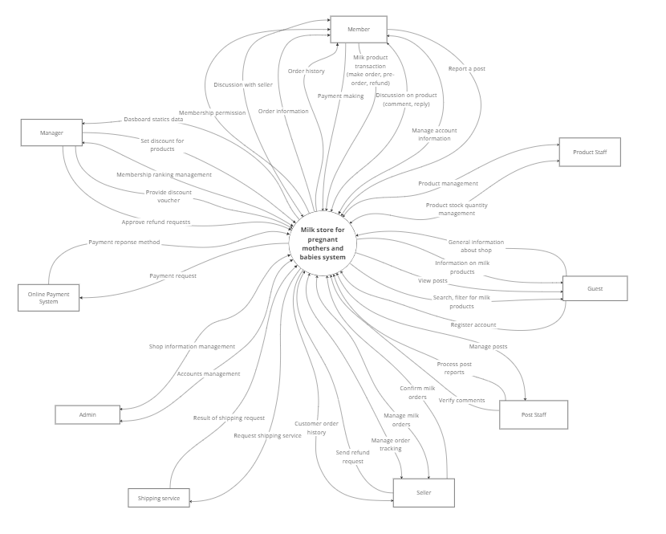

**8. Business Process:**

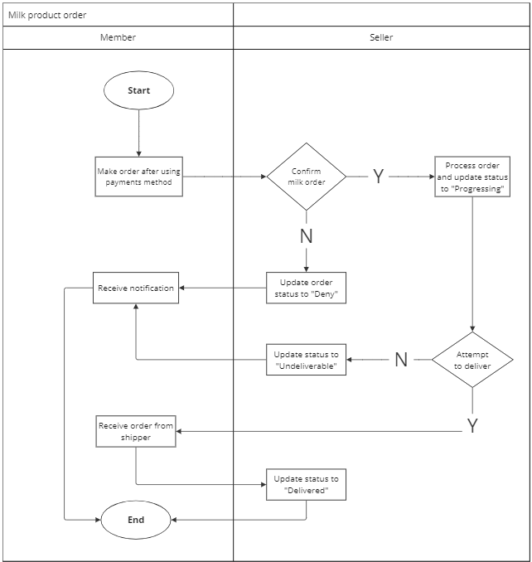

|  |  |  |
| --- | --- | --- |
| **#** | **Process Step** | **Description** |
| 1 | Make order after using payments method | After customers pay online using the payment method provided by the app, the system will create order information and send it to the seller. |
| 2 | Confirm milk order | The system transmits information about paid orders to the seller and the seller will review and confirm the order and package the goods (preparation status) |
| 3 | Process order and update status to “Progressing” | After confirming the order, the seller will prepare the goods and update the status to the system as “Progressing” for the update system to show customers. |
| 4 | Attempt to deliver | At this phase, the seller will hand over the order to the carrier for processing. |
| 5 | Update status to “Undeliverable” | In this handling method, if he the carrier has a specific reason for not being able |
| 6 | Update status to “Deny” | During the process of the seller confirming the order, if the order cannot be prepared for some reason from the store, the seller will update the status to deny in the system. |
| 7 | Receive notification | On the customer side, when the seller’s order statuses are updated, the system will show the customer the order status based on the information provided by the seller to conveniently track their order information. |
| 8 | Receive order from shipper | After the customer receives the goods from the carrier, the information will be upadted by the carrier. |
| 9 | Update status to “Delivered” | The information updated by the carrier about the successful delivery to the customer will be updated by the system and show the seller the status of the delivered order. |

# II. Functional Requirements

## 1. <<Feature Name 1>>

### a. <<Function Name 1>>

*[A function can be a screen or a non-screen function (listed in the part I.2.d above). In this part, you need to provide the details on the related function, focus on mentioning below information*

* *Function trigger: how this function is triggered (navigation path, a timing frequency, etc.)*
* *Function description: actors/roles, purpose, interface, data processing, etc.*
* *Screen layout: mockup prototype of the screen, sample below is for Manage Products screen*

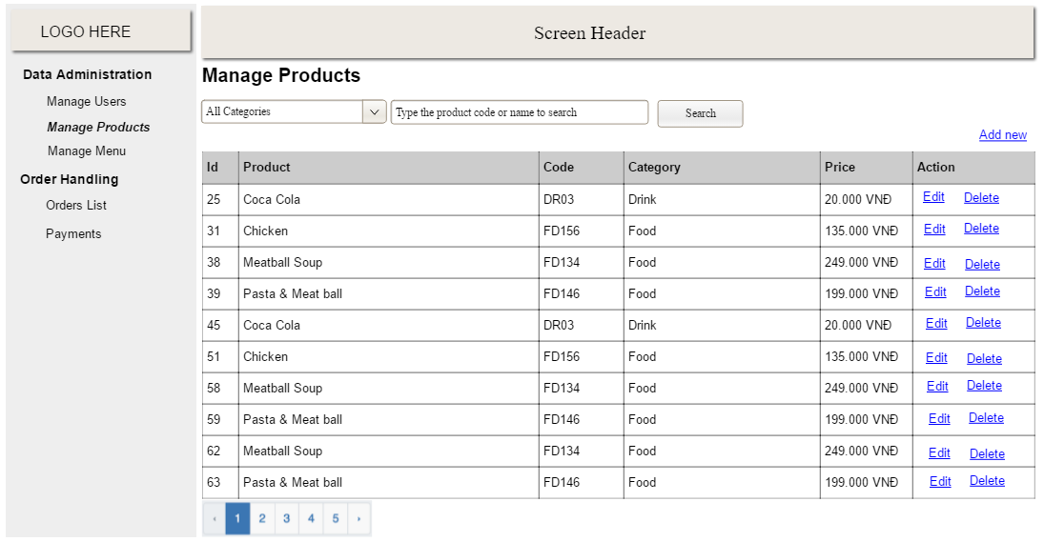

* *Function Details: provide explanation for the data, validation, business logics, functionalities (for both normal cases and abnormal cases), etc. of the function so that the reader can image how it work.*

*]*

### b. <<Function Name 2>>

…

## 2. System Functions

#### a. Screen Flow

- Customer screen flow:

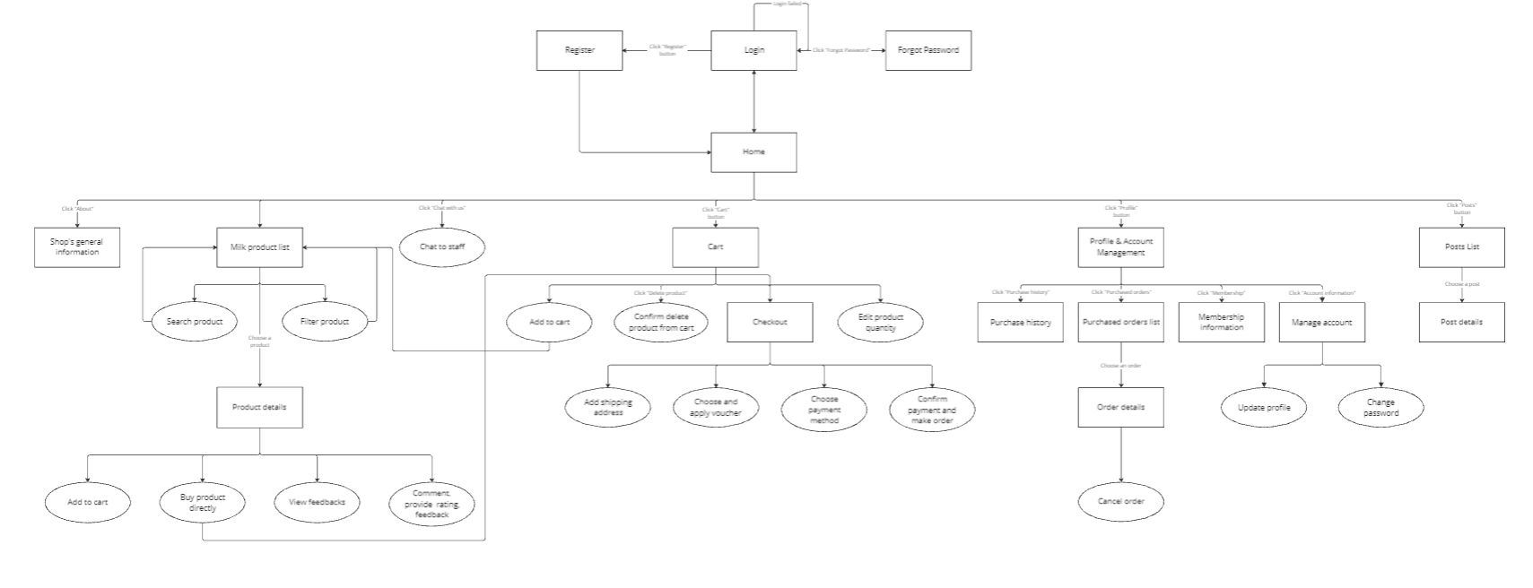

- Admin screen flow:

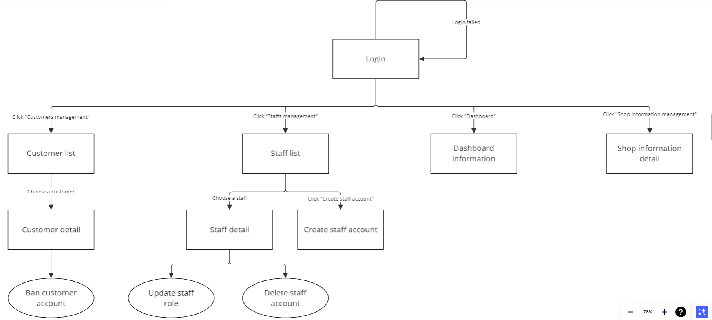

- Staff screen flow:

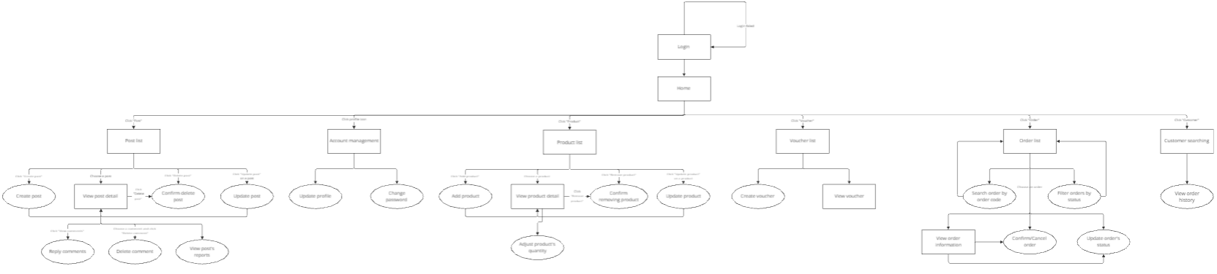

#### b. Screen Details

- Customer screen flow:

|  |  |  |  |
| --- | --- | --- | --- |
| **FR** | **Feature** | **Screen** | **Description** |
| 1 | Register | Register | Screen to register a new account. |
| 2 | Login | Login | Screen to Log in to an existing account. |
| 3 | Forgot Password | Forgot Password | Screen to reset password if forgotten. |
| 4 | View Home | Home | Screen to reset password if forgotten. |
| 5 | View Shop’s General Information | Shop’s General information | Accessible via “About us” button, shows general information about the shop |
| 6 | View Milk Product List | Milk Product List | Main product listing screen |
| 7 | Search Product | Search Product | Allows customers to search for specific products. |
| 8 | Filter Product | Filter Product | Allows customers to filter |
| 9 | View Product Details | Product Details | Shows Detailed information about a selected product |
| 10 | Add to Cart | Add to Cart | Option to add a product to the shopping cart |
| 11 | Buy Product Directly | Buy Product Directly | Option to purchase a product immediately without adding to the cart. (Guest) |
| 12 | View Feedbacks | View Feedbacks | Allows customers to view feedback and reviews for a product. |
| 13 | Provide Feedback | Comment, Provide, Rating, Feedback. | Allows customers to comment, rate, and provide feedback for a product. |
| 14 | Chat with Staff | Chat to Staff | Option to chat with shop staff for assistance. |
| 15 | View Cart | Cart | Screen showing items added to the cart. |
| 16 | Confirm Delete from Cart | Confirm Delete product from Cart | Allows customers to confirm the deletion of a product from the cart. |
| 17 | Edit Product Quantity | Edit Product Quantity | Option to edit the quantity of a product in the cart. |
| 18 | Checkout | Checkout Cart | Screen to proceed with the purchase of items in the cart. |
| 19 | Add information for shipping | Add shipping address | Allows customers to add or edit the shipping address during checkout |
| 20 | Apply voucher | Choose and Apply Voucher | Option to choose and apply a voucher for a discount during checkout |
| 21 | Choose Payment Method | Choose Payment Method | Allows customers to choose a payment method during checkout |
| 22 | Confirm Payment and Make Order | Confirm Payment and Make Order | Final step to confirm payment and place the order |
| 23 | View Profile & Account Management | Profile & Account Management | Screen to manage profile and account details |
| 24 | View Purchase History | Purchase History | Screen to view the history of past purchases |
| 25 | View Purchased Orders List | Purchased Orders List | List of all purchased orders |
| 26 | View Order Details | Order Details | Shows detailed information about a selected order |
| 27 | Cancel Order | Cancel Order | Option to cancel a selected order. |
| 28 | View Membership Information | Membership information | Information about membership benefits and status |
| 29 | Manage Personal Account | Manage Personal Account | Options to manage account details such as updating profile and changing password |
| 30 | Update Profile | Update Profile | Option to update personal profile information |
| 31 | Change Password | Change Password | Option to change account password |
| 32 | View Post List | Pots List | List of posts or articles related to the shop |
| 33 | View Post Details | Post Details | Detailed view of a selected post |

- Admin screen flow:

|  |  |  |  |
| --- | --- | --- | --- |
| **FR** | **Feature** | **Screen** | **Description** |
| 34 | Login | Login | The initial screen where admin logs in. If login fails, a “Login failed” message is shown. |
| 35 | View customer list | Customer list | Accessible after login, lists all customers. |
| 36 | View customer details | Customer detail | Selected from customer list, show detailed information about the customer. |
| 37 | Ban customer account | Ban customer account | Option available in customer details to ban the customer’s account. |
| 38 | View staff list | Staff list | Accessible after login, lists all staff members. |
| 39 | View Staff details | Staff detail | Selected from staff list, shows detailed information about the staff member. |
| 40 | Create staff account | Create staff account | Option to create a new staff account. |
| 41 | Update staff role | Update staff role | Option available in staff details to update the staff member’s role |
| 42 | Delete staff account | Delete staff account | Option available in staff details to delete the staff member’s account. |
| 43 | View dashboard | Dashboard information | Accessible after login, shows overall dashboard information. |
| 44 | View shop information detail | Shop information detail | Accessible after login, shows detailed information about the shop. |

- Staff screen flow:

|  |  |  |  |
| --- | --- | --- | --- |
| **FR** | **Feature** | **Screen** | **Description** |
| 45 | Login | Login | Screen to log in to the staff account. If login fails, a "Login failed" message is shown. |
| 46 | View Home | Home | Main screen after login, shows various options and features. |
| 47 | View Post List | Post List | Screen listing all posts. |
| 48 | Create Post | Create Post | Option listing all posts. |
| 49 | View Post Details | View Post Detail | Shows detailed information about a selected post. |
| 50 | Confirm Delete Post | Confirm Delete Post | Option to confirm deletion of a post. |
| 51 | Update Post | Update Post | Option to update an existing post. |
| 52 | Reply to Comments | Reply Comments | Option to reply to comments on a post. |
| 53 | Delete Comments | Delete Comment | Option to delete comments on a post. |
| 54 | View Post Reports | View Post Reports | Option to view reports about posts. |
| 55 | View Account Management | Account Management | Screen to manage account details. |
| 56 | Update Profile | Update Profile | Option to update personal profile information. |
| 57 | Change Password | Change Password | Option to change account password. |
| 58 | View Product List | Product List | Screen listing all products. |
| 59 | Add Product | Add Product | Option to add a new product. |
| 60 | View Product Details | View Product Details | Shows detailed information about a selected product. |
| 61 | Adjust Product Quantity | Adjust Product Quantity | Option to adjust the quantity of a product. |
| 62 | Confirm Removing Product | Confirm Removing Product | Option to confirm the removal of a product. |
| 63 | Update Product | Update Product | Option to update an existing product. |
| 64 | View Voucher List | Voucher List | Screen listing all vouchers. |
| 65 | Create Voucher | Create Voucher | Option to create a new voucher. |
| 66 | View Voucher | View Voucher | Shows detailed information about a selected voucher. |
| 67 | View Order List | Order List | Screen listing all orders. |
| 68 | Search Order by Code | Search Order by Code | Allows staff to search for an order using its code. |
| 69 | Filter Orders by Status | Filter Orders by Status | Allows staff to filter orders based on their status. |
| 70 | View Order Information | View Order Information | Shows detailed information about a selected order. |
| 71 | Confirm/Cancel Order | Confirm/Cancel Order | Option to confirm or cancel a selected order. |
| 72 | Update Order Status | Update Order's Status | Option to update the status of a selected order. |
| 73 | Customer Searching | Customer Searching | Allows staff to search for customer information. |
| 74 | View Order History | View Order History | Shows the history of orders made by customers. |

#### c. User Authorization

|  |  |  |  |  |  |
| --- | --- | --- | --- | --- | --- |
| **Screen** | **Admin** | **Customer** | **Product Staff** | **Post Staff** | **Seller** |
| **<<Admin Screen Flow>>** |  |  |  |  |  |
| Login | X |  | X | X | X |
| Customer list | X |  |  |  |  |
| Customer detail | X |  |  |  |  |
| Ban customer account | X |  |  |  |  |
| Staff list | X |  |  |  |  |
| Staff detail | X |  |  |  |  |
| Create staff account | X |  |  |  |  |
| Update staff role | X |  |  |  |  |
| Delete staff account | X |  |  |  |  |
| Dashboard information | X |  |  |  |  |
| Shop information detail | X |  |  |  |  |
| **<<Customer Screen Flow>>** |  |  |  |  |  |
| Register |  | X |  |  |  |
| Login |  | X | X | X | X |
| Forgot Password |  | X |  |  |  |
| Home |  | X | X | X | X |
| Shop’s General Information |  | X | X | X | X |
| Milk Product List |  | X | X | X | X |
| Search Product |  | X | X | X | X |
| Filter Product |  | X | X | X | X |
| Product Details |  | X | X | X | X |
| Add to Cart |  | X |  |  |  |
| Buy Product Directly |  | X |  |  |  |
| View Feedbacks |  | X | X | X | X |
| Comment, Provide Rating, Feedback |  | X | X | X | X |
| Chat to Staff |  | X | X | X | X |
| Cart |  | X |  |  |  |
| Confirm Delete Product from Cart |  | X |  |  |  |
| Edit Product Quantity |  | X |  |  |  |
| Checkout |  | X |  |  |  |
| Add Shipping Address |  | X |  |  |  |
| Choose and Apply Voucher |  | X |  |  |  |
| Choose Payment Method |  | X |  |  |  |
| Confirm Payment and Make Order |  | X |  |  |  |
| Profile & Account Management |  | X |  |  |  |
| Purchase Histoty |  | X |  |  |  |
| Purchase Orders List |  | X |  |  |  |
| Order Details |  | X |  |  |  |
| Cancel Order |  | X |  |  |  |
| Membership Information |  | X |  |  |  |
| Manage Account |  | X |  |  |  |
| Update Profile |  | X |  |  |  |
| Change Password |  | X |  |  |  |
| Post List |  | X |  | X |  |
| Post Details |  | X |  | X |  |
| **<<Staff Screen Flow>>** |  |  |  |  |  |
| Login | X |  | X | X | X |
| Home | X |  | X | X | X |
| Post List | X |  |  | X |  |
| Create Post | X |  |  | X |  |
| View Post Detail | X |  |  | X |  |
| Confirm Delete Post | X |  |  | X |  |
| Update Post | X |  |  | X |  |
| Reply Comments | X |  |  | X |  |
| Delete Comments | X |  |  | X |  |
| View Post Reports | X |  |  | X |  |
| Account Management | X |  | X | X | X |
| Update Profile | X |  | X | X | X |
| Change Password | X |  | X | X | X |
| Product List | X |  | X |  | X |
| Add Product | X |  | X |  | X |
| View Product Detail | X |  | X |  | X |
| Adjust Product’s Quantity | X |  | X |  | X |
| Confirm Removing Product | X |  | X |  | X |
| Update Product | X |  | X |  | X |
| Voucher List | X |  | X |  | X |
| Create Voucher | X |  | X |  | X |
| View Voucher | X |  | X |  | X |
| Order List | X |  |  |  | X |
| Search Order by Order Code | X |  |  |  | X |
| Filter Orders by Status | X |  |  |  | X |
| View Order Information | X |  |  |  | X |
| Confirm / Cancel Order | X |  |  |  | X |
| Update Order’s Status | X |  |  |  | X |
| Customer Searching | X |  |  |  | X |
| View Order History | X |  |  |  | X |

In which:

* **Admin:** Manages the entire system, including customer accounts, staff accounts, and overall shop information.
* **Customer:** End-users who interact with the shop to browse products, make purchases, and manage their own accounts.
* **Product Staff:** Responsible for managing products, including adding, updating, and removing products.
* **Post Staff:** Manages posts, including creating, updating, and moderating comments on posts.
* **Seller:** Handles order processing, including confirming, canceling orders, and updating order statuses.

#### d. Non-Screen Functions

*[Provide the descriptions for the non-screen system functions, i.e batch/cron job, service, API, etc.]*

|  |  |  |  |
| --- | --- | --- | --- |
| **#** | **Feature** | **System Function** | **Description** |
| 1 | Customer Management | Daily Inactive User | A batch job that runs daily to identify and flag inactive customer accounts for potential removal. |
| 2 | Customer Management | Customer Data Export | A service that exports customer data to a CSV file and uploads it to secure FTP server monthly. |
| 3 | Product Management | Inventory Sync | A cron job that runs every hour to synchronize the inventory database with the warehouse system. |
| 4 | Product Management | Low Stock Alert | A service that sends an alert to the product Staff when inventory levels drop below a certain threshold. |
| 5 | Order Processing | Order Confirmation Email | A service that sends confirmation emails to customers after they place an order. |
| 6 | Order Processing | Order Status Update | An API that allows sellers to update the status of orders (e.g., shipped, delivered, canceled). |
| 7 | User Authentication | OAuth Token Refresh | An API endpoint that allows users to refresh their OAuth tokens for continued access to the system. |
| 8 | Data Backup | Weekly Database Backup | A cron job that runs weekly to back up the entire database to a secure remote location. |
| 9 | Notification System | Push Notification Service | A service that sends push notifications to users for various events, such as order updates and promotions. |
| 10 | Post Management | Spam Comment Detection | A batch job that runs every hour to detect and flag spam comments on posts. |
| 11 | Voucher Management | Voucher Expiry Reminder | A service that sends reminders to customers about expiring vouchers. |
| 12 | Profile Management | Profile Update Log | A service that logs changes to user profiles for audit purposes. |
| 13 | Membership Management | Membership Renewal Alert | A service that notifies customers when their membership is about to expire. |
| 14 | Feedback Management | Feedback Analysis | A batch job that analyzes customer feedback and generates reports for product improvement. |

## 3. Entity Relationship Diagram

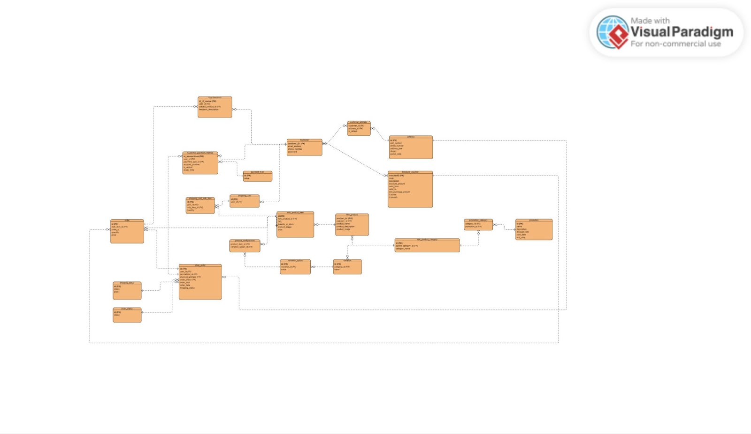

**Entities Description**

|  |  |  |
| --- | --- | --- |
| **#** | **Entity** | **Description** |
| 1 | User | Stores user information including role, email, phone number, password, and username. |
| 2 | Role | Stores roles for users, such as CUSTOMER, SELLER, MANAGER, POST_STAFF, PRODUCT_STAFF, and ADMIN. |
| 3 | |  | | --- | | Payment Type |  |  | | --- | |  | | |  | | --- | | Stores different types of payment methods available. |  |  | | --- | |  | |
| 4 | Order Status | Stores various statuses that an order can have. |
| 5 | Address | Stores address information including unit number, street number, address line, district, and postal code. |
| 6 | Milk Product Category | Stores categories for milk products. |
| 7 | Post | Stores posts created by users, including title, content, date created, and user comments. |
| 8 | |  | | --- | | Milk Product |  |  | | --- | |  | | Stores information about milk products including category, name, description, image, stock quantity, and price. |
| 9 | |  | | --- | | Shopping Cart |  |  | | --- | |  | | |  | | --- | | Stores shopping cart details for users. |  |  | | --- | |  | |
| 10 | Voucher | |  | | --- | | Stores voucher details including name, code, description, discount amount, validity period, and status. |  |  | | --- | |  | |
| 11 | |  | | --- | | Customer Payment Method |  |  | | --- | |  | | |  | | --- | | Stores customer payment methods and details such as account number and default status. |  |  | | --- | |  | |
| 12 | Order | |  | | --- | | Stores order details including user, payment method, shipping address, status, voucher, and total price. |  |  | | --- | |  | |
| 13 | |  | | --- | | Order Item |  |  | | --- | |  | | |  | | --- | | Stores items within an order including product, quantity, and price. |  |  | | --- | |  | |
| 14 | |  | | --- | | Shopping Cart Item |  |  | | --- | |  | | |  | | --- | | Stores items within a shopping cart including product and quantity. |  |  | | --- | |  | |
| 15 | |  | | --- | | User Feedback |  |  | | --- | |  | | |  | | --- | | Stores user feedback on ordered products, including description, time, and rating. |  |  | | --- | |  | |
| 16 | |  | | --- | | Post Report |  |  | | --- | |  | | |  | | --- | | Stores reports on posts including the reason, note, and status. |  |  | | --- | |  | |
| 17 | |  | | --- | | Transaction Log |  |  | | --- | |  | | |  | | --- | | Stores transaction logs including order, payment type, date, content, and amount. |  |  | | --- | |  | |
| 18 | |  | | --- | | User Voucher |  |  | | --- | |  | | |  | | --- | | Stores user vouchers and their usage dates. |  |  | | --- | |  | |
| 19 | |  | | --- | | Promotion Campaign |  |  | | --- | |  | | |  | | --- | | Stores promotion campaign details including name, description, discount rate, validity period, and discount limits. |  |  | | --- | |  | |
| 20 | |  | | --- | | Promotion Category |  |  | | --- | |  | | |  | | --- | | Stores relationship between promotion campaigns and product categories. |  |  | | --- | |  | |
| 21 | |  | | --- | | Promotion Products |  |  | | --- | |  | | Stores relationship between promotion campaigns and products. |

# III. Use Case List

1. Use Case Diagram

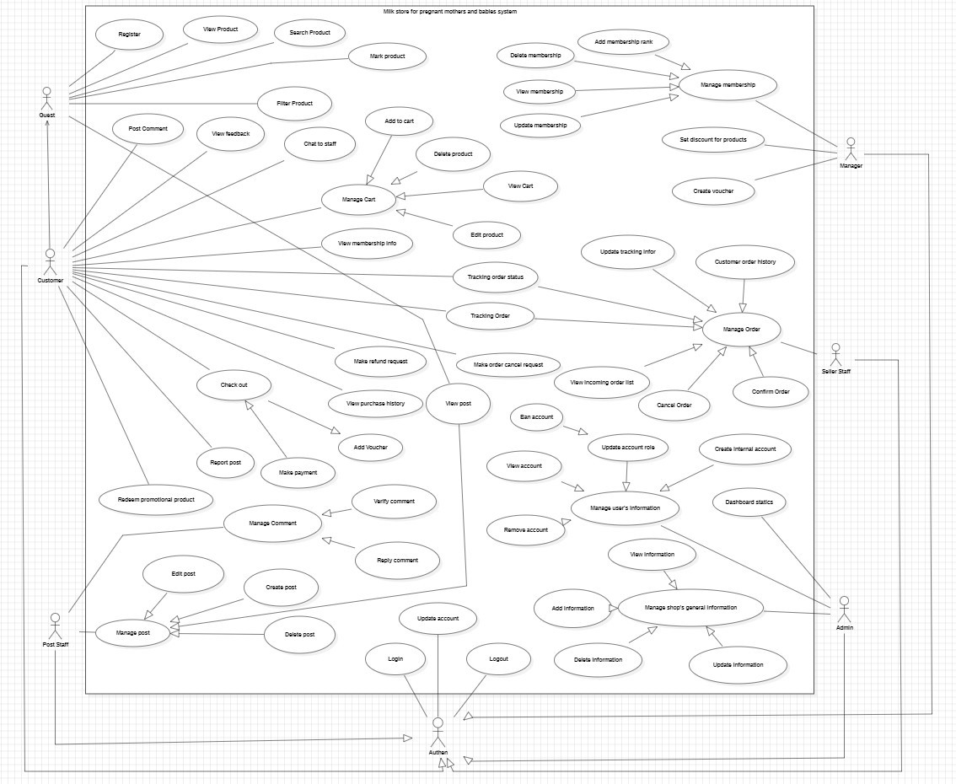

2. Use Case Description

|  |  |  |  |
| --- | --- | --- | --- |
| **UC** | **Use Case** | **Actor** | **Description** |
| 1 | Register | Guest | |  | | --- | | A guest can register for a new account by providing necessary details such as email, username, password, etc. |  |  | | --- | |  | |
| 2 | |  | | --- | | View Product |  |  | | --- | |  | | |  | | --- | | Guest, Customer |  |  | | --- | |  | | |  | | --- | | Allows guests and customers to browse and view details of available products. |  |  | | --- | |  | |
| 3 | |  | | --- | | Search Product |  |  | | --- | |  | | |  | | --- | | Guest, Customer |  |  | | --- | |  | | |  | | --- | | Allows guests and customers to search for specific products using keywords or filters. |  |  | | --- | |  | |
| 4 | |  | | --- | | Rank Product |  |  | | --- | |  | | Customer | |  | | --- | | Allows customers to rank products based on their preferences. |  |  | | --- | |  | |
| 5 | |  | | --- | | Filter Product |  |  | | --- | |  | | |  | | --- | | Guest, Customer |  |  | | --- | |  | | |  | | --- | | Allows guests and customers to filter products based on various criteria such as category, price, etc. |  |  | | --- | |  | |
| 6 | |  | | --- | | Post Comment |  |  | | --- | |  | | Customer | |  | | --- | | Allows customers to post comments on products. |  |  | | --- | |  | |
| 7 | |  | | --- | | View Feedback |  |  | | --- | |  | | |  | | --- | | Guest, Customer |  |  | | --- | |  | | |  | | --- | | Allows guests and customers to view feedback provided by other users on products. |  |  | | --- | |  | |
| 8 | |  | | --- | | Chat to Staff |  |  | | --- | |  | | Customer | |  | | --- | | Allows customers to chat with support staff for assistance. |  |  | | --- | |  | |
| 9 | |  | | --- | | Add to Cart |  |  | | --- | |  | | |  | | --- | | Customer |  |  | | --- | |  | | |  | | --- | | Allows customers to add products to their shopping cart. |  |  | | --- | |  | |
| 10 | |  | | --- | | Delete Product (from cart) |  |  | | --- | |  | | Customer | |  | | --- | | Allows customers to remove products from their shopping cart. |  |  | | --- | |  | |
| 11 | |  | | --- | | Manage Cart |  |  | | --- | |  | | Customer | |  | | --- | | Allows customers to manage their shopping cart by adding or removing items. |  |  | | --- | |  | |
| 12 | |  | | --- | | View Cart |  |  | | --- | |  | | Customer | Allows customers to view the contents of their shopping cart. |
| 13 | |  | | --- | | Edit Product (in cart) |  |  | | --- | |  | | Customer | |  | | --- | | Allows customers to edit product details such as quantity in their shopping cart. |  |  | | --- | |  | |
| 14 | |  | | --- | | View Membership Info |  |  | | --- | |  | | Customer | |  | | --- | | Allows customers to view information about their membership status and benefits. |  |  | | --- | |  | |
| 15 | |  | | --- | | Check Out |  |  | | --- | |  | | Customer | |  | | --- | | Allows customers to proceed to checkout and complete their purchase. |  |  | | --- | |  | |
| 16 | |  | | --- | | Add Voucher |  |  | | --- | |  | | Customer | |  | | --- | | Allows customers to add vouchers to their purchase for discounts. |  |  | | --- | |  | |
| 17 | |  | | --- | | Make Payment |  |  | | --- | |  | | Customer | |  | | --- | | Allows customers to make payments for their purchases. |  |  | | --- | |  | |
| 18 | |  | | --- | | View Purchase History |  |  | | --- | |  | | Customer | |  | | --- | | Allows customers to view their past purchase history. |  |  | | --- | |  | |
| 19 | |  | | --- | | Redeem Promotional Product |  |  | | --- | |  | | Customer | |  | | --- | | Allows customers to redeem promotional products as part of a campaign. |  |  | | --- | |  | |
| 20 | |  | | --- | | Edit Order |  |  | | --- | |  | | Customer | |  | | --- | | Allows customers to edit details of their orders before final confirmation. |  |  | | --- | |  | |
| 21 | |  | | --- | | Manage Pending Order |  |  | | --- | |  | | |  | | --- | | Customer |  |  | | --- | |  | | |  | | --- | | Allows customers to manage their pending orders, including tracking and updates. |  |  | | --- | |  | |
| 22 | |  | | --- | | Refund Product |  |  | | --- | |  | | Customer | |  | | --- | | Allows customers to request a refund for purchased products. |  |  | | --- | |  | |
| 23 | |  | | --- | | Verify Comment |  |  | | --- | |  | | Customer | |  | | --- | | Allows customers to verify comments posted by other users. |  |  | | --- | |  | |
| 24 | |  | | --- | | Reply Comment |  |  | | --- | |  | | |  | | --- | | Post Staff |  |  | | --- | |  | | |  | | --- | | Allows post staff to manage posts, including creating, editing, and deleting posts. |  |  | | --- | |  | |
| 25 | |  | | --- | | Manage Post |  |  | | --- | |  | | |  | | --- | | Post Staff |  |  | | --- | |  | | |  | | --- | | Allows post staff to manage posts, including creating, editing, and deleting posts. |  |  | | --- | |  | |
| 26 | |  | | --- | | View Post |  |  | | --- | |  | | |  | | --- | | Post Staff |   , Guest   |  | | --- | |  | | |  | | --- | | Allows post staff to view posts. |  |  | | --- | |  | |
| 27 | |  | | --- | | Create Post |  |  | | --- | |  | | |  | | --- | | Post Staff |  |  | | --- | |  | | |  | | --- | | Allows post staff to create new posts. |  |  | | --- | |  | |
| 28 | |  | | --- | | Delete Post |  |  | | --- | |  | | |  | | --- | | Post Staff |  |  | | --- | |  | | |  | | --- | | Allows post staff to delete posts. |  |  | | --- | |  | |
| 29 | |  | | --- | | Add Membership Rank |  |  | | --- | |  | | Manager | |  | | --- | | Allows managers to add membership ranks for customers. |  |  | | --- | |  | |
| 30 | |  | | --- | | View Membership |  |  | | --- | |  | | |  | | --- | | Manager |  |  | | --- | |  | | |  | | --- | | Allows managers to view membership details. |  |  | | --- | |  | |
| 31 | |  | | --- | | Update Membership |  |  | | --- | |  | | |  | | --- | | Manager |  |  | | --- | |  | | |  | | --- | | Allows managers to update membership details. |  |  | | --- | |  | |
| 32 | |  | | --- | | Set Discount for Product |  |  | | --- | |  | | Manager | |  | | --- | | Allows managers to set discounts on products. |  |  | | --- | |  | |
| 33 | |  | | --- | | Dashboard Notice |  |  | | --- | |  | | Manager | |  | | --- | | Allows managers to post notices on the dashboard. |  |  | | --- | |  | |
| 34 | |  | | --- | | Create Voucher |  |  | | --- | |  | | Manager | |  | | --- | | Allows managers to create new vouchers. |  |  | | --- | |  | |
| 35 | |  | | --- | | Confirm Refund Request |  |  | | --- | |  | | Manager | |  | | --- | | Allows managers to confirm refund requests from customers. |  |  | | --- | |  | |
| 36 | |  | | --- | | Create Product |  |  | | --- | |  | | |  | | --- | | Product Staff |  |  | | --- | |  | | |  | | --- | | Allows product staff to create new products. |  |  | | --- | |  | |
| 37 | |  | | --- | | Update Product |  |  | | --- | |  | | |  | | --- | | Product Staff |  |  | | --- | |  | | |  | | --- | | Allows product staff to update product details. |  |  | | --- | |  | |
| 38 | |  | | --- | | Delete Product |  |  | | --- | |  | | |  | | --- | | Product Staff |  |  | | --- | |  | | |  | | --- | | Allows product staff to delete products. |  |  | | --- | |  | |
| 39 | |  | | --- | | Manage Product |  |  | | --- | |  | | |  | | --- | | Product Staff |  |  | | --- | |  | | |  | | --- | | Allows product staff to manage product inventory. |  |  | | --- | |  | |
| 40 | |  | | --- | | Manage Quantity |  |  | | --- | |  | | |  | | --- | | Product Staff |  |  | | --- | |  | | |  | | --- | | Allows product staff to manage the quantity of products in stock. |  |  | | --- | |  | |
| 41 | |  | | --- | | Update Tracking Info |  |  | | --- | |  | | |  | | --- | | Seller Staff |  |  | | --- | |  | | |  | | --- | | Allows seller staff to update order tracking information. |  |  | | --- | |  | |
| 42 | |  | | --- | | View Sales Income |  |  | | --- | |  | | Manager | |  | | --- | | Allows managers to view sales income reports. |  |  | | --- | |  | |
| 43 | |  | | --- | | Customer Order History |  |  | | --- | |  | | Manager | |  | | --- | | Allows managers to view the order history of customers. |  |  | | --- | |  | |
| 44 | |  | | --- | | Manage Order |  |  | | --- | |  | | |  | | --- | | Seller Staff |  |  | | --- | |  | | |  | | --- | | Allows seller staff to manage customer orders. |  |  | | --- | |  | |
| 45 | |  | | --- | | Tracking Order Status |  |  | | --- | |  | | |  | | --- | | Seller Staff |  |  | | --- | |  | | |  | | --- | | Allows seller staff to track the status of customer orders. |  |  | | --- | |  | |
| 46 | |  | | --- | | Tracking Order |  |  | | --- | |  | | |  | | --- | | Seller Staff |  |  | | --- | |  | | |  | | --- | | Allows seller staff to track orders and provide updates to customers. |  |  | | --- | |  | |
| 47 | |  | | --- | | Cancel Order |  |  | | --- | |  | | |  | | --- | | Seller Staff |  |  | | --- | |  | | |  | | --- | | Allows seller staff to cancel customer orders. |  |  | | --- | |  | |
| 48 | |  | | --- | | Confirm Order |  |  | | --- | |  | | |  | | --- | | Seller Staff |  |  | | --- | |  | | |  | | --- | | Allows seller staff to confirm customer orders. |  |  | | --- | |  | |
| 49 | |  | | --- | | View Account |  |  | | --- | |  | | Admin | |  | | --- | | Allows admin to view user accounts. |  |  | | --- | |  | |
| 50 | |  | | --- | | Update Account Role |  |  | | --- | |  | | Admin | |  | | --- | | Allows admin to update the roles of user accounts. |  |  | | --- | |  | |
| 51 | |  | | --- | | Manage Cart Information |  |  | | --- | |  | | Admin | |  | | --- | | Allows admin to manage cart information for users. |  |  | | --- | |  | |
| 52 | |  | | --- | | Manage Internal Accounts |  |  | | --- | |  | | Admin | |  | | --- | | Allows admin to manage internal system accounts. |  |  | | --- | |  | |
| 53 | |  | | --- | | Add Information |  |  | | --- | |  | | Admin | |  | | --- | | Allows admin to add new information to the system. |  |  | | --- | |  | |
| 54 | |  | | --- | | View Information |  |  | | --- | |  | | Admin | |  | | --- | | Allows admin to view system information. |  |  | | --- | |  | |
| 55 | |  | | --- | | Manage Shop’s General Info |  |  | | --- | |  | | Admin | |  | | --- | | Allows admin to manage general information about the shop. |  |  | | --- | |  | |
| 56 | |  | | --- | | Update Information |  |  | | --- | |  | | Admin | |  | | --- | | Allows admin to update existing information in the system. |  |  | | --- | |  | |
| 57 | |  | | --- | | Delete Information |  |  | | --- | |  | | Admin | |  | | --- | | Allows admin to delete information from the system. |  |  | | --- | |  | |
| 58 | Login | |  | | --- | | Authentication |  |  | | --- | |  | | |  | | --- | | Handles the login process for users. |  |  | | --- | |  | |
| 59 | Logout | Authentication | Handles the logout process for users. |
| 60 | Update Account | Authentication | Update personal account information |
| 61 | Ban Account | Admin | Ban an user account |

# IV. Bussiness Rule

|  |  |  |
| --- | --- | --- |
| **#ID** | **Rule Definition** | **Use Case** |
| |  | | --- | | BR-01 |  |  | | --- | |  | | |  | | --- | | User’s login session lasts for 6 hours by default. |  |  | | --- | |  | | |  | | --- | | Login |  |  | | --- | |  | |
| |  | | --- | | BR-02 |  |  | | --- | |  | | |  |  |  | | --- | --- | --- | | |  | | --- | | Full name only contains alphabetical characters. |  |  | | --- | |  | |  |  | | --- | |  | | |  |  |  | | --- | --- | --- | | |  | | --- | | Update Profile |  |  | | --- | |  | |  |  | | --- | |  | |
| |  | | --- | | BR-03 |  |  | | --- | |  | | |  |  |  | | --- | --- | --- | | |  | | --- | | Phone numbers only contain numeric characters. |  |  | | --- | |  | |  |  | | --- | |  | | |  |  |  | | --- | --- | --- | | |  | | --- | | Update Profile |  |  | | --- | |  | |  |  | | --- | |  | |
| |  | | --- | | BR-04 |  |  | | --- | |  | | |  |  |  | | --- | --- | --- | | |  | | --- | | Phone number length limit must be 10 characters. |  |  | | --- | |  | |  |  | | --- | |  | | |  | | --- | | Update Profile |  |  | | --- | |  | |
| |  | | --- | | BR-05 |  |  | | --- | |  | | |  |  |  | | --- | --- | --- | | |  | | --- | | Phone number must be unique. |  |  | | --- | |  | |  |  | | --- | |  | | |  |  |  | | --- | --- | --- | | |  | | --- | | Register, Update Profile |  |  | | --- | |  | |  |  | | --- | |  | |
| |  | | --- | | BR-06 |  |  | | --- | |  | | |  |  |  | | --- | --- | --- | | |  | | --- | | User can update their own profile, including their profile picture, full name, phone number. |  |  | | --- | |  | |  |  | | --- | |  | | |  | | --- | | Update Profile |  |  | | --- | |  | |
| |  | | --- | | BR-07 |  |  | | --- | |  | | |  |  |  | | --- | --- | --- | | |  | | --- | | User’s profile picture must be an image file format. |  |  | | --- | |  | |  |  | | --- | |  | | |  |  |  | | --- | --- | --- | | |  | | --- | | Update Profile |  |  | | --- | |  | |  |  | | --- | |  | |
| |  | | --- | | BR-08 |  |  | | --- | |  | | |  |  |  | | --- | --- | --- | | |  | | --- | | Guests who haven’t logged in to the system can’t comment on posts. |  |  | | --- | |  | |  |  | | --- | |  | | |  | | --- | | Post Comment |  |  | | --- | |  | |
| |  | | --- | | BR-09 |  |  | | --- | |  | | |  |  |  | | --- | --- | --- | | |  | | --- | | Customers who have purchased a product may provide feedback and comments. |  |  | | --- | |  | |  |  | | --- | |  | | |  |  |  | | --- | --- | --- | | |  | | --- | | Post Comment, View Feedback |  |  | | --- | |  | |  |  | | --- | |  | |
| |  | | --- | | BR-10 |  |  | | --- | |  | | |  |  |  | | --- | --- | --- | | |  | | --- | | Customers are only allowed to refund when items haven’t been used and within a specific time after receiving items. |  |  | | --- | |  | |  |  | | --- | |  | | |  | | --- | | Refund Product |  |  | | --- | |  | |
| |  | | --- | | BR-11 |  |  | | --- | |  | | |  | | --- | | Refund requests are only approved by the manager. |  |  | | --- | |  | | |  | | --- | | Confirm Refund Request |  |  | | --- | |  | |
| |  | | --- | | BR-12 |  |  | | --- | |  | | |  | | --- | | Customers can only evaluate the quality of services after the item is received. |  |  | | --- | |  | | |  | | --- | | View Feedback |  |  | | --- | |  | |
| |  | | --- | | BR-13 |  |  | | --- | |  | | |  | | --- | | Contents in comments and names should not contain any vulgar or inappropriate content. |  |  | | --- | |  | | |  | | --- | | Post Comment |  |  | | --- | |  | |
| |  | | --- | | BR-14 |  |  | | --- | |  | | |  | | --- | | Only registered users can add products to the shopping cart. |  |  | | --- | |  | | |  | | --- | | Add to Cart |  |  | | --- | |  | |
| |  | | --- | | BR-15 |  |  | | --- | |  | | |  | | --- | | Users can only use one discount voucher per product. |  |  | | --- | |  | | |  | | --- | | Add Voucher |  |  | | --- | |  | |
| |  | | --- | | BR-16 |  |  | | --- | |  | | |  | | --- | | Once a voucher is used by a user, they cannot use it again. |  |  | | --- | |  | | |  | | --- | | Add Voucher |  |  | | --- | |  | |
| |  | | --- | | BR-17 |  |  | | --- | |  | | |  | | --- | | When consulting with staff, customers must not send abusive messages to staff. |  |  | | --- | |  | | |  | | --- | | Chat to Staff |  |  | | --- | |  | |
| |  | | --- | | BR-18 |  |  | | --- | |  | | |  | | --- | | Reported posts must be verified by the post staff; after that, post staff can delete the post. |  |  | | --- | |  | | |  | | --- | | Report Post, Delete Post |  |  | | --- | |  | |
| |  | | --- | | BR-19 |  |  | | --- | |  | | |  | | --- | | Customers or guests are not allowed to comment on purchases or sales on the website or insult others. |  |  | | --- | |  | | |  | | --- | | Post Comment |  |  | | --- | |  | |
| |  | | --- | | BR-20 |  |  | | --- | |  | | |  | | --- | | The seller staff will call the customer to confirm the order. |  |  | | --- | |  | | |  | | --- | | Confirm Order |  |  | | --- | |  | |
| |  | | --- | | BR-21 |  |  | | --- | |  | | |  | | --- | | Customers have 12 hours to cancel the order. After that time, the order will not be canceled. |  |  | | --- | |  | | |  | | --- | | Cancel Order |  |  | | --- | |  | |
| |  | | --- | | BR-22 |  |  | | --- | |  | | |  | | --- | | Managers create limited vouchers and give them to customers. |  |  | | --- | |  | | |  | | --- | | Create Voucher |  |  | | --- | |  | |
| |  | | --- | | BR-23 |  |  | | --- | |  | | |  | | --- | | Only product staff can view the list of incoming products. |  |  | | --- | |  | | |  | | --- | | View List of Incoming |  |  | | --- | |  | |
| |  | | --- | | BR-24 |  |  | | --- | |  | | |  | | --- | | Updated tracking orders for customers every 1 hour. |  |  | | --- | |  | | |  | | --- | | Update Tracking Info |  |  | | --- | |  | |
| |  | | --- | | BR-25 |  |  | | --- | |  | | |  | | --- | | Only customers can view their order history. |  |  | | --- | |  | | |  | | --- | | View Purchase History |  |  | | --- | |  | |
| |  | | --- | | BR-26 |  |  | | --- | |  | | |  | | --- | | Only managers can set default discounts for products. |  |  | | --- | |  | | |  | | --- | | Set Discount for Product |  |  | | --- | |  | |
| |  | | --- | | BR-27 |  |  | | --- | |  | | |  | | --- | | Admin cannot remove manager accounts. |  |  | | --- | |  | | Remove Account |

# V. Technical Requirement

|  |  |  |
| --- | --- | --- |
| **Module Name (SR#)** | **Applicable**  **Roles** | **Description** |
| Account Management | Admin | - View Account: Allows admin to view user accounts.  - Update Account Role: Allows admin to update the roles of user accounts  - Manage Cart Information: Allows admin to manage cart information for users  - Manage Internal Accounts: Allows admin to manage internal system accounts.  - Manage User Accounts |
| Personal Account | Customer | - View Membership Info: Allows customers to view information about their membership status and benefits.  - Update information : Allows customers to update or change their personal information.  - Change Password: Allows customers to change old password to new password. |
|  | Staff | - Update information : Allows staff to update or change their personal information. |
| Shop Information Management | Admin | - Add Information: Allows admin to add new information to the system.  - View Information: Allows admin to view system information.  - Manage Shop’s General info: Allows admin to manage general information about the shop.  Update Information: Allows admin to update existing information in the system. |
| Order | Customer | - Edit Order: Allows customers to edit details of their orders before final confirmation.  - Managing Pending Order: Allows customers to manage their pending orders, including tracking and updates.  - Refund Product: Allows customers to request a refund for purchased products. |
|  | Staff | - Manage Order: Allow seller staff to manage customer orders.  - Tracking Order Status: Allows seller staff to track the status of customer orders.  - Tracking Order: Allows seller staff to track orders and provide updates to customers.  - Cancel Order: Allow seller staff to cancel customer orders  - Confirm Order: Allow seller staff to confirm customer orders. |
| Product | Customer, Guest | - View Product: Allows guests and customers to browse and view details of available products.  - Search Product: Allows guests and customers to search for specific products using keywords or filters.  - Filter Product: Allows guests and customers to filter products based on various criteria such as category, price, etc.  - View Feedback: Allows guests and customers to view feedback provided by other users on products. |
|  | Product Staff | - Create Product: Allows product staff to create new products.  - Update Product: Allows product staff to update product details.  - Delete Product: Allows product staff to delete products.  - Manage Product: Allows product staff to manage product inventory.  - Manage Quantity: Allows product staff to manage the quantity of products in stock. |
| Content | Post Staff | - Reply Comment: Allows post staff to manage posts, including creating, editing, and deleting posts.  - Manage Post: Allows post staff to manage posts, including creating, editing, and deleting posts.  - View Post: Allows post staff to view posts created by other users or staff.  - Create Post: Allows post staff to create new posts.  - Delete Post: Allows post staff to delete posts. |
|  | Customer | Post Comment: Allows customers to post comments on products. |
| Promotion Management | Manager | - Add Membership Rank: Allows managers to add membership ranks for customers.  - Update Membership: Allows managers to update membership details  - Set Discount for Product: Allows managers to post notices on the dashboard. |
| Shopping Cart & Checkout | Customer | - Add to Cart: Allows customers to add products to their shopping cart.  - Delete Product (from Cart): Allows customers to remove products from their shopping cart.  - Manage Cart: Allows customers to manage their shopping cart by adding or removing items.  - View Cart Detail: Allows customers to view the contents of their shopping cart.  - Edit Product (in cart): Allows customers to edit product details such as quantity in their shopping cart.  - Checkout: Allows customers to proceed to checkout and complete their purchase.  - Make Payment: Allows customers to make payments for their purchases. |

**TEST CASES**

**Account Management**

1. **Add Staff Account** - Email - Email must be unique
2. **Add Staff Account** - Role - Role must be a valid role within the system
3. **Add Staff Account** - Password - Password must meet security criteria (e.g., minimum length, complexity)
4. **Add Staff Account** - Account Status - Account must be set to active by default
5. **Edit Staff Account** - Email - Email must be unchangeable
6. **Edit Staff Account** - Role - Role must be a valid role within the system
7. **Edit Staff Account** - Password - Password must meet security criteria (e.g., minimum length, complexity)
8. **Edit Staff Account** - Account Status - Account must be set to active by default
9. **Ban User Account** - Remove Staff Account - Generic - Staff account must be soft deleted and must be retained
10. **Ban User Account** - Generic - Banned users must not be able to log in
11. **Ban User Account** - Generic - Banned user's data must be retained
12. **Ban User Account** - Notification - User must be notified of account ban via email

**Personal Account**

1. **Change Password** - Old Password - Old password must match the current password
2. **Change Password** - New Password - New password must be different from the old password
3. **Change Password** - New Password - New password must meet security criteria (e.g., minimum length, complexity)
4. **Change Password** - Password Change - User must be notified of password change via email
5. **Register** - Email - Email must be unique and not associated with any other account
6. **Register** - Password - Password must meet security criteria (e.g., minimum length, complexity)
7. **Register** - Email Verification - Email verification is required before account activation
8. **Edit** **Profile** - Email - Email must not be changeable
9. **Edit** **Profile** - Profile Information - Profile information must be valid and follow specified formats (e.g., date of birth)
10. **Edit Profile** - Profile Picture - Profile picture must meet specified format and size requirements
11. **Login** - Email – Email must exist in the system
12. **Login** - General – An OTP must be required if user exceeds 5 failed login attempts

**Shop Information Management**

1. **Edit Shop Information** - Shop Description - Shop description must not exceed a specified character limit

**Order**

1. **Update Order Status -** Status - Status updates must follow a valid sequence (e.g., from pending to shipped)
2. **Update Order Status -** Notification - User must be notified of order status update via email
3. **Confirm/Cancel Incoming Order -** Order Status - Order status must be updated instantly according to the change of confirmed or canceled
4. **Confirm/Cancel Incoming Order -** Inventory – Product’s quantity must be adjusted accordingly if order is confirmed
5. **Confirm/Cancel Incoming Order -** Notification - User must be notified of order confirmation or cancellation via email

**Cart & Checkout**

1. **Add product to cart -** Quantity – Quantity cannot be less than 0
2. **Add product to cart -** Total – Total cannot be less than 0
3. **Apply voucher -** Voucher – Customer can choose only one voucher
4. **Checkout and make order -** Voucher – Customer can choose only one voucher

**Promotion Management**

1. **Create voucher -** Quantity – Quantity cannot be less than 0
2. **Create voucher -** Discount amount – Discount amount must above or equal 0
3. **Create voucher -** Discount amount – Discount amount must below or equal 100
4. **Create voucher -** Voucher id – Voucher id must not be duplicate
5. **Edit voucher -** Quantity – Quantity cannot be less than 0
6. **Edit voucher -** Discount amount – Discount amount must above or equal 0
7. **Edit voucher -** Discount amount – Discount amount must below or equal 100
8. **Create a membership rank -** Rank – Rank must not duplicate
9. **Delete a membership rank -** Rank – Rank must existed
10. **Update membership -** Rank – Rank must existed
11. **Update membership -** Discount Privilege - Discount amount must above or equal 0
12. **Update membership -** Discount Privilege - Discount amount must below or equal

**Product**

1. **Filter Product -** Checkbox – Double click checkbox will remove filter
2. **Add Product -** Product Name – Product name must be unique
3. **Add Product -** Product Description – Product description is required
4. **Add Product -** Product Image – Product Image must be as type JPEG, JPG
5. **Add Product -** Quantity – Quantity cannot be less than 0
6. **Add Product -** Price – Price cannot be less than 0
7. **Edit Product** - ProductID – Product ID must exist in the system
8. **Edit Product** - Product Name – Product name must be unique
9. **Edit Product** - Product Image – Product Image must be as type JPEG, JPG
10. **Edit Product** - Quantity – Quantity cannot be less than 0
11. **Edit Product** - Price – Price cannot be less than 0
12. **Remove Product -** ProductID – Product ID must exist in the system
13. **Remove Product -** ProductID – Product must not be part of any pending orders
14. **Search Product -** Product name – Product name must be existed in the system
15. **Search Product -** Product name – Save search history of the users

**Content**

1. **Add Post** - Title – Title must be unique
2. **Add Post** - Content – Content cannot contain offensive words
3. **Edit Post -** Post – Post must be existed in the system
4. **Edit Post -** Title – Title must be unique
5. **Edit Post -** Content – Content cannot contain offensive words
6. **Remove Post -** PostID – PostID must be existed in the system
7. **Update Post -** PostID – PostID must be existed in the system
8. **Update Post -** Title – Title must be unique
9. **Update Post -** Content – Content cannot contain offensive words
10. **Remove Comment From Post -** PostID – PostID must be existed in the system
11. **Remove Comment From Post -** Reason - Reason must be selected in the form
12. **Remove Comment From Post -** Note – Must be valid by post staff
13. **Remove Comment From Post -** Status – Status must be selected in the form