**SOFTWARE REQUIREMENTS SPECIFICATION**

**1. Product overview**

* Product name: FunixSwap – A decentralized exchange for swapping tokens.
* Product description:

Considering the problem of various tokens issued by startup companies out there have gone into forsaken because of low liquidity in the market, the inconvenience of trading between tokens through other indexed coins like BTC or ETH, the issue of trusting your precious assets to other centralized exchanges.

This product is a secured and trustful decentralized exchange that connects all the tokens in the same and swaps tokens directly on the platform

* The benefit to users:

This product to provide the best experiences for the user interact with their wallet. Firstly, displaying the correct information of their imported wallet such as their address and balances of each supported token. Secondly, showing the correct market rate between tokens

* Actors:

|  |  |  |
| --- | --- | --- |
| *No.* | *Actor* | *Description* |
| *1.* | *Guest* | *Who can import user wallet using Metamask*  *Keystore and Private Key is provided as optional methods* |
| *2.* | *User* | *Who imported their wallet to system. Who can:*   * *View wallet information* * *Swapping tokens* * *Transferring tokens* * *Transaction montoring* |

**2. Functional Specifications**

**2.1. Use Cases Diagram**

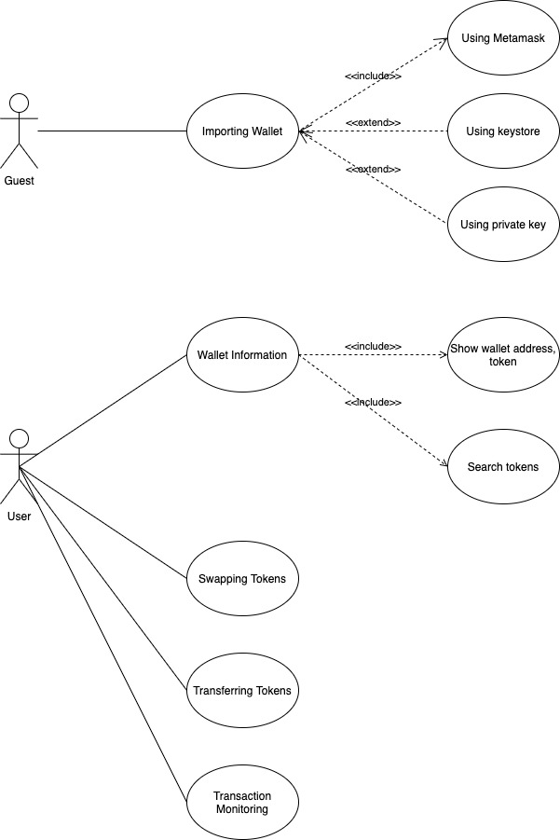

**2.2. Use Cases Specifications**

**2.2.1. Importing Wallet**

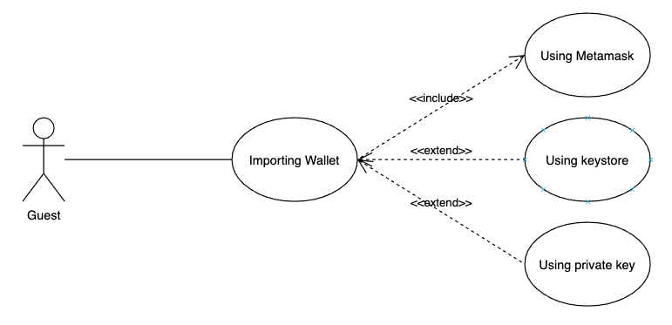

***Use Case****: Importing wallet*

***Primary Actor****: Guest*

***Brief****: This function accept guest when access to the website can import wallet by Metamask or keystore and private key for the optional.*

***Post-conditions***

*Minimal Guarantees:*

*Success Guarantees: Guest can access to Metamask, keystore or private key and imported to the system.*

***Preconditions****:*

*Guest can access to system.*

*Guest have exist account at Metamask, keystore or private key.*

***Triggers****:*

*Guest want to import the wallet to system to use another function*

***Basic flow****:*

*1. Guest access to website*

*2. Guest choose Metamask.*

*3. System connect to Metamask.*

*4. Guest choose keystore or private key for optional.*

***Extensions****:*

*a. Guest can’t access to the website:*

*b. Guest can’t connet to Metamask:*

*1. System show error*

**2.2.2. Wallet Information**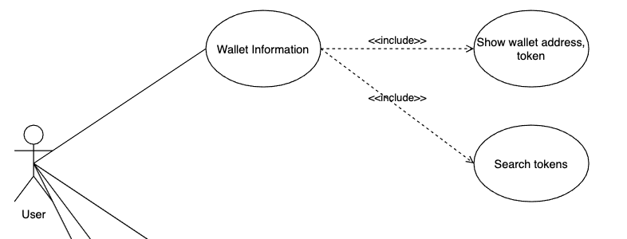

***Use Case****: Wallet Information*

***Primary Actor****: User*

***Brief****: After import wallet user can view wallet information: wallet address, wallet token, search token.*

***Post-conditions***

*Minimal Guarantees:*

*Success Guarantees:*

*• User can view current imported wallet address and its balance for each token.*

*• User can search tokens by name or symbol.*

***Preconditions****:*

*User’s wallet imported to the system.*

*User’s connecting to system.*

***Triggers****:*

*User want to view their account information.*

***Basic flow****:*

*1. After user account imported, user can view their account address.*

*2. User can choose token from dropdown list to view its balance.*

*3. User can search tokens by name or symbol from token dropdown list.*

*4. System fetch user balance in an interval of 10s.*

***Extensions****:*

*a. System can’t load account address and balance:*

*1. Show error message*

**2.2.3. Swapping Tokens**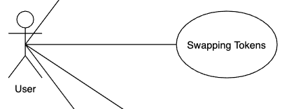

***Use Case****: Swapping Tokens*

***Primary Actor****: User*

***Brief****: User want to swap token amount from current wallet to destination token amount.*

***Post-conditions***

*Minimal Guarantees:*

*Success Guarantees:*

*• User can exchange token between current wallet to destination token*

***Preconditions****:*

*User’s wallet imported to the system.*

*User’s connecting to system.*

***Triggers****:*

*User want to view their account information.*

***Basic flow****:*

*1. User enter source token amount to transfer and on for entering a valid address from dropdown list token.*

*2. When user input amount as a number to amount inputs, auto fill optional 25%, 50%, 100% of user balance source amount.*

*3. User can choose Swap button.*

*4. A modal is displayed to show confirmation with all the information selected and estimated transaction fee to execute the transaction.*

*5. User choose confirm to swap tokens.*

***Extensions****:*

*a. User input swap amount is over wallet amount:*

*1. Show error message*

*2. Show available amount to swap.*

*b. System can’t run swapping tokens confirmation*

*1. Show error message.*

*c. System cant fetch market rate of selected token pair in interval of 10s.*

*1. Show error message.*

**2.2.4. Transferring Tokens**

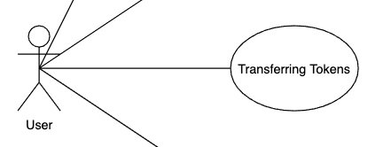

***Use Case****: Transferring Tokens*

***Primary Actor****: User*

***Brief****: User want to transfer token amount from current wallet to destination token amount.*

***Post-conditions***

*Minimal Guarantees:*

*Success Guarantees:*

*• User can exchange token between current wallet to destination token*

***Preconditions****:*

*User’s wallet imported to the system.*

*User’s connecting to system.*

***Triggers****:*

*User want to view their account information.*

***Basic flow****:*

*1. User enter source token amount to transfer and on for entering a valid address from dropdown list token.*

*2. When user input amount as a number to amount inputs, auto fill optional 25%, 50%, 100% of user balance source amount.*

*3. User can choose Transfer button.*

*4. A modal is displayed to show confirmation with all the information selected and estimated transaction fee to execute the transaction.*

*5. User choose confirm to swap tokens.*

***Extensions****:*

*a. User input swap amount is over wallet amount:*

*1. Show error message*

*2. Show available amount to swap.*

*b. System can’t run swapping tokens confirmation*

*1. Show error message.*

**2.2.5. Transaction Monitoring**

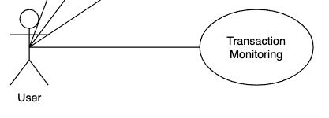

***Use Case****: Transaction Monitoring*

***Primary Actor****: User*

***Brief****: User want to monitor transaction after swapping or transferring tokens.*

***Post-conditions***

*Minimal Guarantees:*

*Success Guarantees:*

*• User can monitor swapping tokens or transferring tokens.*

***Preconditions****:*

*User confirm swapped tokens or transferred tokens*

*User’s connecting to system.*

***Triggers****:*

*User want to view their transactions.*

***Basic flow****:*

*1. User confirmed transaction.*

*2. User can view transaction status: broadcasting, broadcasted, failed or success.*

***Extensions****:*

*a. Transaction error:*

*1. Show error message.*

**3. Non-Functional Requirements**

* *Web browser coverage:* 
  + *Chrome*
  + *Firefox*
  + *Opera*
  + *Brave*
* *Mobile platform: if your application is a mobile app, then the requirements of mobile OS need to specify. It is a considerable effort to develop and deliver the application in an additional OS platform. Thus, it needs to be well-scoped at this stage, requirement analysis.*
* *System security: Keystore and private key don’t commit to store or leak by any way.*

**4. Product Upgrades**

* *Create mobile app for ios and android device.*
* *Push notification for transaction status for send and receive account.*