**HCM UNIVERSITY OF ECONOMICS AND FINANCE**



**THE REPORT**

**JAVA TECHNOLOGY**

***PROJECT: HOTEL MANAGEMENT SYSTEM***

**Class: B04E**

|  |
| --- |
| **Instructor: Nguyễn Minh Tuấn** |
| **Members:** |
| 1. ***Trương Quang Huy – 185050162*** 2. ***Phạm Tiến Đạt – 195050762*** 3. ***Phạm Tuấn Dũng – 195050561*** 4. ***Phan Hoàng Trọng Tín – 195050389*** 5. ***Nguyễn Văn Tài - 195050710*** |

# Table Of Contents

Table Of Contents 1

Table Of Figure 4

Member’s work assignment: 5

CHAPTER 1: INTRODUCTION 1

1.1. The reason to choose this topic. 1

1.2. The targets of this project. 1

CHAPTER 2: OVERVIEW 2

2.1. Status survey 2

2.2. Rating 2

2.2.1. Disadvantages 2

2.2.2 Advantages 2

2.3. Objectives and scope of the system 3

2.3.1. Objectives 3

2.3.2 The scope 3

2.3.3 System constraints 4

CHAPTER 3: THEORETICAL BASIS 5

3.1. Introduction about NetBeans IDE 5

3.2. Java language 5

3.2.1. History of Java language 6

3.2.2. Programming environment 8

3.3 Overview of SQL Server database data system 8

CHAPTER 4: SYSTEM ANALYSIS AND DESIGN 9

4.1. Definition requirements 9

4.1.1. Require function 9

4.1.2. Require system 9

4.2. Modeling 10

4.2.1. Functional Decomposition (FDD) Diagram 10

4.3. Some basic database of the system 10

4.3.1. Employee table 11

4.3.2. Service table 11

4.3.3. Room table 12

4.3.4 Customer table 12

4.3.5 Invoice table 13

4.4. FUNCTIONAL COMPONENTS OF THE SYSTEM 13

4.4.1 Menu 13

4.4.2. System login function 13

4.4.3. Employee information function 13

4.4.4 Service information display function 13

4.4.5. Room information display function 14

4.4.6. Customer information display function 14

4.4.7. Invoice display function 14

4.5. Source code 14

4.5.1 Source code class MyConnection 14

4.5.2. Source class Login 15

4.5.3. Source code add employee information 15

4.5.4. Source code edit employee information 16

4.5.5. Source code delete employee information 17

4.5.6. Source code add, edit , delete information room 17

4.5.7. Add, edit, delete customer information 18

4.6. Design system interface 19

4.6.1. Login interface 20

4.6.2. Main interface 20

4.6.3. Employee management interface 21

4.6.4. Service management interface 22

4.6.5. Room management interface 22

4.6.6. Customer management interface 23

4.6.7. List ( include statistics of invoices and employee salary) 24

CHAPTER 5: CONCLUSION 25

5.1. Conclusion of project 25

5.1.1. General assessment 25

5.1.2. Direction of development and expansion of the topic 25

5.2. Epilogue 26

# Table Of Figure

Figure 4.1. Functional Decomposition Diagram 10

Figure 4.2. Employee table. 11

Figure 4.3. Service table. 11

Figure 4.4. Room table. 12

Figure 4.5. Customer table. 12

Figure 4.6. Invoice table. 13

Figure 4.7. Source code class MyConnection. 14

Figure 4.8. Source code class MyConnection 15

Figure 4.9. Source class Login. 15

Figure 4.10. Source code add employee information 16

Figure 4.11. Source code edit employee information 17

Figure 4.12. Source code delete employee information 17

Figure 4.13. Source code add, edit , delete information room 18

Figure 4.14. Add, edit, delete customer information 19

Figure 4.15. Login interface 20

Figure 4.16. Main interface 20

Figure 4.17. Employee management interface 21

Figure 4.18. Room management interface 22

Figure 4.19. Customer management interface 23

Figure 4.20. List 24

# Member’s work assignment:

* Trương Quang Huy : Report project word file and design report.
* Phạm Tiến Đạt : Sql server.
* Phạm Tuấn Dũng: Report project word file and design report.
* Phan Hoàng Trọng Tín : Main coding.
* Nguyễn Văn Tài : Design interface.

PREFACE

Today, we have entered the 21st century, the era of Information Technology, the role of IT and knowledge has become the most important factor determining the success of each industry, each country. IT has been changing our lives, with the strong development of software technologies, the application of information technology to social life as well as management is very developed and widespread. All sciences such as: Army, health, education, economy, commerce, finance .... All are widely computerized, it helps the management industry more and more effective. . , reducing the time and effort to complete the work. It can be affirmed that informatics is indispensable in all activities of the social life of each branch and each unit.

In the world as well as in Vietnam, IT has a very strong influence on the development of the country and the world. It has become an indispensable and decisive factor to the success or failure of many industries in our country today. IT is developing at a fairly strong speed and is widely applied in all fields. field, especially in management. It contributes a great part to simplifying as well as shortening the labor time and improving the working efficiency of managers.

In today's era, people's lives are increasingly enhanced and developed, followed by the development of a system of services for people's lives. Not only outside of that rule, but the system of service hotels and motels is increasingly developing.

In Vietnam, the State is developing the service industry and investing in tourism. Therefore, the hotel industry is also being focused to attract domestic and foreign tourists to visit.

The introduction of information technology into business operations has made management more efficient and easier to handle situations, requests, provide numbers and reports accurately and quickly. Besides, it also helps to automate tasks that contribute to the growth of businesses, helping Vietnam's hotel business grow and attract more visitors to come to visit and travel.

However, in reality, only large hotels have management software. As for the small and medium hotels, most of them are handmade, while in our country, the large hotels are not really many, because the material and economic conditions are still developing.

Starting from that fact, we chose the topic "Hotel Management System". This is a topic that is not new, but it is still not popular in the process of hotel management. Therefore, we research this topic in the hope that it will contribute to making hotel management easier.

# INTRODUCTION

## 1.1. The reason to choose this topic.

In recent years, tourism is one of the fastest growing industries in the country. Many hotels race to develop continuously and rapidly according to the development of society in terms of scale and quality.

Currently, hotels have to directly receive and manage a large volume and often many types of customers along with a series of services arising according to customer needs. As a result, the management of hotel business is becoming more and more complicated.

Moreover, the management job is not simply managing guests staying, using services... but the management work must meet the needs of reporting various types of revenue, business situation of the hotel... from that sets the direction and development plan for that business company. But with today's manual storage and handling, it will be very time-consuming and labor-intensive, but the efficiency is not high. Therefore, it is necessary to computerize the management form, the tool to build a software that meets the requirements of comprehensive, systematic and most effective management for the hotel's business.

Stemming from the above needs, we decided to choose the topic "Hotel Management".

## 1.2. The targets of this project.

Successfully built Hotel Management System for the purpose of managing activities in the hotel, meeting the most important business needs and increasing profits. When applying information technology to management, it will reduce effort and time and help managers understand hotel operations so that they can make quick decisions.

# OVERVIEW

## 2.1. Status survey

Vietnam is facing a shortage of highly qualified and well-trained human resources, especially in the hotel industry. This need becomes even more urgent when in the near future, in 2015, the ASEAN Agreement on the free movement of human resources in the tourism industry between countries in Southeast Asia will be implemented. However, human resources for hotel management in our country in recent years have not been clearly shaped, leading to a situation of both surplus and shortage. Every year, universities, colleges, and professional schools across the country "ship out" a lot of students majoring in hotel management. However, most of them, after graduating from school, do not find a job in the right profession, if any, only "temporarily" in small areas such as mini hotels, motels...

## 2.2. Rating

### 2.2.1. Disadvantages

The storage of information about customers and rooms is complicated, requires many types of papers and books, so it is cumbersome, the storage place is not convenient, and it requires many employees.

When looking for information about customers, assets will take a long time to find directly on recorded documents and books.

### 2.2.2 Advantages

Low investment capital, no need to invest in computer equipment and management software.

From the above advantages and disadvantages, it is necessary to build a new system with more professional technical and management requirements, which can solve the existing problems of the old system.

## 2.3. Objectives and scope of the system

### 2.3.1. Objectives

The hotel management system is built towards the following objects:

* System Administrator
* Management staff.

### 2.3.2 The scope

#### a. Statement of the Point

With the number of customers increasing every year, X Hotel has a need to improve the automatic storage, search and printing of reports to meet information processing and information accuracy. The intervention of the hotel management system is going to bring higher operational efficiency in the management of hotel X

#### b. Goals

Allow staff to manage and track information for each customer, each room accurately. Look up, statistics results, ...

Ensure that the database is secure and highly reliable.

#### c. Description

The system will collect all the information about employees, services, rooms, customers, invoices.

Make lists, reports… to make it easier for managers to understand the necessary information.

#### d. Benefits

Create convenience, speed and comfort for the management staff.

Automation for hotel management creates professionalism for information management.

Save time and money.

#### e. Steps taken to complete the project:

Include steps:

* System development planning.
* System analysis.
* Design.
* Installation.
* Check.
* Prepare documents.
* User training.

## 2.3.3 System constraints

Software after deployment must automatically meet the needs of 50% of related jobs.

Data must be factual and must be updated regularly.

# THEORETICAL BASIS

## 3.1. Introduction about NetBeans IDE

NetBeans IDE is a free, open source, integrated development environment (IDE) that enables you to develop desktop, mobile and web applications. The IDE supports application development in various languages, including Java, HTML5, PHP and C++. The IDE provides integrated support for the complete development cycle, from project creation through debugging, profiling and deployment. The IDE runs on Windows, Linux, Mac OS X, and other UNIX-based systems.

The IDE provides comprehensive support for JDK 8 technologies and the most recent Java enhancements. It is the first IDE that provides support for JDK 8, Java EE 7, and JavaFX 2. The IDE fully supports Java EE using the latest standards for Java, XML, Web services, and SQL and fully supports the GlassFish Server, the reference implementation of Java EE.

## 3.2. Java language

Java is a high-level, class-based, object-oriented programming language that is designed to have as few implementation dependencies as possible. It is a general-purpose programming language intended to let programmers write once, run anywhere (WORA), meaning that compiled Java code can run on all platforms that support Java without the need to recompile. Java applications are typically compiled to bytecode that can run on any Java virtual machine (JVM) regardless of the underlying computer architecture. The syntax of Java is similar to C and C++, but has fewer low-level facilities than either of them. The Java runtime provides dynamic capabilities (such as reflection and runtime code modification) that are typically not available in traditional compiled languages. As of 2019, Java was one of the most popular programming languages in use according to GitHub, particularly for web applications, with a reported 9 million developers.

Java was originally developed by James Gosling at Sun Microsystems and released in May 1995 as a core component of Sun Microsystems' Java platform. The original and reference implementation Java compilers, virtual machines, and class libraries were originally released by Sun under proprietary licenses. As of May 2007, in compliance with the specifications of the Java Community Process, Sun had relicensed most of its Java technologies under the GPL-2.0-only license. Oracle offers its own HotSpot Java Virtual Machine, however the official reference implementation is the OpenJDK JVM which is free open-source software and used by most developers and is the default JVM for almost all Linux distributions.

As of March 2022, Java 18 is the latest version, while Java 17, 11 and 8 are the current long-term support (LTS) versions. Oracle released the last zero-cost public update for the legacy version Java 8 LTS in January 2019 for commercial use, although it will otherwise still support Java 8 with public updates for personal use indefinitely. Other vendors have begun to offer zero-cost builds of OpenJDK 18 and 8, 11 and 17 that are still receiving security and other upgrades.

### 3.2.1. History of Java language

James Gosling, Mike Sheridan, and Patrick Naughton initiated the Java language project in June 1991. Java was originally designed for interactive television, but it was too advanced for the digital cable television industry at the time. The language was initially called Oak after an oak tree that stood outside Gosling's office. Later the project went by the name Green and was finally renamed Java, from Java coffee, a type of coffee from Indonesia. Gosling designed Java with a C/C++-style syntax that system and application programmers would find familiar.

Sun Microsystems released the first public implementation as Java 1.0 in 1996. It promised write once, run anywhere (WORA) functionality, providing no-cost run-times on popular platforms. Fairly secure and featuring configurable security, it allowed network- and file-access restrictions. Major web browsers soon incorporated the ability to run Java applets within web pages, and Java quickly became popular. The Java 1.0 compiler was re-written in Java by Arthur van Hoff to comply strictly with the Java 1.0 language specification. With the advent of Java 2 (released initially as J2SE 1.2 in December 1998 – 1999), new versions had multiple configurations built for different types of platforms. J2EE included technologies and APIs for enterprise applications typically run in server environments, while J2ME featured APIs optimized for mobile applications. The desktop version was renamed J2SE. In 2006, for marketing purposes, Sun renamed new J2 versions as Java EE, Java ME, and Java SE, respectively.

In 1997, Sun Microsystems approached the ISO/IEC JTC 1 standards body and later the Ecma International to formalize Java, but it soon withdrew from the process. Java remains a de facto standard, controlled through the Java Community Process. At one time, Sun made most of its Java implementations available without charge, despite their proprietary software status. Sun generated revenue from Java through the selling of licenses for specialized products such as the Java Enterprise System.

On November 13, 2006, Sun released much of its Java virtual machine (JVM) as free and open-source software (FOSS), under the terms of the GPL-2.0-only license. On May 8, 2007, Sun finished the process, making all of its JVM's core code available under free software/open-source distribution terms, aside from a small portion of code to which Sun did not hold the copyright.

Sun's vice-president Rich Green said that Sun's ideal role with regard to Java was as an evangelist. Following Oracle Corporation's acquisition of Sun Microsystems in 2009–10, Oracle has described itself as the steward of Java technology with a relentless commitment to fostering a community of participation and transparency.[35] This did not prevent Oracle from filing a lawsuit against Google shortly after that for using Java inside the Android SDK (see the Android section).

On April 2, 2010, James Gosling resigned from Oracle.

In January 2016, Oracle announced that Java run-time environments based on JDK 9 will discontinue the browser plugin.

Java software runs on everything from laptops to data centers, game consoles to scientific supercomputers.

### 3.2.2. Programming environment

Java Development Kit (JDK - Java Programming Language) is a set of software tools developed by Sun Microsystems for software developers, used to write those Java applets or Java applications.

## 3.3 Overview of SQL Server database data system

There are many powerful basic management systems such as: Oracle, MySQL…. But in the graduation report, I asked for permission to use SQL Server to build software.

SQL Server is one of the most popular database management systems today. It provides an environment used to create and manage databases. It allows secure and efficient storage. It provides other components and services that support the business intelligence platform to generate reports and help analyze the data.

# SYSTEM ANALYSIS AND DESIGN

## 4.1. Definition requirements

### 4.1.1. Require function

* + The system must update and store all details about rooms, employees, invoices, customers, etc.
  + Update by category: employees, services, rooms, customers, invoices
  + Provide, look up hotels

### 4.1.2. Require system

* The system using a database management system is large enough to meet the increasing number of hotels.
* The server has the ability to calculate quickly, accurately, long-term storage, and security.
* The network system has a large access capacity.
* Synthesize and evaluate hotel quality through the system, automatically.
* Information is synchronized and strictly decentralized.
* Good security for system administrators.

## 4.2. Modeling

### 4.2.1. Functional Decomposition (FDD) Diagram

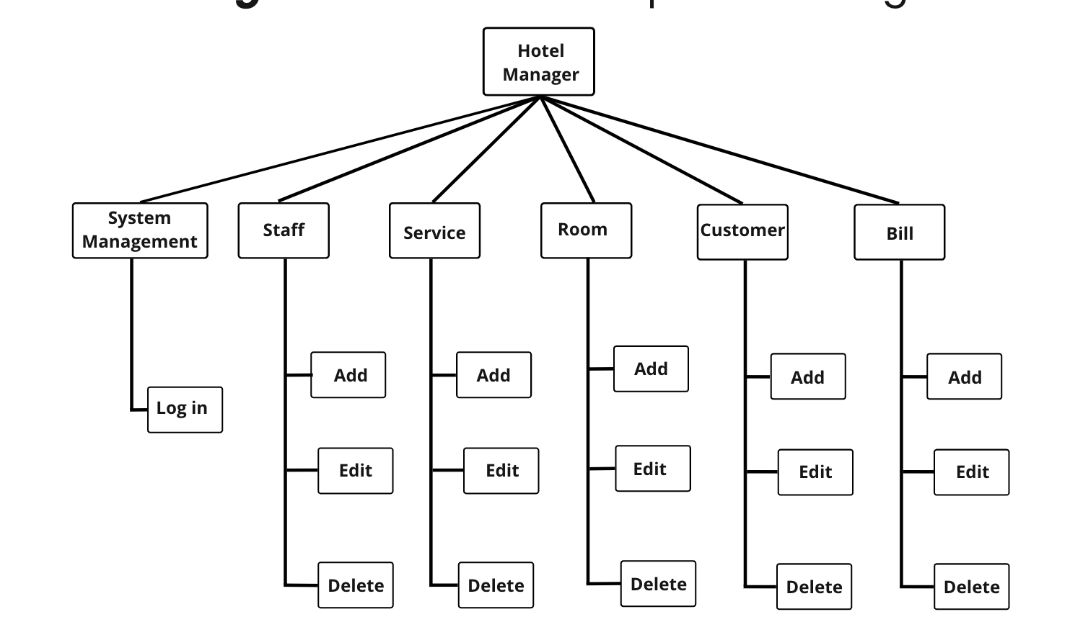

Figure 4.1. Functional Decomposition Diagram

## 4.3. Some basic database of the system

To understand the problem's requirements, we need to understand the database the problem needs. Here, we would like to give the following information that hotel management software needs to have:

### 4.3.1. Employee table

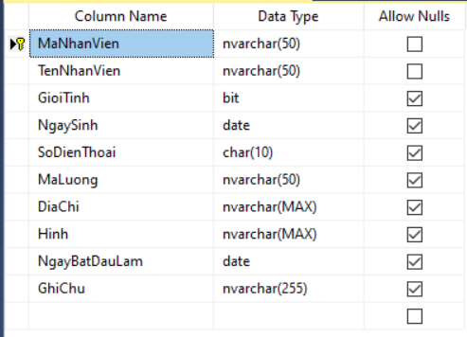

Figure 4.2. Employee table.

### 4.3.2. Service table

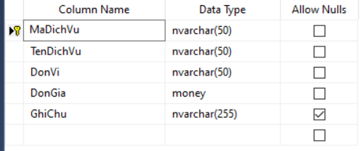

Figure 4.3. Service table.

### 4.3.3. Room table

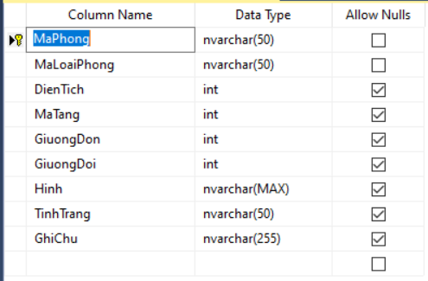

Figure 4.4. Room table.

### 4.3.4 Customer table

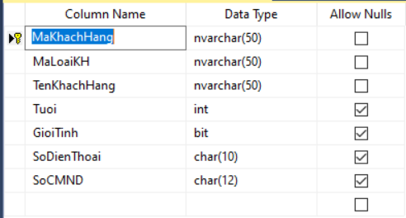

Figure 4.5. Customer table.

### 4.3.5 Invoice table

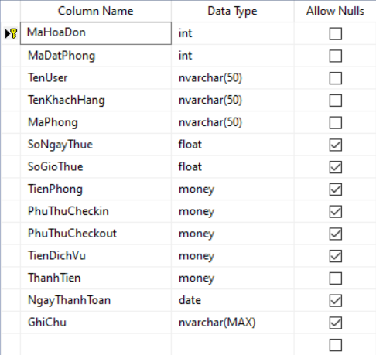

Figure 4.6. Invoice table.

## 4.4. FUNCTIONAL COMPONENTS OF THE SYSTEM

### 4.4.1 Menu

Contains the main functions of the program.

### 4.4.2. System login function

Sign in to your account to process the program.

### 4.4.3. Employee information function

Add, edit, delete and display employee information

### 4.4.4 Service information display function

Add, edit, delete and display service information

### 4.4.5. Room information display function

Show more, edit, delete room information

### 4.4.6. Customer information display function

Display more, edit, delete customer information

### 4.4.7. Invoice display function

Display, add, edit, delete invoice information

## 4.5. Source code

### 4.5.1 Source code class MyConnection

Used to connect MySql and NetBeans databases.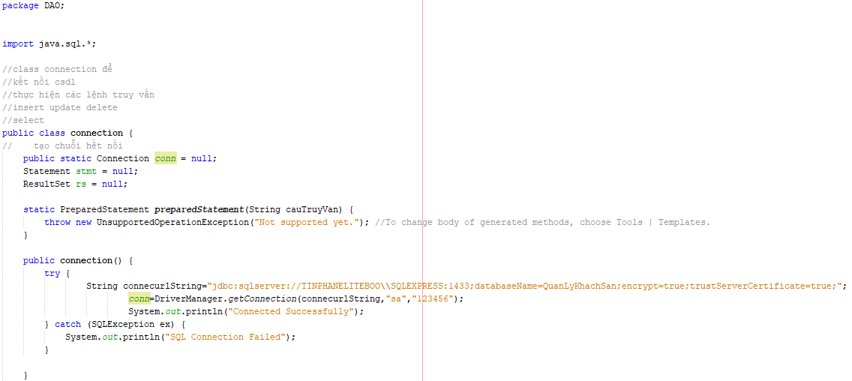

Figure 4.7. Source code class MyConnection.

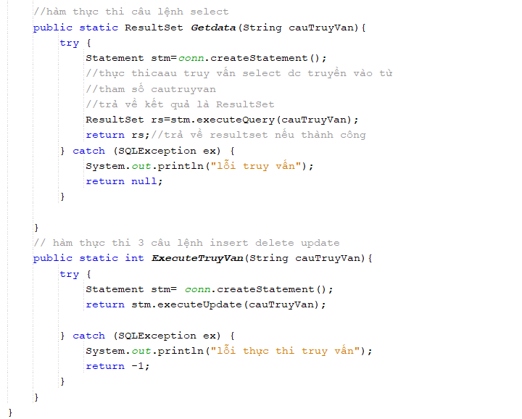

Figure 4.8. Source code class MyConnection

### 4.5.2. Source class Login

Used to login to the system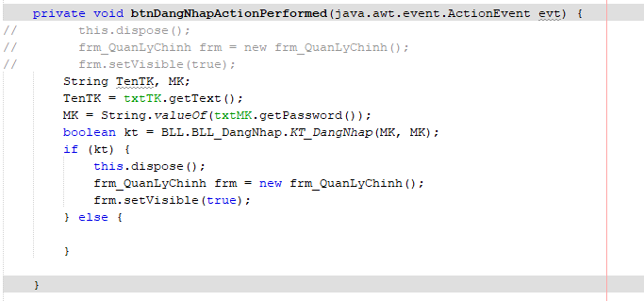

Figure 4.9. Source class Login.

### 4.5.3. Source code add employee information

Used to add employee information to the database

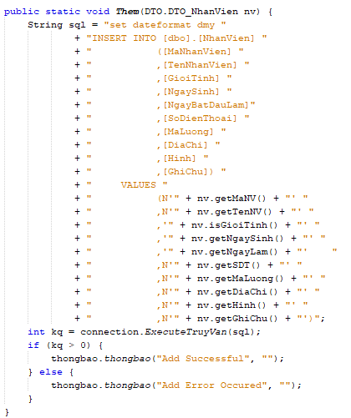

Figure 4.10. Source code add employee information

### 4.5.4. Source code edit employee information

Used to edit employee information in the database.

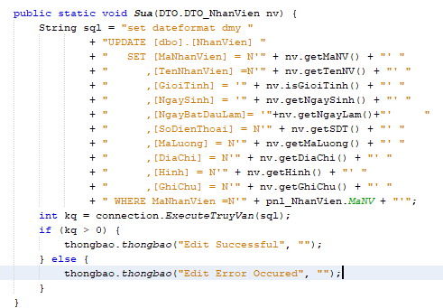

Figure 4.11. Source code edit employee information

### 4.5.5. Source code delete employee information

Used to delete employee information in the database.

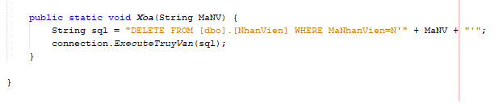

Figure 4.12. Source code delete employee information

### 4.5.6. Source code add, edit , delete information room

Add, edit , delete information room in the database.

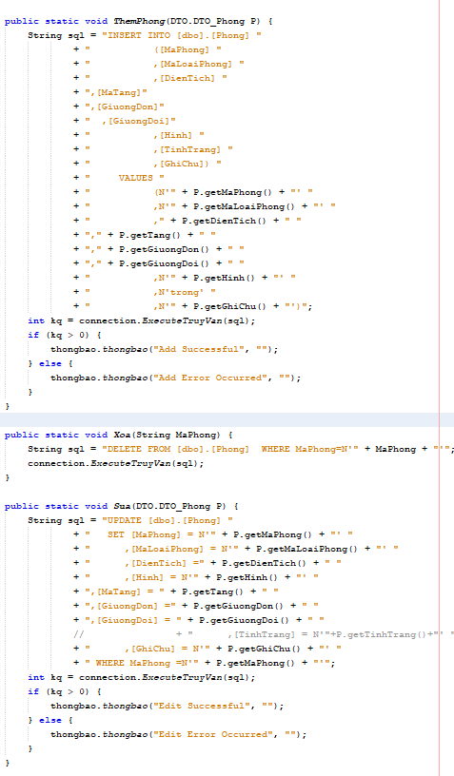

Figure 4.13. Source code add, edit , delete information room

### 4.5.7. Add, edit, delete customer information

Add, edit, delete, search customer information in the database.

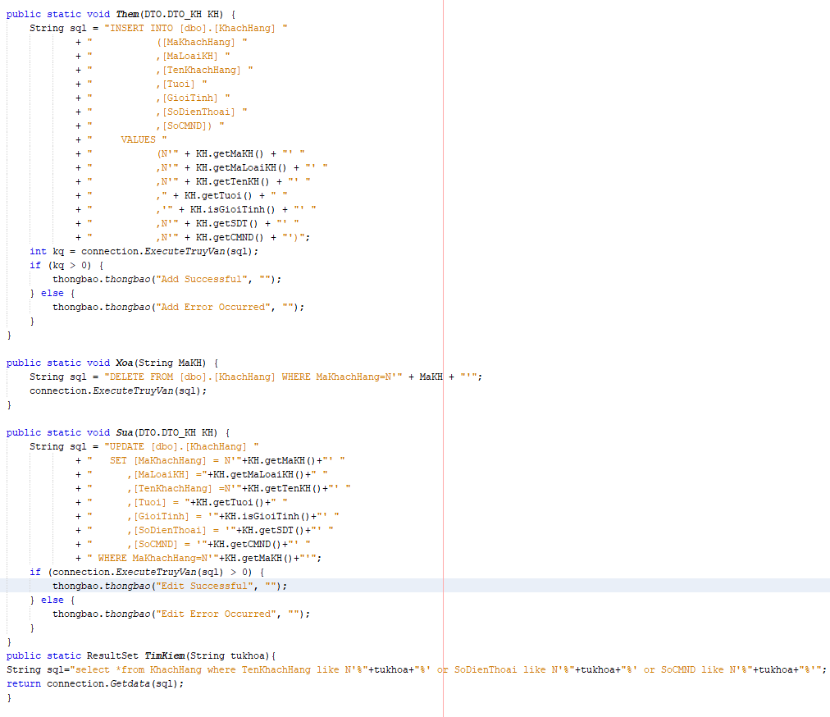

Figure 4.14. Add, edit, delete customer information

## 4.6. Design system interface

Next is to design the form for the program so that the system works efficiently, beautifully and easy to use. The software must work well, without information problems, and limit errors in technical operations.

### 4.6.1. Login interface

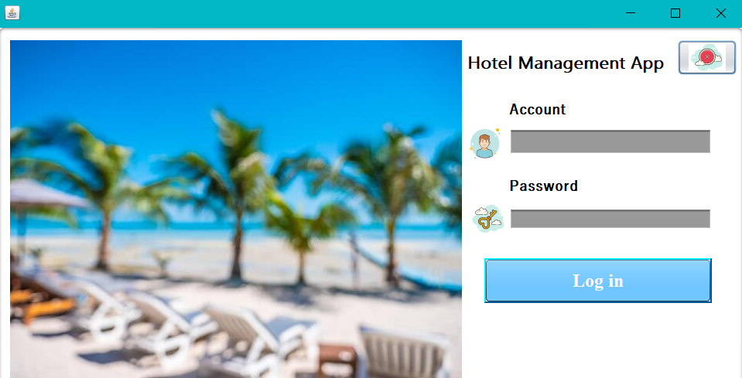

Figure 4.15. Login interface

### 4.6.2. Main interface

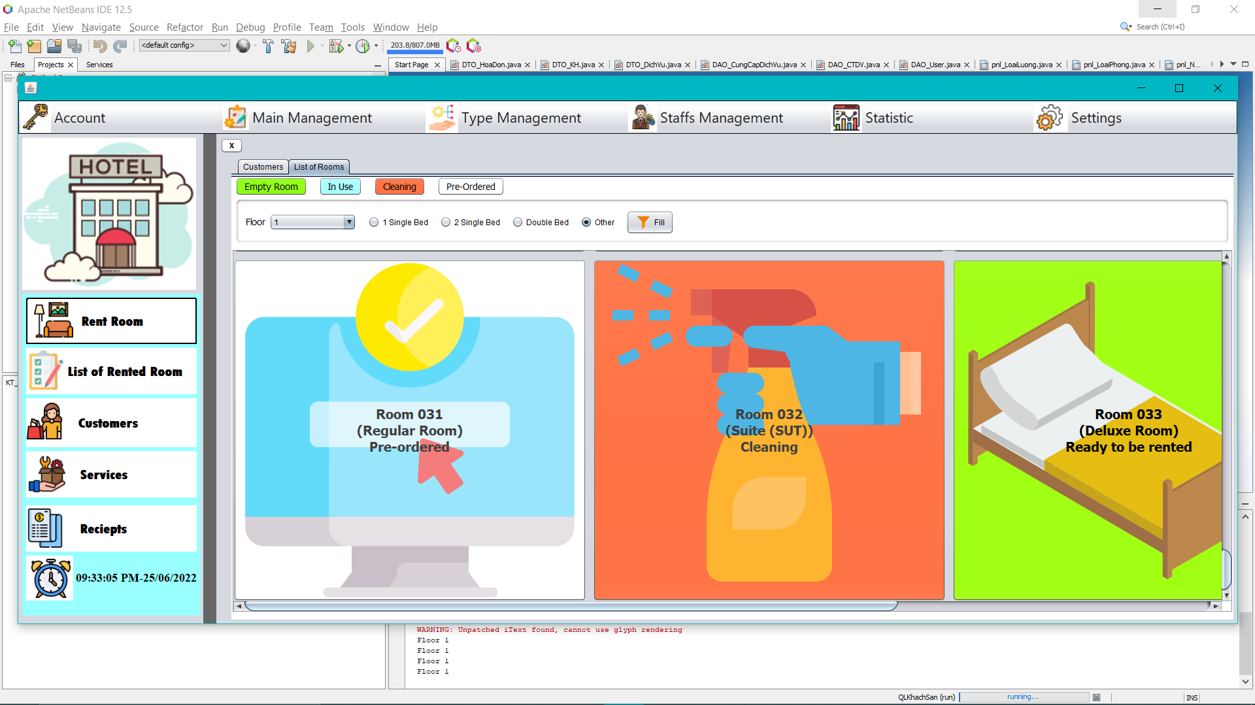

Figure 4.16. Main interface

Function of buttons:

| **Name** | **Meaning** | **Event** |
| --- | --- | --- |
| Rent room | Show information room | Click |
| Service | Manage service | Click |
| Rent room list | Manage rent room | Click |
| Customer | Manage customer | Click |
| Invoice list | Manage invoice | Click |
| Employee management | Manage employee | Click |
| Statistics | Revenue statistics | Click |

### 4.6.3. Employee management interface

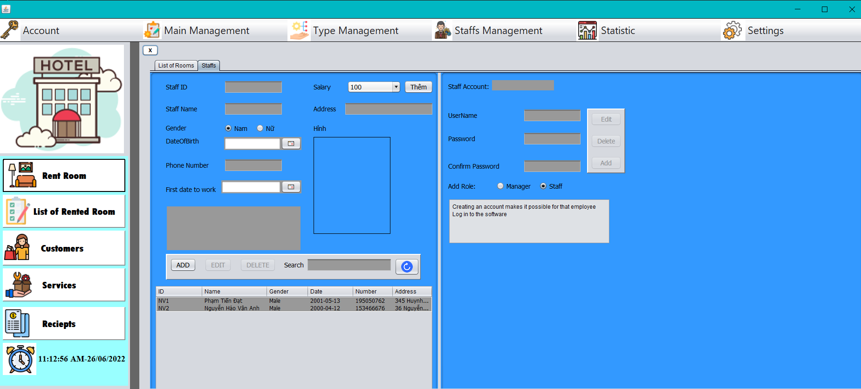

Figure 4.17. Employee management interface

Function of buttons:

|  |  |  |
| --- | --- | --- |
| **Name** | **Meaning** | **Event** |
| Add | Add employee information | Click |
| Edit | Edit employee information | Click |
| Delete | Delete employee information | Click |

### 4.6.4. Service management interface

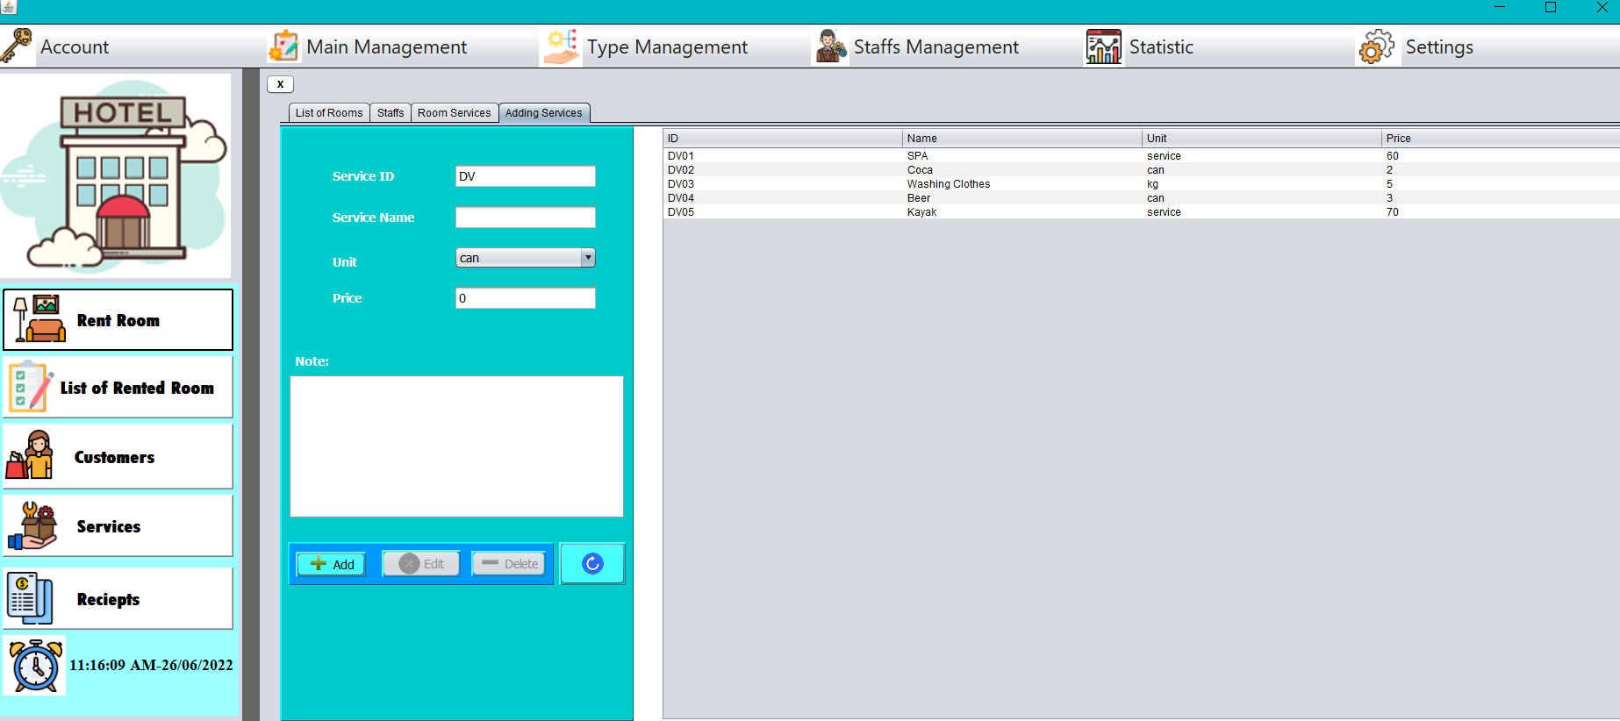

Function of buttons:

|  |  |  |
| --- | --- | --- |
| **Name** | **Meaning** | **Event** |
| Add | Add service information | Click |
| Edit | Edit service information | Click |
| Delete | Delete service information | Click |
| Reset | Reset service information | Click |

### 4.6.5. Room management interface

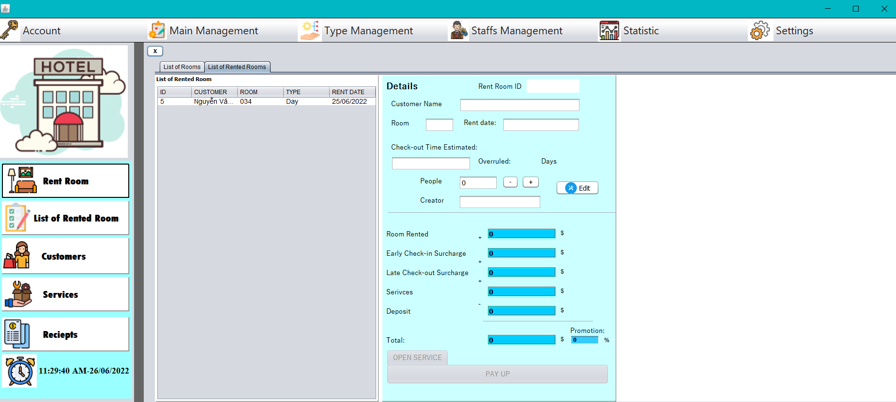

Figure 4.18. Room management interface

Function of buttons:

|  |  |  |
| --- | --- | --- |
| **Name** | **Meaning** | **Event** |
| Edit | Edit room information | Click |
| Exit | Exit room interface | Click |
| Payment | Pay room | Click |
| View service | Open service interface | Click |

### 4.6.6. Customer management interface

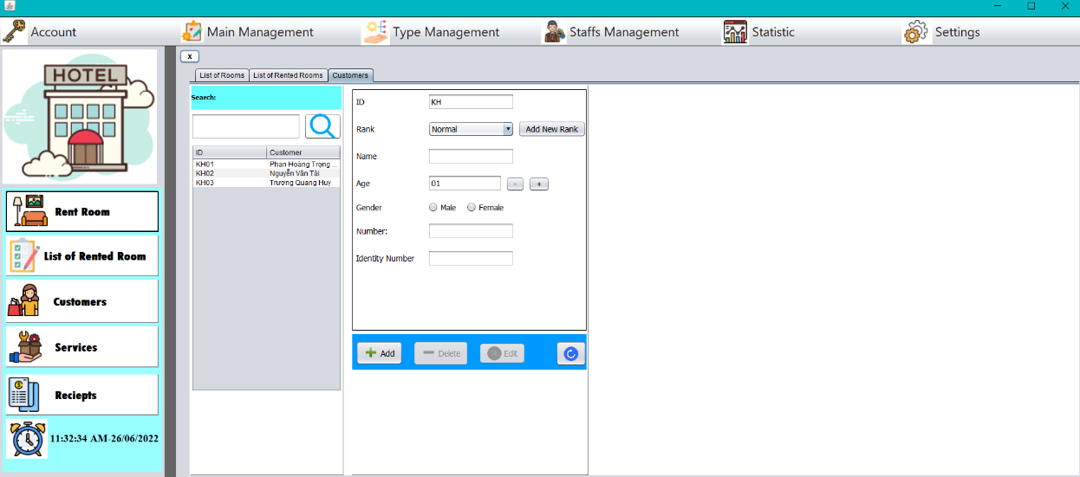

Figure 4.19. Customer management interface

Function of buttons:

|  |  |  |
| --- | --- | --- |
| **Name** | **Meaning** | **Event** |
| Add | Add customer information | Click |
| Edit | Edit customer information | Click |
| Delete | Delete customer information | Click |
| Reset | Reset customer information | Click |
| New add | Edit type of customer | Click |

### 4.6.7. List ( include statistics of invoices and employee salary)

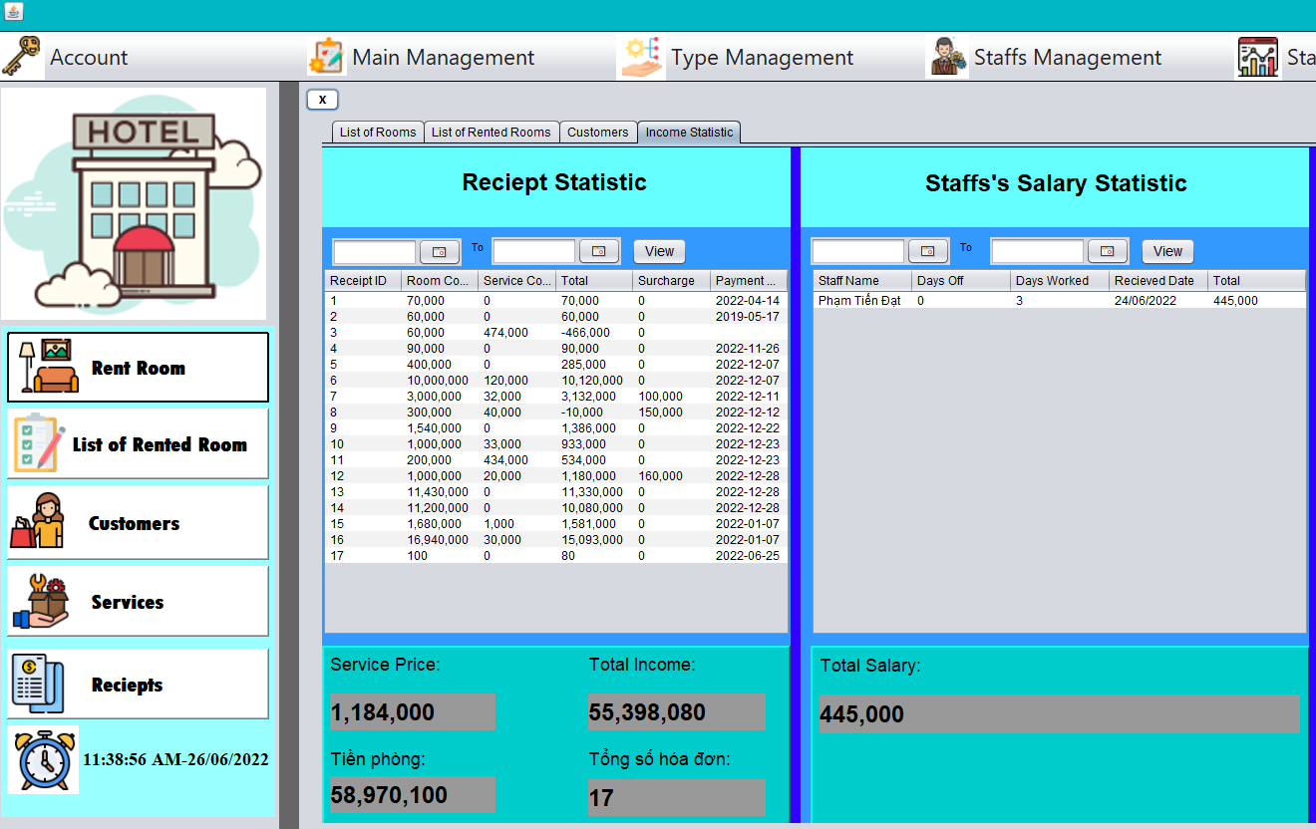

Figure 4.20. List

# CONCLUSION

## 5.1. Conclusion of project

### 5.1.1. General assessment

#### a. Advantages

* Shorten waiting time when booking room
* Using computers to search for detailed information about rooms in the hotel will be easy, quick and convenient. The storage will be simple, no need to have a large storage place, the hotel information will be accurate and fast.
* Statistics of bills and rooms will be easier and more convenient
* With the new processing function, the system will shorten the work of management staff and reduce the number of management staff, avoiding redundancy.

#### b. Disadvantage

* The cost of building a system management device including computers, software, etc. is very expensive.
* The time to work and the reporting software is only encapsulated in 1 month, so this article is still incomplete, some other cases in the management department have not been solved yet.

### 5.1.2. Direction of development and expansion of the topic

In order for hotel management software to make an important contribution to the management of the hotel system, reduce the cumbersomeness of the books, etc., it is advisable to expand the topic and consider more aspects so that the software can be perfected. than. very necessary. In this topic, I only analyze and build simple, uncomplicated software. Therefore, the development direction of this topic is:

* The connection between the boards of the base needs to be tighter.
* Integrate more management when booking
* Redirect hotel information management over the network.
* Expand more web application: allow to enter and edit information remotely.
* Continue to improve the missing functions.

## 5.2. Epilogue

Building management software in general, hotel management software in particular is not only simple to build, but it requires a systematic survey of the stage, design analysis must be conducted before.

Facing the current development trend of information technology, building hotel management software is indispensable, this is a highly practical topic. Through researching and building this topic, a part has been fixed to give me knowledge about programming, it also provides me with how to build a complete software, through this management lesson. you can be used to build the same software as: the management library, manager event…