Every year, when the monsoon season arrives in Ho Chi Minh City, Vietnam, from May to November, it brings higher humidity and heavier rainfall. While these rains provide essential nutrients for the fertile lands of the Mekong Delta—the largest rice field in Vietnam, crucial for feeding the nation's population—they also create significant challenges for the residents of Ho Chi Minh City.

The city is sinking, a problem attributed to insufficient urban infrastructure development and the warming of the Earth. Consequently, the streets and roads of Ho Chi Minh City experience increasingly severe flooding with each passing year. 1(<https://vtv.vn/xa-hoi/da-nang-duong-pho-ngap-nuoc-nguoi-dan-di-lam-sang-som-gap-kho-khan-20241105094430673.htm>)

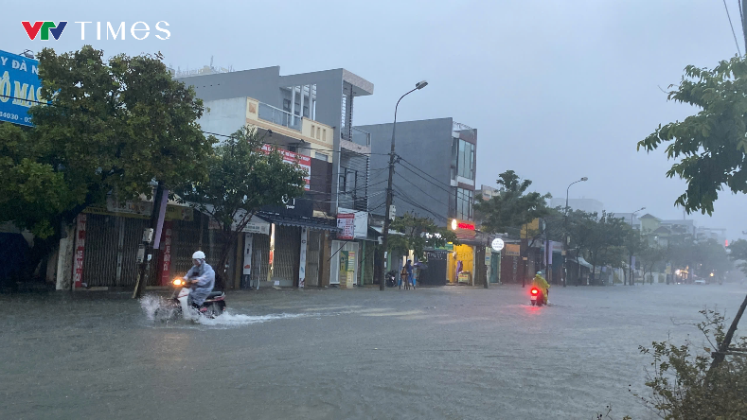

Figure 1. Streets in Ho Chi Minh City, Vietnam, after heavy rain.

As an active commuter in the bustling streets of Ho Chi Minh City, I have firsthand experience with the chaos and dangers these floods bring. Navigating the crowded and waterlogged streets becomes not only frustrating but also perilous. When floodwaters rise too high, they can seep into motorcycle engines, rendering them useless. Worse, the low visibility of the road surface hides potholes and other hazards, leading to accidents and injuries for riders. 2(<https://nld.com.vn/loat-anh-duong-pho-tp-hcm-menh-mong-nuoc-sau-tran-mua-lon-chieu-nay-196240825160240379.htm>)

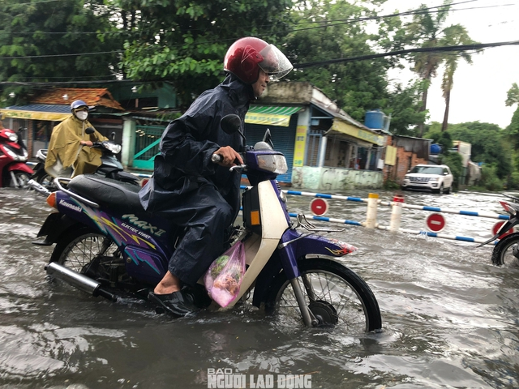

Figure 2. A man riding his motorcycle through water that reaches halfway up his wheels.

Foreigners and tourists often find themselves in awe of the city’s resilience during these challenging times, with some even managing to enjoy the unique experience of flooded streets. 3(<https://e.vnexpress.net/news/news/tourists-enjoy-heavy-downpours-flooding-in-saigon-3844744.html>) However, for residents, this is far from a joyous spectacle. Videos showcasing the extent of flooding and its impact highlight the difficulties locals face in their daily commutes. 4(<https://www.youtube.com/watch?v=pPpW29skPk0>) Despite these challenges, some have learned to coexist with the flooded streets, adapting to the circumstances with ingenuity and resilience. 5(<https://e.vnexpress.net/news/trend/foreigners-learn-to-coexist-with-hcmcs-flooded-streets-4642777.html>)

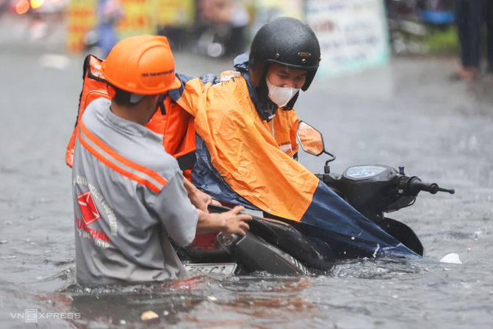

Figure 3. A worker helping a man remove his stalled motorcycle from the flooded streets after water entered the engine

One of the biggest challenges for residents like me is deciding which roads to take during heavy rain. Google Maps, while helpful for navigation, does not provide real-time information about flooded streets or the risks associated with them. This lack of information often leaves travelers unaware of dangerous conditions on their routes. To address this issue, I have designed a user interface that displays flood levels along chosen routes. This interface aims to inform users of the risks associated with specific streets, allowing them to take necessary precautions and choose safer paths.

By providing accurate and timely information about flooded areas, this tool has the potential to make traveling in Ho Chi Minh City during the monsoon season safer and more manageable. With this solution, residents and visitors can better prepare for their journeys, reducing accidents and the inconvenience caused by flooded streets.

**Project 4: User Interface for Good Drafts**

