SafeFamily
Booking & Payment Guide
Implementation, usage, lifecycle, payment architecture, operations, and testing reference

Document status | Implementation-ready reference
Scope | Booking, Payment, Admin queue, Notes, Linked context, Reports

1. Purpose and scope
This document consolidates the full Booking and Payment design for SafeFamily. It is intended for product owners, developers, admins/operators, QA, and anyone who needs a single reference for how booking and payment should behave in production-oriented MVP mode.
The document covers business meaning, state models, database structure, customer and admin flows, payment architecture, required APIs, operational SOPs, testing expectations, and recommended next improvements.

2. What Booking is in SafeFamily
Booking is the core service transaction of SafeFamily. It converts user intent into an operational case, connects that case to payment, and creates the bridge from product usage into revenue and support delivery.
A booking may originate from direct package selection, an assessment result, an incident flow, the dashboard, or a checklist call-to-action. Payment is related to a booking but is tracked separately so business state and money state do not become mixed.

3. What Booking and Payment are responsible for
- Booking captures the requested service, preferred scheduling, package selection, source context, and case progression.
- Payment tracks money movement, gateway interaction, retries, expiry, refunds, and reconciliation.
- Incident is a problem context that may create a booking.
- Assessment is a recommendation context that may create a booking.
- Report is an output that may be attached to a completed booking.

4. Core business use cases
- Direct booking: a user chooses a package and books directly.
- Assessment-driven booking: a user completes an assessment and books Family Reset or another recommended package.
- Incident-driven booking: a user creates an incident and books Emergency Help from the incident result screen.
- Admin-assisted booking: an operator creates or completes a booking after out-of-band communication.

5. Actors and responsibilities
Actor | Primary responsibility | Typical actions
Customer | Creates demand and pays | Choose package, submit booking, complete payment, view status
Admin / Operator | Runs the case | Confirm booking, assign owner, add notes, complete service, link report
Payment gateway | Processes payment | Create checkout order, host payment, send callback/webhook
System | Maintains integrity | Track statuses, validate rules, record events, expose queues and timelines

6. Service package model
Every booking should reference a service package. Service packages standardize pricing, duration, booking type, and payment requirements.
Package field | Purpose
code | Stable identifier such as family_reset or incident_help
name | Display name shown to customers and admins
price_amount / currency | Commercial terms
duration_minutes | Expected session length
requires_payment | Determines whether payment is mandatory
is_deposit_allowed / deposit_amount | Supports staged payment
supports_online / supports_onsite | Controls booking channel availability
Bookings must also store a package snapshot so that historical bookings remain correct even if a package is edited later.

7. Booking source model
To preserve conversion context and improve admin handling, each booking should store where it came from.
Source value | When to use it
direct | The user booked directly from the booking page or package list
assessment | The booking was created from an assessment result
incident | The booking was created from an incident workflow
dashboard | The booking was started from a dashboard CTA
checklist | The booking was started from a checklist CTA
When applicable, bookings should also store source_incident_id or source_assessment_id.

8. Booking lifecycle
BookingStatus | Meaning
draft | The form is being filled and not yet submitted
submitted | The booking exists and is awaiting the next action, commonly payment
paid | Payment succeeded for a paid package
confirmed | Admin accepted the case
scheduled | A specific time has been confirmed
in_progress | The support session or handling is underway
completed | The service has finished
cancelled | The booking was cancelled
expired | The booking or its payment opportunity expired

9. Payment lifecycle
PaymentStatus | Meaning
unpaid | No payment attempt exists yet
pending | A payment order exists and is awaiting gateway completion
paid | Payment was confirmed
failed | Payment attempt failed
expired | Payment order expired
refunded | Full refund completed
partially_refunded | Partial refund completed

10. Why BookingStatus and PaymentStatus must be separate
- A booking can be submitted while payment is pending.
- A booking can be confirmed only after payment for paid packages, or without payment for free/manual packages.
- A booking can be cancelled after payment, which requires a refund path.
- BookingStatus describes service execution. PaymentStatus describes financial execution.

11. State transition rules

11.1 Booking state transitions
From | To | Rule
draft | submitted | User submits booking form
submitted | paid | Payment succeeds for paid package
submitted | confirmed | Only for free/manual package or controlled override
paid | confirmed | Admin accepts the case
confirmed | scheduled | Final service time agreed
scheduled | in_progress | Session starts
in_progress | completed | Service ends
submitted | expired | Payment link or request validity expires
submitted / paid / confirmed / scheduled | cancelled | Cancelled under policy

11.2 Payment state transitions
From | To | Rule
unpaid | pending | Payment order created
pending | paid | Webhook confirms success
pending | failed | Gateway reports failure
pending | expired | Payment order expires
paid | refunded | Full refund processed
paid | partially_refunded | Partial refund processed

12. Database schema overview
The recommended schema uses separate tables for packages, bookings, payment orders, payment events, booking events, and optional booking notes.

service_packages
Column | Purpose
id | uuid PK
code | Unique package code
name | Display name
description | Longer package description
booking_type | family_reset / incident_help / review / custom
price_amount | Numeric price
currency | Normally VND
duration_minutes | Estimated length
requires_payment | Boolean
is_deposit_allowed | Boolean
deposit_amount | Numeric nullable
supports_online | Boolean
supports_onsite | Boolean
is_active | Boolean
sort_order | Integer
created_at | Timestamp
updated_at | Timestamp

bookings
Column | Purpose
id | uuid PK
family_id | FK to families
customer_user_id | FK to users
service_package_id | FK to packages
package_code_snapshot | Snapshot package code
package_name_snapshot | Snapshot package name
price_amount_snapshot | Snapshot package price
currency_snapshot | Snapshot currency
duration_minutes_snapshot | Snapshot duration
booking_source | direct / assessment / incident / dashboard / checklist
source_incident_id | Nullable FK
source_assessment_id | Nullable FK
preferred_start_at | Requested time
confirmed_start_at | Final confirmed time
channel | online / onsite
booking_status | Business lifecycle state
payment_status | Financial lifecycle state
customer_notes | User-facing notes
assigned_admin_user_id | Optional owner
cancellation_reason | Nullable
completed_at | Nullable completion time
created_at | Timestamp
updated_at | Timestamp

payment_orders
Column | Purpose
id | uuid PK
booking_id | FK to bookings
gateway | payos / momo / zalopay
gateway_order_id | Gateway order reference
gateway_transaction_id | Gateway transaction id
amount | Numeric amount
currency | Currency
payment_type | full / deposit / remaining
status | created / pending / paid / failed / expired / refunded
payment_url | Checkout URL
qr_code_url | QR payment link
expires_at | Expiry time
paid_at | Payment completion time
failure_reason | Nullable
raw_gateway_response | JSONB payload
created_at | Timestamp
updated_at | Timestamp

payment_events
Column | Purpose
id | uuid PK
payment_order_id | Nullable FK
gateway | Gateway name
event_type | payment.success / payment.failed etc
event_idempotency_key | Unique dedupe key
payload | JSONB webhook payload
processed_successfully | Boolean
processed_at | Nullable timestamp
created_at | Timestamp

booking_events
Column | Purpose
id | uuid PK
booking_id | FK to bookings
event_type | booking.created / booking.confirmed etc
actor_user_id | Nullable actor
data_json | JSONB metadata
created_at | Timestamp

13. Required indexes and integrity rules
- Unique index on service_packages.code.
- Indexes on bookings.family_id, customer_user_id, service_package_id, booking_status, payment_status, preferred_start_at, confirmed_start_at, and source_incident_id.
- Indexes on payment_orders.booking_id, status, expires_at, and gateway_order_id if the gateway guarantees uniqueness.
- Unique or constrained idempotency key handling on payment_events where supported by the gateway.
- Every booking that requires payment should have at least one payment order.

14. Payment architecture
- Booking remains the source business record.
- PaymentOrder is the source payment record.
- A payment abstraction layer should exist, such as IPaymentGateway plus a PaymentService.
- Gateway implementations should remain replaceable so local providers can be supported without rewriting booking logic.
For Vietnam-first rollout, the architecture should be ready for payOS, MoMo, or ZaloPay through one integration contract.

15. Customer flow
- User selects a package and fills the booking form.
- Frontend submits POST /api/bookings.
- Backend creates the booking and, if required, a payment order.
- Frontend receives paymentUrl, qrCodeUrl, and expiresAt.
- User pays through the gateway.
- Frontend refreshes booking state and explains whether the booking is waiting for payment, waiting for admin confirmation, or already confirmed.

16. Admin flow
- Admin opens the booking queue and filters by paid not confirmed, pending payment, scheduled, in progress, completed, cancelled, or expired.
- Admin opens booking detail and sees package snapshot, source context, linked incident or assessment, payment summary, and notes.
- Admin confirms the booking, assigns an owner, schedules the final time, and later marks the booking in progress and completed.
- If a deliverable exists, admin links a report back to the booking.

17. How to use the implemented feature
Audience | Usage
Customer | Open packages, create a booking, complete payment when required, check My Bookings for payment state and service state, and retry payment when a payment order fails or expires.
Admin / Operator | Open Admin Bookings, filter queue, inspect booking detail, review linked context, assign owner, confirm, schedule, add notes, complete service, and attach or generate a report.

18. Required UI states
- Booking created and waiting for payment
- Payment pending
- Payment paid
- Payment failed
- Payment expired
- Booking confirmed
- Booking scheduled
- Booking in progress
- Booking completed
- Booking cancelled
- Refunded or partially refunded when relevant

19. Webhook and idempotency rules
- Every webhook must verify provider signature or checksum before state mutation.
- Webhook processing must be idempotent; repeated callbacks must not create duplicate side effects.
- PaymentOrder and Booking updates must happen in a safe transaction boundary where practical.
- Payment events should be logged so reconciliation and debugging remain possible.

20. Retry and expiry rules
- Retry payment should create a new PaymentOrder rather than overwrite an old one.
- Expired payment orders should move to expired status and no longer be considered active.
- Bookings that are waiting only on an expired payment should surface payment_status = expired and allow retry where policy permits.
- Retry should be blocked for already-paid bookings.

21. Operational SOPs

21.1 New booking
- Check payment_status first.
- If payment is pending, wait for success or expiry.
- If payment is paid, move the case into admin confirmation.
- Assign owner and confirm the final time.

21.2 Incident-driven booking
- Use source_incident_id to understand urgency.
- Prioritize high-severity bookings.
- Confirm quickly after payment where an emergency package is involved.
- Link outcome and report back to the incident if applicable.

21.3 Completion
- Mark booking completed after the session.
- Link or generate a report.
- Update notes and timeline.
- Optionally trigger follow-up or upsell.

22. Security, integrity, and policy guardrails
- Do not confirm paid-only packages before payment succeeds unless a controlled override path exists.
- Do not overwrite old payment orders on retry.
- Do not expose booking detail, payment data, or reports across family boundaries.
- Do not lose package pricing history when packages change later.
- Do not process the same webhook twice.

23. Minimum implementation checklist
Capability | Minimum expectation | Why it matters
Separate BookingStatus and PaymentStatus | Implemented | Prevents business and money state collisions
PaymentOrder table | Implemented | Supports retries, expiry, and reconciliation
Package snapshot | Implemented | Preserves history
Booking source and linked context | Implemented | Improves conversion analysis and operator context
Webhook verification + idempotency | Implemented | Protects financial integrity
Retry payment | Implemented | Recovers failed attempts cleanly
Admin queue filters | Implemented | Makes operations usable
Notes / linked report / timeline | Implemented or planned | Improves real service handling

24. Recommended tests
- Direct booking success path
- Incident-driven booking success path
- Duplicate webhook path
- Failed payment then retry path
- Expired payment order path
- Admin queue filtering by both booking and payment status
- Report and note linkage to the correct booking

25. Recommended next improvements
- Deposit flow for larger services
- Refund and partial refund operations
- Reschedule requests
- Notification and reminder workflows
- Receipt or invoice generation
- Conversion analytics by booking source

26. Final handoff summary
If Booking and Payment are implemented according to this guide, SafeFamily has a service workflow that is capable of operating in pilot mode with real transactions and real admin handling.
The critical success criteria are clear statuses, safe payment tracking, idempotent webhook processing, package snapshots, linked context, a usable admin queue, and enough event visibility to understand what happened in every booking.

27. Payment flow diagrams
This section adds implementation-ready representations of the Booking and Payment flow for documentation, engineering alignment, and future onboarding. The text flow is easier to read for operators and product reviewers. The Mermaid diagrams are suitable for copying into markdown docs, architecture notes, or internal wikis that support Mermaid rendering.

27.1 Payment flow diagram in text

Direct booking flow
User
-> selects package
-> submits booking form

Frontend
-> POST /api/bookings

Backend
-> creates Booking with booking_status = submitted and payment_status = unpaid
-> creates PaymentOrder with status = pending
-> calls payment gateway
-> stores paymentUrl, qrCodeUrl, expiresAt, gatewayOrderId
-> returns booking + payment info

Frontend
-> redirects user to paymentUrl or shows QR code

User
-> completes payment

Payment Gateway
-> sends webhook to backend

Backend
-> verifies signature/checksum
-> checks idempotency
-> updates PaymentOrder.status = paid
-> updates Booking.payment_status = paid
-> updates Booking.booking_status = paid
-> writes payment event + booking event

Admin
-> sees paid booking in queue
-> confirms booking
-> booking moves to confirmed / scheduled

Later
-> booking moves to in_progress
-> booking moves to completed
-> optional report is generated and linked

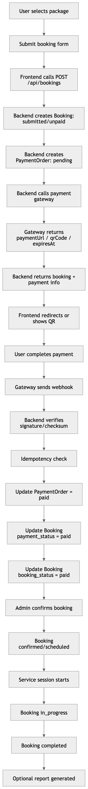

Incident-driven emergency booking flow
User
-> creates incident
-> sees first action plan
-> clicks Book Emergency Help

Frontend
-> pre-fills booking source = incident
-> submits booking with source_incident_id

Backend
-> creates Booking
-> creates PaymentOrder
-> returns payment info

User
-> completes payment

Webhook
-> marks PaymentOrder as paid
-> marks Booking.payment_status = paid
-> marks Booking.booking_status = paid

Admin
-> sees booking source = incident
-> prioritizes the case
-> confirms and handles the booking
-> links report if needed

27.2 Mermaid diagrams
The following Mermaid blocks are included as source diagrams for reuse in markdown-based documentation. They are intentionally provided as code blocks inside the Word file so they remain copyable and editable.

Mermaid: direct booking and payment flow
flowchart TD
A[User selects package] --> B[Submit booking form]
B --> C[Frontend calls POST /api/bookings]
C --> D[Backend creates Booking: submitted/unpaid]
D --> E[Backend creates PaymentOrder: pending]
E --> F[Backend calls payment gateway]
F --> G[Gateway returns paymentUrl / qrCode / expiresAt]
G --> H[Backend returns booking + payment info]
H --> I[Frontend redirects or shows QR]
I --> J[User completes payment]
J --> K[Gateway sends webhook]
K --> L[Backend verifies signature/checksum]
L --> M[Idempotency check]
M --> N[Update PaymentOrder = paid]
N --> O[Update Booking.payment_status = paid]
O --> P[Update Booking.booking_status = paid]
P --> Q[Admin confirms booking]
Q --> R[Booking confirmed/scheduled]
R --> S[Service session starts]
S --> T[Booking in_progress]
T --> U[Booking completed]
U --> V[Optional report generated]

Mermaid: booking state machine
stateDiagram-v2
[*] --> draft
draft --> submitted: user submits booking

submitted --> paid: payment success
submitted --> confirmed: no payment required
submitted --> cancelled: user/admin cancels
submitted --> expired: payment timeout or stale request

paid --> confirmed: admin confirms
confirmed --> scheduled: time confirmed
scheduled --> in_progress: session starts
in_progress --> completed: service finished

paid --> cancelled: cancelled after payment
confirmed --> cancelled: cancelled before service
scheduled --> cancelled: cancelled before service

completed --> [*]
cancelled --> [*]
expired --> [*]

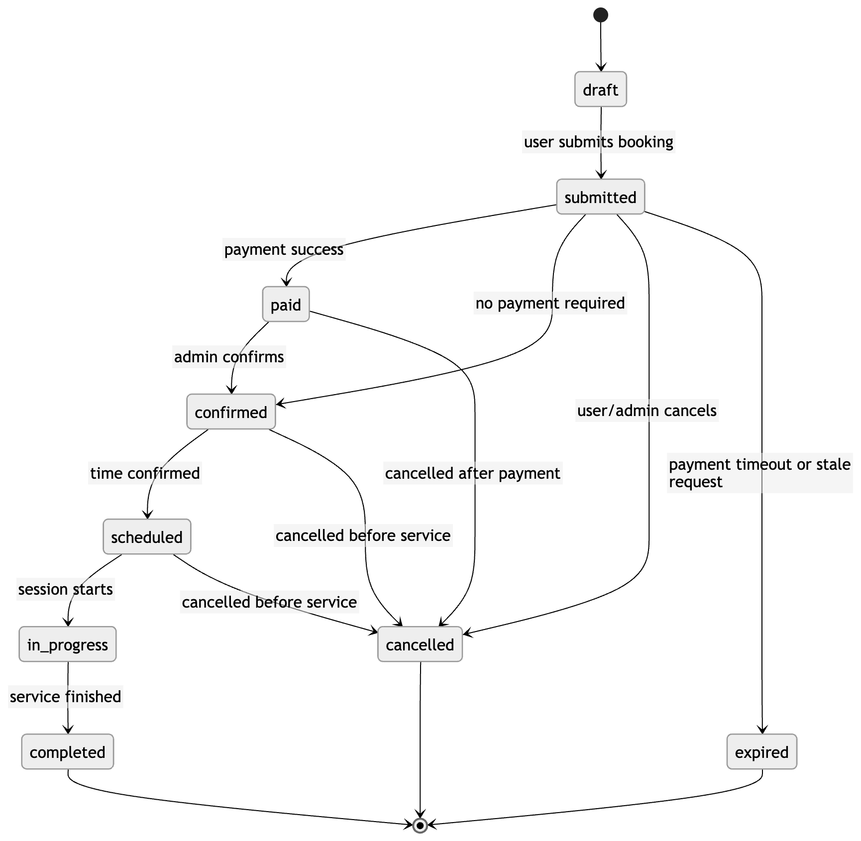

Mermaid: payment state machine
stateDiagram-v2
[*] --> unpaid
unpaid --> pending: payment order created
pending --> paid: webhook success
pending --> failed: payment failure
pending --> expired: payment expired
paid --> refunded: full refund
paid --> partially_refunded: partial refund
failed --> [*]
expired --> [*]
refunded --> [*]
partially_refunded --> [*]
