
DunisTech Academy
https://dunistech.ng
Computer Fundamentals Lesson 6

To use templates, go to File, then click on New. From where you will see a variety of templates to choose from whether resumes, Letterheads, Invoice and the likes.

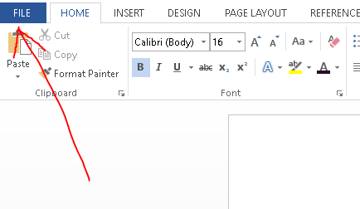

Then,
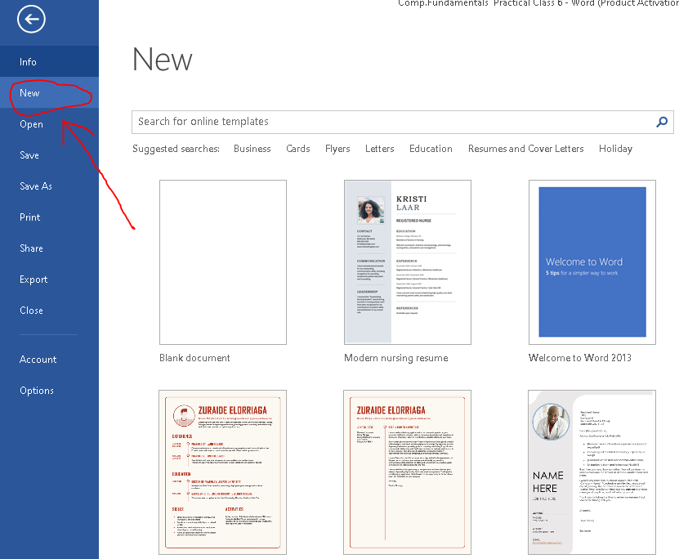

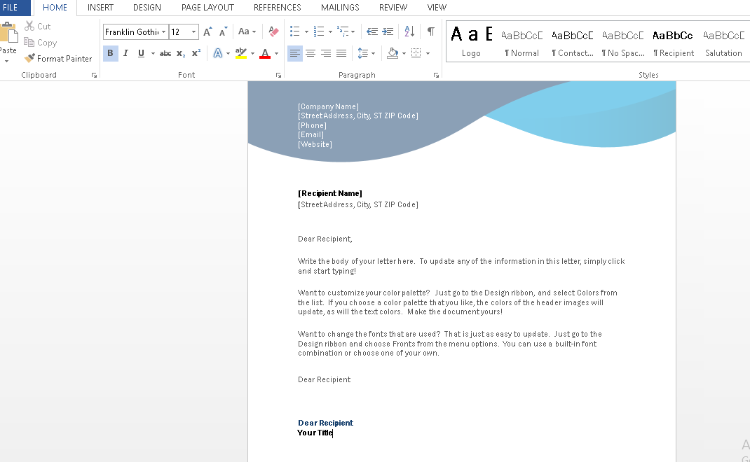

E.g A sample of A Letterhead

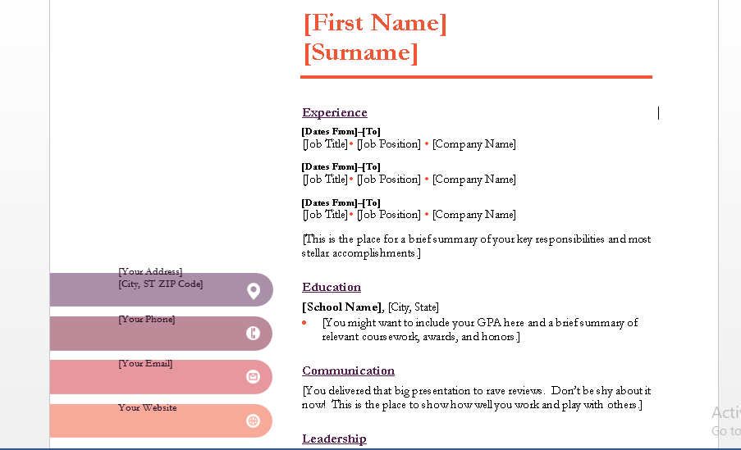
E.g 2. A sample of a Resume.

MICROSOFT WORD – USE OF TABLES

The second part in our Class today is the use of tables. There are different ways to create tables.
TO CREATE TABLES, GO TO INSERT TAB. THEN CLICK ON TABLE AND THEN CLICK ON THE FLYOUT TO ACCESS THEM.
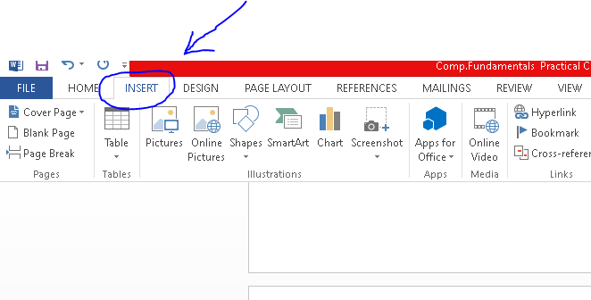

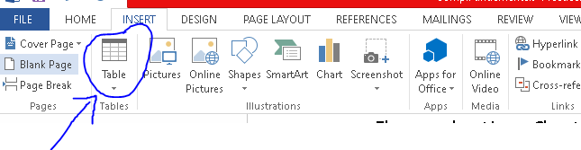
From Here You can select any of the following to create your table.
- INSERT TABLE
- DRAW TABLE
- EXCEL SPREADSHEET
- QUICK TABLES

A SAMPLE FROM INSERT TABLE OPTION

S/N | NAME | SIZE | QUANTITY | PRICE | COLOUR | LOCATION
1.
2
3
4
5

A SAMPLE FROM QUICK TABLE OPTIONS

S/N | NAME | SIZE | PRICE (#) | COLOUR | QUANTITY
1. | LADIES GOWNS | 38 | 15,000 | Lilac | 14
2. | SHOES | 39 | 10,000 | Black | 9
3. | BAGS | BIG | 60,000 | Red | 10
4. | JEWELRIES | 20 | 20,000 | Gold | 5

