

DunisTech Academy

https://dunistech.ng

Computer Fundamentals Lesson 6

**To use templates, go to File, then click on New. From where you will see a variety of templates to choose from whether resumes, Letterheads, Invoice and the likes.**

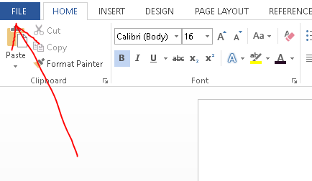

**Then,**

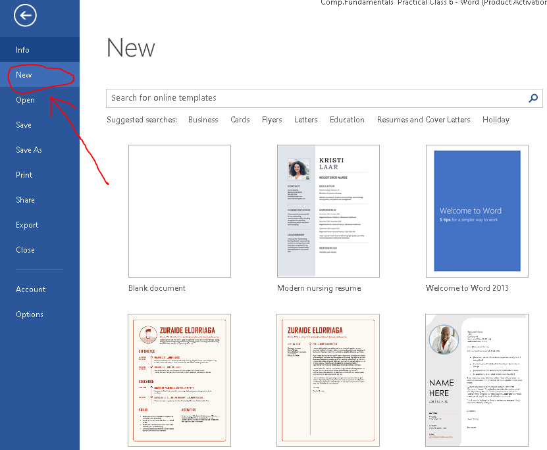

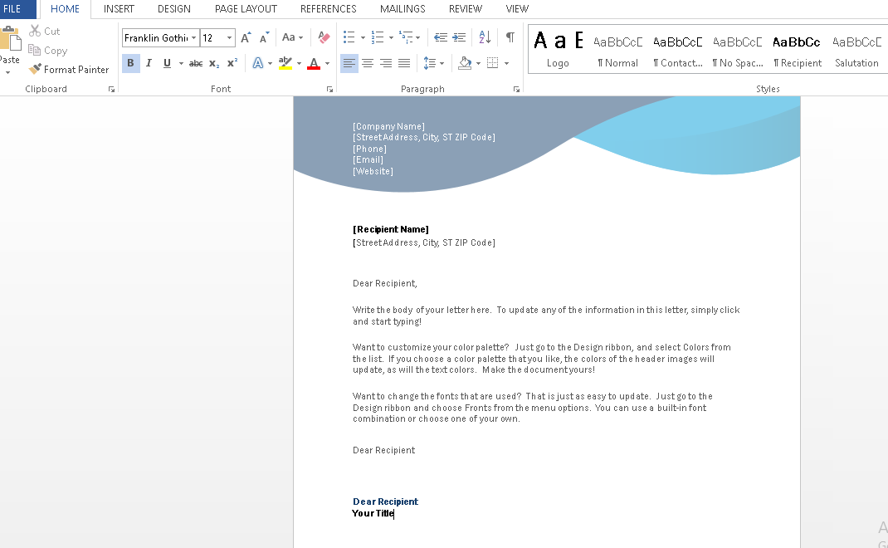

E.g A sample of A Letterhead

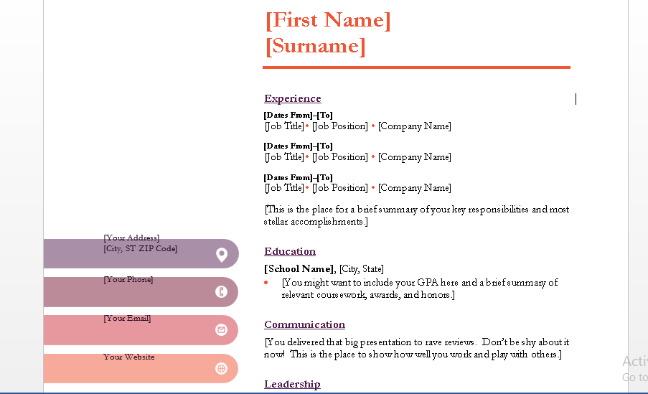

E.g 2. A sample of a Resume.

|  |
| --- |
| **MICROSOFT WORD – USE OF TABLES** |

**The second part in our Class today is the use of tables. There are different ways to create tables.**

**TO CREATE TABLES, GO TO INSERT TAB. THEN CLICK ON TABLE AND THEN CLICK ON THE FLYOUT TO ACCESS THEM.**

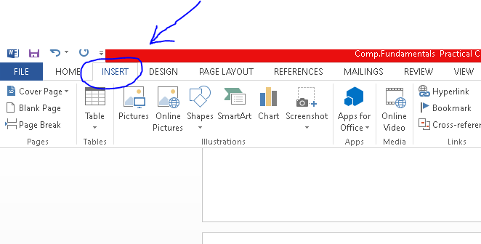

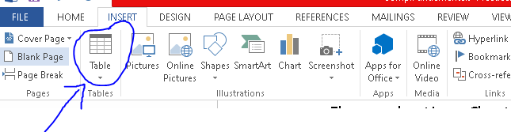

**From Here You can select any of the following to create your table.**

1. INSERT TABLE
2. DRAW TABLE
3. EXCEL SPREADSHEET
4. QUICK TABLES

**A SAMPLE FROM INSERT TABLE OPTION**

|  |  |  |  |  |  |  |
| --- | --- | --- | --- | --- | --- | --- |
| S/N | NAME | SIZE | QUANTITY | PRICE | COLOUR | LOCATION |
| 1. |  |  |  |  |  |  |
| 2 |  |  |  |  |  |  |
| 3 |  |  |  |  |  |  |
| 4 |  |  |  |  |  |  |
| 5 |  |  |  |  |  |  |

**A SAMPLE FROM QUICK TABLE OPTIONS**

|  |  |  |  |  |  |
| --- | --- | --- | --- | --- | --- |
| **S/N** | **NAME** | **SIZE** | **PRICE (#)** | **COLOUR** | **QUANTITY** |
| **1.** | **LADIES GOWNS** | **38** | **15,000** | **Lilac** | **14** |
| **2.** | **SHOES** | **39** | **10,000** | **Black** | **9** |
| **3.** | **BAGS** | **BIG** | **60,000** | **Red** | **10** |
| **4.** | **JEWELRIES** | **20** | **20,000** | **Gold** | **5** |