**VLSM**

With Public IP address : 215.147.22.15

Number of networks = 25

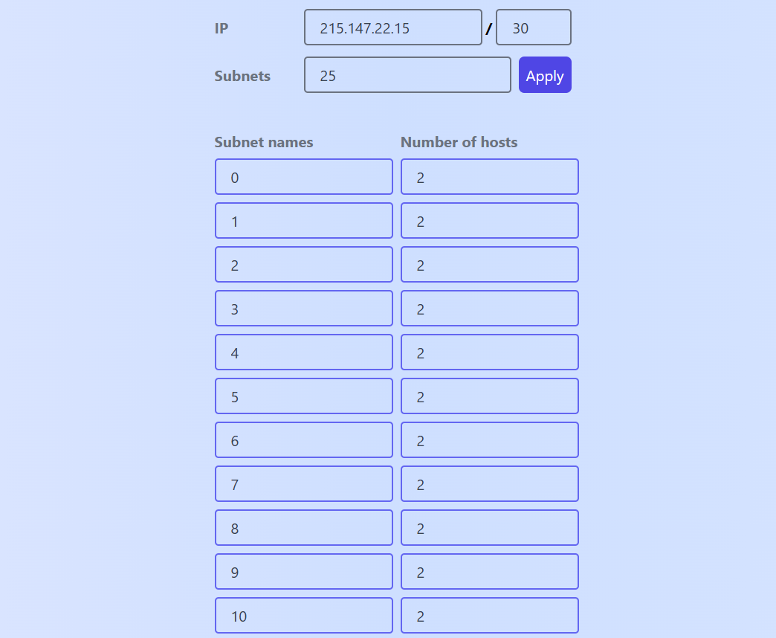

Subnet names: filled from 0 to 24, number of hosts: all 2

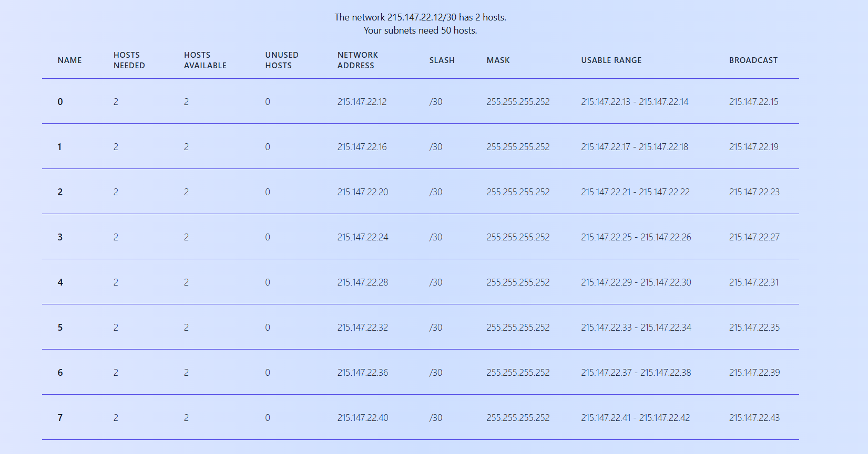

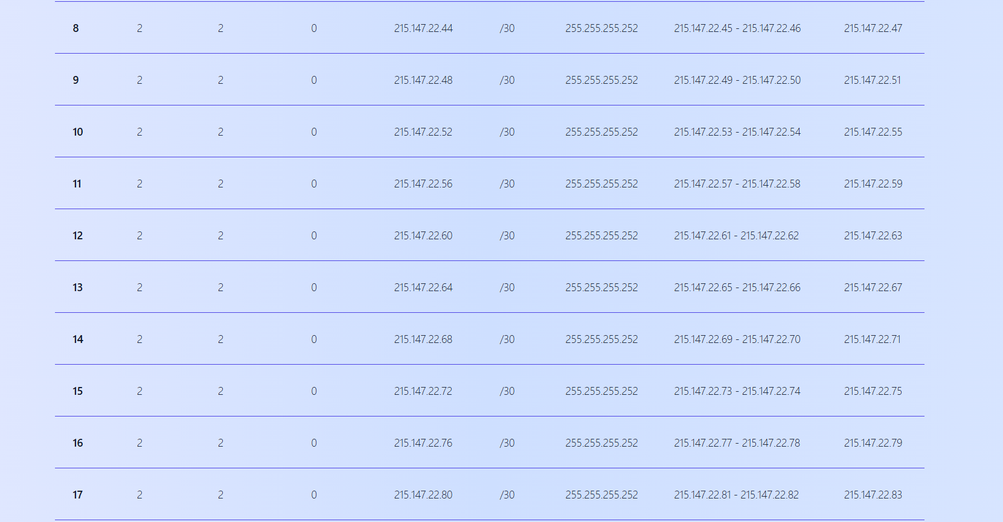

With Private IP address: 192.168.1.60

Number of networks = 11 (A-K)

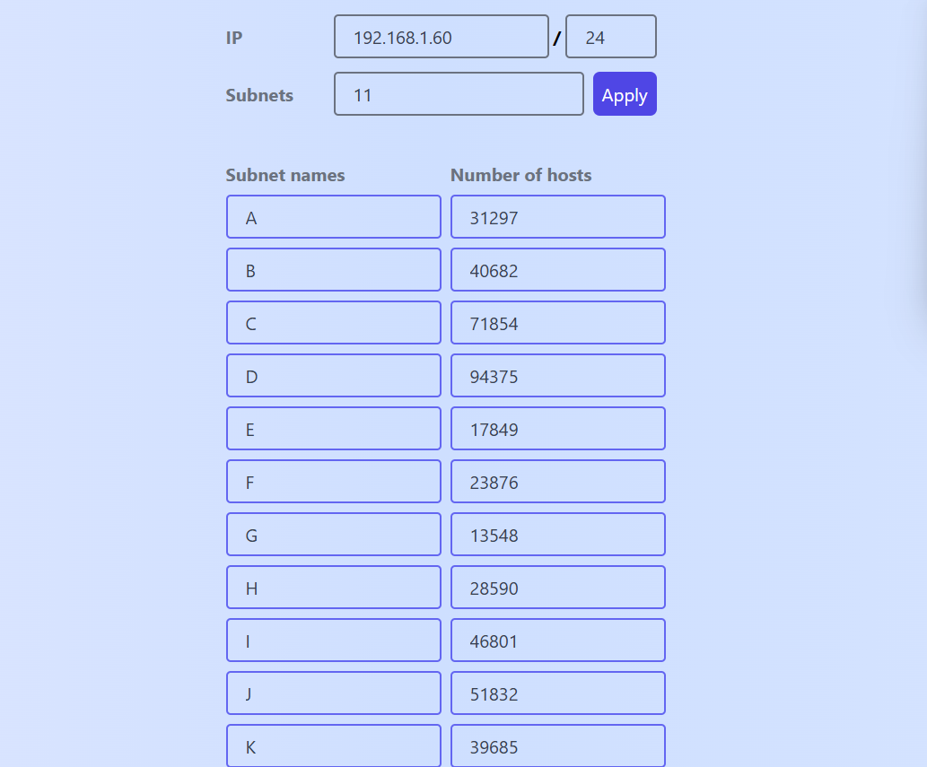

Subnet Names: A-K, number of hosts: as per defined in the excel provided

