**LAB 09**

**Zirwah Khalil i220748**

**CNet A**

**Lab Work 01**

Server

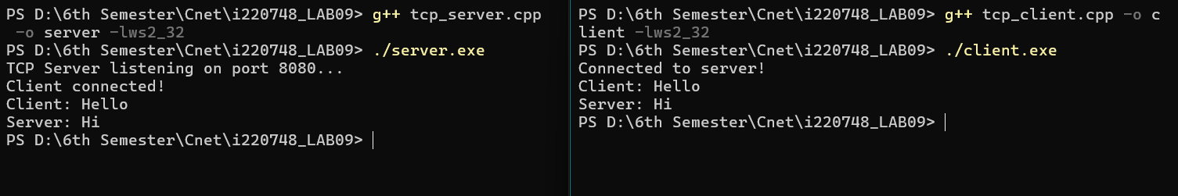

Client



**Lab Work 02**

Server

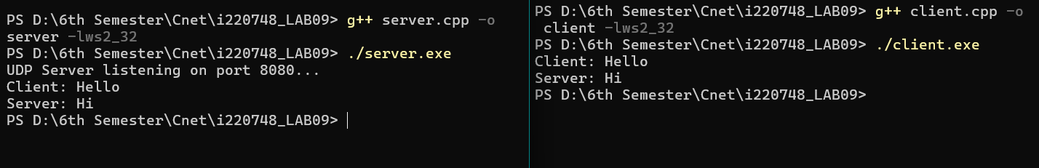

Client

**Lab Task 01**

Server

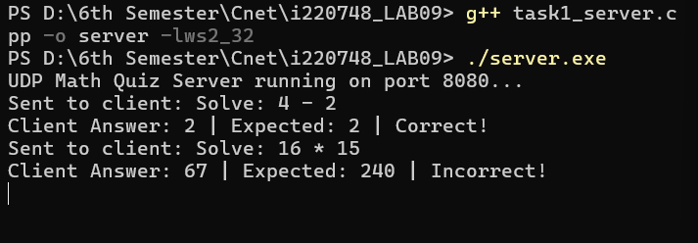

Client 1

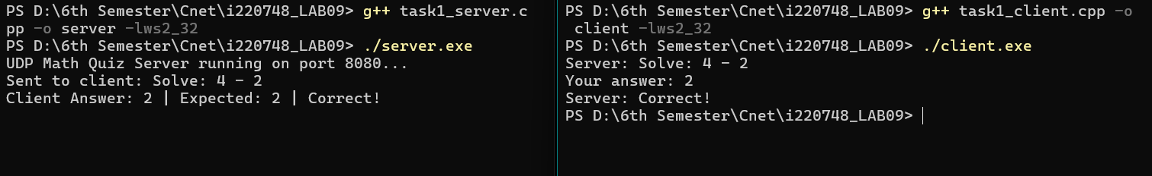

Client 2

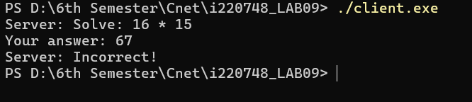

**Lab Task 02**

Server

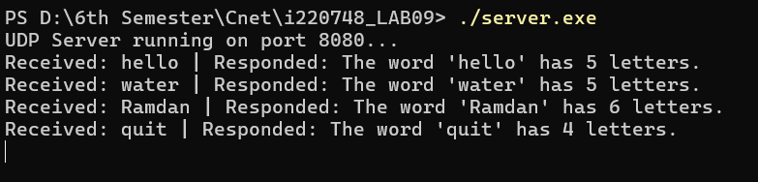

Client 1

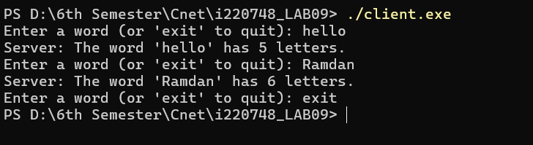

Client 2

