**LAB 10**

**Zirwah Khalil i220748**

**C-Net A**

**Lab Work 01**

Server

Client

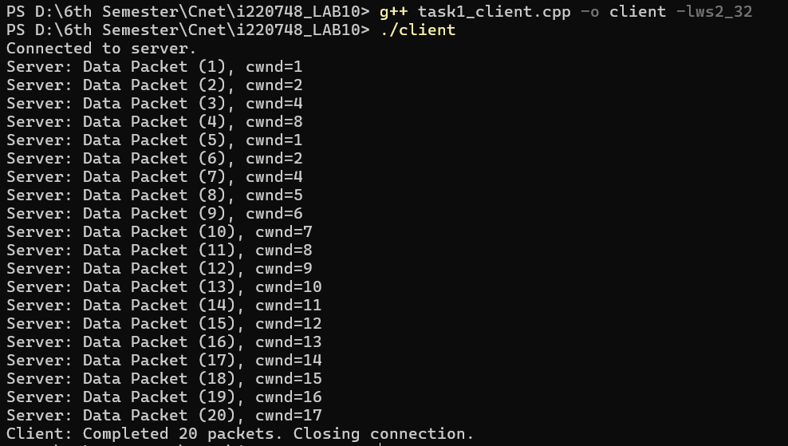

**Lab Work 02**

Server

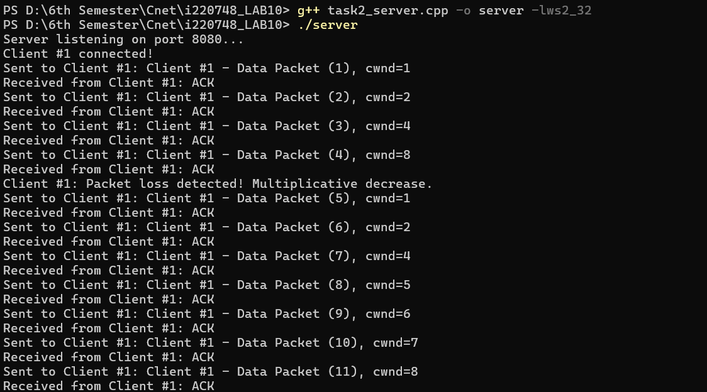

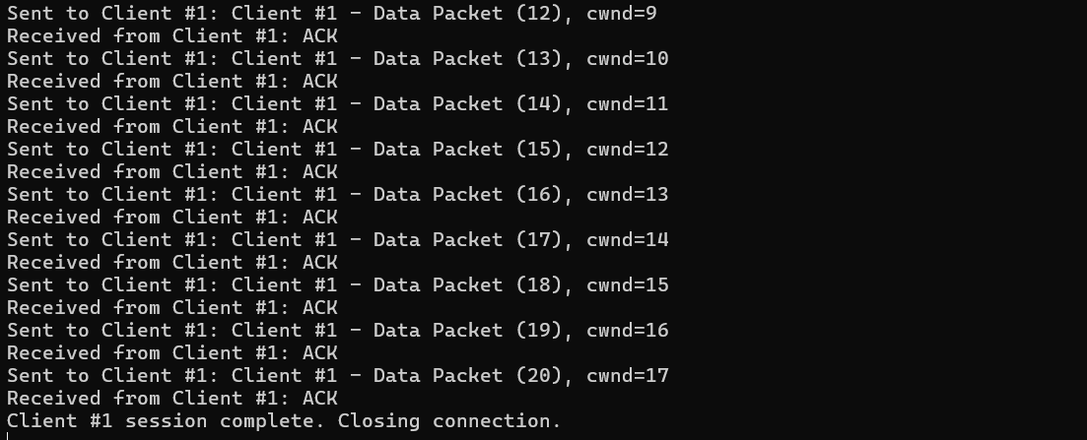

Client

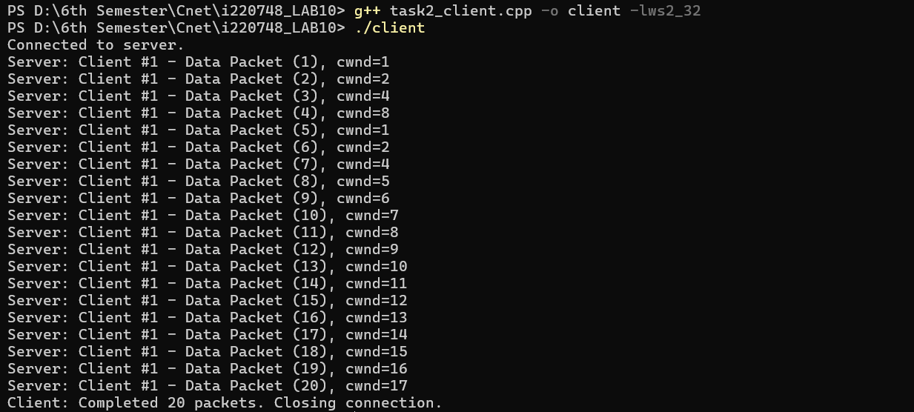

**Lab Task 01**

Server

Client

