**LAB 12**

**Zirwah Khalil i220748**

**C-Net A**

**Lab Work 01**  
**Topology**

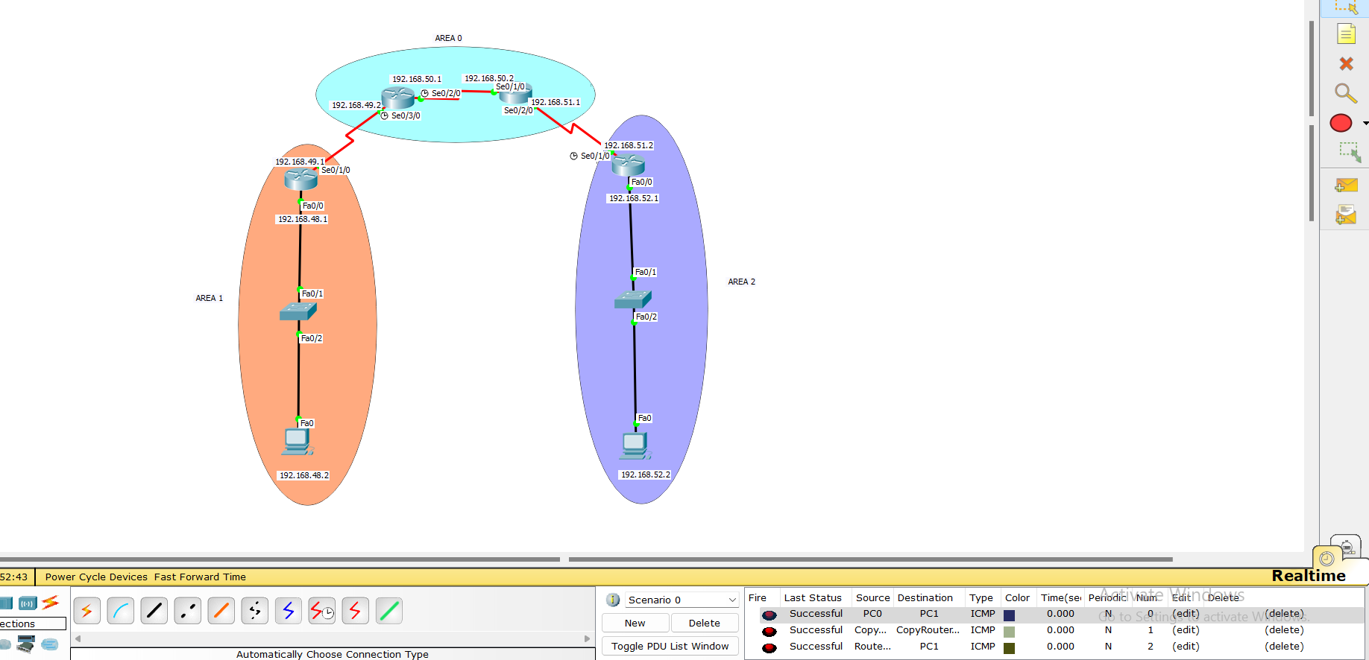

Router 1

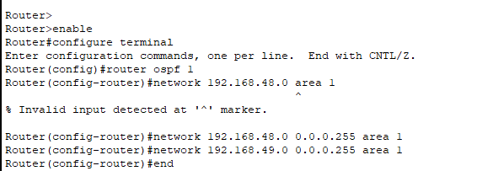

Router 2

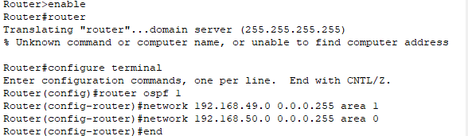

Router 3

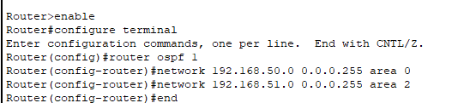

Router 4

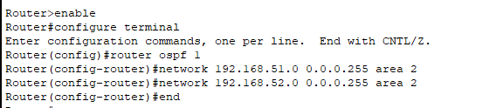

**Lab work 2**

**Topology**

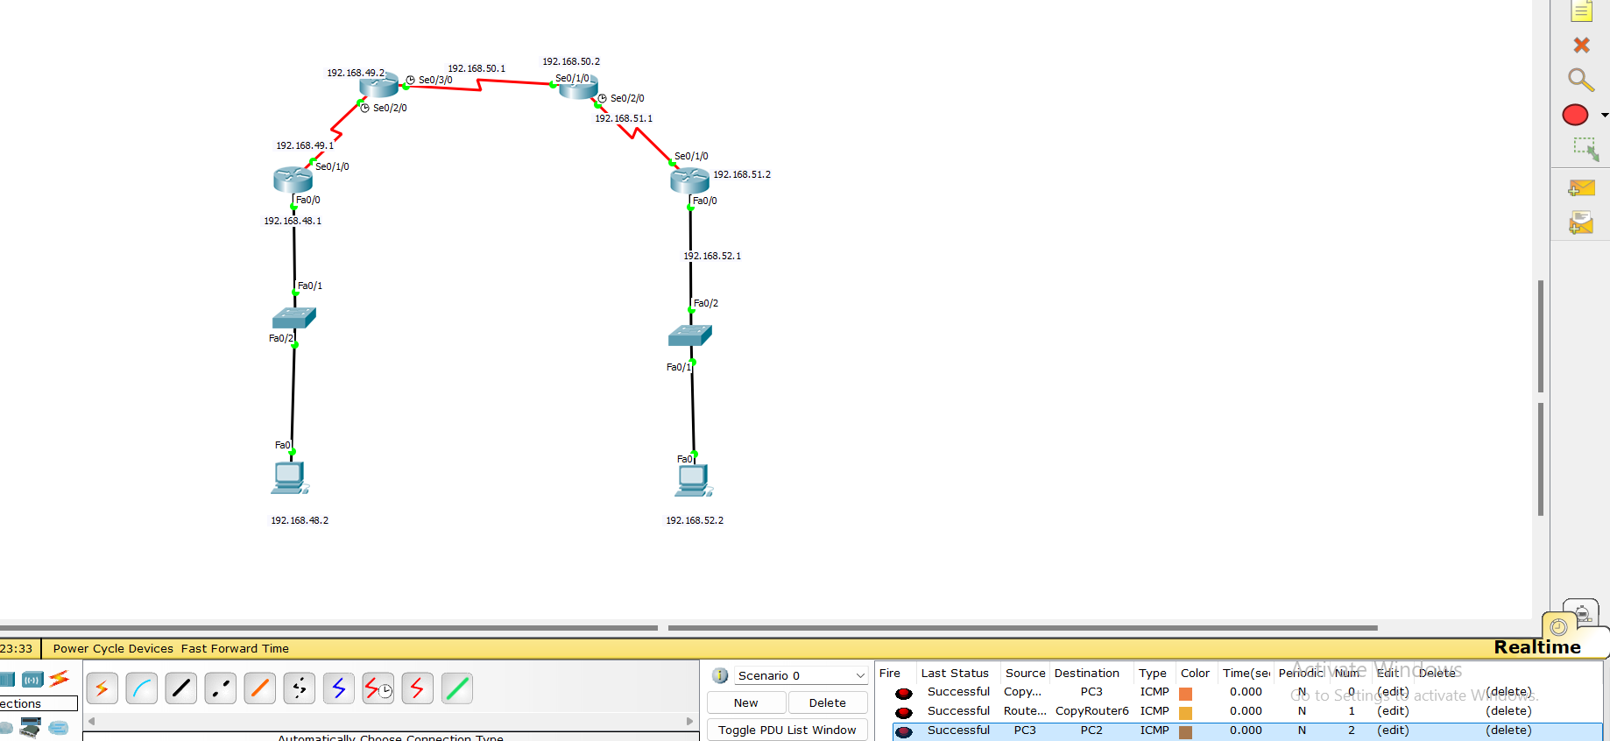

Router 1

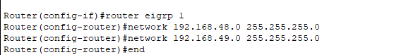

Router 2



Router 3

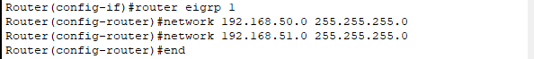

Router 4



**Lab task 1**

Topology

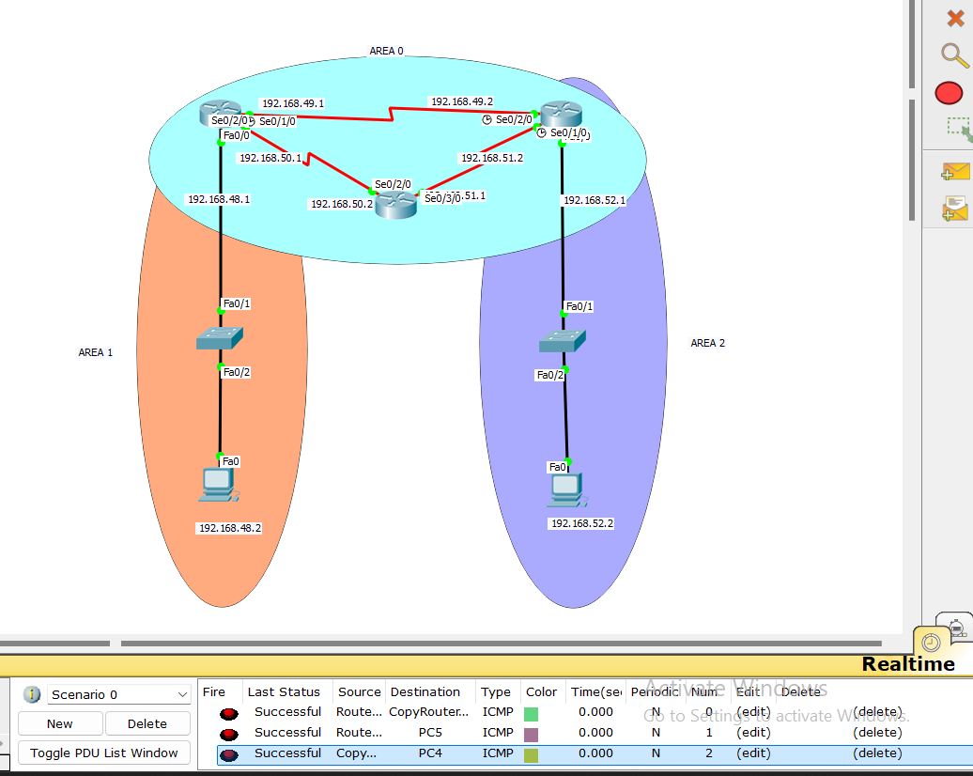

**Lab task 2**

Topology

