**LAB 15**

**Zirwah Khalil i220748**

**C-Net A**

**VLAN**

**

**Switch 1**

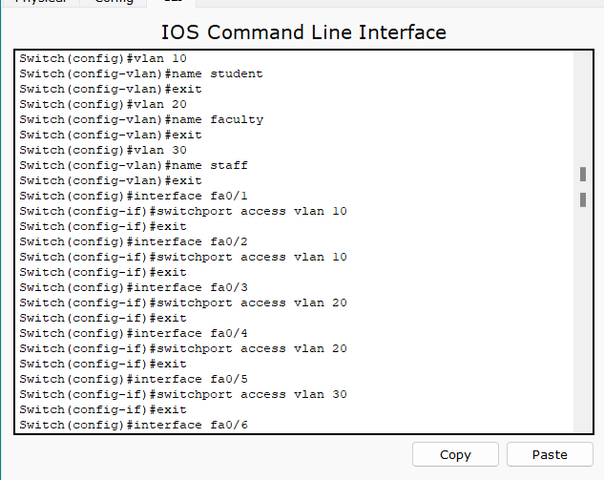

**Switch 2**

**After attaching Router**

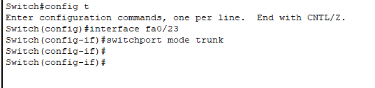

**ACL**

