Software Requirements Specification

for

Lost and Found System
Version 1.0 approved
Prepared by Kelompok 6
Bina Nusantara University
24 February 2026
Table of Contents
Table of Contents ii
Revision History ii
1. Introduction 1
1.1 Purpose 1
1.2 Document Conventions 1
1.3 Intended Audience and Reading Suggestions 1
1.4 Product Scope 1
1.5 References 1
2. Overall Description 2
2.1 Product Perspective 2
2.2 Product Functions 2
2.3 User Classes and Characteristics 2
2.4 Operating Environment 2
2.5 Design and Implementation Constraints 2
2.6 User Documentation 2
2.7 Assumptions and Dependencies 3
3. External Interface Requirements 3
3.1 User Interfaces 3
3.2 Hardware Interfaces 3
3.3 Software Interfaces 3
3.4 Communications Interfaces 3
4. System Features 4
4.1 System Feature 1 4
4.2 System Feature 2 (and so on) 4
5. Other Nonfunctional Requirements 4
5.1 Performance Requirements 4
5.2 Safety Requirements 5
5.3 Security Requirements 5
5.4 Software Quality Attributes 5
5.5 Business Rules 5
6. Other Requirements 5
Appendix A: Glossary 5
Appendix B: Analysis Models 5
Appendix C: To Be Determined List 6

Revision History
Name | Date | Reason For Changes | Version
Kelompok 6 | 24/02/2026 | Introduction

Introduction

Purpose
Dokumen ini menjelaskan kebutuhan perangkat lunak untuk sistem Lost and Found Center, yaitu sebuah platform berbasis web dan/atau mobile yang dirancang untuk mengelola barang hilang dan barang temuan secara terstruktur dan efisien.
Tujuan penyusunan dokumen ini adalah untuk mendefinisikan kebutuhan fungsional dan non-fungsional sistem secara jelas serta menjadi acuan bagi tim pengembang, manajer proyek, penguji, dan pemangku kepentingan selama proses perancangan dan pengembangan sistem.
Lost and Found Center System dikembangkan untuk menggantikan metode manual seperti papan pengumuman fisik atau pengecekan langsung ke lokasi Lost & Found yang kurang efektif dan tidak terdokumentasi dengan baik. Sistem ini menyediakan fitur pelaporan barang (Post Item), pencarian dan penyaringan berdasarkan kategori (Search & Filter), serta mekanisme verifikasi klaim (Claim System) guna memastikan barang dikembalikan kepada pemilik yang sah.
Dokumen SRS ini bertujuan memastikan seluruh pihak memiliki pemahaman yang sama mengenai ruang lingkup, tujuan, dan batasan sistem sebelum proses implementasi dimulai.

Document Conventions
Dokumen ini disusun mengikuti struktur standar Software Requirements Specification (SRS). Setiap kebutuhan fungsional diberi kode unik dengan format REQ-XX dan diklasifikasikan berdasarkan tingkat prioritas: High (Tinggi), Medium (Sedang), dan Low (Rendah). Istilah TBD (To Be Determined) digunakan untuk menandai kebutuhan yang masih memerlukan klarifikasi lebih lanjut. Penomoran menggunakan format hierarkis seperti 1.1, 2.3, dan 4.1.2.

Intended Audience and Reading Suggestions
Dokumen ini ditujukan untuk tim pengembang (Development Team), manajer proyek (Project Manager), penguji (tester), serta pemangku (Stakeholders) kepentingan yang terlibat dalam perancangan dan pengembangan sistem Lost and Found Center.
Tim pengembang disarankan membaca seluruh dokumen dengan fokus pada bagian Overall Description, External Interface Requirements, System Features, dan Nonfunctional Requirements sebagai acuan implementasi teknis.
Manajer proyek dan pemangku kepentingan disarankan memprioritaskan bagian Introduction dan Overall Description untuk memahami tujuan, ruang lingkup, serta batasan sistem.
Sementara itu, tim penguji dapat menggunakan bagian System Features dan Nonfunctional Requirements sebagai dasar dalam menyusun skenario pengujian dan validasi sistem.
Dokumen sebaiknya dibaca secara berurutan mulai dari bagian Introduction hingga bagian akhir untuk memperoleh pemahaman menyeluruh mengenai sistem yang akan dikembangkan.

Product Scope
Lost and Found Center adalah platform digital yang dirancang untuk mengelola proses pelaporan, pencarian, dan pengembalian barang hilang dalam suatu lingkungan komunitas, khususnya lingkungan kampus.
Sistem ini menyediakan mekanisme terstruktur untuk memastikan proses pengelolaan barang hilang menjadi lebih cepat, aman, dan terdokumentasi dengan baik.
Fitur Utama Sistem

Fitur | Deskripsi
Autentikasi Pengguna | Pengguna dapat melakukan registrasi dan login untuk mengakses fitur sistem secara aman.
Post Item | Pengguna dapat mengunggah foto barang, deskripsi, kategori, dan lokasi terakhir barang ditemukan atau hilang.
Search & Filter | Pengguna dapat mencari barang berdasarkan kata kunci dan menyaring berdasarkan kategori seperti Elektronik, Dokumen, dan Kunci.
Claim System | Pengguna harus melalui proses verifikasi tanya jawab sebelum klaim barang disetujui.
Riwayat Aktivitas | Pengguna dapat melihat riwayat laporan dan klaim yang pernah dilakukan.
Manajemen Admin | Admin dapat memverifikasi klaim, mengubah status barang, dan mengelola data laporan.

Tujuan Sistem
- Menggantikan papan pengumuman fisik dengan sistem digital terpusat.
- Mengurangi risiko kehilangan barang secara permanen.
- Meningkatkan keamanan melalui sistem verifikasi klaim.
- Menyediakan database barang hilang dan temuan yang dapat diakses secara daring.
Sistem ini mendukung transformasi digital dalam pengelolaan layanan kampus dengan meningkatkan efisiensi, transparansi, dan kemudahan akses informasi.

References
https://bantucari.id/

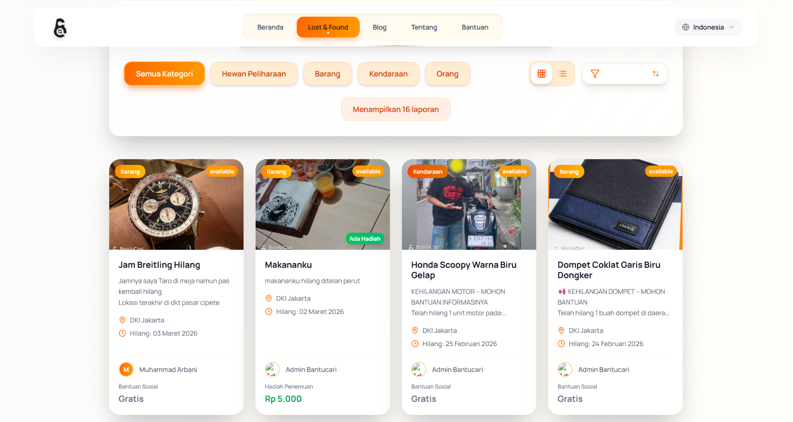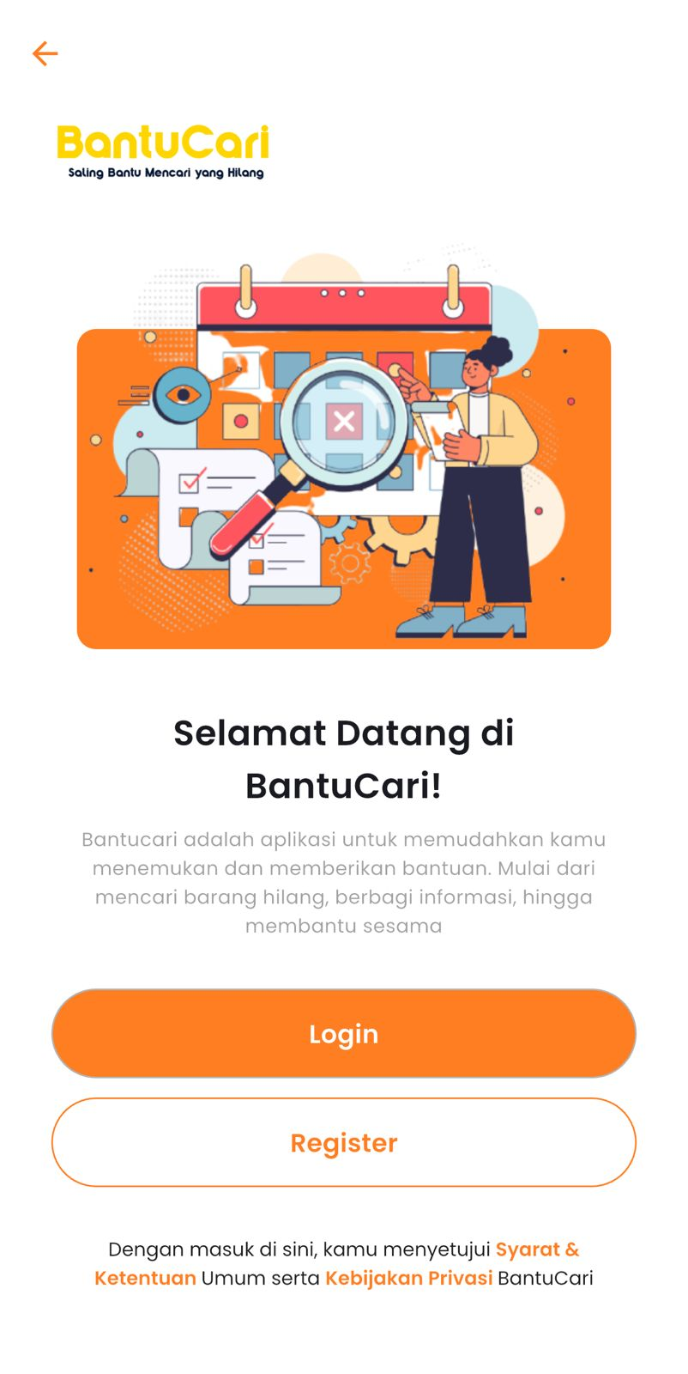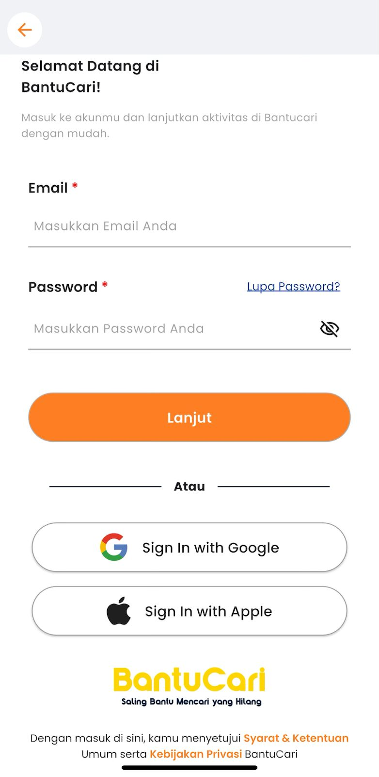
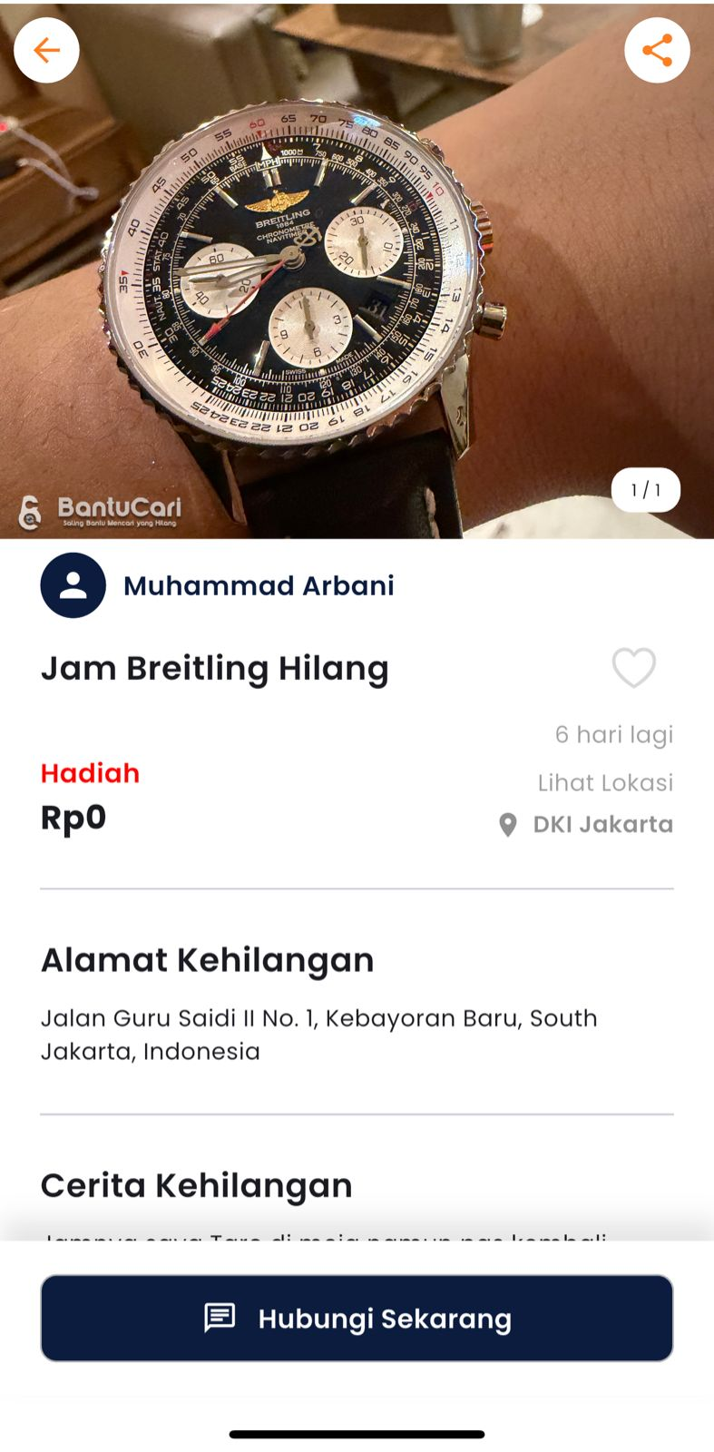

Overall Description

Product Perspective
<Describe the context and origin of the product being specified in this SRS. For example, state whether this product is a follow-on member of a product family, a replacement for certain existing systems, or a new, self-contained product. If the SRS defines a component of a larger system, relate the requirements of the larger system to the functionality of this software and identify interfaces between the two. A simple diagram that shows the major components of the overall system, subsystem interconnections, and external interfaces can be helpful.>

Product Functions
Functional Requirement:
1. Sistem harus memungkinkan pengguna untuk melakukan registrasi akun.
2. Sistem harus memungkinkan pengguna untuk melakukan login.
3. Sistem harus memungkinkan pengguna untuk melihat daftar barang (browse items).
4. Sistem harus memungkinkan pengguna untuk melihat detail barang.
5. Sistem harus memungkinkan pengguna untuk melaporkan barang yang ditemukan.
6. Sistem harus memungkinkan pengguna untuk mengajukan klaim barang.
7. Sistem harus memungkinkan pengguna untuk melihat status klaim.
8. Sistem harus memungkinkan admin untuk menyetujui klaim.
9. Sistem harus memungkinkan admin untuk menolak klaim.
10. Sistem harus memungkinkan admin untuk menandai barang sebagai selesai.
Non-Functional Requirement:
11. Sistem harus memberikan respon dalam waktu maksimal 3 detik.
12. Sistem harus memiliki keamanan login yang baik dan menyimpan password dalam bentuk terenkripsi.
13. Sistem harus memiliki tampilan yang mudah digunakan (user-friendly).
14. Sistem harus dapat berjalan dengan stabil dan minim error.
15. Sistem harus dapat diakses melalui browser di perangkat desktop maupun mobile.

User Classes and Characteristics
<Identify the various user classes that you anticipate will use this product. User classes may be differentiated based on frequency of use, subset of product functions used, technical expertise, security or privilege levels, educational level, or experience. Describe the pertinent characteristics of each user class. Certain requirements may pertain only to certain user classes. Distinguish the most important user classes for this product from those who are less important to satisfy.>

Operating Environment
<Describe the environment in which the software will operate, including the hardware platform, operating system and versions, and any other software components or applications with which it must peacefully coexist.>

Design and Implementation Constraints
<Describe any items or issues that will limit the options available to the developers. These might include: corporate or regulatory policies; hardware limitations (timing requirements, memory requirements); interfaces to other applications; specific technologies, tools, and databases to be used; parallel operations; language requirements; communications protocols; security considerations; design conventions or programming standards (for example, if the customer’s organization will be responsible for maintaining the delivered software).>

User Documentation
Berikut adalah UML diagram dari sistem:

Usecase Diagram:
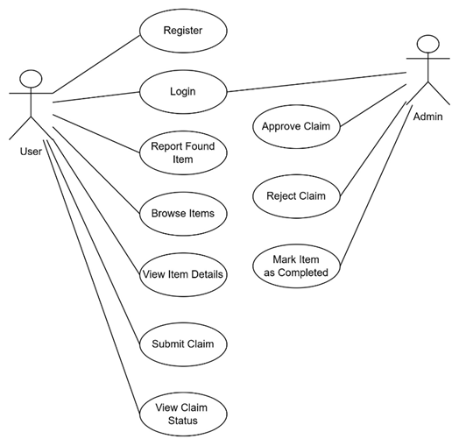
Activity Diagram:
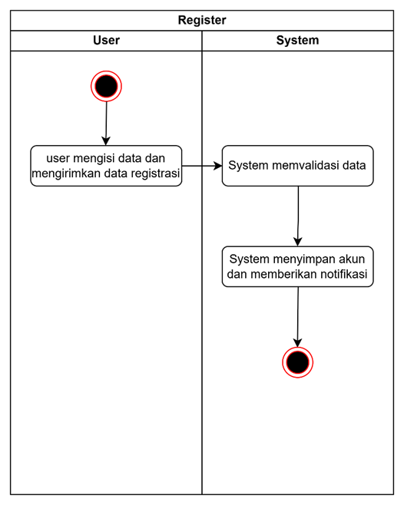
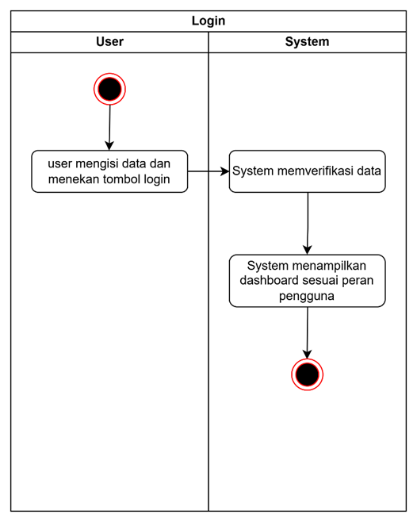
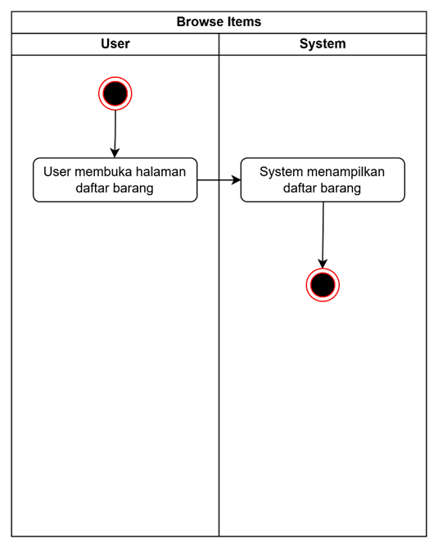
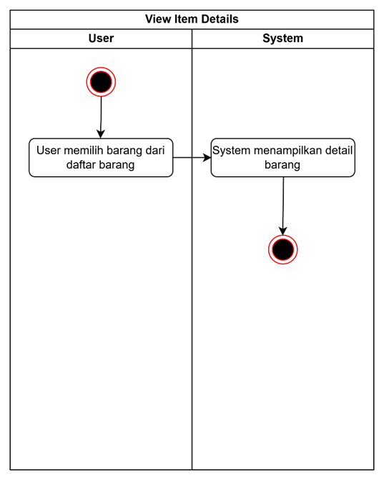
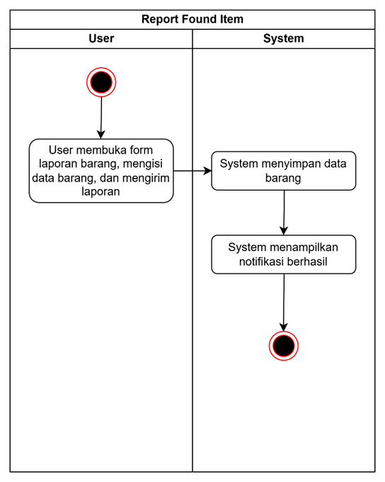
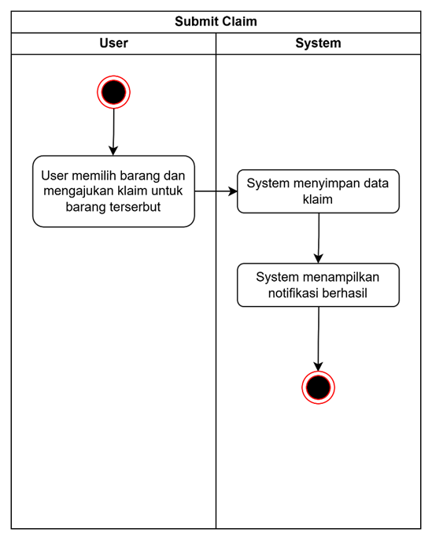
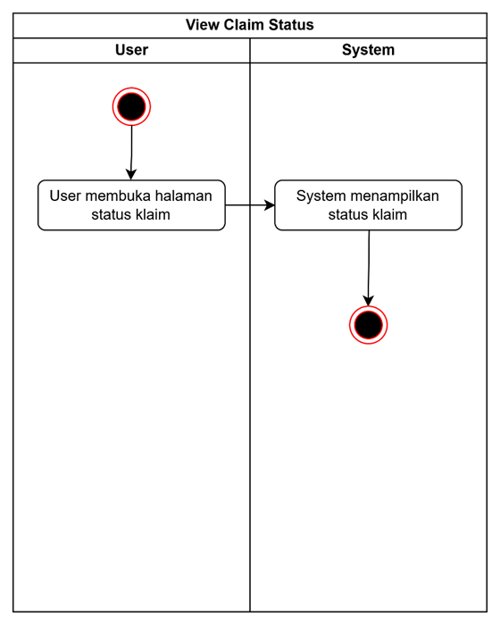
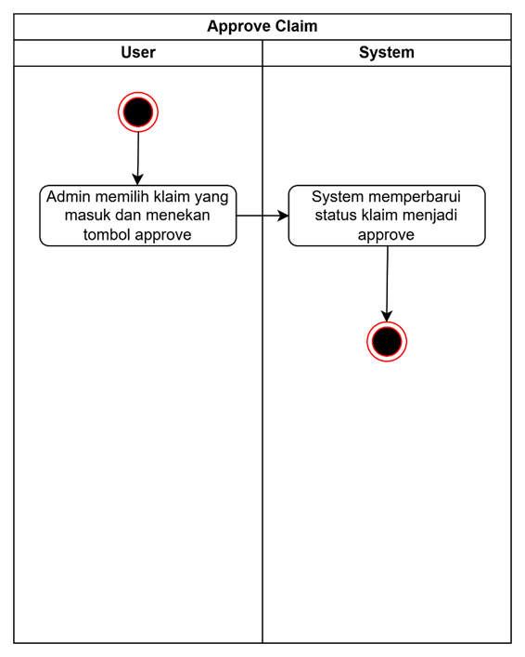
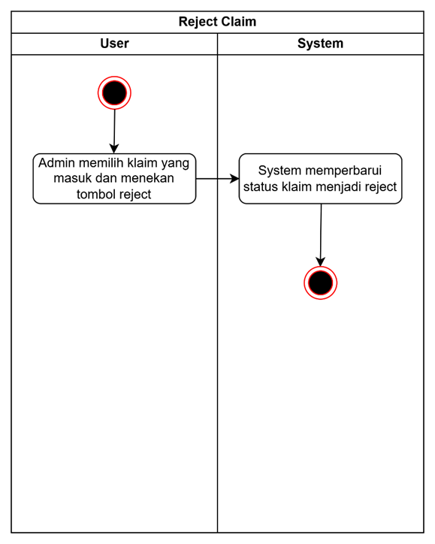
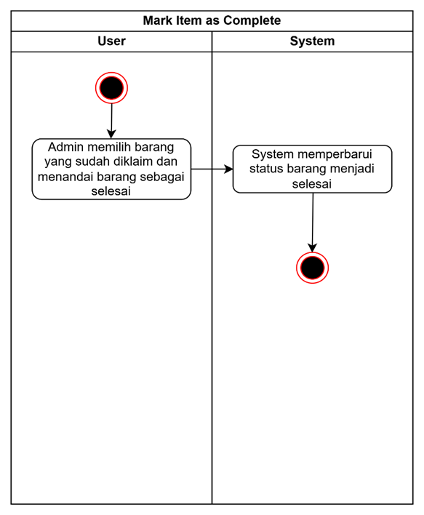
Sequence Diagram:
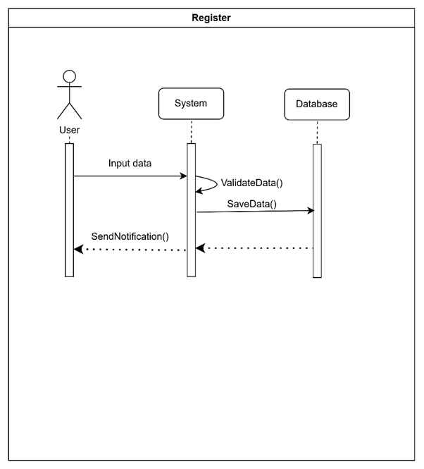
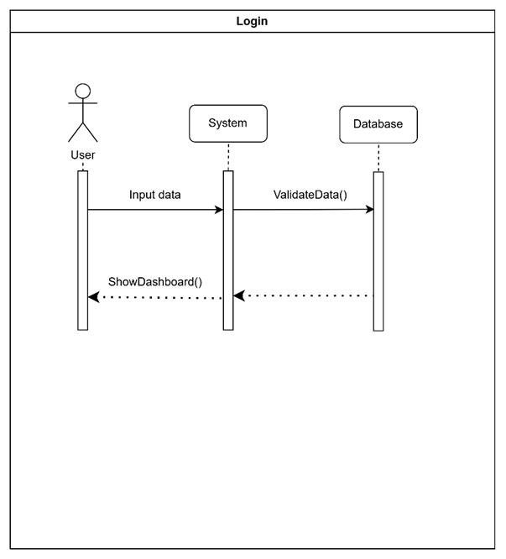
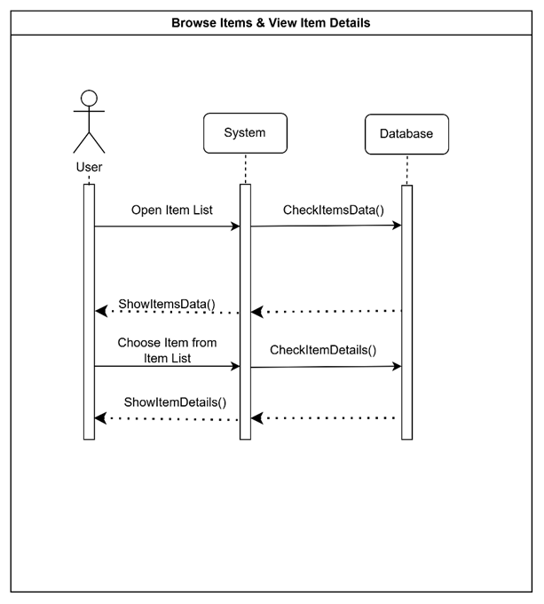
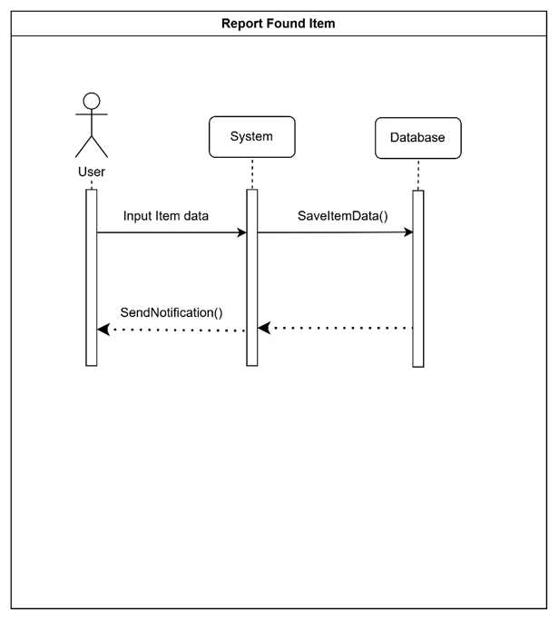
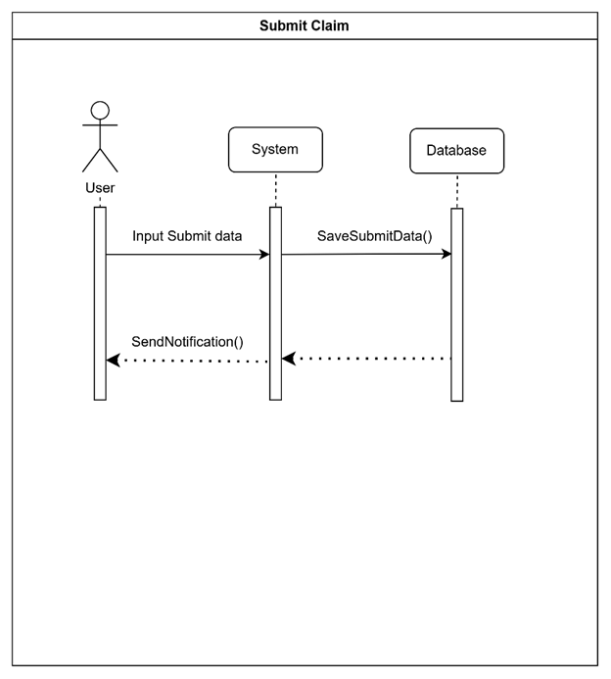
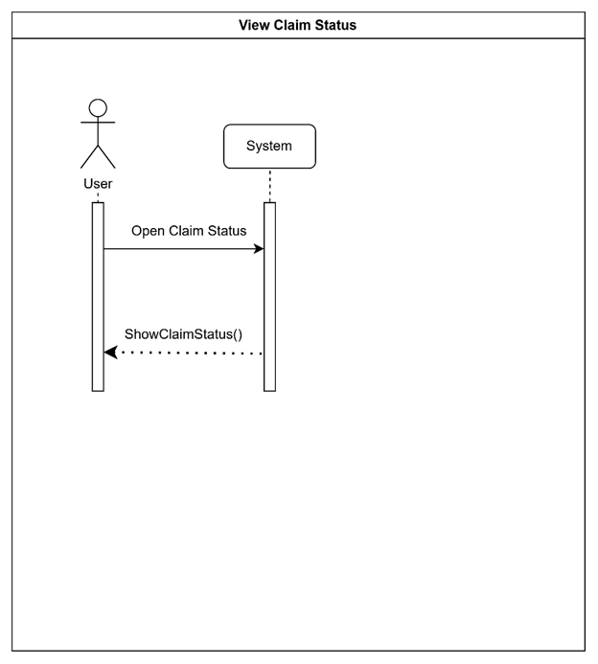
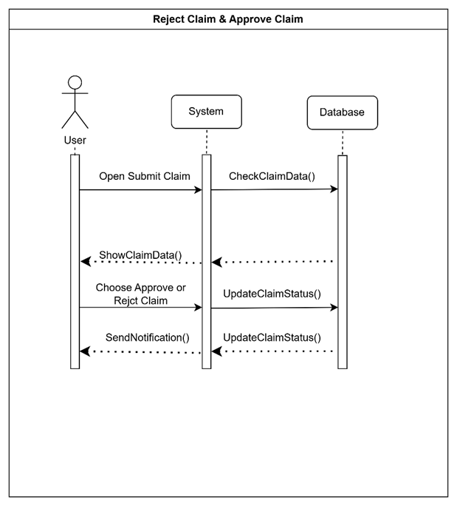
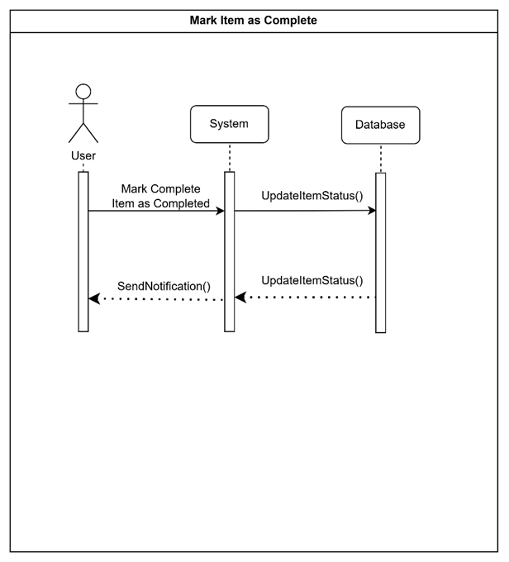

Class Diagram:
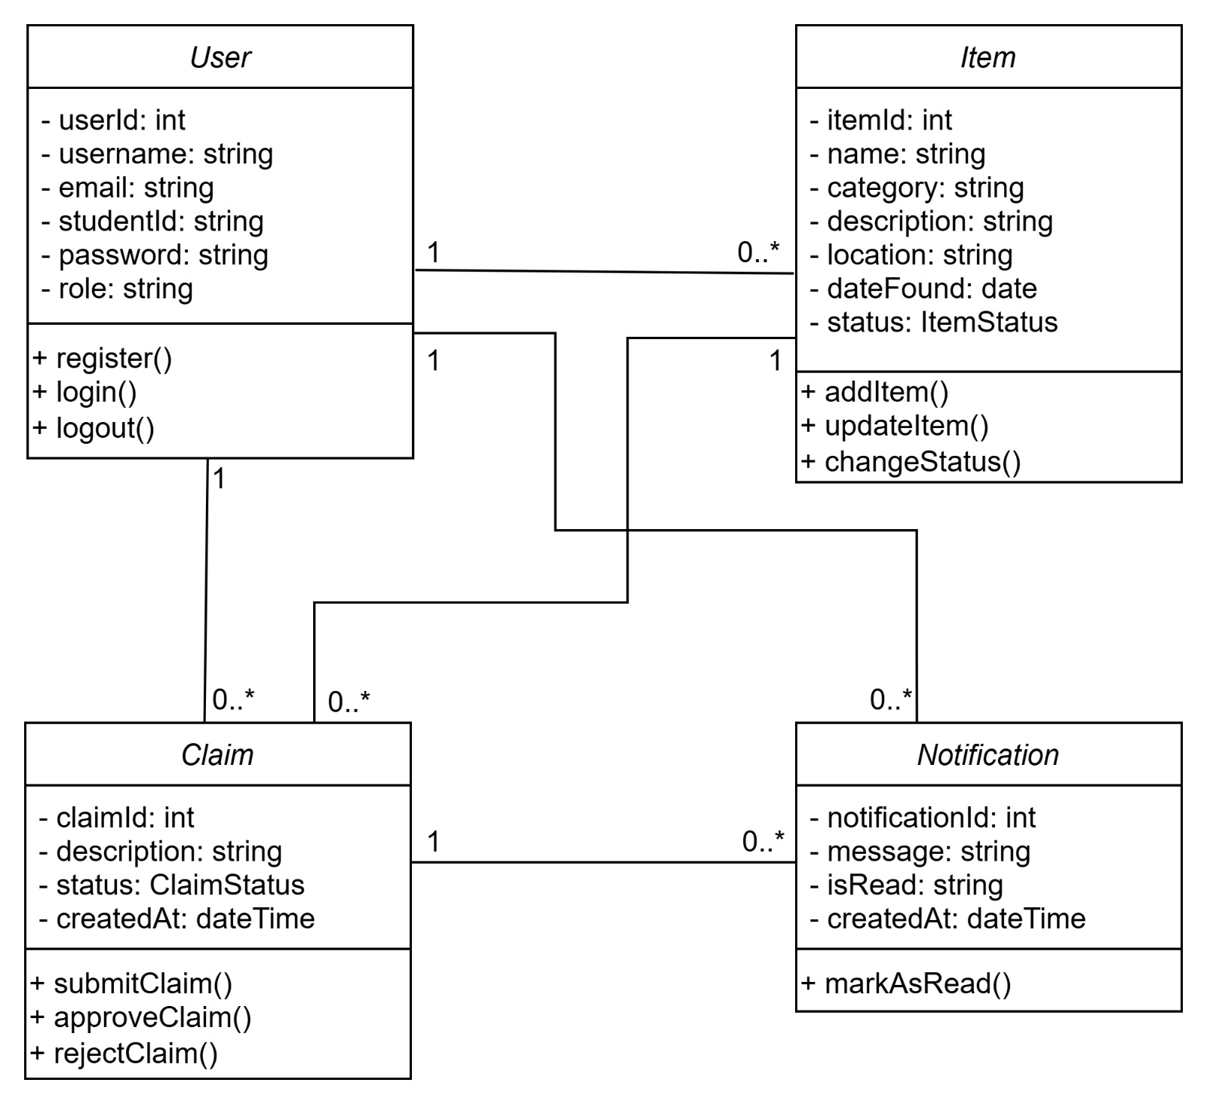

Assumptions and Dependencies
<List any assumed factors (as opposed to known facts) that could affect the requirements stated in the SRS. These could include third-party or commercial components that you plan to use, issues around the development or operating environment, or constraints. The project could be affected if these assumptions are incorrect, are not shared, or change. Also identify any dependencies the project has on external factors, such as software components that you intend to reuse from another project, unless they are already documented elsewhere (for example, in the vision and scope document or the project plan).>

External Interface Requirements

User Interfaces
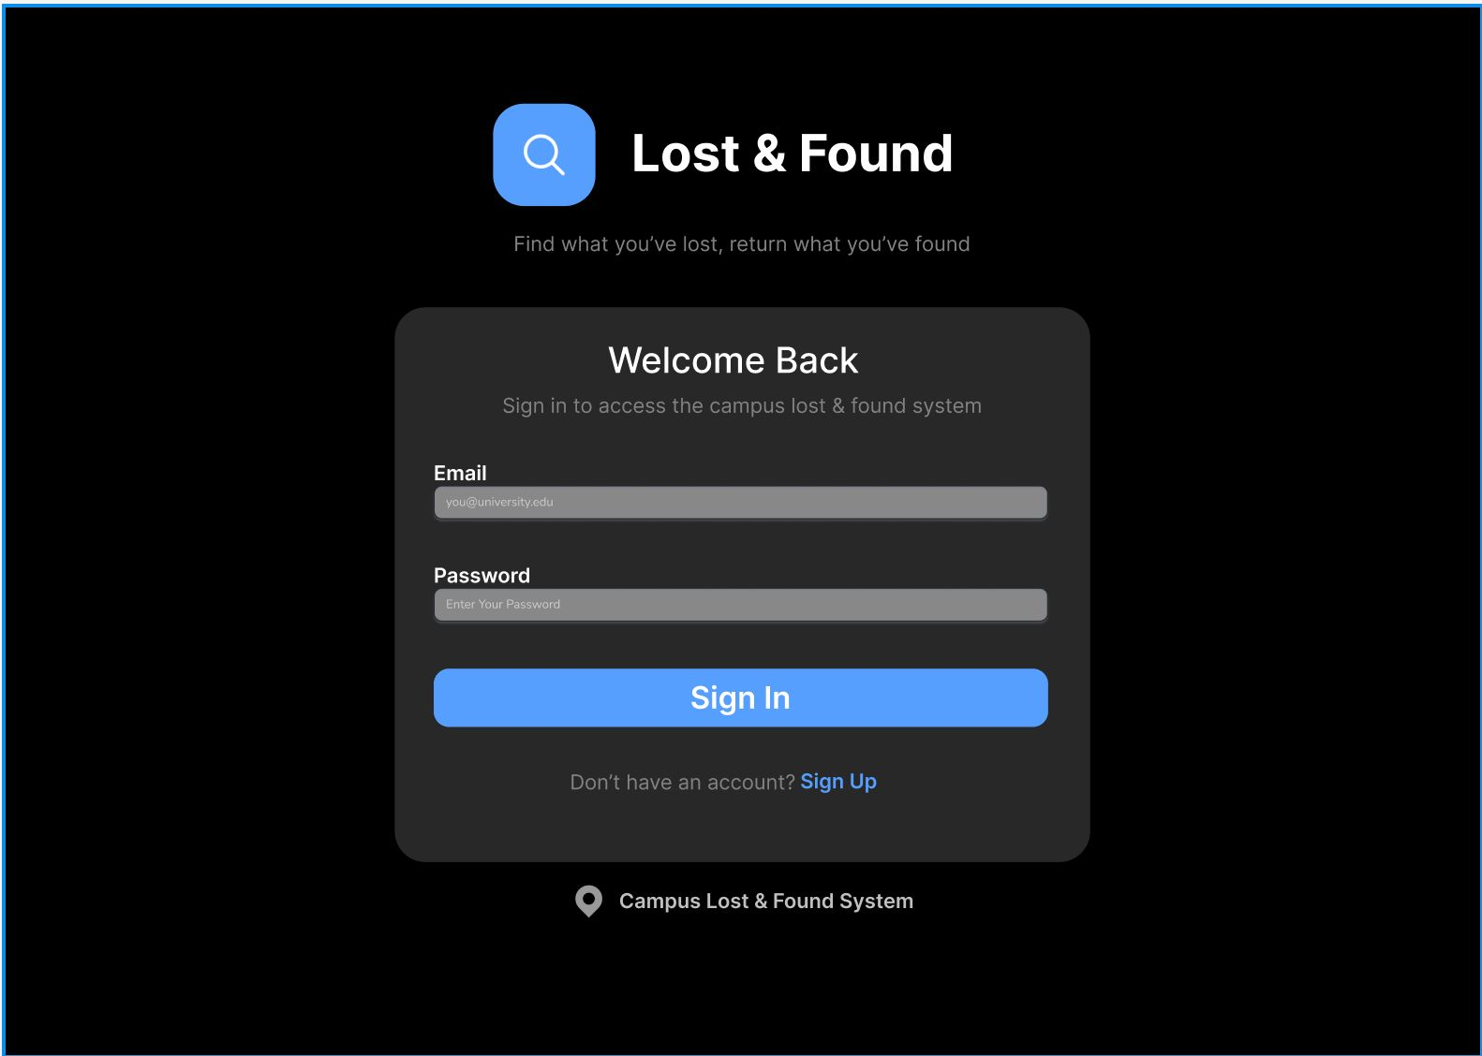
Ini adalah halaman untuk login. User akan menginput email dengan format “you@university.edu” dan password yang sudah didaftarkan sebelumnya. Setelah login berhasil, user akan dipindahkan ke halaman dashboard. Apabila user belum memiliki akun, user akan dialihkan ke halaman create account.

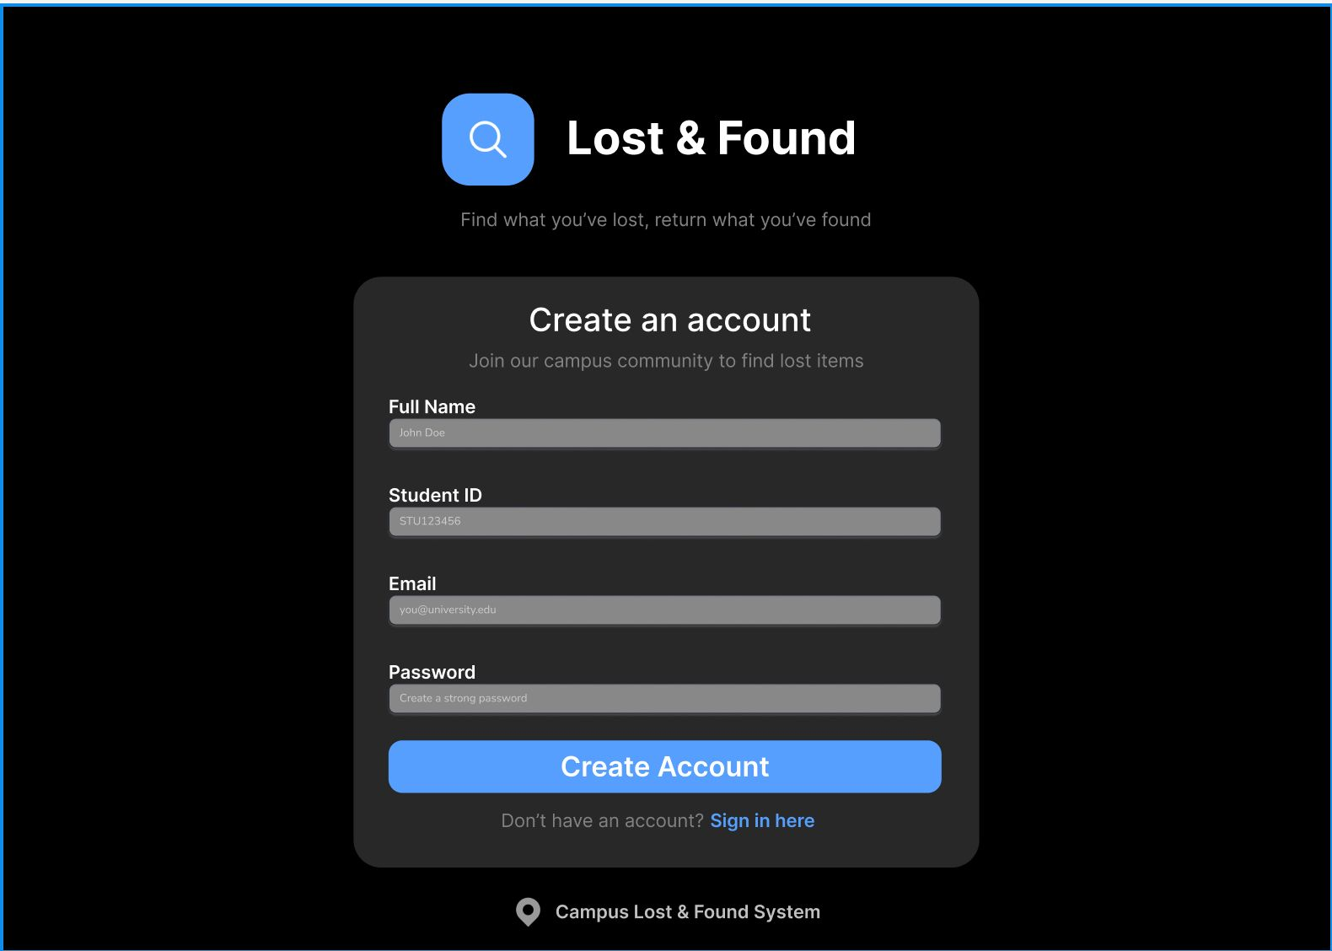
Ini adalah halaman “create account” dimana user akan diarahkan ke halaman ini apabila belum memiliki akun untuk login. User akan diminta untuk memasukkan beberapa data kedalamnya antara lain Full Name, Student ID, Email dan juga password untuk akunnya. Untuk Email harus dengan format “you@university.edu”. Apabila sudah user dapat membuat akun dengan tekan tombol “Create Account”

Hardware Interfaces
<Describe the logical and physical characteristics of each interface between the software product and the hardware components of the system. This may include the supported device types, the nature of the data and control interactions between the software and the hardware, and communication protocols to be used.>

Software Interfaces
<Describe the connections between this product and other specific software components (name and version), including databases, operating systems, tools, libraries, and integrated commercial components. Identify the data items or messages coming into the system and going out and describe the purpose of each. Describe the services needed and the nature of communications. Refer to documents that describe detailed application programming interface protocols. Identify data that will be shared across software components. If the data sharing mechanism must be implemented in a specific way (for example, use of a global data area in a multitasking operating system), specify this as an implementation constraint.>

Communications Interfaces
<Describe the requirements associated with any communications functions required by this product, including e-mail, web browser, network server communications protocols, electronic forms, and so on. Define any pertinent message formatting. Identify any communication standards that will be used, such as FTP or HTTP. Specify any communication security or encryption issues, data transfer rates, and synchronization mechanisms.>

System Features
<This template illustrates organizing the functional requirements for the product by system features, the major services provided by the product. You may prefer to organize this section by use case, mode of operation, user class, object class, functional hierarchy, or combinations of these, whatever makes the most logical sense for your product.>

System Feature 1
<Don’t really say “System Feature 1.” State the feature name in just a few words.>
4.1.1 Description and Priority
<Provide a short description of the feature and indicate whether it is of High, Medium, or Low priority. You could also include specific priority component ratings, such as benefit, penalty, cost, and risk (each rated on a relative scale from a low of 1 to a high of 9).>
4.1.2 Stimulus/Response Sequences
<List the sequences of user actions and system responses that stimulate the behavior defined for this feature. These will correspond to the dialog elements associated with use cases.>
4.1.3 Functional Requirements
<Itemize the detailed functional requirements associated with this feature. These are the software capabilities that must be present in order for the user to carry out the services provided by the feature, or to execute the use case. Include how the product should respond to anticipated error conditions or invalid inputs. Requirements should be concise, complete, unambiguous, verifiable, and necessary. Use “TBD” as a placeholder to indicate when necessary information is not yet available.>

<Each requirement should be uniquely identified with a sequence number or a meaningful tag of some kind.>

REQ-1:
REQ-2:

System Feature 2 (and so on)

Other Nonfunctional Requirements

Performance Requirements
<If there are performance requirements for the product under various circumstances, state them here and explain their rationale, to help the developers understand the intent and make suitable design choices. Specify the timing relationships for real time systems. Make such requirements as specific as possible. You may need to state performance requirements for individual functional requirements or features.>

Safety Requirements
<Specify those requirements that are concerned with possible loss, damage, or harm that could result from the use of the product. Define any safeguards or actions that must be taken, as well as actions that must be prevented. Refer to any external policies or regulations that state safety issues that affect the product’s design or use. Define any safety certifications that must be satisfied.>

Security Requirements
<Specify any requirements regarding security or privacy issues surrounding use of the product or protection of the data used or created by the product. Define any user identity authentication requirements. Refer to any external policies or regulations containing security issues that affect the product. Define any security or privacy certifications that must be satisfied.>

Software Quality Attributes
<Specify any additional quality characteristics for the product that will be important to either the customers or the developers. Some to consider are: adaptability, availability, correctness, flexibility, interoperability, maintainability, portability, reliability, reusability, robustness, testability, and usability. Write these to be specific, quantitative, and verifiable when possible. At the least, clarify the relative preferences for various attributes, such as ease of use over ease of learning.>

Business Rules
<List any operating principles about the product, such as which individuals or roles can perform which functions under specific circumstances. These are not functional requirements in themselves, but they may imply certain functional requirements to enforce the rules.>

Other Requirements
<Define any other requirements not covered elsewhere in the SRS. This might include database requirements, internationalization requirements, legal requirements, reuse objectives for the project, and so on. Add any new sections that are pertinent to the project.>
Appendix A: Glossary
<Define all the terms necessary to properly interpret the SRS, including acronyms and abbreviations. You may wish to build a separate glossary that spans multiple projects or the entire organization, and just include terms specific to a single project in each SRS.>
Appendix B: Analysis Models
<Optionally, include any pertinent analysis models, such as data flow diagrams, class diagrams, state-transition diagrams, or entity-relationship diagrams.>
Appendix C: To Be Determined List
<Collect a numbered list of the TBD (to be determined) references that remain in the SRS so they can be tracked to closure.>

