Holding | Sector | Qty/Quantity | Price | Value/Total Value | P&L | Weight | 30D/30-Day Range | 52W/52-Week Range
Logo + Ticker  _{Company Name} |  |  | Price  _{Day Change (% + $)} | Value  Day Change (% + $) (tho not sure if this is kinda pointless as Price does it already). |  | Ribbon  _{(vs Target)}

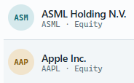
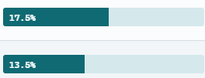

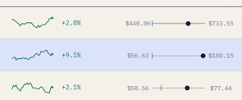
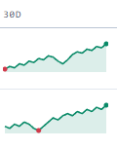
Like this (with the ASM/AAP replaced with actual logo later)

