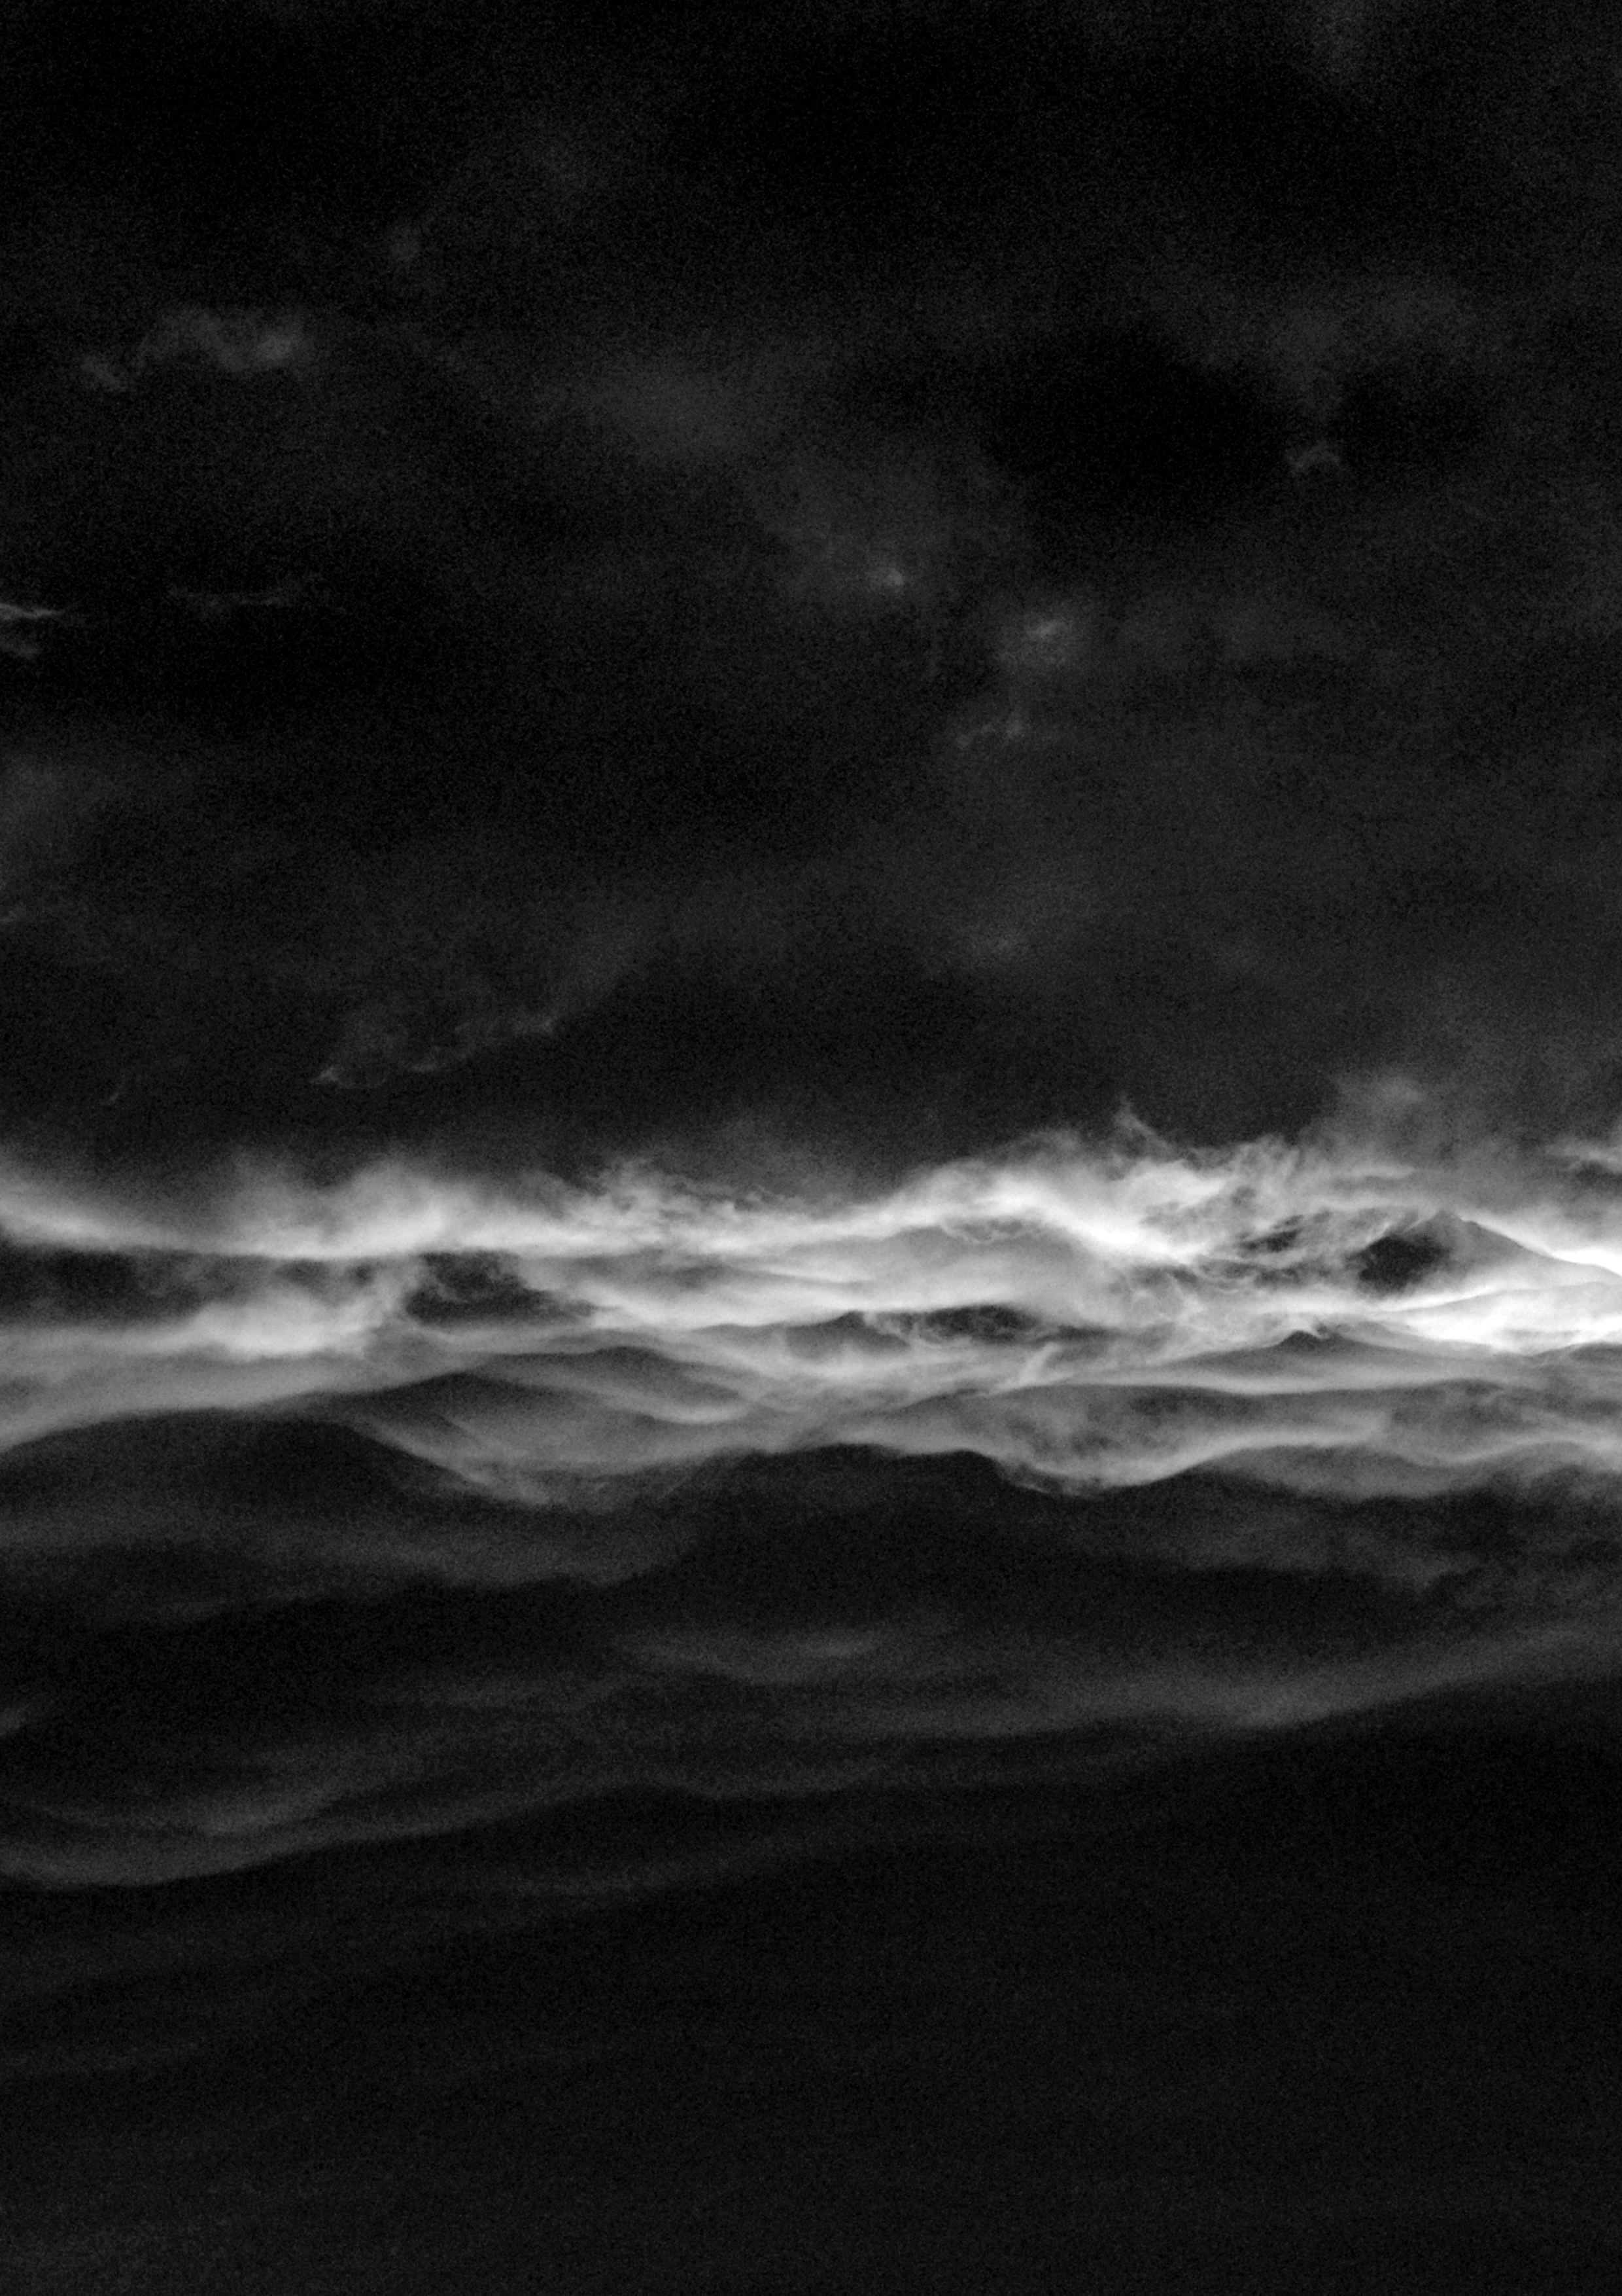

Sound and Time
on the timeliness of ambient music
and a quantum theory of sound
by David Unland

An Essay
by David Unland
Digital Media Program
University of the Arts, Bremen
submitted: January 22nd, 2020
dunland@hfk-bremen.de

Contents
Introduction...............................................................................................…........................................………… 2
I. Sound in the center of all senses:
A new perspective towards the character of anything..................……………………………………………… 3
II. The times are a-changing. Why so?..............................................................................................…….... 6
III. Time richness and information content of sound......................…...............................................….. 7
IV. A walk without a ground: How we lose our time.....................…................................................…….. 8
V. Unity, infinity, emptiness ....................................................….......................................................…………9
VI. Against all odds: a quantum theory of sound.............................................................................….... 11
Bibliography and media references...................................................................................................……… 14
Acoustic and musical references..................................................................................................………….. 15

Introduction
Let me begin this text with an anecdote, an experience I had and repeatedly have with a certain type of ambient music: When listening to the music by William Basinski (2003), Thomas Köner (2002), Harold Budd (2007), Kyle Bobby Dunn (2019), Brian Eno (1978), Pauline Oliveros (1989) and similar (the list could go on with many, many names) – that music, which, through its’ low topology in melody and perpetual undulations of harmony, amplitude and modulation, creates some sort of niche in the sonic surrounding, then I often discern an emerging peculiar feeling of timelessness, as if the flow of time suspended to make space for something sublime. To me, a glimpse to something out there, something eternal, some sort of a universal truth was offered in such a situation (multiple times), and I feel that a sacred door, maybe, opens in the back of my head to carry my soul as long as I am rapt.
One might want to embrace those situations, that music, those artists, and get all pious, if one has a predisposition for it, or get all high or maybe bored from those ceaseless successions of sounds – or one might want to know why there is such a potential in ambient music for such elevated sentiments, why it opens up the possibility for such an encounter with that “truth” out there, and what that experience is all about.
I could not help but see a potential answer by describing the music’s texture density, in terms of the variety of appearing sounds over the course of a piece. My research started with the basic question:
How do a sound’s texture density and the perception of time through that sound interdepent?
The answers are, of course, manifold. And that is not only because it is, in its very character, impossible and pointless to speak about sound and music, but also because the reader would think that, by doing so, I could only write about my own sensations with that sound. Aren’t our musical preferences purely subjective, considering that they already differ between two persons from within the same cultural group? How could I posit anything of general validity then?
Even though an introductory question is posited, this text is more a discourse about human consciousness and about the way we perceive and structure the world around us. The question herein will be taken up repeatedly throughout the course of the essay and be tried to answered in chunks.
To avoid writing something too subjective, I tried to take care of the general discourse taken up by philosophers around the field of Sonic Studies. We will see that a new perspective on reality comes about, when we take sound as the ground of our thinking.
After that, I present a few approaches to what our concept of time might be and how time forms (in) our consciousness.
Departing further from the introductory question then, theories situated somewhere between quantum physics and perception philosophy will eventually lead to a quantum theory of sound and shortly explicate its impacts on our whole ontology.

I. Sound in the center of all senses:
A new perspective towards the character of anything
Our senses are the interface to reality, meaning that, the way we use them (and ascribe significance to them) structures the way we perceive our environment – not only the immediate surroundings, but also our thinking, our characterizing and assessment of situations, the way we situate ourselves in the world with respect to all other creatures and objects, how we differentiate between these, our emotions and all the things we can only experience beyond any possibility of verbalization, in short: our whole Being is constructed by our senses. One could say that we think by them, and that the mental world that is formed in our heads can only take from the building blocks of sensation and perception. There is no way to describe a color from outside our visual spectrum.
It turns out that western existential philosophy has pointed out a hierarchy in the way we rank our senses in terms of their significance for us (Jonas 1954), describing a clear dominance of the realm of visual perception in our thinking (Herzogenrath 2017, pp. 3 ‒ 4). Applied to our ontology (the conception of what our reality is), we think for example of logically closed (complete) moments when remembering events from the past. This way, closed memory objects are formed and recalled, according to our tendency to process time in a visual way – as a succession of snapshots, that are only saved when relevant to us. These memories usually provide an incredible amount of detail (whether coherent or not remains undecided), but at the same time they lack a degree of consistency, as there are no sharp cuts on the level of emotions, nor at the subconsciousness or non-consciousness.
Similarly, we experience in the center of our attention the presence of one object at a time. We can shift that focus from object to object so that it stands to reason that we talk about this in a very materialistic way. We structure our reality by a material-focused perspective; one can speak of an object-oriented ontology.
In his book Sonic Thinking, Bernd Herzogenrath presents an alternative idea of how we can conceive of the world. The book contains a collection of essays concerned with the ontology of sound. To understand what that means, we must take into account the time-bound character of sound:
Sound, as we perceive it, is the neurophysiological reception of oscillating acoustic waves. Oscillations can not be described without a time-axis ‒ they are the changes of a position of some kind, or more specifically in acoustics, the differences in the position of air (or water, etc) particles. There is no possibility to make snapshots of sound at a (close to) infinitely small time frame (this would result in a amplitude at a moment, which again describes the maximum deviation of a particle from its former position. A snapshot of sound would bring you but the positions of particles at a time). The flow of time plays a seemingly crucial role in the formation of sound. Without time, the aural apparatus has no base to function on. The perception of sound is a perception of fluctuations, of differences that can only evolve with the passing of time.
This has a fundamental impact on the notion of a sonic ontology. There are no complete objects, nothing can ever have a fixed form, as everything is constantly in motion and subject to processes. Every material manifestation will fall back into what it was, as every molecule will eventually break apart into its compound atoms. Philosophers have talked about the ontological shift from Being to Becoming, an idea that was postulated by Deleuze and Guattari, Nietzsche, Spinoza, Schopenhauer, Whitehead and Bergson (who included the notion of a sonic ontology to different degrees) (Herzogenrath 2017, p. 4). They all create, with the shift from fixed objects to a fluent material world, an ontology that’s best described by a flow from which events can emerge and temporarily manifest to eventually fall back into their components and disappear.
What could cause our physical world to be in a constant flow? According to Manuel de Landa a thinkable driving force for that are thermodynamics, a discipline that had a major impact on the philosophy of processes in the 20th century (de Landa 2012). The laws of thermodynamics proclaim that all physical systems strive for maximum entropy, i.e. for a state of maximum disorder. All chemical systems reach a state of equilibrium, once that maximum entropy is reached. Hence, the ones far from equilibrium have a high potential to become subject to change.
The consequences of thermodynamics cast a light onto our relationship to matter that is much more vivid than seen in conventional world views. De Landa (2012) proposes a conception of an active, morphogenic matter, that ascribes to the world an ability of creating form. The artist or crafts*man is no longer in a superior position and has not only the power to mould the material according to their wishes ‒ de Landa describes Art as a “partnership of interaction” between human and matter. Joining in to that thought, Herzogenrath (2017, p. 6) equates consciousness to the activity and interaction with the material world. His observation, that sound is the sound artists’ material, completes the coherence of a Sonic Materialism, as suggested by de Landa, Herzogenrath and Cox (2004, pp. 9 ‒ 10).
Cox proposes a shift from Being to Becoming by a turn from music to sound. He argues that these are two fundamentally dividable concepts, according to their relationships to being and time (Cox 2004, p. 1). His differentiation of the two as of different kinds is a supportive measure in his argumentation, but there are other opinions about this as well: Karl-Heinz Stockhausen was not the first, but an important composer who adopted an attitude in which sound and music are considered as one and the same material performing on different time scales (Roads 2001, p. 71). In this discourse I comply with Stockhausen’s and Roads’ concept of a unity of music and sound, for reasons that might become clearer in VI.
Besides that, drawing from Henri Bergson, Cox proposes another shift: a temporal one, from time to duration. Bergson splits time into two differing concepts: the “spatialized, quantified conception of time”, which he calls le temps (Cox 2004, p. 3). This idea of time is associated with an object-oriented world view that tries to objectify our understanding of what time is. Opposed to that is the concept of la durée (duration), describing the “very flow that produces beings and events and by which they constantly become-other” (ibid.), an idea that is connectable to the conception of a world in constant progress. The author suggests a conceiving of sound as an “anonymous, non-human, and impersonal flux” (ibid., p. 9).
Joining these concepts ‒ the notion of a world conception of fluid material, a "sonic matter" and a ubiquitous flow of potentiality from which all things emerge and resolve back in ‒ it slowly becomes clear how important the timely character of sound is with respect to its potentiality of placing us in a new right in the center of a Becoming. The experience, as it will be shown in V., of that timeliness, of durations, can cause a sublime feel of sacredness. A common quality of ambient music is its composition. It embodies continuous currents of sound; dense patches that stretch across the entire consciousness, embedding all other stimuli and thoughts. Unlike pure sine waves, that music has some texture, and the passing of time can be perceived through fine sound structures easing past the attention – as imbalances in the homogeneous layers of timbre.

II. The times are a-changing. Why so?
So what is time, at all? Considering the way of measuring physical time we'll notice that we seem to be dealing with something quite arbitrary here: the smallest time intervals we experience in everyday life are physically still captured by radiation times of subatomic events. The smallest physically defined interval, the Planck time, is the time span needed for a photon to pass a certain ultra small distance, which, analogously, is called one Planck length. So what is running in the background, that guarantees an uninterrupted progress of things to happen? The misconception that time passes steadily has ended with the advent of Einstein's Theory of Relativity, which links the pace of passing time to gravity. Equally, it erases all possibility of simultaneity, because if time and space are interlocked (by gravity), time must pass at different speeds at different sites. There is no way of measuring nor any reason to believe that time, in a physical sense, is really passing at all. Even though it is described as a succession of events, there is simply no proof for it to be continuously going forward and that it does not, between the smallest intervals, just stop for a(n eternal) while.
Furthermore, there is no clear idea whether we can speak of time is a continuously evolving matter that is infinitely dividable, resulting in a universe that one can in theory infinitely zoom in to. In times of a dominance of the scientific discourse by quantum theory the question whether the universe is to be understood as continuous or whether it consists of quantified intervals (of Planck time, maybe) still is unsolved and splits the scientific community into two parts.
Instead of drowning any deeper in the problems that physical time bears, it may be more helpful to look at how time is perceived. This question is not bound to the question whether the universe is in its essence compounded of discrete states or whether it is infinitely dividable. It is logical to differentiate between perceived time and physical time. The fact, that our senses act only on certain degrees, levels, scopes, while most of the universe remains obscure, is reason enough to separate the two areas.
Back to the initial question, how sound is capable of producing an awareness for passing time, one might argue that the sound's texture density is an important factor: it is the only factor providing any information, that times are a-changing. And information is an important key to understanding how we can even form a feel of progression.

III. Time richness and information content of sound
What is information at all? The producers of the YouTube series "Veritasium" equate information with the amount of disorder, or as it is called in chemistry: entropy (Veritasium 2014). The second law of thermodynamics posits that the entropy of interacting systems always increases. Because of that, the universe strives to a state of maximum disorder.
The state of order in which the world presents itself is closely bound to what we understand by information: patterns can only be recognized if the degree of disorder is not too high for us. This is a fundamental insight to how the brain filters the environment. Within a certain frame, the amount of information, which we can draw from the world, increases with the amount of disorder. A perfectly predictable environment yields no information for us. Such an environment would, as the producers of Veritasium state, become subject to compression: summarized simply as a multitude of its unit pattern and hence, absolutely predictable.
In computer sciences, the compression of data is possible only by the detection of patterns. The notion of compression provides an interesting analogy to how we make sense of the world. This should not mean that we can understand the functioning of our brain by an analogy of how computers work, but it is an interesting invitation to introduce the fact that our expectation plays an important role for the processing of our surroundings. If anticipation is too easy, we will shut off and quickly start ignoring the stimulus. If, on the other hand, it is too hard to extract outstanding features from an overwhelming amount of information, the attention will shut down, likewise, because it will not be able to find an object to cling on to. We can make sense of the universe only within a certain span somewhere between perfect order and absolute randomness ‒ somewhere between the extremes of how information is exposed to us.
Applied to sound, the absolutely ordered side of the spectrum of possible configurations would constitute a perfect sine wave. This kind of an oscillation basically provides no information for our minds. To the other extreme, there is white noise, the event of all possible frequencies oscillating at the same time. The brain can not make any sense of that, either.
Beyond the perceivable area between overwhelming order and disorder, all events really form a unity and there is no discrimination between them; information is but a purely human expression to how we deal with the incoming stimuli ‒ but more on that later (in V.).

IV. A walk without a ground: How we lose our time
The idea concerning perceivable information as something located between noise and order can easily be applied to music. And it shows straightforwardly that there is no direct, linear relation between sound texture density and the pace of perceived time! Take, for example, Draft by $3.33: The manifold piano cascades in the beginning of the piece "+" seem to pass to quickly to be all registered by the attention, just some protrude from the masses. The music has a high pace of tone successions, but only little change in the tonal spectrum (and a compositional progression with not much that can be anticipated). The piece ("+") is situated further towards the side of noise (chaos) on the spectrum between perfect order and absolute chaos and provides little guidance for the listener. There is a lot happening in that music, with many elements or time-objects passing quickly so that one might expect a subjectively fast progression of time. But still, some sort of time suspension is created.
This shows that not the texture density alone is responsible for the perceived pace of time. The potential amount of information to be extracted from noise plays a role, too. Ambient music often suspends the subjective experience of time when it offers no handle to be, to a certain degree, compressed in our minds.
The same is valid for music that is too obviously structured in rhythm and harmony. The mind would glide off, because of a lack of features to follow. I would locate both Brian Eno's Ambient 1 (Music for Airports) and Steve Reich's Music for 18 Musicians in this area. The patterns presented in their works are quickly understood and compressed by the mind; the excitation of the attention then takes place on a level of lower fluctuations.
The notion of suspension basically describes the experienced loss of a timely dimension. It happens when the equilibrium of anticipation and memory gets lost.
The base for our ability to create memories is, trivially, the fact that we have experienced any kind of informational input. The ratio of detectable features from an overall increasingly noisy universe must not be too low. Memories are the substrate for our expectation to form. Together memory and expectation create our experience of time, and even more, our consciousness, as a wise man has put it in an informal presentation during the 36th Chaos Communication Congress in Leipzig (Steini 2019). According to him, the difference of memory and expectation is what creates the present. Linking back to the before mentioned works, this concept explains how suspension is caused. $3.33's Draft has a high degree of randomly occurring sounds, it is in this way fairly noisy. Because of that, it is hard to store all the information (or the mind does not even draw much information from it, respectively) and to anticipate the future progression. Even though much happens, little changes, so that the difference between memory and expectation shrinks to a minimum and the present collapses.

V. Unity, infinity, emptiness
We have learned how the universe, from a human perspective, spreads out on a spectrum between chaos and order. The following texts ‒ A chronic condition: noise and time by Paul Hegarty (2012), and Zero by Kay Larson (2012) show a complementary conception that is characterized by a collapse of this spectrum, that can be achieved by experiencing a reality beyond the scales of information.
Paul Hegarty takes up the notion of noise and presents it as a questioning of time. According to him, noise spawns a timeless experience for the listener ‒ a hint to Bergson's duration, the previously explained counterpoint to quantized clock-time. Hegarty recalls the work of noise artists Hijokaidan and Vomir, who proclaim that their music is "not doing noise through its long duration, but in how duration is never allowed to supersede empty time, and this through the collapse of the vertical (the recorded layers), so that the horizontal is always thwarted” (Hegarty 2012, p. 22).
The music tries to escape the spectrum of a logical reality by focusing on the overabundance of information. "It is the arbitrariness of time taken that reconnects these tracks [...] which leaves us in a duration that is about becoming", Hegarty writes (p. 23). In this, again, elementary key words that we know from Bergson's time theory are taken up. But Hegarty points out that the Bergsonian duration has one flaw: that "rhythm and measure [in sound] seem to reinforce quantitative time".
An understandable thought that he supports by introducing Deleuze's and Guattari's notion of intensity, a sense for "something that is entering the mind to a degree that measure is lost". For Deleuze, duration is an "internal multiplicity", a "succession", "fusion", "organization", "heterogeneity", a discrimination of quality and of nature (Hegarty 2012, p. 18). It is something that is virtual and continuous, and cannot be quantized. In short, it is an experience that we make when we leave the realms of the spectrum in which our senses make sense of the world; the spectrum of information.
Deleuze and Guattari furthermore refer to a volatile materialism Manuel de Landa and Bernd Herzogenrath have encountered, too. They speak of the "proliferation of material" as an "involution, in which form is constantly being dissolved, freeing times and speeds [...], a fixed sound plane, or visual plane, or writing plane, etc." Their notion of intensity is more on the "static" or suspended side of timely experience. "Once we accept that Bergsonian duration is exposed as an insufficient recasting of time, then the 'involution' which Deleuze and Guattari spoke of can oocur in however short or long a moment as it structures", Hegarty writes (p. 23).
Recalling Steini's theory of a subjective progress of time (Steini 2019), which can be suspended for infinite amounts for the individual, the passing of time unfolds as an internal experience by the overlapping of memory and expectation. In this context, Deleuze's and Guattari's involution becomes a more tangible term, as it expresses a reconfiguration of internal (eternal) states, rather than an external adding-of-states to the actual configuration.
Larson's (2012) text is another argumentation in favor of the experience of a nothingness. Throughout its course, it becomes clear, that the nothingness is a void which causes events to come about so that it can be filled with something. Aligning perfectly with de Landa's philosophy about thermodynamics, a nothingness, thought of as a difference of states with a maximum distance to an equilibrium, can not be preserved for long. It acts as an ultimate driving force for all other things to evolve.
Even more radically, John Cage argues that there is not even a nothingness! On his long pursuit for the experience of an ultimate silence, of nothing, which led him not only to Zen Buddhism, but eventually to the anechoic chamber of the Harvard University in Cambridge, he had an important insight that influenced his artistic practice profoundly: "[I] heard that silence was not the absence of sound but was the unintended operation of my nervous system and the circulation of my blood. It was this experience and the white paintings of Rauschenberg that led me to compose 4'33" [...]".
As simple as his experience may have been, it showed clearly to him, that nothingness is but the (before mentioned) difference of states. Cage has experienced what his Zen teacher Suzuki has explained before: that all things can only really be described "in relation to what they are not" (Larson 2012, p. 267). This, too him, had drastic impacts resulting even in a conviction that there is no split between matter and spirit, that it all is one. We can understand that by a unity of chaos and disorder, a unity that we can only describe by something eternal, something that is either in a constant state of change, thus, never graspable as an entity, or something that is nothing really. In short, the act of accessing the realm outside of our perceivable reality, outside of the spectrum that we make sense of and where information forms, reveals that there is no essence in things, there is only emptiness, that needs to be filled.
Larson joins in to Cage's observations with his words: "It's because everything is empty ‒ it's because this world is like a bubble on the stream ‒ that this interlocking chain of cause and effect can arise, can transform, can appear to us as real. If things weren't empty, how could they change?" (ibid., p. 265).
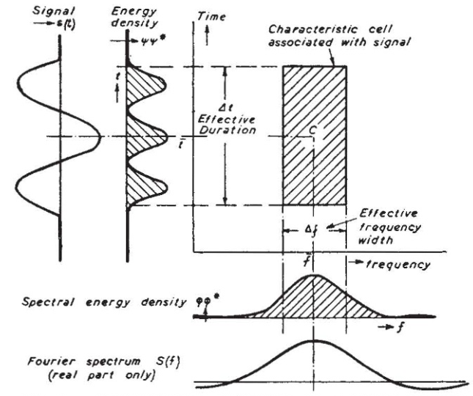Figure 1: Gabor's Information Diagram describes a sound signal by the two coordinates time and frequency. The effective duration and the effective frequency width on the y- and x-axis, respectively, yield a characteristic energy cell associated with the analyzed sound signal. (Gabor 1947, p. 591)
Zen Master Suzuki, from whom Cage has learned, connects the two realms outside of the field of information ‒ the two ends of the spectrum between perfect order and absolute disorder ‒ and presents a simple and equally meaningful equation: ZERO = INFINITY.
Cage's masterpiece 4'33" is probably the most meaningful manifestation of this zen philosophy in Sound Art of the past six decades. By presenting but nothing, it opens up a void that stages the performers and the audiences (re)actions (ibid., p. 279).
The piece creates, by drowning the audience in emptiness, another layer: The link from an event-creating emptiness to a sonic ontology of Becoming offers the possibility to experience a certain sacredness ‒ a sacredness that can be perceived outside of the frame of sensation. By entering this realm, David Tudor, a fellow of Cage's, confirms the existence of a very flow of potentiality and a somewhat sacred momentum when he speaks about practicing 4'33" as a life experience (ibid., pp. 276‒277). Like a mantra, he repeats it everyday by turning his attention toward it. He actively enters the river of infinity. "The roar of being [Becoming] never ceases. Cage has "divided" what can never be divided." (ibid., p. 280).

VI. Against all odds: a quantum theory of sound
The idea of a sonic ontology bears one simple problem: It strongly assumes that the universe is infinitely dividable. This idea, as mentioned before, has many critics. A group of physicists concerned with fundamental questions about the essential character of the universe proclaim an idea of a digital universe, whereas others are in favor the idea that there are no discrete steps on the smallest scales (meaning, there is not even a smallest scale).
The problem lies in the word "infinite(ly)": Conceiving reality through a sonic approach means to accept a continuous stream of change ‒ both into the future and the past. Here, the question about a beginning and an ending arises, which is reflected in a technical issue in signal analysis:
The Fourier transformation is a tool to analyze the spectral distribution of tones (frequencies) in a sound signal by examining the occurring oscillations in a certain sample rate. The rate by which the amplitude samples are taken must be at least twice as high as the resolution of the smallest wavelength in order to depict all frequencies correctly. This means that we will never be able to detect waves that fluctuate faster than the machines we use for measuring.
Similarly, the possibilities to measure extremely long wavelength are limited. An eternal oscillation, from which all other things emerge, as Bergson, Herzogenrath and Cox have thought it, must envelop all other possible fluctuations and therefore act outside of the ranges of time. We would obviously need an instrument that persists longer then the absolute duration of the universe to measure the slowest thinkable amplitude change.
Most striking, though, is the fact that for the measurement of any sound signal that stretches across a time axis, an analysis of a certain time span is required. Hence, we cannot say that we know the frequencies in a sound at any given discrete moment in time. Looking at a time window, there is always an uncertainty as to where on the time axis the frequency occurs! Slowly it becomes apparent that there is a duality in our conception of sound, that Dennis Gabor has pointed out in his discourse on Acoustical Quanta and the Theory of Hearing: “Fourier analysis is a timeless description, in terms of exactly periodic waves of infinite duration. On the other hand, it is our most elementary experience that sound has a time pattern as well as a frequency pattern” (Gabor 1947, p. 591).
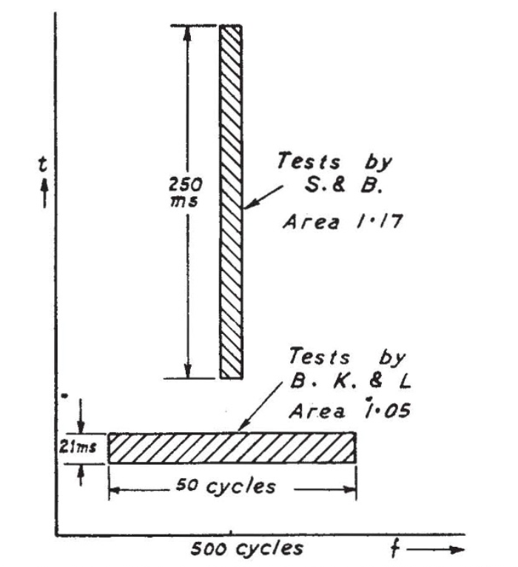Figure 2: Physiological tests have shown that the minimum discernible stimulus for the ear is exactly one acoustical quantum. Here two different experiments at the threshold of human hearing capability were conducted. The upper one focused on the smallest perceivable frequency in a given time, whereas the lower bar represents an experiment that found the smallest time frame in which a given frequency can be discriminated. (Gabor 1947, p. 593)
Gabor observed in his 1947 article that the only valid dealing with this duality is a mathematical description of acoustical phenomena, which closely resembles the description of phenomena in quantum theory. Every signal can be described only through the combination of two differing perspectives: their characteristic as a function of timeas well as as a description of Fourier components.
Gabor has stagedandas two coordinates of sound. By defining an effective duration and an effective frequency width (according to the observed time frame) and applying a Hilbert transform on both of the axes, the energy density of the signal is obtained for both dimensions (Figure 1). The overlap of these two functions now describes the same amount of acoustic energy ‒ calculated from two different perspectives, and represented in a characteristic cell.
Furthermore, the relation between effective duration and effective frequency width can be described by the formula. This mathematical representation is but a simple uncertainty relation that is known from quantum theory. It signifies that “the area of the characteristic rectangle or cell of a signal is at least unity” (Gabor 1947, p. 591) ‒ we can either have a certainty in the frequency resolution, or in the resolution of its occurrence in time. Either we minimize the frame of observation and lose accuracy in the frequency range or vice versa. Depending on what dimension we want to observe ‒ what perspective we want to adopt ‒ the equilibrium of the formula shifts to either the one or the other side. The bigger 𝚫t, the smaller 𝚫f and the smaller 𝚫t, the bigger 𝚫f.
Gabor proceeds with the statement that there is an elementary signal, at which both ranges are exactly of equal size. These elementary signals can be described mathematically by the combination of a harmonic wave function and a Gaussian probability distribution:According to this function, the author writes, “the elementary signals are harmonic oscillations […] modulated by a probability pulse” (ibid., p. 592).
What an insight! Sound informed by a character of probability! Chance comprised in the formation of acoustical phenomena! Excuse this emotional outburst, but the consequences are tremendous.
Physiological experiments have shown that, at the threshold of our perception, acoustic quanta are indeed existent and measurable. Gabor lists in his article experiments that all prove that the range of possible tone discrimination is exactly one acoustic quantum (Figure 2) (Gabor 1947, p. 592) ‒ either by adjusting the frequency of a sound stimulus or the duration of its playback, the experiments have shown that “the ear possesses a threshold area of discrimination of the order unity” (ibid.). The author concludes that “from the time and frequency intervals involved in each case it is possible to form a product, the ‘threshold area’, in which the ear [is] capable of registering one sensation only, and which must be exceeded if it is to register a second” (ibid.).
Our hearing sense is, thus, fundamentally constituted through the sensation of acoustical quanta. This theory seems to support the ideas about a digital universe and contradict to the ideas of a sonic ontology and of de Landa’s morphogenic matter.
But, as de Landa has drawn from thermodynamics, I want to learn from quantum physics. And quantum theory has taught us in the recent decades, more than anything else, how things can be in contradiction, how they possess inner conflicts without collapsing ‒ up until the moment we begin casting our attention toward them. All and none of the possible states an object can adopt are real, as long as we do not begin to observe it. To put it in Deleuze’s terms: by observing, we actualize the virtual from the bulk of all potentiality.
Applied to a sonic material, the application of a quantum theory invites for a beautiful thought experiment: By the description of acoustical phenomena as acoustical quanta, the sound objects that we discern are only actualized in the very moment we begin to listen. Before that, they assimilate every state possible. A fluid, morphogenic, sonic matter is obtained, that is permanent, eternal, and always in a flux. It takes on every (im-)possible form, until it starts to become something in the moment we observe it, interact with it.

Bibliography and media references
Baddeley, Alan (2003): Working Memory: Looking Back and Looking Forward. Nature Neuroscience, Vol 4., pp. 829 ‒839.
Cox, Christoph (2004): From Music to Sound: Being as Time in the Sonic Arts. https://www.kim-cohen.com/Assets/CourseAssets/Texts/Cox_Sonambiente%20(2004).pdf, last visited: 2020-01-12
Cox, Christoph (2017): Sonic Thought. In: Herzogenrath, Bernd (Editor): Sonic Thinking: a media philosophical approach. Bloomsbury Academic, London. pp. 99-109.
Meeting of Minds: Interview with Manuel de Landa. (2012) https://www.youtube.com/watch?v=fu24Jl66jgY, last visited: 2020-01-12.
Gabor, Dennis (1947): Acoustical Quanta and the Theory of Hearing. Nature, Vol. 159, Issue 4044, pp. 591 ‒ 594.
Hegarty, Paul (2012): A chronic condition: noise and time. In: Goddard, Michael; Halligan, Benjamin; Hegarty, Paul (Editors): Reverberations. The Philosophy, Aesthetics and Politics of Noise. Continuum, New York. pp. 15-25.
Herzogenrath, Bernd (2017): sonic thinking ‒ An Introduction. In: Herzogenrath, Bernd (Editor): Sonic Thinking: a media philosophical approach. Bloomsbury Academic, London.
Jonas, Hans (1954): The Nobility of Sight. A Study in the Phenomenology of the Senses. Philosophy and Phenomenological Research, Vol. 14, 04/1954, pp. 507-519.
Larson, Kay (2012): Zero. In: Larson, Kay (Editor): Where the Heart Beats: John Cage, Zen Buddhism, and the Inner Life of Artists. The Penguin Press, London.
Roads, Curtis (2001): Microsound. MIT Press. Cambridge, Massachussets.
Pasquinelli, Matteo (2016): Abnormal Encephalization in the Age of Machine Learning. e-flux journal, Vol. 75.
Steini (2019): Was ist Zeit? Conference Talk at the 36th Chaos Communication Congress. https://media.ccc.de/v/36c3-oio-195-was-ist-zeit, last visited: 2020-01-14.
Veritasium (2014): What is NOT Random? https://www.youtube.com/watch?v=sMb00lz-IfE, last visited: 2020-01-15.

Acoustic and musical references
$3.33 (2014): Draft. Leaving Records, Los Angeles. https://leavingrecords.bandcamp.com/album/draft, last visited: 2020-01-15.
Antitainment (2010): Ich kannte die, da waren die noch real!. Zeitstrafe, Hamburg.
Brian Eno (1978): Ambient 1 (Music for Airports). Polydor, Berlin.
Harold Budd, Robin Guthrie (2007): before the day breaks. Darla Records, New York.
How To Disappear Completely (2017): Mer de Revs II. (not on label,) Poland
Kyle Bobby Dunn (2019): FHTE-B. Dunn Music, Canada.
Music for Sleep (2019): Background Music. https://mforsleep.bandcamp.com/album/background-music-shard-of-the-ancient, last visited: 2020-01-12
Pauline Oliveros, Stuart Dempster, Panaiotis (1989): Deep Listening. New Albion Records, San Francisco.
Steve Reich (1978): Music for 18 Musicians. ECM Records, München.
Thomas Köner (2002): Daikan. Mille Plateaux, Frankfurt.
William Basinski (2003): Desintegration Loops II. 2062, New York.

It is not only an insight taken up by the German music group Antitainment, that hyperdefining musical genres keeps musicians back from doing what they are supposed to really do (Antitainment 2010), but also a statement by famous philosophers like Nietzsche and Schopenhauer that music has the power to figure “the world as it is in itself” (Cox 2017) – it possesses a stance so elevated that it cannot even be dissected by philosophical description.
Look for example at the vocabulary from the realm of knowledge and insight: You will see that many words clearly originate from visual perception. Furthermore, there are expressions that show how our imagination is coined from our visual sense in a more mediate way: The word imagination, for example, translates to German as Vorstellung: A placing-in-front, which would be necessary to actually see things ‒ unnecessary, if we had a more aurally based ontology, since our aural apparatus can almost equally well recognize objects that are behind us.
The fact alone that we say that we can shift the focus of our attention from one thing to another proves how object-oriented our perceiving is. Also, a limited working memory that serves the storage of information in the short term, is alone an indication for our perception of stimuli as completed, rather than infinite (Baddeley 2003).
meaning both making time-objects by quantifying as well as generalized; opposed to subjectivity
not as in how it is constructed by a composer but rather, what its compounds are
as to be experienced in Background Music: Shard of the Ancient by Music for Sleep; Deep Listening by Pauline Oliveros, Stuart Dempster and Panaiotis or Harold Budd & Robin Guthrie: before the day breaks
The equation of present and consciousness is probably the most helpful approach to understanding time at all. If the present is borne by the difference of memory and expectation, no progression of time is needed to perceive a present at all! The present is then just a state, that can be infinitely suspended without notice. An infinite amount of time could pass in the meantime, but if the interplay between memory and expectation does not change, no time passes for the individual. All time is absolutely subjective and that is an important thought for our self-understanding as well, because it means no less than that the universe, from a subjective point of view, is created by the consciousness, and not by an external evolution of time! We will find out more about that in VI.
The ambient record label Mille Plateaux puts it in their own words: “Ryhthm mutates into a non-linear evilness and becomes a black sound- ground. Ultrablack-Music will escape from the ban of time and intensifies itself in the principle: and-when-you-hear-in-rhythm-you-are-the-co(s)mic-warrior-with-the-golden-imperative-in-the-last-instance: tic-toc – fuck the clock.” https://forceincmilleplateaux.bandcamp.com
Some even go as far as positing a computational character of the universe; they conceive of reality as an algorithmically calculated structure and human thinking as a product of logical Boolean operators (AND, OR and NOT) (Pasquinelli 2016)
Our technical possibilities to measure extremely short time intervals are enormously precise, but from a theoretical point of view, they will never be able to extend beyond the speed of light, which, thus, becomes a border for our measurable world ‒ and will never provide an answer to the question whether the universe is infinitely dividable essentially discrete.
The Hilbert transform can be applied to two functions that modify each other to produce a third one that expresses how exactly the two are interdependent. From the real parts of the respective functions, the the energy density can be acquired by this trick, which means a mirroring of the wave at all negative values around the center of oscillation.

