Summer Internship Project: UK Sports Viewership Data Collection and Analysis
Intern: Samuel Dunn Project Lead: Dr Peter Dawson
School of Economics, University of East Anglia

August 2026
Abstract
Audience demand for live sport is a foundational area of sports and media economics, but empirical research remains largely constrained by the lack of publicly accessible, high-frequency broadcast data. This project addresses this gap by constructing an original, cross-sport dataset of live UK digital audience figures for broadcasted sporting events. Moving beyond in-person attendance demand and broadcasting rights, a systematic data-extraction pipeline was engineered to autonomously capture concurrent viewership and match metadata from within the BBC Sport digital infrastructure. This project’s dataset comprises 1,025 intra-match observations across five sporting competitions in 2026, including Wimbledon and the FIFA Men’s World Cup. The baseline estimations confirm that audience demand is heavily dictated by a match’s competitive balance, and predictive margins highlight a non-linear demand curve for competitive balance, demonstrating that audiences value both competitive jeopardy and high-quality, predictable dominance. Ultimately, this project creates a highly structured, scalable data collection pipeline and subsequent dataset to apply robust empirical frameworks that support future sports economics research and external engagement activities.
Keywords: Sports Economics, Media Economics, Broadcast Demand, Competitive Balance, Uncertainty of Outcome Hypothesis.

Introduction
Audience demand for live sport remains a pivotal area of study within sports economics, media economics and consumer behaviour. Given that substantial academic and commercial attention is routinely focused on broadcasting rights, franchise revenues, and the drivers of in-person stadium attendance, empirical research focusing on granular, event-level broadcast or online audience figures is highly constrained by limited data availability. This project specifically focuses on addressing this empirical research gap by developing an original, structured dataset of UK television and streaming audiences for live sporting events.
Comprehensive research reviews concerning the demand for sport have been long established by Cairns et al. (1986) and Downward and Dawson (2000). Market demand for sports is inherently derived from fan interest of the fundamental product: the contest between two competitors or teams (Sutton, 1992). Fan utility from consumption derives from two central sources: association with a specific team/participant involved in the sporting contest increases the baseline level of fan interest (S. Mason, 1999), and a higher quality of the contest itself, given by the competitors’ demonstration of capabilities (Rottenberg, 2000) and the uncertainty of outcome (Madrigal, 1995). It is seminally understood that sports competitions must be considered as a ‘close’ contest in order to attract spectators (Rottenberg, 1956; Neale, 1964) – a theoretical framework now coined the Uncertainty of Outcome Hypothesis (UOH).
The impact of outcome uncertainty becomes greatly nuanced when the focus is turned to the demand for television viewership itself. Nalbantis et al. (2017) highlighted that fans’ perceptions of ‘suspensefulness’ are independent to their distinct perceptions of game uncertainty. However, Johnsen and Solvoll (2007) established that the demand for televised football specifically, is intrinsically associated to fan’s preference for competitive balance and scheduling quality. Nevertheless, recent literature found that outcome uncertainty is not significantly connected to the size of television audiences in the UEFA Champions League; rather European television audiences are driven by the presence of star players and respective team quality (Wills et al., 2022). Such preference for star talent over uncertainty is reflected in Italian Serie A television broadcasts, wherein domestic Italian viewers are more engaged by aggregate quantity of talent over individual talent (Caruso et al., 2019).
However, conflicting empirical evidence concerning the UOH in domestic league broadcast is apparent. Forrest et al. (2005) demonstrated the English Premier League television viewers prefer close and unpredictable contests over predictable ones, utilising odds-setters as forecasters to distinguish a significant positive relationship between outcome uncertainty and television audience size. Buraimo and Simmons (2009) corroborated this trend with Spanish football television audiences, likewise, identifying a significant positive relationship between free-to-air broadcast audiences and the closeness of the contest. Nevertheless, Buraimo and Simmons (2008) investigated the English football second tier finding no significant impact of match outcome uncertainty on gate attendance or television audiences. Importantly, given the UOH framework was created around head-to-head team sports such as rugby or football, assessing the uncertainty in individual sports and multi-competitor environments necessitates an extended methodology.
Contemporary methods shift away from the aforementioned ranking data in Formula 1, demonstrating that the utility of implied probabilities from betting odds can also capture race outcome uncertainty (Fahy et al., 2026). In professional golf, television broadcast demand introduces complexities to the standard UOH framework due to the prominent “Superstar Effect”. Literature emphasises that professional golf television ratings are influenced exponentially more by the presence of generational talents on the golf leaderboard, rather than strict outcome uncertainty (Gooding and Stephenson, 2017). Such superstar presence has been identified to impact the competitive balance itself; Brown (2011) demonstrated the presence of Tiger Woods was correlated with deflated performance from highly-skilled competitors, structurally entangling the established traditional measurements of the UOH.
Nationalistic bias or a ‘home-team preference’ frequently moderates these dynamics; Nüesch and Franck (2009) seminally proved that patriotism plays a paramount role in elucidating the drivers in television audiences, providing robust evidence that national team games yield sizeable viewership premiums. As broadcasting allows for granular measurement of audience retention, modern literature acknowledges that UOH is not solely a pre-match observation. That is, the live progression of a match dynamically drives viewership changes (Alavy et al., 2010): viewers are more likely to turn their attention elsewhere if a draw looks progressively likely during a game. Therein, there is a clear theoretical demand to move beyond whole-match averages, towards high-frequency, intra-match audience data across sports to accurately model dynamic fan demand for consuming sport.

Methodology
This project captures intra-match sports viewership figures across five major international and domestic competitions occurring during the summer of 2026 including: Football, Tennis, Formula 1, Golf, and Rugby Union. As the UK’s largest free-to-air public broadcaster, BBC Sport was selected as the primary data collection environment, to capture representative, domestic high-frequency audience figures. A decoupled, sport-specific snapshot scheduling architecture was deployed to successfully bypass the visual BBC web infrastructure and parse raw backend JSON payloads, creating a panel dataset of 1,025 intra-match observations.
To transition from unstructured web data to an econometrically viable panel, multiple data cleaning and transformations were applied (the full constructed Data Dictionary is outlined in Appendix A). The dependent variable was defined by the natural logarithm of the audience size (Log Viewer Count) to normalise the distribution, and the UOH metric (UOH Score) was constructed using historical pre-match betting odds (https://www.oddschecker.com/) standardised into a metric of implied probability.
To estimate the drivers of live broadcast audience demand across sports, this study relies on panel data regression frameworks. a Random Effects (RE) panel model is employed as the main specification to control for unobserved, time-invariant heterogeneity across matches, alongside intra-day fixed effects (time id) and day-of-the-week fixed effects (day id). The baseline model is specified as:
$Log{\left(Viewers\right)}_{i,t}=β_{0}+β_{1}UO{H_Score}_{i}+β_{2}UK_Involved_{i,t}+γTimeControls_{t}+u_{i}+ϵ_{i,t}$.

Key Descriptive Findings and Empirical Analysis
The summary statistics (Table 3.1) highlight a significantly positive skewed audience demand. The mean Viewer Count across 1,025 observations is 37,118, the standard deviation is extraordinarily large (71,839), driven by the maximum concurrent audience peak of 873,343 viewers. Such variance warrants the use of the log-transformed dependent variable (Log Viewer Count) to normalise the variable’s distribution for econometric modelling. Moreover, 42% of the observations feature a UK (domestic) athlete or team (UK Involved). For the head-to-head sports, the Uncertainty of Outcome (UOH Score) average is 0.66, suggesting that, on average, matches feature a moderate pre-match favourite.
Table 3.1. Summary Statistics of UK Audience Demand
 | Count | Mean | Std. Dev. | Min. | Max.
Viewer_Count | 1025 | 37118.50 | 71839.45 | 0.00 | 873343.00
Log Viewer Count | 1025 | 9.43 | 1.92 | 0.00 | 13.68
UOH Score | 711 | 0.66 | 0.27 | 0.05 | 1.00
UK Involved | 1025 | 0.42 | 0.49 | 0.00 | 1.00
Is Televised | 1025 | 0.98 | 0.15 | 0.00 | 1.00
Observations | 1025

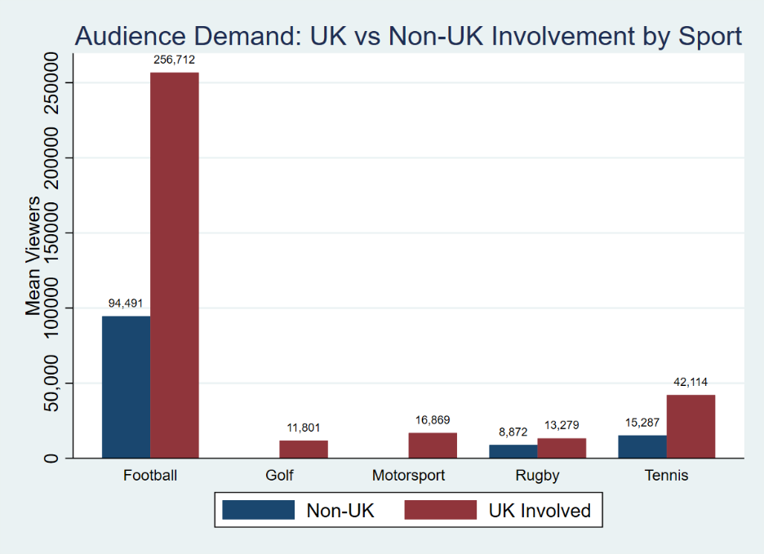
When audience demand is disaggregated by sport, the domestic premium becomes extremely evident. In every sport where comparative data exists, the presence of a UK team or athlete critically increases audience demand (Figure3.1).
Figure 3.1. Audience Demand: UK vs Non-UK Involvement by Sport
Notes: Golf and Motorsport distinctly register as ‘UK Involved’ within this specific sample, accurately reflecting the domestic nature of Grands Prix and The Open Championship, which feature domestic competitors throughout the broadcast.
To empirically test the foundational UOH, a series of panel data regressions were estimated (Table 3.2). Model 1 – which successfully accounts for unobserved match heterogeneity (via Random Effects) while strictly controlling for the Time of Day and Day of the Week fixed effects – establishes a UOH coefficient of -3.183. Because the dependent variable is log-transformed, this large negative coefficient statistically confirms that as a match becomes highly predictable (as the win probability of the match favourite approaches 1.0), expected audience demand contracts severely. Conversely, the presence of a UK athlete/team does not significantly impact audience demand for sport because the RE model is clustered at event level, and therefore, Audience demand during the game is not impacted by this domestic involvement, despite the general increase in aggregate audience demand established in Figure 3.1.
Table 3.2. Baseline and Non-Linear Regression Analysis of Audience Demand
 | (1) RE (Time Controls) | (2) Quadratic UOH
UK Athlete/Team Involved | -0.0700 | -0.0734
 | (0.0573) | (0.0570)
Uncertainty of Outcome (UOH) | -3.183*** | -23.11**
 | (1.034) | (10.59)
UOH Score Squared (Quadratic) |  | 13.61*
 |  | (7.102)
Constant | 12.61*** | 19.31***
 | (0.922) | (3.697)
Fixed Effects
Sport Fixed Effects | No | No
Day of Week Fixed Effects | Yes | Yes
Time of Day Fixed Effects | Yes | Yes
Observations (N) | 574 | 574
Notes: Standard errors in parentheses clustered at the event level. * p < 0.10, ** p < 0.05, *** p < 0.01.
To test whether audiences prefer higher uncertain contests, but at a non-linear rate, Model 2 introduces a squared term for outcome predictability (UOH Score Squared). The model results suggest a highly significant non-linear relationship: the linear UOH Score coefficient is statistically strongly negative (-23.11, p-value < 0.05), but the quadratic term is significantly positive (13.61, p-value < 0.10). This indicates that the UOH Score curve does not follow a linear structure, which can be visualized by the following predictive margins plot (Figure 3.2). The curve accurately captures Rottenberg’s (1956) original hypothesis: expected UK audience demand slopes downward at a decreasing rate as matches transition from highly competitive to somewhat predictable. However, as the pre-match probability reaches the extreme right bound of certainty, confirming that UK audiences value both competitive jeopardy and (potentially) high-quality, predictable dominance.
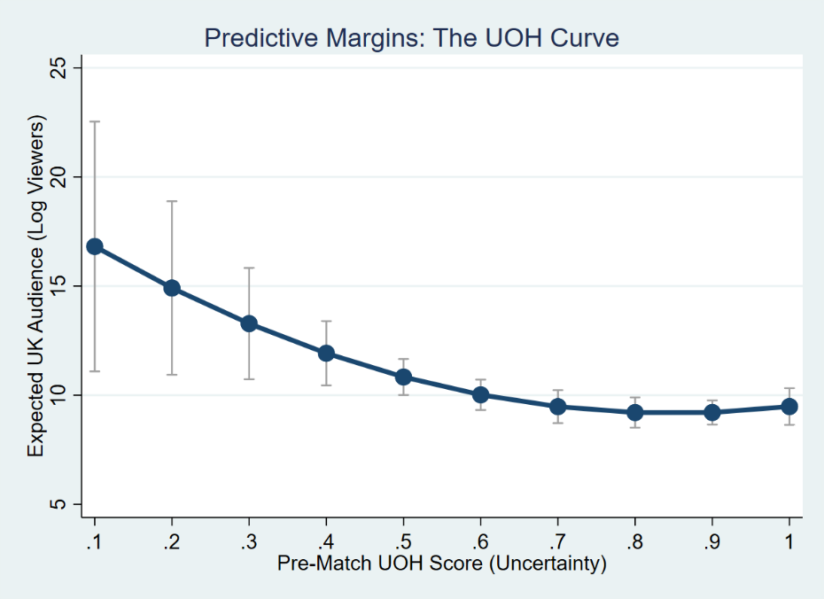
Figure 3.2. Predictive Margins: The UOH Curve
Notes: Predictive margins represent the expected log-transformed audience demand across the continuum of pre-match uncertainty scores, given from the quadratic Random Effects specification in Table 4.5. Error bars represent 95% confidence intervals based on event-clustered standard errors.
To validate the empirical stability of the baseline findings, robustness checks and sensitivity analyses were executed. The Hausman specification test yielded a $χ^{2}$statistic that failed to reject the null hypothesis at the 5% confidence level (p-value > 0.05), confirming the use of the RE specification. Despite excluding the top 1% and 5% viewership and also excluding football (which exhibits an unequivocal larger average viewer count) entirely from the sample, the UOH Score estimate remained statistically significant. Furthermore, a placebo refutation test with a statistically randomised, normally distributed noise instead of UOH Score successfully dismissed the potential of a spurious correlation between audience demand and viewer uncertainty.

Conclusion
This project set out to address a gap in the intersection of media and sports economics: the limited availability of event-level broadcast and online viewership figures. A highly structured, scalable data collection pipeline was conducted to construct an original dataset to map the dynamics of UK sports media consumption across multiple sports. The preliminary results illustrate the large favouritism towards the demand for the FIFA Men’s World Cup relative to the other observed tournaments, of which UK athlete/team presence also increases average viewership. However, intra-match audience demand is heavily dictated by competitive balance and non-linear jeopardy.
Building upon this foundational dataset, future research and data expansion should focus on a few key recommendations. Firstly, expanding the dataset by merging the existing high-frequency viewership figures with time-stamped, in-game match events (e.g., goals scored, point-by-point tennis scores, simulation). This would enable the static pre-match competitive balance proxy to be replaced with a dynamically updating, time-varying UOH Score, capturing audience elasticity as match states change. Furthermore, there is a clear opportunity for this high-frequency methodological approach to be applied to subscription-based platforms (e.g., Sky Sports). Such investigation as to whether paying subscribers (audiences) realise a different elasticity of demand to domestic involvement and outcome uncertainty relative to free-to-air media consumers would improve upon the existing knowledge of the sports media economics space. Additionally, the constructed UOH probability metric adopted in this project is inherently designed for head-to-head formats, and conceptually it was not able to translate to a 156-field Golf event, thereby limiting cross-sport analysis universally. It is imperative for future researchers to design an UOH metric which is appropriate to transfer from head-to-head events to such multi-competitor events. Finally, the dataset would benefit from pairing the concurrent BBC viewership counts with high-frequency social media scraping (e.g., counts of relevant sport hashtags during a contest). Ultimately, this would enable future models to determine whether digital audience retention is driven by active online talking points, in-contest events, and whether there is a difference between those consumers paying for the product relative to those who are not.

Bibliography
Alavy, K., Gaskell, A., Leach, S. and Szymanski, S., 2010. On the edge of your seat: Demand for football on television and the uncertainty of outcome hypothesis. International Journal of Sport Finance, 5(2), pp.75-95.
Bond, A. and Addesa, F., 2019. TV demand for the Italian Serie A: star power or competitive intensity?. Economics Bulletin, 39(3), pp.2110-2116.
Brown, J., 2011. Quitters never win: The (adverse) incentive effects of competing with superstars. Journal of Political Economy, 119(5), pp.982-1013.
Buraimo, B. and Simmons, R., 2008. Do sports fans really value uncertainty of outcome? Evidence from the English Premier League. International Journal of Sport Finance, 3(3), pp.146-155.
Buraimo, B. and Simmons, R., 2009. A tale of two audiences: Spectators, television viewers and outcome uncertainty in Spanish football. Journal of economics and business, 61(4), pp.326-338.
Cairns, J., Jennett, N. and Sloane, P.J., 1986. The economics of professional team sports: A survey of theory and evidence. Journal of Economic Studies, 13(1), pp.3-80.
Caruso, R., Addesa, F. and Di Domizio, M., 2019. The determinants of the TV demand for soccer: Empirical evidence on Italian Serie A for the period 2008-2015. Journal of Sports Economics, 20(1), pp.25-49.
Downward, P. and Dawson, A., 2000. The economics of professional team sports. Routledge.
Fahy, R., Butler, D. and Butler, R., 2026. Broadcasting demand for Formula One: Viewer preferences for outcome uncertainty in the United States. Managing Sport and Leisure, 31(1), pp.181-192.
Forrest, D., Goddard, J. and Simmons, R., 2005. Odds-setters as forecasters: The case of English football. International journal of forecasting, 21(3), pp.551-564.
Gooding, C. and Stephenson, E.F., 2017. Superstars, uncertainty of outcome, and PGA Tour television ratings. Journal of Sports Economics, 18(8), pp.867-875.
Johnsen, H. and Solvoll, M., 2007. The demand for televised football. European Sport Management Quarterly, 7(4), pp.311-335.
Madrigal, R., 1995. Cognitive and affective determinants of fan satisfaction with sporting event attendance. Journal of leisure research, 27(3), pp.205-227.
Nalbantis, G., Pawlowski, T. and Coates, D., 2017. The fans’ perception of competitive balance and its impact on willingness-to-pay for a single game. Journal of Sports Economics, 18(5), pp.479-505.
Neale, W.C., 1964. The peculiar economics of professional sports. The quarterly journal of economics, 78(1), pp.1-14.
Nüesch, S. and Franck, E., 2009. The role of patriotism in explaining the TV audience of national team games—evidence from four international tournaments. Journal of Media Economics, 22(1), pp.6-19.
Rottenberg, S., 1956. The baseball players' labor market. Journal of political economy, 64(3), pp.242-258.
Rottenberg, S., 2000. Resource allocation and income distribution in professional team sports. Journal of Sports Economics, 1(1), pp.11-20.
S. Mason, D., 1999. What is the sports product and who buys it? The marketing of professional sports leagues. European Journal of marketing, 33(3/4), pp.402-419.
Sutton, W.A., 1992. Marketing the core product in professional team sports in the United States. Sport Marketing Quarterly, 1(2), pp.7-19.
Wills, G., Tacon, R. and Addesa, F., 2022. Uncertainty of outcome, team quality or star players? What drives TV audience demand for UEFA Champions League football?. European sport management quarterly, 22(6), pp.876-894.

- Data Dictionary
The dataset consists of intra-match, high-frequency audience figures extracted from the BBC Sport website and pre-match betting odds of international summer sporting events in 2026.
- Observations: 1,025
- Variables: 38
- Panel Structure: Match ID (match_id), Snapshot Sequence (time_id)
Variable Name | Type |  | Description
Key Identifiers & Time Series Variables
$$match_id$$ | Categorical (Panel ID) |  | A unique identifier for every match created by grouping Competition, Data, and Home/Away Entities. Used as the panel variable ($i$).
$$time_id$$ | Continuous (Sequential) |  | A sequential chronological identifier for each snapshot taken within each distinct $match_id$. Used as the time variable for panel data ($t$).
$$Date$$ | Data |  | The date each snapshot was captured (formatted as $\%td$ in Stata).
$$UK_Time$$ | Datetime |  | The exact UK timestamp the snapshot was web scraped from the BBC Sport Live Page (formatted as $\%tc$ in Stata).
$$Day_of_Week$$ | Categorical (String) |  | The day of the week the snapshot occurred.
$$day_id$$ | Categorical (Numeric) |  | Categorical encoding of $Day_of_Week$ used for Fixed Effects modelling (1 = Monday, ..., 7 = Sunday).
$$Game_Time$$ | String |  | The live match clock at the time the snapshot occurred.
$$clock_num$$ | Continuous |  | The continuous numeric conversion of $Game_Time$ (excluding string values e.g., “HT”, “FT”, “ET”).
Match Metadata
$$Sport$$ | Categorical (String) |  | The primary sport (e.g., “Tennis”, “Football”).
$$sport_id$$ | Categorical (Numeric) |  | Categorical encoding of $Sport$ used in regression models.
$$Competition$$ | Categorical (String) |  | The specific tournament (e.g., “Wimbledon”, “FIFA World Cup”).
$$comp_id$$ | Categorical (Numeric) |  | Categorical encoding of $Competition$.
$$Stage$$ | Categorical (String) |  | The specific round of the competition (e.g., “Semi-Final”, “Round of 32”).
$$stage_id$$ | Categorical (Numeric) |  | Categorical encoding of $Stage$.
$$Venue$$ | Categorical (String) |  | The location/stadium where the match/event took place.
$$Country$$ | Categorical (String) |  | The host country of the match/event.
$$Home_Entity$$ | Categorical (String) |  | The designated home team or Player 1.
$$Away_Entity$$ | Categorical (String) |  | The designated home team or Player 2.
$$Filename$$ | String |  | The raw, timestamped html file name.
Core Econometric Variables
$$Viewer_Count$$ | Continuous (Count) |  | The concurrent live viewer count extracted from the BBC backend JSON.
$$Log_Viewer_Count$$ | Continuous |  | The natural logarithm of $Viewer_Count$ used as the primary dependent variable to normalise positive skew.
$$UOH_Score$$ | Continuous |  | The Uncertainty of Outcome Score ($P_{favourite}$). A continuous variable between 0.0 and 1.0, representing the pre-match implied win probability of the favoured competitor derived from betting odds.
$$UK_Involved$$ | Binary (Dummy) |  | A binary dummy indicator for domestic involvement: $1$ if a UK athlete/team is competing, $0$ otherwise.
$$Top_6$$ | Binary (Dummy) |  | A binary dummy indicator for star quality (proxy): $1$ features a top 6 seeded athlete/team in the contest, $0$ otherwise.
$$Is_Televised$$ | Binary (Dummy) |  | A binary dummy indicator: $1$ if the BBC broadcast included live viewer count and telemetry, $0$ if it was text/radio commentary only.
Constructed & Standardized Variables
$$match_phase$$ |  | Categorical (Ordinal) |  | A categorical variable mapping the live match clock into chronological bins for temporal visualisation of Football (e.g., 1 = “0-23 mins”, 2 = “24-45+ mins”).
$$macro_stage$$ |  | Categorical (String) |  | An aggregated grouping of competition stages for cross-sport comparisons (e.g., “Early Knockouts”, “Late Knockouts”).
$$macro_stage_id$$ |  | Categorical (Numeric) |  | Categorical encoding of $macro_stage$.
$$is_weekend$$ |  | Binary (Dummy) |  | Temporal control variable for whether a fixture was broadcast on a weekend or a weekday. 1 if Match Broadcast on Saturday or Sunday, 0 otherwise. Used to test for structural variations in UOH elasticity based on UK leisure time availability.
$placebo_UOH$* |  | Continuous |  | An artificial, time-invariant falsification parameter, consists of pure, normally distributed match-level noise ($N(0,1)$). Used strictly for post-estimation refutation tests to empirically diagnose any spurious correlation and validate baseline model.
$$z_Log_Viewer_Count$$ |  | Continuous (Standardized) |  | Standardized value (Z-score) of $Log_Viewer_Count$used for coefficient plotting.
$$z_UK_Involved$$ |  | Continuous (Standardized) |  | Standardized value of $UK_Involved$ used for coefficient plotting.
$$z_UOH_Score$$ |  | Continuous (Standardized) |  | Standardized value of $UOH_Score$ used for coefficient plotting.
Notes: * Variable constructed strictly for post-estimation placebo tests; not included in descriptive statistics or baseline estimations.

