

Republic Entertainment

Functional Specification

Christopher Dunne

15310866

CA400

***Table of Contents***

**1. Introduction**

1.1 Overview……………………………………………………………………….3

1.2 Business Context………………………………………………………………3

1.3 Glossary……………………………………………………………………….4

**2. General Description**

2.1 Product/System Functions…………………………………………………..4

2.2 User characteristics and objectives……………………………………….. 5 2.3 Operational Scenarios……………………………………………………….6 2.4 Constraints……………………………………………………………………11

**3. Functional Requirements**

3.1 External Interfaces…………………………………………………………...12

3.2 Sign Up register………………………………………………………………12

3.3 Sign In…………………………………………………………………………13

3.4 Complete Tasks……………………………………………………………....13 3.5 Buying Tickets…………………………………………………………….......13 3.6 Android/iOS……………………………………………………………...........14 3.7 Internet Connection…………………………………………………………...14

3.8 Adaptable UI……………………………………………………………………16

**4. System Architecture**

4.1 Application Components……………………………………………………….17

**5. High-Level Design**

5.1 Figure 5.1 explained…………………………………………………………....18 5.2 Figure 5.2 explained…………………………………………………………….19

5.3 Use Case Diagram ……………………………………………………………..20

5.4 Dataflow Diagram………………………………………………………………..21

**6. Preliminary Schedule**

6.1 GANNT Chart …………………………………………………………………….22

6.2 Proposed Schedule……………………………………………………………….23

**7. Appendices**…………………………………………………………………………24

1. ***Introduction***
   1. Overview

Republic Entertainment is a smart marketing tool for entertainment companies. The app will allow companies to connect with their customers and give them something back. The app will show different upcoming events and allow customers to buy tickets for these events.

But the main part of the app is the rewards section, here the customer will be rewarded for certain tasks he/she carries out. When the client performs a task they will be rewarded by obtaining points.

The customer can obtain different items at events determining the amount of points they have. There will be different prizes at different point stages. For example 5 points may get you free cloakroom at a certain event, whereas 1000 points could get you tickets to Electric Picnic. The task that will be performed by the user will in turn help the entertainment company.

The task will be things such as “like” or “follow” the companies page on Facebook. The idea of the app is to connect more and more of the entertainment niche and provide an even better experience for the customer.

* 1. Business Context.

The target demographic for the app would be for people between the ages of 17 - 30. Mainly people who are actively going to different social events and in more need of discounts. This app will be a smart approach to marketing. You are immediately targeting your niche market, your customers are your marketing team without them realising it. To gain rewards they need to share on social media. The average young person has 500 friends, of them 1 fifth of their followers will then be interested by the event as they share the same interests. As Douglas Rushkoff quoted “Social media is itself as temporary as any social gathering, nightclub or party. It's the people that matter, not the venue. So when the trend leaders of one social niche or another decide the place everyone is socializing has lost its luster or, more important, its exclusivity, they move on to the next one, taking their followers with them”

* 1. Glossary
* **API** – Application Programming Interface: A software intermediary that allows applications to talk to each other.
* **Social Media**: Websites that allow users to post and share content or participate in a social network.
* **React**: An open source java script library.
* **QR code**: A machine readable code consisting of an array of black and white squares typically used for storing information that can be read by a camera on a smart phone.

1. ***General Description***
   1. Product/systems Functions

The primary goal of this app is smarter marketing for entertainment companies. You’re rewarding your customer by advertising for your company by something as simple as sharing a post on Facebook or following an Instagram page. It will build a much larger audience for the company while allowing them to further identify their niche. Below is a list of the main functions of the project, which is preliminary as it may need to be changed as the app develops, but should be very close to what the app will contain.

* Sign up
* Sign in
* Upcoming events
* Buy tickets
* Prizes
* Claim prize
* Analysis of tasks
* Read/ write reviews
* View profile
* Wallet for QR codes

This will be explained in greater detail in the functional requirements.

* 1. User Characteristics & Objectives.

The main users of the app will be people attending events. I would imagine the majority of the audience would be in their late teens to mid-20s. It will allow users to see all events that are coming up and if tickets are necessary they will be able to buy them through the app.

Then there is the reward section which will allow the user to carry out certain tasks. Some of these tasks will be linking up with social media accounts such as Facebook, Instagram and Twitter. This is where the user will help promote the company by carrying out tasks like sharing upcoming events or content which the company releases.

If the user decides to carry out the tasks, they will be rewarded. The reward will operate on a point based system and will allow the user to opt out at any stage. This means the user can opt out at 10 points where he may be able to receive a free cloakroom voucher, but if he continues using the app and carrying out tasks and building up these points they could reach up to 1000 points, this may entitle them to a ticket for electric picnic. If the user decides to opt out at any point, a barcode will be generated, the amount of points the user has built up will determine what “treat” they are entitled to.

The users will be able to monitor their progress of performing all the tasks and maybe see what they could avail of with potential points.

* 1. Operational Scenarios.

With the current proposed design the operational scenarios are as follows.

|  |  |
| --- | --- |
| Use Case 1 | Register |
| Goal in Context | User Registers |
| Preconditions | User hasn't already registered and has a valid email account |
| Successful end conditions | User becomes registered |
| Failed end Condition | User is not able to register |
| Primary Actor  Secondary Actor | User  Database |
| Trigger | User clicks register Button |
| Description 1. | User selects register |
| 2. | They enter required credentials |
| 3. | Database stores user details |
| 4. | User is registered |

|  |  |
| --- | --- |
| Use Case 2 | Sign in |
| Goal in Context | User signs in to the app |
| Preconditions | User has already registered |
| Successful end conditions | User successfully logged in. |
| Failed end Condition | User is not able to log in |
| Primary Actor  Secondary Actor | User  Database. |
| Trigger | User clicks Login Button |
| Description 1. | User clicks login |
| 2. | Enters email and password |
| 3. | Database is checked to see if they match |
| 4. | User is signed in |

|  |  |
| --- | --- |
| Use Case 3 | Complete Task |
| Goal in Context | User carries out task on Social media site |
| Preconditions | User is logged in |
| Successful end conditions | User carries out selected task |
| Failed end Condition | User can’t carry out task |
| Primary Actor  Secondary Actor | User  Social media site |
| Trigger | Click on selected task |
| Description 1. | Selects chosen task |
| 2. | Brought to social media site |
| 3. | Carries out action |
| 4. | Rewarded points for action |

|  |  |
| --- | --- |
| Use Case 4 | Buy Tickets |
| Goal in Context | User buys ticket for event |
| Preconditions | Connected to ticketing api |
| Successful end conditions | Customer buys tickets |
| Failed end Condition | Customer can't buy ticket |
| Primary Actor  Secondary Actor | User  Ticketing Api |
| Trigger | Buy ticket button |
| Description 1. | User selects chosen event |
| 2. | Connects to ticketing Api |
| 3. | Eventbrite slides up and ticket is bought in the app |
| 4. | Can add ticket to wallet |

|  |  |
| --- | --- |
| Use Case 5 | Checks Profile |
| Goal in Context | See activity/history |
| Preconditions | Logged in |
| Successful end conditions | View points earned/ history of events |
| Failed end Condition | No display or incorrect details |
| Primary Actor  Secondary Actor | User  Database |
| Trigger | User clicks into user profile |
| Description 1. | User selects profile |
| 2. | He can then view event history |
| 3. | Check points earned |
| 4. | View upcoming events |

* 1. Constraints.
* **Time**.

Time will have a major part to play in the developing of the app. With the time allocated to get the project finished, i will be under quite a bit of pressure. With the learning that has to be done with react as I’ve never used it before and working with the different social media API’s, although I’m quite confident of getting the app to carry out all essential feature, but it will be designed so that it can be easily added to in the future.

* **Testing**

The most important thing is that the app works and is easy to use for the intended user, I plan on releasing a prototype of the app to an entertainment company and get some real life feedback, which will be very useful, as I’ll be able to see if it will be able to work with a large number of users and if it will carry out all its intended purposes properly.

* **Security**

Primary users of this app will be young adults. User must register using their email account. This will be verified when signing in. Security protocols must be carried out to ensure the safety of our user’s details.

* **Social Media API’s**

I have to work with different social media platforms and make sure that when they carry out different tasks on the social media the account the app will work coherently with them. The user should have same ease of connecting across all social media accounts.

* **Social Media Permissions.**

The various social media platforms which i intend using may all have different security checks when accessing certain part of the platform

1. .***Functional Requirements***

The following functional requirements include software and hardware interfaces, as well as the main functionality of the app itself.

* 1. External interfaces

Software Interfaces

SQL Database:

The database will be used to hold user information and a record of task completed and points collected.

* 1. Sign Up / Registration

**Description.**

This is the first step for every new user of our application. Each

User must enter a valid email and create a password in order to make a profile.

**Criticality.**

It is essential that each users an account registered in order to use the app.

**Technical Issues.**

Username/Email must be unique. It is important that a new user is not able to sign in with previously used credentials.

**Dependencies.**

Depend on if user has a valid email account and creates a valid password.

* 1. Sign in

**Description.**

The user will have to provide the email and password used when the account was originally created.

**Criticality.**

Like sign up it is critical that each member has an account to use the app.

**Technical Issues.**

Each login must be different and must match with the correct user.

**Dependencies.**

All depending on whether the username has been registered on the database and they then enter correct credentials.

* 1. Complete tasks

**Description.**

User will be given a list of different tasks which they can carry out, at their own discretion. These task will be carried out by connecting to the different social media accounts and promoting the company by sharing or liking their content.

**Criticality.**

Probably the most important aspect of the app. It is essential that it is carried out because I want to make sure the user are actually completing the task and that they are rightfully rewarded for what they do.

**Technical Issues.**

Since there are so many different API’s that are being connected and it is so important we know for sure that a user has carried out a task and the correct points have been allocated to their accounts.

**Dependencies.**

This depend on if the app is connected correctly to all the different API’s.

* 1. Buying Tickets

**Description.**

User will be able to buy tickets to upcoming events throughout the App. This will be done by connecting to companies like Eventbrite and in & out API’s.

**Criticality.**

This is also another important aspect, it is not essential however but it is something which I’d like to have included in the app.

**Technical Issues.**

I will have to connect to both Eventbrite’s and in & out API. This may prove difficult to keep it coherent with my app, but it's a feature which I have seen already being used in apps like Instagram.

**Dependencies.**

Connecting to Eventbrite API and the other ticket company in & out.

* 1. Android/IOS

**Description.**

The application will require that the user’s device is running an

Android or iOS operating system. As the app will be developed using React Native.

**Criticality.**

Fundamental

**Technical Issues.**

User must be running an Android version of 4.2 or higher on Android and iOS version or higher in order for the app to function correctly.

**Dependencies.**

Requires a device with Android or iOS operating system and the application downloaded on the device.

* 1. Internet Connection

**Description.**

The device must have an active internet connection, either using Wi-Fi or mobile data.

**Criticality.**

Fundamental

**Technical Issues.**

Internet connection is needed for the app to be able to access the server/database and send data back and forth for information regarding the catalogue and news.

**Dependencies.**

Require devise with either android or iOS operating system.

* 1. Adaptable UI

**Description.**

With android running over 2 billion devices and ios running over

1.3 billion Worldwide, screen sizes and ratios can vary.

Applications which look good on tablets may not look as good on smaller sized screens. Positions and fonts may be broken or

Hindered which must be accounted for.

**Criticality.**

High.

**Technical Issues.**

Using react, the application adapts depending on the device. But since it's my first time creating an app I’m not sure how well this will work out.

**Dependencies.**

This is one of the main reasons why I chose to do my project in react native as it is so adaptable to many different devices.

1. ***System Architecture***

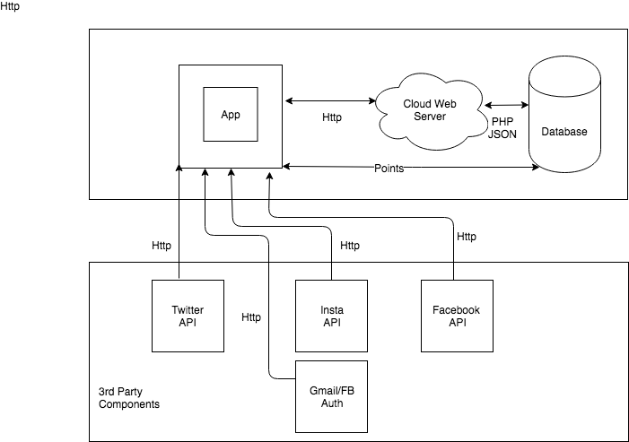

* 1. Application Components.

The application will be written using react. It will provide a graphical user interface. A cloud web server will also be deployed

In order to deploy a database which will be used to store all necessary information.

1. ***High Level Design***

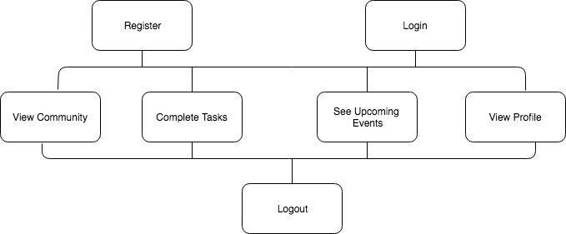

* 1. Description

The high-level design of the systems functionality can be seen in the diagram above. The user will begin the application by registering with their information. Upon successful registration, they can proceed to login. Once logged in the user can navigate through the application by viewing the different sections in the application. See upcoming events, buy tickets, carry out tasks, claim rewards and view their profile. The user will be able to log out of the application too.

* 1. User Interface Mock Ups

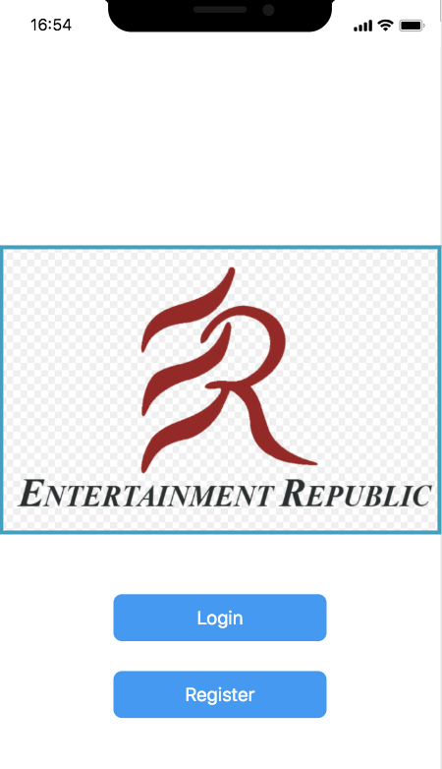 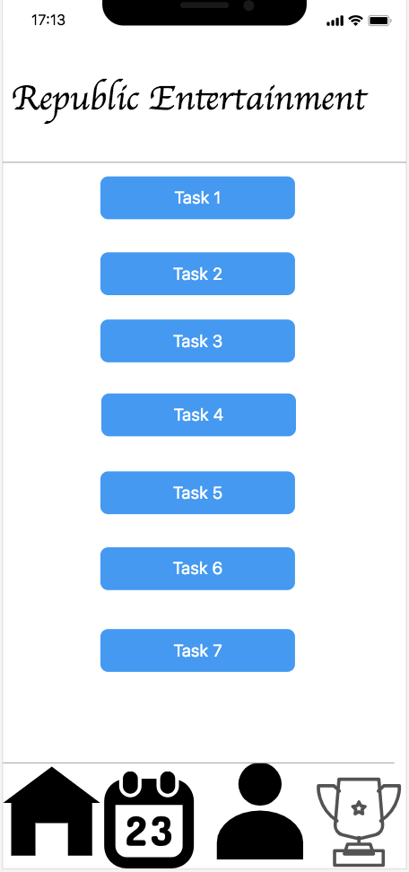

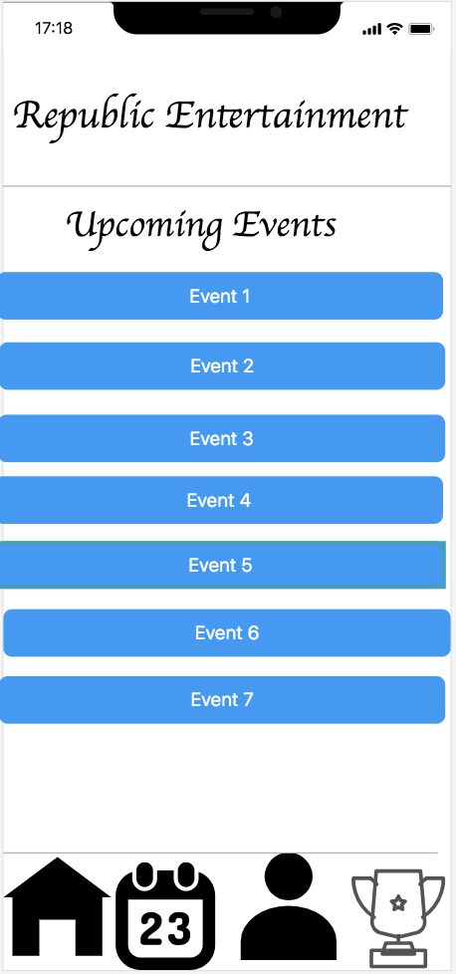 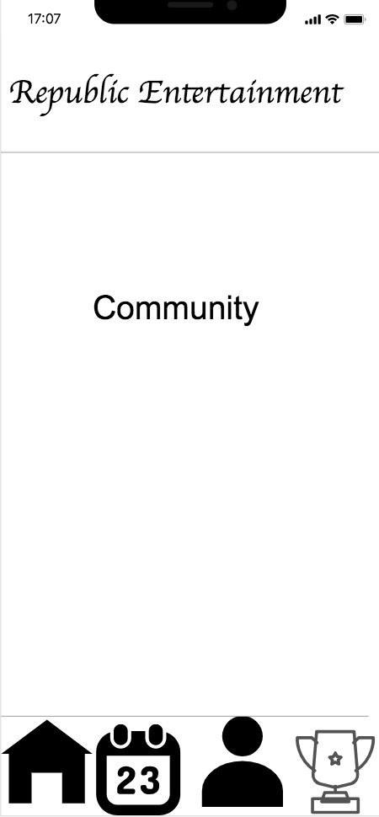

* 1. Use Case Diagram.

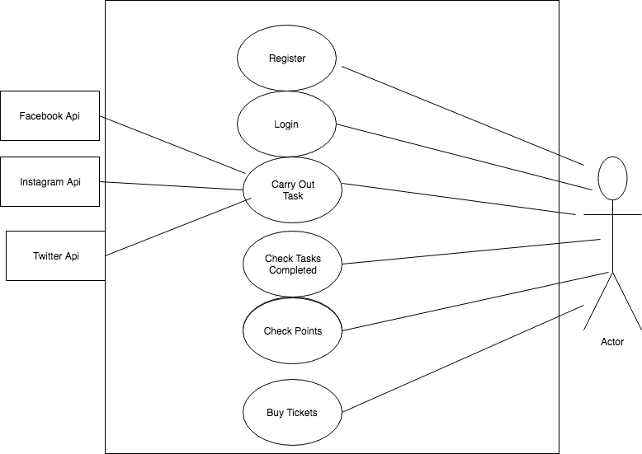

* **Description.**

The following diagram illustrates a typical use of the application by a typical user.

Here is a typical flow of the basic functionality of the app in regards to external parties such as the user and different social media accounts.

* 1. Data Flow Diagram.

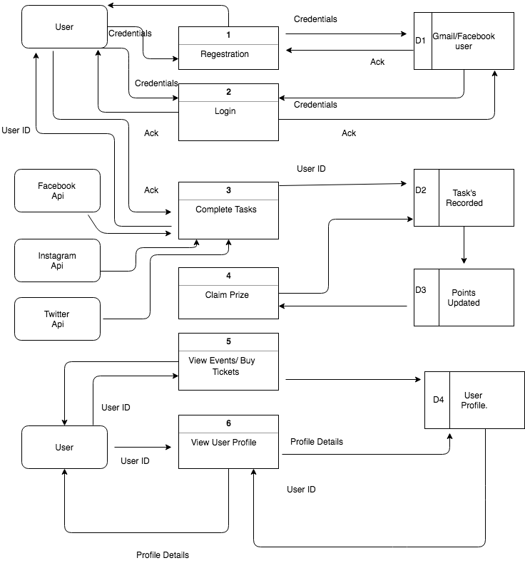

* **Description.**

The above diagram represents the processing of data flow in between various inputs and outputs. Inputs include our typical user carrying out different aspects of the application. There will be four different data store, which will process and combine the data it receives from various inputs. The data will be displayed to user once request is made.

1. ***Preliminary Schedule.***

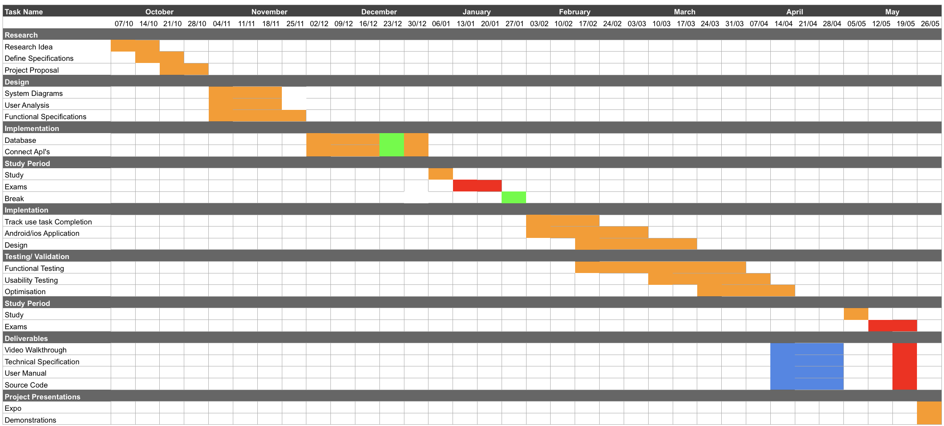

* 1. GANNT Chart

On the above GANNT Chart, you can see my current schedule for the project. I’m well in to my research period and begging to make a start on the framework. On the above GANNT Chart, you can see my current schedule for the project. I’m well in to my research period and begging to make a start on the framework.

I aim to have the database, server and login working by the end of December early January. This is only a rough estimation as I will have exams in mid-January which will take up some time. I intend on having most of the application completed by the end of March. The reason for this is so i can really focus on testing the application. Also so I can release a prototype of the app with an entertainment company to get the app working and try fix as many bugs and errors as possible.

* 1. Proposed Schedule

|  |  |  |
| --- | --- | --- |
| **Activity** | **Start** | **End** |
| **Research & Requirements Gathering** | **24/09/18** | **1/11/18** |
| **Functional Specification** | **1/11/18** | **25/11/18** |
| **Environment Setup** | **11/12/18** | **15/12/18** |
| **Research & Learning** | **11/12/18** | **29/01/19** |
| **Setting up server & database** | **20/12/18** | **23/12/18** |
| **Authentication and login** | **23/12/18** | **26/12/18** |
| **Start Connecting Api’s** | **26/12/18** | **3/02/18** |
| **Creating User profile.** | **21/01/19** | **25/01/19** |
| **Create community area** | **05/02/19** | **10/02/19** |
| **Create upcoming events** | **10/02/19** | **20/02/19** |
| **Testing** |  |  |
| **Optimisation** |  | **19/05/19** |
| **Final Deliverable** | **19/05/19** |  |

1. ***Appendencies***

<https://reactjs.org/>

<https://developers.facebook.com/>

<https://www.instagram.com/developer/>

<https://developer.twitter.com/content/developer-twitter/en.html>