CS 255 Project Two: DriverPass System Design Document
Amanda Dunn
Southern New Hampshire University
CS 255: Systems Analysis and Design
Professor Norm Lippincott
October 18, 2026
UML Use Case Diagram

Figure 1: DriverPass Use Case Diagram
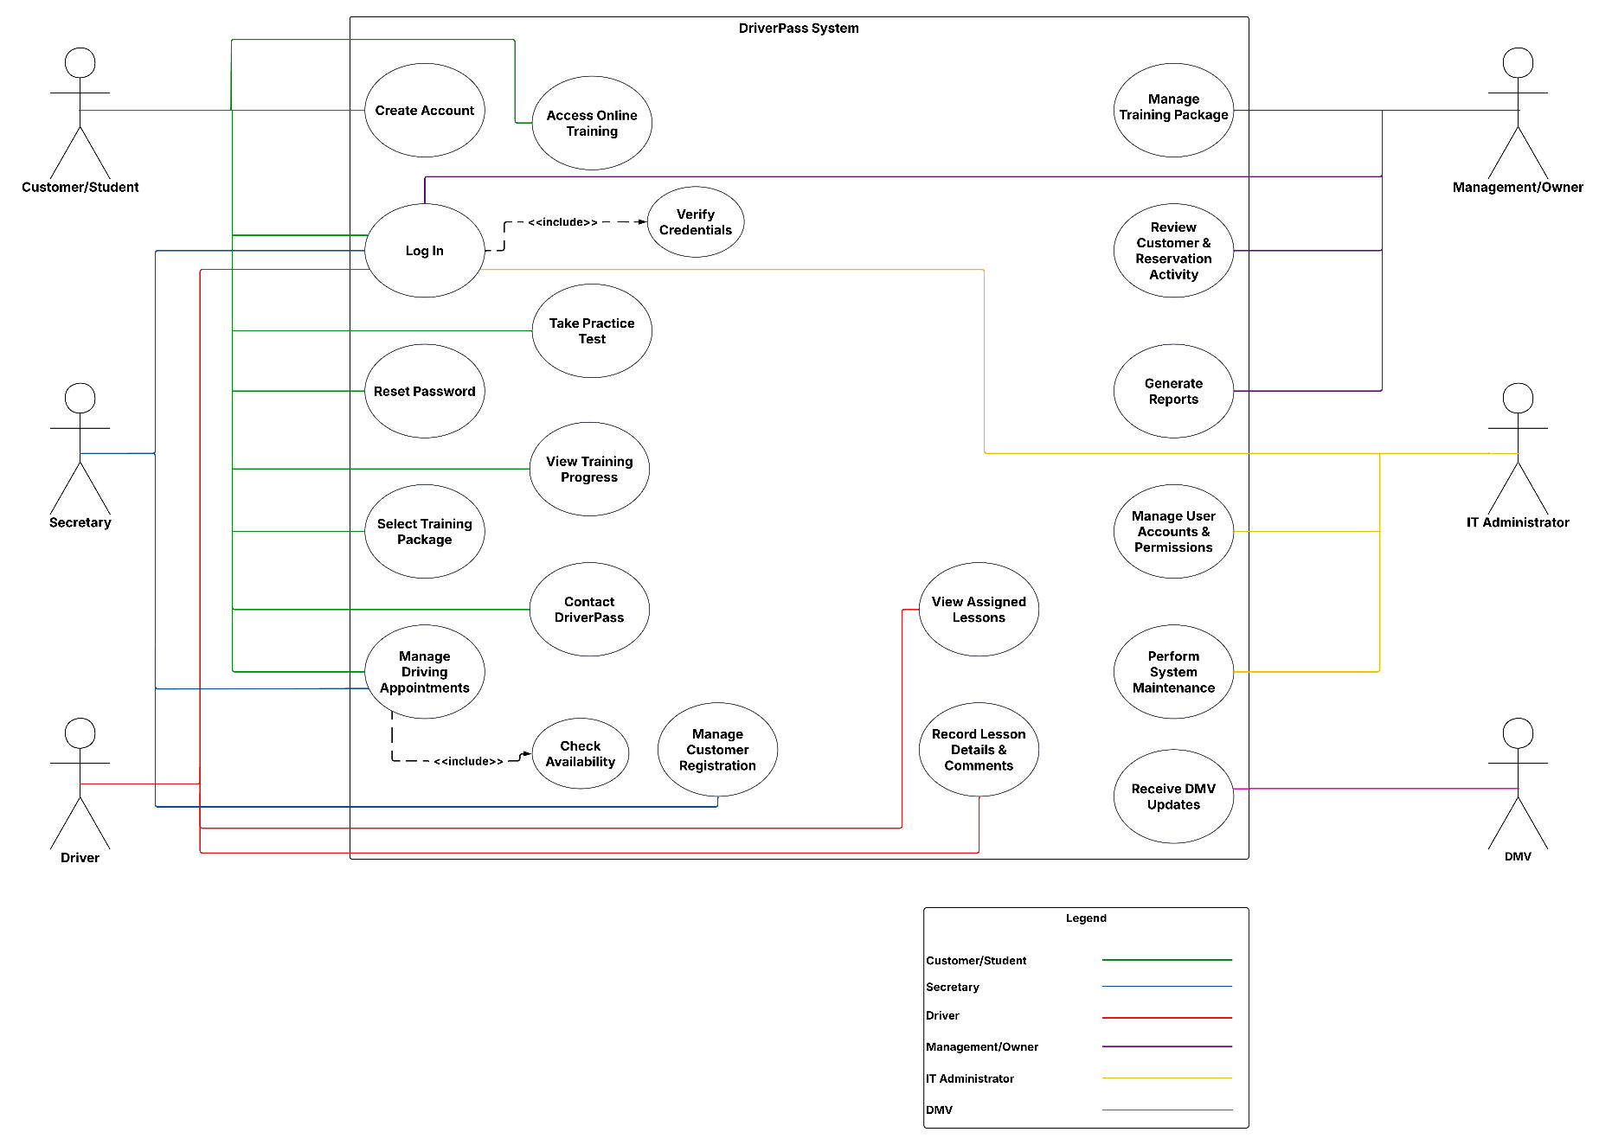

UML Activity Diagrams
Figure 2: Schedule Driving Lesson Activity Diagram
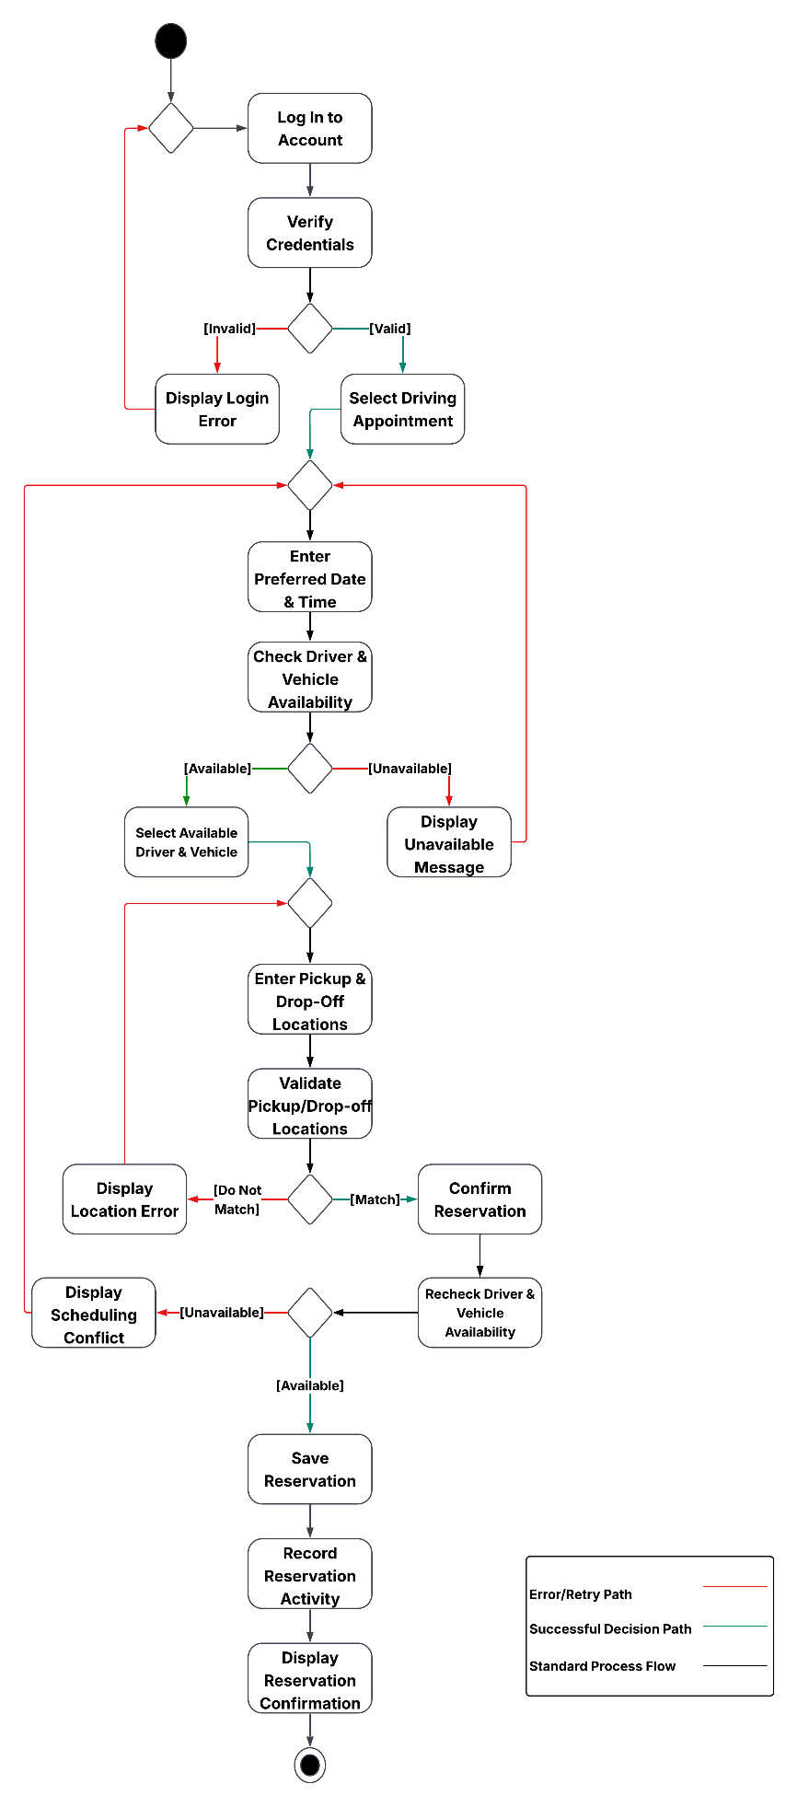

Figure 3: Complete Practice Test Activity Diagram

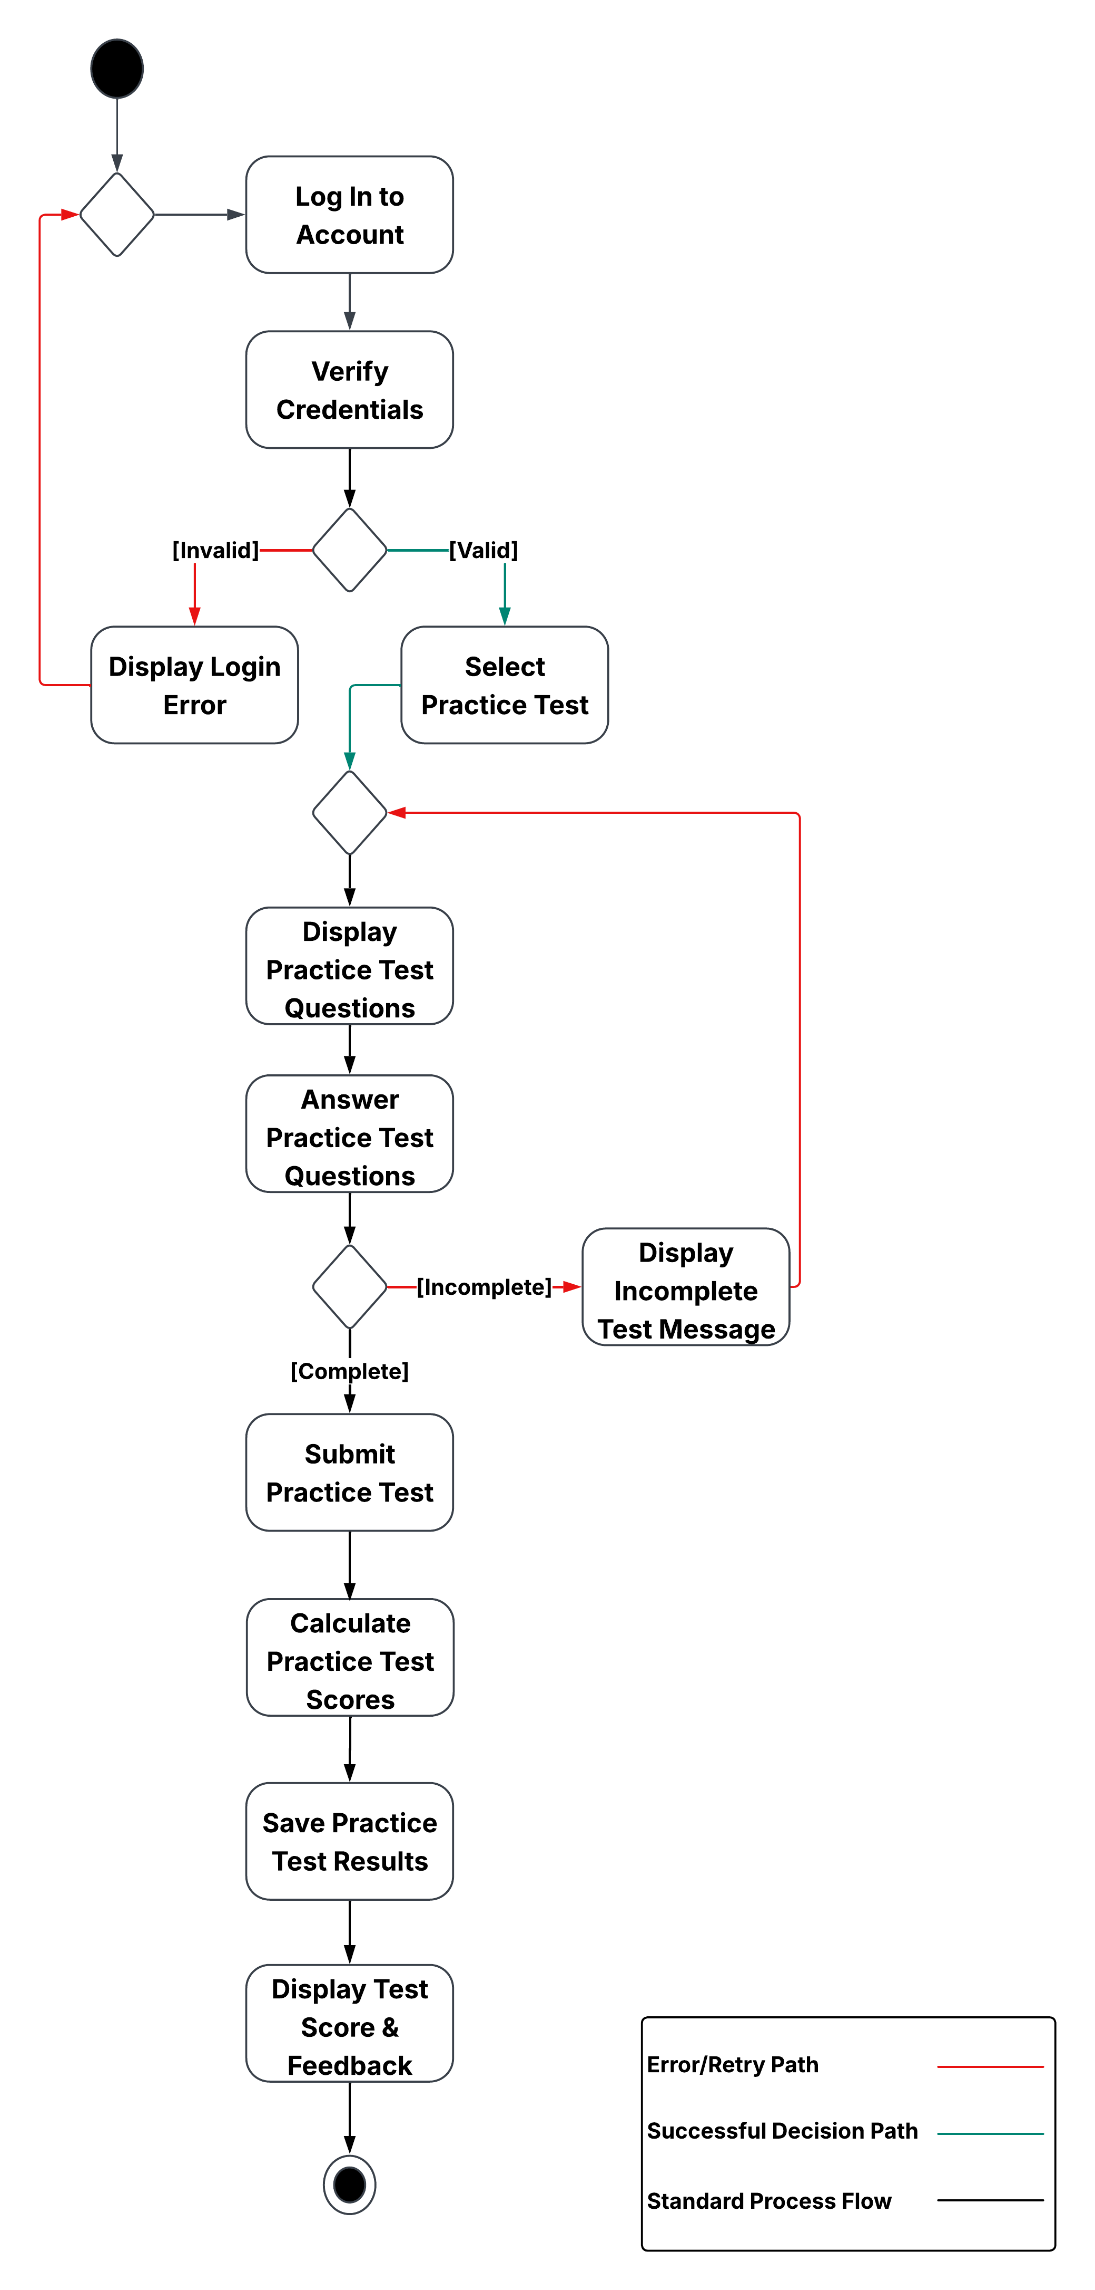

UML Sequence Diagram
Figure 4: Schedule Driving Lesson Sequence Diagram
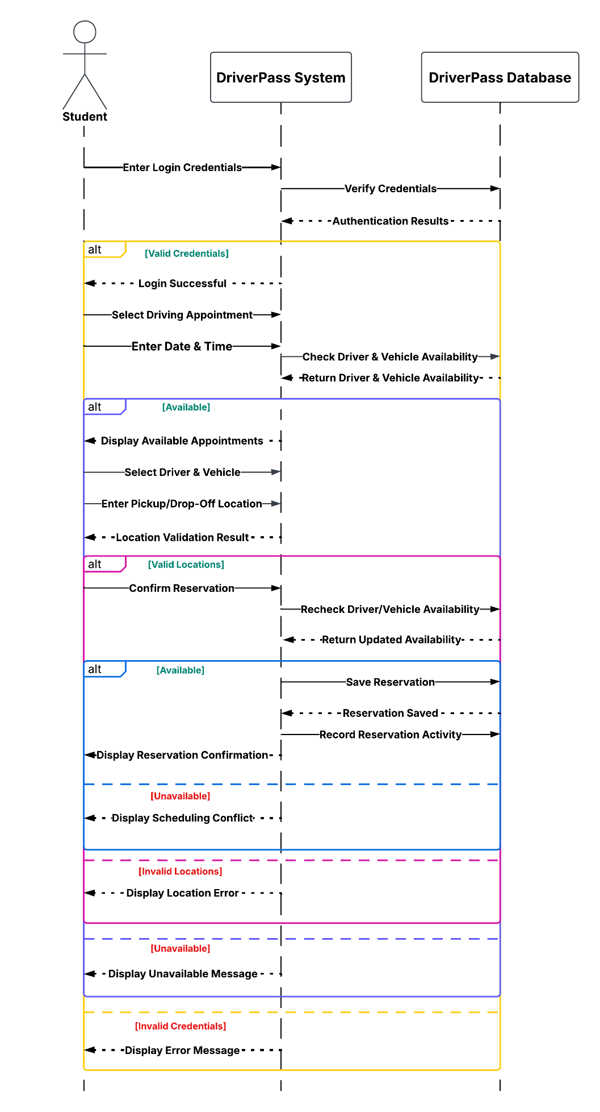

UML Class Diagram
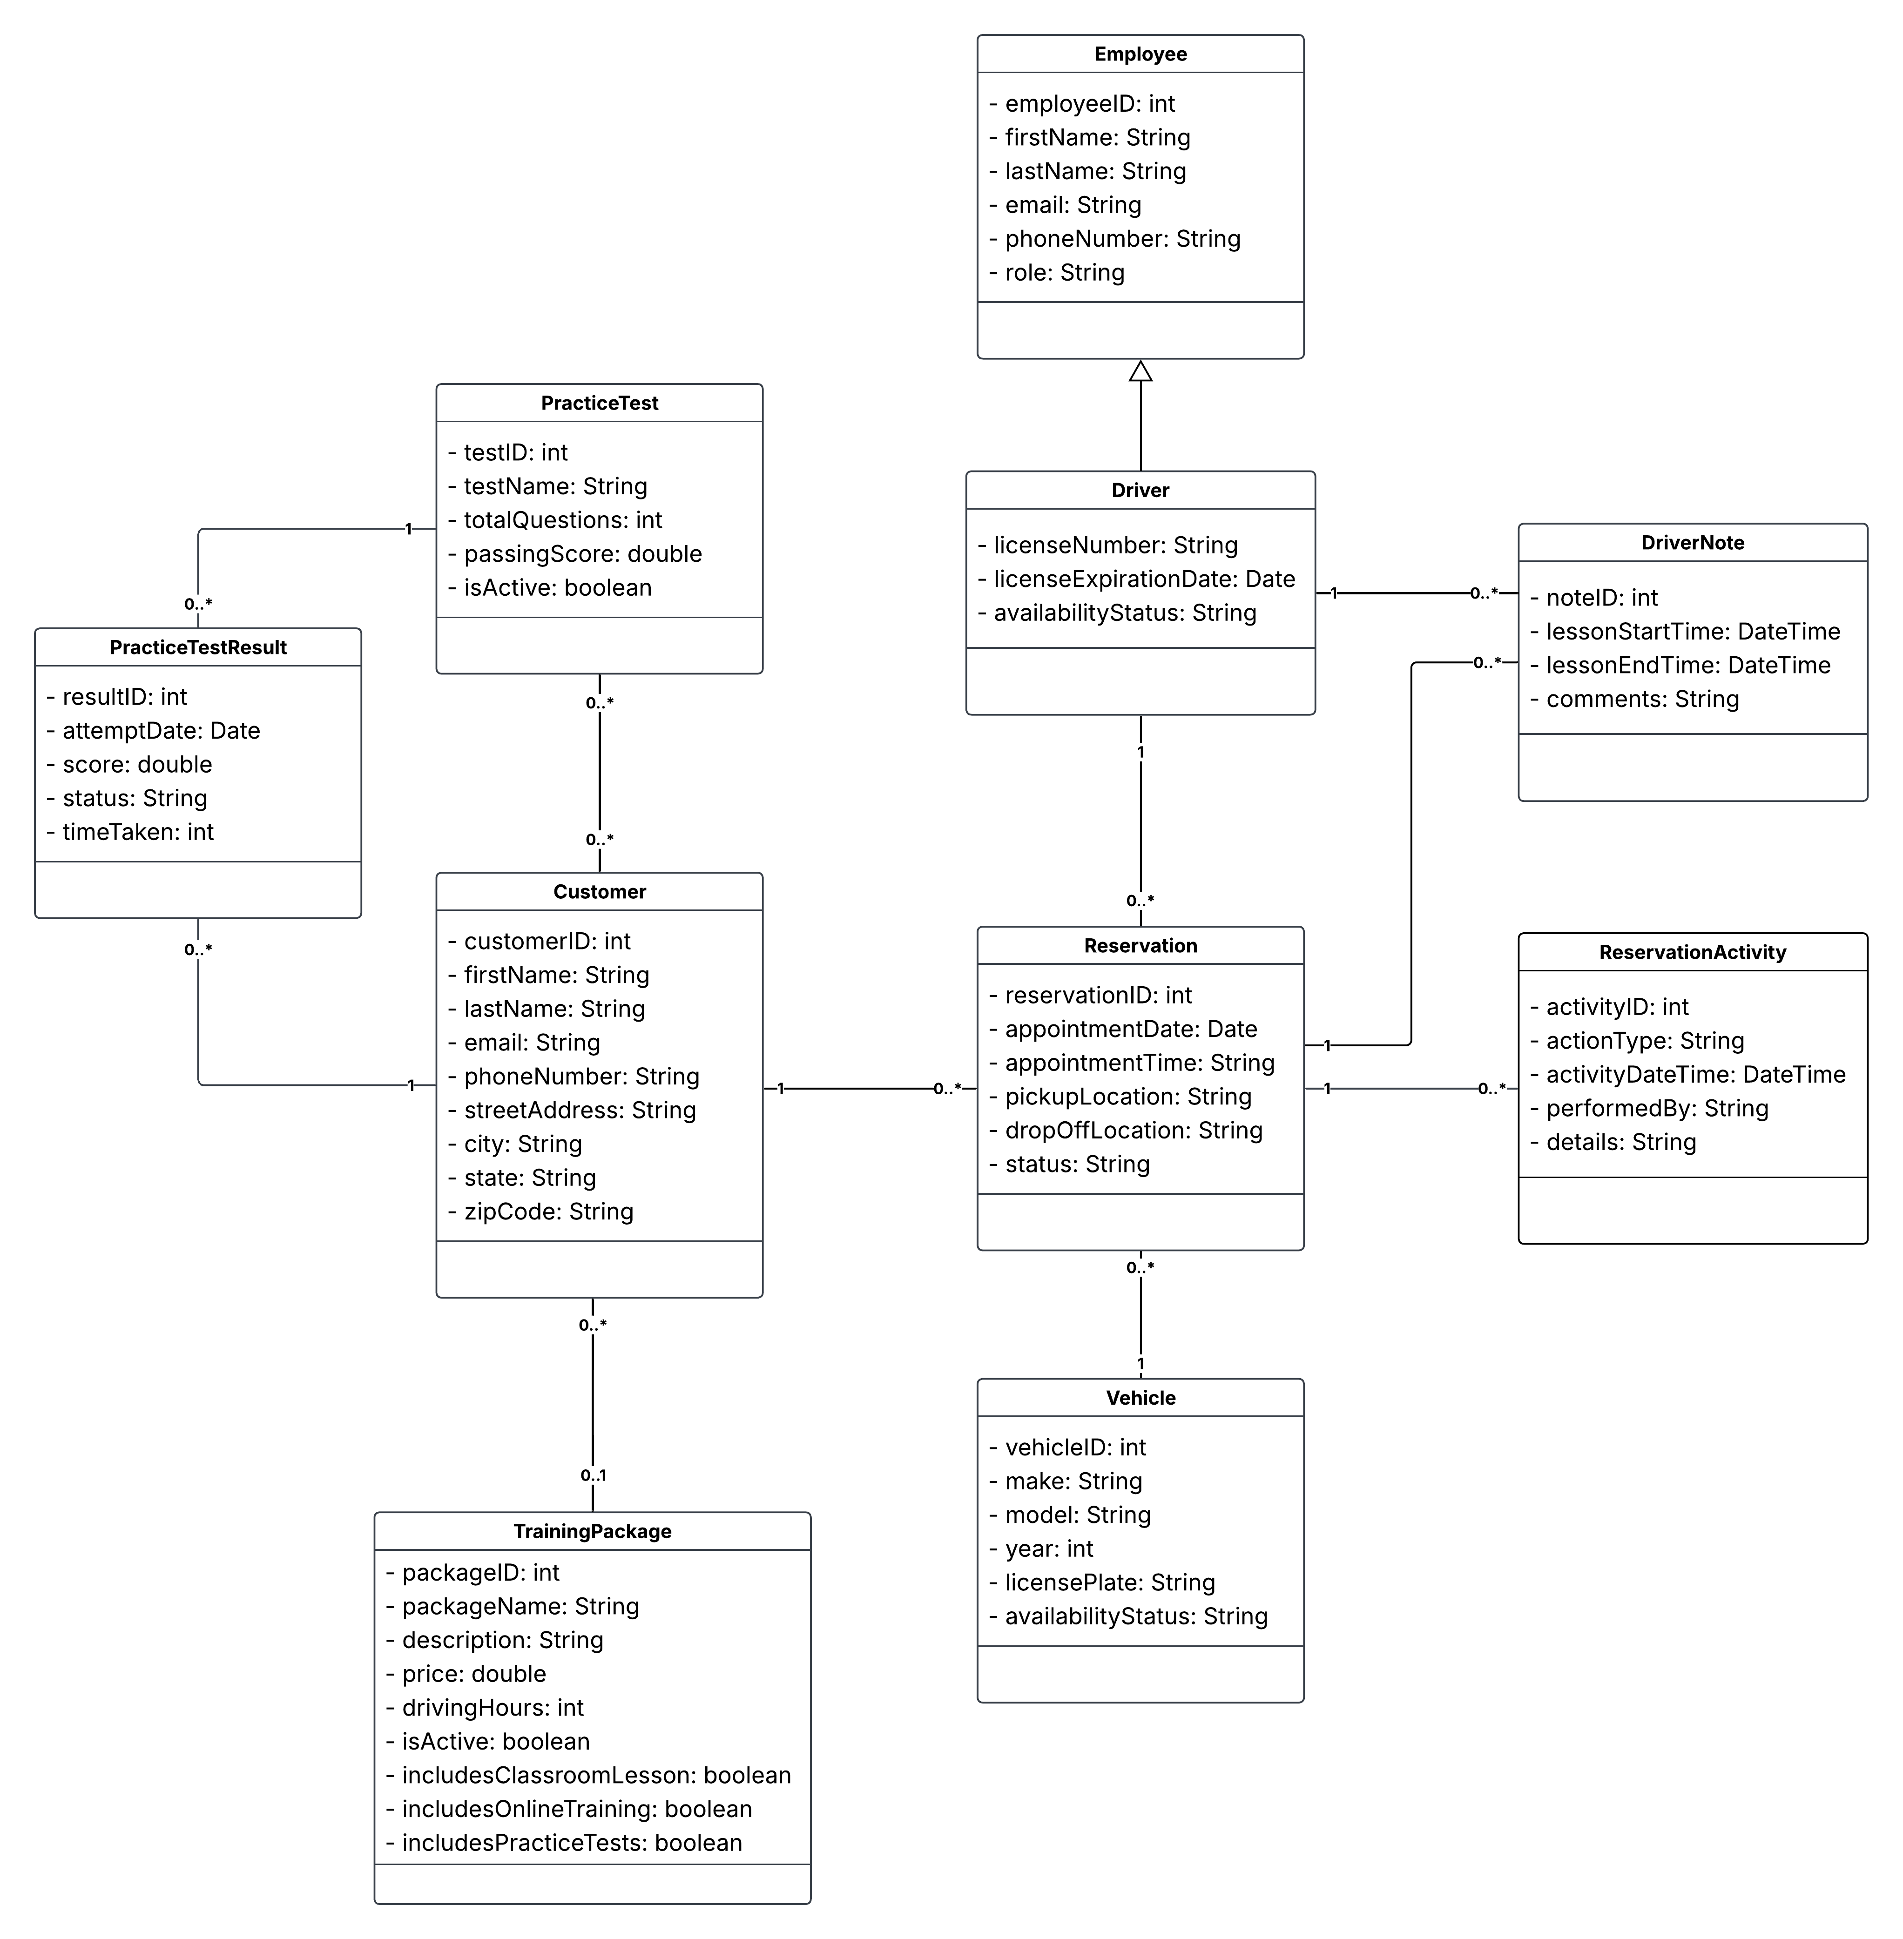
Figure 5: DriverPass Class Diagram

Technical Requirements
DriverPass will use a cloud-based system so customers and employees can access the application without having to be at the business location. Since the system will run through a web browser, customers can use their computers, tablets, or smartphones to access training materials, take practice tests, and schedule driving lessons without installing additional software. Employees will also need internet-connected devices to manage appointments, review customer information, and complete their daily responsibilities. Hosting the application and database in the cloud will allow DriverPass to store its information in one location without having to purchase and maintain its own servers.
The DriverPass software will need to handle several functions, including customer registration, training packages, appointment scheduling, and practice tests. A central database will keep track of customer and employee information, driving lessons, assigned drivers and vehicles, and student progress. When a customer schedules a driving lesson, the system will need to check whether the selected driver and vehicle are available before confirming the reservation. It should also keep a record of any changes made to appointments, including who made them. Practice test results and training progress will be stored with each customer's information so both students and authorized employees can review their progress over time.
Since DriverPass will store personal information and student records, the system will need security measures to protect that data. HTTPS and TLS encryption will help keep information secure as it travels between the user's browser and the application. Users will need to log in to their accounts, and their permissions will determine which parts of the system they can access. For example, customers should be able to view their own training progress and appointments, while management and IT administrators will have access to additional functions based on their responsibilities. The cloud service will also need regular database backups and reliable availability so DriverPass can maintain the system without causing unnecessary interruptions for customers or employees.
Developers will need tools to build, test, and maintain the DriverPass application and its database. Version control will help keep track of changes made during development, while software testing tools will be needed to check that features such as account login, appointment scheduling, and practice test scoring work correctly. DriverPass will also need a way to generate downloadable reports so management can review business information outside the system. Since DMV rules and testing requirements can change, the system should provide a way for DriverPass to receive and review updates so its training materials and practice questions can be kept current.

