1 - After downloading RUFUS and Raspberry Pi - Buster Lite.



2 - Run the Rufus.exe.

3 - Make sure you have the correct device selected and under Boot selection, click the SELECT button and choose the buster-lite iso zip.

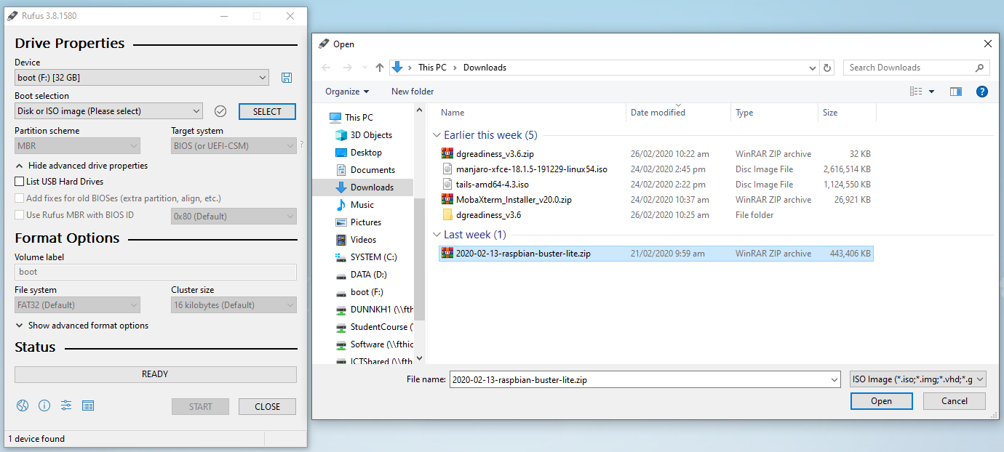

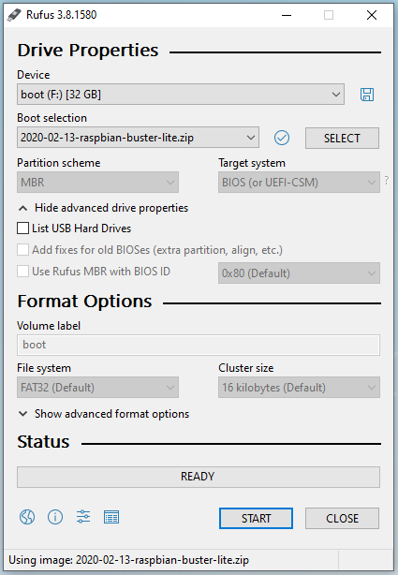

4 - Rufus should be ready to write the image to your SD card via SD card reader aka Device. Click Start to run transfer.

5 - Once Rufus has completed the transfer. Remove the SD card and insert it into the desired Raspberry Pi.