Tutorial : 1

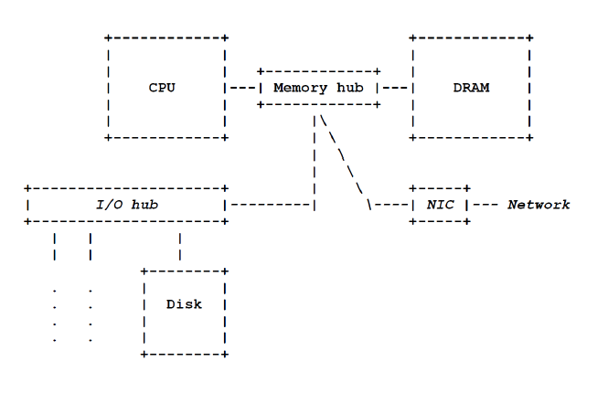A picture of a (standalone) uniprocessor (circa 2003)

Computer components:

The 3 most basic computer components are:

* The processor
* The Memory System - DRAM
* The Storage System - Disk

An interconnection network (wires) shows how signals are transmitted among the 3 components.

A mechanism for transferring data to and from the outside world (I/O peripheral devices).

The processor talks directly to the memory but data must be moved from storage to memory before it can be accessed by the processor.

In larger computers, the interconnect system between processors and memories is an elaborate network.

* To achieve a high peak data-transfer rate between processors and memories, a high-bandwidth communication fabric is required.
  + Bandwidth: The maximum data transfer rate of a network or Internet connection. (E.g. 100 megabytes per second)
* A special processor that is able to sustain a significant fraction of that high bandwidth (i.e. keep itself supplied with useful data) is called a latency-tolerant processor.
* Presently, there is essentially none of these. But the computer industry is slowly recognizing the potential value.

Modern computers use direct point-to-point links (wires) between compatible devices for greater speed & bandwidth.

In contrast, a bus is a shared communication link (party line) that connects multiple subsystems.

The point-to-point interconnect between processors and memories can be designed to provide high peak bandwidth.

The bus interconnect between a processor and its peripherals is necessarily of low bandwidth because of the number and the diversity of the I/O devices that it serves.

The memory controller hub is the switch in the point-to-point network & I/O controller hub, the switch in the bus network.

A Reduced Instruction Set Computer, or RISC is a computer that has a small set of simple and general instructions. RISC allows a computer's microprocessor to use fewer cycles per instruction (CPI) when compared with CISC (Complex ISC)

Instruction Set Architecture (ISA) refers to an abstract model of a computer. ISA will be covered later in the course.

RISC-V is an open-source hardware ISA based on established RISC principles. Used largely for academic purposes.

Unlike other academic designs which are optimized only for simplicity of exposition, the designers state that the RISC-V instruction set is for practical computers.

RISC ARCHITECTURE FEATURES:

Direct hardware implementation of instruction set

Fixed instruction size

Small number of addressing modes

Reduced memory access — Only load and store instructions access memory.

Ease of pipelining — The instructions are designed to be easily divisible into parts.

A floating-point coprocessor

TYPES OF MEMORY

Internal Memory (aka Primary Memory): Stores relatively smaller amounts of data that can be accessed quickly while the computer is running.

* ROM: Read-only memory. Boot up data retained without power.
* RAM: Random Access Memory. Stores data to be processed by CPU.
  + SRAM: Static, keeps data as long as power is on, expensive.
  + DRAM: Dynamic, has to be refreshed to keep data, cheaper.

External Memory (aka Secondary Memory): Refers to external, embedded, or removable storage devices that are used to store larger amounts of data permanently.

Measures of capacity and speed:

•Kilo- (K) = 1 thousand = 103 and 210

•Mega- (M) = 1 million = 106 and 220

•Giga- (G) = 1 billion = 109 and 230

•Tera- (T) = 1 trillion = 1012 and 240

•Peta- (P) = 1 quadrillion = 1015 and 250

•Exa- (E) = 1 quintillion = 1018 and 260

•Zetta- (Z) = 1 sextillion = 1021 and 270

•Yotta- (Y) = 1 septillion = 1024 and 280

Hertz = clock cycles per second (frequency)

1MHz = 1,000,000Hz

Processor speeds are measured in MHz or GHz.

Byte = a unit of storage

1KB = 210 = 1024 Bytes

1MB = 220 = 1,048,576 Bytes

1GB = 230 = 1,073,741,824 Bytes

1TB = 240 = 1,099,511,627,776 Bytes

Main memory (RAM) is measured in GB

Disk storage is measured in GB for small systems, TB (240) for large systems.

Computers with large main memory capacity can run larger programs with greater speed than computers having small memories.

RAM is an acronym for Random Access Memory. Random access means that memory contents can be accessed directly if you know its location (memory address).

Cache is a type of temporary memory that can be accessed faster than RAM.

Computers consist of many things besides chips.

Before a computer can do anything worthwhile, it must also use software.

Writing complex programs requires a “divide and conquer” approach, where each program module solves a smaller problem.

Complex computer systems employ a similar technique through a series of virtual machine layers.

THE COMPUTER LEVEL HIERARCHY

Example: You write a program in a high-level programming language. A compiler translates it into machine instructions (object code). The computer executes the object code.

* Level 6: The User Level
  + Program execution and user interface level.
  + The level with which we are most familiar.
* Level 5: High-Level Language Level
  + We interact with this level when we write programs in languages such as C and Java.
* Level 4: Assembly Language Level
  + Acts upon assembly language produced from Level 5, as well as instructions programmed directly at this level.
* Level 3: System Software Level
  + Controls executing processes on the system.
  + Protects system resources.
  + Assembly language instructions often pass through Level 3 without modification.
* Level 2: Machine Level
  + Also known as the Instruction Set Architecture (ISA) Level.
  + Consists of instructions that are particular to the architecture of the machine.
  + Programs written in machine language need no compilers, interpreters, or assemblers
* Level 1: Control Level (aka microarchitecture)
  + A control unit decodes and executes instructions and moves data through the system.
  + Control units can be microprogrammed or hardwired.
  + A microprogram is a program written in a low-level language that is implemented by the hardware.
  + Hardwired control units consist of hardware that directly executes machine instructions.
* Level 0: Digital Logic Level
  + This level is where we find digital circuits (the chips).
  + Digital circuits consist of gates and wires.
  + These components implement the mathematical logic of all other levels.

RISC MICROARCHITECTURE KILLERS MICROS

A microprocessor is a CPU on a single integrated circuit (IC) chip containing millions of very small components that work together.

A killer micro is a microprocessor-based machine that competes with mainframes and super computers. From 1979 to 2003, killer micros drove competing processor designs out of business.

Almost all computers today are powered by one or more killer micros: A cellphone has a cooling killer micro, probably an ARM (Advanced RISC Machine). A server has one or more killer micros, probably Intel Xeons.

Killer micros steadily got better in performance up until 2003.

Note that computers with the same processor could still differ in the quality of their memory system or the quality of their interconnect.

DESIGN CONCERNS

Users write programs (based on algorithms) to solve problems by computer.

Before designing computers, hardware vendors ask: What kind of programs do my best customers wish to run? This affects design and optimization.

Computer design, like all engineering design, is a series of trade-offs: performance, reliability, speed, etc.

Programs differ in their memory use, computational requirements, storage requirements, etc.

MEMORY USAGE

All computations must engage in communications, which is the major source of time spent and energy consumed by the computer. However, Memory usage is not the same among all programs:

Memory-access. One program never touches memory while another does.

Programs may use short-range or long-range channels depending on the type of communication (Temporal & Spatial Locality)

Programs can differ in their Arithmetic Intensity (measure of the number of arithmetic operations relative to the amount of memory accesses that are required to support these operations).

They can differ in their degree of data reuse.

They differ in the predictability of their memory-accessing patterns.

Is the program task-parallel or/and data-parallel?

PROGRAMS ARE DIFFERENT COMPUTE-INTENSIVE OR DATA-INTENSIVE

A compute-intensive program does more processing than data movement.

In contrast, a data-intensive program does more data movement than processing.

A compute-intensive program will suffer from a bottleneck if the computer has inadequate processing resources relative to its bandwidth capabilities (aka compute-bound)

A data-intensive program will suffer from a bottleneck if the computer has inadequate data-movement resources relative to its compute power (aka bandwidth-bound)

An imbalance between processing power and data-movement capabilities can lead to a performance bottleneck.



Program P1 is compute-intensive, running on computer A with low computing capacity and high-bandwidth interconnect.

Program P2 is data-intensive, running on computer B with high computing capacity) and low-bandwidth interconnect.

SUMMARY

Today, most computers are much better at computation than they are at communication

Hence, low-bandwidth communication can be the principle performance bottleneck.

More programs than you might imagine are data intensive in the sense that their arithmetic intensity is low.

Only highly compute-intensive programs are well matched to today's computers.

To fully understand this last statement, we need the concept of program's working set, which will be introduced later in the course

ARCHITECTURAL CREDO BY DR. PROBST

Computation today is limited by communication, not arithmetic.

Floating-point computation (one of the most expensive types of computation) is essentially free, in time and energy.

In contrast, off-chip bandwidth is limited to a few GWs/s and each word transferred consumes enormous energy.

Running the FPUs is not expensive but Feeding them with data is.

Since communication capability is so limited, we should try to:

* Exploit locality whenever possible to reduce our need for communication bandwidth.
* Tolerate sufficient network/memory latency through some form of parallelism to keep the limited bandwidth resources in our high-latency network/memory systems usefully busy.
* To summarize, we want to extract the highest possible sustained operand bandwidth from our limited bandwidth resources.

PARALLEL PROGRAMS

Parallel Computing: Multiple tasks running simultaneously.

Large computers are aggregates of uniprocessors, and hence are called multiprocessors.

On a multiprocessor or multi-core system, multiple threads can execute in parallel, with every processor or core executing a separate thread simultaneously.

An Important Issue: To what extent are the threads (coming from program decomposition) independent? In other words, to what extent do they communicate and synchronize?

An Embarrassingly Parallel workload or problem (aka perfectly parallel) can be easily separated into a number of parallel tasks.

CPUs (task-parallel) while Optimized GPUs (data-parallel)

MEMORY LATENCY MEMORY BANDWIDTH

A processor is able to sustain a high memory-request bandwidth of B memory requests per processor cycle.

This processor would benefit from a DRAM that can sustain a high memory-reply bandwidth of B memory replies per processor cycle.

In contrast, imagine a processor that issues a single memory request, and must wait for a reply before it can issue its next memory request. This processor would benefit from a DRAM that is able to reply quickly to a single memory request.

Memory Latency is the time between initiating a request for data ( byte or word) in memory until the data is retrieved by the processor.

CPUs have large, deep memory hierarchies to try to keep their processors busy but they are not very successful at running programs with irregular, unpredictable memory access patterns.

A LATENCY-TOLERANT PROCESSOR

A program's data is stored in the memory but can only be processed in the CPU.

A program might make a memory reference to retrieve an operand and then be forced to wait for the operand to arrive.

If the whole processor sits idle while waiting, this would be tragic.

Not utilizing an ALU is less tragic, because it is cheaper.

Some processors are very good at maintaining processor activity, including asking memory for more data, even if some of the programs or threads they are running are waiting for data to arrive.

This rare (and good) form of processor is called a latency-tolerant processor because its utilization does not degrade in the face of memory latency.

LATENCY-AVOIDANCE

Most processors are not latency-tolerant.

So they depend on having latency-avoidance mechanisms

Such as trying to keep operands that will be used in the near future close to the processor (E.g. processor caches).

CPUs are latency intolerant because of their monothreading while GPUs are partly latency tolerant because of their limited multithreading.

Killer micros only perform well when the program's memory-accessing pattern can be exploited by the memory hierarchy, of which caches, at all levels, are the most important part.

Lower-level caches are relevant to the storage-accessing pattern

TWO BROAD COMPUTER FAMILIES

Latency Sensitive (LS):

* Spend lots of time stalled waiting for memory references. Require a latency-reduction mechanism (i.e. cache)

Bandwidth Sensitive (BS)

* Throughput-oriented processors (e.g. vector processors, GPUs)
* Use parallelism to keep long-latency operations outstanding at all times.
* Invest in band-width

PARALLEL PROGRAMS MULTICORE ARCHITECTURE

Computers on offer from major hardware vendors are remarkably architecturally similar ab do not deserve to be called general-purpose computer.

Each computer has been optimized to provide good performance for some restricted class of applications only.

Chips using high-performance single processor were getting too hot. Vendors adopted a new organization: Using many low-performance processors on a single "processor" chip (aka multicore).

There are still many big questions associated with multicore architecture.

MULTICORE ARCHITECTURE MANY BIG QUESTIONS

Is there a memory system that will allow us to ramp up the number of cores that we can profitably put and use on a single multiprocessor chip?

Inadequate memory bandwidth may cancel the benefit of the increased arithmetic capability that a multicore provides.

Are the pins (required for off-chip I/O) and caches (including cache coherence) a stranglehold on the future effectiveness of multicore?

Do we require new programming models (and languages) and new system software to be able to exploit multicore efficiently?

Will all future programmers only write parallel programs?

THE VON NEUMANN MODEL

In early computers, programming was done at the digital logic level and involved moving plugs/wires.

A different hardware configuration was needed to solve every unique problem type and required many days-labor by skilled technicians.

The von Neumann computational model started from the idea of a computer that could store program instructions in memory. Such computers became known as von Neumann Architecture systems or models.

Today’s stored-program computers have the following features:

A Central processing Unit (CPU) (aka The Processor)

A main memory System (E.g. DRAM)

A storage System (E.g. Disk(s))

An I/O System

An interconnection network (wires) to show how signals are transmitted among the above components.

A CPU talks directly to main memory over a single data path.

Program instructions and data are moved from storage to memory where they can be accessed by the CPU using their memory addresses.

The CPU (processor) contains:

An arithmetic-logic unit (ALU) that performs arithmetic and logical operations

A file of registers to serve as high-speed storage of operands

A control unit/datapath (the two are inseparable) that interprets instructions and causes them to be executed

A program counter (PC) that lives inside the datapath.

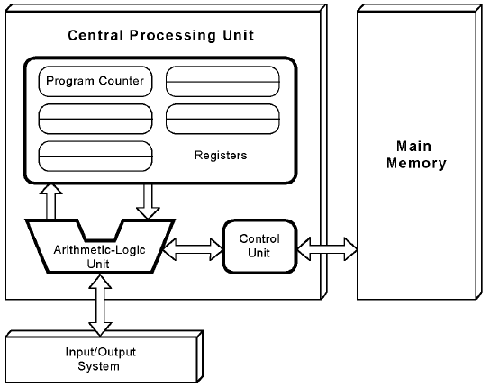This computer employs a fetch-decode-execute (or fetch-execute) cycle to run programs as follows . . .

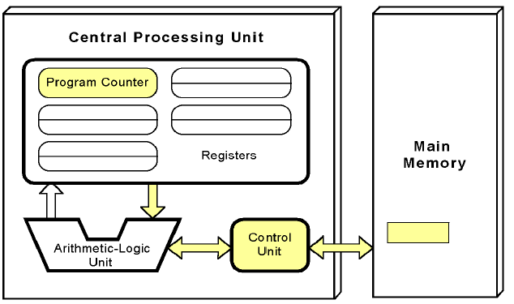Each machine has one program counter (PC), an externally invisible register that holds the memory address of the next instruction to be fetched. The PC gets incremented automatically after a fetch.

The control unit fetches the next instruction from memory.

L-------------->

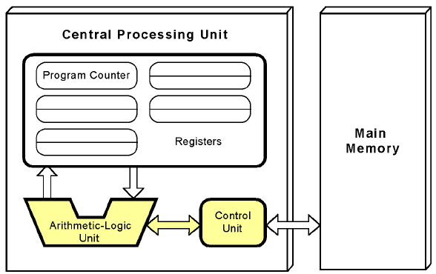

The instruction is decoded into a language that the ALU can understand. The datapath (commonly called “pipeline”) executes instructions, while the Control Unit specifies how this work should be carried out.

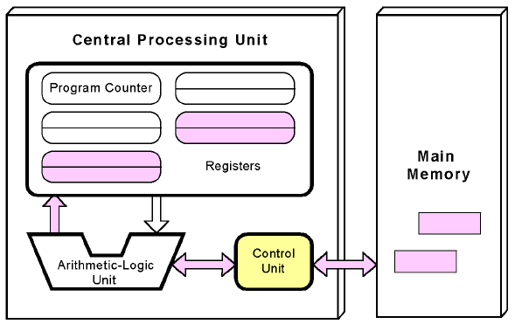<---------l

Any data operands required to execute the instruction are fetched from memory and placed into registers within the CPU.

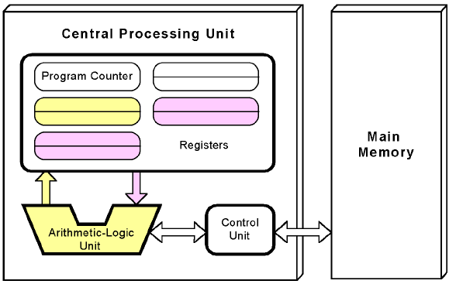 L-------------->

The ALU executes the instruction and places the results in registers or memory (based on the instruction).

<---------l

EXECUTION OF A STRAIGHT-LINE CODE-SEGMENT

Earlier slides showed the execution of one instruction.

Consider a straight-line (no branches) object code segment.

In straight-line code, the fetch-execute cycle steps through the sequence of machine instructions in program order.

This is the simplest form of control-flow of instructions.

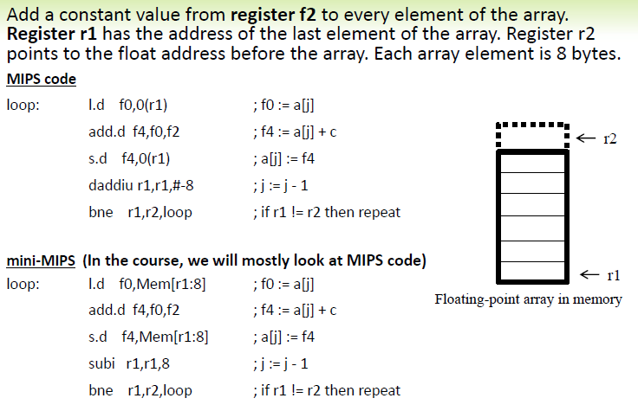The general form includes branches and is slightly more interesting because of the presence of loops and if statements. An example can be seen on the next slide.

THE FETCH-EXECUTE CYCLE

1. The fetch engine ("f-box") in the pipeline fetches an instruction from memory as specified by the PC.

2. Assuming that memory is byte addressed, PC is unconditionally incremented by the length of an instruction in bytes.

3. Unless otherwise specified, we will consider all instructions to be encoded in 32 bits.

4. If the fetched instruction is a branch, further modification of the PC may take place, by some other box, at a later time.

5. The decode engine ("d-box") in the pipeline decodes the instruction, in conjunction with the control unit. This is the first time we know what kind of instruction we have fetched.

6. For a register-register instruction, the execution engine ("x-box") in the pipeline executes the instruction's operation. We will say the details for all types of operations later.

CONTEXT SWITCHING

Consider a floating-point multiply somewhere in the sequence.

Presumably, loads appear earlier in the program to bring the two operands of the multiply from memory.

Suppose the operands haven't arrived yet and the multiply cannot start execution.

Since we are moving through the program in program order, the whole program blocks. Since the processor is running precisely one program, the whole processor blocks (stalls).

Can the processor simply switch to another program?

That depends on the context. If the program will be blocked for a long time, then the cost of context switching will be worth it. (Example: a program that blocks for disk I/O).

However, if the program will be blocked for a much shorter time, then it makes sense just to stall the processor.

Modern CPUs spin wait.

NON-VON NEUMANN MODELS

Conventional stored-program computers have undergone many incremental improvements over the years.

These improvements include adding specialized buses, floating-point units (FPUs), and cache memories, to name only a few.

But enormous improvements in computational power require departure from the classic von Neumann architecture.

Adding processors is one approach.

In the late 1960s, high-performance computer systems were equipped with dual processors to increase computational throughput.

In the 1970s supercomputer systems were introduced with 32 processors.

Supercomputers with 1,000 processors were built in the 1980s.

In 1999, IBM announced its Blue Gene system containing over 1 million processors.

In the late 1960s, high-performance computer systems were equipped with dual processors to increase computational throughput.

In the 1970s supercomputer systems were introduced with 32 processors.

Supercomputers with 1,000 processors were built in the 1980s.

In 1999, IBM announced its Blue Gene system containing over 1 million processors.

AMDAHL’S LAW

Amdahls Law deals with the Max expected improvement (in terms of speed) to an overall system when only part of the system is improved.

Used in parallel computing

Predict theoretical max speedup when using an infinite # of processors.

Limitation on improvement: Time required for sequential (serial) portion.

Simple Example:

Program P needs 20hrs to run on a single processor

Portion P1 requires 1h and cannot be parallelized. This is the serial portion

Minimum execution time is 1h no matter how many processors are used.

Max Speedup is 20x (old-time/improved-time = 20/1)

Another Example (Program P)

Portion P1 is 12% and can be parallelized ➔ Portion P2 is 88% and cannot be (serial part of the program)

Max speedup of P = old-time/improved-time = 100/(100-12)

1/(1-0.12) = 1.136 times

Another Example

Program P has portion A that uses 10% of the sequential time, and gets no parallel speed up, and portion B that uses 90% of the sequential time, and gets a parallel speed up equal to the number of cores. What is the run time of P on this parallel computer with a 100 identical cores?

Old-time = 10 + 90 = 100

New-time = 10 + 90/100 = 10.9

Speedup (SU) = old-time/new-time = 100/10.9 = 9.2

FORMALIZATION OF AMDAHL’S LAW

N = # processors, P is program portion that can be parallelized.

Max Possible or theoretical Speedup S(N) is achieved when using an infinitely large N (an infinite number of processors)

As N → infinity, P/N → 0 and max speedup S(N) = 1/(1-P)

SpeedUp = old-time(single processor)/new-time(n processors)

Conclusion:

Best speedup or improvement results can be achieved as the value of P gets higher. We need to attempt to reduce the component (1 – P) to the smallest possible value.

MAX THEORETICAL SPEEDUP EXAMPLE

On a uniprocessor, perfectly serial portion A of program P1 consumes 5 s, while perfectly parallel portion B consumes 95 s. What integral number of processors is required to achieve half the theoretical maximum speedup for P1? Answer ______________ Processors.

Old-time = 5+95 = 100 s

New-time (for Max SU) = 5 + 95/inf. = 5+0 =5

Max SU = 100/5=20

Required SU = 50% X 20 = 10

10 = 100/(5+95/n)

5+95/n = 10 ➔ 95/n = 5 ➔ n=95/5 = 19

ADDRESS REGISTER

Assume that Memory size = 8 bytes. It means that 8 different addresses are required. Address register (AR) should be able to hold 8 different addresses. What size should the AR be, i.e. how many bits.

AR with 3 bits can have these addresses: or all the different combinations that a 3-bit register can hold.

000 = 0  
001 = 1  
010 = 2  
011 = 3  
100 = 4  
101 = 5  
110 = 6  
111 = 7

Similarly for Memory size = 16 bytes. AR should be able to hold 16 different addresses. What size should the AR be, i.e. how many bits.  
AR with 4 bits can hold addresses from 0 to 15.

0000 = 0  
0001 = 1  
0010 = 2  
0011 = 3 It can be seen that:  
0100 = 4 When memory size is expressed as 2^n bytes. The required Address Register size in  
0101 = 5 bits would be equal to n.  
0110 = 6 In the cases where the memory size cannot be expressed as a clean power of 2,  
0111 = 7 round the memory size up to the next power of 2.  
… Example: memory size = 13 => round it yup to 16 = 2^4 so n=4 bits  
1111 = 15