Electronic Seismologist (6000 words, 10 figures) or Seismica

Title: DR4GM, an open-source community-driven interactive software platform bridging earthquake dynamic rupture simulations and ground motion engineering applications

Dunyu Liu¹, Kyle Withers², Alice-Agnes Gabriel^{3,4}, Yongfei Wang^{*5}, Thomas Ulrich⁴, Elif Oral^{6,7}, Shuo Ma⁸, Frantisek Gallovic⁹, Lubica Valentova^{9,6} Jean-Paul Ampuero¹⁰, Ben Duan¹¹, Christine Goulet^{**5}

¹University of Texas Institute for Geophysics, The University of Texas at Austin
²U.S. Geological Survey, Geologic Hazards Science Center, Golden, CO
³Scripps Institution of Oceanography, University of California at San Diego
⁴Department of Earth and Environmental Sciences, LMU Munich, Germany
⁵Southern California Earthquake Center
⁶Dept. of Mechanical and Civil Engineering, California Institute of Technology, Pasadena, CA
⁷Egis Group, Nuclear Service Line, Egis Advanced Solutions, Marseille, France
⁸Department of Geological Sciences, San Diego State University, San Diego, CA
9asdf
¹⁰Universit´e Cˆote d’Azur, Observatoire de la Cˆote d’Azur, IRD, CNRS, G´eoazur, France
¹¹Department of Geology & Geophysics, Texas A&M University
*Now at Verisk Analytics
**Now at the U.S. Geological Survey, Earthquake Science Center, Pasadena, CA

Abstract
We introduce Dynamic Rupture for Ground Motion (DR4GM), an open-source, community-driven, interactive software platform for processing, analyzing, and visualizing high-resolution wide-area near-source deterministic ground motion products from earthquake dynamic rupture simulations. Dynamic rupture simulations incorporate state-of-the-art physics, providing a framework that coherently integrates source dynamics, wave propagation, and site responses. A coordinated group effort has emerged to supply dynamic rupture models for ground motion applications, validated against leading empirical ground motion models through ensemble statistics. Challenges to process large volume of simulation data, and the absence of standardized formats for archiving and distribution have motivated the development of DR4GM. The platform establishes the cyberinfrastructure with a unified workflow that transforms large-scale simulation outputs into engineering-ready ground motion products, and defines data standards to facilitate consistent data dissemination, allowing research groups to focus on more scientific innovation than processing and computing. DR4GM has offered three major capabilities. (1) It converts simulated ground motion outputs with diverse formats into a standardized, interoperable format. (2) It provides utilities to compute ground motion widely used intensity measures from simulated time series, based on modules from open-source toolkit Openquake. (3) It enables analyses and publishable visualizations of ground motion measures for rapid assessment. Users can interact with DR4GM through a command-line interface, a graphic user interface, or a web portal. DR4GM is built purely on Python, with minimum system and package requirements. Supplementing our companion paper “Physics-based Simulation of Near-Source Ground Motions: A Group Modeling Approach towards Advancing Seismic Hazard Characterization using Dynamic Ruptures”, DR4GM is an essential step towards developing the cyberinfrastructure to make advanced physics-based earthquake source modeling accessible for earthquake engineering hazard applications. In addition, the platform may enable the building of expandable physics-based dynamic rupture database, which may further pave the way for data-driven approaches to better infer seismic hazard for ground shaking jointly with source dynamics in a physically coherent framework.
Plain language abstract
- Introduction
Earthquake dynamic ruptures provide a mechanically coherent framework to incorporate state-of-the-art physics from rock experiments, mechanics, and seismology to understand how key factors such as stresses, friction, and velocity structures impact earthquake dynamics and shaking [Jia et al., 2023; Withers et al., 2023]. With the advance of high performance computing and investments in improving performances of algorithms and software, dynamic ruptures have been increasingly applied to understand ground shaking jointly with source complexity [e.g., Liu and Duan, 2018; Premus et al., 2020; Ramos et al., 2021; Ulrich et al., 2019; Wang and Day, 2020; Withers et al., 2018]. To further push dynamic rupture models to real-world seismic hazard applications, a group effort has emerged to validate the simulated outputs to leading empirical ground motion models through ensemble statistics (see our companion paper titled “Physics-based Simulation of Near-Source Ground Motions: A Group Modeling Approach towards Advancing Seismic Hazard Characterization using Dynamic Ruptures”). Combined, the high-resolution, near-source shaking variability provides essential data that’s missing from observations. However, challenges abound that calls for efficient ways to process large volume of high spatiotemporal resolution dynamic rupture ground motion time series, and data standards to disseminate and archive processed ground motion products. It motivates our group to develop Dynamic Rupture for Ground Motion (DR4GM) that provides uniformed workflow to transform large volume of dynamic rupture ground motion outputs into interoperable, standardized ground motion intensity metrics relevant to engineering applications with publishing quality figures. Figure 1 shows the design and capabilities of DR4GM.
Here, we present DR4GM version 1.0, designed to efficiently process large volumes of raw time series of dynamic rupture output from multiple leading dynamic rupture modeling software, providing a data standards, and pipelined the processing and data analytics of dynamic ruptures to ground motion metrics such as Peak Ground Acceleration (PGA) and Response Spectrum Acceleration (RSA) at various periods and a dozen more products. In addition, DR4GM provide command line clients, Graphic User Interface, and a web service that users can interact with datasets, removing users from technical hassles. DR4GM is open-source, community-driven, interactive, and bridges the gap between earthquake physics modeling to engineering applications.
Currently, DR4GM supports six leading parallel dynamic rupture simulation software, including EQdyna, Waveqlab3D, SeisSol, FD3D, SpecFEM3D, MAFE. With DR4GM, research groups will be able to focus precious research time on scientific innovation rather than data processing and visualization. With the data standards, DR4GM will also help build a database of dynamic ruptures that can be expanded, enriching the near-source shaking data for engineering applications, and drawing in more dynamic rupture modeling groups to contribute. In addition, the dataset can facilitate emerging developments of surrogate models with machine learning (ML) techniques [Gong et al., 2025; Liu and Becker, 2025; Tainpakdipat et al., 2025] and reduced order modeling techniques [Rekoske et al., 2023], which promise significantly speedup and further populate the database.
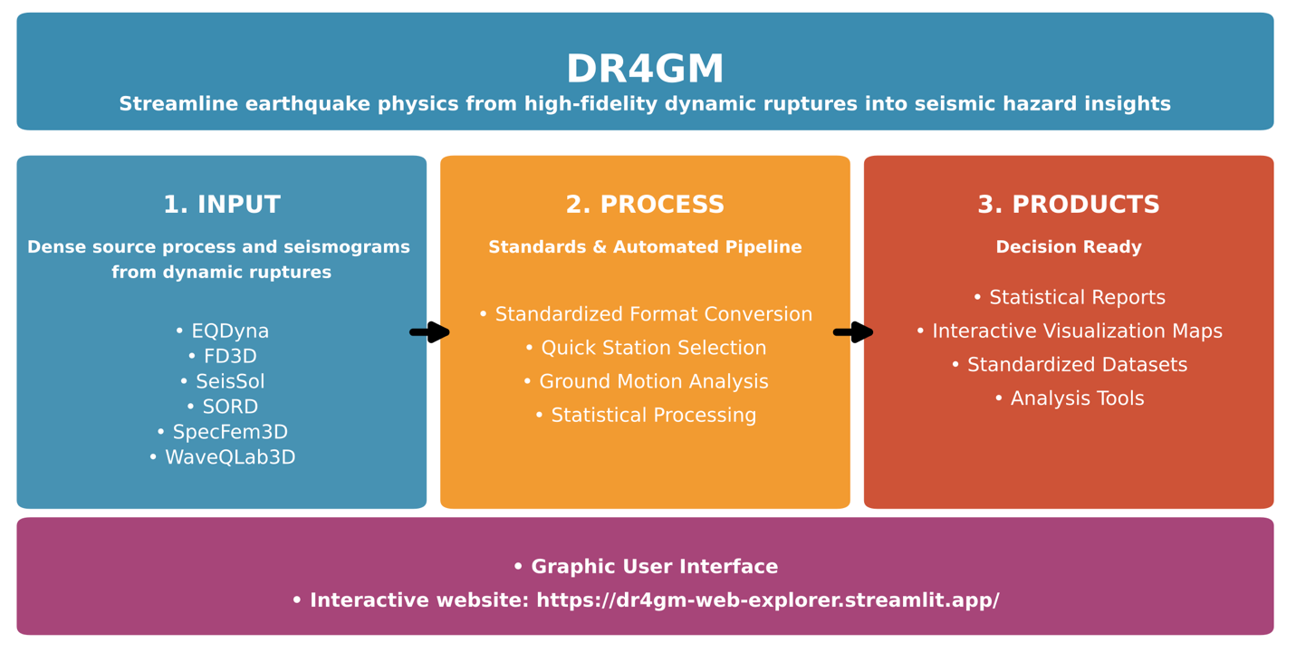
Figure 1. Design and capability of Dynamic Rupture for Ground Motion (DR4GM) platform.

- DR4GM workflow, products, and standards
DR4GM workflow consists of six phases for efficient processing of large volume, raw dynamic rupture simulation time series to engineering-ready products with standardized dataset formats (Table 1).
Phase 1 involves efficient bulk conversion of time series from a few thousands to over one million stations on Earth surface from six leading dynamic rupture software, EQdyna, SeisSol, Waveqlab3D, FD3D, Specfem3D, and MAFE, through individual application programming interfaces (APIs). For example, utility eqdyna_converter_api.py will convert EQdyna ground motion time series to three numpy (https://numpy.org/) archives in the .npz format. stations.npz contains a list of station locations, velocities.npz velocity time series at all the stations in stations.npz, and geometry.npz fault geometric information including fault end locations, dip angles, etc.
Phase 2 involves selection of a subset stations from stations.npz, which is optional. Scenarios can contain over a million stations or more, given the frequency desired in the simulation. Depending on users’ need for station coverage resolution and processing speed, users can use the utility station_subset_selector.py to select a subset of stations at a designated resolution, say 2 km, which may result in a few thousands of stations for faster processing and visualization.
Phase 3 involves processing of all the timeseries at stations selected to widely used ground motion intensity measures including peak ground acceleration (PGA), peak ground velocity (PGV), peak ground displacement (PGD), response spectra acceleration at various periods from 0.1 to 5 sec with 5% damping, cumulative absolute velocity (CAV) using the utility npz_gm_processor.py. The output is ground_motion_metrics.npz with intensity values as lists attached to stations selected. We use the open-source platform openquake.engine to process the time series.
Phase 4 provides mapping of different ground motion metrics for spatial variations of different metrics from different scenarios using the utility visualize_gm_maps.py. The outputs are publishable maps of ground motion intensities including PGA, PGV, PGD, RSA at various periods, CAV, and quality check figures including Rjb distance distributions. Figure 2 shows RSA at 1 second from one EQdyna and SeisSol scenario with different physics adopted.
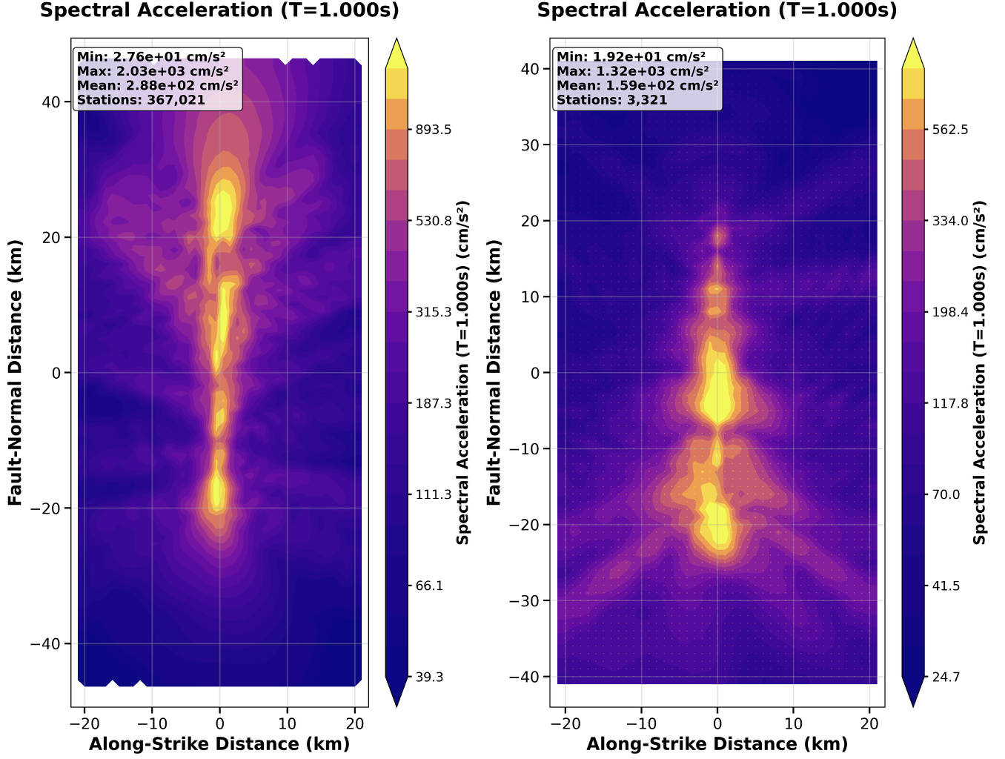
Figure 1. (A) EQdyna (B) SeisSol, and (to-do add more )
Phase 5 provides the utility gm_stats.py to compute statistics of ground motion metrics and compare with leading Ground Motion Models from openquake.engine. The output is gm_statistics.npz with binned ground motion metrics by Rjb, where the bin size and distance to process can be customized.
Phase 6 provides visualize_gm_stats.py to visualize ground motion statistics in gm_statistics.npz, and visualize_ensemble_stats.py to visualize ground motion statistics from an ensemble models specified. Figure 2A and 2B shows RSA at 1 second (g), and intra-event RSA (g) as a function of Rjb distance from an ensemble of scenarios (). Figure 2C shows RSA at Rjb of 10 km for different periods from the ensemble of scenarios ().
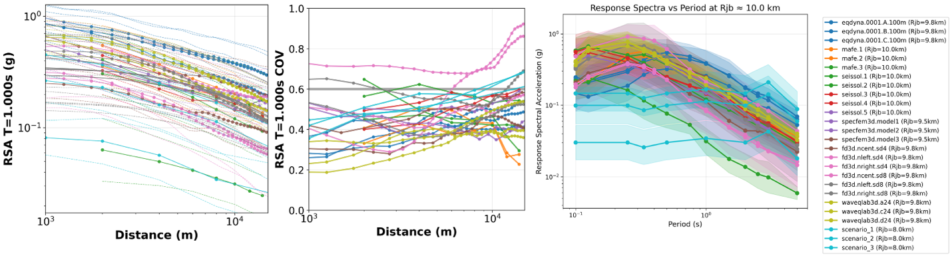
Figure 2. (A) Response spectra acceleration (g) at 1 second as a distance of Rjb for various scenarios. (B) Intra-event standard deviation of RSA at 1 second as a function of Rjb distance. (C) RSA at 10 km Rjb as a function of periods.
Table 1: Six phases processing and visualization of Dynamic Rupture for Ground Motion (DR4GM) with input and output data products for each phase.
Phase |  | Utility | Input | Dataset products
P1 | Data conversion | XX_converter_api.py* | Raw time series from simulations | stations.npz,  velocities.npz,  geometry.npz,
P2 | Station subset selection (optional) | station_subset_selector.py | stations.npz  velocities.npz | processed_stations.npz
P3 | Ground motion metrics processins | npz_gm_processor.py | processed_stations.npz,  velocities.npz | ground_motion_metrics.npz
P4 | Map visualizations | visualize_gm_maps.py | ground_motion_metrics.npz | PGA.png, PGV.png, PGD.png, RSA_T_*.png
P5 | Ground motion statistics | gm_stats.py | ground_motion_metrics.npz,  geometry.npz | gm_statistics.npz
P6 | Stats visualization | visualize_gm_stats.py,  visualize_ensemble_stats.py | gm_statistics.npz | gm_RSA_T_*, PGA, PGV, PGD, COV}_vs_R.png, gm_RSA_vs_periods.png

*XX stands for different dynamic rupture software, which currently supports eqdyna, seissol, waveqlab3d, fd3d, specfem, mafe, and sord.
Table 2.1. Data format and sample values for station.npz.
Station.npz
Key | Shape | Type | Description | Sample Values
‘station_ids’ | (367021,) | int64 | Unique station identifiers | [0,1,2,3,4,…]
‘locations’ | (367021,3) | float64 | Station coordinates [x, y, z] in metters | [[19903.3, -44900.0, 0.0], [19804.2, -44900.0, 0.0], …]
‘chunk_ids’ | (367021,) | Int64 | Source data chunk IDs | [7,7,7,7,7, …]
‘local_ids’ | (367021,) | Int64 | Local station ID within each chunk | [0,1,2,3,4, …]
‘station_types’ | (367021,) | Float64 | Station type indicator | [1.0, 1.0, 1.0, …] (all surface)
‘coordinates_units’ | () | Str | Coordinate system units | “m”
*Total stations: 367,021
*Coordinate system: Fault runs N-S along y-axis.

Table 2.2. Data format and sample values for velocities.npz.
Velocities.npz
Key | Shape | Type | Description | Sample values
‘stations_ids’ | (367021,) | Int64 | Stations identifiers, same as stations.npz | [0,1,2,3,4,5 …]
‘locations’ | (367021,3) | Float64 | Station coordinates [x, y, z] in m. | Same as stations.npz
‘vel_strike’ | (367021,294) | Float64 | Fault-strike velocity (m/s) | Time series per station
‘vel_normal’ | (367021,294) | Float64 | Fault-normal velocity (m/s) | Time series per station
‘vel_vertical’ | (367021,294) | Float64 | Vertical velocity (m/s) | Time series per station
‘time_steps’ | (367021,) | Int64 | Number of time steps per station | [294, 294, 294, …]
‘dt_values’ | (367021,) | Float64 | Time step size per station (seconds) | [0.085030, 0.085030, …]
‘duration’ | () | Float64 | Total simulation duration (seconds) | 25.0
‘units’ | () | Str | Velocity units | “m/s”
‘coordinate_units’ | () | Str | Coordinate units | “m”
*Velocity Time Series: contains raw velocity time series data for all stations in strike/normal/vertical components.

Table 2.3 Data format and sample values for ground_motion_metrics.npz.
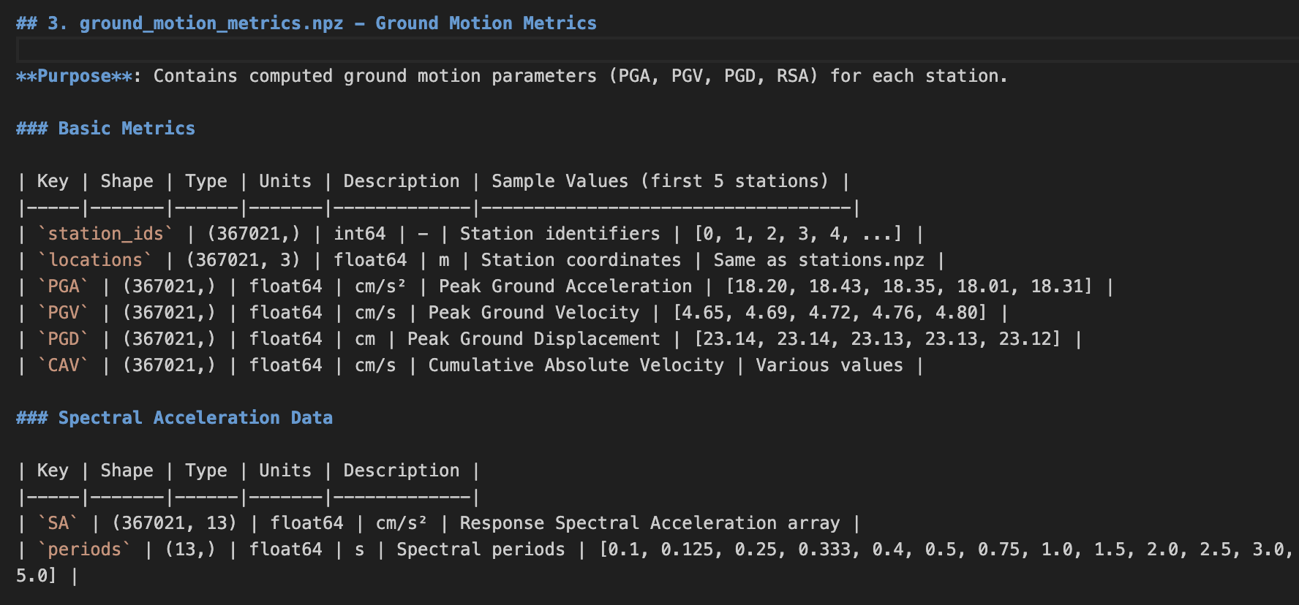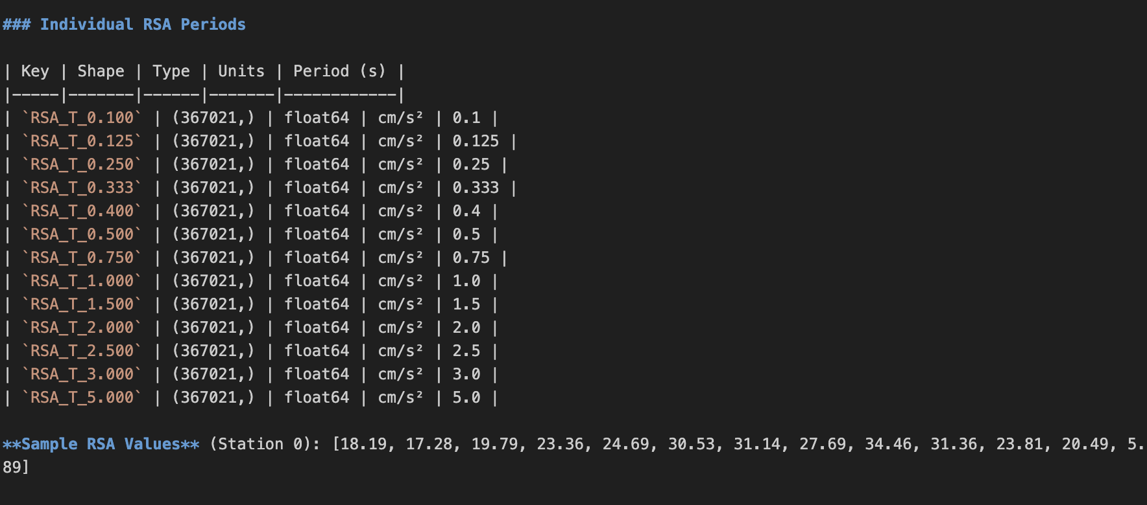

Table 2.4. Data format and sample values for gm_statistics.npz

gm_statistics.npz | Distance-Binned Statistics | Contains statistical analysis of ground motion metrics as a function of distance from fault.
Key | Shape | Type | Units | Description / Sample Values
rjb_distance_bins | (60,) | float64 | m | Distance bin centers | [250, 750, 1250, 1750, 2250, ...]
distance_bin_edges | (61,) | float64 | m | Distance bin edges | [0, 500, 1000, 1500, ...]
distance_units | () | str |  | Distance units | 'm'
Key | Value | Description
PGA_units | cm/s² | Peak Ground Acceleration units
PGV_units | cm/s | Peak Ground Velocity units
PGD_units | cm | Peak Ground Displacement units
CAV_units | cm/s | Cumulative Absolute Velocity units
RSA_units | cm/s² | Response Spectral Acceleration units
Suffix | Shape | Type | Description
_mean | (60,) | Float64 | Geometric mean in each distance bin
_std | (60,) | Float64 | Logarithm standard deviation
_min | (60,) | Float64 | Minimum value in distance bin
_max | (60,) | Float64 | Maximum value in distance bin
_count | (60,) | Int65 | Number of stations in distance bin
Examples | PGA statistics | Available metrics
Distance bins | [0.25, 0.75, 1.25, 2.25] km | PGA, PGV, PGD, CAV | RSA [0.1. 0.125, 0.25, 0.333, 0.4, 0.5, 0.75, 1.0, 1.5, 2.0, 3.0, 4.0, 5.0]
PGA means | [885.7, 592.5, 478.1, 411.3, 358.6] cm/s2
PGA std | [0.340, 0.303, 0.336, 0.374, 0.396]

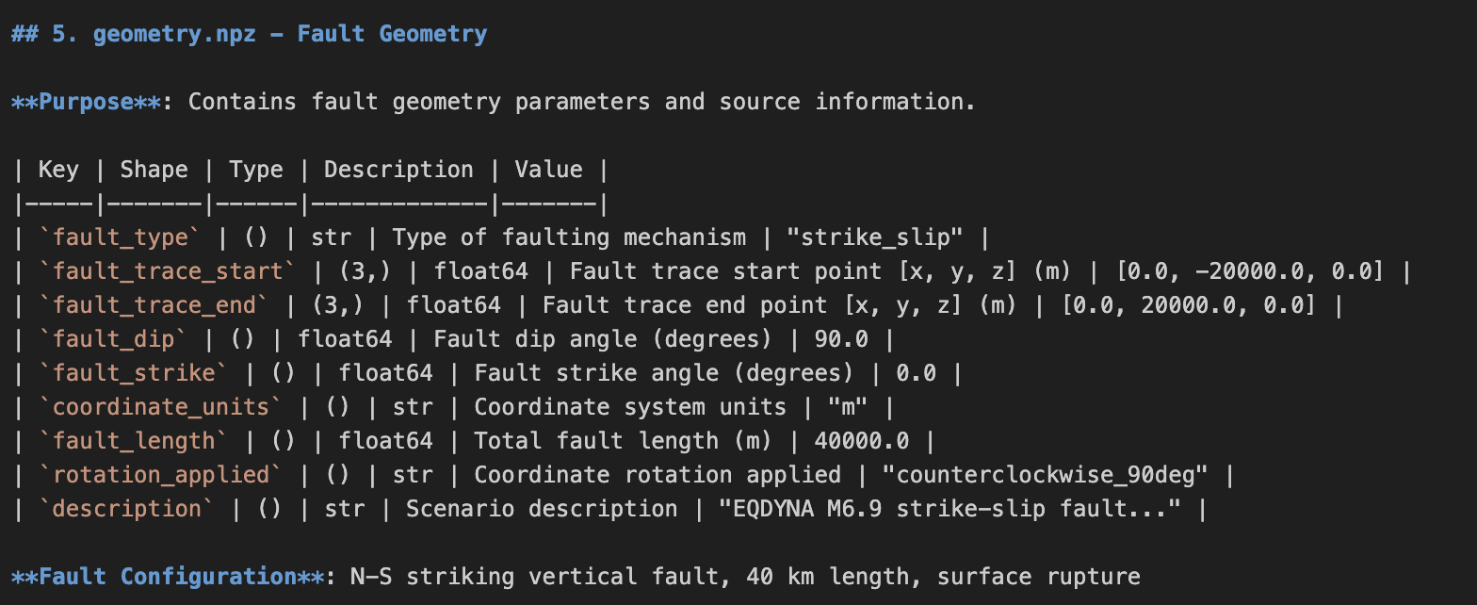
- Terminal command line clients
Command terminal lines are essential elements in DR4GM. Table 2 provides the major utilities, building on Python and open-source packages, and their usage.
- Graphic User Interface
We build a graphic user interface (GUI) based on popular, lightweight Python wrapper tkinter (https://docs.python.org/3/library/tkinter.html) for running the command line clients and visualization.
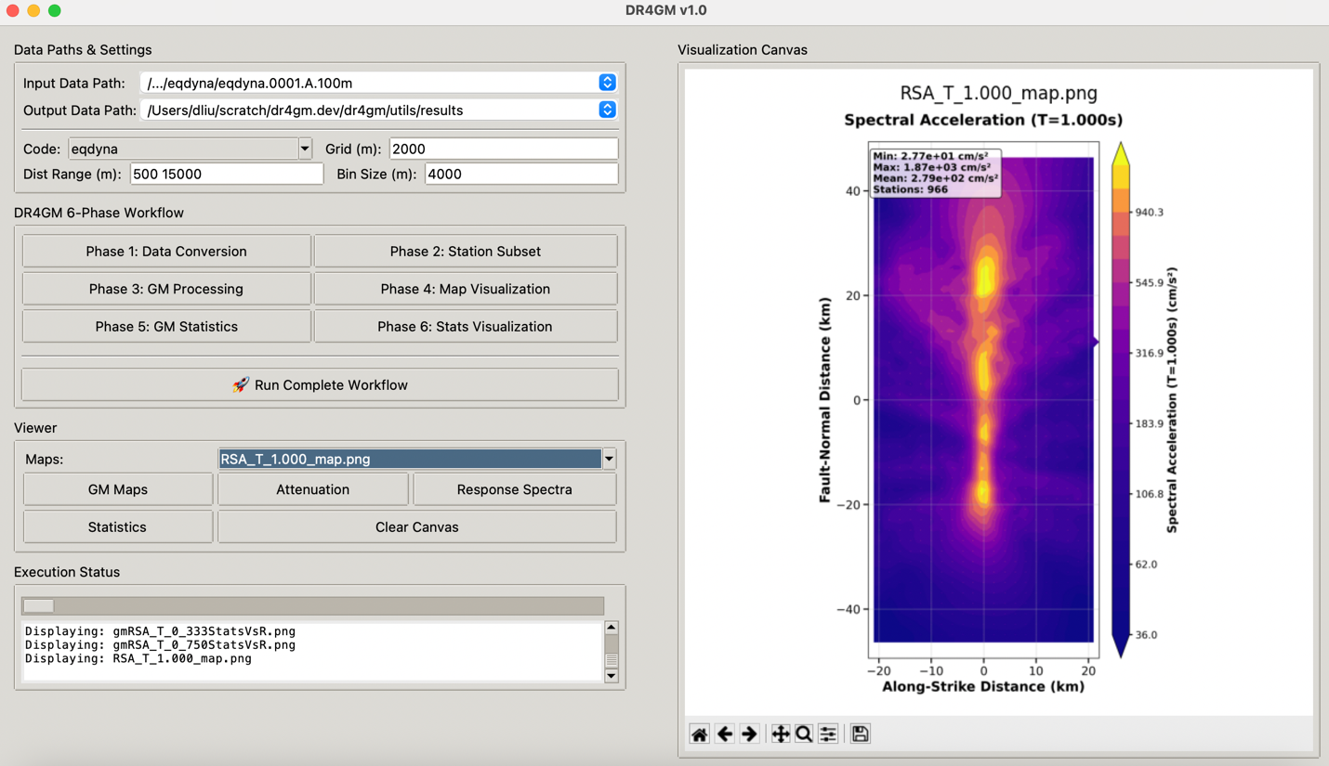
Figure 3. Graphic user interface of DR4GM version 1.0.
- Web service: DR4GM Interactive Explorer
We also build a web service, DR4GM Interactive Explorer, using streamlit (https://streamlit.io/), an open-source Python framework for data scientists and AI/ML engineers to deliver interactive data apps, and streamlit cloud (https://streamlit.io/cloud) to publicly provide ground motion metrics from our dynamic rupture scenarios to end-users with just webbroswer and internet connections. Figure 4 shows the web interface of DR4GM Interactive Explorer. Users can choose a scenario from “Choose dataset” dropdown list, pick a ground motion metrics from “Select ground motion metrics” dropdown list for PGA, PGV, PGD, RSA at various periods. Colormaps can be changed. Users can hover mouse over the map, where the mouse tip will show selected ground motion metrics and its location. More advanced, users can input individual station location under “Find Station by Location” and get returned a table of all available ground motion metrics at that station on the right side of the interface. Users can also upload a customized list of station locations, and upload to the web interface and get returned all available ground motion metrics at those locations as a downloadable file.
The web interface also provide support to analyze locally stored data in DR4GM standards, or upload customized datasets to the web for interactions.
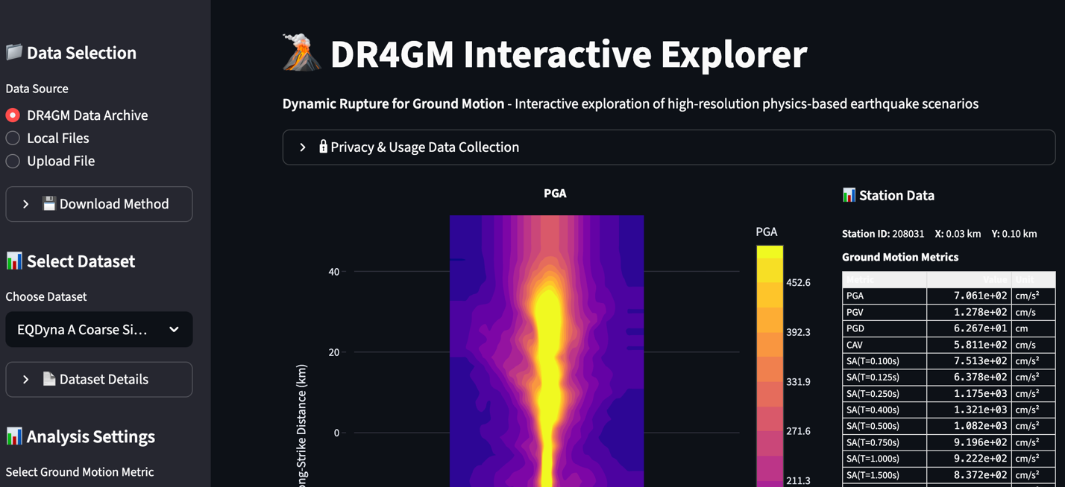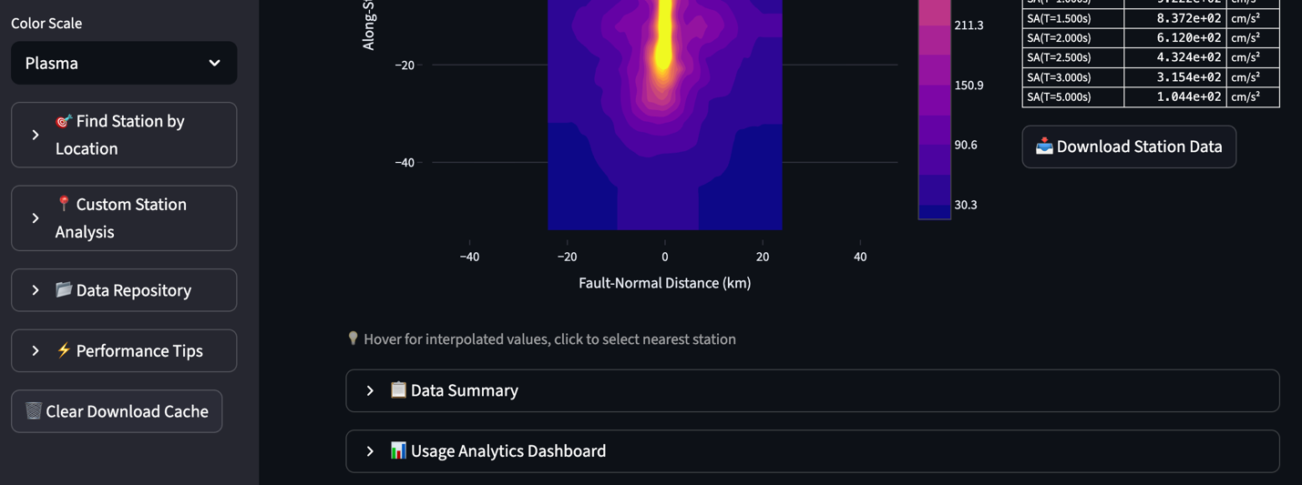
Figure 4. DR4GM interactive explorer. Major services include XX.

- Conclusions
We develop an open-source, community-driven software platform Dynamic Rupture for Ground Motion (DR4GM) to make earthquake dynamic rupture simulations accessible for high-resolution ground motion analytics with the hope to incorporate state-of-the-art physics in seismic hazard applications, facilitating the accumulation of dynamic rupture and shaking simulation data, and accelerate innovations of ML/AI surrogates. Driven by a community of earthquake dynamic rupture modeling groups, and providing benchmark to leading GMMs for validation, DR4GM converts large volume of ground motion time series from diverse dynamic rupture software to a standardized dataset format. The standards will serve as the foundation to encourage modelers to contribute simulations, reducing waste and redundancy. It also provides processing of ground shaking time series to ground motion metrics in engineering-ready format, building on open-source toolkit such as Openquake. It consists analytic utilities to do statistical analyses, and comparison to leading GMMs. Lastly, it provides publication quality visualizations of maps of various ground motion metrics. On top of these core functions, DR4GM provide flexible ways for users to interact, through terminal clients, GUI, or web interface. Supplementary to paper XX, DR4GM is an essential development of cyberinfrastructures to make state-of-the-art physics-based earthquake source modeling accessible to earthquake engineering hazard applications The platform makes the building of expandable physics-based dynamic rupture database feasible, which will further open the opportunity for data-driven approaches to better infer seismic hazard for ground shaking in a physically coherent framework with source dynamics.

Data and software availability statement
Acknowledgement

Gong, Z., Z. Wang, C. Liang, A. Nienkötter, J. Wang, C. Ren, and X. Peng (2025), RuptureNet2D, a Deep Neural Network Based Surrogate for Dynamic Earthquake Rupture Simulation in Two Dimensions, Journal of Geophysical Research: Solid Earth, 130(5), doi:10.1029/2024jb030069.
Jia, Z., et al. (2023), The complex dynamics of the 2023 Kahramanmaraş, Turkey, Mw 7.8-7.7 earthquake doublet, Science, 381(6661), 985-990, doi:doi:10.1126/science.adi0685.
Liu, D., and T. W. Becker (2025), Earthquake rupture dynamics from Graph Neural Networks, doi:10.22541/essoar.174756219.90581027/v1.
Liu, D., and B. Duan (2018), Scenario Earthquake and Ground‐Motion Simulations in North China: Effects of Heterogeneous Fault Stress and 3D Basin Structure, Bulletin of the Seismological Society of America, 108(4), 2148-2169, doi:10.1785/0120170374.
Premus, J., F. Gallovič, L. Hanyk, and A.-A. Gabriel (2020), FD3D_TSN: A Fast and Simple Code for Dynamic Rupture Simulations with GPU Acceleration, Seismological Research Letters, 91(5), 2881-2889, doi:10.1785/0220190374.
Ramos, M. D., Y. Huang, T. Ulrich, D. Li, A.-A. Gabriel, and A. M. Thomas (2021), Assessing Margin-Wide Rupture Behaviors Along the Cascadia Megathrust With 3-D Dynamic Rupture Simulations, Journal of Geophysical Research: Solid Earth, 126(7), e2021JB022005, doi:10.1029/2021JB022005.
Rekoske, J. M., A. A. Gabriel, and D. A. May (2023), Instantaneous Physics‐Based Ground Motion Maps Using Reduced‐Order Modeling, Journal of Geophysical Research: Solid Earth, 128(8), doi:10.1029/2023jb026975.
Tainpakdipat, N., M. Abdelmeguid, C. Zhao, K. Azizzadenesheli, and A. Elbanna (2025), Fourier Neural Operators for Accelerating Earthquake Dynamic Rupture Simulations.
Ulrich, T., A. A. Gabriel, J. P. Ampuero, and W. Xu (2019), Dynamic viability of the 2016 Mw 7.8 Kaikoura earthquake cascade on weak crustal faults, Nat Commun, 10(1), 1213, doi:10.1038/s41467-019-09125-w.
Wang, Y., and S. M. Day (2020), Effects of Off-Fault Inelasticity on Near-Fault Directivity Pulses, Journal of Geophysical Research: Solid Earth, 125(7), e2019JB019074, doi:https://doi.org/10.1029/2019JB019074.
Withers, K. B., K. B. Olsen, S. M. Day, and Z. Shi (2018), Ground Motion and Intraevent Variability from 3D Deterministic Broadband (0–7.5 Hz) Simulations along a Nonplanar Strike‐Slip Fault, Bulletin of the Seismological Society of America, 109(1), 229-250, doi:10.1785/0120180006.
Withers, K. B., et al. (2023), Generation of Near-Source Broadband Ground Motion from Physics-based Dynamic Rupture Simulations: Group Modeling Approach towards better Characterizing Seismic Hazard for Engineering ApplicationsRep., Statewide California Earthquake Center.

