武永超，硕士 简历

2014 ~

三星电子，从事三星Smart Home相关开发，

职位：PL

业务范围：

1. 2014年，基于三星SHP协议的Home Service开发. SHP是三星自己定义的智能家居协议，针对自有Digital Appliance设计的一套资源描述和访问控制标准。应用场景主要是在Tizen TV/Orsay TV平台上实现对设备的Display和Control. 设备都都集成了Wifi模块，以Restful API提供RPC交互.

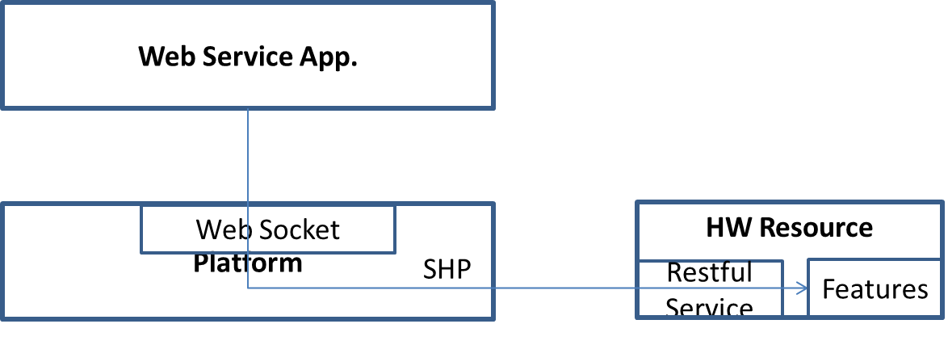

2.2015年，三星收购SmartThings，业务上有所调整。Smart TV上的Home Service开始基于SmartThings(ST)另外构建一套，主要针对欧美市场。Scenarios contains: login/out, things control and display, routine, notification, device discovery. The module include web service UI, native function to interaction with cloud, data cache and etc.

The basic architecture as following:

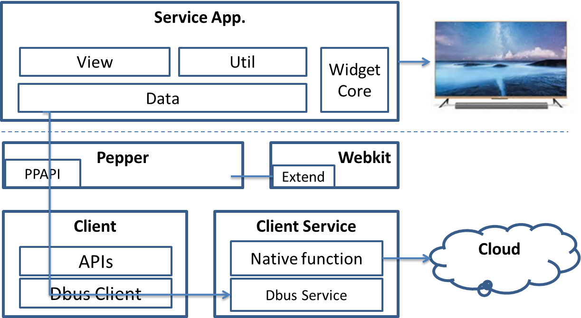

TV is not only the client role in Smart Home, it also play as:

Thing: TV as thing that integrated into ST platform. It means TV is only one terminal thing of SmartThings, you can control it by ST client, such as volume, channel, brightness and so on.  
 ST P/F can support common and customized device ability by its special idea. The basic design idea is :

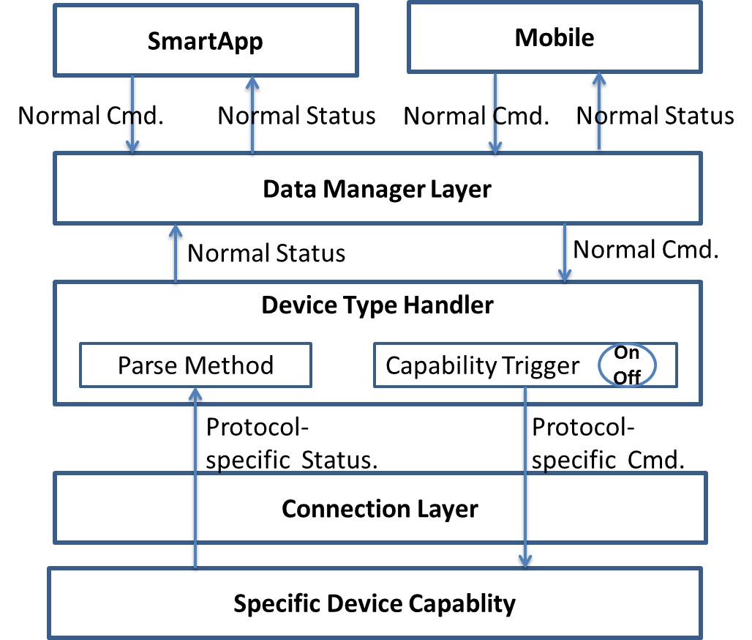

This diagram tell us：ST control **Your** device by **Your** driver script. As we know, In IoT , special SmartHome, the paint point is fragmented device description and interaction protocol. Open and closed method was shown already, such as Weave and HomeKit. SmartThings skip this ache and build one unified interface for 3rd part.

TV also can work as Hub. The gateway to cloud for Zigbee, BLE device.

3. In 2016, Samsung put more focus on IoTivity, an open source IoT framework. Based on this framework and China IoT market status, we developed the platform prototype to integrate Wulian, BroadLink product , together with SHP device.  
 IoTivity capsulate things as resource and controller as client. Make a seamless device to device connectivity. Our design based on IoTivity like:

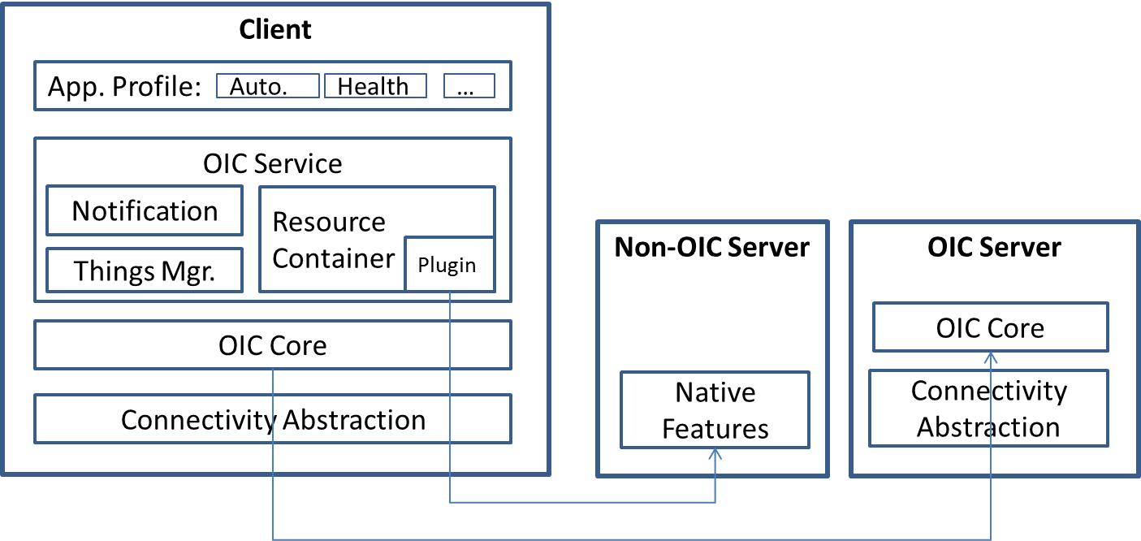

2013-2014

Scope: EFL Application design for player application on Tizen Platform.

Role: PL

Description: This project want to build the multimedia player application on Tizen OS. Tizen support App. framework that help to build a task with life cycle(Start,Playing, Pause,Stop) and main loop