

**School of Computer Science and Engineering**

Winter 2020-21

**Prepared for:**

**Image Processing**

**(CSE-4019) – PROJECT COMPONENT**

**Quality analysis and classification of Rice Grains**

**TEAM MEMBERS**:

Malla Jyotsna Sree Mahima-18BCE0912

Pavan Siddharth E-18BCE0044

Preetham Lekkala-18BCE0854

**ACKNOWLEDGEMENT**

We would like to express our gratitude to VIT University for granting me the oppurtunity of carrying out the project during the Winter Semester 20-21.

We would like to express my gratitude to my faculty Dr. Swathi J.N for her invaluable guidance and advice during the ongoing of the project and for always being available whenever we needed help.

We would like to express gratitude towards Vellore Institute of Technology and all the fellow students in our class there who all made the learning very fruitful. We was able to learn new concepts and gained the exposure to implement the concepts in the real world.

We also express gratitude towards all those who have directly or indirectly contributed to the successful completion of the project.

Place : Vellore

Date : 28.05.21

1. **EXECUTIVE SUMMARY**

In this project, we take processing, enhancement and analysis of digital images as a way to determine the quality of different rice samples. Image is processed in spatial domain. Image reduction, image enhancement, and image increment, object recognition in spatial domain is applied on grain by grain of different samples of rice to determine its size, colour and quality as whole to grade the grain of rice. Grain quality evaluation is done manually but it is relative, time consuming, may be varying the results costly. The evaluation of the rice grains on the basic grain size and shape using image processing edge detection algorithm is used to find the region of boundaries in each grain. We find the endpoints of each grains and after we measure the length and breadth of rice grains. The performance of Image Processing reduces the time of operation.

**TABLE OF CONTENTS**

|  |  |  |
| --- | --- | --- |
| **CHAPTER NO.** | **TITLE** | **PAGE NO.** |
|  | **CHAPTERS** |  |
| **1.** | **Executive Summary** | 7 |
| **2.** | **Introduction** | 8 |
|  | **2.1 Objective** | 8 |
|  | **2.2 Motivation** | 9 |
|  | **2.3 Background** | 9 |
| **3.** | **Literature Review** | 9 |
| **4.** | **Project Description and Goals** | 12 |
| **5.** | **Technical Specifications** | 14 |
| **6.** | **Design Approach** | 16 |
|  | **6.1 Materials and Methods** | 16 |
|  | **6.2 Codes and Standards** | 16 |
|  | **6.3 Constrains , Alternatives and Tradeoffs** |  |
| **7.** | **Schedule Tasks and Milestones** | 17 |
| **8.** | **Project Demonstration** | 22 |
| **9.** | **Cost Analysis** | 23 |
| **10.** | **Results and Discussion** | 23 |

1. **INTRODUCTION**

Rice is favorable and high consumed cereal grain in Asian countries. It can be easily found all over the world. Many values added products are produced by using rice for human beings. In the rice market, key determinant of milled rice is quality. The quality measurement becomes more important with the import and export trade. Rice samples contain different dispensable objects like paddy, chaff, damaged grains, weed seeds, stones etc. Rice quality is varying according to these impurity content.

The main purpose of the proposed method is, to offer an alternative way for quality control and analysis which reduce the required effort, cost and time. Image processing is significant and advanced technological area where important developments have been made.

In agricultural and farming production quality control and analysis of manufactured goods is vital. Quality of grain is analyzed visually by veteran person and technician. But the effect of such measurement is changing in results and prolonged. The excellence and quality also influenced by the mood and atmosphere of technician; so to overcome the shortcoming occurred due to conventional methods advanced technique i.e. Image processing technique is projected, to Maintaining the Integrity of the Specifications.

Image processing manipulates image for performing some operations on targeted image to get an improved and desirable image. And extort some valuable information from input image. Nowadays, image processing is hastily growing technologies. All types of data have to go through three general phases while using DIP technique which are pre-processing, enhancement, and display, information extraction.

* 1. **OBJECTIVE**

Use of image processing algorithms to analyse grains quality by its size. To analysis and classify the quality of rice grains.

* 1. **MOTIVATION**

In this study, the image processing algorithms are developed to segment and identify rice grains. use of image processing algorithm is an efficient method to analyze grains quality by its size. The paper presents a solution of grading and evaluation of rice grains on the basis of grain size and shape using image processing techniques. Specifically, edge detection algorithm is used to find out the region of boundaries of each grain. In thistechnique we find the endpoints of each grain and after using caliper we can measure the length and breadth of rice. This method requires minimum time and it is low in cost.

The conventional methods used for grain shape and size measurement are grain shape tester, dial micrometer and graphical method, but these methods are very lengthy. In above equipment we can measure breadth and length of one grain at a time. The result of this methods is also lengthy and costly and higher possibility of human errors, so it requires high accuracy to assure customers need as well as to conquer restrictions of manual.

Many studies that consider the morphological features of grains such as its area, shape etc. have already been performed. However, the shapes and sizes of the different varieties are too varied to generalize a common formula for the classification of all varieties of rice. In this paper, Fourier features are also extracted from grain images in addition to the spatial features to arrive at an improved accuracy for classification.

* 1. **BACKGROUND**

The Agricultural industry on the whole is very vast and ancient. Quality assessment of grains is a very big challenge since time immemorial. The project presents a solution for quality evaluation and grading of rice grains using image processing techniques. Commercially the grading of rice is done according to the size of the grain (full, half or broken). The food grains quality is rapidly assessed through visual inspection by human inspectors. The decision-making capabilities of human-inspectors are subjected to external influences such as fatigue, vengeance, bias etc. With the help of image processing techniques, we can overcome that and which are also a non-destructive and cost-effective techniques. Here we also discuss the procedure used to obtain the percentage quality of rice grains. Rice quality is nothing but the combination of physical and chemical characteristics. Grain size and shape, chalkiness, whiteness, milling degree, bulk density and moisture content are some physical characteristics, gelatinization temperature and gel consistency are chemical characteristics of rice.

1. **LITERATURE REVIEW**

|  |  |  |  |  |  |  |  |
| --- | --- | --- | --- | --- | --- | --- | --- |
| ***SL.NO*** | ***Title of Paper*** | ***Authors*** | ***Year of Publication*** | ***Dataset Used*** | ***Methodology Proposed*** | ***Pros and Cons*** | ***Future work possible*** |
| 1 | Rice Quality Analysis Based on Physical Attributes  Using Image Processing Technique . | Namita Patel,Hardik Jayswal,Amit Thakkar | 2017 2nd IEEE International Conference On Recent Trends In Electronics Information Communication Technology, May 19-20, 2017, India | RGB IMAGE | Classifying rice grains into three categories small seed, medium seed and long seed based on the parameters: area, major axis length,minor axis length;eccentricity.Methodology consists of preprocessing of image(conversion from rgb to grayscale and then to binary),morphological operations(dilation and erosion),edge detection,object measurement, classification of rice grains | **Pros**:Canny edge detection is used which gives better results than prewitt and sobel edge detections.**Cons**:But the quality analysis of the rice grains is not done. The amout of dust which can also be present in the rice grains is also not considered.Noticing the  precise quality is  difficult. | A future extension to this work is to apply different  classification techniques for better classification of seeds. Possibility of  adding more parameters for better classification. |
| 2 | Identification And Quality Testing Of Rice Grains Using Image Processing And Neural network | Mr. V.S.Kolkure,Ms. B.N.Shaikh | International Journal of Recent Trends in Engineering & Research (IJRTER) (2017). | 640 x 480 JPEG image | A model of quality grade testing and identification is built which is based on  appearance features such as area, major axis length, minor axis length, aspect ratio, the  morphological and color with technology of computer image processing and neural network.The work process system consists of image preprocessing,image segementation, image feature extraction(color, area, major axis,minor axis length,aspect ratio),neural network | **Pros**:Unknown rice grain features can be known using the image processing model combined with neural networks.**Cons:**Explicity the rice grains have not been classified into categories to distingush them based on the features extracted using the model.Noticing the  precise quality is  difficult. | Explicitly categorizing the rice grains quality by classifiying them into groups.Also rice grains can contain dust which has its own features.Dust can also be used for classification. |
| 3 | Rice  Sample Segmentation  and Classification  Using Image  Processing and Support "Rice  Sample Segmentation  and Classification  Using Image  Processing and Support | Nagoda, Nadeesha, and Lochandaka Ranathunga | 2018 IEEE 13th  International  Conference on  Industrial and  Information Systems  (ICIIS), pp. 179-184.  IEEE, 2018. | 3966 x 2976 two images. One is the rice grains image with background. Second image is the background image. | Rice sample  is a combination of full rice, broken rice, damaged rice, paddy,  stones and foreign objects.. A rice sample need to classify in to  these six groups in order to identify rice quality. This paper  provides an approach to separate and classify objects of rice  sample based on color and texture features with the help of  image processing and machine learning techniques. The methodology consists of Gray  scale conversion, noise reduction, binarization, morphological  operations are applied on the acquired images. Contours of the  objects are estimated by using contour detection. | **Pros:**The proposed method provides better results than manual and traditional methods. Because it is accurate and cost effective. This approach requires less time than manual process and also it gives better algorithmic efficiency because of light weighted algorithms and feature vectors utilized. **Cons:**But the stone object identification gives less accuracy. | For further research, stone identification accuracy can be improved by specially designing further validation step in the approach. |
| 4 | Assessment of quality of rice grain using optical and image processing technique. | Parveen, Zahida, Muhammad Anzar Alam, and Hina Shakir. | 2017 International  Conference on  Communication,  Computing and Digital  Systems (C-CODE),pp. 265-270. IEEE,  2017. | d rice grain images from HP Scan jet G2410 with black background. Then saved in JPEG format. | Image processing algorithm to grade the rice on the basis of length, width, area and area of chalky and also worked on the color detection on the rice grain.Methodology consists of image acquisition , image preprocessing, edge detection, color and chalky detection ,classification. | **Pros**:It is concluded that some rice are better on the basis of their length, some are better on the basis of their width while some can be termed good in quality on the basis of their area and area of the chalky**.Cons**:It is not essential that all features can be present in the rice grain . | For further research, the moisture content in the rice grain can also be added to grade the overall quality of the rice grain. |
| 5 | Low Cost Solution for Rice quality analysis using Morphological parameters and its comparison with Standard measurements | Ali, Syed Farooq, Halima Jamil, Razia Jamil, Iqra Torij, and Saira Naz. | 2017 International Multi-topic Conference (INMIC), pp. 1-6. IEEE, 2017. | 103 rice grains were scanned using HP Scanjet G3110 scanner with a resolution of 300 dpi.It contains total of 8 images obtained by placing the rice grains on the scanner. | Rice quality is determined by different parameters including width, length, area, number of large, medium, small and broken rice. In recent years, there has been an increasing trend in automation of rice quality parameters. State of Art Software named Satake RSQI10A Grain Scanner is being used in this regard in various rice mills in Pakistan including Amir Rice Mill. The main aim of this paper is to provide a low cost software product that mimics all the features and functionalities of this state of art software. | **Pros:**Software provides a low cost solution for rice  industry by imitating the state of art Satake RSQI10A Grain  Scanner that is being extensively used in rice industry of  Pakistan including Amir Rice Mill Sheikhupura. The  accurate results and low cost of our software add more  confidence in its future use as a replacement of  SatakeRSQI10A Grain Scanner.**Cons:** Does not consider any other impuritiespresent. | The future directions could be to apply machine learning algorithms and techniques to intelligently classify different types (nations) of rice including Basmati, Kernel and Super Kernel. |
| 6 | A Computer Vision Approach for Grade Identification of Rice Bran | Devraj Vishnu, Gunjan Mukherjee, Arpitam Chatterjee | 2017 Third International Conference on Research in Computational Intelligence and Communication Networks (ICRCICN) | Sample images collected from rice mills | This paper uses a computer vision-based quality analysis. A technique based on PCA and K-mean cluster analysis . Rice bran can be defined as the wastage collected during the rice milling process and can be used for oil manufacturing. On the basis of oil contents there are different types of rice bran e.g. oil contents of boiled rice bran is ranging from (20~26%), and oil contents for raw rice bran are ranging from (16~18%) | **Pros:**Uses Neural networks. So, it can be more precise under difficult circumstances.**Cons:** Needs quality images and also high processing machines. | The work can further be extended to the classification using classifiers, more robust feature extraction, inclusion of prediction models, etc. |
| 7 | Analysis and Identification of Rice Granules Using Image Processing and Neural Network | Pratibha, Nikhade, More Hemlata, M. Krunali, and S. T. Khot | International Journal of Electronics and Communication Engineering. ISSN 0974-2166 Volume 10, Number 1 (2017) | The samples of Basmati rice grains collected from stores | This paper uses the Neural Network Pattern Recognition Tool . System is based on features extraction from rice particles. Features which extracted from image of rice particles are Area, perimeter, major axis, minor axis | **Pros**:Algorithm is light weighted and more efficient in terms of time complexity. **Cons:**It detects stones with same dimension and colour | The model needs to use more features like colour and brightness to differentiate between stones and rice grains that have similar features. |
| 8 | Rice Grain Classification using Fourier Transform and Morphological Features | Teresa Mary Philip and H. B. Anita | Indian Journal of Science and Technology, Vol 10(14), April 2017 | The dataset for the work was collected from retail rice outlets across Karnataka | Fast Fourier transforms and Morphological Features. Also, both spatial and frequency-based features are also used. Study was able to achieve remarkable accuracy as it made use of internal features of the grains in addition to the spatial features. | **Pros:**Uses two layers of classification one is naive Bayes tree and second is sequential minimal optimization.**Cons:** Images suffer from number of environmental constraints. | The scope of this work can be further enhanced by making use of photographic images for classification as the current system suffers from a number of environmental constrains |
| 9 | Rice Quality Analysis Using Image Processing Techniques | Bhagyashree Mahale, Prof. Sapana Korde | International Conference for Convergence of Technology - 2017 | 640 x 380 JPEG Images | Rice seeds are randomly placed on black background for image acquisition. Image is acquired and stored for further analysis. In first pre-processing step image registration takes place and noise is removed from the image by using filter. Shrinkage algorithm is used for segmenting the touching kernels which is the second step. In the third step they perform edge detection to find out the region of boundaries. Then rice seed measurement is done where length, breadth and other parameters are measured. In the fifth step of the algorithm rice is classified according to its size and shape | Requires minimum time; cost is less and gives better results compared with manual results or traditional methods.**Cons:**Classification is done only based on length/breadth ratio and sometimes this might not give the expected results. | For quality analysis, maximum number of parameters are to be measured by image processing techniques. Expansion on this work can target to design such a system which can classify rice grains on the basis of each parameter which can used to enhance the quality of rice. The cost of such system should be less and minimize time requirement for quality analysis. |
| 10 | Standardization for Export Quality of Oreochromis niloticus and Chanos chanos based on Quality Index Method using Integrated Image Processing Algorithms | Flordeliza L. Valiente, Danielle Jaye Agron | Received July 15, 2019, accepted July 29, 2020, date of publication August 27, 2020, date of current version August 26, 2020 | Farmed Bangus and Tilapia typical fish | The prototype design concept is shown , the major components of the prototype are Conveyor Belt, Illumination, and Camera. The conveyor belt is used to transport the sample fish along. A camera is fixed mounted above and located at the middle of the conveyor ramp to capture images of the fish, the images will be send to the computer to be analyzed in MATLAB image processing. A GUI display must be released after a few seconds, the quality assessment procedure is done on the sample and the result of whether it passed the standards will be noted then it would be moved to the desired container, the Bangus sample is separated to a different bin container from Tilapia samples | This research provided the fish farmers and sellers an efficient way to verify and ensure  for consumers that the fishes are of high quality. The study yield  97% accuracy based on International Standards. | A more in-depth study of visual sensory assessment would provide the necessary guidelines in developing such progress and also help the farmers. |
| 11 | DoFP-ML: A Machine Learning Approach to Food  Quality Monitoring Using a DoFP Polarization  Image Sensor | MAEN TAKRURI1  , (Senior Member, IEEE), ABUBAKAR ABUBAKAR | Received July 13, 2020, accepted July 31, 2020, date of publication August 17, 2020, date of current version August 26, 2020 | f 225 DoFP images for 5 five apples. 80% of the dataset (180 images corresponding to four apples) is utilized to train and validate the system using 5-fold cross validation method | The proposed system uses Machine  Learning Systems namely, Support Vector Regression (SVR) and Gaussian Process Regression (GPR),  to estimate the age of apples and determine if they are fit for consumption even before the external rot  appears on the fruit. Initially, the reconstructed images namely, Degree of Linear Polarization (DoLP) and  Angle of Polarization (AoP), are generated from the polarization image and their respective correlations  with the actual age of apples (in days) are established. | Experiments on real data showed that the  proposed DoFP-ML system is capable of estimating the age  of apples with an accuracy of up to 92.57%. Polarization angle keeps on changing based on the given situation. | To study the possibility of using the proposed system on other fruits and vegetables, with the aim of generalizing it into a comprehensive non-invasive and nondestructive solution for determining the shelf life of food items. This will help big stores to properly manage their stored food items. |
| 12 | Assessment of Quality of Rice Grain using Optical and Image Processing Technique | Engr. Zahida Parveen,Dr. Muhammad Anzar Alam | 2017 International Conference on Communication, Computing and Digital Systems (C-CODE) | Rice grains | Apply Morphology Opening,Apply Morphology Erosion and  Reconstruction,Apply Morphology Closing Operation,Apply Extended-Maxima-Transform, Superimposed Regional Maxima on the  Original Image,Compute the Area of Chalky. | The main pros are some rice are better on the basis of their  length, some are better on the basis of their width while some  can be termed good in quality on the basis of their area and  area of the chalky. However the main con is it is not essential that all  features can be present in the rice grain . | .For further  research, the moisture content in the rice grain can also be  added to grade the overall quality of the rice grain. |
| 13 | Detection of Quality in Orange Fruit Image using SVM Classifier | Hardik Patel,Rashmin Prajapati | Proceedings of the Third International Conference on Trends in Electronics and Informatics (ICOEI 2019) | Five type of defect in orange fruit | Input orange image is given to the system.Apply Pre-Processing task of using Median Filter .Hybrid Segmentation method (Color + K means) is apply on Image. After that Color, Shape and Texture Feature is extract and given to the Classifier. Classifier classify the image and give the type of Defect name. | It is also observed that the SVM classification result changes when we change training/testing Ratio. So making theory is used for combining features and combine color and cluster based methods for actual part segmentation. This system is batter works for orange fruit defects classification and can be improved for other fruits | In futere use of image  processing and combining two or more classification system  would give batter output for fruit industry. |
| 14 | Grain Quality Detection by using Image Processing  for public distributionAn Automated Tomato Quality Grading using Clustering based Support Vector Machine | Deepika Sharma,Sharad D. Sawant | International Conference on Intelligent Computing and Control Systems ICICCS 2017 | Raisin grains | The process starts before the customer encounters the food grains. It’s an initial process in food industries. Henceforth, the cost is decided for each type of grain. In this system, images of wheat and rice samples are taken by a camera and then it’s given to the image processing unit. All these food grains are run along a conveyor belt and the images are captured randomly of different samples. | This system is fully automated in food  industry and gives cost effective solution. Also it is relaxed,  reliable and less time consuming. The results found are more  accurate. | The results of this project can me made into an mobile application so that farmers can access and store data in mobile for future trained machine learning models. |
| 15 | Fruit Disease Classification and Identification using Image Processing | Flordeliza L. Valiente, Danielle Jaye Agron,Aarti Manjramkar | Proceedings of the Third International Conference on Computing Methodologies and Communication (ICCMC 2019) | Apple Fruit image samples | different types of diseases of apple fruit namely, Rot, Scab and Blotch in order to verify and validate the given approach. For the fruit disease recognition and categorization automatically we have experimentally approved the importance of clustering method (K-means clustering algorithm) used for the segmentation of disease and for training and classification multi-class support vector machine is used as a classifier. | Experimental outcomes show that the given solution can  significantly support automatic identification and  classification of apple fruit diseases. Based on our  experiments, the more precise outcome for the classification of  apple fruit disease has been achieved. 96.07% average  classification accuracy achieved by using ISADH+GLCM and  96.29% average classification accuracy achieved by using  ISADH+CLBP+ZM features combination. | Further work  incorporates consideration of combination of different features  to enhance the output of the proposed method. |

1. **PROJECT DESCRIPTION AND GOALS**

**4.1 DESIGN APPROACH**

The image processing technique is used for counting the number of rice seeds and classifies them on the basis of length, breadth and length - breadth ratio. Length is the average length of rice grain while breadth is the average breadth of rice grain and length-breadth ratio is calculated as: L/B = [(Average length of rice grain)/(average breadth of rice)]*10. In first pre-processing step image registration takes place and noise is removed from the image by using filter. Shrinkage algorithm used for segmenting the touching kernels which is second step. In third step we perform edge detection to find out the region of boundaries. In fourth step rice seed measurement is done and in the same step length, breadth and length-breadth is also measured. In the fifth step of the algorithm rice is classified according to its size and shape.

**METHODS:**

* Image pre-processing –

Filter is applied to remove noise which occurs during the acquisition of image. Filter also sharpens the image. Threshold algorithm is used to segment the rice grains from the black background.

* Shrinkage morphological operation-

Erosion is applied to separate the touching features of rice grains without losing the integrity of single feature. Dilation process follows erosion process. The goal of dilation is to grow the eroded features to their original shape without re-joining the separated features.

* Edge detection

Edge detection helps to find out the region of boundaries of rice grains. We use canny algorithm to detect the edges.

* Object measurement

Measurement indicates the count of rice grains. After getting the count of rice grains, edge detection algorithms applied on the image and outcome of the applied algorithm is we get endpoint values of each grain. We use calliper to join the endpoints and measure the value of length and breadth of each grain. After getting the value of length and breadth we can calculate length-breadth ratio.

* Object classification

Classification requires all standard, measured and calculated results. The standard database for rice size and shape measurement is referred from laboratory manual on rice grain quality, Directorate of Rice Research, Rajendra nagar, Hyderabad. The classification of rice grains as per the standard database is shown in following tables. Table below indicates classification of rice grains on the basis of length and length- breadth ratio:

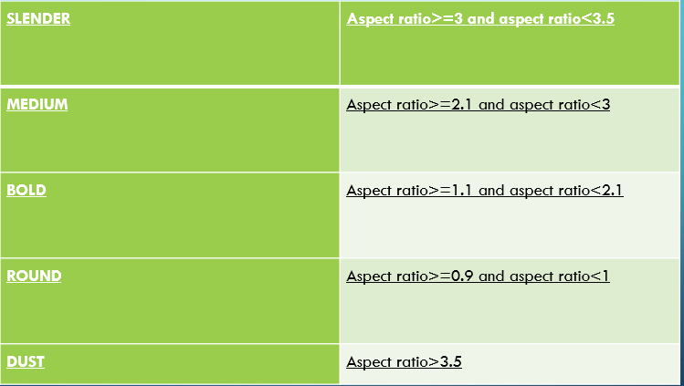

**4.2 SYSTEM ARCHITECTURE DESIGN**

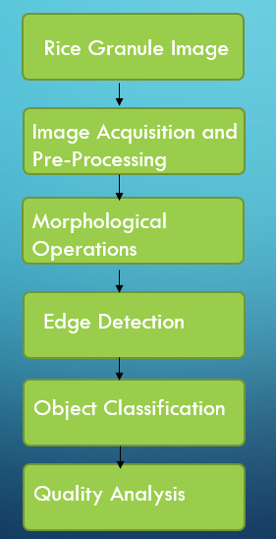

**4.3 CODES AND STANDARDS**

#RICE_QUALITY_DETECTION_USING_IMAGE_PROCESSING AND DATA VIZUALIZATION

#IMPORTING DATASETS

import dash

import dash_core_components as dcc

import dash_html_components as html

import plotly.graph_objects as go

from plotly import subplots

import pandas as pd

import plotly.express as px

import numpy as np

from dash.dependencies import Input, Output, State

import cv2

import PIL.Image as image

from io import BytesIO

import base64

from matplotlib import pyplot as plt

app = dash.Dash(__name__)

#project explanation

text1="""

Rice is favorable and high consumed cereal grain in Asian countries.

It can be easily found all over the world. Many value added products are produced by using rice for human beings .

In the rice market, key determinant of milled rice is quality. The quality measurement becomes more important with

the import and export trade. Rice samples contain different dispensable objects like paddy, chaff, damaged grains, weed seeds, stones etc.

Rice quality is varying according to these impurity content.

"""

text2="""

The main purpose of the proposed method is, to offer an alternative way for quality control and analysis which reduce the required effort,

cost and time. Image processing is significant and advanced technological area where important developments have been made.

"""

text3="""

In agricultural and farming production quality control and analysis of manufactured goods is vital.

Quality of grain is analyzed visually by veteran person and technician. But the effect of such measurement is changing in results and prolonged.

The excellence and quality also influenced by the mood and atmosphere of technician; so to overcome the shortcoming occurred due to conventional methods advanced technique i.e.

Image processing technique is projected, to Maintaining the Integrity of the Specifications.

"""

text4="""

Image processing manipulates image for performing some operations on targeted image to get an improved and desirable image.

And extort some valuable information from input image. Nowadays, image processing is hastily growing technologies.

All types of data have to go through three general phases while using digital image processing technique which are pre-processing, enhancement, and display, information extraction.

"""

text5="""

The Agricultural industry on the whole is very vast and ancient. Quality assessment of grains is a very big challenge since time immemorial.

The project presents a solution for quality evaluation and grading of rice grains using image processing techniques.

Commercially the grading of rice is done according to the size of the grain (full, half or broken). The food grains quality are rapidly assessed through visual inspection by human inspectors.

The decision making capabilities of human-inspectors are subjected to external influences such as fatigue, vengeance, bias etc.

With the help of image processing techniques we can overcome that and which are also a non-destructive and cost-effective techniques.

Here we also discuss the procedure used to obtain the percentage quality of rice grains. Rice quality is nothing but the combination of physical and chemical characteristics.

Grain size and shape, chalkiness, whiteness, milling degree, bulk density and moisture content are some physical characteristics, gelatinization temperature and gel consistency are chemical characteristics of rice.

"""

text6="""

Many studies that consider the morphological features of grains such as its area, shape etc. have already been performed.

However, the shapes and sizes of the different varieties are too varied to generalize a common formula for the classification of all varieties of rice.

"""

#classification of rice particals

def get_classification(ratio):

ratio =round(ratio,1)

toret=""

if(ratio>=3 and ratio<3.5):

toret="Slender"

elif(ratio>=2.1 and ratio<3):

toret="Medium"

elif(ratio>=1.1 and ratio<2.1):

toret="Bold"

elif(ratio>0.9 and ratio<=1):

toret="Round"

else:

toret="Dust"

return toret

#initialisig the values

classification = {"Slender":0, "Medium":0, "Bold":0, "Round":0, "Dust":0}

avg = {"Slender":0, "Medium":0, "Bold":0, "Round":0, "Dust":0}

#load in greyscale mode

from IPython.display import display, Image

img = cv2.imread("rice.png",0)

display(Image(filename='rice.png'))

#histogram part of the image

import cv2

import numpy as np

from matplotlib import pyplot as plt

img = cv2.imread('rice.png',0)

hist,bins = np.histogram(img.flatten(),256,[0,256])

cdf = hist.cumsum()

cdf_normalized = cdf * hist.max()/ cdf.max()

plt.plot(cdf_normalized, color = 'b')

plt.hist(img.flatten(),256,[0,256], color = 'r')

plt.xlim([0,256])

plt.legend(('cdf','histogram'), loc = 'upper left')

#plt.show()

#convert into binary

# 160 - threshold, 255 - value to assign, THRESH_BINARY_INV - Inverse binary

ret,binary = cv2.threshold(img,160,255,cv2.THRESH_BINARY)

#averaging filter

kernel = np.ones((5,5),np.float32)/9

dst = cv2.filter2D(binary,-1,kernel)

# -1 : depth of the destination image

kernel2 = cv2.getStructuringElement(cv2.MORPH_ELLIPSE,(3,3))

#erosion

erosion = cv2.erode(dst,kernel2,iterations = 1)

#dilation

dilation = cv2.dilate(erosion,kernel2,iterations = 1)

#edge detection

edges = cv2.Canny(dilation,100,200)

#size detection

contours, hierarchy = cv2.findContours(erosion, cv2.RETR_EXTERNAL, cv2.CHAIN_APPROX_SIMPLE)

print("No. of rice grains=",len(contours))

total_ar=0

#counting impurities

for cnt in contours:

x,y,w,h = cv2.boundingRect(cnt)

aspect_ratio = float(w)/h

if(aspect_ratio<1):

aspect_ratio=1/aspect_ratio

#print(round(aspect_ratio,2),get_classification(aspect_ratio))

classification[get_classification(aspect_ratio)] += 1

if get_classification(aspect_ratio) != "Dust":

total_ar+=aspect_ratio

if get_classification(aspect_ratio) != "Dust":

avg[get_classification(aspect_ratio)] += aspect_ratio

#getting the average value

avg_ar=total_ar/len(contours)

#setting the values for classification of rice

if classification['Slender']!=0:

avg['Slender'] = avg['Slender']/classification['Slender']

if classification['Medium']!=0:

avg['Medium'] = avg['Medium']/classification['Medium']

if classification['Bold']!=0:

avg['Bold'] = avg['Bold']/classification['Bold']

if classification['Round']!=0:

avg['Round'] = avg['Round']/classification['Round']

#saving different types of images

cv2.imwrite("img.jpg", img)

cv2.imwrite("binary.jpg", binary)

cv2.imwrite("dst.jpg", dst)

cv2.imwrite("erosion.jpg", erosion)

cv2.imwrite("dilation.jpg", dilation)

cv2.imwrite("edges.jpg", edges)

#histogram part for the edge part of the image

import cv2

import numpy as np

from matplotlib import pyplot as plt

img = cv2.imread('edges.jpg',0)

hist,bins = np.histogram(img.flatten(),256,[0,256])

cdf = hist.cumsum()

cdf_normalized = cdf * hist.max()/ cdf.max()

plt.plot(cdf_normalized, color = 'b')

plt.hist(img.flatten(),256,[0,256], color = 'r')

plt.xlim([0,256])

plt.legend(('cdf','histogram'), loc = 'upper left')

#plt.show()

#converting rgb to bgr

def readb64(base64_string):

sbuf = BytesIO()

sbuf.write(base64.b64decode(base64_string))

pimg = image.open(sbuf)

return cv2.cvtColor(np.array(pimg), cv2.COLOR_RGB2BGR)

#updating the image

def update_image(pic):

img = readb64(pic)

img = cv2.cvtColor(img, cv2.COLOR_BGR2GRAY)

classification1 = {"Slender":0, "Medium":0, "Bold":0, "Round":0, "Dust":0}

avg1 = {"Slender":0, "Medium":0, "Bold":0, "Round":0, "Dust":0}

#convert into binary

ret,binary = cv2.threshold(img,160,255,cv2.THRESH_BINARY)# 160 - threshold, 255 - value to assign, THRESH_BINARY_INV - Inverse binary

#averaging filter

kernel = np.ones((5,5),np.float32)/9

dst = cv2.filter2D(binary,-1,kernel)# -1 : depth of the destination image

kernel2 = cv2.getStructuringElement(cv2.MORPH_ELLIPSE,(3,3))

#erosion

erosion = cv2.erode(dst,kernel2,iterations = 1)

#dilation

dilation = cv2.dilate(erosion,kernel2,iterations = 1)

#edge detection

edges = cv2.Canny(dilation,100,200)

### Size detection

contours, hierarchy = cv2.findContours(erosion, cv2.RETR_EXTERNAL, cv2.CHAIN_APPROX_SIMPLE)

#print("No. of rice grains=",len(contours))

total_ar1=0

for cnt in contours:

x,y,w,h = cv2.boundingRect(cnt)

aspect_ratio = float(w)/h

if(aspect_ratio<1):

aspect_ratio=1/aspect_ratio

print(round(aspect_ratio,2),get_classification(aspect_ratio))

classification1[get_classification(aspect_ratio)] += 1

if get_classification(aspect_ratio) != "Dust":

total_ar1+=aspect_ratio

if get_classification(aspect_ratio) != "Dust":

avg1[get_classification(aspect_ratio)] += aspect_ratio

avg_ar1=total_ar1/len(contours)

if classification1['Slender']!=0:

avg1['Slender'] = avg1['Slender']/classification1['Slender']

if classification1['Medium']!=0:

avg1['Medium'] = avg1['Medium']/classification1['Medium']

if classification1['Bold']!=0:

avg1['Bold'] = avg1['Bold']/classification1['Bold']

if classification1['Round']!=0:

avg1['Round'] = avg1['Round']/classification1['Round']

cv2.imwrite("img1.jpg", img)

cv2.imwrite("binary1.jpg", binary)

cv2.imwrite("dst1.jpg", dst)

cv2.imwrite("erosion1.jpg", erosion)

cv2.imwrite("dilation1.jpg", dilation)

cv2.imwrite("edges1.jpg", edges)

return classification1,avg1,avg_ar1

#displaying image

def get_image(path):

img=image.open(path)

# Constants

img_width = 710

img_height = 550

scale_factor = 0.5

fig = go.Figure()

fig.add_trace(

go.Scatter(

x=[0, img_width * scale_factor],

y=[0, img_height * scale_factor],

mode="markers",

marker_opacity=0

)

)

fig.update_xaxes(

visible=False,

range=[0, img_width * scale_factor]

)

fig.update_yaxes(

visible=False,

range=[0, img_height * scale_factor],

scaleanchor="x"

)

fig.add_layout_image(

dict(

x=0,

sizex=img_width * scale_factor,

y=img_height * scale_factor,

sizey=img_height * scale_factor,

xref="x",

yref="y",

opacity=1.0,

layer="below",

sizing="stretch",

source=img)

)

fig.update_layout(

width=img_width * scale_factor,

height=img_height * scale_factor,

margin={"l": 0, "r": 0, "t": 0, "b": 0},

)

fig.show(config={'doubleClick': 'reset'})

return fig

#average aspect vs classification plot

def get_plot1(classification = classification, avg = avg, avg_ar = avg_ar):

fig = subplots.make_subplots(rows=1,cols=1,specs=[[{"type":"bar"}]], shared_xaxes=True)

print(list(classification.keys()))

print(list(classification.values()))

plot1 = go.Bar(x=list(classification.keys()), y=list(classification.values()), name="Particles")

plot2 = go.Bar(x=list(avg.keys()), y=list(avg.values()), name="Avg. Aspect Ratio")

fig.add_trace(plot1,1,1)

fig.add_trace(plot2,1,1)

fig.add_shape(

type="line",

x0=0,

y0=round(avg_ar,2),

x1=5,

y1=round(avg_ar,2),

line=dict(

color="LightSeaGreen",

width=4,

dash="dashdot",

),

)

fig.update_layout(

width = 600,

height = 350,

margin = {"l": 5, "r": 5, "t": 30, "b": 5},

title = "Average Aspect Ratio Vs Classification",

template = "plotly_dark"

)

return fig

#quality annalysis

def get_plot2(classification = classification):

fig = subplots.make_subplots(rows=1,cols=1,specs=[[{"type":"pie"}]])

rice = sum(list(classification.values())) - classification['Dust']

dust = classification['Dust']

values = [rice, dust]

labels = ["Rice", "Dust"]

plot1 = go.Pie(labels=labels, values=values, hole=.3)

fig.add_trace(plot1,1,1)

fig.update_layout(

width = 600,

height = 350,

margin = {"l": 65, "r": 5, "t": 60, "b": 50},

title = "Quality Analysis",

template = "plotly_dark"

)

return fig

#

app.layout = html.Div([

html.Div([

html.Div([

html.Img(

src="logo.jpg",

style={"height" : "40px", "width" : "40px", "border-radius":"20px"}

)

],style={"float":"left","padding" : "5px 0 5px 50px"}),

html.Div(

children="Classification and Quality Analysis of Rice",

style={"float":"left","padding" : "10px 0 10px 10px","font-size": "17px", "font-weight" :"600"}

),

html.Div([

html.Div([html.A("Home",href="#home")], style={"float":"left","padding":"0 10px 0 10px","align-items": "center","font-size": "15px", "font-weight" :"600"}),

html.Div([html.A("About Project",href="#about-project")], style={"float":"left","padding":"0 10px 0 10px","align-items": "center","font-size": "15px", "font-weight" :"600"}),

html.Div([html.A("About Us",href="#about-us")], style={"float":"left","padding":"0 10px 0 10px","align-items": "center","font-size": "15px", "font-weight" :"600"}),

html.Div([html.A("Source Code",href="#bottom")], style={"float":"left","padding":"0 10px 0 10px","align-items": "center","font-size": "15px", "font-weight" :"600"}),

],style={"float":"right", "padding": "10px 50px 10px 0px"})

],className="nav"),

html.Div([],style={"height":"50px"},id="home"),

html.Div([

html.H1(children="Visualisation of Results", style={"text-align":"center", "margin":"0", "padding-bottom" : "20px", "color" : "whitesmoke"}),

html.Div([

html.Div([

dcc.Graph(figure=get_plot1(),id="graph1"),

html.P("Original Image", style={"margin":"0","padding-bottom":"10px"})

], style = {"display": "block", "justify-content": "center", "align-items": "center", "padding":"0 20px 0 20px"}),

html.Div([

dcc.Graph(figure=get_plot2(),id="graph2"),

html.P("Binary Image", style={"margin":"0","padding-bottom":"10px"})

], style = {"display": "block", "justify-content": "center", "align-items": "center", "padding":"0 20px 0 20px"}),

], style = {"display": "flex", "justify-content": "center", "align-items": "center", "text-align":"center"}),

html.Div([]),

html.Div([

html.Div([

dcc.Upload([

'Drag and Drop or ',

html.A('Select a File')

],

style={

'width': '100%',

'height': '60px',

'lineHeight': '60px',

'borderWidth': '1px',

'borderStyle': 'dashed',

'borderRadius': '5px',

'textAlign': 'center'

}, id="upload-image"),

], style = {"display": "block", "justify-content": "center", "align-items": "center", "padding":"0 20px 0 20px"}),

], style = {"display": "flex", "justify-content": "center", "align-items": "center", "text-align":"center", "width" : "100%"})

],style = {"color":"black", "padding" : "20px 0 20px 0", "color" : "whitesmoke"},id='plots'),

html.Div([

html.H1(children="Images", style={"text-align":"center", "margin":"0", "padding-bottom" : "20px"}),

html.Div([

html.Div([

dcc.Graph(figure=get_image("img.jpg"),id="img"),

html.P("Original Image", style={"margin":"0","padding-bottom":"10px"})

], style = {"display": "block", "justify-content": "center", "align-items": "center", "padding":"0 20px 0 20px"}),

html.Div([

dcc.Graph(figure=get_image("binary.jpg"),id="binary"),

html.P("Binary Image", style={"margin":"0","padding-bottom":"10px"})

], style = {"display": "block", "justify-content": "center", "align-items": "center", "padding":"0 20px 0 20px"}),

html.Div([

dcc.Graph(figure=get_image("dst.jpg"),id="dst"),

html.P("Dust Image", style={"margin":"0","padding-bottom":"10px"})

], style = {"display": "block", "justify-content": "center", "align-items": "center", "padding":"0 20px 0 20px"})

], style = {"display": "flex", "justify-content": "center", "align-items": "center", "text-align":"center"}),

html.Div([]),

html.Div([

html.Div([

dcc.Graph(figure=get_image("erosion.jpg"),id="erosion"),

html.P("Erosion", style={"margin":"0","padding-bottom":"10px"})

], style = {"display": "block", "justify-content": "center", "align-items": "center", "padding":"0 20px 0 20px"}),

html.Div([

dcc.Graph(figure=get_image("dilation.jpg"),id="dilation"),

html.P("Dilation", style={"margin":"0","padding-bottom":"10px"})

], style = {"display": "block", "justify-content": "center", "align-items": "center", "padding":"0 20px 0 20px"}),

html.Div([

dcc.Graph(figure=get_image("edges.jpg"),id="edges"),

html.P("Edge Detection", style={"margin":"0","padding-bottom":"10px"})

], style = {"display": "block", "justify-content": "center", "align-items": "center", "padding":"0 20px 0 20px"})

], style = {"display": "flex", "justify-content": "center", "align-items": "center", "text-align":"center"})

],style = {"color":"black", "background-color" : "lightsteelblue", "border-radius":"40px 40px 40px 40px", "padding" : "20px 0 20px 0"},id='images'),

html.Div([

html.H1(children="About Project", style={"text-align":"center"}),

html.P(children=text1),

html.P(children=text2),

html.P(children=text3),

html.P(children=text4),

html.P(children=text5),

html.P(children=text6),

],style = {"color":"white", "padding":"10px 50px 10px 50px"},id="about-project")

])

#app callback

@app.callback([Output('img', 'figure'),

Output('binary', 'figure'),

Output('dst', 'figure'),

Output('erosion', 'figure'),

Output('dilation', 'figure'),

Output('edges', 'figure'),

Output('graph1', 'figure'),

Output('graph2', 'figure')],

[Input('upload-image', 'contents')])

#updating the outputs

def update_output(list_of_contents):

if list_of_contents is not None:

ind = str(list_of_contents).find(",")

cla,av,av_ar = update_image(list_of_contents[ind:])

return get_image("img1.jpg"), get_image("binary1.jpg"), get_image("dst1.jpg"), get_image("erosion1.jpg"), get_image("dilation1.jpg"), get_image("edges1.jpg"), get_plot1(cla, av, av_ar), get_plot2(cla)

else:

return get_image("img.jpg"), get_image("binary.jpg"), get_image("dst.jpg"), get_image("erosion.jpg"), get_image("dilation.jpg"), get_image("edges.jpg"), get_plot1(), get_plot2()

#hosting the website

if __name__ == '__main__':app.run_server(debug=False)

1. **SCHEDULE TASKS AND MILETSTONES**

**Gantt Chart**

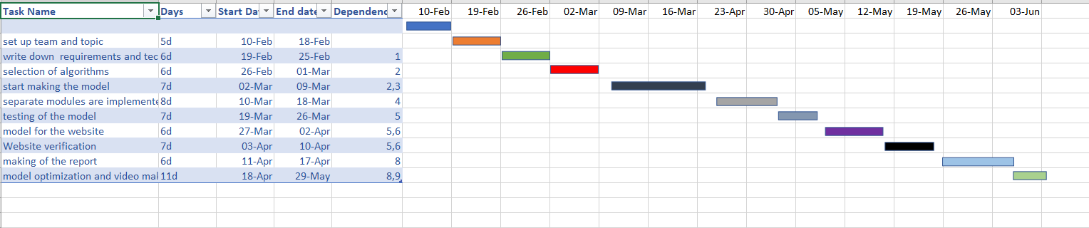

1. **PROJECT DEMONSTRATION**

INPUT IMAGE

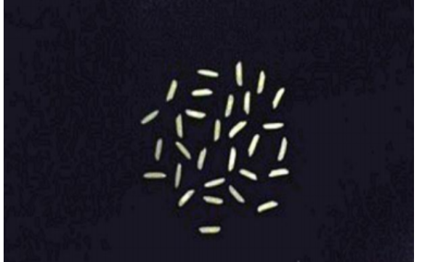

HISTOGRAM BEFORE PROCESSING

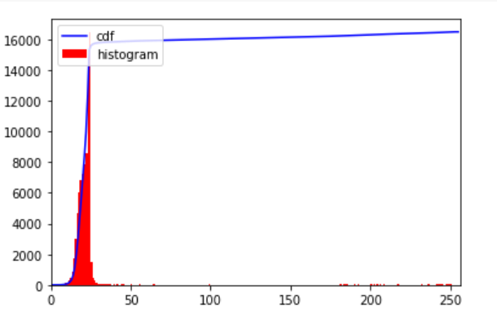

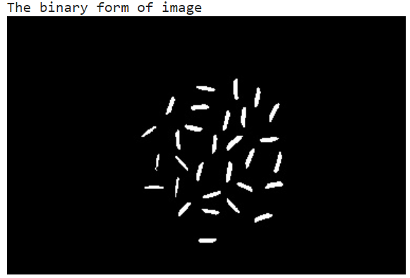

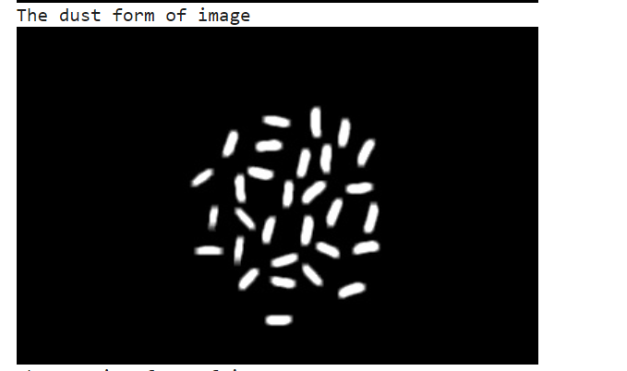

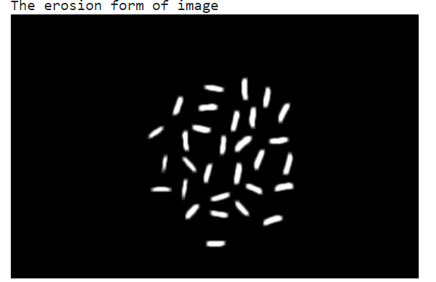

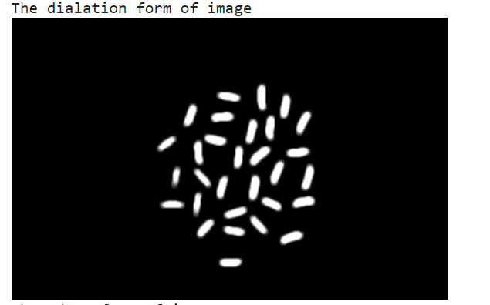

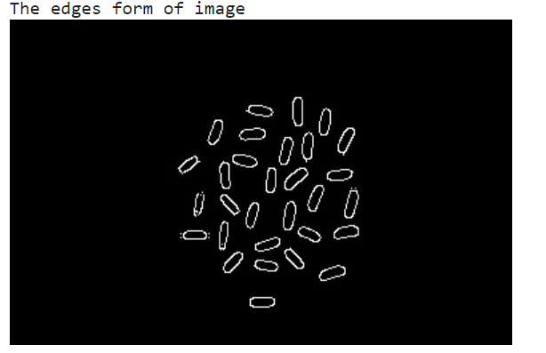

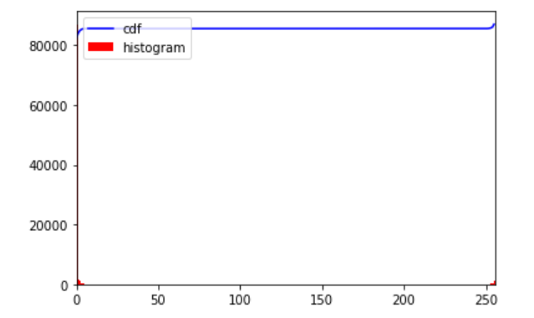

1. **PROJECT COST ANALYSIS**

This project aims in reducing the total amount of physical labour required to classify rice grains and to analyse the rice grains based on their quality. Machine Learning and Python Flask have been used to achieve the objectives of this project.

At the end of the project we are successful in developing a website which can take input in the form of rice images and classify the rice grains and as well as determine the quality of the rice grains.

This is an efficient approach and as well as a cost-efficient approach.

1. **RESULTS AND DISCUSSION**

|  |  |  |
| --- | --- | --- |
| S.NO | INPUT | OUTPUT |
| 1 |  |  |
| 2 |  |  |
| 3 |  |  |
| 4 |  |  |
| 5 |  |  |
| 6 |  |  |

Grouped Bar chart – Used for Classification purpose

• Blue Bar indicates the Number of Rice grains.

• Red Bar indicates Average Aspect Ratio.

Pie chart – Used for Quality Analysis purpose

• Blue Section indicates percentage of Rice grains in the given sample.

• Red Section indicates percentage of Dust in the given sample.

In this project, we are classifying the rice grain sample taken into various categories and also analysing its quality based on its aspect ratio, so it is not possible to compare with other works. Existing works only detect the rice grains, or calculate number of rice grains in the given sample but our work helps to analyse the quality of rice sample and classify them into particular category.

Quality of grains in the samples should be nearly 100% accurate and it should be suitable to grade large quality of grains efficiently, which otherwise will consume lot of time in manual analysis, this feature will be able to save lot of time & human effort

The image analysis algorithms are applied on image in which rice grains are randomly placed and spread in one layer. If the error occurs like touching kernels shrinkage operation works efficiently for separating the connecting part from point touching kernels. Edge detection is performed to find out the region of boundaries and endpoints of each grain; and then after that using calliper length and breadth can be measured. After getting the values for length and breadth, length-breadth ratio is to be calculated. In this study, the image processing algorithms are developed to segment and identify rice grains. use of image processing algorithm is an efficient method to analyse grains quality by its size. The main benefit of proposed method is it requires minimum time; cost is less and gives better results compared with manual results or traditional methods. We have successfully executed all the steps proposed. Last two steps include calculating the size of the grains and then classifying them according to the Table provided.