SYSTEM ARCHITECTURE
ADR & BUSINESS GAP REVIEW
Email Operations Workspace
Field | Value
Version | 2.0 architecture supplement
Date | 2026-08-10
Baseline | BA Rules & Backend Design v1.0 — 118 rules / 159 test cases
Primary decision | Refine CORE headless frontend + hardened Brocoders NestJS boilerplate backend
Architecture style | Modular monolith deployed as API, worker and scheduler runtime profiles
Realtime | Socket.IO + Redis adapter; REST/PostgreSQL remain authoritative

Decision status: The stack is approved as an implementation baseline, subject to a short compatibility/security spike and exact-version lockfile. GrapesJS remains a proposed editor pending output-quality validation.

1. Executive recommendation
Start from Refine CORE headless on the frontend and a reviewed fork of brocoders/nestjs-boilerplate on the backend. Keep the existing custom visual system, use REST/OpenAPI for compatibility, and deploy one modular domain codebase through separate API, worker and scheduler processes. PostgreSQL is the source of truth; BullMQ handles background work; Socket.IO distributes prompt UI updates; durable notifications are stored in PostgreSQL.
Key correction to v1: Notification is a first-class domain, not merely a toast or one schedule rule. Realtime is a delivery mechanism spanning campaign progress, schedule state, validation, import, bulk updates, exports, sender health, quotas and durable notification prompts.

2. Baseline review and material gaps
The review identified 75 concrete gaps across 14 domains. The largest risks are not missing screens; they are undefined consistency, authorization, failure-recovery and compliance behavior behind existing screens.
Gap domain | Count | Main risk
Campaign lifecycle | 8 | Preflight, cancellation, fairness and recovery
Sender & deliverability | 8 | Domain auth, complaint/bounce and suppression
Audience & variables | 6 | Stale estimates, repair workflow and schema evolution
Notification | 6 | No durable inbox or trigger/recipient policy
Organization & users | 6 | Rules and acceptance behavior not yet explicit
Realtime | 6 | Reconnect, authorization, envelope and event volume
Security & governance | 6 | Browser security, secrets, audit and privacy
History & analytics | 5 | Rules and acceptance behavior not yet explicit
Operations | 5 | DLQ, job tooling, health and kill switches
Collaboration & approval | 4 | Rules and acceptance behavior not yet explicit
Import/export | 4 | Rules and acceptance behavior not yet explicit
Template/editor | 4 | Rules and acceptance behavior not yet explicit
UX resilience | 4 | Rules and acceptance behavior not yet explicit
Scheduling | 3 | Rules and acceptance behavior not yet explicit

The detailed gap-by-gap recommendation, priority, owner and required test coverage is in the companion workbook. This document records the architecture decisions needed to close those gaps consistently.

3. System context and architecture style
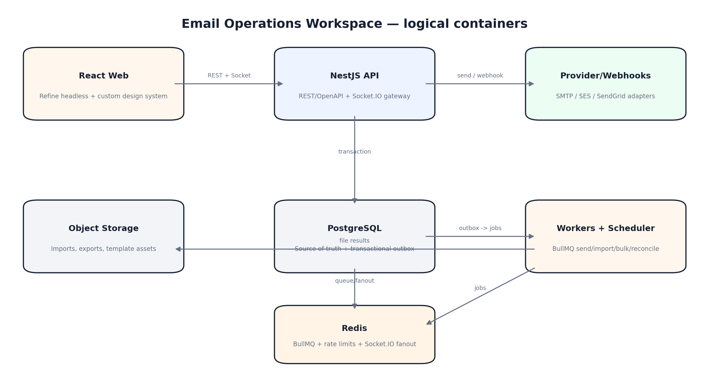

3.1 Why a modular monolith
Campaign, recipient, template, schedule, notification and delivery rules share transactional invariants. Splitting them into networked services before scale and team boundaries are proven would increase distributed consistency work. The codebase is therefore modular but the runtime is separated by workload: synchronous API/gateway, background workers and one scheduler/dispatcher profile.
Runtime | Responsibilities | Scale signal
web | React SPA, Refine resources, notification center, activity/progress UI | CDN/static scaling
api | REST, auth, tenant guards, OpenAPI, Socket.IO gateway | HTTP RPS / socket connections
worker | send, import, export, bulk update, webhook/reconciliation work | queue lag / provider throughput
scheduler | due schedule claim, outbox dispatch, periodic reconciliation | single logical execution with DB locks

4. Critical send and consistency flow
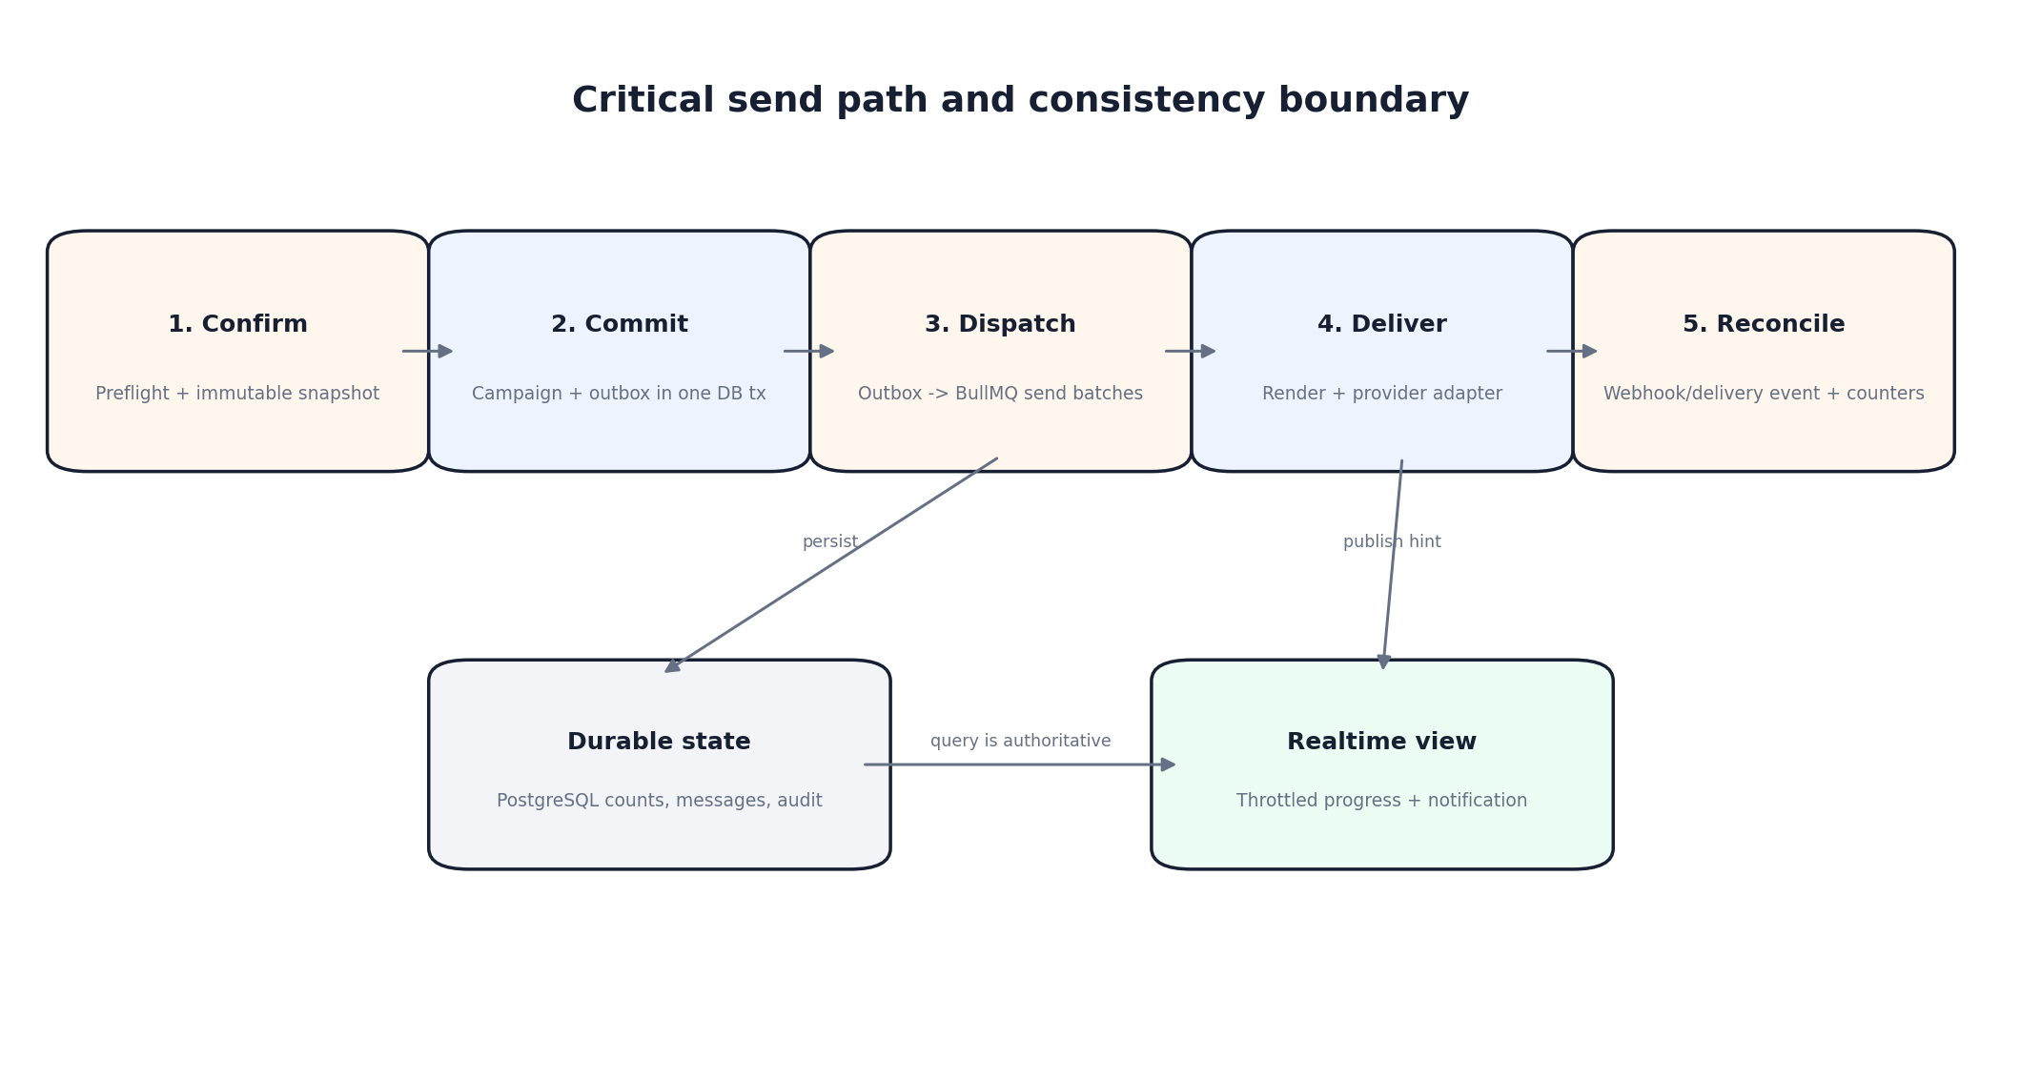
Stage | Invariant | Failure behavior
Confirm | Preflight passes and audience/template/sender/policy snapshot is immutable | Return structured blocking errors/warnings; no job created
Commit | Campaign state and outbox event commit in one PostgreSQL transaction | Rollback both; idempotency key prevents duplicate command
Dispatch | Outbox dispatcher creates deterministic BullMQ batches | Retry safely; unique job keys prevent duplicate batches
Deliver | Each campaign recipient has deterministic message key and provider attempt history | Retry only retryable failure; accepted provider response is not blindly repeated
Reconcile | Provider webhooks are signature-checked, deduped and mapped to canonical state | Late/out-of-order events converge; reconciliation raises issues
Present | PostgreSQL counters are authoritative; socket events are throttled hints | Reconnect/refetch restores truth without lost UI state

5. Boilerplate selection
GitHub stars are used only as an adoption signal, not a quality guarantee. Counts below are approximate snapshots observed on the review date; security posture, maintenance activity, license and product fit were considered separately.
Candidate | Signal | Decision | Fit and condition
Refine CORE + Vite (selected FE foundation) | ~35.5k / MIT | Selected | Headless, CRUD/data-heavy focus, auth/access/realtime/notification provider contracts, preserves the custom Email Operations Workspace design. It is a meta-framework, so the team still owns the design-system components and the Socket.IO LiveProvider adapter.
Brocoders NestJS boilerplate (selected BE seed) | ~4.4k / MIT | Selected with hardening | Includes auth/session foundation, roles, PostgreSQL/TypeORM, mail, S3/local files, Swagger, Docker, unit/E2E tests and CI. Fork at a reviewed commit; remove social auth and unused modules; change browser auth to secure cookie strategy; add tenant enforcement, outbox, jobs and realtime.
Bulletproof React | ~35.7k / MIT | Reference only | Excellent feature-folder, API, testing, security and error-handling conventions. Its README explicitly says it is not a template/boilerplate/framework, so copying the repository as product source would contradict upstream guidance.
Extensive React Boilerplate | ~0.5k / MIT | Not selected | Explicitly compatible with the selected backend and already includes auth/user flows. Next.js/MUI is more opinionated than the current Vite/custom design system and adoption is materially lower than Refine.
NestJS official TypeScript starter | Public template / MIT | Fallback | Smallest official baseline and lowest upstream coupling. Auth, roles, database, storage, mail, Docker and application tests must be built from scratch.

5.1 Compatibility contract
The frontend and backend are compatible through a deliberately small contract: versioned REST endpoints, OpenAPI-generated TypeScript types, problem-details errors, HttpOnly cookie authentication, idempotency keys, correlation IDs and a versioned Socket.IO event envelope. Refine's DataProvider/AuthProvider/AccessControlProvider/LiveProvider adapters isolate application code from transport details.

6. Library baseline
ID | Concern | Selection | Status | Decision note
FE-001 | Application core | React 19 + TypeScript strict + Vite | Selected | Keep the current web stack and fast local build; exact versions locked after compatibility spike.
FE-002 | Enterprise data framework | @refinedev/core v5 | Selected | Headless resources, auth, access control, notification and live-provider contracts.
FE-003 | Routing | React Router | Selected | Browser routes, protected layouts and deep links from notifications.
FE-004 | Server state | TanStack Query v5 via Refine | Selected | Caching, mutation, invalidation and background refetch; do not add a second query client.
FE-005 | Forms | React Hook Form v7 | Selected | Large recipient/template/schedule forms with controlled rerenders.
FE-006 | Validation | Zod | Selected | Client-side UX validation and event-envelope parsing; backend remains authoritative.
FE-007 | Accessible primitives | Radix UI Primitives | Selected | Dialog, popover, select, tooltip, tabs and focus management without imposing visual styling.
FE-008 | Tables | TanStack Table | Selected | Server-side pagination/sort/filter and row selection for recipient/history modules.
FE-009 | Realtime client | socket.io-client 4.x | Selected | Reconnect, rooms and event acknowledgements compatible with NestJS gateway.
FE-010 | Toast feedback | Custom Refine NotificationProvider + Radix Toast | Selected | Transient mutation feedback is separate from durable notification center.
FE-011 | Dates/timezone | date-fns + date-fns-tz | Selected | IANA timezone display and schedule validation.
FE-012 | I18n | i18next + react-i18next | Selected | Vietnamese-first with stable message keys and future locale support.
FE-013 | Email visual editor | GrapesJS + newsletter preset | Spike required | Likely fit for drag/drop email content; must pass output, accessibility and sanitization spike before commitment.
FE-014 | Unit/component test | Vitest + Testing Library + MSW | Selected | Fast component/hook testing with deterministic REST mocks.
FE-015 | E2E | Playwright | Selected | Cross-browser core flows, scheduling, reconnect and notification tests.
BE-001 | API framework | NestJS 11 | Selected | Modular, testable TypeScript backend with official OpenAPI/WebSocket/queue integrations.
BE-002 | HTTP adapter | Fastify adapter | Selected | Lower overhead; verify middleware compatibility from boilerplate during spike.
BE-003 | Database | PostgreSQL | Selected | Strong relational constraints, JSONB custom data, indexes and transactional outbox.
BE-004 | ORM/migrations | TypeORM 0.3 line | Selected | Matches chosen boilerplate; migrations mandatory, synchronize=false outside local scratch.
BE-005 | Validation | class-validator + class-transformer | Selected | Matches NestJS boilerplate DTO conventions; OpenAPI is the cross-boundary contract.
BE-006 | API contract | @nestjs/swagger + openapi-typescript | Selected | Generate typed FE contract in CI; breaking-change check required.
BE-007 | Jobs | BullMQ + @nestjs/bullmq | Selected | Send, import, export, bulk custom data and reconciliation jobs.
BE-008 | Queue/cache | Redis | Selected | BullMQ, rate limit, short-lived locks and Socket.IO fanout; never source of truth for campaign counts.
BE-009 | Realtime server | Socket.IO 4.x + Nest gateway + Redis adapter | Selected | Per-user/org rooms, reconnect, acknowledgements and horizontal scaling.
BE-010 | Template merge | Handlebars strict mode | Selected with restrictions | Existing {{variable}} syntax; disable arbitrary helpers and prototype access.
BE-011 | Email HTML | sanitize-html + juice + html-to-text | Selected | Sanitize, inline CSS and produce text alternative before provider submission.
BE-012 | Mail transport | Provider adapter; Nodemailer for SMTP | Selected | Adapter boundary supports SMTP/SES/SendGrid without leaking provider details into campaign domain.
BE-013 | Object storage | AWS SDK S3 client / compatible storage | Selected | Imports, exports, assets and error reports; signed URLs and retention policies.
BE-014 | Logging | Pino | Selected | Structured logs with correlation, tenant, campaign and job IDs; PII redaction.
BE-015 | Telemetry | OpenTelemetry | Selected | Trace REST -> outbox -> queue -> provider/webhook path and collect queue lag.
WS-001 | Monorepo | pnpm workspaces + Turborepo | Selected | Atomic FE/BE/contract changes, shared tooling and filtered builds.
WS-002 | Dependency governance | Renovate + lockfile + SBOM | Selected | Scheduled updates, controlled majors, license/security review and reproducible builds.

Version rule: Do not copy version numbers from this document into package.json. During the implementation spike, resolve the current stable compatible set, pin exact versions in pnpm-lock.yaml, record the commit SHA of each boilerplate fork and enable automated patch/minor update PRs.

7. Domain module architecture
Module | Owns | Primary state | Publishes
Identity & Organization | Users, sessions, roles, permissions, organization settings | PostgreSQL | user/organization events
Recipients & Segmentation | Recipients, lists, tags, custom fields, suppression | PostgreSQL + object storage | segment changed, bulk jobs
Templates | Drafts, published versions, assets, variable schema, preflight | PostgreSQL + object storage | template published
Campaigns | Draft, audience definition/snapshot, approvals, schedule and state | PostgreSQL | campaign/schedule events
Delivery | Message generation, provider adapter, retry, webhooks and reconciliation | PostgreSQL + BullMQ | progress/delivery events
Notifications | Durable inbox, preferences, trigger policy and channel deliveries | PostgreSQL | notification events
Realtime Gateway | Socket authorization, rooms, replay cursor and throttled fanout | Redis adapter | versioned socket envelope
Import/Export | File intake, mapping, batch processing and result files | Object storage + BullMQ | job progress/completion
Audit & Compliance | Immutable audit, unsubscribe/complaint policy and retention | PostgreSQL | audit/compliance events
Platform Operations | Quota, feature flags, health, telemetry, DLQ and admin job tools | PostgreSQL + Redis | operational alerts

7.1 Boundary rules
Ownership. Only the owning module writes its aggregate tables; other modules call an application service or consume an outbox event.
No Redis truth. Redis may cache, queue or fan out but campaign/message/notification counters are reconciled from PostgreSQL.
No provider leakage. Provider-specific statuses live in attempt/event records and map to canonical internal states.
No frontend authority. Frontend validation improves UX; send/schedule/preflight and permission checks always run on the server.

8. Realtime architecture
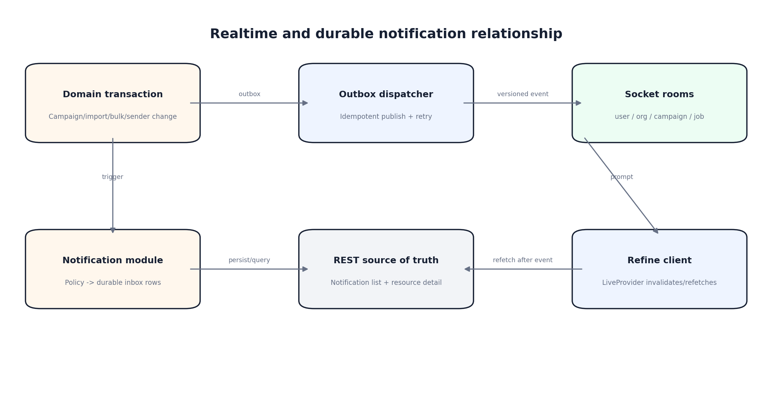

8.1 Event envelope
Field | Rule
event_id | Globally unique; used for dedupe and diagnostics
type | Stable dotted name such as campaign.progress
schema_version | Integer; clients ignore/telemetry-log unsupported versions and refetch
occurred_at | UTC ISO-8601 timestamp from server
channel | Authorized user/org/campaign/job resource channel
resource | Type + id + monotonically increasing state version where applicable
payload | Minimal data needed for prompt UI; never secret or unnecessary PII
cursor | Replay/resume position per connection or channel
correlation_id | Traces original REST command/outbox/job/provider flow

8.2 Event catalog
Event | Channel | Purpose | Cadence | Dedupe | Prio
rt.connection.ready | user:{user_id} | Connection authorized; includes server_time and resume capability | At connect | No | P0
rt.resync_required | user:{user_id} | Cursor is outside replay window; client refetches affected resources | On gap | No | P0
notification.created | user:{user_id} | New durable notification; update badge and optionally show toast | Immediate | notification_id | P0
notification.updated | user:{user_id} | Notification resolved/changed | Immediate | notification_id | P1
notification.read | user:{user_id} | Read state synchronized across tabs/devices | Immediate | notification_id+user_id | P1
campaign.state_changed | campaign:{campaign_id} | Draft/scheduled/queued/sending/paused/completed/failed/canceled | Immediate | campaign_id+version | P0
campaign.progress | campaign:{campaign_id} | Aggregate processed/sent/failed/skipped/pending/progress/ETA | Throttle <=1/s | campaign_id+version | P0
campaign.issue_detected | campaign:{campaign_id} | Failure threshold, provider rejection or reconciliation mismatch | Immediate | issue_id | P0
schedule.state_changed | campaign:{campaign_id} | Created, rescheduled, canceled, due, dispatched, missed | Immediate | schedule_id+version | P0
audience.validation_progress | campaign:{campaign_id} | Large audience/variable validation progress | Throttle <=1/s | validation_job_id+version | P1
audience.validation_completed | campaign:{campaign_id} | Counts and link to missing-variable resolution | Once | validation_job_id | P0
import.progress | job:{job_id} | Rows parsed/valid/created/updated/skipped/failed | Throttle <=1/s | job_id+version | P1
import.completed | job:{job_id} | Final import summary and error-file link | Once | job_id | P1
bulk_update.progress | job:{job_id} | Resolved scope and progress for custom data/list/tag changes | Throttle <=1/s | job_id+version | P1
bulk_update.completed | job:{job_id} | Final result with partial failures | Once | job_id | P1
export.completed | job:{job_id} | Download is ready or export failed | Once | job_id | P2
sender.state_changed | org:{organization_id} | Sender verified, disabled, credential problem or quota issue | Immediate | sender_id+version | P0
quota.threshold_reached | org:{organization_id} | Configured 80/90/100 percent sending quota threshold | Per threshold | quota_period+threshold | P1
recipient.segment_changed | resource:recipients | Invalidate list/tag/member counts after bulk job | After commit | change_set_id | P2
template.published | resource:templates | Invalidate template list/version cache | After commit | template_version_id | P2

8.3 Client behavior
On an event, the Refine LiveProvider either updates a narrow progress cache or invalidates the affected resource query. On reconnect, the client sends its last cursor. If replay is unavailable, the gateway returns rt.resync_required and the client refetches the notification badge, open jobs and visible resource detail. Rapid progress events are supersedable; state-change and notification events are not.

9. Notification domain
Refine NotificationProvider is used for transient toast feedback from current user actions. The product notification center is a separate durable backend domain. A new notification is committed to PostgreSQL, then a notification.created socket event prompts the UI to refresh the authoritative unread feed.
Rule | Title | Business rule | Priority
BR-NOT-001 | Durable vs transient | A toast confirms the current action; notification center stores durable business events. A toast alone must not represent a failure requiring later action. | P0
BR-NOT-002 | Recipient scope | Every notification resolves explicit user recipients within one tenant based on role, ownership, subscription and preferences. | P0
BR-NOT-003 | Authorization | Opening a notification deep link rechecks current permission; payload must not reveal data the user can no longer access. | P0
BR-NOT-004 | Read state | Unread/read is stored per user and synchronized across devices; marking one item or all items is idempotent. | P1
BR-NOT-005 | Action state | Actionable notifications may be open, resolved or expired independently of read state. | P1
BR-NOT-006 | Deduplication | The same source event and recipient creates at most one notification; repeated provider webhooks cannot inflate unread count. | P0
BR-NOT-007 | Severity | Severity is info, success, warning or critical and controls icon/color only; it does not replace event type. | P1
BR-NOT-008 | Preferences | Users may mute optional event categories; security, permission and critical delivery failures cannot be muted unless policy allows. | P1
BR-NOT-009 | Channels | MVP supports in-app; email channel is opt-in per event policy. Channel failure does not roll back the underlying business transaction. | P1
BR-NOT-010 | Deep link | Each actionable notification has a stable route and resource ID; invalid/deleted targets show a safe explanatory state. | P1
BR-NOT-011 | Batching | High-volume similar events are grouped into one summary notification within a configured window. | P1
BR-NOT-012 | Offline recovery | After reconnect/login, the unread API is authoritative and fills events missed by the socket connection. | P0
BR-NOT-013 | Retention | Notification retention and PII minimization are configurable; deletion of notification does not delete audit events. | P1
BR-NOT-014 | Trigger catalog | Campaign completion/failure, schedule dispatch/miss, import/bulk completion, sender failure and quota thresholds have explicit trigger definitions. | P0
BR-NOT-015 | Localization | Store message key and structured parameters, not only rendered text, so UI can render the user's locale. | P2
BR-NOT-016 | Observability | Notification creation, socket delivery, channel attempt and read action emit metrics with notification/event IDs but no unmasked PII. | P1

9.1 Initial trigger catalog
Trigger | Recipients | Default severity | Durable | Realtime
Campaign completed | Owner + watchers | success or warning if partial | Yes | Yes
Campaign failed/auto-paused | Owner + Operators + Admins | critical | Yes | Yes
Schedule dispatched/missed/canceled by another user | Owner + watchers | info/warning | Yes | Yes
Audience validation missing variables | Current actor + owner | warning | Yes if async | Yes
Import/bulk/export completed | Job initiator | success/warning | Yes | Yes
Sender credential/domain/quota issue | Admins + affected campaign owners | critical/warning | Yes | Yes
Ordinary form save | Current actor | success/error toast | No | Local only

10. Data and API additions
Entity | Key fields / constraints | Purpose
notifications | id, organization_id, source_event_id, type, severity, message_key, params_json, resource_type/id, action_state, created_at; unique org+source_event+type | Durable notification fact
user_notifications | notification_id, user_id, read_at, delivered_realtime_at, channel_status; unique notification+user | Per-user inbox/read/delivery state
notification_preferences | organization_id, user_id, event_category, channel, enabled; unique user+category+channel | Optional notification control
outbox_events | id, aggregate_type/id/version, type, payload, occurred_at, published_at, attempts | Reliable event publication
realtime_event_log | optional bounded replay: event_id, channel, cursor, payload, expires_at | Short reconnect replay; not long-term audit
campaign_issues | campaign_id, type, severity, status, detected_at, resolved_at, detail | Actionable failures separate from notifications
sending_domains | domain, verification status, DKIM selector/status, SPF/DMARC check timestamps | Deliverability configuration
suppressions | normalized_email, scope, reason, source, effective_at, expires_at | Canonical eligibility block

Method | Endpoint | Purpose
GET | /api/v1/notifications | Cursor-paginated inbox with filters
GET | /api/v1/notifications/unread-count | Authoritative badge count
POST | /api/v1/notifications/{id}/read | Idempotently mark one item read
POST | /api/v1/notifications/read-all | Mark all through server cutoff timestamp
GET/PUT | /api/v1/notification-preferences | Read/update optional category/channel settings
GET | /api/v1/realtime/bootstrap | Allowed channels, cursor policy and server time
POST | /api/v1/campaigns/{id}/preflight | Blocking errors/warnings and audience hash
GET | /api/v1/campaigns/{id}/issues | Actionable failure/reconciliation issues
GET | /api/v1/jobs/{id} | Authoritative async-job progress after reconnect

11. Architecture Decision Records

ADR-001 — Modular monolith with separate runtime profiles
Field | Content
Status | Accepted
Decision | Use one domain codebase deployed as API, worker and scheduler profiles.
Rationale | Faster domain consistency than microservices while isolating workloads; define module boundaries and outbox events so future extraction remains possible.
Rejected/Deferred | A single process; microservices now

ADR-002 — Frontend foundation
Field | Content
Status | Accepted
Decision | Use Refine CORE headless on React/Vite and retain the existing design tokens/components.
Rationale | Fits a data-heavy internal workspace and provides auth/access/live/notification extension points without forcing AntD/MUI.
Rejected/Deferred | Extensive React Boilerplate; raw Vite only

ADR-003 — Backend seed
Field | Content
Status | Accepted with conditions
Decision | Fork Brocoders NestJS boilerplate at an audited commit and remove unused modules.
Rationale | Relevant built-in auth/database/storage/mail/testing features reduce setup time.
Rejected/Deferred | Official empty starter

ADR-004 — Repository topology
Field | Content
Status | Accepted
Decision | Use pnpm workspace with apps/web, apps/api, apps/worker and packages/ui/contracts/config.
Rationale | Atomic API contract changes and shared quality gates.
Rejected/Deferred | Separate repositories

ADR-005 — External API style
Field | Content
Status | Accepted
Decision | REST JSON under /api/v1 with OpenAPI as source of truth and generated FE types.
Rationale | Most workflows are resource-oriented; easier operationally than GraphQL and compatible with selected foundations.
Rejected/Deferred | GraphQL; shared handwritten DTOs

ADR-006 — Browser authentication
Field | Content
Status | Accepted
Decision | Short-lived access session and rotated refresh token in Secure HttpOnly SameSite cookies; server-side RBAC/tenant guards.
Rationale | Avoid exposing long-lived tokens to browser JavaScript.
Rejected/Deferred | localStorage bearer tokens

ADR-007 — Persistence
Field | Content
Status | Accepted
Decision | PostgreSQL + TypeORM migrations; tenant_id on tenant data and invariant unique constraints.
Rationale | Relational integrity matters for dedupe, snapshots, progress reconciliation and audit.
Rejected/Deferred | MongoDB; Prisma migration

ADR-008 — Background processing
Field | Content
Status | Accepted
Decision | BullMQ workers on Redis for send/import/export/bulk/reconciliation jobs.
Rationale | Retry/backoff, delayed jobs, concurrency and operational visibility are required.
Rejected/Deferred | In-process timers; database polling only

ADR-009 — Realtime transport
Field | Content
Status | Accepted
Decision | Socket.IO through Nest gateway with Redis adapter; versioned server-originated events.
Rationale | The product needs rooms, reconnect and acknowledgements for notification and progress streams.
Rejected/Deferred | SSE; native WebSocket; managed Ably

ADR-010 — Realtime consistency
Field | Content
Status | Accepted
Decision | Realtime is a hint, not source of truth; every event carries event_id/version and causes targeted cache update/refetch.
Rationale | Prevents stale UI after gaps, duplicate delivery or reconnect.
Rejected/Deferred | Treat socket payload as authoritative state

ADR-011 — Durable notification model
Field | Content
Status | Accepted
Decision | Persist notification + per-user delivery/read state; use socket only for prompt delivery.
Rationale | Users must recover notification history after offline periods and across devices.
Rejected/Deferred | Toast-only notifications

ADR-012 — Domain event reliability
Field | Content
Status | Accepted
Decision | Transactional outbox in PostgreSQL; dispatcher publishes queue/realtime work idempotently.
Rationale | DB mutation and event publication must not diverge.
Rejected/Deferred | Direct publish inside request transaction

ADR-013 — Campaign snapshot
Field | Content
Status | Accepted
Decision | Freeze audience, template version, merge data, sender and policy result at send/schedule confirmation.
Rationale | Reproducible rendering, audit and protection from later data changes.
Rejected/Deferred | Resolve live data at worker execution

ADR-014 — Email provider integration
Field | Content
Status | Accepted
Decision | Provider adapter plus canonical internal message/delivery states; verify signed webhooks and deduplicate events.
Rationale | Avoid provider lock-in and handle differing provider semantics.
Rejected/Deferred | Provider-specific state in domain

ADR-015 — Template rendering
Field | Content
Status | Accepted
Decision | Handlebars strict/whitelisted merge, sanitized HTML, CSS inlining and deterministic text fallback.
Rationale | Matches variable syntax while limiting injection and non-determinism.
Rejected/Deferred | Execute arbitrary template helpers

ADR-016 — Progress aggregation
Field | Content
Status | Accepted
Decision | Persist counters in PostgreSQL; workers emit throttled aggregate updates no faster than 1/s or 250 recipients.
Rationale | Avoid event storms and reconcile final counts from durable data.
Rejected/Deferred | Per-recipient success event to every viewer

ADR-017 — Observability
Field | Content
Status | Accepted
Decision | Pino structured logs + OpenTelemetry traces/metrics; correlation IDs propagate through outbox and jobs.
Rationale | Required to explain duplicate, delay, retry and provider failures.
Rejected/Deferred | Log-only diagnostics

ADR-018 — Dependency/version policy
Field | Content
Status | Accepted
Decision | Pin exact versions in lockfile; use current stable majors after a two-day compatibility spike; automate patch/minor PRs.
Rationale | The reviewed ecosystem is fast-moving and new major versions must not enter implicitly.
Rejected/Deferred | Caret ranges without lock governance

ADR-019 — Email visual editor
Field | Content
Status | Proposed
Decision | Run a GrapesJS newsletter-output spike before committing; keep stored canonical HTML independent of editor JSON.
Rationale | Visual builders can lock data to proprietary schemas and produce inconsistent email HTML.
Rejected/Deferred | Adopt immediately; developer-only templates

ADR-020 — Notification service boundary
Field | Content
Status | Accepted
Decision | Implement notification as a Nest domain module first; do not add Novu in MVP.
Rationale | Current need is in-app durable notifications; an external platform adds operations and synchronization cost.
Rejected/Deferred | Novu now; no notification center

12. Delivery sequence and gates
Phase | Scope | Exit gate
0 — Compatibility spike | Fork FE/BE, convert workspace, cookie auth, OpenAPI generation, one Socket.IO event, one BullMQ job, render one template | Exact dependency set locked; threat review and license/SCA pass
1 — Platform foundation | Tenant guards, outbox, queue, job model, telemetry, problem details, notification schema/gateway | Cross-tenant, idempotency, reconnect and worker-restart tests pass
2 — Core email workflow | Recipient/template/campaign snapshot, preflight, schedule, provider adapter, progress/history | 100k campaign reconciliation; no duplicate send; schedule replica race pass
3 — Data operations | Import/export, bulk custom data, missing-variable repair, notification triggers | Partial failures, file security, long-job navigation tests pass
4 — Hardening | Deliverability domain, complaint/bounce, approval if enabled, admin job/DLQ tools, DR/load/a11y | All P0 gaps closed and P0 test coverage traced

Release gate: No production send until tenant isolation, idempotent confirm/send, immutable snapshot, unsubscribe/suppression, provider webhook verification, outbox reliability, DLQ/replay, notification authorization and realtime resync tests are evidenced.

13. Source register
All technical recommendations were checked against primary project repositories or official documentation on the review date. Star counts are approximate snapshots and will change.
ID | Source | URL | Evidence used
SRC-001 | Refine GitHub | https://github.com/refinedev/refine | Headless React meta-framework; GitHub organization snapshot showed about 35.5k stars.
SRC-002 | Refine realtime | https://refine.dev/core/docs/realtime/live-provider/ | LiveProvider contract and server-published event guidance.
SRC-003 | Refine notifications | https://refine.dev/core/docs/notification/notification-provider/ | NotificationProvider contract for transient UI feedback.
SRC-004 | Bulletproof React | https://github.com/alan2207/bulletproof-react | About 35.7k stars; explicitly a reference architecture, not a boilerplate.
SRC-005 | NestJS boilerplate | https://github.com/brocoders/nestjs-boilerplate | About 4.4k stars; auth, TypeORM/Postgres, mail, file storage, Swagger, Docker, tests and CI.
SRC-006 | NestJS official starter | https://github.com/nestjs/typescript-starter | Official minimal starter; intentionally lacks application features.
SRC-007 | Compatible React boilerplate | https://github.com/brocoders/extensive-react-boilerplate | Explicit companion to the Brocoders backend; Next.js/MUI and more UI-opinionated.
SRC-008 | Socket.IO | https://github.com/socketio/socket.io | About 63.2k stars; rooms, reconnect and fallback transports.
SRC-009 | NestJS WebSocket adapter | https://docs.nestjs.com/websockets/adapter | Official Redis adapter pattern for scaled Socket.IO gateways.
SRC-010 | BullMQ | https://github.com/taskforcesh/bullmq | About 9.3k stars; distributed background job and batch processing.
SRC-011 | NestJS BullMQ | https://github.com/nestjs/bull | Official Nest modules for Bull and BullMQ.
SRC-012 | NestJS OpenAPI | https://docs.nestjs.com/recipes/swagger | Official OpenAPI generation from NestJS applications.
SRC-013 | TanStack Query | https://github.com/TanStack/query | About 50.1k stars; server-state and caching; also used by Refine.
SRC-014 | React Hook Form | https://github.com/react-hook-form/react-hook-form | Widely adopted form state management.
SRC-015 | Zod | https://github.com/colinhacks/zod | About 43.4k stars; TypeScript-first validation.
SRC-016 | Radix UI primitives | https://github.com/radix-ui/primitives | About 19.1k stars; accessible unstyled primitives.

13.1 Maintenance and review notes
Item | Required maintenance
Boilerplate revisions | Pin audited commit SHAs after the compatibility spike; record local hardening changes in the relevant ADR.
Adoption signals | Treat star counts as dated context only; re-check maintenance activity, security posture and license before each major upgrade.
Architecture decisions | Supersede—not silently edit—an accepted ADR when a constraint or decision changes.
Gap closure | Update the workbook status, implementation reference and test evidence as each gap is closed.

