Introduction about project

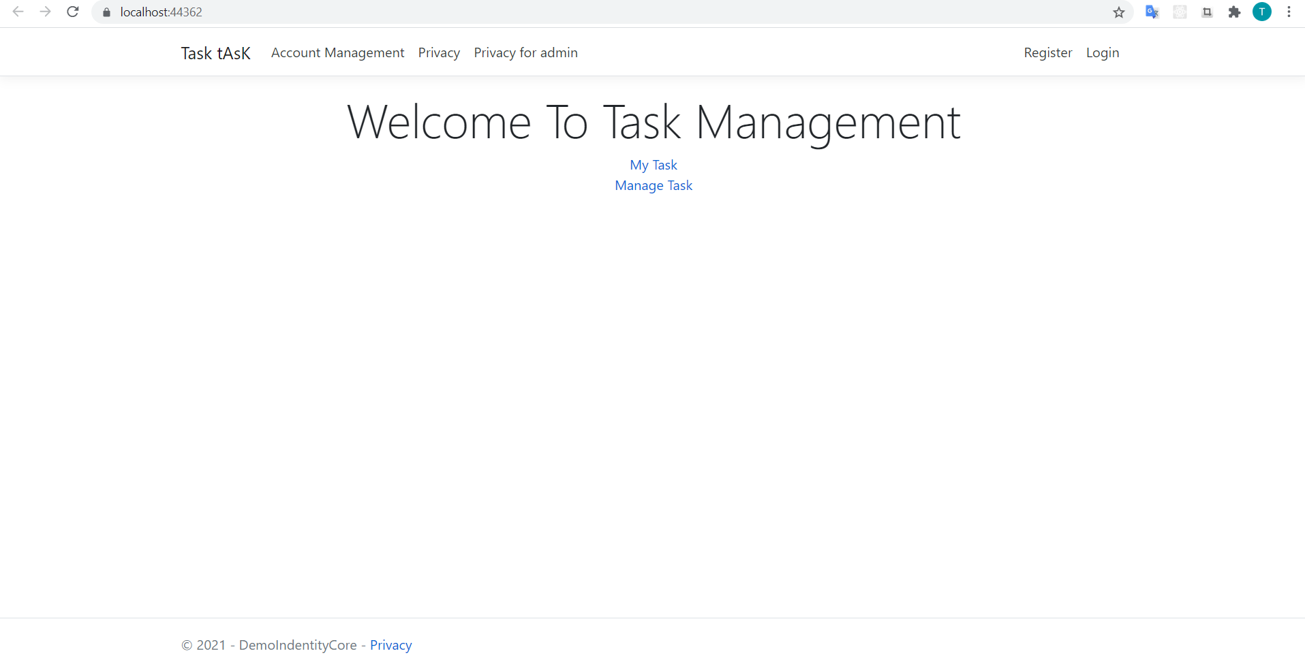

1. Idea

Today, The Manager Task List in the Company is very important in this time . We are gradually moving from working at the company to the online form, so checking the work progress and assigning tasks to employees is extremely important during this time. So we created a project: TASK MANAGER WEB

1. Scope

Users can see the task and view its content. if they finished it They can check Done in the status. And the Manager/Staff can see it and view the report.

1. **Technique**

Front-end:

* Html5
* CSS 3

Back-end:

* ASP .NET Framework MVC5.
* Identity Framework
* SQL Server

1. Connection:

ADO .NET Entity Framework Code First

1. USE CASE DIAGRAM 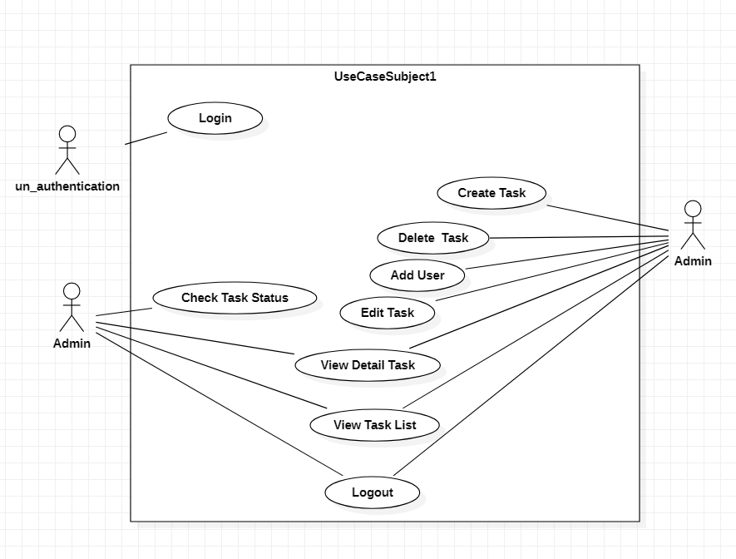

Figure 1 Use Case Task Manager

1. Database DIAGRAM

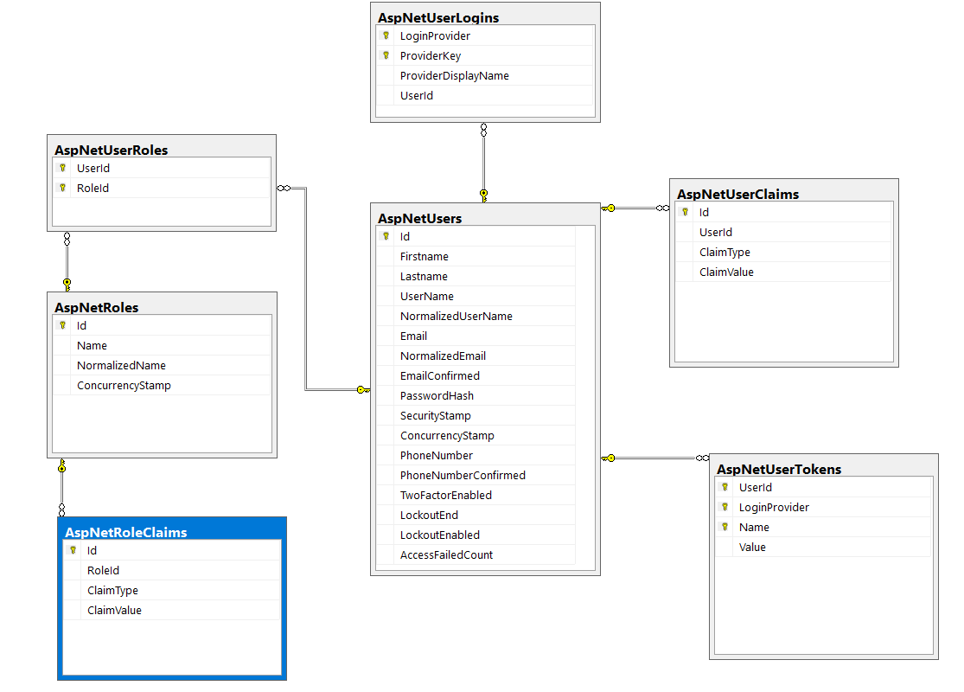

Figure 2 DB User

The DB manage task with user

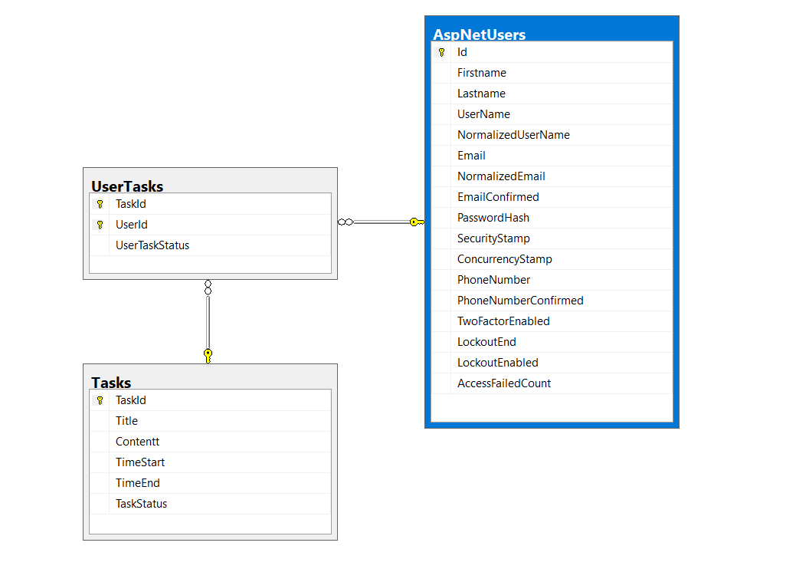

Figure 3 DB task

The DATA CODE :

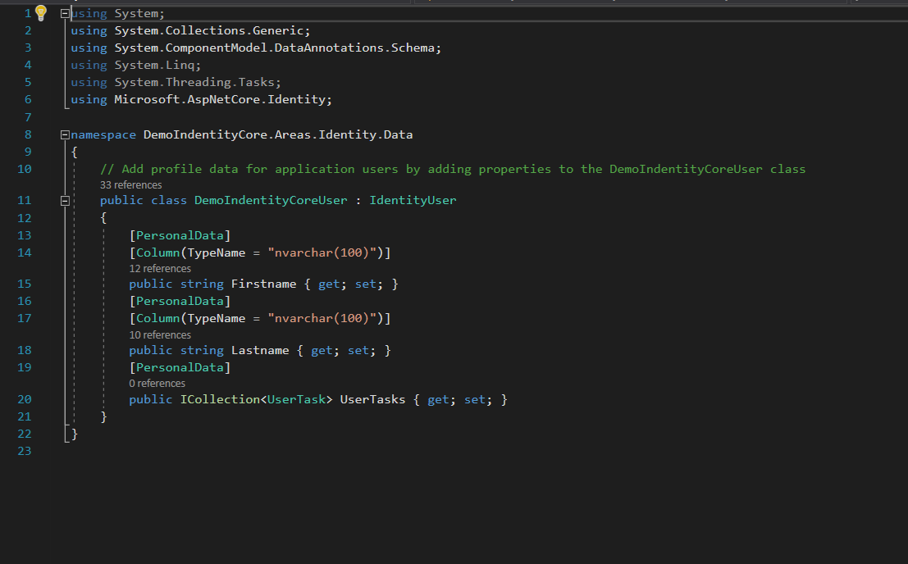

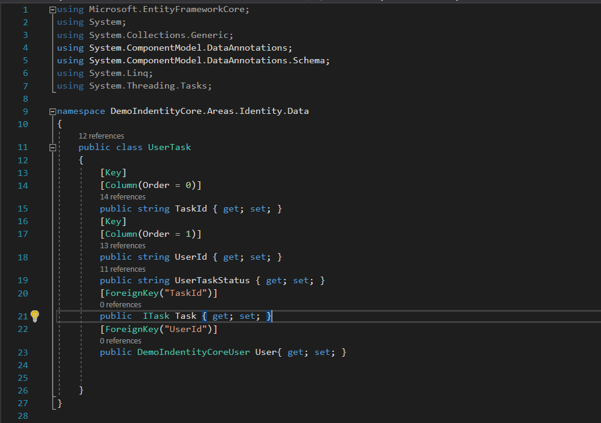

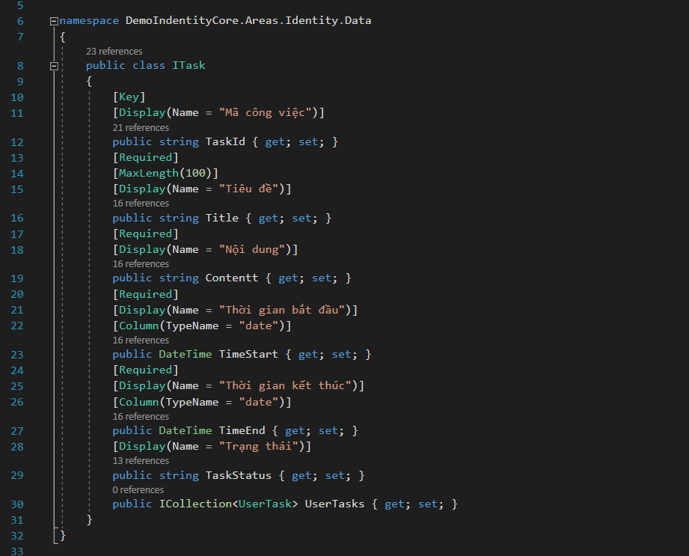

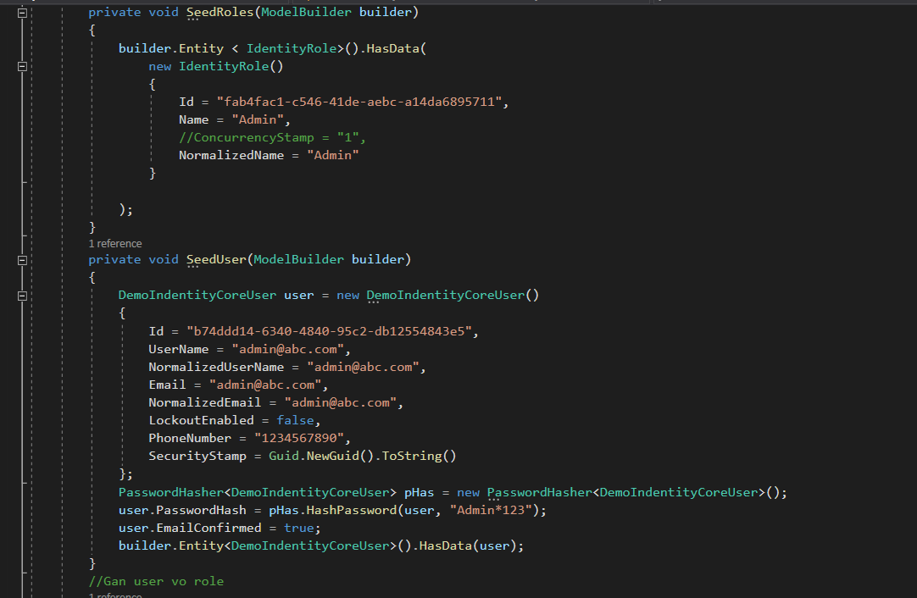

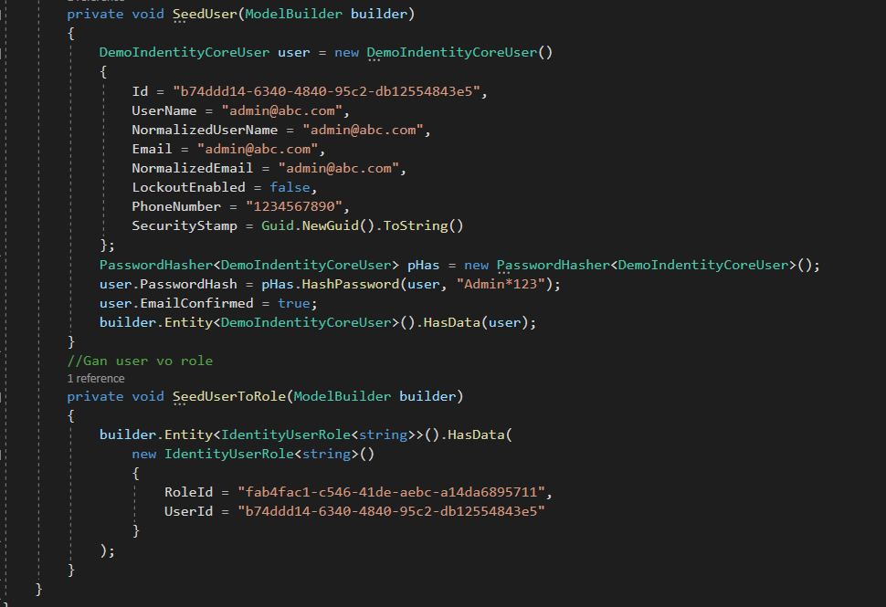

* Project :



Figure 4 Home Page

My task : this function for user to see the detail / list task / check status

Manager task : this function for admin can be added, deleted and update, see details.

Before user/ admin can use these function they need to login 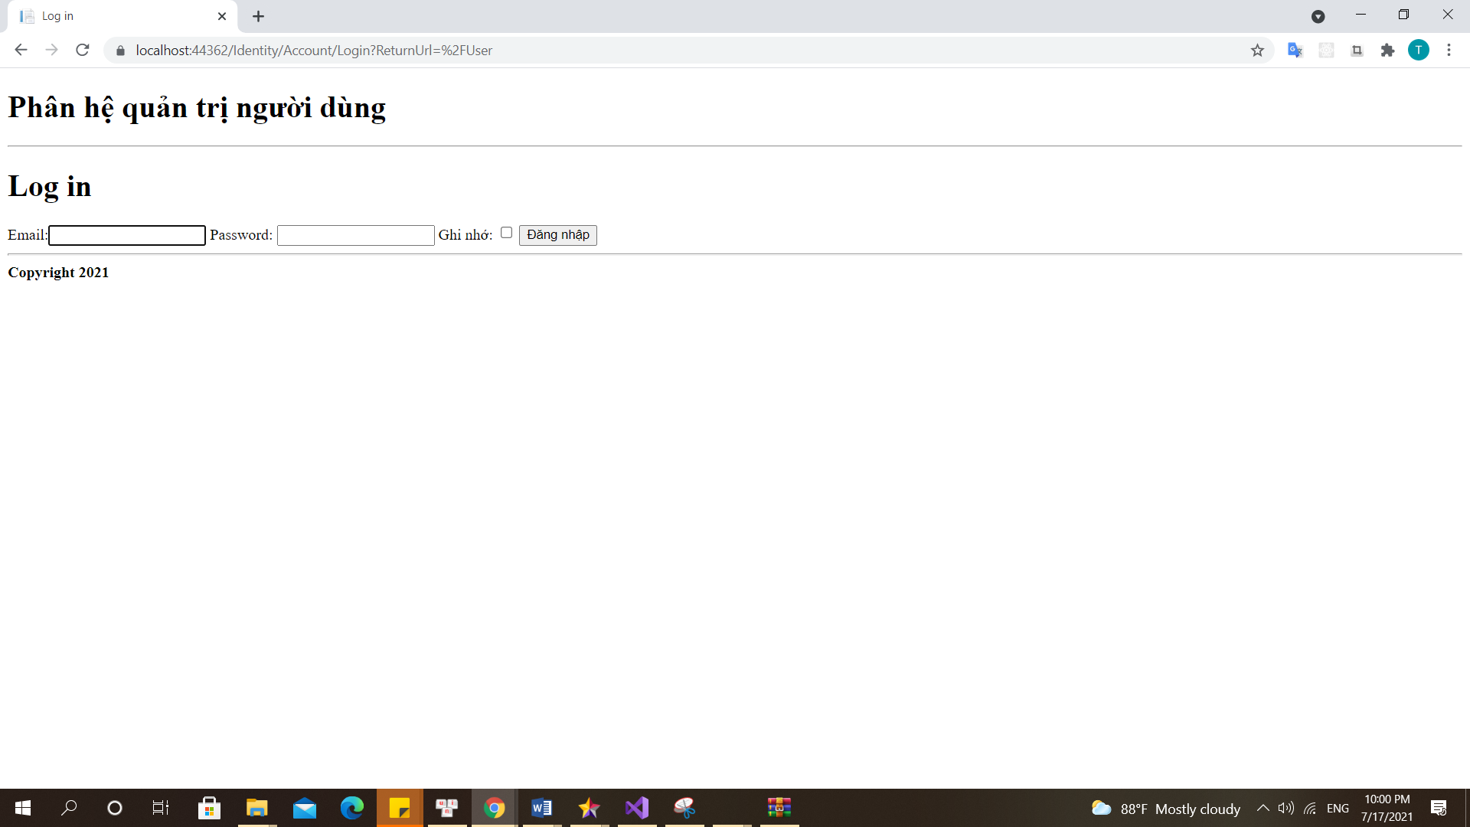

Figure 5 Login Page

Figure 2 : this page for admin to manage the task

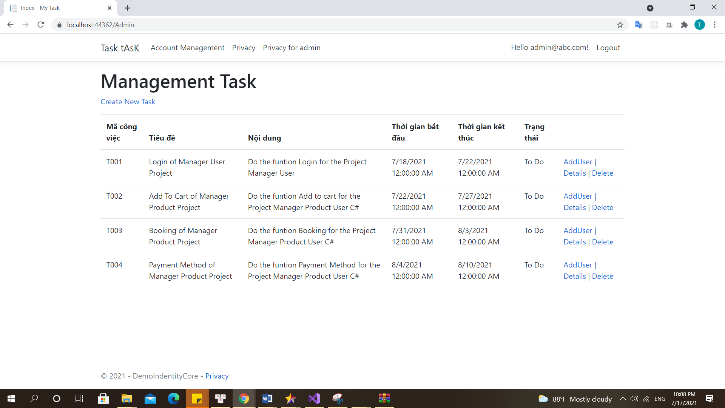

Figure 6 The Manager Task of Admin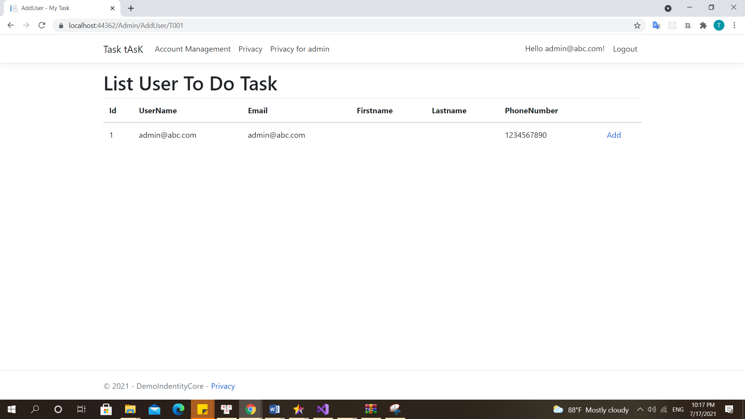

Figure 7 ADD User To Task

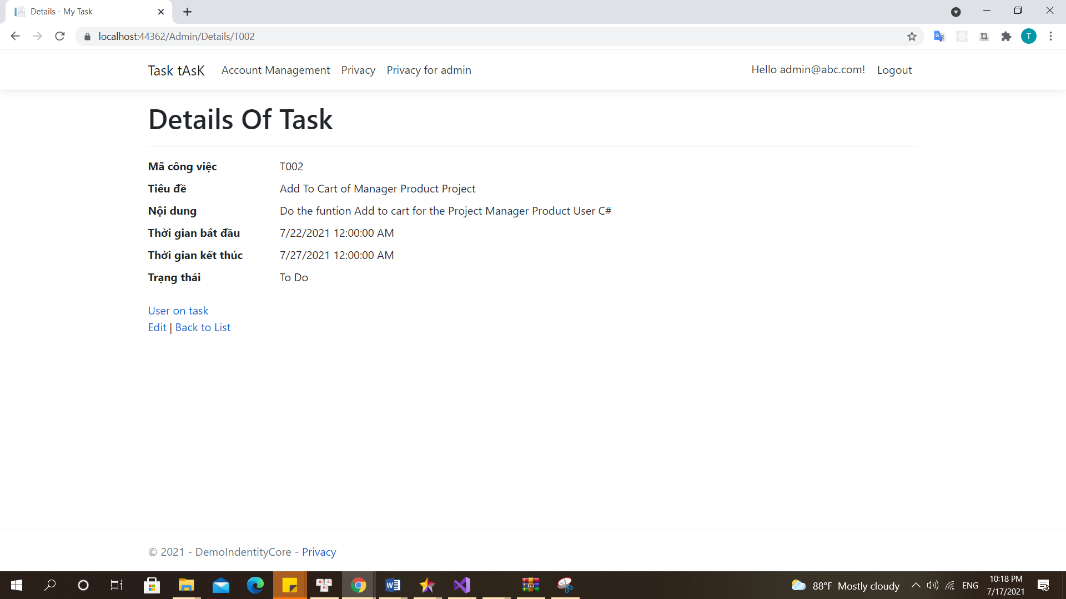

Figure 8 View Detail of Task

UserPage :

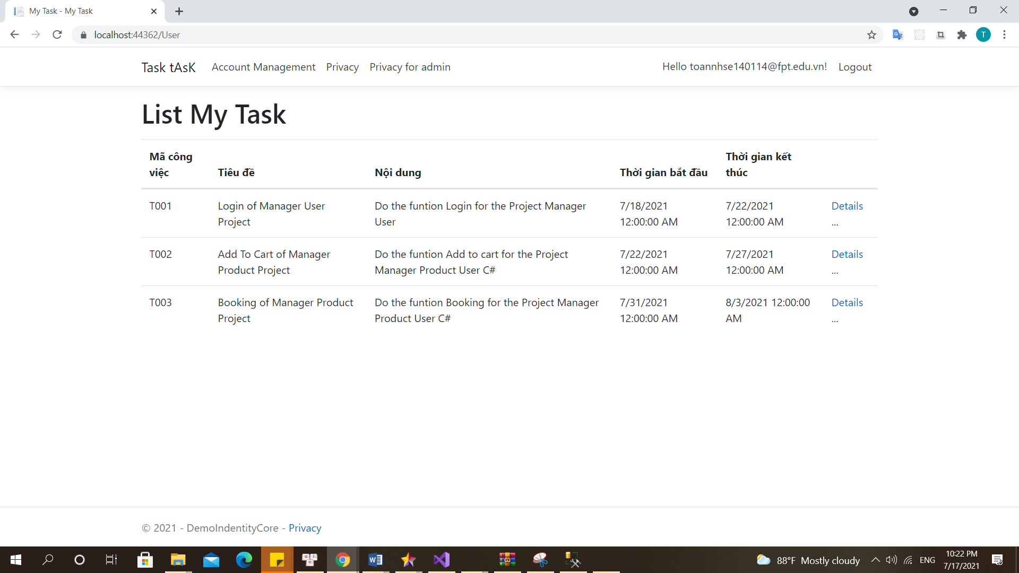

Figure 9 List all task user in

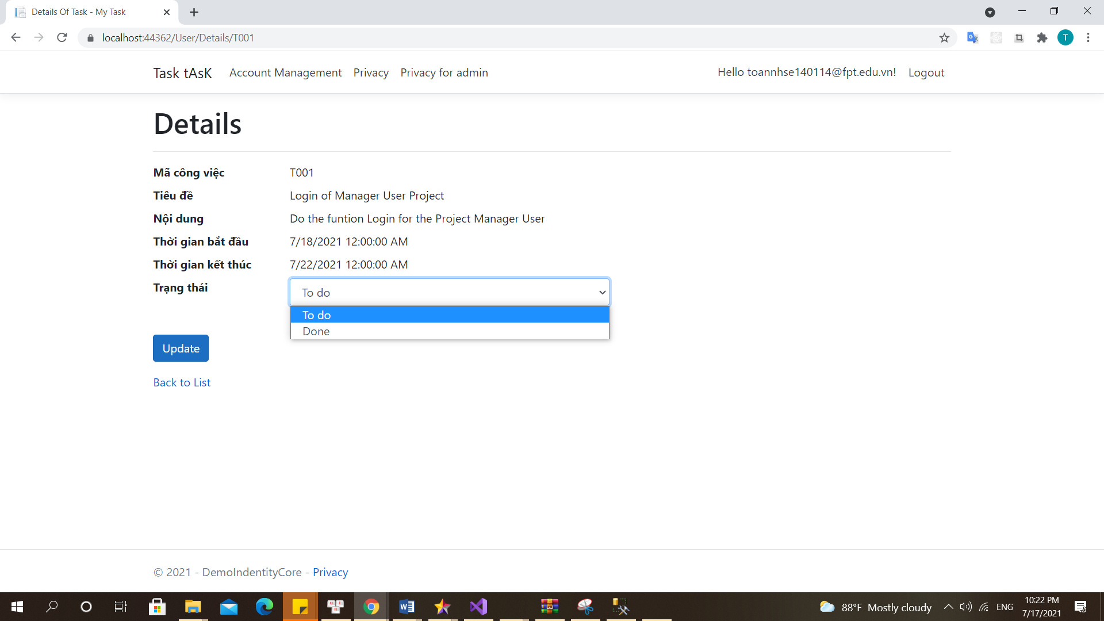

Figure 10 Detail of task